What are the current challenges that the hospitality industry is facing that is affecting business performance?

A 2000 Word Research Project Proposal

BMIH 5005: Personnel Resourcing and Development
STUDENT: FESTUS TUMI 2121888
LECTURER: Helen Jones

Abstract

Contents

Abstract 1
Introduction 3
Background and Area of Study 3
PESTLE and SWOT Analysis 4
Political 5
Economic 6
Social 6
Technological 6
Legal 6
Environmental 6
SWOT Analysis 7
Recommendations 8
REFERENCES 9

Introduction

The aim of this report is to have an analysis of the external environments of the hospitality industry as it affects the internal operations of the Accra Marriott Hotel, Ghana. It will seek to understand how these external factors have an impact on local recruitment, and retention at the hotel; and which in turn are having an effect on the overall business performance of the hotel within the wider Marriott International brands in general and the hotel vis a vis its competition in the “green zone” area of Accra that it serves.

Background and Area of Study

In 2018 a local consortium African Hospitality Ltd, debuted Marriott International’s first west African hotel, Accra Marriott Hotel (Marriott International 2018.) Although not the first international brand to open in Accra (Marriott International was preceded by Accor, Golden Tulip and Ramada), its premier location in the emerging Airport City enclave of Accra was a sign of growing international business confidence in Ghana. Located literally walking distance from the Accra airport and featuring a total of 208 rooms, extensive dining, leisure facilities, the hotel also has over 800 square metres of meeting space with the latest audio-visual equipment.
As one of the major international brands to be completed in the area it now competes with other international brands such as Holiday Inn, Protea, Ibis Styles; while Sheraton, Mercure and Hilton are under various stages of construction. All these hotels are within an 8 minute walk of the Accra Marriott Hotel. Other international brands within a 15 minute drive include Kempinski, Movenpick and Swiss Spirit.
This report will be looking at the external factors that is affecting the performance of the Accra Marriott since its grand opening in 2018, less than 18 months before the global COVID 19 pandemic. Arif and Hossin (2016) have surmised that it is essential that hotels have a clear understanding of the external forces that come to bear on the internal processes of that hotel in order to be profitable in such a highly competitive industry. The idea for studying the external forces that fashion the internal strategies have been studied by scholars such as Chrisman, Hofer and Boulton (1988) all of whom have reiterated that the success of the company was clearly determined by a study of the internal operations of the company and the external forces it faced. Barney (1991) determined that businesses gained sustained competitive advantages if they implemented strategies that “exploit their internal strengths, through responding to environmental opportunities, while neutralising external threats and avoiding internal weaknesses.” Fernandez, Cala and Domecq (2011) echoing Porter have also acknowledged that companies will need to have an understanding of their external environment together with their own internal processes to help create strategies to identify and produce create competitive advantage.

PESTLE and SWOT Analysis

This report will be using Francis Aguilar’s PESTLE analysis to understand the external factors that affect the Accra Marriott Hotel and then use a SWOT analysis historically credited to Albert Humphrey in the 1960’s to determine the best internal strategies to help develop strategies to overcome the challenges of recruitment and retention at the hotel.
Tourism and the hotel and lodging industry in Ghana has grown significantly since 1985 when there was a total of 85,332 arrivals to 586,612 in 2007, the year before the first hotel in the Accra Airport enclave was completed (Acheampong 2009)
Fig. 1
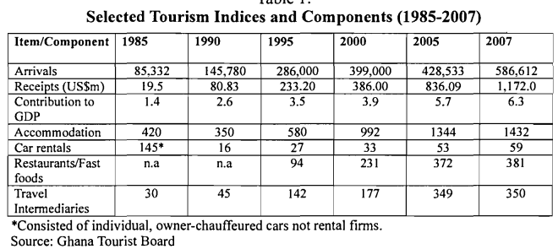
Just eight years later the receipts had grown to $2.7bn in 2017 (Danso et al, 2020)
The Accra Marriott Hotel operates within the highly competitive accommodation market, especially within Accra and the new Airport City developments. Notable chains include Accor (Ibis Styles, Movenpick), Best Western (Atlantic Hotel, Best Western Premier Accra Airport, Accra Beach Hotel), Kempinksi (Gold Coast Accra City), International Hotel Group (Holiday Inn Accra Airport), and Marriott International (Marriott Accra Airport, Protea Accra Airport).

The travel and hospitality industry took a really big hit in terms of revenue during the recent COVID-19 outbreak. Behsudi (2020) of the International Monetary Fund (IMF) reported in 2020 that there was more than a 65% drop in tourism receipts, with near total halt in April 2020. As the pandemic receded and governments reopened borders and lifted travel restrictions the industry has shown resilience and has bounced back. The UNWTO (2023) noted that in the Africa region has regained 88% of the 2019 pre-pandemic levels.
Fig 1
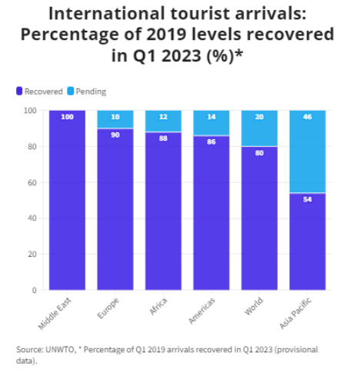

Political
- Ghana has been described the poster child of political stability in West Africa (Campbell 2013) due to the successful transfer of power five times in the Fourth Republic (1992 to date). It is based on this stability that many international hotel chains have opened hotels in Ghana.
- Ghana is now gearing up for the 2024 Presidential and Parliamentary elections but as previous elections have shown this is unlikely to be a cause of undue tensions. The US State Department (2023) ranks Ghana as a level 2 advisory, on the same level as the United Kingdom.
- Government through the Ghana investment Promotion Council offers lucrative tax incentives for companies like the Marriott if they recruit a minimum number of local people.

Economic
- The biggest global economic challenge of the last 3 years has of course been the COVID-19 pandemic. In Ghana, occupancy among the 3-5 star hotel category of which the Accra Marriott is part, occupancies dropped to as low as 5% (Danso et al, 2020b.) The biggest effect on the Accra Marriott hotel was whether to lay off recently hired staff and lose their expertise, or to retain them without any government support
- The current economic outlook for Ghana as determined by Fitch (April 2023) has been downgraded further to RD, effectively limiting the country’s ability for credit.
- This has caused a sharp devaluation in the local currency, and affected the purchasing power of both hotel staff and patrons.

Social
- With a growing “middle class” young professional Ghanaians and a moneyed elite and political class with a propensity to spend (Lentz 2016) the Marriott by paying higher wages has been at once both a contributor to this and a benefactor from it.
- Located in the affluent Airport City, residential area and environs and close to the modern malls and shopping centres.
- Many patrons are expatriates and second generation Ghanaians living and working abroad. The Marriott brand is an international staple and often a welcome retreat for these people, and aspirational for many local residents.

Technological
- Fully integrated booking management software, and the popularity of Online Travel Agencies like Expedia and Booking.com has changed the way potential guests interact with hotel reservation departments. At the Accra Marriot, in line with all Marriott International properties reservations are now 100% online or by phone.
- Automated email responses confirming reservations saving front desk staff time
- Smart keys, QR codes for menus and other non-contact has made the use of “hard” keys and menus obsolete.

Legal
- The relaxation of COVID era legislation has made international travel so much easier for the core clientele of the Accra Marriott Hotel.
- The Accra Marriott Hotel would ensure that it is compliant with the recently rewritten Companies Law 2019 (Act 992) and the Ghana Labour Act 2003 (Act 651)

Environmental
- The issue of illegal mining is a major topic of discussion within the Ghana body politic and its effects on the degradation of the water bodies and farms is an area of concern.
- As clients question Ghana’s commitment to environmental protection, the Accra Marriott Hotel puts its green credentials front and centre of its advertising and informational literature.

SWOT Analysis

With an understanding of the PESTLE factors affecting the hospitality industry in Ghana in general and the Accra Marriott in particular, a SWOT analysis for the hotel would be best to help determine how to respond the PESTLE factors
Benzaghta el al (2021) using definitions described by numerous scholars has outlined a strengths, weaknesses, opportunities, and threats (SWOT) analysis as an essential strategic tool to evaluate a company’s relevance and market position vis a vis external forces and competition.
Figure 2: Definition of SWOT (Source: Arif and Hossin 2016a) 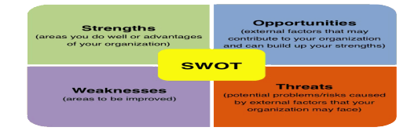

In reference to the recruitment and retention of staff at the Accra Marriot the
- Strengths are brand recognition, and the reputation of being one of the US Fortune top 10 companies to work for (Fortune.com 2022) and able to attract and retain quality candidates.
- Weaknesses – an over reliance on foreign guests and international conferences for income, made all the more challenging when COVID-19 caused a near shut down of international travel throughout 2020 and 2021. The Accra Marriott during this time was unable to recruit or retain staff during this time
- Opportunities – The Accra Marriott encouraged staycations during the COVID restrictions. It also had the opportunity to develop training and while similar properties in Accra were laying off staff, the Marriott retained theirs.
- Threats – As mentioned elsewhere, there are numerous international brand hotels within a ten minute walk and there has been several anecdotes of staff, once trained by one international brand are quick to move around to gain the best financial advantage.

Recommendations

Following

REFERENCES
Acheampong, O. (2009) Tourism Development in Ghana 1957-2007 Legon Journal of Sociology 3(2) Dec 2006-June 2009: 1-23. https://journals.co.za/doi/pdf/10.10520/AJA08556261_68 Accessed 15th June 2023
Arif, T and Hossin, Z (2016) A comparative analysis of internal and external environments between Hyatt Hotel, UK and Hotel The Cox Today, Cox’s Bazaar, Bangladesh. IOSR Journal of Humanities and Social Science (IOSR-JHSS) Volume 21, Issue 6, Ver. 3 (June. 2016) PP 13-22 e-ISSN: 2279-0837, p-ISSN: 2279-0845. www.iosrjournals.org https://www.researchgate.net/profile/Tanvir-Arif/publication/312320719_A_comparative_analysis_of_internal_and_external_environments_between_Hotel_Hyatt_UK_and_Hotel_The_Cox_Today_Bangladesh/links/6194b11761f0987720a5ec3e/A-comparative-analysis-of-internal-and-external-environments-between-Hotel-Hyatt-UK-and-Hotel-The-Cox-Today-Bangladesh.pdf (Accessed: 14 June 2023)
Barney, J (1991) Firm Resources and Sustained Competitive Advantage. Journal of Management 1991, Vol 17, No 1, 99-120. https://josephmahoney.web.illinois.edu/BA545_Fall%202022/Barney%20(1991).pdf (Accessed: June 14th 2023)
Behsudi (2020) IMF Finance and Development: Wish you were here. https://www.imf.org/en/Publications/fandd/issues/2020/12/impact-of-the-pandemic-on-tourism-behsudi#:~:text=In%20the%20first%20half%20of,in%20a%20post%2Dpandemic%20world. (Accessed: 14 June 2023)
Benzaghta, M. A., Elwalda, A., Mousa, M. M., Erkan, I., & Rahman, M. (2021). SWOT analysis applications: An integrative literature review. Journal of Global Business Insights, 6(1), 55-73. https://www.doi.org/10.5038/2640-6489.6.1.1148 https://digitalcommons.usf.edu/cgi/viewcontent.cgi?article=1148&context=globe (Accessed: 15th June 2023)
Chrisman, J., Hofer, C., Boulton, W (1988) Toward a system for classifying business strategies. The Academy of Management Review, Vol 13, No 3 (July 1988) https://doi.org/10.2307/258089
Campbell, J (2013) Ghana: An African Poster Boy? Council on Foreign Relations, Africa in transition. https://www.cfr.org/blog/ghana-african-poster-boy (Accessed: 14th June 2023) https://repositorio.uam.es/bitstream/handle/10486/664072/Hotels%20investments_Saez_TE_2011.pdf;jsessionid=5713B20648D649556EB7F76F5E85FD03?sequence=1 (Accessed: 14th June 2023)
Danso, B., Osei-Tutu, A., Whyte, T., and Ocquaye. (2020) Ghana Hotel Industry (Three-Five Star Rated) And Covid-19: Present Scenario And The Way Forward East African Scholars Multidisciplinary Bulletin. Vol 3, Issue 9 2020
https://d1wqtxts1xzle7.cloudfront.net/66434868/EASMB_39_279-292-libre.pdf?1619023377=&response-content-disposition=inline%3B+filename%3DGhana_Hotel_Industry_Three_Five_Star_Rat.pdf&Expires=1686837434&Signature=NVvXhH4hDujyqr2aebjX7Z-o7KyrXmQD~tf8uzpTY88wP498-L3nhj-rKw6GNJDYscgIO7hH1BdBHR1cpV~DkOTFkyiLJ6oEVRNe4tjMVVwk3uiX-fOFZM4cftM3HK9QaVS3Hya8RSgiaOaQ8~T7MqBtRcB9okiblBKRGoXk5Z8YHIBApZHNunQr4yCXyFWGXkYnFDbu2058yPOoMDC595Kuv2SdsfCnR~nbDUB5yNJY2-HfFjyQI~rAvnaUAg4duufnTcVzRu61pQzjTljP59Likz97djGt8KZyBAYlhDps1y5~QuFR5I7N9TyGkKUHekpKclBs6DH8V-B7gS7fQA__&Key-Pair-Id=APKAJLOHF5GGSLRBV4ZA Fernandez, J., Cala, A., Domecq, C. (2011) Critical external factors behind hotels’ investments in innovation and technology in emerging urban destinations. Tourism Economics, 2011, 17 (2), 339–357 doi: 10.5367/te.2011.0033 (Accessed:15th June 2023)
Fitch Ratings (2023) Fitch Downgrades Ghana’s LTLC IDR to ‘RD’ https://www.fitchratings.com/research/sovereigns/fitch-downgrades-ghana-ltlc-idr-to-rd-21-04-2023#:~:text=Sovereign%20Rating%20Model%20(SRM)%20and,Term%20Foreign%2DCurrency%20IDR%20scale. (Accessed: 15th June)
Fortune.com (2022) 100 Best Companies to work for: Marriott International Rank 10 https://fortune.com/company/marriott-international/best-companies/ (Accessed: 15th June 2023)
Lentz, C. (2016) The Rise of Africa's Middle Class: Myths, Realities and Critical Engagements edited by Henning Melber. Chapter 1. African Middle Classes: lessons from transnational studies and a research agenda. Bloomsbury Publishing 2016
Marriott International (2018) Marriott Hotels Debuts in West Africa with the opening the opening of Accra Marriott Hotel, Ghana. https://news.marriott.com/news/2018/04/30/marriott-hotels-debuts-in-west-africa-with-the-opening-of-accra-marriott-hotel-ghana#:~:text=Marriott%20Hotels%2C%20part%20of%20Marriott,%E2%80%9CGateway%20to%20West%20Africa%E2%80%9D (Accessed: 14 June 2023)
UNWTO (2023) AMNEWS Vol 54 Highlights https://webunwto.s3.eu-west-1.amazonaws.com/s3fs-public/2023-06/NL-54-June.pdf?VersionId=X0CUr1Hy9ibF62QSbDKTuLlDfJCY9s0M (Accessed: 14 June 2023)
US State Department (2023) Ghana Travel Advisory https://travel.state.gov/content/travel/en/traveladvisories/traveladvisories/ghana-travel-advisory.html (Accessed: 14th June 2023)

