PROFESSIONAL CAREER DEVELOPMENT

Recruitment and Selection Process
from Job Analysis

Speaker Note by
Sarwat Asfi
Student no: 1905650

Recruitment and Selection Process
from Job Analysis

Recruitment Process

Recruitment is a procedure of attracting, interviewing, deciding, hiring and on boarding personnel. It entails the entirety from the identity of a staffing need to filling it. Depending on the capacity of a company, recruitment is the obligation of more than a few workers. Larger companies can also have complete groups of recruiters, at the same time as others most effective a single recruiter. In smaller companies, the manager is responsible for recruiting. Many organization outsource recruiting from other companies. Companies recruit applicants via advertisement, social media, Labour Union, Colleges, Universities and employment agencies. Company's recruitment works together with Human Resources department.
“Recruitment is the process of searching for prospective employees and stimulating and encouraging them to apply for the job.” – (Flippo EB,1980)

Types Of Recruitment

Internal Recruiting:

Internal recruitment involves filling the vacancy with existing employee from the company. The advantage of internal recruitment that candidate is already working for the company and have better understanding with companies rules and regulation, goals and work ethos.

The advantages and disadvantages of internal recruitment:

Advantages | Disadvantages
- Cost Effective  - Transfer (from one department to another)  - Promotions  - Motivation of good performance | - Morale problem those not promoted  - Politics of infighting of promotion

External Recruiting:

External recruitment means finding and hiring the candidate from outside the organisation.

The advantages and disadvantages of external recruitment:

Advantages | Disadvantages
- New People New Prospective  - New Professionals  - No group of political supporter  - May bring new business ideas | - May not select person fit for the job or organization  - Longer adjustment time in company

Selection Process
The selection is the method of choosing the most suitable candidate for the job role in any organization. It is a process of taking unsuitable applicants out and choosing the candidates with adequate qualification, capabilities and work experience to fulfil the job requirements. Based on analysing the information of the candidates and comparing with the company's requirements and demands and those who met the essential requirements they proceed the selection process.
Selection process is based on several steps:
- Job Vacancy
- Job Application
- Evaluation of Applications
- Physical ability test, Personality test (Myres Briggs)
- Questioner
- Interview
- Reference Checking
- Final Selection
Job Analysis
Job Analysis is the process of identifying the job description. It is the procedure for company to know if the candidate is suitable for the job as well as for candidates to know if they are capable to full fill job requirement. There are verity of methods that employers undertake to fill the position e.g. job application, gathering personal information, testing abilities through different method, interviews, questioners, discussions, portfolios, strengths, weaknesses, getting references from old employers and final stage hiring the candidate.
Reference:

"Peter Morgan" The Business student's guide to study and Employability
page: 328

"Peter Morgan" The Business student's guide to study and Employability
page: 329

Flippo, E.B. (1980) Personnel Management London. Mcgraw-Hill

https://businessjargons.com/external-sources-recruitment.html

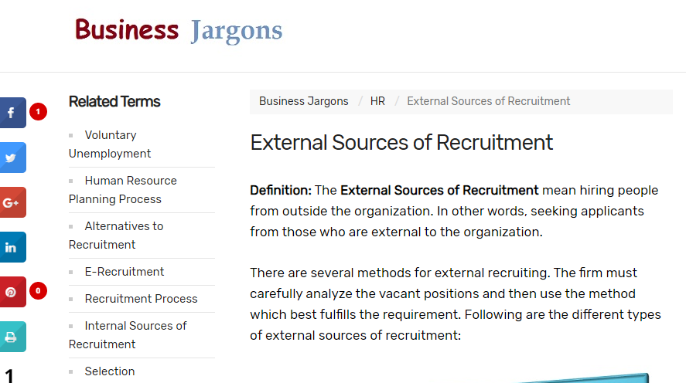

https://www.mbtionline.com/
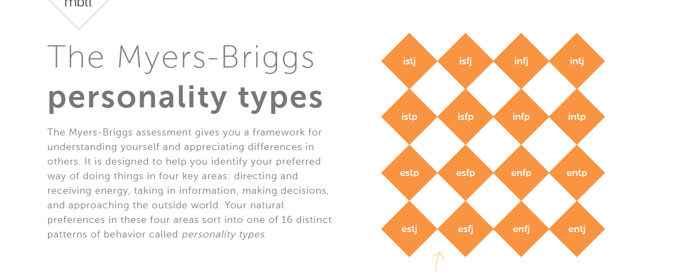
https://www.grb.uk.com/recruiter-research/selection-methods


