My Body is the Canvas.

By Erin Jayne Lloyd.
1805550.

Photography in the Arts.

Summary of topic.

The purpose of my dissertation is to challenge the social judgement of tattoos, tattoos have become more popular these days, where you see them everywhere from sports stars, singers and even to politicians. I am going to be conducted research into several subjects ranging from identity, history of tattoos, art and tattoos as an expression and the medical effects that tattoos have on the body, I believe conducting this research is important because it allows you to expand on your own knowledge and will help you understand things about the subject you are interested in or things you didn’t know about said subject.
The reason for my research is to understand the history of tattoos and to see where it became socially unacceptable to have tattoos and I want to look into the effects that having tattoos does to your working life along with your health. One of the main reasons I am interested in this subject is because I was turned down for a job in a coffee shop in London and I was interested in seeing what other jobs refuse to employ or refuse to promote staff member who are inked.

Table of contents.

Front cover Page 1
Summary of topic Page 2
Table of contents Page 3
List of Illustrations Page 4
Chapter one: Who are we? Page 5
Chapter two: Art as a form of expression Page 8
Chapter three: History of tattoos Page 9
Chapter four: Tattoos as a form of expression Page 14
Chapter five: How tattoos affect your working life Page 16
Chapter six: Medical effects of tattoos Page 17
Conclusion Page 19
My personal work on tattoos Page 20
Bibliography Page 21

List of Illustrations.

Artwork:

Gillian, J. (2018). International Journal of Paleopathology.

Jorre from Theblacklotus. (2017). Reddit online.

Krutak, L. (2013). Tatu Lu.

Live Auctioneers. (2011). Museums.

Lloyd, E. (2018). University of East London.

Lucky Diamond Rich. (2006). Guinness Book of World Records.

Mayers, M. (2018). The National Museum of Women in the Arts in D.C.

Chapter One: Who are we?

There are many roles we take on when in a social situation, you can be a daughter, mother, sister, aunty, cousin, friend etc... and each of these has their own roles and responsibilities. You would never act the same way around your mother and your friends, they are all different sides of your personality, yet they may not be true you.

To understand identity there are two different approaches to this and they are essentialism and anti-essentialism. (Oxford Dictionaries, 2018.) Essentialism reduces people to a single thing, it takes people at face value and doesn’t look deeper into who the person is, photography is like this. You see what is in front of you and not the story behind the photograph and anti-essentialism is the opposite of essentialism, this makes us see that a person’s identity is made up of many factors and we aren’t just focused on the one thing. (Thomas Davies, 2018)

Ervin Goffman (1922-1982) is known as one of most influential sociologists of the 20th Century, due to his many significant and lasting contributions to the field. There is a great quote from Ervin Goffman which says; ‘We are wear masks, how we display ourselves to others. We are constantly worried about what we look like and how we come across.’ (Goffman, 1956.)
When we think of identity we think, who we are and how we think of ourselves
and how the world sees us. It’s about the characteristics we have and what skills sets we have that define us, for example a person’s name is a form of identity.
The main questions we ask when talking about identity is ‘who are you?’ and ‘what does it mean to be you?’ our identity relates to our basic values that dictate the choices we make, and these choices reflect who and what are important to us. A few people choose their identity, they internalize the vales of their parents or dominant culture, such as; money, power and materialistic things. But sometimes these things are not what they value, and it leads to an unfulfilling life. A lack of sense of identity will lead to uncertainty about one wants out of life. (Heshmat, 2014.)

Our identities are constructed from the moment we are born, our parents choose our name and that is the main base of someone’s identity. When you think about identity there are many things that make it up such as; qualities, beliefs, personality, looks and/or expressions, race, ethnical and sexuality, if you take one of these things away someone could have an identity-crisis and/or breakdown. If you force someone to act and behave a certain way it could result in a destructive way and could cause them to not be able to express themselves but also hurt themselves.

One or more of these things could change the outcome of your life and identity, such as having family money might make you not appreciate the money or being gay and not being able to express this. If we are not able to express ourselves the way, we want to it isn’t being true to who we are, and it could lead your life down a negative path and a self-destructive path and one that is not true to who you are.
Gender is a big part of forming your identity, there are somethings that a certain gender will stop you from doing or hold you back from, it also dictates to a certain degree on how we view ourselves both as a person and in relation to other people, nature and your ideas. The Teen Health Board have stated that;

Your gender identity is how you identify and present yourself, for example as a boy or man, or as a girl or woman. Gender isn’t about whether you were born with a penis* or vagina*, but how you feel about yourself. Some people are transgender, which means their gender identity that doesn’t align with their biological sex. You are free to present your gender in different ways. Your race, culture, age, ability and even your personality can affect how you think about your gender. Your gender identity may be fluid and can change throughout your life.

In cognitive psychology they use the term ‘identity’ as a reference for self-reflection and the awareness of self. (Gender Spectrum, 2017.)
The description of individual identity is a central task for psychologists, sociologist and anthropologists and those of other disciplines where ‘identity’ needs to be mapped and defined.

When you think about identity you have to think about socially constructed identity, social media and self-identity, with each of these we act differently. When you think about the social media platforms that we use on a daily basis, such as; Snapchat, Facebook, LinkedIn, Twitter and Instagram. With each of these platforms our identity/personality changes, you want to display yourself in different ways with different medias because they are all set up for different things. When looking at the mission statements for each of these online social media platforms shows what they each intended for their sites. When Instagram was created it was designed to capture and share the world’s moments. (Mølby, 2018) They have done this by creating an app which you can download onto your phone/tablet and you can capture and share the moments you deem important, where Snapchat’s mission statement says that they want to contribute to human progress by empowering people to express themselves and for them to live in the moment and to learn about themselves and to have fun in life. (Snap Inc, 2018.) Where Facebook was designed to help build community and to bring the world closer together, people use Facebook to stay connected with friends and family and to discover and share thing with the world that matters to them. LinkedIn is designed to connect the worlds professional people to make them more productive and successful. (Facebook, 2017.) With twitter, it gives everyone the power to create and share your ideas and information with the world instantly without barriers. (Fox, 2014.) When looking at the mission statements from each of these social media platforms Snapchat has a combination of both Instagram and Facebooks idealisms and wants to connect the world.
I have noticed this when looking at the social media platforms the differences between them, where on Instagram people mainly post photographs, Snapchat is mainly use filtered photos of yourself and your friends and then with Facebook there is a mixture of personal and professional things on them, yet there is stuff you may not want people on Instagram and LinkedIn to see on Snapchat.

Chapter two: Art is a form of expression.
Ever since human being have been around, they have been making art. They have been using anything they can to create these pieces. When you think of the phrase ‘Art as a form of expression’ you think of it being connected to a person’s emotions, if you are sad, you paint a sad painting using dark and depressing colours and if you are happy you paint a happy painting using bold and bright colours, but it goes deeper than that not only can you express your emotional aspects of life you can hit upon political, historical and romantic etc... aspects of life. The older you get the more you take from a piece of artwork, wither it being a sculpture to a canvas painting to a photograph, your knowledge of various mediums of art and the amount of statements you can make through this. (Barco, 2016.)
There are many ways for someone to express themselves, through their wardrobe, hair make-up, how they act, talk and through body art. By expressing yourself through art you are portraying your feelings and views and different statements you wish to portray. While expressing yourself through art you are putting your feeling onto paper and in a way, it is a form of therapy. You are also letting the world see something personal of yours that you want them to see and feel. (Apice, 2016.)
Monica Mayers’ is a feminist artist that works with a variety of mediums except ceramics, she talks about challenges that women face in society and her work speaks about women empowerment. Her girl with her career s to shake people up, to get people’s emotions going and to really cause an effect on them.
One of Mayer’s most popular pieces us titled; El Tendedero (The Clothesline) in which she has pinned post-it notes that have statements and questions about sexual harassment written on them. One of the post- it notes on her clothesline asks’ ‘When was the last time you were sexually harassed?’. Many people participated in this piece of work, in one of her exhibitions she received around 7,000 written response and around 3,000 electronic responses which is incredible. This shows that the phrase ‘Art as a form of expression’ is deeper than what we see on the surface of happy and sad, art can be used in therapy for many different reasons. She is very passionate about this work and has addressed different issues within immigration such as; deportation, racism, assimilation, risks, hardship along with others.

Mónica Mayer, El-tendedero, 2016.
Chapter Three: History of Tattoos.

While researching tattoos, I was recommended to look at Netflix’s original series, Explained. They did an episode on tattoos, they covered the history of tattoos and their thoughts on tattoos. They say that there is something in our DNA that makes us want to make our bodies different to the people around us, every monkey wants to be different. Tattoos these days are everywhere, in 2015 only 1 in 3 Americans had tattoos, where a few years prior 1 in 5 had tattoos and now more sports stars, actors and even elected officials are sporting them. (Posner and Klein, 2018.)

Around 56 years ago tattoos we’re incredibly rare, Lars Krutak is an American anthropologist, photographer and writer and he is known for his research about tattoos and its cultural background stated, ‘Tattooing didn’t develop and then spread around the world, it’s more independent and grew.’ (Krutak, 2018.)

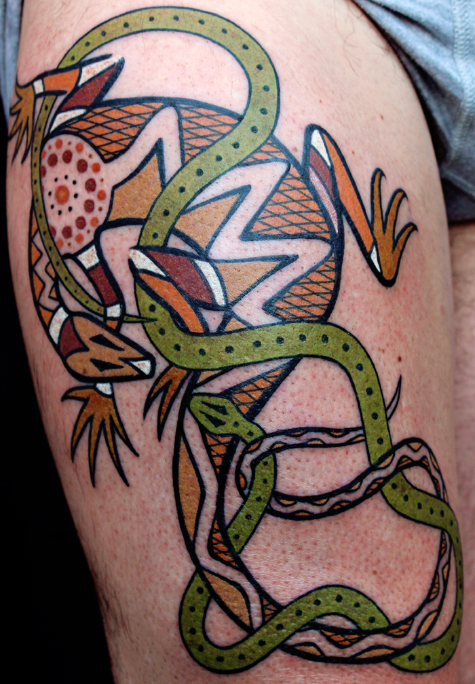
Lars Krutak, A goanna and green tree snake, 2013.
Tattoos are classed as a form of body modifications, where pigments of ink are inserted into the skin and the colour is changed permanently. It is an old tradition. (Posner and Klein, 2018.)
We see getting tattoos is an act of rebellion against society, that is one of the main reasons people get tattoos these days. It is documented that in 3300bc a body was found with roughly 61 tattoos, he was named the ice-man (Ötzi) he is a 5000-year-old mummy that was found in the Ötz valley in the Alps. Other tribes such as; Germanic and Celtic tribes have also been tattooing themselves, and the Mummy of Amunet that was from ancient Egypt and the mummies from Pazyryk and Siberia that have dated back to the end of the 2ns Millennium, BC, so tattoos we’re known around the world back in early history. In both Ancient Egypt and India, they used tattoos are a method of healing and religious worship, along with marks of status and punishments. Where in the Philippines they are a marking of ranks and accomplishments and people believes that the tattoos held magical properties. (Posner and Klein, 2018.)

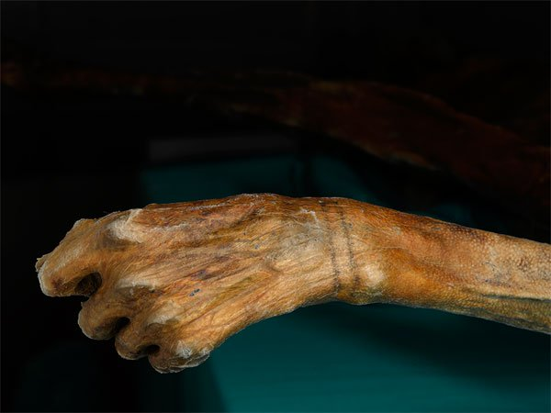
Joanna Gillian, Evidence from Ötzi, 2018.

When Christianity appeared, they believed tattoos was a barbaric tradition and slowly faded in Europe and it returned in 16th century. Sir Martin Frobisher, William Dampier and Captain James Cook we’re travellers and brought home with them indigenous people from all over the world and they were often tattooed. At first, having a tattoo were reserved for sailors and lower classes at the time. As tattoo artists became more popular, tattoos became a hobby of aristocracy which had more money to pay high prices for professionals. When the tattoos became cheaper again it was seen as a mark of the lower classes. It was like that until the 1060s and the hippie movement when it became an acceptable form of self-expression. Mattel started selling barbie dolls that sported tattoos when it became mainstream. In 2000 15% of Americans had tattoos and that is of all gender, sexes, economic classes and age can have tattoos if they want to. (History of Tattoos, 2018.)

In some cultures, tattoos are a sign of strength and rite of passage into adult-hood and of a spiritual journey. In some country’s tattoos were a form of address, you would be able to tell what clan someone comes from based on their tattoo along with their rank within the clan, so you would know how to properly address them and to use the right amount of respect. (MEDermis, 2018.)
Most of the tattoos you see these days come from a handful of traditional tattoos; Algeria, Micronesia, Tunisia, India, Egypt and Alaska. One of the traditional methods of tattooing someone is to use a piece of barn, they get the barn banged into the skin and ink is added once the skin has been broken.
Tattooing was a painful ritual and still is in some cultures, once the tattooing is completed it marks your place within your community. This was especially true in countries like Somalia. (Posner and Klein, 2018.) Whereas, in come cultures tattoos are a sign or respect and status some cultures and religions tattoos are a sign of desecration of the body ‘Do not cut your bodies for the dead, and do not mark your skin with tattoos. I am the LORD.’ New Living Translation, Leviticus 19:28. (Bible Hub, 2004.)
By the end of the 17th century, Japan tattooed their prisoners on their faces or arms. This dies out because the rise in decorative tattoos and criminals could cover their prison tattoos with these new ones, to mask their criminal records.
Horiyoshi 111 is a Japanese tattoo master, he said ‘Tattoos are a symbol of power. You carve a hero onto your back to take on his characteristics.’

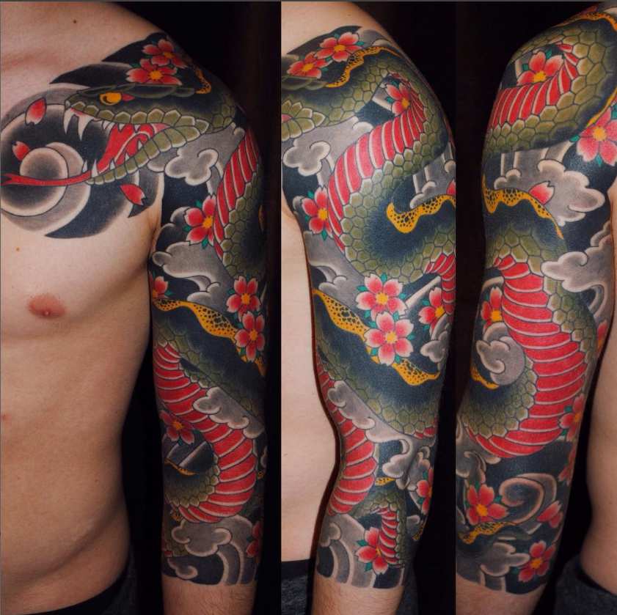
Jorre from Theblacklotus in Antwerp, Belgium, Irezumi 3/4 sleeve, 2017.

In Japan, their traditional tattoos also known as ‘Irezumi’ can take several years to be completed. They are known for their bright colours, myths and monsters. Tattoos were outlawed in the early 19th century. Tattoos were classed as dangerous, they held power and people with tattoos were feared. In Japan, their tattoos are based around myths and legends and the weak are not honoured within myths and legends because there is no weakness in myths and legends. Even though tattoos are legal in Japan now they are still highly associated with criminality and the history involved with it over the generations. The art work of tattoos has become a visual symbol of the Japanese mafia – Yakuza. (Posner and Klein, 2018.)
Around the world you see more tattoos being done that have been influenced by Japanese tattoos. (MEDermis, 2018.)
When you get something tattooed most of the time it means something personal to you.

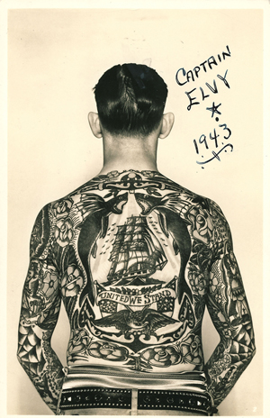
‘Captain Elvy’ and his full body suit of tattoos. Elvy’s back features a clipper ship, roses, flying fish, eagle, American flags, and a banner reading ‘United We Stand,’ circa 1940. Image courtesy Tattoo Archive, Winston-Salem, N.C, 2011.

In American tattoos there are many designs that were only used by sailors, such as the swallow, anchor, heart, initials and nautical theme along with the flag. If you were a sailor and had a swallow tattoo it meant the sailor had sailed 5000 nautical miles. Back then if they had one or more swallows on them it was beyond impressive. Other traditions sailors had we’re collecting tattoos of where they had docked, it was a map of their journey. (Posner and Klein, 2018.)
In 1891, tattoo guns were introduced and getting a tattoo became quicker and less painful.
As in Japan, tattoos thrived in prison, but where Japan marked their prisoners the prisoners are the tattooing. The main groups of people tattoos are associated with are bikers, criminals (thin lined tattoos, no colours - it is the prison signature style.) and gangs it stayed like this for a long time.
In 1981 the popularity of tattoos exploded when television became a thing. The circus helped the popularity of tattoos around the countryside. All around the world mixed cultural tattoos have become popular with the help of Instagram, also the number of Americans that have tattoos has grown more and more over the years. (Posner and Klein, 2018.)
Since tattoos have become a big thing, so has tattoo removals, it has become a multi-billion-dollar business. (Kramer, 2010.)

People wasn’t to be the most expressive that they can be, and tattoos allow you to do that. It is an expression of Human Life. (Farrell, 2013.)
There is a world record for the amount of body that is tattoos and that belongs to Gregory Paul McLaren and 100% of his skin is covered in tattoos and runner up to him is Tom Leppard who is born in 1934 99.9% of his skin is covered. (Guinness World Records, 2006.)

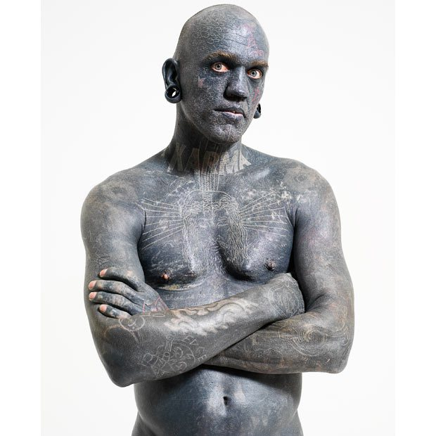
Gregory Paul McLaren, Guinness world record holder, 2006.
During the second world war that was a huge problem with Hepatitis and many places had banned tattoos to avoid people from catching this, it wasn’t until recently that many places have lifted this ban. (History of Tattoos, 2018.)
The Ancient Greeks and Romans tattooed their slaves and criminals, so they could be easier to identify if they escaped, Chinese culture also tattooed their criminals. The earliest tattoo inks were made of carbon and ash. (History of Tattoos, 2018.)

Chapter Four: Tattoos as a form of expression.

Jessica Checkland has stated that her tattoos are a physical manifestation of the person she is on the inside and the kind of person she wants others to see in her. They reflect who she is and what she believes in and it shows her passion and it dedicates to the values. (Checkland, 2017.)
Checkland has also stated some more reasons why she thinks tattoos are the ultimate form of self-expression.
- They represent a new beginning.
Everyone has scars that remind them of their past that, tattoos can cover up bad memories by replacing them with artwork which turns the deepest of scars into something you love. Tattoos can be part of a healing process.

They’re Perfect Conversation Starters
Having a unique tattoo on your body is a great way to break the ice with someone while having a conversation. Fellow tattoo enthusiast, Konnor Geel, says, “Tattoos are a way you can take pieces of your personality and put them on display for others to see.”

Let’s Not Forget That Tattoos Are Works Of Art.
Tattooing is one of humanity’s most ancient forms of art, within the last century tattoos have made their way into galleries, museums, auctions and conversations. Tattoos are like art, they can have multiple meanings and is open to the viewers interpretation. When a tattoo is designed, it is a unique piece of art created just for you which you keep forever.
Your body is a canvas and tattoos are your masterpiece – embrace it!

They Remind Us Of Who We Are.
Tattoos are reminders of unique stories. Sure, it could be sentimental, or it could be a funny memory from a drunken night.
Whether silly or sentimental, calming or hilarious, tatts are great. Deal with it. (Checkland, 2017.)
Tattoos have been around for many years and they are viewed in many different ways. Tattoos sell stories and act as reminders, they can also show culture and express feelings and ideas. Tattoos can be very painful and extremely time-consuming, it just adds to how great they are, knowing someone the pain and someone took the time to sit and create the tattoo, it’s something to be proud of and amazing. People get to show off their art and get to represent their lives on their skin. In today’s society you can’t walk down the street today without seeing someone with tattoos, in different shapes, sizes, colours and you can hear people discuss what they are getting next. Having a tattoo is a way to give insight to everything about a person, tattoos all take different time scale to heal, depending on the size, colour and location on your body that you have the tattoo. There is a lot of care that goes into looking after a tattoo you need to keep it clean, cover it with healing cream, not to pick at it or starch it and let it peel naturally. (Anderson, 2016.)
Having a tattoo can be motivation to get better grades or to achieve something. Once you have a tattoo it become a part of your physical make-up and should be insulted. People shouldn’t be judges based on having tattoos, not so long ago the only people with tattoos were sailors, criminals and degenerates. People like saying that ;you would look better without tattoos’ or give their opinions on your tattoos or the reasoning behind your ink. (D’Imperio, 2014.)

Kat Von D has quoted: ‘Express yourself through your art - whether it’s your drawings in a sketchpad, tattoos on your skin, the shade of your lipstick, or the clothes that you wear.’ (Von D, 2011.)

‘Hair is just one way of expressing ourselves. We express ourselves through how we dress, or through tattoos or body art or piercings or cosmetic surgery.’ (Evangelista, undated.)

Chapter Five: How tattoos affect your working life.

In the UK back in 2014, you could be fired if you had tattoos, the law on equality doesn’t cover people who have tattoos as a protective characteristic, this allows employers to base their recruitment decisions based on that. There are different rules regarding tattoos in different employment situations, primary school teachers are required to cover all tattoos in the workplace because they are role models. In 2010, the Metropolitan police employees were banned from getting tattoos in a visible place and they had to disclose any and all tattoos that they already have for they could face termination. (Hart, 2014.)
20% of today’s generations have tattoos and more professionals have tattoos these days as well. The Guardian did a survey and 1 in 5 UK residents have tattoos and it is a figure that has risen to 1 in 3. A number of your colleagues and employees are more than likely inked, but should it impact a person’s career choice?
When it comes to tattoos in the work place, they all have different attitudes towards their staff having tattoos. Some companies believe that if their employees have tattoos on show it could shine a bad light onto the business. The main business’ that may have a problem with tattoos would be the food and hospitality sectors and law firms.
Commercial manager at recruitment firm Acorn, Katrina Raposo said; ‘Tattoos seemed to have become less of an issue for employers and the workplace in recent years, but in reality, whether or not they are deemed acceptable depends very much on that particular job and the nature of the organisation where a person works.’
Damian Phillips, a partner at Darwin Gray, and who specialises in employment law, said: ‘Employers are free to deal with tattoos as they see fit. Sadly, there are no anti-tattoo discrimination laws in the UK.’ (Pyke, 2016.)
According to the Harris pole which was produced in 2016, half the people aged between 18 and 35 have tattoos and almost 1 in 4 of these with tattoos regret their tattoos. Base on this data, an estimate of approximately 60 million people have tattoos in that age ground and that mean about 7.5 million have regrets about their tattoos. A lot of the tattoos which they regret are from not thinking about the tattoo and the meaning behind it and they were young having them. There are many concerns people need to know about when thinking of getting a tattoo, there was a lot of reports of ink complications, infections, toxin effects, scarring, burns, chromic irritations and much more. (Hall, 2016.)

Chapter Six: Medical effects of tattoos.
When researching the long-term effects that tattoos cause your body, he found that the tattoo ink can affect your immune system, pathology specimen interpretation and other health complications. In 2012, according to the Danish Environmental Protection Agency, certain tattoo inks can be toxic, and some could cause cancer. According to the Australian government-sponsored study found that 1 in five inks used for tattooing contain chemicals that could cause cancer, and a vast majority of the inks that have been tested didn’t comply with international health safety standards. What is more concerning is that 83% of blank inks has a substance capable of causing cancer in living tissue. (Hall, 2016.)
In 2013, The European Society of Tattoo and Pigment Research was established, and its mission was to educate the public about the ‘fundamental facts about tattooing’ which is ignored by most of the younger generation. The European Society found barium, copper, mercury and other unsafe components in tattoo inks. There is also mismatch between the listed ink containers contents and its actual chemical compositions found on testing the ink. (Serup, 2013.)
The Food and Drug Administration stated, ‘Many pigments used in tattoo inks are industrial-grade colours suitable for printers’ ink or automobile paint.’ They have become more involved with tattoo inks; the agency is now examining the chemicals composition of inks and pigments and how they break down in the body along with their short and long-term safety. (Hall, 2016.)
According to Hall’s research, tattoos have led to errors in medical treatment, metal-based inks can react badly with magnetic resonance imaging studies, for instance, patients who suffered burns induced by an MRI machine on their tattoos that were attributed to iron compounds in the tattoo pigments. Radiologist says that magnet-based reactions are rare, but some suggested to simply avoiding iron-based tattoo inks. Pathologists have reported that tattoo ink in surgical biopsy specimens of lymph nodes. In 2015 it has been reported in the journal of Obstetrics and Gynaecology that cases of a young woman that was diagnosed with cervical cancer and the doctors treating her believe it has spread to her lymph nodes and after they operated on her they discovered that what appeared to be malignant cells in a scan was actually tattoo ink. Pseudomonas bacteria that arises from poor skin preparation or equipment sterilization is one of the most common infections and causes of infections. One of the more serious infections which could become life-threatening is “Staph.” In 2015, the University of Medicine Tulane released a statement that 3% of tattoos that get infected and almost 4% of people who get tattoos recount that the pain lasting more than a month and approximately 22% of people with new tattoos reported constant itching that lasted more than a month. Between 2011 and 2012, 22 people across four different states with ill with mycobacterial skin infections, that was tied to a few specific brands of ink. More serious cases of tattoo-induced skin disorders have become reported in current literature, such as; sarcoidosis, lichen planis and lupus-like reactions, each of these can leave permanent scarring. Hepatology published a study that tattoo exposure is associated with hepatitis C virus, everyone with tattoos, should be considered at a higher risk for HCV and should be offered counselling and testing. Hepatitis is ten times more infectious than HIV and can be transmitted through needles used by tattoo artists. That is why you have to wait a time period before you can give blood after having a tattoo the same goes for piercings, this was restricted by American Red Cross. (Hall, 2016.)

Conclusion
What I have learned while conducting my research is that tattoos didn’t originate from one specific culture that it became well known roughly the same time and each culture brought something new to the tattoo world which is now used worldwide. The long-term health effects that tattoos have on your body shocked me the most, because I never thought about what was happening to my body while I was getting this art work put onto my body. I was only thinking of the end result not that it could give me Hepatitis or that it could give me cancer. I also didn’t know that some of the inks have such a high metal count or that many of them have the same pigments that are used in industrial-grade colours suitable for printers’ ink or automobile paint. Conducting research is very important because you find out these things which could save your life or at least let you know what to look out for it you do end up getting a tattoo or three and it also helps you think about the meanings behind the tattoos that you are thinking of getting. Reading up on the history of tattoos was very interesting because our history is amazing, and it shows that the tattooing process have grown along with the styles and how quickly you can have a tattoo done these days. I personally would rather have a tattoo done with a tattoo gun instead of a stick and rock.

My personal work on tattoos.

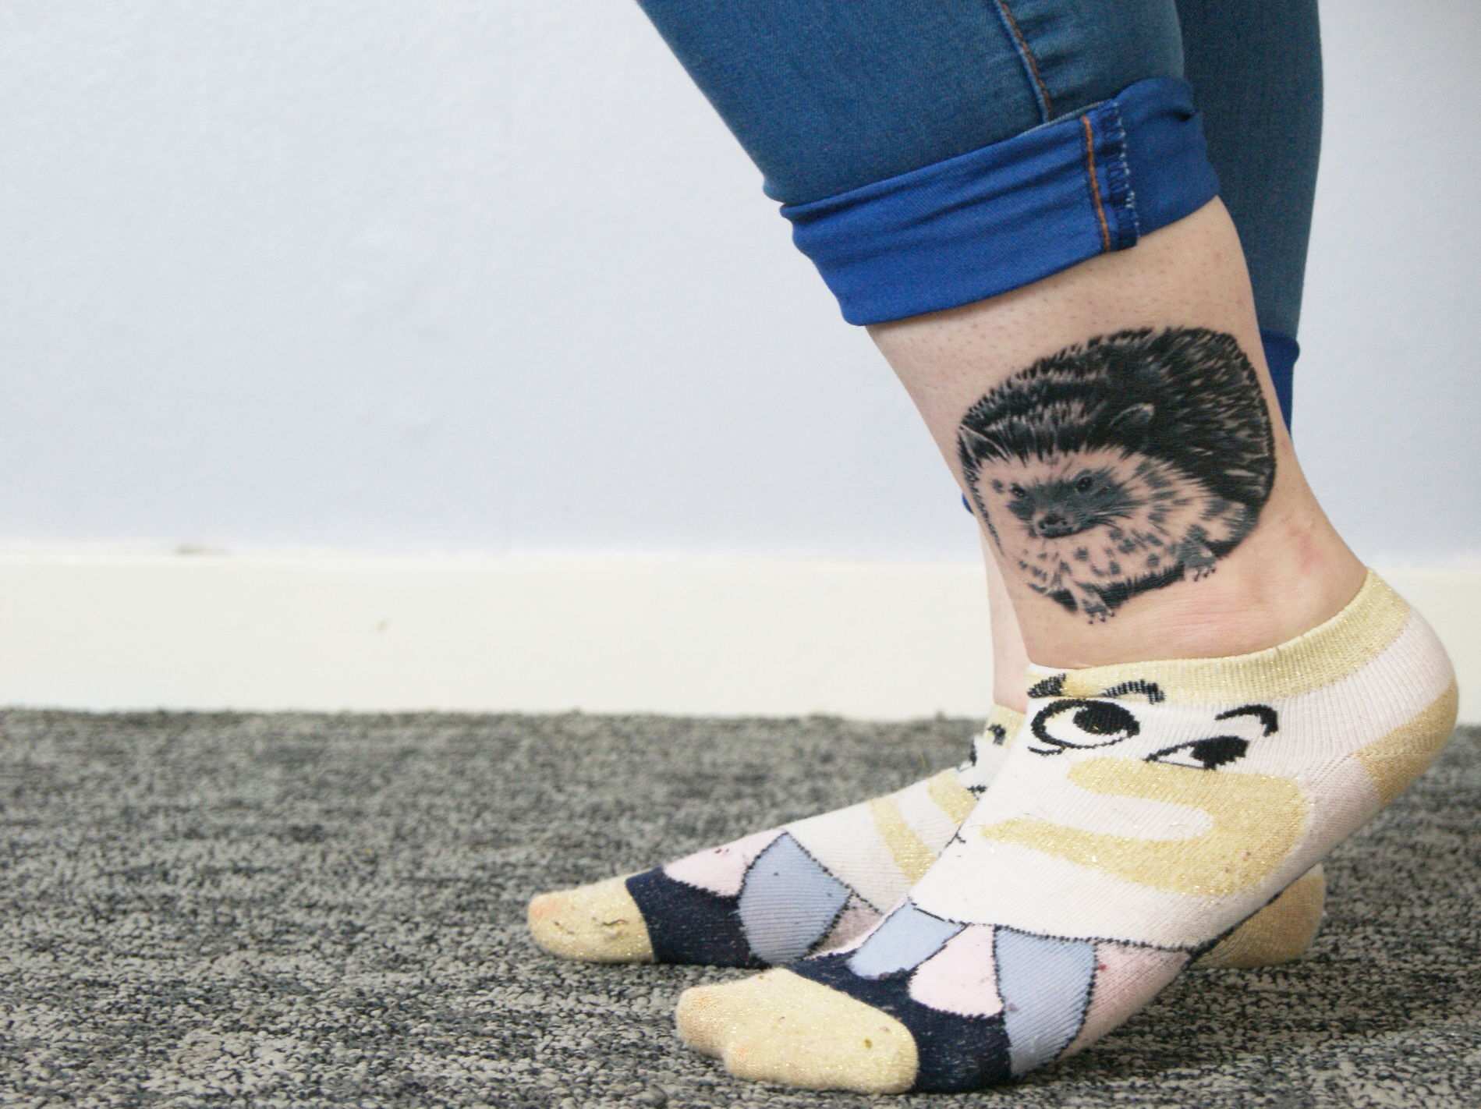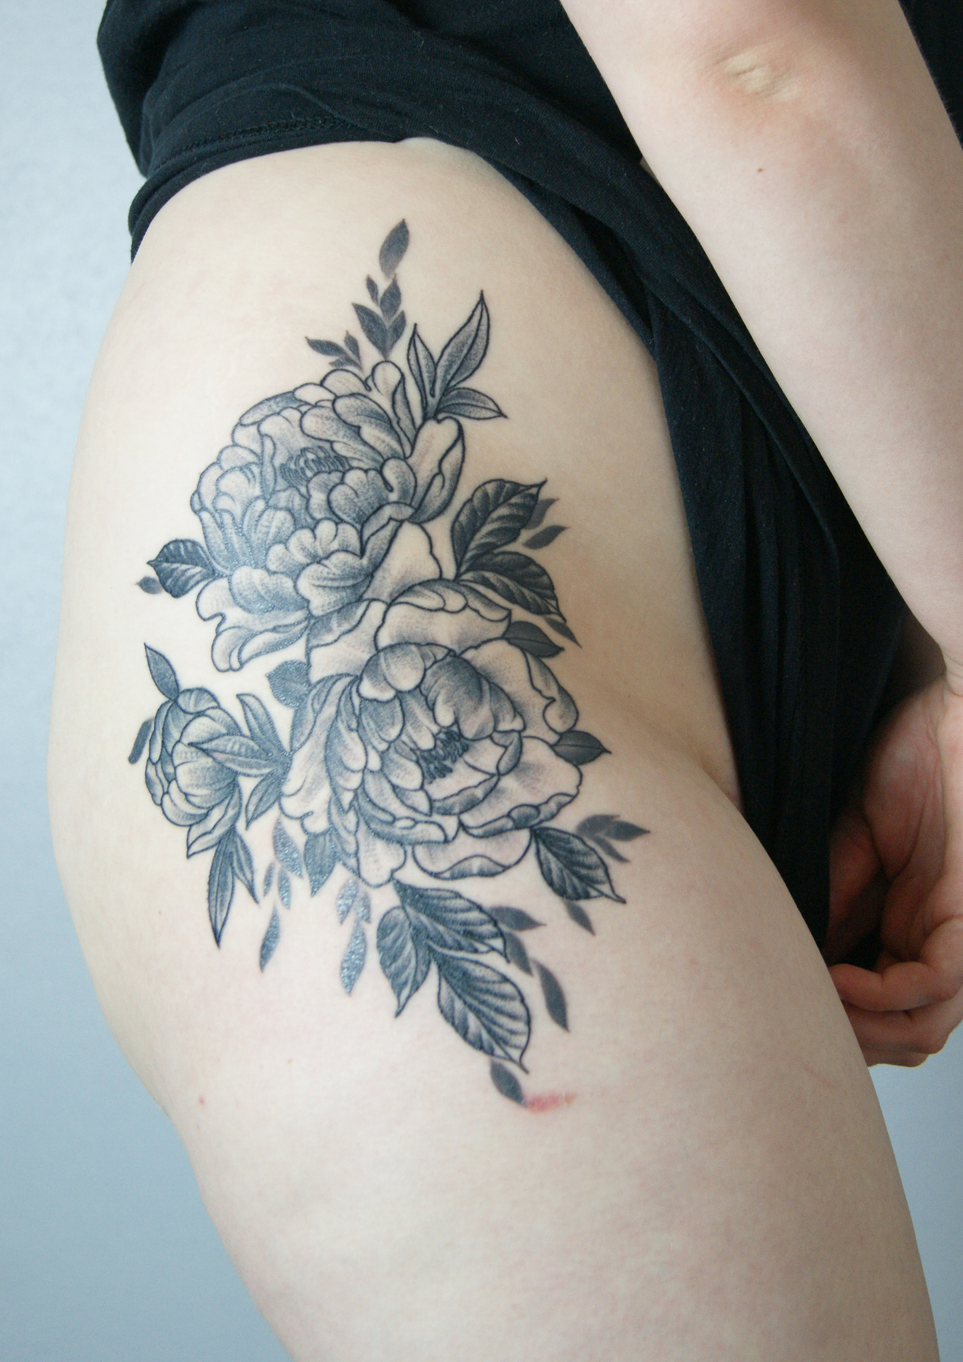

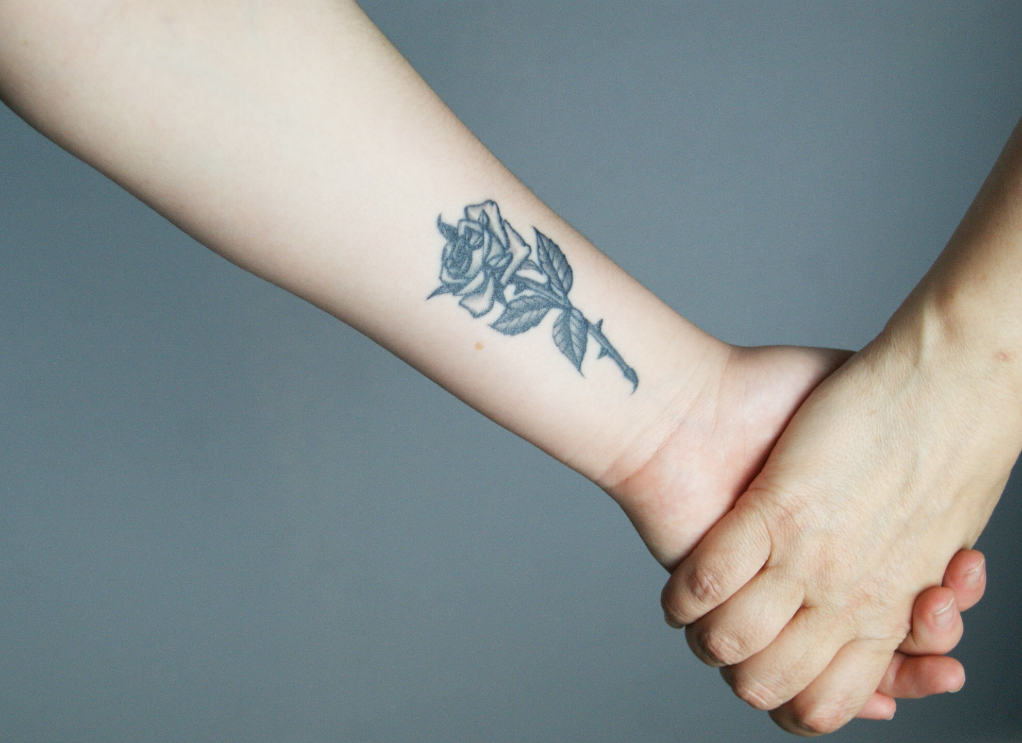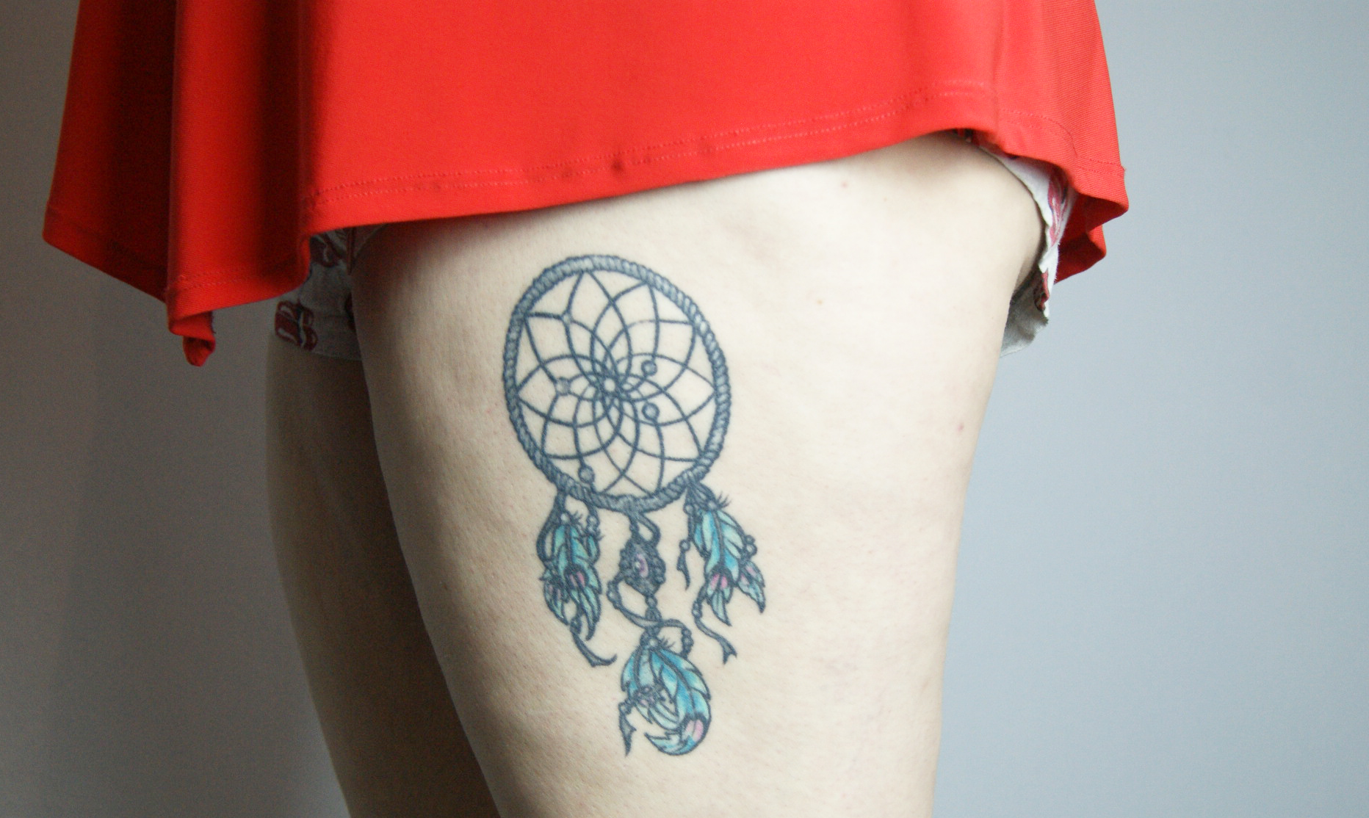
Erin Jayne Lloyd, Tattoos, 2018.

Bibliography.
A Brief History of Tattoos (no date). Available at: http://www.powerverbs.com/tattooyou/history.htm (Accessed: 10 December 2018).
Anderson, K. Here's Why Tattoos Are The Most Beautiful Form Of Self-Expression (2016). Available at: https://www.theodysseyonline.com/heres-why-tattoos-are-the-most-beautiful-form-self-expression (Accessed: 3 December 2018).
Gina Apice. 10 Ways You Can Express Yourself (2016). Available at: https://www.theodysseyonline.com/10-ways-express-yourself (Accessed: 24 November 2018).
Barco. E. Art: A Form of Expression – Writing the Ship – Medium (2016). Available at:
https://medium.com/writing-the-ship/art-a-form-of-expression-c2cb7dc9f47 (Accessed: 24 November 2018).

(2014) Blog.tat2x.com. Available at: https://blog.tat2x.com/tattoos-in-the-workplace-will-your-profession-accept-your-ink/ (Accessed: 7 December 2018).

Chabner, E Thompson, M. (2014) Tattoos and Body Piercing: Self-Expression or Self-Mutilation?, EverydayHealth.com. Available at: https://www.everydayhealth.com/columns/elizabeth-thompson-womens-wellness/tattoos-body-piercing-self-expression-self-mutilation/ (Accessed: 3 December 2018).
Checkland, J. 4 Reasons Why Tattoos Are The Perfect Form Of Self Expression (2017). Available at: https://junkee.com/tattoos-perfect-form-self-expression/125104 (Accessed: 2 December 2018).
D'Imperio, J. (2014) How Tattoos Are My Form Of Self-Expression And Why I Don't Care That You Hate Them, Elite Daily. Available at: https://www.elitedaily.com/life/culture/dont-care-hate-tattoos (Accessed: 3 December 2018).
essentialism | Definition of essentialism in English by Oxford Dictionaries (2018). Available at: https://en.oxforddictionaries.com/definition/essentialism (Accessed: 21 November 2018).
estpresearch.org: estpresearch.org (2013). Available at: http://www.estpresearch.org (Accessed: 8 December 2018).
Linda Evangelista Quote: “Hair is just one way of expressing ourselves. We express ourselves through how we dress or through tattoos or body art o...” (no date). Available at: https://quotefancy.com/quote/1179771/Linda-Evangelista-Hair-is-just-one-way-of-expressing-ourselves-We-express-ourselves (Accessed: 3 December 2018).
Facebook - Resources (2017). Available at: https://investor.fb.com/resources/default.aspx (Accessed: 21 November 2018).
Farrell, K. If Tattoos Could Talk (2013). Available at: https://www.psychologytoday.com/intl/blog/swim-in-denial/201310/if-tattoos-could-talk (Accessed: 2 December 2018).
Mandy Freeman. 5 dangerous health risks of tattoos (2018). Available at: https://www.health24.com/Medical/Skin/About-skin/5-dangerous-health-risks-of-tattoos-20180504 (Accessed: 10 December 2018).
Most tattooed man (current) (2006). Available at: http://www.guinnessworldrecords.com/world-records/most-tattooed-person (Accessed: 2 December 2018).
Greg Hall. Tattoos Affect Your Health: Long-Term Side Effects Ink Has On Your Immune System And Disease Risk (2016). Available at: https://www.medicaldaily.com/tattoos-affect-your-health-long-term-side-effects-ink-has-your-immune-system-404404 (Accessed: 7 December 2018).
Gillian, J. Evidence From Ötzi Tells Us He Came From a Caring Bunch Who Dabbled in Medicine (2018). Available at: https://www.ancient-origins.net/news-general/were-tzi-icemans-tattoos-therapeutic-00975 (Accessed: 8 December 2018).
Hart, L. Are tattoos a stain on your job prospects and career? (2014). Available at: https://www.theguardian.com/careers/careers-blog/tattoos-workplace-job-prospects-career (Accessed: 3 December 2018).
Heshmat, S. Basics of Identity (2014). Available at: https://www.psychologytoday.com/us/blog/science-choice/201412/basics-identity (Accessed: 3 December 2018).
History of Tattoos - Origin and Meaning of Tattoos (2018). Available at: http://www.historyoftattoos.net (Accessed: 24 November 2018).
Hoepf, T. (2011) American sailors cling to their tradition of tattoos, Live Auctioneers | Auction Central News. Available at: https://www.liveauctioneers.com/news/top-news/museums/american-sailors-cling-to-their-tradition-of-tattoos/ (Accessed: 8 December 2018).
Dan Hunter. The #1 Tattoo Resource Website On The Internet (2018). Available at: https://authoritytattoo.com/history-of-tattoos/ (Accessed: 10 December 2018).
What is Instagram's mission and vision statement? - Quora (2018). Available at: https://www.quora.com/What-is-Instagrams-mission-and-vision-statement (Accessed: 21 November 2018).
Kramer, H. Tattoo Removal: A Bigger Business than Tattooing (2010). Available at: https://www.huffingtonpost.com/hilary-kramer/tattoo-removal-a-bigger-b_b_474675.html (Accessed: 2 December 2018).
TATU LU: TATTOOS FROM THE DREAMTIME | | LARS KRUTAK (2013). Available at: https://www.larskrutak.com/tatu-lu-tattoos-from-the-dreamtime/ (Accessed: 8 December 2018).
NETFLIX'S 'EXPLAINED' TACKLES TATTOO! | | LARS KRUTAK (2018). Available at: https://www.larskrutak.com/netflixs-explained-tackles-tattoo/ (Accessed: 24 November 2018).
Leviticus 19:28 You must not make any cuts in your bodies for the dead or put tattoo marks on yourselves. I am the LORD. (2004). Available at: https://biblehub.com/leviticus/19-28.htm (Accessed: 2 December 2018).
Summaries, B. et al. (2018) Book Summary: Essentialism by Greg McKeown | Sam Thomas Davies, Sam Thomas Davies. Available at: https://www.samuelthomasdavies.com/book-summaries/business/essentialism/ (Accessed: 21 November 2018).
Foto 1. Mónica Mayer, El tendedero (2016), MUAC. Fotografía de Oliver Santana. Cortesía MUAC (2016). Available at: http://www.m-arteyculturavisual.com/2016/03/12/monica-mayer-una-exposicion-retrocolectiva/foto-1-monica-mayer-el-tendedero-2016-muac-fotografia-de-oliver-santana-cortesia-muac/ (Accessed: 24 November 2018).
Tattoo ink could contain printer ink; car paint – My Office News (2016). Available at: http://myofficemagazine.co.za/tattoo-ink-contain-printer-ink-car-paint/ (Accessed: 8 December 2018).
Nastasi, A. (2017) Women Share Stories About Violence and Harassment in Installation ‘El Tendedero/The Clothesline Project’, Flavorwire. Available at: http://flavorwire.com/611442/women-share-stories-about-violence-and-harassment-in-installation-el-tendedero-the-clothesline-project (Accessed: 11 December 2018).
Posner, J. Klein, E. Explained | Netflix Official Site (2018). Available at: https://www.netflix.com/watch/80243763?trackId=14277283&tctx=0%2C7%2C5906ffae-c36f-49e4-b888-e059dd7b6cb6-81506718%2C%2C (Accessed: 24 November 2018).
Pyke, C. (2016) Can tattoos prevent you getting a job or promotion?, walesonline. Available at: https://www.walesonline.co.uk/business/business-news/can-tattoos-prevent-you-getting-11774524 (Accessed: 3 December 2018).
P. Shimamura, A. Creativity and Art Expression (2014). Available at: https://www.psychologytoday.com/us/blog/in-the-brain-the-beholder/201402/creativity-and-art-expression (Accessed: 10 December 2018).
Snap Inc. (2018). Available at: https://www.snap.com/en-US/ (Accessed: 21 November 2018).
Special Tattooed People Lucky Diamond Rich Tattoo Planet 112 - Tattoo Planet Magazine(2006). Available at: https://tattooplanetmagazine.com/special-tattooed-people-lucky-diamond-rich-tattoo-planet-112/ (Accessed: 8 December 2018).
Tattoo Culture Around The World: How Tattoos Differ Around the Globe (2018). Available at: https://medermislaserclinic.com/tattoo-culture-around-the-world/ (Accessed: 10 December 2018).
My Irezumi 3/4 sleeve by Jorre from Theblacklotus in Antwerp, Belgium. : tattoos (2017). Available at: https://www.reddit.com/r/tattoos/comments/5m1h55/my_irezumi_34_sleeve_by_jorre_from_theblacklotus/ (Accessed: 8 December 2018).
Why Twitter’s Mission Statement Matters (2014). Available at: https://hbr.org/2014/11/why-twitters-mission-statement-matters (Accessed: 21 November 2018).
Understanding Gender (2017). Available at: https://www.genderspectrum.org/quick-links/understanding-gender/ (Accessed: 3 December 2018).
Kat Von D Quote (2011). Available at: https://www.azquotes.com/quote/940988 (Accessed: 3 December 2018).

