LCBB4004

Component 2: Coursework:

Individual Report

Name: Mihaela Ruxandra Iancu
Student ID: 2133740
Table of Contents
Introduction 3
Theoretical Framework for External Analysis 3
PESTLE Analysis: 3
The Porter Five Forces Analysis: 4
A SWOT analysis 4
Framework relevance: 4
External Analysis of the Sainsbury’s 5
PESTLE Analysis of Sainsbury's 5
Porter's Five Forces Analysis of Sainsbury's 7
SWOT Analysis of Sainsbury's 9
Future Recommendations for Sainsbury's 11
Conclusion 12
Reference 14

Introduction
Organisations are part of a dynamic ecosystem formed by external influences in the ever-changing business landscape. Like the unexpected factors affecting a ship at sea, these forces shape and succeed enterprises. Organisational survival and development depend on understanding and handling these external factors. External environmental pressures include political, economic, social, technical, legal, and environmental issues outside a company's control. These influences affect organisational decision-making, market dynamics, and the business environment. From consumer behaviour to regulatory changes and technical advances, these dynamics provide company possibilities and dangers. Effective company plans need external examination. Organisations may identify development possibilities and risks by thoroughly examining these external influences. As a strategic guide, external analysis helps firms predict market developments, capitalise on trends, and manage risks. It helps organisations match their aims with market circumstances and make educated decisions.

Theoretical Framework for External Analysis
Different theoretical frameworks help organisations like Sainsbury's comprehend the intricate interactions that affect strategic decision-making in their external environments. Explore each framework's relevance:

PESTLE Analysis:
Political:
Political factors include government policies, legislation, and geopolitical shifts that impact enterprises. Political stability, trade policy, taxes, and food and retail laws affect Sainsbury's operations, growth, and compliance (McKellar, 2023).
Economic:
Economic factors including inflation, interest rates, GDP growth, and consumer confidence significantly impact company success (Vanlaer, Bielen and Marneffe, 2020). Sainsbury's is affected by economic changes that affect customer spending, buying power, and product demand.
Social:
Sainsbury's relies on social factors such as trends, cultural shifts, demographic changes, and customer behaviour patterns. Product and marketing strategies must account for consumer preferences for healthier eating, ethical sourcing, and sustainability (McKellar, 2023).
Technological:
Advancements in technology impact industry and customer expectations. Sainsbury's must embrace e-commerce, digital supply chain management, and online purchasing to remain competitive in the fast-changing retail industry.
Legal:
Legal factors include legislation, industry norms, and frameworks that enterprises must follow (McKellar, 2023). Sainsbury's must comply with food safety, advertising, employment, and competition laws.
Environmental:
Environmental factors such as sustainability and climate change affect corporate operations and customer perceptions (Vanlaer, Bielen and Marneffe, 2020). Sainsbury's commitment to sustainable sourcing, carbon reduction, and environmental efforts matches customer demand for eco-friendly goods.

The Porter Five Forces Analysis:
Sainsbury's has competition from Tesco, Asda, Aldi, Lidl, and Amazon in the retail business. For market positioning and distinctiveness, Sainsbury's analyses competition intensity (The Guardian, 2023). Assessing supplier and buyer negotiating strength is vital for Sainsbury's procurement strategy and price choices. Knowing consumer preferences and having good supplier connections improve supply chain efficiency and customer satisfaction. By identifying risks from alternatives and possible new entrants, Sainsbury's may design measures to maintain market dominance and strengthen barriers to entrance.

A SWOT analysis
Sainsbury's strengths (strong brand, diverse product variety) and weaknesses (limited worldwide presence, dependence on physical shops) should be analysed to capitalise on opportunities and prevent risks.
Sainsbury's may establish strategic routes and manage risk by analysing external possibilities and risks, such as expanding into new markets and e-commerce growth (Reuters, 2021). Sainsbury's may innovate in a growing phase or consolidate in a mature market by assessing the retail industry's life cycle (growth, maturity, decline).

Framework relevance:
Each framework provides a distinct perspective on Sainsbury's operations, market positioning, and strategic choices by examining the external environment. For sustained success in the dynamic retail industry, integrating these frameworks helps with decision-making, market forecasting, and strategy alignment.

External Analysis of the Sainsbury’s

PESTLE Analysis of Sainsbury's
Operating in the cutthroat retail industry, Sainsbury is subject to a great deal of external influences that impact its operations, positioning in the market, and strategic decisions.
Political factors:
Politicians' actions may affect Sainsbury's in a number of ways, including via changes to laws and policies. The political atmosphere, the consequences of Brexit, and changes in trade policy all have direct impacts on supply chains, import/export costs, and sourcing strategies (McKellar, 2023). The decisions made by politicians regarding import tariffs and food safety regulations affect the prices and availability of products at Sainsbury's. Tax policy, employment regulations, and stimulus initiatives all have an effect on the retail sector.
Economic Factors:
Depending on the economy, Sainsbury's performance can be better or worse. Macroeconomic factors, such as GDP growth, inflation rates, and consumer spending patterns, have a significant impact on consumers' purchasing power and spending habits. This statistic shows the underlying sales revenue of J Sainsbury plc in the UK from 2011/12 to 2022/23. Around 35.16 billion British pounds were taken in by Sainsbury's underlying sales in the fiscal year 2022-23 (Statista, 2023). During economic downturns, consumers are more price-sensitive, which impacts Sainsbury's bottom line. Interest rate fluctuations impact growing strategies and investment decisions because of the impact on borrowing costs.
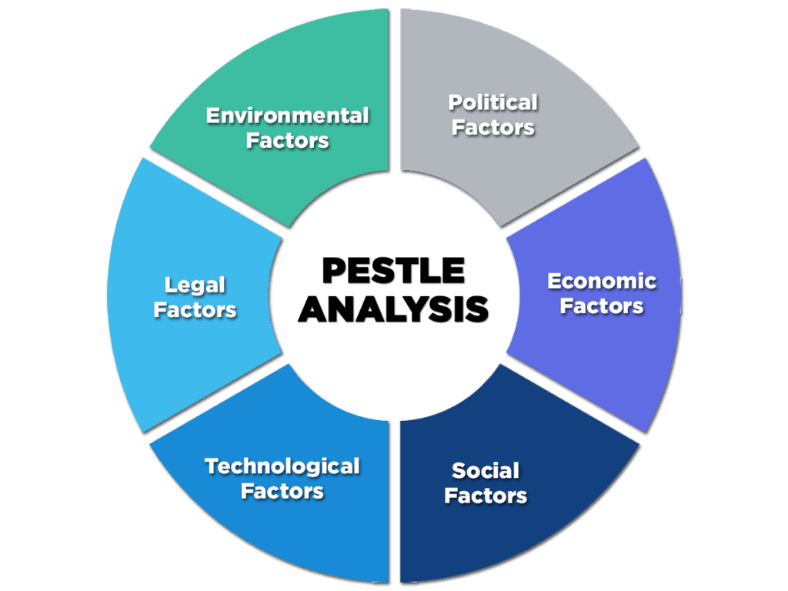
Figure 1: Pestle Analysis
(Source: McKellar, 2023)
Social Factors:
For Sainsbury, the bottom line is affected by societal and demographic shifts. Variations in household income, average age, and consumer choices are all effects of these demographic shifts. With an older population comes the potential for a surge in demand for health-focused products and services, along with those that value convenience (McKellar, 2023). More ethical consumption, more sustainability, and better lifestyles are ever-present social movements that impact Sainsbury's marketing strategies and product lines.
Technological factors:
Progress in technology has a significant impact on Sainsbury's business and competitive standing. Sainsbury has to become digital with their supply chain management, start selling online, and employ data analytics to learn about their customers if they want to stay in the game. Investing in customer-centric online platforms, mobile apps, and delivery services is important in today's tech-driven retail industry. Automated inventory management system advancements have also led to better efficiency and effectiveness.
Legal Matters:
There is a strong correlation between the retail sector's regulatory structure and Sainsbury's business practises. Laws governing advertising, food safety, employment, and competition are among the most important. Any changes to data protection laws, employment constraints, or tax policies might have an impact on HR planning, budgets, and procedures (McKellar, 2023). Regulation of market conduct by mergers and competition laws impacts Sainsbury's development and competitive standing.
Environmental Factors:
Environmental concerns and efforts to reduce human impact are changing business practises and consumer habits. Sustainable practises, reduced environmental effect, and ethical product sourcing are all parts of Sainsbury's plan to meet the rising demand for environmentally conscious items. Impacts on supply chains, agricultural yields, and food production are some of the ways in which climate change impacts Sainsbury's inventory and prices. Efforts to reduce plastic usage, boost energy efficiency, and promote sustainable sourcing may satisfy both environmentalists and consumers that prioritise sustainability.
There are a lot of moving parts that make up Sainsbury's exterior environment. The company's ability to weather environmental, social, technological, legal, and political storms is critical to its survival and growth in the long run. In the ever-changing retail business, Sainsbury's may adjust its strategies, seize opportunities, mitigate risks, and adjust its operations by monitoring these external factors.

Porter's Five Forces Analysis of Sainsbury's
Competitive Rivalry within the Industry:
Competitors in the food market that Sainsbury's must contend with include Asda, Amazon, Lidl, Tesco, and Aldi. The grocery and retail sectors are known for their fierce competitiveness, which is characterised by low prices, distinctive items, and excellent customer service. Price gouging and other aggressive marketing strategies are common tactics used by competitors to win over customers (Vanlaer, Bielen and Marneffe, 2020). The fierce rivalry in the industry affects market share, profits, and customer loyalty. Even yet, Sainsbury is able to counteract this rivalry to a lesser extent because to its distinctive product assortment, excellent quality, and community engagement.
Power of Suppliers and Their Impact:
The influence of suppliers on the retail industry is substantial, and this influences Sainsbury's bottom line. The company sources a broad range of products from its network of suppliers. Supply chain bargaining power impacts Sainsbury's bottom line in three ways: price, availability, and quality (Vanlaer, Bielen and Marneffe, 2020). The quality of a company's relationships with its suppliers determines how well it can negotiate terms and pricing. However, disruptions in the supply chain, changes in supplier prices, and over-reliance on specific suppliers may all have an impact on Sainsbury's operations and profitability.
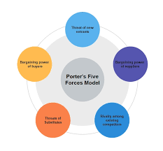
Figure 2: Porter's Five Forces Analysis
(Source: Reuters, 2021)
Power of Buyers and Their Influence:
As consumers can readily learn about products, compare costs, and choose the one that suits them best in terms of price, convenience, and quality, they have considerable influence in the retail industry. Since they may shop at brick-and-mortar establishments or online marketplaces, customers have a great deal of power. Because customers are price sensitive and easily swayed, their impact is amplified (Vanlaer, Bielen and Marneffe, 2020). By providing excellent customer service, high-quality products, and incentive programmes, Sainsbury's hopes to reduce the impact of buyer power.
Threat of New Entrants to the Industry:
Competition from upstarts is a minor worry for long-standing companies like Sainsbury's. When competing in the retail industry, new entrants need substantial capital, whereas well-established brands benefit from economies of scale, name recognition, and established distribution networks. However, upstarts with fresh perspectives on business and technology might disrupt established markets, especially online marketplaces and unique niche stores (Reuters, 2021). It is difficult for new entrants to make a dent in the market due to Sainsbury's dominant position and loyal customer base.
Threat of Substitutes and Their Effect:
The retail industry is in imminent danger from possible substitutes, such as e-commerce and other non-traditional retail formats, which are seeing rapid growth in popularity. Convenient stores, online food delivery services, and speciality stores are just a few of the many options to traditional brick-and-mortar merchants that customers have at their fingertips. The impact of substitutes on customer behaviour is one challenge that Sainsbury's has in its fight to keep customers (The Guardian, 2023). In response, Sainsbury's is putting its faith in online shopping to cater to consumers' evolving preferences while setting itself apart from the competition via superior quality, extensive selection, and user-friendliness.
Porter's Five Forces analysis reveals that the intricate dynamics of the retail industry have a direct impact on Sainsbury's. Competitors, suppliers, and buyers are less of an issue because to the company's strong brand, diverse product offering, and customer contact strategies. Furthermore, efforts to thwart new entrants and replacements help keep Sainsbury's market position strong (The Guardian, 2022). Aware of these dynamics, Sainsbury's may devise strategies that capitalise on their strengths, address their weaknesses, and conquer industry difficulties, allowing them to adapt to the ever-changing retail market.

SWOT Analysis of Sainsbury's
Strengths
A great reputation for quality, reliability, and community participation has helped Sainsbury's build a robust brand image and history in the UK retail market. Customers' faith and devotion are fostered by this strong brand identity.
Variety of items: The company offers a wide range of products in several categories to cater to the needs and tastes of a diverse consumer base. This kind makes a lot of people happy and attracts a lot of customers.
A commitment to innovation is shown by Sainsbury's in many ways, including sustainability, ethical sourcing, and technological achievements. Its innovative approach includes things like the "Taste the Difference" product line and partnerships with local merchants (Derval, 2022).
By embracing e-commerce and developing a robust website, Sainsbury's has expanded its online presence. Customers' accessibility and convenience are enhanced with the omnichannel approach.
Weaknesses:
Sainsbury is mostly focused on the UK market, limiting its exposure to international competition. This oversaturation of some regions might impede both growth and variety.
With more and more people opting to purchase online due to the convenience and changing tastes of consumers, Sainsbury's reliance on brick-and-mortar stores might limit its expansion (Neurauter, 2022).
Profit Margins: The retail industry is very competitive, and with shrinking profit margins—especially due to price wars and cost constraints—Sainsbury's profitability might take a hit.

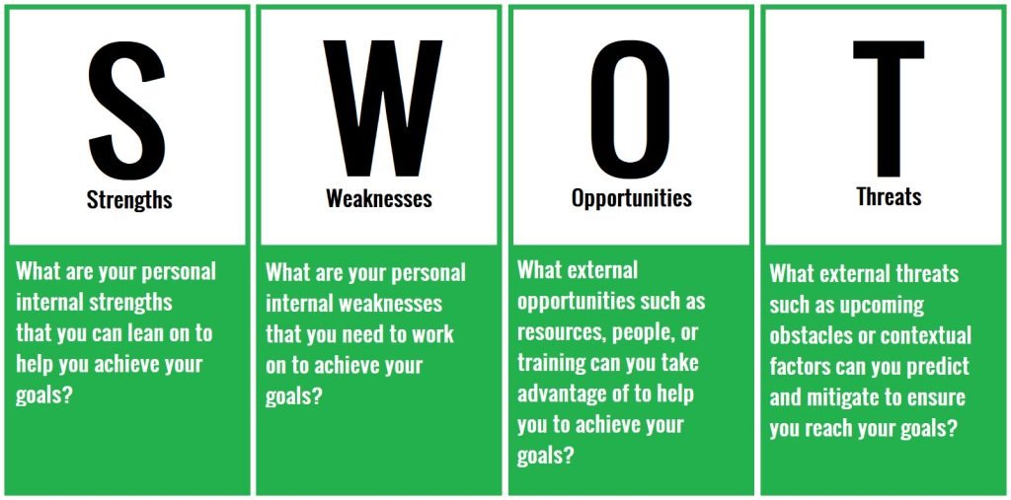
Figure: SWOT Analysis
(Source: Neurauter, 2022)

Opportunities:
Using its existing web infrastructure, Sainsbury's may further expand its e-commerce business. Taking advantage of the growing popularity of online shopping and providing clients with more tailored experiences are both made possible by this.
Investigating international expansion opportunities beyond the UK market may help Sainsbury diversify its revenue streams and lessen its reliance on any one market (Sainsbury, 2023).
Trends in Health and Wellness: Sainsbury's might expand its assortment of organic, nutritious food options and wellness-related products to take advantage of the growing demand for these products.
Strategic partnerships or collaborations with technology companies or niche brands could help Sainsbury improve its product selection and innovation abilities.
Threats:
The rivalry between long-standing brick-and-mortar establishments and upstarts in the online retail space is fierce in the retail industry. The emergence of new, disruptive competitors, pricing wars, and oversaturation all pose threats to profitable market share.
Preferences of consumers: Sainsbury's traditional business model may face challenges from consumers' increasing demand for online shopping, ethical sourcing, and sustainability, necessitating adjustments to meet customer expectations. Government rules, especially those pertaining to taxation, food safety, and employment law, may increase compliance costs and have an impact on Sainsbury's business (Huang et al., 2021). Sales and profitability at Sainsbury's may be affected by fluctuations in consumer spending, changes in the economy, or changes in consumer behaviour and purchasing power. Sainsbury's market prominence is due to its strong brand, extensive product variety, and innovation. However, worldwide reach, physical store dependence and competitive obstacles may be improved. Growth might come from e-commerce development, foreign market diversification, and health and wellness trends. To succeed in the dynamic and competitive retail market, Sainsbury's must mitigate challenges, adapt to customer preferences, and navigate regulatory changes.

Future Recommendations for Sainsbury's
Expand E-commerce: Sainsbury's should enhance its online presence with user-friendly interfaces, personalised suggestions, and efficient delivery. Omnichannel strategies that combine physical businesses and online platforms may improve consumer convenience and capture the rising online market.
Expand Product Offerings: Sainsbury's could provide more organic, sustainable, and healthier food alternatives to capitalise on health and wellness trends (Trewern et al.,2021). Working with niche brands or local manufacturers may provide new items and meet customer demands.
International Expansion Strategy: Growth requires exploring prospects outside the UK market. Strategically targeting overseas areas with comparable demographics and customer preferences helps diversify revenue. Entering developing areas or partnering with global merchants may help.
Strengthen Brand Differentiation: Sainsbury's should emphasise sustainability, ethical sourcing, and community participation to strengthen its brand (Forbes, 2021). Promoting these ideals across platforms and product categories will appeal to socially concerned customers.
Innovation and Partnerships: Tech investments and strategic partnerships may promote innovation. AI-driven data for personalised customer experiences and collaborations for creative solutions will keep Sainsbury's competitive.
Mitigating Threats:
Addressing Intense Competition: Sainsbury's should prioritise value differential over pricing to compete effectively. Quality, innovative goods, and excellent customer service will keep customers loyal under competing challenges. Adapting to changing customer preferences requires ongoing observation and response. Sainsbury's can quickly adjust to customer trends via agile product development, marketing, and supply chain changes.
Regulatory Compliance and Economic Stability: Proactively address regulatory changes and economic variations. Monitoring regulatory landscapes and diversifying source tactics helps reduce regulatory risk (Newborne, 2022). Effective inventory management and cost optimisation can also endure economic instability.
Actionable Steps for Implementation:
Strategic Planning: Create a plan with short- and long-term objectives based on the suggestions. Set implementation deadlines and responsibilities.
Technology Investment: Upgrade technology, data analytics, and digital infrastructure to improve online platforms and consumer experiences (HBR, 2021).
Market research and consumer insights: Track customer trends and preferences often. Use data to adjust plans in real time.
Collaboration and Alliances: Partner with tech companies, local suppliers, and worldwide brands to innovate, increase product variety, and enter new markets.
Staff Training and Culture: Train employees to reflect the company's values and goals. Promote innovation, flexibility, and client focus (Metz, Ilieș, and Nistor, 2020).
Regular Performance Evaluation: Monitor and evaluate strategy effectiveness. Review performance indicators and adjust plans often.
Sainsbury's may position itself for success by adopting e-commerce, broadening product offers, growing worldwide, and concentrating on innovation and distinctiveness. Preventing dangers, responding to customer preferences, and complying with regulations can strengthen its resilience in the competitive retail sector. These proposals and a clear action plan will help Sainsbury's develop and lead the market.

Conclusion
Sainsbury's external research showed how external influences shape the company's operational environment in the dynamic retail market. This review used Porter's Five Forces, SWOT analysis, and PESTLE variables to understand the company's environment. Political uncertainty, economic volatility, shifting customer tastes, technical improvements, legal restrictions, and environmental issues affect Sainsbury's market. Understanding external variables is crucial. Strategic decision-making is complicated by industry competition, supplier and buyer power, new entrants, and replacements. These external influences emphasise the necessity for firms to adapt and be proactive to changing market dynamics. Sainsbury's resilience and performance in a continuously changing retail sector depend on its ability to understand and adapt to these external pressures. The suggestions for Sainsbury's future success are crucial. To capitalise on opportunities and manage risks, e-commerce development, product diversification, international expansion, brand distinction, and innovation are strategic imperatives. E-commerce development will increase customer reach and convenience, while product variety will match consumer desires. International growth will diversify income, and brand distinctiveness will build customer trust and loyalty. Innovation and key collaborations will keep Sainsbury's ahead of technology. Sainsbury's market position will be strengthened by differentiating, adapting to customer preferences, and proactively addressing regulatory changes and economic stability. The external analysis and strategy suggestions conclude that knowing and reacting to external pressures is crucial. Sainsbury's can overcome the tough external environment and succeed in the competitive retail industry by leveraging strengths, fixing weaknesses, seizing opportunities, and minimising dangers. This study will help Sainsbury's make strategic decisions that match market circumstances and lead to success.

Reference
Derval, D., 2022. The right sensory mix: Decoding customers’ behavior and preferences. Springer Nature.
Forbes, 2021, “Do Consumers Care About Ethical Sourcing?”, Available at https://www.forbes.com/sites/stevebanker/2021/10/05/do-consumers-care-about-ethical-sourcing/?sh=468172435f50
HBR, 2021, “The Essential Components of Digital Transformation”, Available at https://hbr.org/2021/11/the-essential-components-of-digital-transformation
Huang, I.Y., Manning, L., James, K.L., Grigoriadis, V., Millington, A., Wood, V. and Ward, S., 2021. Food waste management: A review of retailers’ business practices and their implications for sustainable value. Journal of Cleaner Production, 285, p.125484.
Johnson, J., Whittington, R., Regnér, P., Angwin, D., Johnson, G. and Scholes, K., 2020. Exploring strategy. Pearson UK.
McKellar, R., 2023. Political Risk Intelligence for Business Operations in Complex Environments. Taylor & Francis.
Metz, D., Ilieș, L. and Nistor, R.L., 2020. The impact of organizational culture on customer service effectiveness from a sustainability perspective. Sustainability, 12(15), p.6240.
Neurauter, C., 2022. The future of grocery stores: Omnichannel and AI technologies and Next-Generation Brick-and-Mortar Grocery Stores (Doctoral dissertation).
Newborne, P., 2022. Crossed wires: public regulation and private action for water stewardship and sustainable farming. Water International, 47(7), pp.1169-1186.
Reuters, 2021, “Britain's Sainsbury's makes it personal in price battle with rivals”, Available at https://www.reuters.com/business/retail-consumer/britains-sainsburys-makes-it-personal-price-battle-with-rivals-2021-09-15/ [Accessed on 18th November 2023]
Sainsbury, 2023, “home”, Available at https://www.sainsburys.co.uk/ [Accessed on 18th November 2023]
The Guardian, 2022, “Sainsbury’s boss warns UK living costs squeeze will ‘only intensify”, Available at https://www.theguardian.com/business/2022/jul/05/uk-living-costs-squeeze-sainsburys-prices-low-sales [Accessed on 18th November 2023]
The Guardian, 2023, “Sainsbury’s declares it is winning back Lidl and Aldi customers”, Available at https://www.theguardian.com/business/2023/nov/02/sainsburys-declares-it-is-winning-back-lidl-and-aldi-customers [Accessed on 18th November 2023]
Trewern, J., Chenoweth, J., Christie, I., Keller, E. and Halevy, S., 2021. Are UK retailers well placed to deliver ‘less and better’meat and dairy to consumers?. Sustainable Production and Consumption, 28, pp.154-163.
Vanlaer, W., Bielen, S. and Marneffe, W., 2020. Consumer confidence and household saving behaviors: A cross-country empirical analysis. Social Indicators Research, 147, pp.677-721.
Xiao, B., Chen, Q. and Yu, Z., 2021, April. Research on the Investment Value of Sainsbury’s. In 2021 6th International Conference on Social Sciences and Economic Development (ICSSED 2021) (pp. 108-115). Atlantis Press.

