Name: Omodunni Adeoba
Student Number: 1914727
Module Code: BMSW 4005
Module Title: Professional and Career
Development
Assignment Title. Reflective Portfolio
Lecturer: Olubukola Adegbite

INDEX

S.No. | Content | Page No.
1. | Analysis of my own skills and learning methods - PDP task | 2 - 6
2. | Assistant Manager Task | 7 - 11
3. | Self-Reflection | 12- 13
4. | References | 14 - 16

Audit your own skills and competencies using the analysis tools learned in the class (PDP).
Identify the skills required for a career of your choices. Evaluate your own skills in
comparison to your chosen career.

”Plans are useless, but Planning is indispensable” (Sheffi, 2020).” Personal Development Planning (PDP) is an important pursuit for personal growth that enhances the quality of life and helps us in achieving our dreams and aspirations (Geukes, Zalk and Back, 2018). I describe PDP in my own words, as a process of improving oneself through conscious habits and activities. In this section of my assessment, I am going to analyse, identify and evaluate my own skills and competencies required to pursue my desired career. A PDP plan shall serve as my guiding map not only giving me clarity to think, but also making it easier to make decisions, evaluate my progress and set up benchmarks (Osgerby, Marriott and Gee, 2018).

Presently, I am studying for a Level 4 certificate in higher education skills for the workplace (Health and Social Care) at University of Wales Trinity St. David (UWTSD). My dream job is to become a social worker and grow in the field of health and social care. After completing my Level 4 Certification, I intend to pursue BSc in Health and Social Care and become a qualified social worker. I have over 8 years of work experience as a care support worker for people with learning disabilities. My personal qualities of empathy and good listening skills have helped me in my career profile. I utilised National Careers Service Online Skill test, consisting of many questions to identify best career options for myself. The results showed that I am a good listener and enjoy helping others, as for instance in care homes, the job itself revolves around helping inmates to run their errands and look after their needs. The result also stated that I am a motivated individual, who likes to set up her own goals and I feel comfortable working with other people around me. This interpersonal skill has been useful, as in the health and social care sector we have to work as a team (Lejeune, Beausaert and Raemdonck, 2018) . The following model shows the steps I need to follow to realise my goal of becoming a social worker after completing Level 5 and 6.

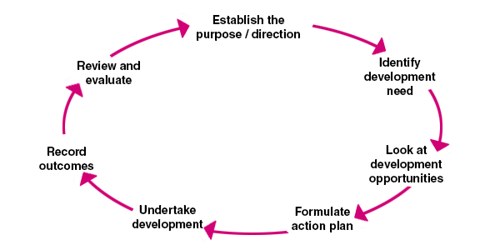

(Figure 1) CMI 2020 PDP CYCLE MODEL

As I decide to use PDP for finding out ways to accomplish my B.Sc. degree successfully, I will study a range of topics including academic skills, health and care enterprise, communication and counselling techniques, and healthcare management processes. Level 5 and 6 shall offer me a specialisation in key areas of health and care sector and help me built a wide range of knowledge expanding my thinking. I shall choose to study physiology and community care modules, as I feel I can utilise my previous work experience and also develop my professional expertise in the chosen field. With my current Level 4 qualification, I am not qualified to become a social worker. I utilised PDP cycle to streamline my educational goals to realise my career aspirations fully (Rubens, Schoenfeld, Schaffer and Leah, 2018). The PDP cycle is a personalised tool of cyclical assessment of our goals and progress towards them (Gibbs,1988). This cycle makes it easier to understand the purpose, development, action plan review and outcome of my career planning and education based on my learning style. As per my class activities, I have been assessed to be a Visual learner with a combination of learning to do things through practical training. I have used a Strength, Weakness, Opportunity and Threat Analysis (SWOT) to get a clear picture of where I stand, in relation to my career goals and identify my areas of improvement and set further goals to advance my career options (Haberberg 2000).

Table 1 SWOT ANALYSIS

Strengths  - Ability to understand complex situations  - Managerial skills  - Hardworking and Disciplined  - Creative and Flexible  - Effective Communication Skills  - Social and Empathetic  - Time Management | Weaknesses  - Very Emotional and Sensitive  - Too Analytical  - Lack of delegation skills  - Low confidence/self esteem level due to lack of qualification for my desired career designation  - Less focused, easily distracted
Opportunities  - The BSc. degree in Health and Social care shall enable me to do a paid or unpaid internship,giving valuable work experience  - Job in Care/Old Age Home or a Community Centre  - Job in the Charity sector in a managerial role like fundraising manager etc.  - Work with vulnerable adults and children | Threats  - Covid-19 Pandemic causing job loss  - Increased Domestic responsibilities causing distraction to my studies  - Dwindling income in social care sector  - Strict regulations in Health and Social Care sector  - Expensive tuition fee for Bsc.

Table 2

What do I need to do | Activity during gap in my Education | Timeframe to reach my goals | Method to achieve my goal | Review Period
Enrol in B.Sc. in Health and Social Care from University of Wales Trinity St. David in September 2021 ,continuing my education upwards from current Level 4  Try to coordinate my domestic and academic activities better | I will find a part time job to sustain my income and avoid financial stress.  I shall try to do independent reading and research in physiology and community health modules to broaden my knowledge  I shall also try to volunteer as a social worker with local charity to gain work experience | B.Sc. course begins from September 2021, so I intend to complete my course within the set time period of 3 years and join as a Social Worker with some good agency by September 2024 | I shall have to work on my focus and time management to complete all modules of my course successfully | I shall review my progress quarterly

The PDP analysis describes my future steps and goals systematically and I am better aware of gap between my current position and future professional aspirations. This utility tool shall remain useful to plan my academic strategies and outcomes enabling me to not only have better planning and managerial skill, but also, improving my confidence level and grooming me as an empathetic health care professional.

As an Assistant Manager, you have been tasked to assess the learning and development training methods for your new employees who are due to start in your organisation. You can use theories learned in the class. Explain and evaluate why you have selected these theories and methods.

As an Assistant Manager, assigned with the task of assessing learning and development training methods of new employees, due to start working in my organisation, I strongly believe that investment in employee training and development has benefits for the organisation and the staff itself. Almost all organisations offer some kind of training (Salas and Cannon- Bowers, 2001; Sloman, 2003). However, there has been a paradigm shift in the way learning and development training methods are undergoing changes.(Thompson, 2019)

Being the Assistant Manager, I shall begin by acquainting my new employees with myself, providing them fundamental information about the Company's infrastructure, layout plan, emergency exit points, leisure and rest rooms, break timings and biometric attendance. Following this, I would use a popular technique of learning and development training methods, the Icebreaker Technique (Martin and Bolliger, 2018). This is an interactive and fun method leading to introduction amongst the group members and also helps in discovering the purpose of the exercise.The icebreakers are aimed at making the team members comfortable with each other,as they get familiarised, developing team spirit (White, Torabi and Froehle, 2017). I would facilitate this session ensuring the new employees become more engaged in the proceedings and ease group contribution, which shall help them in performing their job duties efficiently. These are usually designed by focussing on the similarities of participants in an event, depending upon the objective of training (Clark, 2021). There are different types of icebreakers ranging from true or false, the little known fact, the human web, the ball challenge and brainstorming (Karlsen, Gabrielsen, Falch and Stubberud, 2017). All are aimed at making new employees work more cohesively towards shared goals (Karlsen et al. 2017)

There is no single method of delivering training, as is also plurality in learning methodologies (Barbara Ostrowski Martin; Klodiana Kolomitro; Tony C.M Lam, 2013). Therefore, trainers keep searching for best methods to provide targeted information to trainees. There are different methods of training (Numonjonov, 2020), such as coaching and lecture, e-learning, stimulus based training, game based training, simulation, mentoring and apprenticeship, internship, job shadowing, role modeling, case studies, programmed instruction job rotation and role play (Hamdani, 2018). On the other hand, learning methods are also diversified depending upon the needs of the trainees (Faridi and Baloch, 2019). Inorder to maximize the learning outcome of training, the value of learning cognitive styles or learning preferences of trainers must be taken into account (Reid and Barrington,1994). There are many theories highlighting different learning methods for individuals (Coffield; Frank; Moseley; David; Hall; Elaine; Ecclestone; Kathryn, 2004). Neil Fleming's VARK Model was developed in 1987 to help students know about their learning preferences (Fleming,1995), I'm different; not dumb.The diagram describes VARK model as follows:

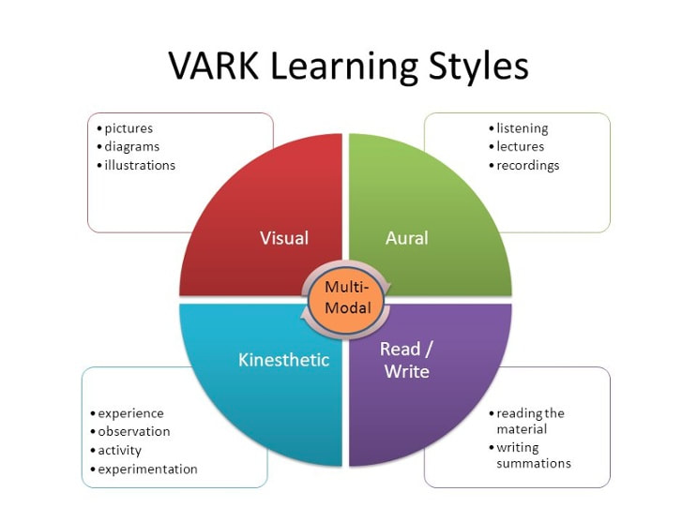

(Figure 2) Example of VARK Learning Style UWTSD 2021

Another model is by David Kolb, based on two bipolar dimensions of abstract conceptualisation and concrete experience (Secheresse, Pansu and Lima, 2020).These two tend to show the individual perception of information, while reflective observation and active experimentation determines how the individual internalises information (Watson, Pelkey, Noyes and Rodgers, 2019) Abstract learners are very analytical and logical, while concrete learners tend to grasp more through examples and reflectives astend to observe before arriving at any judgement and active learners have tendencies to experiment and are extroverts (Watson, Pelkey, Noyes and Rodgers, 2019) This combination gives rise to quadrant learning style as Diverger, Assimilator, Accommodator and Converger (Kolb,1984)

An improvement of Kolb's learning model came up in 1986, when Peter Honey and Alan Mumford developed a Learning Style Questionnaire (LSQ) to ascertain the learning styles of individuals (Honey and Mumford 1986). Unlike Kolb`s method of directly asking how an individual learns, the Honey and Mumford learning style uses a questionnaire that examines the general behavioural tendencies of the learners (Leaver, 2005).The four learning styles are as Activist, Theorist, Pragmatist and Reflector (Weng, Ho, Yang and Weng, 2018). The Activist learns by doing things, learning activities ranging from group discussions, puzzles, brainstorming, role play, problem solving and competitions (Yousef, 2018). The theorists tend to apply concepts based on the theory and background information. These learners require models, stories, statistics, truth and ideas to participate in group learning activities (Yousef, 2018). The Pragmatist learners put learning into practice in their current reality. Their learning tools are discussions, case studies, experiment with new ideas/speculation and problem solving (Yousef, 2018). The Reflective types are visual learners and they think about the happening of events as observers and not majorly as participants themselves. They learn by using techniques like personality/self analysis questionnaires, feedback from others, interviews, paired discussion and coaching (Yousef, 2018).

A company needs its employees to develop self awareness, soft skills, empathetic behaviour, group dynamics, team development and inter group relationships (Scaffidi, 2018). The Johari window model developed by American Psychologists Joseph Luft and Harry Ingham in the 1950s is an effective tool in learning and development training methods for the employees (Luft & Ingham, 1950)

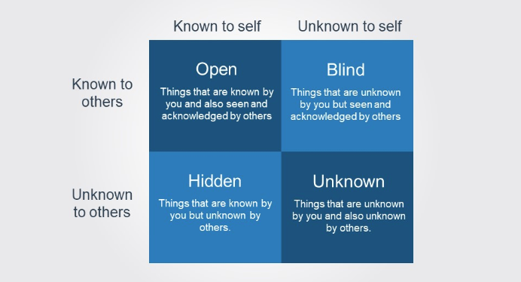
(Figure 3 ) Example of Johari Window (University of West England 2020)

As seen from the model above, the objective of this model is to explain the trainees to enlarge the “open self” and reduce the “unknown self”(Osmanoğlu, 2019).These two objectives can be achieved through feedback and self disclosure (Winstone, Hepper and Nash, 2019).This helps the employers to become more self aware also improving communication within a group (Koca and Erigüç, 2019). The methodologies of learning and training development are not exhaustive (Clark, 2021). Continuous Professional Development (CPD) and Personal Development Plan (PDP) are also utilised by managers to enhance the efficiency of their employees (Abraham, 2019). Continuous Professional Development enables employees to develop their personal and technical competencies through learning courses and certifications, while in job, paving way for promotions, bonus or rewards (Peleman et al., 2018). For instance, Health and Safety safeguards are in place at care homes and employees dealing with vulnerable adults are given training of manually handling lifting patients/inmates in Care Homes/ Hospitals, ensuring safety of all (Rodrigues, Vale and Silva, 2018). This describes the relevance of training at the workplace. On the other hand, a Personal Development Plan (PDP), majorly facilitates the development of personal abilities to work under pressure and team building etc (Egert, Fukkink and Eckhardt, 2018). The manager can set Specific Measurable Achievable Relevant Time Based (SMART) goals for employees, supporting them to self evaluate and make progress (Greco and Kraimer, 2020). Job Shadowing is also one of the best techniques to give a real time experience to new employees, as they can learn by watching and doing the tasks assigned in a job (Leary and Sherlock, 2020). This also helps in removing the communication barriers between new and old employees making them interdependent (Wilson, Baer and Villalona, 2019).

The ultimate goal of learning and development training methods is to bridge the gap between current and desired learning and the skill set of the employees (Malik and Venkatraman, 2017). All the above discussed methods are utilised by companies based on the needs of the organisation, employees` areas of improvement and their learning (Saengchai, Siriattakul and Jermsittiparsert, 2019).

An effective learning and training development method could be a combination of Johari Window and Honey and Mumford Learning Style as they help in personal development of employees and also meet the managerial needs of a company.

Write a reflection on your experience before the start of this course and after (800 words
approximately)

The process of reflection is an intellectual and affective exercise, that makes individuals explore their experiences, so that they could have a new understanding and appreciation (Boud, Keogh and Walker,1985). As I am in the health care sector and I continue to grow in my knowledge and skills, reflection is an important component. My personal reflection shall enable me to better understand from my past formal/informal learning and work experience and gain an insight into improvement for my present and future.

I began this Level 4 Certification in Higher Education Skills for the Workplace from University of Wales Trinity St. David (UWTSD). Prior to getting admission into this course, I have been working as a healthcare professional, majorly with adults and young adults with learning disabilities. My previous qualification also includes, Principles of Working with Learning Disabilities NCFE LEVEL 2, but this ongoing study has broadened my perspective by merging the health and care sector with a blended learning approach. I have been fortunate to secure admission in this course at UWTSD and learn from some amazing module tutors with their diversified academic backgrounds. Despite of Covid-19 Pandemic situation, the taught program successfully assisted students to understand modules and engage in class activity to process my learning. Although virtual learning platforms have their own disadvantages, I have enjoyed my learning through this certification.

In my whole personal and academic background, prior to getting enrolled in this course, I was not fully aware of my learning styles and model of personal development planning. As I submit my final work and recollect my learning from the modules, I feel I have become a better learner and be able to utilise my skills effectively in my career. The job I continued to be in till September 2017, before starting this course, has helped me deeply analyse my new learning from the study and has inspired me to pursue my undergraduate degree of BSc. I have utilised a Personal Development Plan to identify my future course of action, development needs, opportunities, action plan, undertaking development activities, record outcomes and review and evaluate my progress towards becoming a social worker. This Planning Skill through PDP is one of the best learning outcomes of this module.

I also reflect on the class activities of doing a National Careers Service Online Skill Test, consisting of many questions to identify my skills and career options (Karadeniz, 2017). The test highlighted my empathetic side, listening ability, helpful nature and creative instincts. It showed that health and care could be the right match to my skills as a career. This assessment encouraged me to start financial planning to continue my university studies. The concept of self awareness (Rolfe, Freshwater, Jasper, 2001) taught during this study has helped me to understand the skills and knowledge to work effectively and become a competent employee. The Strength, Weakness, Opportunity and Threat Analysis (SWOT) enabled me to have a clear picture of my current stage in learning and development and my weakness and strengths (Haberberg, 2000). However, I kept working to sustain myself financially for the last ten years of my life, but I could not increase my productivity and secure a job in a managerial role to increase my income. This certificate has not only valued my previous skills and experience, but also provided additional support to become more self aware. I have not only learnt about how to enrich my work experience, but also helped me to manage domestic chores, for instance managing children at home during pandemic continues to teach me handling of behaviour, planning activities and resourcefulness. I have realised to have become a more responsible person in handling finances.The self awareness class has taught me to become confident in budgeting and planning ensuring that in my future roles, I remain open to accepting more job responsibilities .

Although I could not enjoy University life due to the ongoing lockdown situation, the self reading content of the module on Moodle and continuous online interactive session of our group, enabled me to sail through assignments and activities, ensuring I submit my final work within the deadline. I am excited to continue my study for Level 5 and 6, and as the lockdown eases, look forward to being on campus. The course has been useful in more than one ways, the most being, using information technology tools as learning became absolutely virtual. The Professional Career development session has helped me to customise my CV , raising my employability. The mock interviews as part of my final assessment has ensured that I am ready for the job market and knowledge of employment legislation has empowered me.

In contrast to previous and current learning, my experience with this Level 4 study at UWTSD, has been of wholesome learning in understanding the dynamics of Workplace and Personality and Career development.

While I conclude my reflection, I feel certain to have developed skills for university and the life beyond.

REFERENCE

1. Gibbs, G.1988, “Learning by Doing: A Guide to Teaching and Learning Methods”, Oxford: Further Educational Unit, Oxford Polytechnic
10. Eln.io. 2021. Honey and Mumford Learning Styles. [online] Available at: <https://www.eln.io/blog/honey-and-mumford-learning-styles> [Accessed 31 March 2021].
11. Geukes, K., van Zalk, M. and Back, M. D. (2018) ‘Understanding personality development: An integrative state process model’, International Journal of Behavioral Development, 42(1), pp. 43–51. doi: 10.1177/0165025416677847.
12. Osgerby, J., Marriott, P. and Gee, M., 2018. Accounting students perceptions of using visual metaphor as part of personal development planning: an exploratory case study. Accounting Education, 27(6), pp.570-589.
13. Lejeune, C., Beausaert, S. and Raemdonck, I., 2018. The impact on employees’ job performance of exercising self-directed learning within personal development plan practice. The International Journal of Human Resource Management, 32(5), pp.1086-1112.
14. Rubens, A., Schoenfeld, G., Schaffer, B. and Leah, J., 2018. Self-awareness and leadership: Developing an individual strategic professional development plan in an MBA leadership course. The International Journal of Management Education, 16(1), pp.1-13.
15. Hamdani, M., 2018. Learning how to be a transformational leader through a skill-building, role-play exercise. The International Journal of Management Education, 16(1), pp.26-36.
16. Winstone, N., Hepper, E. and Nash, R., 2019. Individual differences in self-reported use of assessment feedback: the mediating role of feedback beliefs. Educational Psychology, pp.1-19.
17. Faridi, A. and Baloch, A., 2019. Training and Development Methods affecting Professionalism and Empowerment of Banking Sector Employees. Journal of Management Sciences, 6(2), pp.75-92.
18. Numonjonov, S., 2020. INNOVATIVE METHODS OF PROFESSIONAL TRAINING. Theoretical & Applied Science, 81(01), pp.747-750.
19. Thompson, D., 2019. ASEG Young Professionals Network: Training, training, training!. Preview, 2019(203), pp.7-7.
2. Rolfe G, Freshwater D, Jasper M. 2001, “Critical Reflection in Nursing and the Helping Professions: A User’s Guide”, Basingstoke: Palgrave Macmillan; 2001.
20. Karadeniz, M., 2017. Reflections from the Application of Different Type of Activities: Special Training Methods Course. European Journal of Educational Research, 6(2), pp.157-174.
21. Rodrigues, M., Vale, C. and Silva, M., 2018. Effects of an occupational safety programme: A comparative study between different training methods involving secondary and vocational school students. Safety Science, 109, pp.353-360.
22. Clark, R., 2021. [BOOK] Evidence-based training methods: A guide for training professionals RC Clark - 2019 - books.google.com.
23. Secheresse, T., Pansu, P. and Lima, L., 2020. The Impact of Full-Scale Simulation Training Based on Kolb’s Learning Cycle on Medical Prehospital Emergency Teams. Simulation in Healthcare: The Journal of the Society for Simulation in Healthcare, 15(5), pp.335-340.
25. Watson, M., Pelkey, J., Noyes, C. and Rodgers, M., 2019. Using Kolb’s Learning Cycle to Improve Student Sustainability Knowledge. Sustainability, 11(17), p.4602.
26. Koca, G. and Erigüç, G., 2019. The effects of communication skills levels of health professionals on the dimensions of the Johari Window model. International Journal of Healthcare Management, 13(sup1), pp.434-446.
26. Weng, F., Ho, H., Yang, R. and Weng, C., 2018. The Influence of Learning Style on Learning Attitude with Multimedia Teaching Materials. EURASIA Journal of Mathematics, Science and Technology Education, 15(1).
27. Leary, M. and Sherlock, L., 2020. Service-Learning or Internship: A Mixed-Methods Evaluation of Experiential Learning Pedagogies. Education Research International, 2020, pp.1-9.
28. Greco, L. and Kraimer, M., 2020. Goal-setting in the career management process: An identity theory perspective. Journal of Applied Psychology, 105(1), pp.40-57.
29. Wilson, J., Baer, R. and Villalona, S., 2019. Patient Shadowing. Academic Medicine, 94(11), pp.1722-1727.
3. Schön DA.1983, “The Reflective Practitioner: How Professionals Think in Action,” New York, NY: Basic Books;
30. Saengchai, S., Siriattakul, P. and Jermsittiparsert, K., 2019. The Mediating Role of Employee Engagement between Team and Co-worker Relation, Work Environment, Training and Development and Employee Performance. International Journal of Psychosocial Rehabilitation, 23(4), pp.853-864.
31. Malik, G. and Venkatraman, A., 2017. “The great divide”: skill gap between the employer’s expectations and skills possessed by employees. Industrial and Commercial Training, 49(4), pp.175-182.
32. Abraham, T., 2019. The practice and challenges of school-based teachers continuous professional development: A case of Government Secondary Schools of Hawassa City in Ethiopia. Educational Research and Reviews, 14(1), pp.33-43.
33. Peleman, B., Lazzari, A., Budginaitė, I., Siarova, H., Hauari, H., Peeters, J. and Cameron, C., 2018. Continuous professional development and ECEC quality: Findings from a European systematic literature review. European Journal of Education, 53(1), pp.9-22.
34. Martin, F. and Bolliger, D., 2018. Engagement Matters: Student Perceptions on the Importance of Engagement Strategies in the Online Learning Environment. Online Learning, 22(1).
35. White, D., Torabi, E. and Froehle, C., 2017. Ice-Breaker vs. Standalone: Comparing Alternative Workflow Modes of Mid-level Care Providers. Production and Operations Management, 26(11), pp.2089-2106.
36. Karlsen, M., Gabrielsen, A., Falch, A. and Stubberud, D., 2017. Intensive care nursing students’ perceptions of simulation for learning confirming communication skills: A descriptive qualitative study. Intensive and Critical Care Nursing, 42, pp.97-104.
4. Laird, D. (1985), “Approaches to Training and Development”, New York, U.S:Wiley
5. Kirkpatrick, D. L. (1959), “Techniques for evaluating training programs”, Journal of American Society of Training and Development, 13, pp. 3-9
6. Goldstein, I. L. (1993), “Training in organisations”, Pacific Grove, CA, U.S.: Brooks Cole.
7. Cook, M. (2009). Personnel Selection: Adding Value through People. London, Wiley Blackwell.
8. Ilgen, D. R., Fisher, C. D. and Taylor, M.S. (1979), “Consequences of Individual Feedback on Behaviour in Organisations”, Journal of Applied Psychology, Vol. 64,
9. Davenport, T. O. (1999), “Human Capital: What is it and why people invest in it” San Francisco, Jossey Bass

