Student name: | Marta-Catalina Iamandi | Student ID number:
Programme: | Certificate in Higher Education Business Skills for the Workplace
Module: | Enterprise and Entrepreneurship

Executive summary
GalaBags Ltd is an early stage, circular economy business based in Digbeth, Birmingham. Using abandoned music festival tents from the UK, it produces high performance, weatherproof commuter bags, roll-top backpacks and bike panniers. GalaBags not only connects commerce with environmental responsibility but does so in a quantifiable way, while meeting the seasonal synthetic landfill waste problem alone (250,000 discarded tents a year) and flatters the urban cyclist desire to have better, dryer, and more secure transportation solutions.
The company is operated under the structure Private Limited Company (LTD) where it comes up with a closed loop supply system in the locality. Synthetic materials are collected by formal festival relationships, cleaned with low impact, ultrasonic cleaning technology and produced in collaboration with local Birmingham community, sewing workshops. Initial capitalisation of £25,000 has been raised using a £15,000 loan from British Business Bank (Start Up Loan) and a £10,000 grant from West Midlands Combined Authority (WMCA) Circular Economy Grant which funds Capital Equipment, initial stock and working capital. GalaBags has a differentiated retail price (£65-£85), an integrated commuter-focused marketing strategy and reaps operational breakeven by Month 9 and verifiable living-wage employment and waste diversion.

Table of Contents
Executive summary 2
1. OVERVIEW OF THE BUSINESS IDEA 5
1.1. Value Proposition and Product Portfolio 5
1.2. Legal Format and Management Structure 6
1.3. Environmental Sustainability and Community Support 6
2. Market research 8
2.1. Macro-Environmental Analysis (PESTEL) 8
Political 8
Economic 8
Social 8
Technological 9
Environmental 9
Legal 9
2.2. Competitive Analysis and Market Positioning 10
Freitag 10
Ortlieb & Chrome Industries 10
High-Street Brands (e.g., ASOS, H&M) 10
Strategic Differentiation 11
3. Marketing communications strategy 11
3.1. Target Audience Segmentation 11
Active Urban Commuter (Primary Segment) 11
Secondary segment 11
3.2. Integrated Marketing Communications (IMC) 12
Unique QR Code 12
Experiential Pop-Up Installations 12
4. Financial requirements and startup budget 13
4.1. Capital Requirements and Funding Sources 13
British Business Bank Start Up Loan (up to £15,000) 13
WMCA Circular Economy Innovation Grant (£10,000) 13
4.2. First-Month Operational and Capital Budget 13
References 15

1. OVERVIEW OF THE BUSINESS IDEA

Value Proposition and Product Portfolio
Most traditional outdoor backpacks are made from virgin petrochemical fibers (polyester, nylon) treated with environmentally harmful per- and polyfluoroalkyl substances (PFAS) (Ellen MacArthur Foundation, 2020). GalaBags, on the other hand, directly collects fabrics of weather treated fabrics like polyurethane-coated ripstop nylon, polyester fly sheets and durable polypropylene webbings from festival recovery grounds.
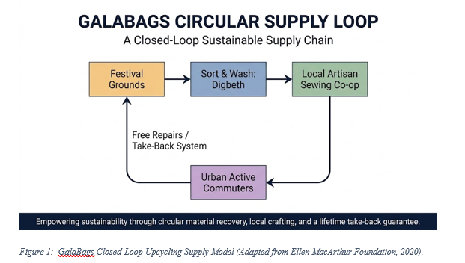
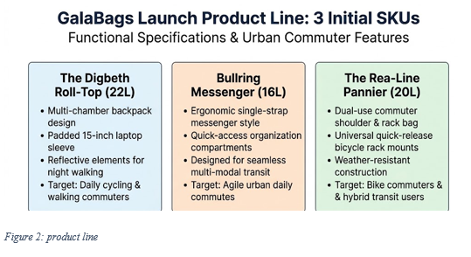
According to the research (Rosário, Raimundos and Cruz, 2022) we can determine that...Each bag comes with some original colour blocks and typography from the tent fly sheets, creating an aesthetically individual piece of luggage that is professionally and seam sealed as well as being waterproof.

Legal Format and Management Structure
An incorporated company, "GalaBags" Limited by Shares (Ltd) under the UK Companies Act 2006. The choice of this legal vehicle aims to shield the founders from personal liability, to provide a significant barrier to risk, as a normal part of running a business, involves physical logistics, workshop machinery and commercial distribution. According to the research (Dal Mas et al., 2021) we can determine that corporate status provides clear equity structures which are needed to attract institutional capital and competitive regional public funding.
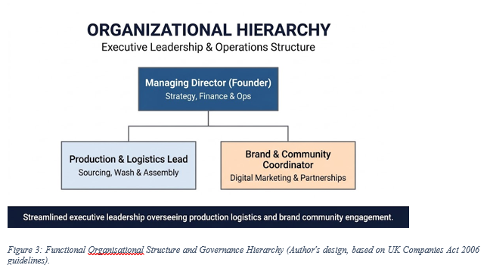
According to Suriyankietkaew, Krittayaruangroj and Iamsawan (2022) we can determine that held by leadership of a streamlined core team is essential of a well-functioning company.
Recurring fixed overheads are minimised by splitting off specialist services such as statutory tax accounting and independent legal advisory to local professional practices in central Birmingham.

Environmental Sustainability and Community Support
Its Circular Economy Framework (Ellen MacArthur Foundation, 2020) is directly applied to the enterprise, emphasising the design out waste, keeping products and materials in high value use and regenerating natural systems. The Association of Independent Festivals (AIF, 2023) states that festivalgoers in the UK throw away around 250,000 tents every year, generating more than 875 tonnes of composite plastic material waste that is just sent to incineration or landfill.
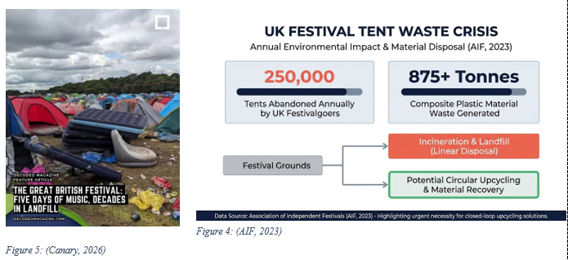
Direct upcycling – reusing, do not downcycle, energy-intensive mechanical plastic transformation, keeping the energy put in the technical and high-grade synthetic textiles and prolonging their useful functional lifespan by 5-10 years and it is what GalaBags does.
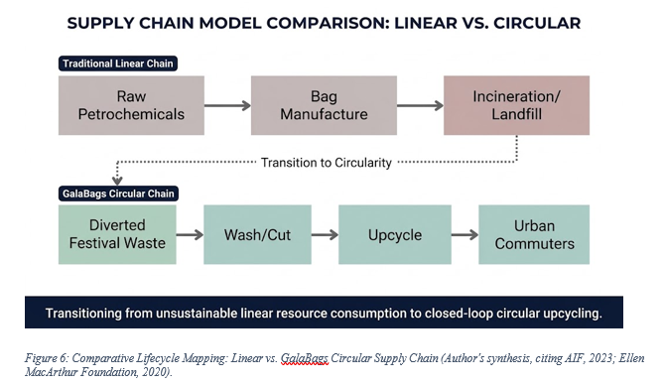
According to Mansoori and Lackéus (2019) the operational base of the enterprise is community integration. Instead GlaBags sets up its workshop in the Digbeth industrial quarter of Birmingham rather than outsourcing to overseas low-cost manufacturing units. According to Nakajima and Sekiguchi (2025) assembling involves working with local social enterprises and freelance textiles workers. This set-up offers apprenticeships for creative Birmingham City University and vocational college graduates, skills training in technical apparel assembly, and stable living-wage micro-employment.

Market research
According to the (Lapchuk and Dub, 2025) PESTEL breaks down macro-level pressures and factors that could impact on decisions regarding operations at the margin and assess external risk and strategic tailwinds in this area within the boundaries of the West Midlands.

Macro-Environmental Analysis (PESTEL)

Political
Regional manufacturing circularity is a priority in the Plan for Growth of the WMCA, providing non-repayable capital mechanisms for de-risking investments (WMCA, 2023). But a heavy dependence on public subsidies makes early-stage investments vulnerable to re-direction of public budgets; GalaBags counteracts this by providing commercial solvency as a baseline through unit sales, as opposed to grants.

Economic
According to Statista (2026) real disposable incomes in the UK are still restricted. However, Mintel (2023) reveals an accelerated "bifurcation of consumption", with an actual loss of demand and spending power on non-durable and non-functional active travel products, and a growth of demand and spending power amongst multifunctional and durable active travel products. GalaBags can be bought at £65 to £85, effectively breaking ground on the high-end market for circular luggage (e.g., Freitag starting at £180+) and protects consumers from buying and buying poor quality alternatives repeatedly.

Social
Sustrans (2023) shows Birmingham's cycling journeys were increasing over time, after incentives were made in the city to increase segregated cycle lanes (e.g A38 & A34). At the same time, there is an unprecedented level of consumer scepticism of corporate sustainability claims, which GalaBags are subversive of making it possible to achieve radical traceability to verify textile provenance through their serialised digital batch tags.

Technological
Conventional high-temperature industrial laundry degrades polyurethane (PU) waterproof membranes and releases secondary microfibres, which is a Technological issue. GalaBags removes particulate grime at 35 kHz, before lowering processing energy by 40% and maintaining membrane hydrostatic head ratings (>2,000mm) without mechanical friction and synthetic detergents, thus eliminating any such needs (IBISWorld, 2026).

Environmental
A major environmental market failure is that festival tents are made of cheap and imported synthetic materials and are just thrown away. Unlike mechanical reprocessing of nylon, which uses significant thermal energy and results in unrecoverable nylon composites (Ellen MacArthur Foundation, 2020), the material morphology is retained in the GalaBags manufacturing process and it is estimated that the savings in carbon-emissions are 82%, compared with virgin polyester backpack production.

Legal
The enterprise faces rigorous legal compliance with the UK Consumer Rights Act 2015 with respect to product durability and UK REACH (extended producer responsibility) (chemicals safety for skin contact (SVHC / azo dyes)). With upcoming Extended Producer Responsibility (EPR) regulations for textile waste streams in the UK, Galabags will ensure that their batch of textiles is wiped to ensure toxicity is not harmful before the product hits the market (Han, Yin and Liu, 2024).

Competitive Analysis and Market Positioning
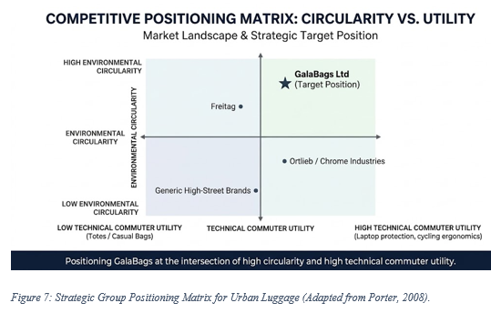
To examine competitive dynamics, Porter's (2008) strategy group analysis is applied on functional luggage segment:

Freitag
The existing global benchmark for upcycled bags, using commercial truck tarpaulins to make bags. Freitag is demonstrating that the market appetite for circular design is there, though the value add-on that their retail pricing model brings (£180-£340) would come with heftier material and Tare weight, which can make them cumbersome to use for a daily bike commute.

Ortlieb & Chrome Industries
All weather cyclists and courier’s bags, market leaders. Although their technical functionality and usability are top-notch, they require virgin materials such as TPU, PVC, and virgin Cordura, which singe out less concerned commuters.

High-Street Brands (e.g., ASOS, H&M)
They offer low-cost fashion backpacks (£20-L1,000), with few being waterproof and having linear, exploitative supply chains.

Strategic Differentiation
GalaBags aims to serve the market quadrant that is still not serviced in terms of technical commuter performance and authentic circularity attracting consumers at affordable mid-market prices (£65 to £85).

Marketing communications strategy

Target Audience Segmentation
GalaBags categorises the addressable market for its products to two main segments in the UK metropolitan centres:

Active Urban Commuter (Primary Segment)
Profile skews towards young professionals and university students, 20 to 35, who use chassis light electric mobility, bikes and public rail to move around cities. They require strong, weatherproof build quality, ergonomic convenience and compartmentalization for electronics.

Secondary segment
Conscious Eco-Consumer: People driven by values, who value transparent and ethically produced lifestyle products. They refuse to put up with green washed corporate doublespeak and instead prefer to verify provenance and community benefit (Gast, Gundolf and Cesinger, 2017).

Integrated Marketing Communications (IMC)
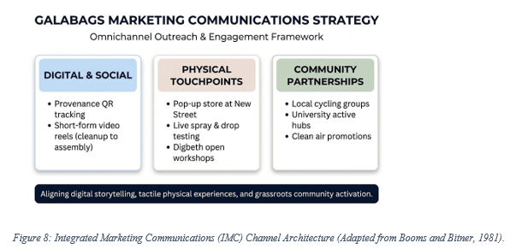
Using the 7Ps Marketing Mix model (Booms and Bitner, 1981), GalaBags designs, implements and manages a coherent and orchestrated multi-channel communications strategy:

Unique QR Code
The bags come with durable labels inside and have individual QR codes. Once scanned, it performs an overview of the festival cleanup site where the tent was recovered, the composition of the material and the diverted carbon emissions from incineration. Documentary-style content, like short things on TikTok and Instagram, highlights the recovery efforts and thus jobs environmental in their authenticity (Departemen Ilmu Komunikasi, Universitas Komputer Indonesia, Indonesia et al., 2022).

Experiential Pop-Up Installations
GalaBags will create pop-up stands and set-ups that have minimal impact on key commuter transport destinations throughout Birmingham, such as Birmingham New Street Station as well as university campuses during induction weeks in the autumn (DiBella et al., 2022). Live water submersion and abrasion tests will convince skeptical buyers of the durability of the upcycled technical nylon.
GalaBags will partner with commuter groups across the region such as Transport for West Midlands (TfWM) cycle-to-work schemes and urban cycling clubs. Along with co-promoted events, community puncture-repair clinics and student commuter discounts will help solidify local grassroots advocacy.

Financial requirements and startup budget

Capital Requirements and Funding Sources
GalaBags will need a total of £25,000 to invest in workspace infrastructure, capital machinery and working capital at the start of the operation.
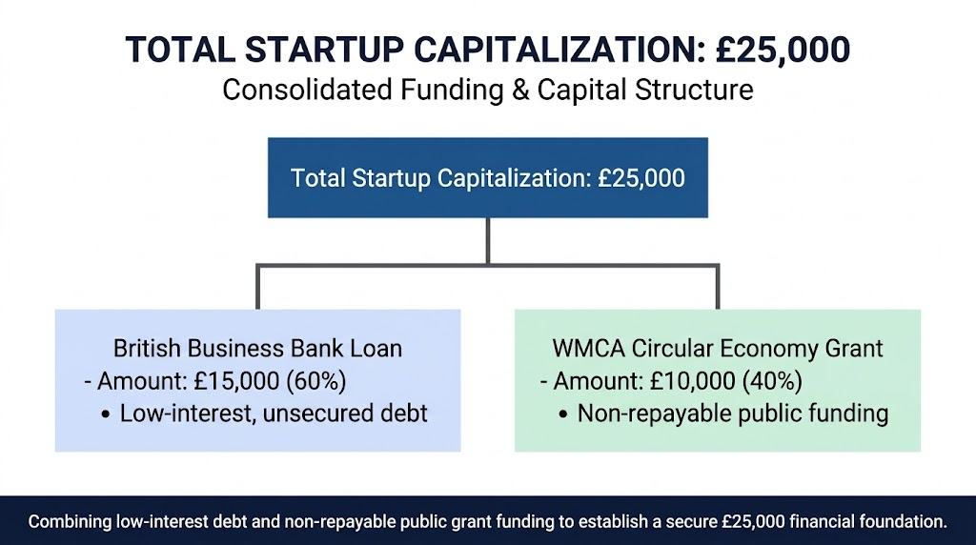

British Business Bank Start Up Loan (up to £15,000)
This is an unsecured start up loan (fixed loan at 6% per year for 5 years) backed by the government. This maintains 100% founder stake without laying ground for corporate trustworthiness.

WMCA Circular Economy Innovation Grant (£10,000)
Grant capital, non-repayable, awarded for innovation on clean techn at regional level that will support diversion of municipal waste and increase local clean tech manufacturing jobs. The investment is not a dilutive one and reduces initial financial risk and debt-servicing overhead costs.

First-Month Operational and Capital Budget
The £25k capital addition provides about £5k directly to cover Month 1 set-up costs and gives a sensible cash reserve to provide operating runway to Month 3.
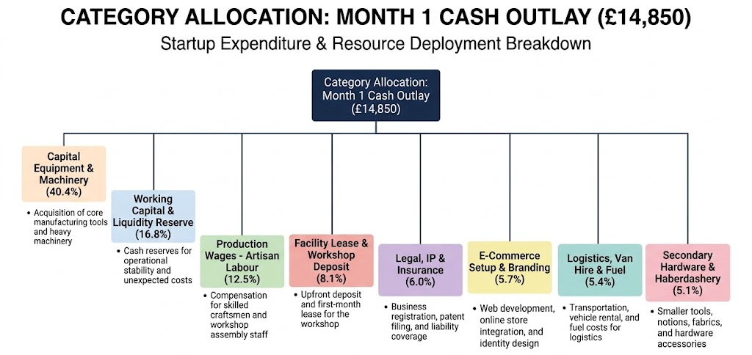
Figure 9: First-Month Expenditure Apportionment by Operational Function (Author's financial model, 2026).
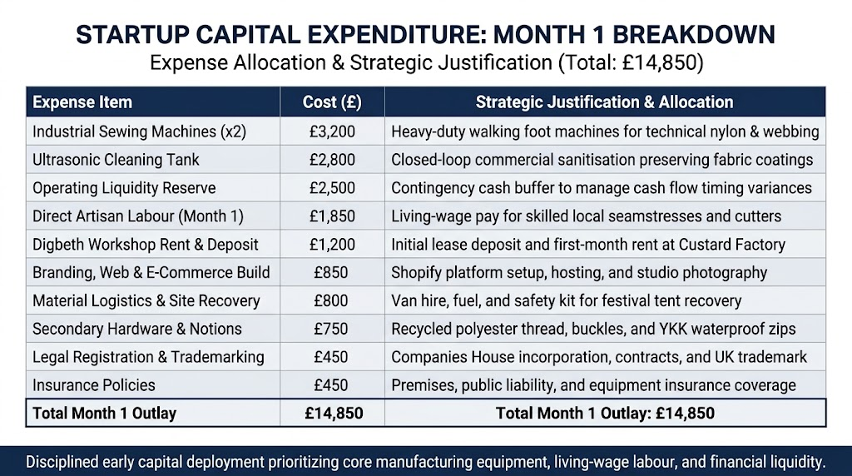
Being retained as liquid working capital, the £10,150 funds are used in the operational cycles, holding raw material inventories during Month 2 through Month 6, and for promotional marketing, while protecting solvency until breakeven at Month 9.

References
- Association of Independent Festivals. (2023) Festival Waste and Tent Abandonment Report 2023. London: AIF. Available at: https://aiforg.com (Accessed: 14 October 2026).
- Booms, B.H. and Bitner, M.J. (1981) ‘Marketing strategies and organization structures for service firms’, in Donnelly, J.H. and George, W.R. (eds.) Marketing of Services. Chicago: American Marketing Association, pp. 47–51.
- British Business Bank. (2024) Start Up Loans Guide and Financing Provisions. Sheffield: British Business Bank.
- Canary, T. (2026) Festival tent abandonment creates 875 tonnes of waste each year, Canary. Available at: https://www.thecanary.co/uk/news/2026/08/11/tent-litter/ (Accessed: October 15, 2026).
- Dal Mas, F., Massaro, M., Paoloni, P. and Kianto, A. (2021) “Translating knowledge in new entrepreneurial ventures: The role of business plan development,” VINE Journal of Information and Knowledge Management Systems, 53(6), pp. 1159–1177. Available at: https://doi.org/10.1108/vjikms-04-2021-0060.
- Departemen Ilmu Komunikasi, Universitas Komputer Indonesia, Indonesia, Rusdana, N.R., Choirani, S.J. and Friska, A.S. (2022) “Digital Marketing Communication Strategy for Micro, small and medium enterprises (MSMEs) in business competition,” International Journal of Research and Applied Technology, 2(1), pp. 163–168. Available at: https://doi.org/10.34010/injuratech.v2i1.6913.
- DiBella, J., Forrest, N., Burch, S., Rao‐Williams, J., Ninomiya, S.M., Hermelingmeier, V. and Chisholm, K. (2022) “Exploring the potential of SMEs to build individual, organizational, and community resilience through sustainability‐oriented business practices,” Business Strategy and the Environment, 32(1), pp. 721–735. Available at: https://doi.org/10.1002/bse.3171.
- Ellen MacArthur Foundation. (2020) Upstream Innovation: A Compact Guide to Packaging and Circular Solutions. Cowes: Ellen MacArthur Foundation.
- Gast, J., Gundolf, K. and Cesinger, B. (2017) “Doing business in a green way: A systematic review of the ecological sustainability entrepreneurship literature and future research directions,” Journal of Cleaner Production, 147(1), pp. 44–56. Available at: https://doi.org/10.1016/j.jclepro.2017.01.065.
- Han, S., Yin, S. and Liu, L. (2024) “Analysis of the importance of business model and business plan in the process of entrepreneurship: Taking college students entrepreneurship as an example,” Sustainable Economies, 2(3), pp. 38–38. Available at: https://doi.org/10.62617/se.v2i3.38.
- IBISWorld (2026) Luggage, handbags & harness manufacturing in the UK - market research report (2016-2031), ibisworld. Available at: https://www.ibisworld.com/united-kingdom/industry/luggage-handbags-harness-manufacturing/14471/ (Accessed: October 14, 2026).
- Lapchuk, Y. and Dub, M. (2025) “PESTLE analysis as a tool for strategic planning of digital marketing communications of retail enterprises,” Marketing and Digital Technologies, 9(4), pp. 150–168. Available at: https://doi.org/10.15276/mdt.9.4.2025.10.
- Mansoori, Y. and Lackéus, M. (2019) “Comparing effectuation to discovery-driven planning, prescriptive entrepreneurship, business planning, lean startup, and design thinking,” Small Business Economics, 54(3). Available at: https://doi.org/10.1007/s11187-019-00153-w.
- Mintel. (2023) Green and Sustainable Consumer Trends – UK. London: Mintel Group Ltd.
- Nakajima, H. and Sekiguchi, T. (2025) “Is business planning useful for entrepreneurs? A review and recommendations,” Businesses, 5(1), p. 10. Available at: https://doi.org/10.3390/businesses5010010.
- Porter, M.E. (2008) ‘The five competitive forces that shape strategy’, Harvard Business Review, 86(1), pp. 78–93.
- Rosário, A.T., Raimundos, R.J. and Cruz, S.P. (2022) “Sustainable entrepreneurship: A literature review,” Sustainability, 14(9), p. 5556. Available at: https://doi.org/10.3390/su14095556.
- Statista (2026) Luggage & bags - United Kingdom | statista market forecast, Statista. Available at: https://www.statista.com/outlook/cmo/accessories/luggage-bags/united-kingdom/ (Accessed: October 14, 2026).
- Suriyankietkaew, S., Krittayaruangroj, K. and Iamsawan, N. (2022) “Sustainable leadership practices and competencies of SMEs for sustainability and resilience: A community-based Social Enterprise Study,” Sustainability, 14(10), p. 5762.
- Sustrans. (2023) Walking and Cycling Index: Birmingham and West Midlands Metropolitan Area. Bristol: Sustrans. Available at: https://sustrans.org.uk (Accessed: 14 October 2026).
- West Midlands Combined Authority. (2023) Plan for Growth: Clean Tech and Circular Manufacturing Across the West Midlands. Birmingham: WMCA.

