Dissertation – Research Proposal
The Pizza War, A Critical Analysis of the competition between Pizza Hut and Dominos
Michael Williams
P149184

Contents
Introduction 3

Title 3

Rationale 3

Aims and Objectives 4

Research Design 4

Research Strategy 5

Sample 6

Limitations 6

Reliability 6

Ethics 7

Validity 7

Resources and Planning 7

Timescale - Gantt chart 7-8

Bibliography 8

Introduction

Title

The Pizza War, A Critical Analysis of the competition between Pizza Hut and Dominos

This dissertation aims to analyse and discover the effects of a pricing war on a particular market, in this case, the takeaway pizza market. To ascertain the implications of this oligopoly, Oligopolies being one of the best market types if not the best for consumers to interact with the business ,as Orlando and Selten, (2018) suggested in their book,”When sellers and buyers interact repeatedly, buyers can use their power to lower prices. These features add more realism for many market contexts, for example markets for perishable goods.”Whilst also benefiting from the size and stability of a larger company (Griffiths, Wall & Wall, Stuart, 2011.).
The implications of technology (ICT) and emerging technologies in the workplace (Rangriz, V. 2011) .Any other recent developments in areas such as marketing strategies that could lead to maximising worker output such as A.I and software advancements. (Clements 2006)The most beneficial advancements may also be useful to consider implementing in other businesses.

Rationale
The business environment nowadays is increasingly competitive, every company wants to make their business as efficient as possible .In many business nowadays the importance of employee satisfaction, fulfillment and the methods of marketing are being focused upon by companies to squeeze as much profit of the business as possible (Clements 2006). Meanwhile the invent of new technologies in increasingly making businesses go online (Ryan, 2017) and replacing or augmenting their workforce with technology to take advantages of profit maximisation technologies and automated systems. Peter Cheese (2018) states in an article about AI, robotics and automation technologies at work “The Resolution Foundation estimates that 10-35% of current jobs in the UK could be automated by 2030; sectors such as retail could lose as many as one in three jobs.” this is evidence for large amounts of the workplace being replaced by technology.

Pizza Hut and Dominos are in an oligopoly The definition of an oligopoly is “ a market dominated by a few producers. An oligopoly is an industry where there is a high level of market concentration. Examples of markets that can be described as oligopolies include the markets for petrol in the UK, soft drinks producers and the major high street banks.”(Riley, 2011) so Businesses in a perpetual oligopoly are forced to improve to compete with each other,(Markgraf, 2018) meaning that these businesses should be growing and developing faster than business in a monopoly where there is no competition and faster than a market with perfect competition as the smaller business in that market would struggle to gather enough funds to make large strides in technological development.

Aims and Objectives
This dissertation aims to analyse and discover the effects of a pricing war on a particular market,In this cast the takeaway Pizza market. The findings should useful for other organisation to implement to increase their efficiency. The reason Dominos and Pizza hut have been chosen is that they are market leaders they are very transparent with their innovations, publishing them on the internet they are also locked in a oligopoly forcing each company to constantly improve to try and take market share from their rival company.
The main aims and objectives of this research project are ,

- To research into the methods that both Dominos and Pizza Hut use that increase their employee engagement.
- To investigate into the technologies each company is utilising and how it has a positive impact on the company.
- To evaluate Dominos and Pizza Hut’s innovations and research into their impact on the company's organisational performance.
- To interpret if applied other businesses they would also provide benefits.

Research Design
Research can be defined as ‘something that people undertake in order to find out things in a systematic way, thereby increasing their knowledge’ (Saunders, et al., 2009, p. 5). The research taking place for this study will utilise the research onion. The research onion as seen below is a method of conducting research in a methodical process .

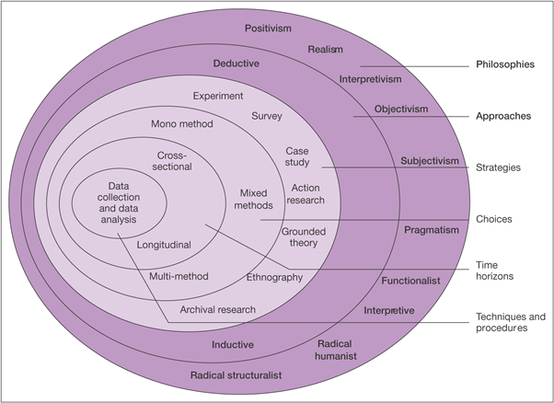
Figure 2.1. The Research Onion. Source: (Saunders, et al., 2009)

Research Strategy
Literature review
Firstly what is employee engagement and competing theories about how to keep employees engaged or whether they need to be engaged at all will be discussed, maslow's hierarchy of needs (Maslow,1998), theory X and Y (as developed by douglas McGregor). Methods of employee engagement will be studied, different hour contracts ,benifit like private health care or dental care plans (Sullivan, J.M., 2014).
Data will be gathered from the internet and from the interview that concerns new technological advancements in both Domino's Pizza and Pizza Hut , the data from the interview will be used to support the data collected from the internet.
The innovations for both of the companies will then be examined and the best innovations will be highlighted and examples of these innovations will then be found in other business where they are currently emerging or where they are likely to emerge next.

The investigation will be conducted by using 3 different methods as to provide a good mix of different types of data from different sources ,each sources will be most relevant to the types of data it is collecting ,for example a survey will be used to gather data on what the public think of particular pizza restaurants. Having multiple sources for data collection han help minimise errors in data interpretation, they will also make it easier to answer the research question as more data will be collected (Bryman & Bell, 2011).

The first set of data will be taken from sources directly published by the organisations in question dominos and pizza hut this data should be reliable and easy to find as the organisations are very transparent with there advancements and innovations, data can be collected from websites such as Dominos.com.au, 2018, Pizza Hut Delivery UK Franchise Site, 2018. Data about the companies innovations can be taken directly from published material online, data on pricing strategies can be taken from the published menus and information can also be taken from online interviews with the directors or ceos of the companies also published stock and shareholder information.

The second method will involve interviewing a worker at Dominos pizza to gather data on the technology in the workplace this method will be used to back up finding from the first data collection method or to disprove them , the researcher will interview the participant for no longer than 15 minutes and ask them questions concerning any technology that may have or is to be added to the workplace. Data collected from this method can be quiet detailed which is good for the purpose of data collection and analysis but it can be harder to interpret the data in to something quantifiable ,that is why it will be only used as support data to the main findings (Greener, 2008).

The third method of data collection will involve an online survey as it has particular benefits over a paper based survey, The main benefits of using an online survey are, It’s faster to collect the data, It's considerably easier to collect the data,It’s easier to analyses the data (Schlesinger, 2018). The data that will be collected will be the british public's thoughts on Domino's Pizza and Pizza Hut.

Sample
This study will utilise Purposive Sampling as set out by Saunders & Philip, (2012, pp. 138). A question will be asked at the beginning of the survey to rule out those who cannot participate in the survey for example if they don’t eat pizza or if they don’t buy takeaway pizza. Participants will vary in age but will mostly be between the ages of 18 and 50 (none of which being younger than 18). Both genders shall take place in this survey. This should give me a fair cross section of the british public in the final data.

Limitations
The sample of 100 people who will fill out the survey may not be enough to get an accurate view of what the british public think, The time frame given is the main constraint as it is what has restricted the sample size to 100 participants. To make sure the data is correct secondary supporting data will be sourced online to support the findings.

The data that will be collect through the interview could be more inclusive if a worker from Pizza hut was also interviewed, this would help to get an all around perspective ,though this may be difficult if the researcher can contact someone at Pizza Hut to give a more rounded view point he will do so.

Reliability and Validity
2 out of the 3 methods of data collection that will be used in this research project will be qualitative, Kirk, J., & Miller, M. (1986) talk about the reliability and validity of qualitative research in their book ,they discuss the reliability of qualitative data as they conclude that qualitative data isnt that reliable because it has the quantifiable part of it missing making it very hard to make sense of. To establish reliability it is important to be able to quantify the qualitative data, the surveys in this research project will be quantifiable by using Likert-type scales as part of the questioning.

Ethics
The completed ethics form will be submitted alongside this dissertation proposal to ensure any ethical considerations are made before the research begins. For the investigation into what consumers think about both dominos and Pizza Hut, the main ethical risk that could be posed could be the collection of potentially sensitive data about people's view of each of the companies, to avoid this all primary data will be collected anonymously and the questionnaire will be comprised of likert scale questions to help prevent any Defamation of the companies names, brand’s or existing reputation.

The only other ethical concern could be that if the data suggests that the public are bias towards one brand of the pizza greatly over the other, it could be perceived that the researcher is bias. This has been discussed with the supervisor and it has been agreed upon that by making sure that all data is merely a suggestion that has come from the data analysis, and there is a mix of positive and negative data ,so it can be shown that both companies have strengths in certain areas over the other.

Resources and Planning
Resources

The main resources that will be required to carry out this project include access to both the public and university library so books and other documentation can be studies for academic references to include in the work. Access to the internet so that data can be gathered about the organisations in question. Access to a computer to compile questions for the survey and to type the essay and use to process the data collected from the various data collection methods. Access to both Dominos and Pizza Hut to gather promotional material.

Planning

Timescale - Gantt chart

The researcher has created a gantt chart to mitigate any time limitations over the next few months. Time management is an extremely useful tool to have ,and to be able to create gantt charts to help split up some of the larger chunks of the dissertation. Having smaller self made deadlines can help achieve the bigger deadlines and make they seem less intimidating in the long run with the added benefit of avoiding last minute panics.

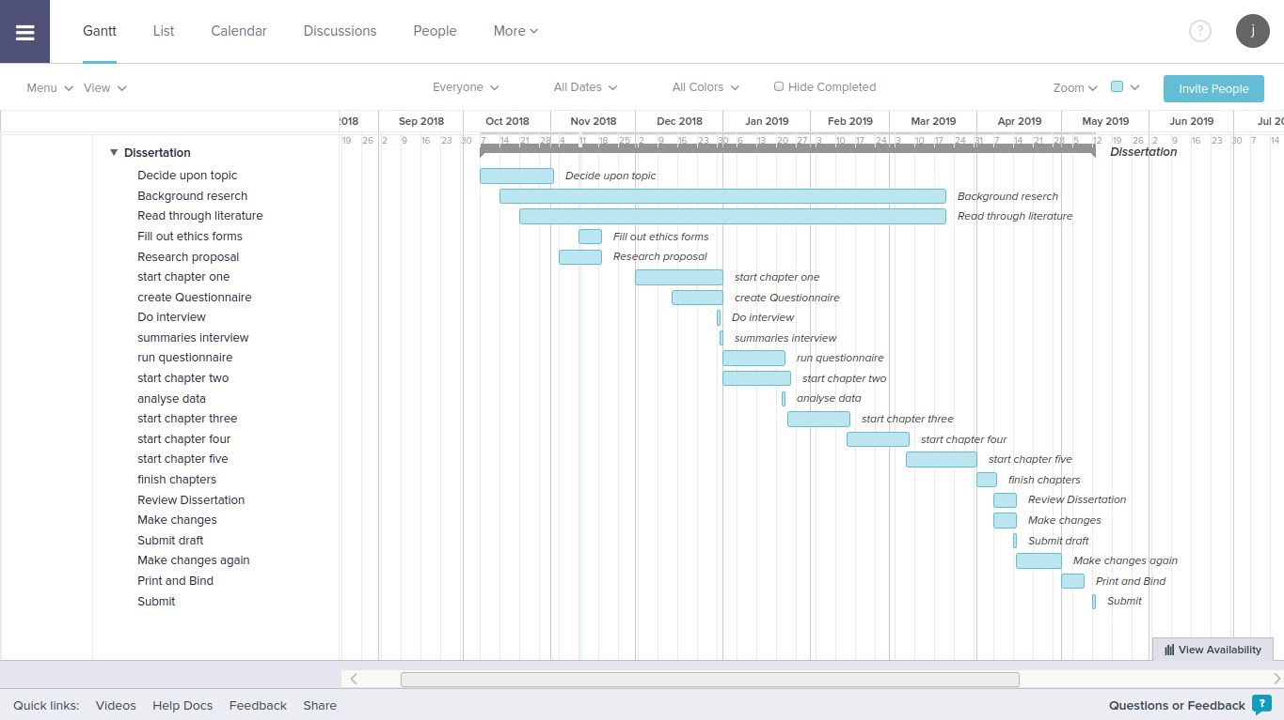
Bibliography
- Bryman, A. & Bell, E., 2011. Business research methods 3rd ed., Oxford: Oxford University Press, pp 600-700.

- Cheese, P. (2018). Peter Cheese on AI, robotics and automation technologies at work. [online] Changeboard. Available at: https://www.changeboard.com/article-details/16760/peter-cheese-on-ai-robotics-and-automation-technologies-at-work/ [Accessed 16 Nov. 2018].

- Clements-Croome & Clements-Croome, Derek, 2006. Creating the productive workplace 2nd ed., Abingdon: Taylor & Francis.

- Dominos.com.au. (2018). Technology & Innovation - Domino's Pizza. [online] Available at: https://www.dominos.com.au/inside-dominos/technology [Accessed 15 Nov. 2018].

- Dosi et al., 1998. Technology, Organization, and Competitiveness. Perspectives on Industrial and Corporate Change., Oxford: Oxford University Press.

- Feldman, A. (2018) ‘Pizza Unchained: Tech Startup Slice Helps Local Pizzerias Get Online And Fight Back Against Domino’s’, Forbes.com, p. 3. Available at: https://ezproxy.uwtsd.ac.uk/login?url=https://search.ebscohost.com/login.aspx?direct=true&db=bth&AN=128991453&site=ehost-live (Accessed: 16 November 2018).

- Greener, D. (2008). Business Research Methods. 1st ed. Ventus Publishing ApS, pp.80-93.

- Griffiths, Wall & Wall, Stuart, 2011. Economics for business and management 3rd ed., Harlow: Financial Times Prentice Hall, pp.150-200.

- Ishii, J. and Zhang, D. H. (2017) ‘Options Compensation as a Commitment Mechanism in Oligopoly Competition’, Managerial & Decision Economics, 38(4), pp. 513–525. doi: 10.1002/mde.2797.

- Kirk, J. and Miller, M. (2005). Reliability and validity in qualitative research. 6th ed. Newbury Park, Calif: Sage, p.chapter 2 onwards.

- Markgraf, B. (2018). How Does a Market Structure Positively or Negatively Affect a Firm?. [online] Smallbusiness.chron.com. Available at: https://smallbusiness.chron.com/market-structure-positively-negatively-affect-firm-78927.html [Accessed 16 Nov. 2018].

- Maslow, A.H., Stephens, D.C. & Heil, G., 1998. Maslow on management, New York: Wiley.

- Orlando, A. and Selten, R. (2018). Buyer power in bilateral oligopolies with advance production: Experimental evidence. 1st ed. Potsdam, Germany: University of Potsdam, Department of Economics, pp.21-42.

- Pizza Hut Delivery UK Franchise Site. (2018). Pizza Hut Delivery UK Franchise Site. [online] Available at: http://www.pizzahutfranchise.co.uk/ [Accessed 15 Nov. 2018].

- Rangriz, V. (2011) ‘Information and Communication Technology & Organisational Performance: Different Approaches To Evaluation’, International Journal of Global Business, 4(2), pp. 73–90. Available at: https://ezproxy.uwtsd.ac.uk/login?url=https://search.ebscohost.com/login.aspx?direct=true&db=bth&AN=69684100&site=ehost-live (Accessed: 18 November 2018).

- Riley, G. (2011). A2 Micro: Oligopoly | tutor2u Economics. [online] tutor2u. Available at: https://www.tutor2u.net/economics/blog/a2-micro-oligopoly [Accessed 15 Nov. 2018].

- Ryan, D. (2017). Understanding digital marketing. 7th ed. London: Kogan Page, pp.10-16,20-21.

- Ryan, D. & Jones, C., 2009. Understanding digital marketing : marketing strategies for engaging the digital generation, London: Kogan Page.

- Saunders, M., Lewis, P. & Thornhill, A., 2009. Research Methods for Business Students. 5th ed. Essex: Pearson Education Limited.

- Saunders, M. & Philip, L., 2012. Doing Research in Business & Management. 1st ed. Harlow: Pearson Education Limited .

- Schlesigner, V. (2018). Surveys: Online vs Paper - SmartSurvey Blog. [online] SmartSurvey Blog. Available at: https://blog.smartsurvey.co.uk/surveys-online-vs-paper/ [Accessed 15 Nov. 2018].

- STOLLER, M. (2017) ‘The Return of Monopoly’, New Republic, 248(8/9), pp. 18–25. Available at: https://ezproxy.uwtsd.ac.uk/login?url=https://search.ebscohost.com/login.aspx?direct=true&db=bth&AN=123839488&site=ehost-live (Accessed: 18 November 2018).

- Sullivan, J.M., 2014. Creating employee champions how to drive business success through sustainability engagement training, Oxford: Dō Sustainability.

- Y.C. Chung et al., 2012. THE CORRELATION BETWEEN BUSINESS STRATEGY, INFORMATION TECHNOLOGY, ORGANISATIONAL CULTURE, IMPLEMENTATION OF CRM, AND BUSINESS PERFORMANCE IN A HIGH-TECH INDUSTRY. South African Journal of Industrial Engineering, 23(2), pp.1–15.

