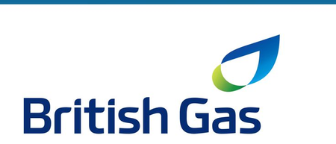

FORMAL HR REPORT
Contemporary HR Challenges at British Gas
A Critical Evaluation of Technological Advancement,
Talent Retention, and Diversity, Equity & Inclusion

Student Name: Latoya Brown
Student Number: 2428456
Module Code: LCLM5002
Module Title: BA (Hons) Leadership and Management Skills for the Workplace
Lecturer: Dr Mudassar Hasan
Assignment Title: Developing and Managing Individuals and Teams
Submission Date: March 30, 2026

Executive Summary
This report critically evaluates three HR challenges facing British Gas: technological advancement, talent acquisition and retention, and Diversity, Equity and Inclusion (DEI). Each challenge is examined in the context of a business navigating a net-zero transition with a workforce that has been significantly affected by the 2020–2021 industrial dispute.
The analysis shows that the problem at British Gas is not a shortage of HR frameworks. The frameworks exist. What is missing is consistent execution — and execution depends on managers who are capable, supported, and held to account. A culture of low trust following the fire and rehire dispute compounds this: employees will not engage with HR initiatives they do not believe are genuine.
Three strategic priorities emerge from the analysis:
- Reskilling the workforce at pace, through a Digital Skills Academy with clear capability targets.
- Rebuilding the employer value proposition through actions that demonstrate change, not communications that describe it.
- Making people management accountability visible and consequential at all manager levels.

Central finding: British Gas does not lack an HR strategy. It lacks the managerial consistency and organisational trust needed to turn strategy into practice. Until that gap is closed, even well-resourced HR interventions will underperform.
The report concludes with six prioritised, time-bound recommendations. Each one is specific enough to be implemented and measurable enough to be evaluated.

Introduction
British Gas is the UK's largest domestic energy supplier and a subsidiary of Centrica plc. It serves around ten million homes and businesses, employs approximately 20,000 people, including 7,000 field engineers, and is in the middle of one of the most significant transformations in its history (Centrica, 2023). The shift to net-zero energy, the rapid growth of smart technology, and a post-pandemic labour market that has fundamentally changed what employees expect from work are all pressing in on the HR function at the same time.
These pressures do not sit in isolation. The 2020–2021 fire and rehire dispute, which ended with around 500 engineer dismissals and 44 days of strike action, left a trust deficit that shapes how employees respond to any management-led initiative today (GMB Union, 2021). That context matters when evaluating what HR practices are likely to work in practice, not just in theory.
This report examines three interdependent challenges: reskilling the workforce, attracting and retaining talent, and embedding DEI. For each one, it evaluates the relevant HR practices critically, including where those practices fall short and identifies what needs to happen and why. The central argument is straightforward: British Gas does not lack an HR strategy; it lacks the execution consistency and organisational trust to make that strategy real. The recommendations at the end of this report are written with that in mind.

Section 1: Key HR Factors at British Gas

1.1 Meeting Technological Advancement
The scale of technological change at British Gas is not gradual. The company is deploying smart meters nationally, building EV charging infrastructure, and integrating AI into customer-facing operations (Centrica, 2023). Each of these creates an immediate skills gap. A field engineer trained on gas boilers is not automatically equipped to diagnose smart systems. A customer adviser is not automatically equipped to work alongside AI. The transition is happening faster than the workforce has been prepared for.
Figure 1 below sets this in a broader context. The World Economic Forum (2023) finds that 44% of workers' core skills will need to change by 2027, up from 35% in 2016. For a technical workforce of the kind British Gas employs, that trajectory is not background noise. It is an operational risk.
✓ Verified statistic: WEF (2023): 44% of workers' core skills expected to change by 2027, rising from 35% in 2016. Source: World Economic Forum, Future of Jobs Report 2023.
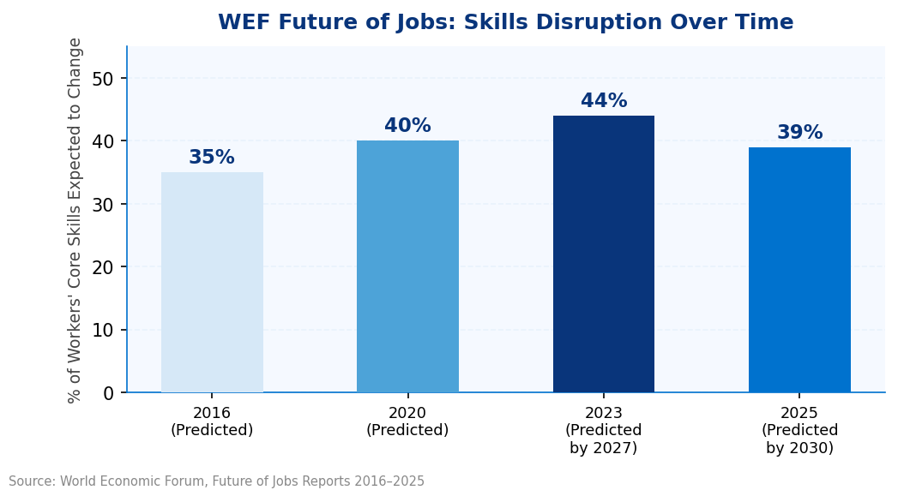
Figure 1: WEF Future of Jobs — Skills Disruption Forecasts 2016–2025(% of workers’ core skills expected to change within each forecast window)Sources: World Economic Forum (2016, 2020, 2023, 2025)
The human dimension of this is just as important. Kotter (2012) makes the point that employees cannot be upskilled until they first accept the need for change. Lewin (1951) reinforces this: established habits and attitudes must be actively disrupted before new behaviours take hold. At British Gas, many field engineers have 10–20 years of experience in a specific technical discipline. Retraining feels like a challenge to that identity. HR and managers need to plan for that response, not be surprised by it.

1.2 Talent Acquisition and Retention
British Gas is competing for talent in a market where energy companies start at a disadvantage. Technology firms, consultancies, and fast-growing start-ups typically offer better pay, more flexibility, and a stronger sense of career momentum. The Energy and Utility Skills Partnership (2022) identifies serious shortages in cyber security, data science, and smart grid engineering the exact skills British Gas needs to deliver its net-zero strategy.
When attrition happens, it is expensive. Oxford Economics (cited in CIPD, 2023) puts the average cost of replacing a UK employee at £30,614 per leaver. That covers recruitment, the productivity gap while the role is vacant, and the time it takes a new hire to get up to speed. Across a 20,000-person organisation with voluntary turnover consistently above 15% in technical roles, the annual cost of preventable attrition is material.
✓ Verified statistic: Oxford Economics / CIPD (2023): Average UK employee replacement cost £30,614 per leaver. A 5% improvement in voluntary retention across British Gas's 20,000-strong workforce would prevent approximately £30 million in annual replacement costs.
The reputational issue compounds the recruitment challenge. The 2021 fire and rehire dispute in which British Gas threatened to dismiss and rehire 7,000 engineers on worse terms, and ultimately did dismiss around 500, is well-documented and widely known to candidates (GMB Union, 2021). Purpose-driven candidates, and particularly those in the younger technical talent pool, research employers before they apply. A damaged employer brand does not disappear through a new careers website or a sustainability pledge. It requires substantive change to the employment relationship: transparent pay, genuine employee voice, and leadership that is visibly accountable. Without that foundation, employer branding campaigns produce noise, not candidates.

1.3 Diversity, Equity and Inclusion (DEI)
The energy sector's diversity problem is structural, and it is not improving fast enough. As Figure 2 below shows, the gap between where the sector is now and where it needs to be by 2030 is significant at every level of leadership. Women make up just 29% of the UK's electricity, gas and steam sector workforce (ONS, 2023). POWERful Women and PwC (2023) found that only 16% of executive board positions in the top 80 UK energy companies are held by women, with six female CEOs across the entire sector. Ethnic minority underrepresentation at senior levels is arguably worse, and harder to quantify, because ethnicity pay gap reporting remains voluntary.
✓ Verified statistic: ONS (2023): Women constitute 29% of the UK energy sector workforce. POWERful Women/PwC (2023): Only 16% of executive board positions held by women in the top 80 UK energy companies.
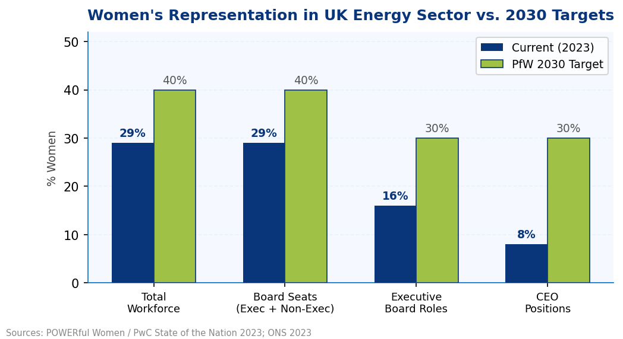
Figure 2: Women's Representation in UK Energy Sector vs. POWERful Women 2030 TargetsSources: ONS (2023); POWERful Women/PwC, State of the Nation (2023)
McKinsey and Company (2020) found that companies in the top quartile for ethnic diversity outperform bottom-quartile peers by 36% in profitability, with their 2023 study reporting a 39% outperformance likelihood. Green and Hand (2024) have challenged the statistical methodology behind these findings, arguing that the causal relationship is less robust than the McKinsey reports suggest. That is a fair challenge to acknowledge. However, it does not change the underlying case for DEI at British Gas. A workforce that does not reflect the diversity of the communities it serves and that draws leadership from too narrow a pool makes worse decisions. That is the operational argument. The Equality Act 2010 provides the legal framework.

Section 2: Critical Evaluation of Contemporary HR Practices

2.1 Practices to Address Technological Advancement
The 70-20-10 model (Lombardo and Eichinger, 1996) is the most widely used framework for structuring workplace learning. The principle is that 70% of development comes from doing the job, 20% from learning alongside colleagues, and 10% from formal training. As Figure 3 below illustrates, applied to British Gas, this means: engineers picking up smart system competencies on live installations, peer coaching between those who have been reskilled and those who have not, and targeted certification programmes delivered through a digital Learning Management System such as SAP SuccessFactors. The Apprenticeship Levy already funded by British Gas should be redirected towards these emerging technical roles rather than legacy skills.
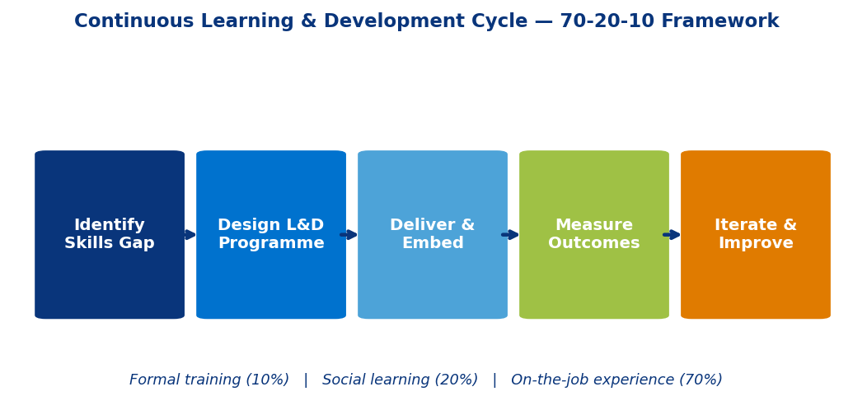
Figure 3: 70-20-10 Continuous Learning and Development Cycle in Practice(Lombardo and Eichinger, 1996); British Gas application context
Important caveat: Clardy (2018) argues that the 70-20-10 proportions were never empirically validated — they came from practitioner surveys, not controlled research. British Gas should use the framework as a planning structure, but must build in proper evaluation: pre- and post-training skills assessments, certification rates, and productivity measures. Without that, there is no way to know whether the investment is working.
The ADKAR model (Hiatt, 2006) and Lewin's (1951) change framework both reinforce a point that L&D planners frequently underweight: people need to want to change before they can be trained to change. At British Gas, where long-tenured field engineers will be asked to reskill in ways that challenge their professional identity, structured communication and genuine engagement must come before the training programme is launched. Managers need to lead those conversations. A training calendar is not a change management strategy.

2.2 Practices to Address Talent Acquisition and Retention
An employer value proposition only works if it is credible. Candidates who look up British Gas on Glassdoor before applying will find reviews that reflect the 2021 dispute. Rebuilding that reputation requires demonstrably different behaviour: transparent pay bands, published career development pathways, genuine hybrid working options, and leadership that is visibly present with frontline teams. These are not communications decisions. They are HR and operations decisions that the business must commit to before any recruitment campaign launches.
Herzberg, Mausner and Snyderman's (1959) Two-Factor Theory offers useful framing here. It argues that pay and job security prevent dissatisfaction but do not, on their own, drive engagement. What drives engagement is meaningful work, recognition, and opportunities to grow. For British Gas, that means linking individual roles explicitly to the energy transition narrative, investing in visible recognition programmes, and building career progression frameworks with real substance behind them.
Worth noting: House and Wigdor (1967) challenge the Two-Factor Theory on methodological grounds, showing that people tend to attribute good outcomes to intrinsic factors and bad ones to extrinsic ones — which may inflate the apparent separation between the two categories. The practical implication for British Gas is that pay cannot be treated as a box to tick. In a competitive technical talent market, below-market pay drives attrition regardless of how meaningful the work feels. Both dimensions need attention simultaneously.
On retention, Purcell et al. (2003) found across a three-year study of eleven UK organisations that perceived employee voice is one of the strongest predictors of organisational commitment. People who feel heard stay. British Gas must establish forums with published outcomes, surveys with visible follow-through, and pay reporting that is honest. Not because these things look good, but because they are what rebuilding trust actually requires.

2.3 Practices to Address DEI
Structural change to hiring processes is the most important near-term action British Gas can take on DEI. Blind CV screening, structured competency-based interviews with diverse panels, and standardised scoring rubrics directly reduce the influence of unconscious bias on hiring decisions. Bertrand and Mullainathan (2004) demonstrated through a field experiment that identical CVs with white-sounding names received 50% more callbacks than those with Black-sounding names. The implication is clear: without process change, diversity targets remain aspirational rather than achievable.
Reverse mentoring pairing junior employees from underrepresented groups with senior leaders has generated measurable outcomes at organisations, including BNY Mellon/Pershing, where Jordan and Sorell (2019) report a 96% Millennial retention rate in the first reverse mentoring cohort, alongside documented shifts in senior leader behaviour. British Gas should run a structured cohort within its executive population, tracking outcomes through annual 360-degree feedback rather than attendance records.
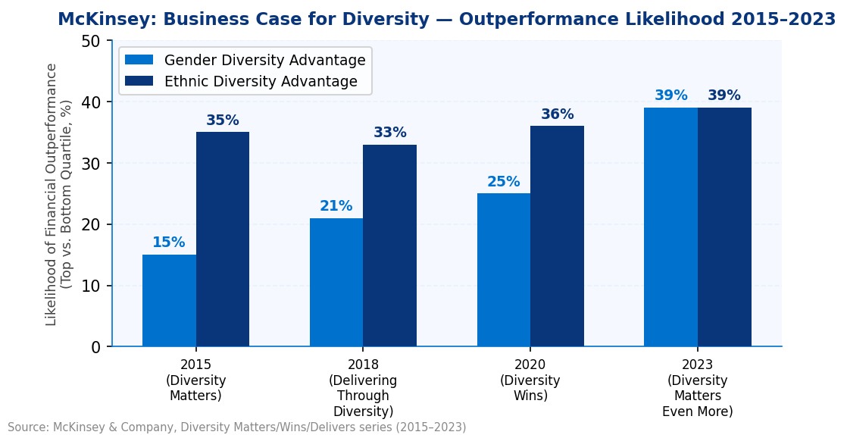
Figure 4: McKinsey Diversity Research Series — Likelihood of Financial Outperformance (Top vs. Bottom Quartile)by Gender and Ethnic Diversity in Executive Teams, 2015–2023. Sources: McKinsey and Company (2015, 2018, 2020, 2023)
Figure 4 above shows that the correlation between diverse leadership and financial outperformance has held across every McKinsey study cycle since 2015, even as Green and Hand (2024) have questioned the underlying methodology. The stronger argument, however, is Ahmed's (2012) point about organisational theatre: companies frequently respond to diversity pressure by running visible initiatives — training days, awareness campaigns, ERG launches — without changing the structural conditions that produce inequality in the first place. Time-bound targets, pay transparency, and DEI metrics embedded in leadership appraisals are the structural levers. British Gas needs to pull those levers, not commission another training programme.

Section 3: Ensuring Urgent Implementation — The Role of Departmental Managers
HR strategy at British Gas will only be as effective as the managers who implement it. That statement sounds obvious, but it is consistently underestimated in how organisations design and resource their people strategies. The frameworks exist. The policies exist. What determines whether they land in the day-to-day experience of employees is the quality, motivation, and behaviour of line managers, and at British Gas, there are good reasons to think that gap is significant.
Managers in field operations and customer service divisions work under persistent performance pressure. Jobs-per-day targets, first-fix rates, customer satisfaction scores, and cost controls all compete for the same management bandwidth that development conversations, inclusive leadership, and coaching for growth require. In that environment, people management gets deprioritised. Not because managers are negligent, but because the system does not reward it with the same urgency it rewards service delivery. That is a structural problem, and training alone will not solve it.
The core issue: HR strategy fails not at the design stage but at the manager level. Until people management is measured, rewarded, and resourced with the same seriousness as operational performance, implementation will be inconsistent. British Gas needs to change the incentive structure, not just the training offer.

3.1 Managers as Strategic Enablers, Not Just Operational Leads
The first shift British Gas must make is in how it defines the manager's role. People management is not an add-on to the real job. It is how the real job gets sustained over time. Retention, capability development, and engagement are all downstream of manager behaviour. When managers coach well, invest in their teams, and handle performance fairly, the business benefits directly through lower attrition, better productivity, and stronger service delivery. That connection needs to be explicit — not assumed.
Ulrich's (1997) HR Business Partner model provides the right structural support: embedding HR professionals within operational divisions to provide real-time coaching and guidance rather than reactive transactional support. However, Caldwell (2008) raises a genuine concern with this model in practice that Business Partners become commercially-captured and lose their credibility as employee advocates. At British Gas, where trust in management-aligned HR functions is already fragile, this risk is real. Business Partners must have a clearly defined dual mandate: supporting business outcomes and representing employee interests. Both sides of that mandate need to be visible to the workforce, or the credibility advantage of the model disappears.

3.2 Closing the Capability–Expectation Gap
Many of British Gas's operational managers were promoted on the strength of their technical ability. The best engineer became the engineering supervisor. That is a common pattern in technical industries, and it creates a predictable gap: technical expertise and people leadership are different skill sets, and the latter is rarely developed through promotion alone. Brewster and Holt Larsen (2000) identify managerial capability as one of the main reasons HR strategies fail to translate into practice.
A mandatory People Management Programme covering performance conversations, managing resistance to change, and inclusive leadership in practice is a necessary investment. It must be practical and grounded in the British Gas operational context, not a generic leadership course that field managers will dismiss as irrelevant before they finish the first module. Critically, training is not the endpoint. Without reinforcement through coaching, peer discussion, and accountability mechanisms, the behaviour change will not stick beyond the first few weeks after the programme ends.

3.3 Driving Behaviour Through Accountability and Consequence
Managers at British Gas must be accountable for people's outcomes, not just operational ones. That means embedding people management KPIs into performance appraisals with real weighting of a minimum of 25% tied to salary progression and promotion eligibility. Metrics should include team voluntary turnover, employee engagement scores for direct reports, DEI representation in promotion nominations, and 360-degree feedback. Armstrong and Taylor (2014) argue that HR strategy without performance ownership stays on the shelf. The point applies here: if people's leadership carries no consequence, managers will continue to allocate their attention where the consequences are sharpest.
However: Guest (2011) cautions that metrics-driven HR tends to produce compliance rather than commitment — managers tick the box without changing the underlying behaviour. British Gas must complement the KPI framework with qualitative review: peer learning forums where managers share real challenges openly, narrative performance conversations that probe the quality of people leadership rather than just its measurable outputs, and direct feedback channels from teams to HR that bypass the management hierarchy.

3.4 Creating the Conditions for Sustainable Implementation
Structural accountability and training capability are necessary. They are not sufficient. Long-term implementation depends on what senior leaders do, not what they ask managers to do. When the executive team at British Gas visibly participates in reverse mentoring, responds to pulse survey findings with action, and talks about people outcomes in the same breath as commercial performance, they give middle managers the permission and the cover to do the same. When they do not, the cultural signal is clear, and it undermines every HR initiative below it.
Manager communities of practice offer a practical mechanism for lateral learning and mutual accountability. Field-based managers, often working across large geographical areas with limited peer contact, benefit disproportionately from structured opportunities to discuss what is working and what is not. These communities reduce isolation and accelerate the spread of effective approaches without requiring central HR to be present in every conversation.
An agile approach to HR implementation (Rigby, Sutherland and Takeuchi, 2016) with quarterly review cycles, fast feedback loops from employees and managers, and willingness to adjust what is not working, is the operational mechanism for keeping HR strategy connected to reality. British Gas must build responsiveness into how its HR function operates day-to-day, rather than treating it as an annual refresh exercise.

Conclusion and Strategic Recommendations
British Gas faces three HR challenges that are urgent, interconnected, and consequential. A workforce that is not reskilled fast enough will create an operational capability gap within three years. A damaged employer brand and poor retention economics will sustain avoidable attrition costs running into tens of millions of pounds annually. And a diversity gap in leadership will persist with real consequences for decision quality and organisational performance unless structural change is made, not just announced.
The analysis in this report points to a consistent finding across all three areas: the primary barrier is not strategy. The frameworks exist, the evidence base exists, and British Gas has the resources to act. What has been missing is an execution consistent, accountable, and credible implementation at the manager level, in an organisation where the trust needed to make that work has been seriously damaged. That is the problem this report's recommendations are designed to address.

R1 Launch a Digital Skills Academy (Priority: Immediate — 0–12 months)
British Gas must establish a centrally governed Digital Skills Academy, funded through the Apprenticeship Levy, targeting the reskilling of at least 2,000 employees in Year 1, with a focus on field engineers and digital customer service roles. The programme must combine on-the-job learning, peer coaching, and formal certification aligned to the 70-20-10 framework (Lombardo and Eichinger, 1996), with mandatory pre- and post-assessment to measure capability uplift. Without structured reskilling at this pace, British Gas will not have the workforce it needs to deliver smart energy services by 2027 (WEF, 2023).
R2 Rebuild the Employer Value Proposition Through Actions, Not Messaging (Priority: Immediate — 0–6 months)
British Gas must introduce quarterly employee forums with published outcomes, transparent pay and progression frameworks, and a visible executive presence in frontline operations. These changes must come before, not alongside, any employer branding campaign. Rebuilding trust after the 2021 dispute requires evidence of different behaviour, not communication of different values. This is the highest-return retention investment British Gas can make in the short term (Purcell et al., 2003).
R3 Mandate Structured DEI Practices Across All Hiring and Promotion Processes (Priority: 6–18 months)
Blind CV screening, diverse interview panels, and standardised scoring rubrics must be implemented across all hiring processes. Time-bound diversity targets at senior leadership level, aligned to the POWERful Women 2030 framework, must be set and linked to executive remuneration. British Gas must also voluntarily publish annual ethnicity pay gap data alongside gender pay reporting. Structural process change is the only lever that moves representation data (Bertrand and Mullainathan, 2004; POWERful Women and PwC, 2023).
R4 Embed People Management Accountability into All Manager Performance Frameworks (Priority: Immediate — 0–12 months)
People management KPIs must be integrated into all manager appraisals with a minimum 25% weighting tied to salary progression and promotion eligibility. Metrics must include team voluntary turnover, employee engagement scores, DEI representation in promotion nominations, and 360-degree feedback. A mandatory People Management Programme must be delivered to all managers within 12 months, grounded in the British Gas operational context (Armstrong and Taylor, 2014). Qualitative mechanisms — peer forums, narrative performance conversations — must complement the KPI framework to guard against surface compliance (Guest, 2011).
R5 Deploy HR Business Partners with a Dual Mandate (Priority: 6–12 months)
HR Business Partners must be embedded within all operational divisions with an explicitly defined dual accountability: supporting business performance and acting as credible advocates for employees. Their mandate, and their visibility to the workforce, must make both sides of that role clear. A Business Partner function perceived as commercially-captured will not rebuild the trust the organisation needs (Ulrich, 1997; Caldwell, 2008).
R6 Adopt an Agile Approach to HR Implementation (Priority: Ongoing)
HR delivery must incorporate quarterly review cycles, fast feedback loops from employees and managers, and genuine willingness to adjust interventions that are not working. Static annual policy cycles are not adequate for an organisation managing the pace of change that British Gas faces. An agile HR model keeps strategy connected to operational reality (Rigby, Sutherland and Takeuchi, 2016).

Final position: British Gas has the strategy. The question is whether it has the execution discipline to make it real. The cost of continued inaction in capability gaps, talent loss, and reputational damage is already visible. The cost of acting is measurable and manageable. The six recommendations above are designed to be implemented, not debated.

References
Ahmed, S. (2012) On Being Included: Racism and Diversity in Institutional Life. Durham, NC: Duke University Press.
Armstrong, M. and Taylor, S. (2014) Armstrong's Handbook of Human Resource Management Practice. 13th edn. London: Kogan Page.
Bertrand, M. and Mullainathan, S. (2004) 'Are Emily and Greg More Employable Than Lakisha and Jamal? A Field Experiment on Labour Market Discrimination', American Economic Review, 94(4), pp. 991–1013.
Brewster, C. and Holt Larsen, H. (eds.) (2000) Human Resource Management in Northern Europe: Trends, Dilemmas and Strategy. Oxford: Wiley-Blackwell.
British Gas (2023) About British Gas [Online]. Available at: https://www.britishgas.co.uk/about-us.html (Accessed: 30 March 2026).
Caldwell, R. (2008) 'HR Business Partner Competency Models: Re-contextualising Effectiveness', Human Resource Management Journal, 18(3), pp. 275–294.
Centrica plc (2023) Annual Report and Accounts 2023. Windsor: Centrica plc. Available at: https://www.centrica.com/investors/annual-report-2023/ (Accessed: 30 March 2026).
Chartered Institute of Personnel and Development (CIPD) (2022) Recruitment and Selection [Online]. London: CIPD. Available at: https://www.cipd.org/uk/topics/recruitment/ (Accessed: 30 March 2026).
Chartered Institute of Personnel and Development (CIPD) (2023) Employee Turnover and Retention [Online]. London: CIPD. Available at: https://www.cipd.org/uk/topics/turnover-retention/ (Accessed: 30 March 2026).
Clardy, A. (2018) '70-20-10 and the Dominance of Informal Learning: A Fact in Search of Evidence', Human Resource Development Review, 17(2), pp. 153–178.
Deloitte (2021) The Future of Learning: How AI Is Transforming Corporate Training. London: Deloitte Insights.
Deloitte (2023) 2023 Gen Z and Millennial Survey [Online]. London: Deloitte. Available at: https://www.deloitte.com/global/en/issues/work/content/genzmillennialsurvey.html (Accessed: 30 March 2026).
Energy and Utility Skills (2022) Workforce Renewal and Skills Strategy 2020–2025. Solihull: Energy and Utility Skills.
GMB Union (2021) British Gas Strike Dispute Timeline [Online]. London: GMB Union. Available at: https://www.gmb.org.uk/commercial-services-section/energy-noticeboard/british-gas-noticeboard (Accessed: 30 March 2026).
Green, J.R. and Hand, J.R.M. (2024) 'McKinsey's Diversity Matters/Delivers/Wins Results Revisited', Econ Journal Watch, 21(1), pp. 66–134.
Guest, D.E. (2011) 'Human Resource Management and Performance: Still Searching for Some Answers', Human Resource Management Journal, 21(1), pp. 3–13.
Herzberg, F., Mausner, B. and Snyderman, B.B. (1959) The Motivation to Work. New York: John Wiley and Sons.
Hiatt, J.M. (2006) ADKAR: A Model for Change in Business, Government and Our Community. Loveland, CO: Prosci Learning Centre Publications.
House, R.J. and Wigdor, L.A. (1967) 'Herzberg's Dual-Factor Theory of Job Satisfaction and Motivation: A Review of the Evidence and a Criticism', Personnel Psychology, 20(4), pp. 369–389.
Jordan, J. and Sorell, M. (2019) 'Why Reverse Mentoring Works and How to Do It Right', Harvard Business Review [Online], 3 October. Available at: https://hbr.org/2019/10/why-reverse-mentoring-works-and-how-to-do-it-right (Accessed: 30 March 2026).
Kotter, J.P. (2012) Leading Change. Boston, MA: Harvard Business Review Press.
Lewin, K. (1951) Field Theory in Social Science: Selected Theoretical Papers. New York: Harper and Row.
LinkedIn Talent Solutions (2022) Global Talent Trends 2022 [Online]. Sunnyvale, CA: LinkedIn Corporation. Available at: https://business.linkedin.com/talent-solutions/global-talent-trends (Accessed: 30 March 2026).
Lombardo, M.M. and Eichinger, R.W. (1996) The Career Architect Development Planner. Minneapolis, MN: Lominger Limited.
McKinsey and Company (2020) Diversity Wins: How Inclusion Matters [Online]. Available at: https://www.mckinsey.com/featured-insights/diversity-and-inclusion/diversity-wins-how-inclusion-matters (Accessed: 30 March 2026).
McKinsey and Company (2023) Diversity Matters Even More: The Case for Holistic Impact [Online]. Available at: https://www.mckinsey.com/featured-insights/diversity-and-inclusion/diversity-matters-even-more-the-case-for-holistic-impact (Accessed: 30 March 2026).
Office for National Statistics (ONS) (2023) Labour Force Survey: Employment by Industry (SIC 2007) [Online]. Newport: ONS. Available at: https://www.ons.gov.uk/employmentandlabourmarket/peopleinwork/employmentandemployeetypes (Accessed: 30 March 2026).
POWERful Women and PwC (2023) State of the Nation: Gender Diversity in the UK Energy Sector 2023 [Online]. London: POWERful Women. Available at: https://powerfulwomen.org.uk (Accessed: 30 March 2026).
Purcell, J., Kinnie, N., Hutchinson, S., Rayton, B. and Swart, J. (2003) Understanding the People and Performance Link: Unlocking the Black Box. London: CIPD.
Rigby, D.K., Sutherland, J. and Takeuchi, H. (2016) 'Embracing Agile', Harvard Business Review, 94(5), pp. 40–50.
Ulrich, D. (1997) Human Resource Champions: The Next Agenda for Adding Value and Delivering Results. Boston, MA: Harvard Business School Press.
World Economic Forum (2023) The Future of Jobs Report 2023 [Online]. Geneva: World Economic Forum. Available at: https://www.weforum.org/publications/the-future-of-jobs-report-2023/ (Accessed: 30 March 2026).
World Economic Forum (2025) The Future of Jobs Report 2025 [Online]. Geneva: World Economic Forum. Available at: https://www.weforum.org/publications/the-future-of-jobs-report-2025/ (Accessed: 30 March 2026).

