

BREAST CANCER

Name: Karen Alcantara Vicioso
Student ID: 2213116
Lecturer’s name: Dr Laila Surani
Module name: Introduction to Public Health
Module code: LCHS4004_LON

Table Of Content

- Introduction……………………………………………………. Page 3

- Public Health Measures………………………………………. Page 4

- Risk Factors of Breast Cancer………………………………. Page 6

- Short-Term Public Health Consequences ………………… Page 7

- Long-Term Public Health Consequences …………………. Page 8

- Conclusion ……………………………………………………… Page 9

- Reference List …………………………………………………. Page 11

1. Introduction

Breast cancer is an ailment characterised by the breast tissue growing out of control. The type of breast cancer depends on the specific cells of the breast affected. The cancer starts spreading to different cells within the breast, such as the connective tissues, ducts, or lobules. These different parts have specific roles to play in a healthy breast. For example, the lobules produce milk while the ducts carry it to the nipple. The connective tissue is a fatty mass of cells with fibrous structures surrounding and holding the breast together. Most cases start in the lobules or ducts. Breast cancer can spread to other body tissues through the blood or lymph vessels. In such cases, the cancer is considered to have metastasised.

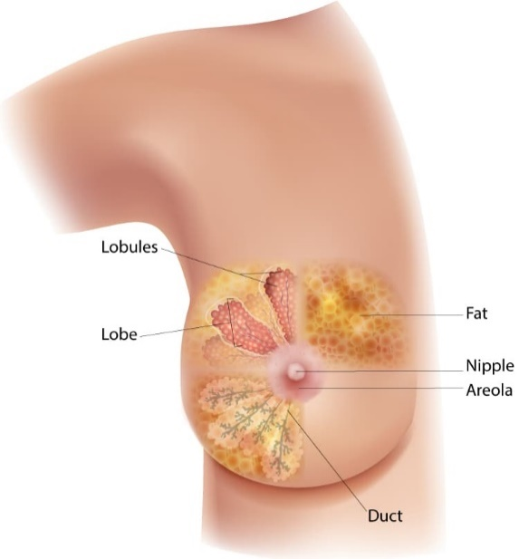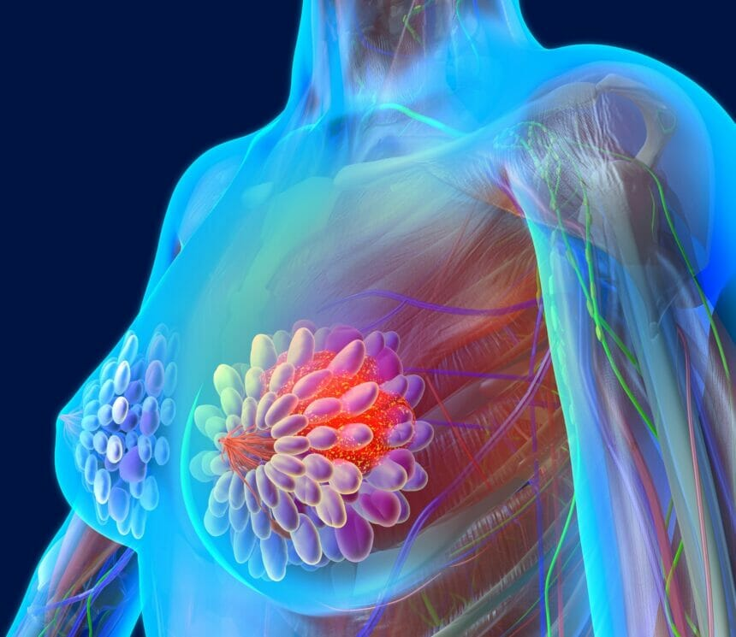
(CDC, 2022). (Lawrence, L, 2022).

Breast cancer is one of the commonest types of cancer among adult women. About 2.3 million were diagnosed with breast cancer in 2020 (Breast Cancer, 2021). The source reports that about 685,000 women died globally in the same year. The number of infections in 2020 placed this cancerous infection at the top of the list regarding prevalence. This type of cancer is associated with more loss of disability-adjusted life years (DALYs) than any other type of cancer. Unlike other kinds cancer, breast cancer has been reported in every country worldwide. Its manifestation is often reported from puberty.

The prevalence increases as women get older since age is a key risk factor. The UK reports similarly high numbers of cancer cases. In 2021, 11,500 women died from breast cancer in the United Kingdom (Facts and Statistics, 2021). Breast cancer is the leading cause of death in the UK for women above 50. While the infection rate has increased, survival has also improved over the past four decades due to early screening and detection, faster diagnosis, and improved treatment methods.

2. Public Health Measures

Various public health measures have been proposed to address the high rate of breast cancer infections in the UK and worldwide. Public education and awareness campaigns are effective methods for reaching out to various communities (Solikhah, Promthet, and Hurst, 2019). The education covers crucial topics such as symptoms, prevention, and treatment options.

The knowledge is aimed at promoting healthier behaviors and attitudes on breast cancer. For example, teaching women different options for preventing breast cancer, such as keeping fit and undergoing regular screening, will significantly minimise breast cancer rates in the UK. In addition to this measure, it is necessary to set up more breast cancer screening programs nationwide. The facilities should offer adequate services for mammography, among other tests necessary to detect the ailment in its early stages. Early diagnosis is directly linked to the probability of successful treatment.

Testing and genetic counseling should be integrated into institutional education and empowerment curricula. All women above puberty must understand the link between genetics and one's probability of being diagnosed with breast cancer. It would allow at-risk women to make necessary lifestyle choices to prevent breast cancer infections (Mahdavi et al., 2019). For example, they may consider eliminating sugar to avoid obesity. They may also set up more frequent screening sessions than the rest of the population since they have a higher predisposition for developing cancerous cells. In addition, increasing access to quality healthcare will likely minimise the incidences of breast cancer diagnosis.

Quality healthcare is a key determinant of one’s likelihood of recovering from the ailment through remission. Some of the factors that determine the quality of healthcare include efficiency, access, and affordability. While the government facilitates most of these factors in public hospitals, private entities can play a key role in ensuring that medical outlets handling breast cancer diagnosis and treatment have the necessary support.

Research and development are a critical function that may be adopted as a strategic measure against cancerous infections. The government and non-governmental organisations should invest more funds, time, and effort into cancer research. It will likely lead to the discovery of new methods that facilitate early detection, accurate treatments, and cure for the ailment. While pharmacological interventions are crucial in addressing the high prevalence of breast cancer, spreading awareness of lifestyle modifications is necessary. Healthy behaviors, such as regular physical activity, a clean diet, and minimal alcohol and tobacco, will be key in reducing a woman’s risk of developing breast cancer.

The government should increase the number and quality of supportive services available to breast cancer patients and relatives. This will improve the patient’s experience with the quality of the treatment.

Environmental pollution is linked to cellular malfunction and the development of cancerous cells. The government can minimise incidences of breast cancer diagnosis by addressing environmental pollution. For example, outlawing products that contain toxins associated with breast cancer will play a huge role in minimising the development of the ailment. These efforts can be combined with advocacy and community engagement to tackle environmental degradation. Notably, the toxins linked to breast cancer are also associated with other cancer affecting the colon and lungs. Community engagement will remove toxins from the regulatory environment with the government's help.

3. Risk Factors of the Breast Cancer

Various risk factors are associated with the development of breast cancer cells in the general population. Gender is the most important predictor of one’s susceptibility to breast cancer. The disease is predominantly diagnosed among women (Burstein et al., 2021). However, there have been a few cases of men developing breast cancer and facing the same hardships as their female counterparts during and after treatment. Age is a major factor determining one’s overall risk of developing breast cancer cells. Generally, the risk increases as one gets older.

Family history is often associated with specific ailments. Breast cancer is considered a genetic disease since having a first-degree relative with the ailment increases one’s likelihood of a similar diagnosis later in life. In these cases, first-degree relatives include the mother, sister, or daughter. The genetic risk factor of breast cancer explains why individuals should undergo regular screening.

Aside from familiar genetics, other physiological changes may increase one’s risk of developing breast cancer. Genetic mutation in the BRCA2 and BRCA1 genes increases the risk of developing breast cancer cells (Venkitaraman, 2019). Personal history is also associated with higher incidences of breast cancer diagnosis. Women who have undergone treatment for this type of cancer have a higher risk of developing a similar infection in the other breast.

Breast cancer is also associated with a woman’s reproductive history. The commonest factors which increase one’s risk of developing breast cancer cells are starting menstruating at a young age and undergoing menopause at an older age. Women who manifest either of these characteristics should undergo more regular screening for breast cancer as they are at a higher risk breast cancer. In addition, hormone therapy is associated with a higher risk of breast cancer. Notably, hormone therapy is often undertaken to extend a woman’s fertility window.

Some lifestyle choices are associated with higher incidences of breast cancer. Regular alcohol consumption increases one’s risk of developing the disease due to the inflammatory nature of the ingredients added to drink (Rumgay, Murphy, Ferrari, and Soerjomataram, 2021). Obesity also increases a woman’s likelihood of developing breast cancer, given that the increased deposition of adipose fatty tissues often impacts the breast tissues. Physical inactivity or a sedentary life increases a woman’s likelihood of developing breast cancer cells due to her slower metabolism.

4. Short-Term Public Health Consequences

There are various short-term public health consequences of breast cancer in social care settings such as rehabilitation centers. Cancer patients may require rehabilitation services as they receive or recover from treatment. Rehabilitation settings allow patients to gain strength following a major procedure, such as surgery. While public awareness of breast cancer is critical in minimising the incidences of late diagnosis, several short-term repercussions must be addressed.

An increase in the demand for breast screening services may strain the available public resources. Similarly, reports of a high rate of breast cancer diagnosis may increase the demand for the available treatment services such as radiation therapy, surgery, and chemotherapy. Challenges may arise once the demand exceeds the available capacity, especially in public hospitals and medical clinics. Another short-term impact of breast cancer in a rehabilitation center is the increased demand for supportive care services. These include nutrition services, counseling, and social work.

A high rate of breast cancer in a rehabilitation setting will likely increase the cost of treatment and the associated supportive care services. Notably, cancer treatment can be incredibly expensive for families without insurance (Resnicow, Patel, Mcleod, Katz, and Jagsi, 2019). Families may have to part with life savings to offset some of the costs of caring for a patient constrained to a rehabilitation center. In addition to the increased demand for treatment and care, breast cancer incidences may disrupt the routine operations of a rehabilitation center in the short term. This may cause delays in providing other services, especially if the available human, technical, and financial resources are limited.

Patients and families may suffer emotional distress following an increase in the number of reported breast cancer cases in a care setting. Cancer is emotionally distressing since the ailment has no cure and is associated with hardships and death. The psychological impact of the disease may increase the demand for support services in the short term. In addition, patients with advanced cases of infection may require additional palliative care services to manage their symptoms. These services may include pain management, comfort, and end-of-life care.

5. Long-Term Public Health Consequences

A social care setting such as a rehabilitation center will exhibit slightly different outcomes following an increase in breast cancer diagnoses. For example, the management may observe more breast cancer survivors under supportive care and ongoing medication. While this may cause a major strain on the available resources, the long-term nature provides adequate time to determine alternative sources of additional resources. Another long-term health consequence linked to breast cancer in rehabilitation is the development of secondary infections (Mosele et al., 2020). These may include ovarian cancer and the recurrence of breast cancer following remission.

Long-term cancer treatment often entails lots of bed rest. This may pave the way for side effects associated with the nature of the treatment, such as cognitive impairment, cardiovascular diseases, and lymphedema. Patients with severe cases of breast cancer are likely to manifest more side effects due to the limitations associated with the treatment. Notably, patients need treatment for the primary and secondary ailments associated with their admission or residence in a rehabilitation center. This increases the overall cost associated with surviving breast cancer.

Patients and their families may deal with reduced productivity in the case of long-term breast cancer treatment and survival. This often leads to economic challenges that may set the family back several years or decades (Resnicow et al., 2019). Families that had achieved financial independence may easily end up lining up at the food banks to collect government assistance. Long-term breast cancer incidence may easily impact a patient’s family members. For example, a relative considered the breadwinner may be less productive if they have to support a patient in the rehabilitation center. They may easily be distracted, missing out on opportunities leading to career growth, such as promotions. These factors can lead to career stagnation, dismissal from work, and other negative consequences.
While most long-term impacts of breast cancer treatment and survival entail increased hardships for patients, there are a few positive outcomes. It may increase the demand for genetic counselling, encouraging women to embrace preventive care and early screening. Relatives and friends of long-term care patients may seek more information and screening services. In addition, long-term treatment increases advocacy and public awareness, allowing more public members to talk about prevention, detection, and available treatment options. It also facilitates long-term breast cancer research, which is only possible with actual subjects undergoing treatment for years and decades.

6. Conclusion

Breast cancer is a leading cause of morbidity and mortality among women worldwide. Like other forms of cancerous infections, breast cancer has no known origin. However, various risk factors increase once the likelihood of breast cancer. They include gender, age, genetic history, obesity, hormone replacement therapy, alcohol consumption, and inactivity. Some measures that increase one’s likelihood of recovery from the ailment include early diagnosis, quality of care, and access to the necessary support services.

Breast cancer can be effectively treated when discovered in its earliest stages. However, this requires regular screening since it lacks any prominent symptoms until its later stages. The implication is that individuals with a higher risk of developing cancerous cells should be under regular screening. They should also make permanent lifestyle modifications, including eating healthy diets, losing weight, and minimising alcohol consumption.

It is necessary to consider breast cancer's short- and long-term impacts in social care settings such as rehabilitation centers. Most short-term impacts include a demand for more services, treatment options, resources, and information on breast cancer diagnosis and treatment. On the other hand, the long-term impacts of breast cancer in rehabilitation settings include heavier spending on treatment, increased awareness and screening, and more time to undertake complex research into the nature of breast cancer. Overall, breast cancer is associated with multiple challenges which require education, prevention, early detection, high-quality treatment, and supportive services. Raising awareness about breast cancer will play a major positive role in addressing the challenges associated with the disease.

7. Reference List

Breast cancer (2021). Available at: https://www.who.int/news-room/fact-sheets/detail/breast-cancer (Accessed: 3 May 2023).

Burstein, H.J., Curigliano, G., Thürlimann, B., Weber, W.P., Poortmans, P., Regan, M.M., Senn, H.J., Winer, E.P., Gnant, M., Aebi, S. and André, F., 2021. Customizing local and systemic therapies for women with early breast cancer: the St. Gallen International Consensus Guidelines for treatment of early breast cancer 2021. Annals of Oncology, 32(10), pp.1216-1235.

Facts and Statistics 2021. (2021). Available at: https://breastcancernow.org/about-us/media/facts-statistics#:~:text=Every%20year%20around%2011%2C500%20women,under%2050%20in%20the%20UK

Mahdavi, M., Nassiri, M., Kooshyar, M.M., Vakili‐Azghandi, M., Avan, A., Sandry, R., Pillai, S., Lam, A.K.Y. and Gopalan, V., 2019. Hereditary breast cancer; Genetic penetrance and current status with BRCA. Journal of cellular physiology, 234(5), pp.5741-5750.

Mosele, F., Remon, J., Mateo, J., Westphalen, C.B., Barlesi, F., Lolkema, M.P., Normanno, N., Scarpa, A., Robson, M., Meric-Bernstam, F. and Wagle, N., 2020. Recommendations for the use of next-generation sequencing (NGS) for patients with metastatic cancers: a report from the ESMO Precision Medicine Working Group. Annals of Oncology, 31(11), pp.1491-1505.

Resnicow, K., Patel, M.R., Mcleod, M.C., Katz, S.J. and Jagsi, R., 2019. Physician attitudes about cost consciousness for breast cancer treatment: differences by cancer sub-specialty. Breast cancer research and treatment, 173, pp.31-36.
Rumgay, H., Murphy, N., Ferrari, P. and Soerjomataram, I., 2021. Alcohol and cancer: epidemiology and biological mechanisms. Nutrients, 13(9), p.3173.

Solikhah, S., Promthet, S. and Hurst, C., 2019. Awareness level about breast cancer risk factors, barriers, attitude and breast cancer screening among Indonesian women. Asian Pacific journal of cancer prevention: APJCP, 20(3), p.877.

Venkitaraman, A.R., 2019. How do mutations affecting the breast cancer genes BRCA1 and BRCA2 cause cancer susceptibility? DNA repair, 81, p.102668.

CDC (2022) Breast Cancer. Available at: https://www.cdc.gov/cancer/breast/basic_info/what-isbreastcancer.htm#:~:text=Breast%20cancer%20is%20a%20disease,different%20parts%20of%20the%20breast (Accessed: 26 April 2023).

