

LOCATION: Swansea | LLEOLIAD: abertawe
LEVEL 5 | LEFEL 5
EXAMINATION PERIOD | CYFNOD ARHOLIADAU
January 2016 | IONAWR 2016

MODULE CODE: M5X01046
LOCAL AREA NETWORKS
TIME: 2 HOURS



Faculty of Architecture, Computing and Engineering/ Cyfadran Pensaernïaeth, Cyfrifiadura a Pheirianneg
School of Applied Computing/Ysgol Cyfrifiadureg Gymhwysol

Local Area Networks
HN/BSc (Hons) Computer Networks (M5X01046)

Practical Lab Assessment
Year 2/Level 5
January 2016

Name :

Student ID :

Date & Time :

This is an individual practical lab-test, held under examination conditions. You will be assigned three Switches and a Router; you should configure these devices based on the given specifications. Router ISP is preconfigured.

This paper is marked out of 100.

You will have 2 hours to complete this task.

TOPOLOGY DIAGRAM

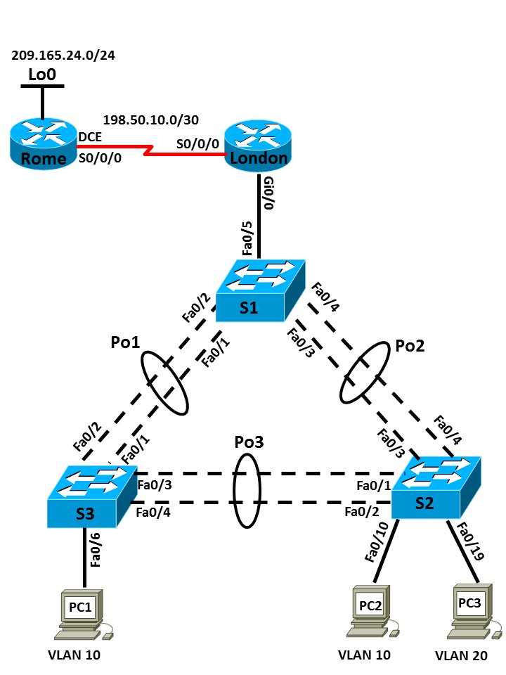

VLAN 10 – Students: 192.168.10.0/24 VLAN 20 – Staff: 192.168.20.0/24
VLAN 99 – Management: 192.168.99.0/24

Addressing Table (10 marks)
Device | Interface | IP Address | Subnet Mask | Default Gateway
Rome | S0/0/0 | 198.50.10.1 | 255.255.255.252 | N/A
Rome | Lo0 | 209.165.24.1 | 255.255.255.0 | N/A
London | S0/0/0 |  |  | N/A
London | Ge0/0 |  |  | N/A
London | Ge0/0.10 |  |  | N/A
London | Ge0/0.20 |  |  | N/A
London | Ge0/0.99 |  |  | N/A
S1 | VLAN99
S2 | VLAN99
S3 | VLAN99
PC1 | NIC
PC2 | NIC
PC3 | NIC

Port Assignments

S1
Ports | Assignment | Network
Fa0/1 – 0/5 | 802.1q Trunks (Native VLAN 99) | 192.168.99.0

S2
Ports | Assignment | Network
Fa0/1 – 0/4 | 802.1q Trunks (Native VLAN 99) | 192.168.99.0
Fa0/5 – 0/15 | VLAN 10 (Students) | 192.168.10.0
Fa0/16 – 0/24 | VLAN 20 (Staff) | 192.168.20.0

S3
Ports | Assignment | Network
Fa0/1 – 0/4 | 802.1q Trunks (Native VLAN 99) | 192.168.99.0
Fa0/5 – 0/15 | VLAN 10 (Students) | 192.168.10.0
Fa0/16 – 0/24 | VLAN 20 (Staff) | 192.168.20.0
Task 1: Prepare the Network (5 marks)
Step 1: Cable a network that is similar to the one in the topology diagram.
Step 2: Clear any existing configurations on the devices.
Before proceeding, have your cabling verified by the examiner. Instructor Sign-off: ______________
Task 2: Perform Basic Device Configurations (10 marks)
Configure the S1, S2, and S3 switches and R1 router according to the following guidelines:
- Configure the hostname.
- Disable DNS lookup.
- Configure an EXEC mode password.
- Configure a message-of-the-day banner.
- Configure a password for console connections.
- Configure synchronous logging.
- Configure a password for vty connections.
- Enable service password encryption.
Task 3: Router and Switch configuration instructions (60 marks)
- Configure S1 as a VTP server, and S2 & S3 as VTP clients in the soac.com domain. Set the VTP password to ‘cisco’.
- Configure EtherChannel between the switches as per the topology diagram.
- Create VLANs 10, 20 & 99, and name as required. Populate the VLANs with the appropriate port as per the diagram.
- Assign ports to appropriate VLANs as shown in the Port Assignments table.
- Configure RSTP PVST+ on all switches.
- Configure DS1 to be the primary root for all VLANs and AS2 to be secondary.
- Configure PortFast and BPDU Guard on the interface connected to PC1, PC2, and PC3.
- Configure S1 as a DHCP server to provide IP addresses and default gateways to users on VLAN 10 & 20. Verify all PCs receive IP address details.
- Configure management IP addresses for all network switches in VLAN 99, and configure them for Telnet access.

- Configure SSH access on S1. Configure port security on S2 and S3.
- Configure router-on-a-stick inter-VLAN routing.
- Configure subinterfaces on R1 to operate on VLAN 10, 20, and 99 with the address from the Address table.
- Configure static routing on R1 and ISP.
- Configure dynamic NAT on R1.
Task 4: After configuring each host computer, record the host network settings with the ipconfig /all command. (15 marks)

Host PC1 Network Configuration
Description
Physical Address
IP Address
Subnet Mask
Default Gateway

Host PC2 Network Configuration
Description
Physical Address
IP Address
Subnet Mask
Default Gateway

Host PC3 Network Configuration
Description
Physical Address
IP Address
Subnet Mask
Default Gateway

Task 5: Document the Configurations
All documentation for your solution should be submitted. Your name should be clearly printed on the documents.
At the end of the test a pen drive will be given to you, the configuration files for all routers should be copied to the media and handed in to your instructor. It is you responsibility that you copy the files correctly.
On each device, issue the following commands and capture the configurations. Save the file as devicename_surname_Pno.txt.
show run
sh ip int brief
sh ip route
sh nat statistics
sh vlan
sh int trunk
sh spanning-tree
sh etherchannel summary
sh vtp status

