

Student name: Roman Pacek
Student ID: 2415805
Module name: Protecting and Supporting Families in Health and Care
Module code: BMHP5021
Lecturer name: Umma Suleiman
Assessment (REPORT): An examination and analysis of how the ‘Early Help’ system is signposted to UK families by their local authority website.

Table of Contents
Table of Contents 2
1. Introduction 3
2. The Early Help System 4
2.1 Multiagency Working 5
2.2 Review Method 6
2.3 Evaluation of Norfolk County Council 6
2.4 Evaluation of Leeds City Council 7
2.5 Evaluation of Tower Hamlets Council 8
2.6 Comparative Analysis 9
3. Conclusion 9
4. Recommendations 10
References 11

Introduction

Early Help is a fundamental component of safeguarding children and promoting positive outcomes for families in England. It seeks to identify emerging concerns and coordinate support before difficulties escalate to the point at which statutory intervention may be required. Families may need help in relation to financial hardship, domestic abuse, parental mental ill-health, substance misuse, school attendance, housing or a combination of these circumstances. Current statutory guidance places help, support and protection within a shared, child-centred safeguarding system (Department for Education, 2026).
The importance of timely help has been reinforced by major reviews of children’s services. Allen (2011) argued for earlier intervention to improve children’s life chances, while the Munro Review emphasised a child-centred system capable of responding to children’s circumstances rather than relying on procedural compliance alone (Munro, 2011). Under sections 10 and 11 of the Children Act 2004, relevant agencies have duties concerning cooperation and arrangements to safeguard and promote children’s welfare. These responsibilities are developed through Working Together to Safeguard Children, which sets expectations for local authorities, safeguarding partners and relevant agencies (Children Act 2004; Department for Education, 2026).
Council websites can be an important route through which parents, carers and practitioners discover what assistance is available. An effective webpage should explain Early Help in family-facing language, identify who can receive support, provide a visible contact or request route, describe what happens next and distinguish Early Help from urgent child-protection reporting. It should also enable users to move between family services without unnecessary complexity.
This report evaluates how Norfolk County Council, Leeds City Council and Tower Hamlets Council signpost Early Help online. The report first outlines the Early Help system and the role of multi-agency working. It then reviews each authority’s webpages using common criteria: findability, clarity, actionability, inclusivity and transparency. A comparative analysis identifies strengths and limitations before recommendations are made.

The Early Help System
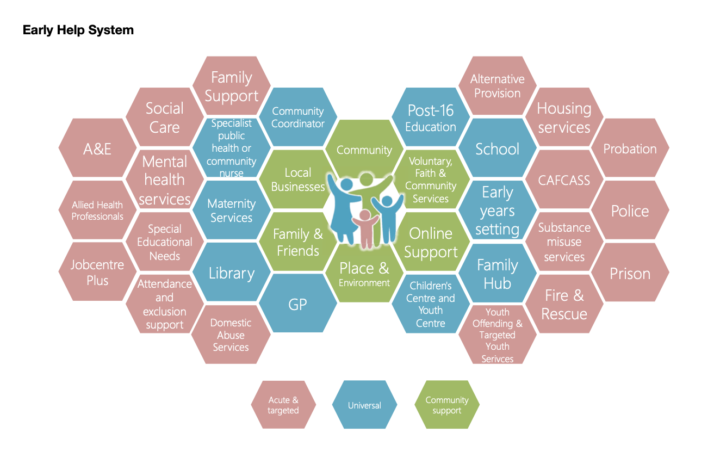
(Department for Education, 2022)

Early Help is a preventative and collaborative approach within the wider safeguarding system. It is intended to respond when a child or family would benefit from additional assistance, including circumstances in which needs may not require a statutory children’s social care response. The 2022 Supporting Families: Early Help System Guide describes a mature system as a network of services, processes and interactions designed to help children, young people and families at the earliest opportunity (Department for Levelling Up, Housing and Communities and Department for Education, 2022).
A common mechanism is an Early Help Assessment and Plan. This is generally undertaken with the family and records needs, strengths, views, goals and agreed support. Norfolk, for example, explains that an assessment is completed alongside a family and is used to build on strengths and create shared goals (Norfolk County Council, n.d.-c). Tower Hamlets similarly states that its assessment is intended to identify children at risk of poor outcomes, reduce duplicated assessment and improve collaboration between agencies (Tower Hamlets Council, n.d.-c).
Early Help is usually voluntary and depends upon meaningful engagement with children and their parents or carers. It should not, however, delay a referral to statutory children’s social care when there is reason to believe that a child may be suffering, or is likely to suffer, significant harm. Clear online signposting therefore needs to direct users both to preventative support and to urgent safeguarding routes.
Evidence supporting early intervention is broader than any single local delivery model. Allen (2011) concluded that effective early intervention can improve children’s development and future outcomes and argued for greater use of evidence-based programmes. The quality of local implementation remains important: a service cannot provide timely support if families and practitioners cannot understand how to reach it.

2.1 Multiagency Working
Multi-agency working is central to Early Help because children’s needs rarely fit within one organisation’s responsibilities. Education, health, social care, housing, police and voluntary-sector practitioners may each hold different information and offer different forms of assistance. Working Together to Safeguard Children establishes a framework for the local authority, integrated care board and police to work together as statutory safeguarding partners and with other relevant agencies (Department for Education, 2026).
In practice, teachers, designated safeguarding leads, health visitors, school nurses, general practitioners, family support practitioners, housing officers and other professionals may contribute to assessment and planning. Effective coordination can provide a fuller account of the child’s circumstances and reduce fragmented intervention. It must also be lawful, proportionate and transparent, particularly in relation to information sharing and family consent.
Multi-agency practice can be weakened by organisational boundaries, competing priorities and an excessive focus on process. Munro (2011) warned that over-bureaucratisation can divert attention away from children lived experiences and professional judgement. Local websites cannot resolve these structural difficulties, but they can make the pathway more transparent by explaining who may be involved, why information may be shared and what families should expect.

2.2 Review Method
The review was conducted on 8 August 2026 and examined the principal public-facing and professional Early Help pages located through each council’s website and web search. It was a structured qualitative review rather than a technical accessibility audit or user-testing study. Each authority was considered against five criteria:
• Findability: whether the main Early Help page and request route could be located readily.
• Clarity: whether the purpose, intended users and terminology were explained in family-facing language.
• Actionability: whether contact details, request routes and next steps were visible.
• Inclusivity: whether the pages acknowledged different ages, needs and communication requirements and signposted accessible support.
• Transparency: whether assessment, consent, professional involvement and urgent safeguarding routes were explained.
Judgements about page length, navigation and prominence are observations from this review. They are not presented as findings from representative usability testing. Page content may change after the review date.

2.3 Evaluation of Norfolk County Council
Norfolk’s principal family-facing page gives a concise definition: Early Help involves information, advice and guidance offered when family difficulties begin, with the aim of preventing worries from becoming larger problems (Norfolk County Council, n.d.-a). This is clear and non-stigmatising. The page directly reassures families that support is available if they are experiencing difficulties or are worried about their children.
The council also maintains a distinct professional information area containing the continuum of needs, Early Help process guidance and links for requesting support (Norfolk County Council, n.d.-b). Its assessment guidance describes work undertaken alongside the family to record needs, strengths, views and goals (Norfolk County Council, n.d.-c). Taken together, these materials provide substantial procedural detail and support consistent professional practice.
The separation of family and professional material is useful, but it also disperses information. During the review, the fullest account of assessment and process required movement between the main family page, professional pages and safeguarding-partnership material. A parent seeking a simple answer to “how do I ask for help?” could benefit from a persistent request button, a short description of what happens after contact and a clearer distinction between self-request and professional referral.
Overall, Norfolk performs strongly on clarity and professional detail. Its main limitation is not a lack of content but the distribution of that content across different locations. A single family-facing pathway, supplemented by optional professional detail, would improve actionability.

2.4 Evaluation of Leeds City Council
Leeds presents its Early Help approach through a concise “one minute guide”. It describes four elements, beginning with “right conversations, right people, right time”, and explains that families should be asked what support they need and may be helped by a practitioner they already know (Leeds City Council, n.d.-a). This framing is accessible and places collaboration with families at the centre of the process.
Leeds also explains its Family Hubs and Early Help Front Door. The hubs are described as multidisciplinary, with practitioners from Early Help, social work, domestic abuse, substance use, mental health, SEND and policing. Where Early Help is appropriate, information may be shared with the Front Door team for advice, workforce support or signposting to an appropriate service (Leeds City Council, n.d.-b). This gives readers a clearer view of how agencies connect.
The principal strength is the combination of plain language and a visible service structure. Information about Family Hubs, children’s centres and wider family support enables users to move from a general explanation towards practical local assistance. The material also communicates that support may be coordinated rather than supplied by one isolated service.
There are nevertheless areas for improvement. The one minute guide is written partly for practitioners, and families may still need to move between pages to identify the most appropriate point of contact. A prominent family-specific “ask for help” route, a concise explanation of consent and information sharing, and consistently visible emergency safeguarding information would strengthen the pathway. Translated summaries and Easy Read material should also be made easy to locate rather than relying only on general council accessibility functions.
On the criteria used in this review, Leeds achieves the strongest overall balance of clarity, actionability and transparency. This is an evaluative conclusion based on the pages reviewed, not the result of user testing.

2.5 Evaluation of Tower Hamlets Council
Tower Hamlets provides a substantial collection of Early Help pages. Its introductory page states that support is available to families living in the borough from pregnancy to age 19, or up to 25 for young people with special educational needs and/or disabilities (Tower Hamlets Council, n.d.-a). This clearly communicates an inclusive age range and corrects the possible misconception that Early Help is only for very young children.
The MAST Early Help page identifies common reasons for seeking support, including family breakdown, housing, emotional wellbeing, financial difficulties, parenting, behaviour and drug or alcohol problems. It also states that obtaining help early can prevent problems from becoming harder to manage (Tower Hamlets Council, n.d.-b). A separate assessment page explains that the Early Help Assessment aims to identify risk of poor outcomes, reduce duplicated assessment and improve involvement between agencies (Tower Hamlets Council, n.d.-c).
These pages provide considerable breadth and show how Early Help connects with Children and Family Centres, Family Hubs and partner services. The explicit inclusion of SEND and the broad range of presenting needs are important strengths. Tower Hamlets also provides direct explanations of what support may address, making the service more recognisable to families who may not know the term “Early Help”.
The principal weakness is fragmentation. During the review, definitions, eligibility, examples, assessment information and service access were located on separate pages within a relatively deep Children and Families structure. Bringing these elements together in a task-oriented landing page would reduce navigation. Clear translation links, Easy Read material and a single persistent contact route would also help the council demonstrate inclusion through the design of the pathway as well as through the range of services described.
Overall, Tower Hamlets is comprehensive and inclusive in scope, but its public pathway could be more direct.

2.6 Comparative Analysis
All three authorities explain the preventative purpose of Early Help and connect it to broader family services. None lacks substantive information. The differences concern how that information is organised and how quickly a family can move from understanding the concept to taking action.
Norfolk is particularly strong in professional guidance and in its strengths-based description of assessment, but information is divided between family and practitioner locations. Tower Hamlets provides the broadest explicit account of ages and presenting needs, yet its content is distributed across several pages. Leeds uses the clearest short-form explanation and gives a relatively transparent account of its multidisciplinary hubs and Front Door arrangements.
Leeds therefore ranks highest under the review criteria, principally because its language and service structure are easier to interpret. That conclusion should be treated with appropriate caution. The review did not involve parents, carers, people using assistive technologies or speakers of community languages, and it did not measure completion rates for actual requests. A robust council evaluation would combine content review with accessibility testing and user research.
The comparison also shows why completeness alone is an insufficient measure of online signposting. A large collection of accurate documents may serve practitioners well while requiring families to interpret professional terminology or navigate between services. Effective digital signposting requires both authoritative content and a visible route to action.

3. Conclusion

Early Help is an important part of England’s safeguarding and family-support system. Its purpose is to coordinate timely assistance and address emerging needs before circumstances become more serious. Successful delivery depends on multi-agency practice, but families must also be able to recognise the offer and understand how to obtain support.
The three councils reviewed provide credible and broadly comprehensive information. Leeds offers the strongest overall balance of plain language, service explanation and signposting. Norfolk provides clear family-facing reassurance and extensive professional material but would benefit from a more unified public pathway. Tower Hamlets communicates an inclusive age range and wide spectrum of needs but spreads key information across several webpages.
The findings demonstrate that a council can meet informational requirements while still improving the user journey. The strongest Early Help landing page would answer five questions immediately: What is Early Help? Is it for my family? How do I ask for it? What will happen next? What should I do if a child is in immediate danger?

4. Recommendations

Local authorities should:
• Create one task-oriented Early Help landing page for families, with professional guidance clearly separated but directly linked.
• Keep a prominent “Ask for help” or contact route visible on every Early Help page.
• Explain eligibility, consent, assessment, information sharing and likely next steps in plain English.
• Display urgent safeguarding and emergency routes clearly without confusing them with voluntary Early Help.
• Provide readily discoverable Easy Read, translated, large-print and accessible formats, and test pages with assistive technologies.
• Use short process diagrams, captioned videos or frequently asked questions only where they clarify the route to support.
• Test the complete journey with parents, carers, young people and practitioners, including users with limited English or digital access.
• Review links, contact details and forms regularly and publish a visible review date.
These changes would make online information easier to understand and act upon while supporting earlier engagement with family services.

References

Allen, G. (2011) Early intervention: the next steps. London: HM Government. Available at: https://www.gov.uk/government/publications/early-intervention-the-next-steps--2 (Accessed: 8 August 2026).
Children Act 2004, c. 31. Available at: https://www.legislation.gov.uk/ukpga/2004/31/contents
(Accessed: 8 August 2026).
Department for Education (2026) Working together to safeguard children 2026: a guide to multi-agency working to help, protect and promote the welfare of children. Available at: https://www.gov.uk/government/publications/working-together-to-safeguard-children--2 (Accessed: 8 August 2026).
Department for Education (2022) Early Help System Guide A toolkit to assist local strategic partnerships responsible for their Early Help System . Available at:
https://assets.publishing.service.gov.uk/media/628de13be90e071f5f7e1bd2/Early_Help_System_Guide.pdf

Department for Levelling Up, Housing and Communities and Department for Education (2022) Supporting Families: Early Help System Guide. Available at: https://www.gov.uk/government/publications/supporting-families-early-help-system-guide (Accessed: 8 August 2026).
Leeds City Council (n.d.-a) One minute guide: Early Help. Available at: https://www.leeds.gov.uk/one-minute-guides/early-help (Accessed: 8 August 2026).
Leeds City Council (n.d.-b) Family Hubs and the Early Help Front Door team. Available at: https://www.leeds.gov.uk/one-minute-guides/family-hubs-and-early-help-front-door-team (Accessed: 8 August 2026).
Munro, E. (2011) The Munro review of child protection: final report – a child-centred system. London: Department for Education. Available at: https://www.gov.uk/government/publications/munro-review-of-child-protection-final-report-a-child-centred-system (Accessed: 8 August 2026).
Norfolk County Council (n.d.-a) Early Help for children and families. Available at: https://www.norfolk.gov.uk/article/40407/Early-help-for-children-and-families (Accessed: 8 August 2026).
Norfolk County Council (n.d.-b) Information for Early Help professionals. Available at: https://www.norfolk.gov.uk/article/41092/Information-for-early-help-professionals (Accessed: 8 August 2026).
Norfolk County Council (n.d.-c) Early Help Assessment and Plan. Available at: https://www.schools.norfolk.gov.uk/article/67982/Early-Help-Assessment-and-Plan (Accessed: 8 August 2026).
Tower Hamlets Council (n.d.-a) About Early Help. Available at: https://www.towerhamlets.gov.uk/lgnl/health__social_care/children_and_family_care/Early_Help/About_Early_Help.aspx (Accessed: 8 August 2026).
Tower Hamlets Council (n.d.-b) Early Help at the front door (MAST). Available at: https://www.towerhamlets.gov.uk/lgnl/health__social_care/children_and_family_care/Early_Help/Early_Help_Hub.aspx (Accessed: 8 August 2026).
Tower Hamlets Council (n.d.-c) Early Help Assessment (eEHA). Available at: https://www.towerhamlets.gov.uk/lgnl/health__social_care/children_and_family_care/Early_Help/Early_Help_Assessment_eEHA.aspx (Accessed: 8 August 2026).

