Research Design and Analysis
2 x 3 Between-Subjects ANOVA

In this workshop you will practice a procedure for using SPSS to analyse data from studies where more than one IV has been studied for their effect upon the DV. You will be using a 2 x 3 between-subjects ANOVA analysis to test for differences between two or more independent groups.
We will use the example of end of year three grades (DV). For this study, you are interested in looking at the following IV’s:
- Gender - between-subjects with two levels [male / female]
- Subject of study – between-subjects with three levels [psychology / art / education]
Step 1)
Input the variables into the ‘variable view’ as shown below, making sure to give your between-subjects variables appropriate values.

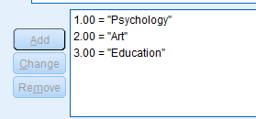
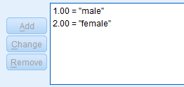

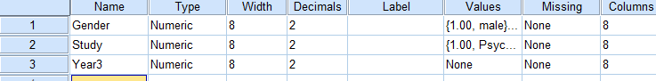

Step 2)
Click back to the ‘Data view’ tab and enter the data as shown below, which represents data from males and females (IV) studying three different subjects (IV). The end of third year grades (DV) is recorded as a continuous number.
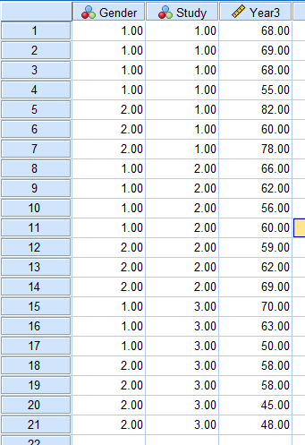

Remember: one row of data = one participant

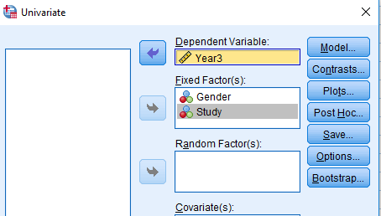
Step 3)
Now you can start to run the ANOVA analysis. On the ‘Analyze’ menu, selection the option for ‘General linear model’ and then the option for ‘Univariate’.
You will see the following dialogue box. Transfer the DV (year3) into the ‘Dependent Variable’ box, and transfer both IV’s (gender and subject) into the ‘Fixed Factors’ box.

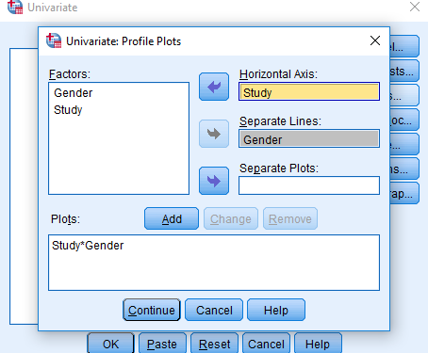

Step 4)
Click on the ‘Plots’ button. You will be presented with the ‘Univariate: Profile plots’ dialogue box. Transfer the IV Study from the Factors box into the ‘Horizontal axis’ box, and transfer the IV Gender to the ‘Separate lines’ box. Click ‘Add’, and then ‘Continue’.

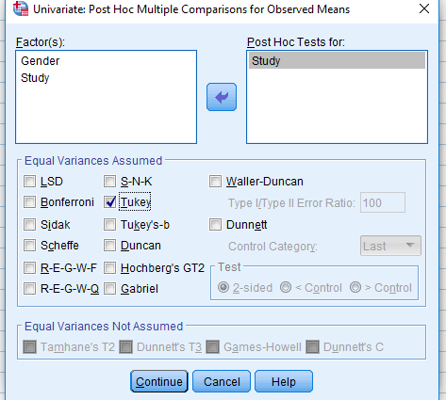
Step 5)
Click on the Post Hoc button and you will be shown the following box. Transfer your IV with more than two levels (Study) into the box on the right, and select Tukey at the bottom.

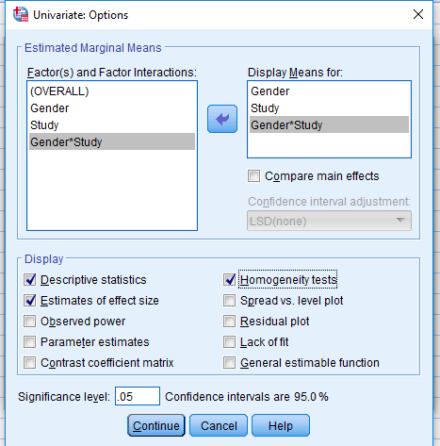
Step 6)
Next, click on the ‘Options’ button. This will present you with the ‘Univariate: Options’ dialogue box. Transfer ‘Gender’, ‘Study’ and ‘Gender*Study’ from the left box to the box labelled ‘Display Means for:’.
In the ‘Display’ section at the bottom of this box, make sure there is a tick for Descriptive statistics, Estimates of effect size, Homogeneity tests. Then click ‘Continue’.

SPSS Output – the important parts
Descriptive statistics:
In this table, the descriptives are shown for the different conditions of your study. This is useful for referring back to in order to understand where differences have been shown to be significant or non-significant. (N = number of scores in the grouping where shown).

Levene’s Test of Equality of Error Variances
This test provides a test of one of the assumptions underlying analysis of variance. The value you are most interested in is the Sig. level. You want this to be greater than .05 and therefore not significant. A significant result suggests that the variance of your DV across the groups is not equal.

Tests of between-subjects effects:
The first thing you need to do is check for the possibility of an interaction effect. In the SPSS output, look at the line labelled Gender*Subject. Check the Sig. column for whether the interaction is significant or not.
Secondly, you need to check the Main Effects of each IV. Find the column you are interested in (e.g., Gender). To determine whether there is a main effect for each IV, check in the column marked Sig. next to each variable.

When you have a statistically significant interaction, reporting the main effects can be misleading. Therefore, you will need to report the simple main effects. This would involve determining the mean difference in end of year grade between genders at each subject, as well as between subject for each gender. Unfortunately, SPSS does not allow you to do this using the graphical interface you will be familiar with (i.e., plots below), but requires you to use syntax.
If you do not have a statistically significant interaction, you might interpret the Tukey post hoc test results for the different levels of subject studied, which can be found in the Multiple Comparisons table.

Profile Plots
This graph will provide a good graphical illustration of your results. An interaction effect can usually be seen as a set of non-parallel lines. If the lines actually cross each other, you might expect a statistically significant interaction effect (which you can confirm using the statistics).

Write out the necessary output data (using the output tables you have now produced) in the correct format (as shown below). This should include an analysis of the interaction effects, the effect of the within variables, and the effects of the between variables. The format for reporting all of these is the same:
F(df, df) = F-value, p < 0.05 or p > 0.05

