

BA Leadership and Management
LEVEL 5

Module Title: Managing Projects in the Organisation
BMSW5009

Module Lead: l.zhang

Email:l.zhang@uwtsd.ac.uk

Submission Date: 09/07/2026
Table of Contents
1 Part Two: Report 3
1.1 Executive Summary 3
1.2 Introduction 3
1.3 Findings 4
1.3.1 Critical Discussion of Planning Tools: WBS and Gantt chart 4
1.3.2 Critical Discussion of Stakeholder Analysis Using the Power-Interest Grid 7
1.3.3 The Planning and Scheduling of Work Activities 9
1.3.4 Critical Evaluation of the Limitations and Practical Challenges of Tools 10
1.4 Conclusion 14
1.5 Recommendations 14
2 References 16

Part Two: Report

Executive Summary
The aim of the report is to critically review the project management tools employed to plan a project to convert a mobile kitchen. The project was designed to be a functional and modern mobile kitchen that will be sold and a horse trailer that will be offering ready to operate system as a food vendor for managing several summer music festival. In this report, four project management tools are analysed and evaluated on a mobile kitchen conversion project: the Work Breakdown Structure, Gantt Chart, Power-Interest Grid and the Iron Triangle of project management. The findings suggest that each tool has its merits, but also that there are overlaps in the ways in which it can be used and that some of the other tools have limitations that necessitate using other complementary approaches, especially in stakeholder management and physical uncertainties. The single greatest risk was the ability to communicate with high power suppliers. It ensures that the final product will be meeting the health and safety standards as considering the festival deadline. The report ends with recommendations for buffers and regular updates for stakeholders.

Introduction
This report aims to review the project management tools and techniques employed in the planning stage of a students' project. Project Management Institute (2021) defines a project as a temporary endeavour undertaken to produce a unique product, service or result. We took a horse trailer and converted it to a mobile kitchen. The project aimed to design and deliver one fully converted mobile kitchen trailer within a 12-week timeframe for operational use during a summer music festival.” The main products delivered were a running prototype, a CAD blueprint and a sales site with maintaining the health and safety certification for all the public usages. The aim of this project is to design, convert and deliver one fully operational mobile kitchen trailer within a fixed 12-week timeframe for use at a summer music festival while meeting health and safety requirements.
Project Objectives
• To source and purchase a suitable used horse trailer for conversion.
• To complete refurbishment work including insulation, flooring and structural repairs.
• To install electrical, plumbing and gas systems safely and effectively.
• To deliver a functional mobile kitchen prototype by the end of Week 12.
This report is broken down into the following three sections: a critical discussion of the planning tools, such as WBS and Gantt charts, a critical discussion of the social tools, such as Stakeholder Analysis, and a discussion and evaluation of the project lifecycle and recommendations for project life cycle improvement.

Findings

Critical Discussion of Planning Tools: WBS and Gantt chart
The Work Breakdown Structure (WBS) as a hierarchical decomposition of the total scope of work that will be performed by the project team. The WBS is a vital part of our project as it is a common student error to be too vague. We have broken down the project into four major deliverables. The Mobile Kitchen conversion WBS is displayed at the bottom. The below table shows the Mobile Kitchen conversion Work Breakdown Structure.
Widespread though traditional Gantt charts do have certain drawbacks. Dynamic Gantt charts are better adapted to project management in the face of uncertainty, as emphasized in the discussion on digital transformation in the world of project management. This rigidity is a big problem in a project like a trailer conversion, where unexpected problems like rust or structural damage can be uncovered during the make. Recognizing that the tool has certain limitations, we built in a 1-week buffer to offset this risk.
WBS and Gantt Chart
Tasks: ■ Procurement ■ Refurbishment ■ Installation ■ Finishing & Sales
WBS | Stage / Task | Wk 1–2 | Wk 3–4 | Wk 5–7 | Wk 8–9 | Wk 10–11 | Wk 12
1.1 | 1. Procurement Strategies and Evaluation
1.1.1 | Sourcing used trailer
1.1.2 | Purchasing of the materials
1.2 | 2. Refurbishment Process and Practices
1.2.1 | Insulation and flooring
1.2.2 | Structural repairing system
1.3 | 3. Installation Stages
1.3.1 | Electrical working measures
1.3.2 | Plumbing and gas fitting system
1.3.3 | Equipment fitting
1.4 | 4. Finishing and Sales Management
1.4.1 | Branding and vinyl wrap
1.4.2 | Photography and website listing system
1.4.3 | Health and Safety Inspections

WBS and Gantt Chart
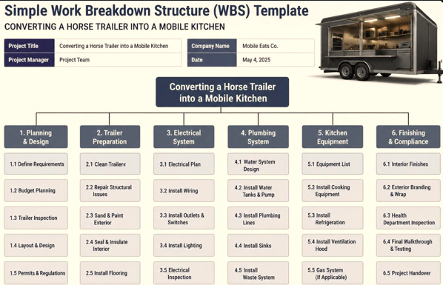
Task | Week 1-2 | Week 3-4 | Week 5-7 | Week 8-9 | Week 10-11 | Week 12
Source used trailer
Purchase materials
Insulation and flooring
Structural repairs
Electrical work
Plumbing and gas
Equipment fitting
Branding and wrap
Website and listing
Health and Safety Measures

Critical Discussion of Stakeholder Analysis Using the Power-Interest Grid
Project management is not just about project management; it is about managing people too. The Power-Interest Grid is a chart that shows how to classify stakeholders by their power (authority) and their interest in the project outcome. This analysis is guided by the framework of Teymouri and Nsakanda (2022). Gomes, Sousa and Tereso (2024) highlight that the management of stakeholders and communication management are key to project success. The project also aimed to support small food traders by providing a functional mobile kitchen prototype within a fixed project timeframe. The Power-Interest Grid was used for our mobile kitchen project is like:
Quadrant | Stakeholder | Strategy | Communication Method
High Power, High Interest | Project Sponsor System, festival organisers | Management in the Close Manners | Weekly email of the updates plus progress in the meetings
High Power, Low Interest | Material Suppliers and Services | Keeping the Satisfactory Level | Professional management of purchase orders with prompt payment system
Low Power, High Interest | Future Buyers Experiences (Small Cafes) | Keeping the Informed Decisions | Social media previews with effective website mock-ups
Low Power, Low Interest | General Public Reviews | Monitoring the Progress | Safety signs with reduction in the overall engagement
The most important takeaway from the quadrant of High Power and Low Interest came from this one. Türesov, Günaydin and Topcu Oraz (2024) found that determining stakeholders' priority and importance is the most significant critical success factor in project management. In the beginning, we viewed material suppliers as stakeholders to Keep Informed, and sent them long email messages to inform them about our academic module needs. This strategy didn't work. As we saw it had huge authority as far as time and expenses were concerned, we moved to short professional purchase orders and payment terms. Whenever the conflicts occur, there is a suitable stakeholder management strategies which can easily be applied on the project as stated by Ghamarimajd and Ghanbaripour (2024). It seems that some of the effective use of communication skills and stakeholder involvement are effective for the achievement of the success of a related project. This discovery was a direct basis for our modified communication plan.

The Planning and Scheduling of Work Activities
The Iron Triangle project management principle (Time, Cost, and Quality) will always remain a basic project management concept. The three factors are linked to each other, as if one changes the other two might change as well, according to the Project Management Institute (2021). For our project, our priorities were set as follows in Table 4:
From the 2011–2012 Iron Triangle meeting, the priorities were agreed upon as follows:
Constraint | Our Priority | Justification
Quality | Higher | Safety-critical management systems including gas and electrical working process
Cost | Moderate | Must remaining the affordable for small business buyers procedure
Time | Fixed | 12-week academic timeline which cannot be extended efficiently. It leads to the start of the festival.
Klaus-Rosińska and Iwko (2021) state that one of the components of sustainable project management is stakeholder management, which should be combined with the Iron Triangle concept. We learned that if we are going to be focused on quality, we have to make sure we're not trying to rush the installation phase and we directly ended up with our realistic 12-week Gantt chart. However, the new project purpose, 'Time' is one of the primary constraints. It shows that it must offer trade-offs for the complexity of the interior design or branding to ensure about meeting the hard deadline and providing minimum standards of quality and safety to manage effective health inspection. Al-Nakeeb et al. (2023) suggest the adoption of integrated project management information systems to improve the communication with the stakeholders and project quality. They suggest a way forward that we have adopted for documenting all planning tools systematically.
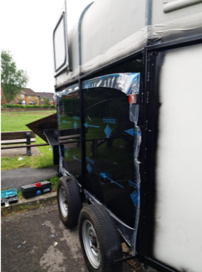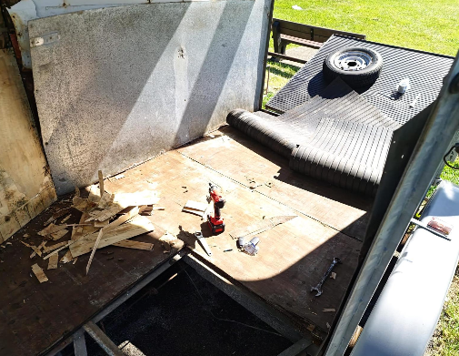

Critical Evaluation of the Limitations and Practical Challenges of Tools
Although the above tools for project management were clearly beneficial to the project, there are significant caveats that need to be considered. Al-Nakeeb et al. (2023) state that no one project management tool can achieve all the results for complex projects and practitioners should know the limitations for each technique. This proved correct when we were considering converting our mobile kitchen.
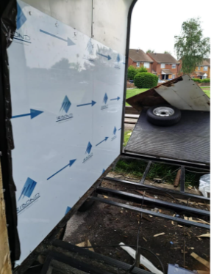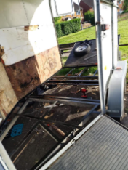
If there were rust, rot or dimensions that did not match, it would need to be added tasks which were not in the original WBS. This restriction implies that a WBS needs to be regarded as a document that evolves over time, not a static plan. Similarly, the Gantt Chart was misleading in terms of accuracy. In their study, Melecký and Staníčková (2021) discovered that project teams will tend to think that tasks will follow the planned timeline, and they will over-rely on the Gantt chart. Our experience was to the contrary. We mapped the plumbing and gas installation to two weeks, and we found that the time it takes suppliers to provide a qualified gas fitter to install the gas services varies significantly. When a task is represented as a solid block of time on a Gantt chart, it suggests certainty which is not found in the real world of a project.
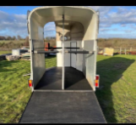
During analysis, we also discovered conceptual flaws in the Power-Interest Grid. Teymouri and Nsakanda (2022) accept that stakeholder power and interest is not a static attribute and varies over the course of the project. For instance, a supplier would have a low interest during normal operations, but a high interest if there would be a payment dispute. Likewise the Project Sponsor will be very powerful at all times but might decrease their involvement if the project is running well. Our static grid did not reflect these dynamics and as such, stakeholder analysis should be updated regularly. One of the practical issues seemed in satisfying multiple stakeholder expectations? Ghamarimajd and Ghanbaripour (2024) have described this as the stakeholder prioritization dilemma in which meeting the needs of one group of stakeholders means that another group is let down. This tension needed to be addressed in a transparent manner, through communicating the Iron Triangle trade-offs to the buyers, telling them that it would take longer or cost more, to have the premium features. In future projects that would give added flexibility over static Gantt charts that were created in Excel or PowerPoint.

Conclusion
To sum up, the analysis shows that the success of planning tools is their use as a dynamic document and that stakeholder analysis tools have to be reviewed periodically to be relevant. One of the lessons learned from this project is that power and interest in the stakeholders vary over time and should not be classified in one-off events. It seemed that the quality of the documentation was important for tool usefulness. To achieve project management digitalization and have it working regularly, one needs to enter data into it and update it regularly. The initial enthusiasm in our group generated detailed WBS entries, but keeping that level of detail throughout the project would take discipline. Planning tools will lose their value as a means of monitoring and control if they are not reviewed regularly. The discovery further emphasizes how vital it is to combine planning tools into frequent project reviews and team meetings.

Recommendations
Development of the Comprehensive Risk Register
Develop a risk register with specific risks of key suppliers and material availability, as well as physical risks such as rust, structural damage, dimensional mismatch that can hinder the progress of the project. This directly relates to our limitation in our WBS analysis that some structural damage was found, which was unexpected, and thus unplanned tasks were required. Haloul et al (2024) suggested that the project management information system (PMIS) should have risk management models. The project is made more resilient to the physical uncertainties that will be faced during conversion of the trailers by integrating the WBS with a risk register.
Implementation of the Rolling Wave Planning Actions
Do not start with a detailed Gantt at the beginning of the project, but have a detailed plan for the next 2 weeks and high level milestone plans for the rest of the weeks. This will enable a detailed plan of the immediate task, and flexibility regarding future work. This relates to the Gantt chart rigidity we mentioned in our analysis. A rolling wave approach would enable the schedule to be adjusted without affecting the overall 12-week plan, when it took longer to install plumbing and gas because of the availability of the suppliers. When relying on fixed timelines, one could feel like they have a certain certainty, whereas including uncertainty and adding flexibility to the plan is rolling wave planning, as described by Melecký and Staníčková (2021).
Adaptation of the Digital Stakeholder Management Tools
Adopt integrated project management information systems (IPMIS) like Trello, Asana, etc., to share project progress, schedule updates and deliverables status with all the parties in real time basis. Findings: This is a recommendation to overcome the Power Interest Grid limitation of assuming stakeholder power and stakeholder interest as fixed. Digital tools enable flexible stakeholder communication, which can adapt to the changing needs of stakeholders and the situation of the project. AIPMIS can be used to enhance the communication between stakeholders, as suggested by Al-Nakeeb et al. (2023).
The Use of Stakeholder Analysis Reviews
Regularly review the power, interest and approach of stakeholders, as appropriate, at project milestones (e.g., every 3 weeks) through formal stakeholder analysis. Findings: This directly addresses the Power-Interest Grid limitation to the stakeholder dynamics that changed throughout the project lifecycle. There's a possibility that a supplier's interest may rise in the payment process and the Project Sponsor's may wane at the state of the project running smoothly. Teymouri and Nsakanda (2022) recognize that power and interest of the stakeholders are not fixed attributes.
Documentation of the Planning Tools
Formalise all changes to WBS, Gantt chart, stakeholder analysis, and have a documented and agreed process for change, including reasons for the change and the approval process. This relates to the Finding that planning tools become less effective at monitoring without review. Initial WBS detail was not kept during project, which decreased effectiveness of tools, our experience showed.

References
Al-Nakeeb, A., El Khatib, M., Abu Zitar, R., Alhosani, A. and Alhosani, I. (2023) Project Manager's Role in Manage Project Knowledge Process: An Approach to Enhance Project Quality, International Journal of Computers and their Applications, 30(4), pp. 425-439.
Ghamarimajd, Z. and Ghanbaripour, A. (2024) Leveraging Stakeholder Management Strategies for Construction Project Success: A Systematic Literature Review, Paper presented at the 47th Australasian Universities Building Education Association (AUBEA) Conference, Melbourne, Australia, 24-27 November.
Gomes, A.R., Sousa, P.F. and Tereso, A. (2024) Stakeholder Management and Communication Management in Non-Governmental Organizations: a systematic literature review, Procedia Computer Science, pp. 1942-1949.
Haloul, M.I.K., Mohd Ariffin, M.K.A., Supeni, E.E., Ahmad, S.A.B., Bilema, M. and Ahmad, M. (2024) A Systematic Review of the Project Management Information Systems in Different Types of Construction Projects, UCJC Business and Society Review, 21(80).
Klaus-Rosińska, A. and Iwko, J. (2021) Stakeholder Management—One of the Clues of Sustainable Project Management—As an Underestimated Factor of Project Success in Small Construction Companies, Sustainability, 13(17), p. 9877.
Melecký, L. and Staníčková, M. (2021) Project Management Skills: Hard Versus Soft. Is It Enough? Technical Tools That Really Work, Proceedings of the 14th International Conference on Strategic Management and its Support by Information Systems, pp. 198-206.
Project Management Institute (2021) A Guide to the Project Management Body of Knowledge (PMBOK Guide). 7th edn. Newton Square, PA: Project Management Institute, Inc.
Teymouri, A. and Nsakanda, A.L. (2022) Managing Project: Stakeholder Analysis, and Communication Planning and Management. Ottawa: University of Ottawa.
Türesov, M., Günaydin, H.M. and Topcu Oraz, G. (2024) Critical Success Factors in Stakeholder Management, ITU A|Z, 21(1), pp. 65-82.
Yordanova, Z. (2025) Digitalization of Project Management—A Bibliometric Analysis, in Smart Innovation, Systems and Technologies: Marketing and Smart Technologies, Singapore: Springer Nature, pp. 57-68.

