CLSK6003 Exploring Sustainability in the Ancient World~
Group Discussion 7th October 2016
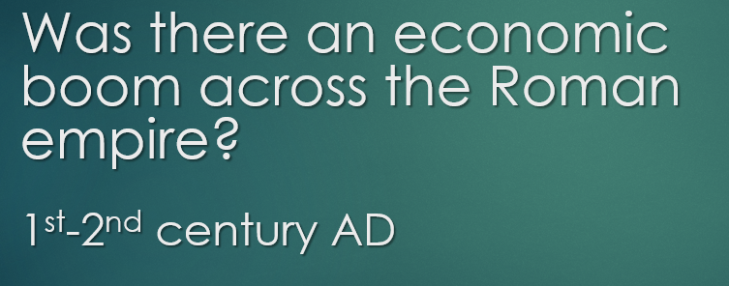

What are indicators for economic growth across the Empire? | How do you explain economic growth during the 1st-2nd century AD?
What is your ancient evidence? | Can you think of counter arguments for this period? Was there decline…?

Members of your group? ____________________________________________
_________________________________________________________________

