STUDENT NAME: RALUCA IOANA SERBAN
STUDENT ID: 2213917
MODULE CODE: LCBB5010
LECTURE NAME: PATRICK YEBOAH
COMPONEN 1
COMPANY SELECTED – AIRBNB

Table of Contents
Introduction 3
Cost Analysis and Business Model 4
Cost Structure: Fixed Costs and Variable costs 5
Budgeting and Financial Planning 7
Performance Measurement and Decision-Making 9
Sustainability and Ethical Considerations 10

Introduction
Airbnb, Inc., is an online marketplace for arranging or offering lodging, primarily homestays, or tourism experiences. Launched in 2008 in San Francisco, the company has grown to become one of the biggest players in the sharing economy, matching hosts offering short-term rentals with guests from across countless borders (Guttentag, 2015). In 2023, Airbnb has published millions of properties in over 190 countries for accommodation and experience services (Airbnb, 2023). Unlike other conventional hotel chains, Airbnb operates as a technology platform which relies mostly on service fees made to hosts and guest (Dolnicar, 2019).



For the likes of Airbnb, management accountancy is essential when it comes to decision-making. It is Responsible for providing financial and non-financial information that can be used to support the planning, control and evaluation of organizations' performances (Drury, 2018). It allows managers to price services, predict revenue, and determine the contribution to profit of various service types - helping you make strategic pricing and investment decisions. Amidst dynamic digital business environment, such activities are believed to be crucial in the coordination of competition and long-term development (Nuhu et al., 2016).

Cost Analysis and Business Model
Revenue Model Airbnb, a multi-sided marketplace that connects hosts people who have an extra room in their home or apartment with guests looking for short term accommodations (like the “sharing economy)” model. Its main source of income comes from service fees or commissions on bookings. There are fees imposed by Airbnb at both the Guest and Host side: hosts are generally charged around 3 % of the booking subtotal in a “split-fees” scheme while guests incur an extra service fee (which can be as high as approximately 14 % per booking, its amount varies depending on type of booking, location and duration).
In some cases, Airbnb uses the host-only fee system (especially professionals an hotels) where the hosts pay everything (including the whole service fee of 14-16 %), and makes it more simple for guests to see price + guests doesn't pay a guest service ,the website is not trampling in host fees for people who don’t know good hosting or they are new dwellings prices stays what got search rules laid back on without any other filters! May mots look effective but with Airbnb taking out without telling me about changes effecting my rating i would rather have my bottom-line line as predictable as possible then harass app fanners for extra. In addition to their core booking fees, Airbnb also generates supplemental revenue within experiences (local tour activity) and extra services (e.g. cancellation protection, premium listing promotion) (Business Model Analyst; QoreUps).
As Airbnb does not actually own most properties listed on its website, it is a relatively asset light business focusing primarily on facilitating transactions and developing user trust, marketing, and technology infrastructure (Strategized).

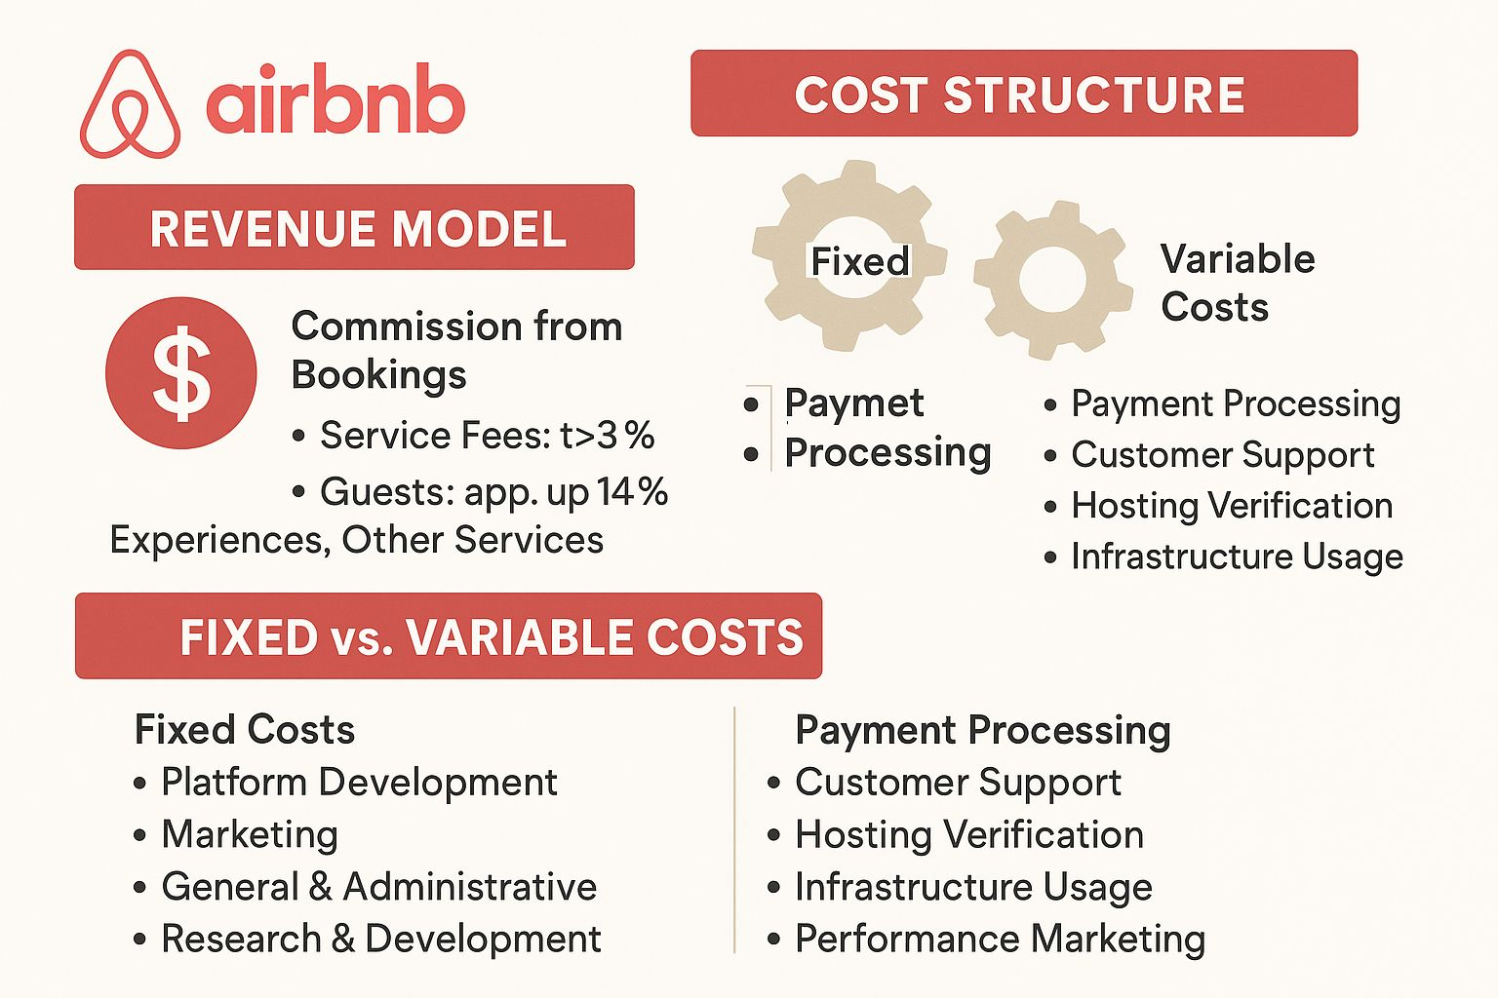

Airbnb Revenue: Commission Vs. Array Collection Wings Airbnb's revenue growth in the year 2023 is likely to be led by an increase in gross booking value (GBV), which will more than offset any pressure on its take rate Treis Team A DCF Valuation of Halliburton Company Going through a company's financials and operating metrics could tell you whether it is a sound.

Cost Structure: Fixed Costs and Variable costs

While Airbnb is an asset-light business, it has fixed and variable costs.
Fixed Costs. These are costs that do not scale (or nearly do so) based on the number of bookings or transactions, at least in relative short term.
Key fixed costs include:
Platform development and maintenance: software development, server infrastructure, cybersecurity, data storage.
Marketing and brand: fixed banner campaigns, global cost per click advertising displays, partnerships.
General & administrative (G&A): corporate staffing salaries (exec, legal, finance), office operations, insurance coverage, leases.
R&D: continued investment in platform features, AI and search algorithms. It's this undifferentiated heavy lifting that keeps the service running and ahead of its competition. Because Airbnb’s fixed costs are large but do not vary with transaction volume, the company can take advantage of operating leverage: as booking quantity grows, the average fixed cost per booking decreases. Variable Costs. These change approximately in relation to the volume of booked stays or platform activity.

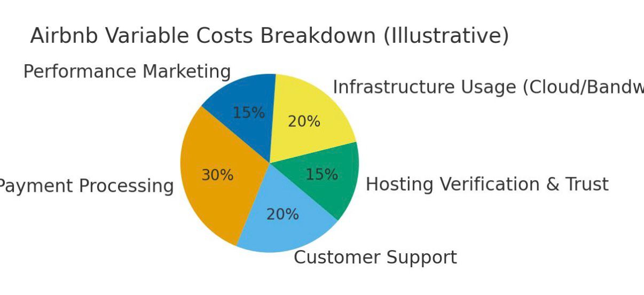

Key variable costs include:
Payment processing and transaction fees (credit card fees, foreign exchange fees).
Customer support costs related to specific transactions (such as returns, disputes).
Host and listing verification, trust & safety resolution (such as claims and damage).
Indirect costs with the scalability of infrastructure usage (e.g. bandwidth, cloud services) as more users access the platform.
The variable cost portion is more sensitive to volume, and as they scale more effectively their margins should improve with business growth. Finally, the cost structure is a function of fixed investment (in platform, marketing and corporate overhead) and variable costs as a percentage of transaction volume. The company benefits from a business model that is highly scalable, offering potential for margin expansion as bookings roll in.
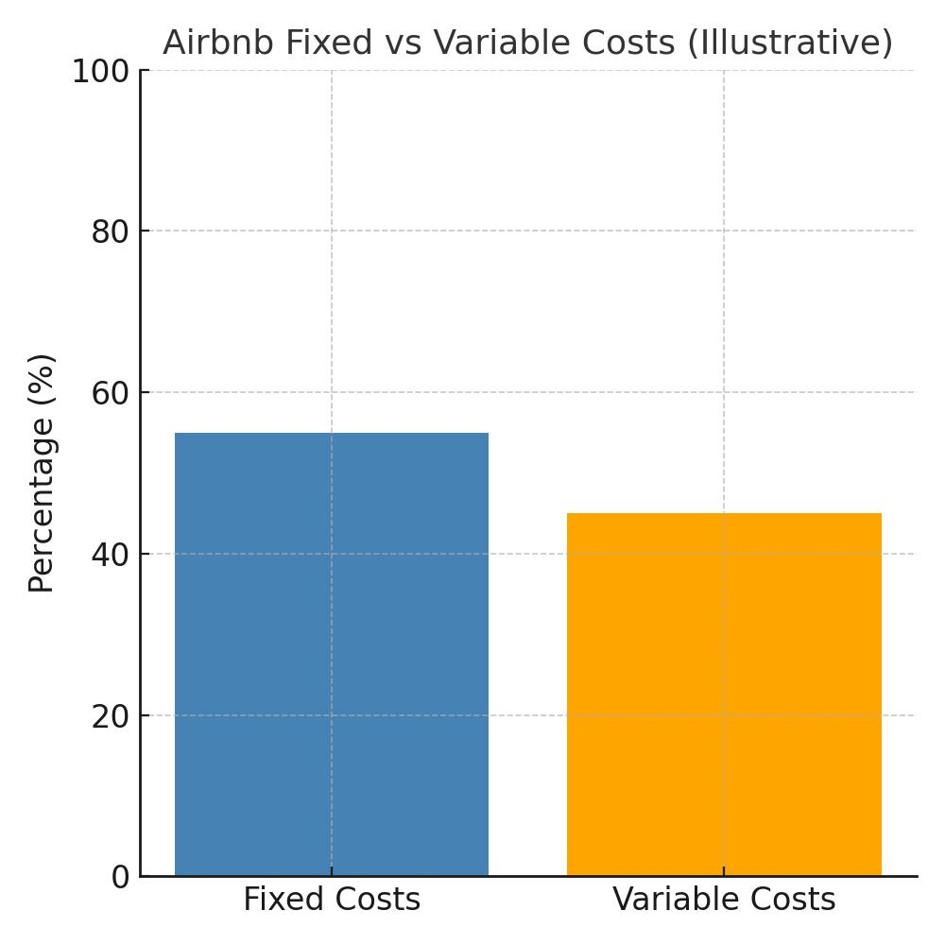

Budgeting and Financial Planning

Budgeting is a critical element of Airbnb’s financial management as it enables the organisation to plan, coordinate, and control its operations. Through formal budgets, management can set expenditure limits, allocate resources across functions such as marketing, technology, and customer support, and monitor performance via variance analysis (Drury, 2018). Budgets also serve as a decision-making tool, allowing managers to test scenarios, anticipate demand fluctuations, and adjust resource allocation to maximise profitability. Given Airbnb’s position in a dynamic hospitality and technology market, regular revisions and rolling forecasts are essential to maintain strategic flexibility (Libby et al., 2019).

Recent financial reports indicate that Airbnb’s operating expenses have remained relatively stable year on year. In 2023, operating expenses were approximately £5.29 billion, compared with £5.27 billion in 2024, showing only a marginal decline (Macrotrends, 2024). In the quarter ending June 2025, operating expenses were reported at around £1.96 billion (Trading Economics, 2025). This relative stability demonstrates disciplined cost management despite growth in revenues and expansion of services.

The evolution of expenses reflects both internal managerial choices and external macroeconomic pressures. Internally, Airbnb has pursued a strategy of cost discipline, with tighter control of administrative overheads and greater efficiency in marketing spend. The company has shifted focus toward more brand-driven campaigns rather than heavy reliance on performance advertising, aiming for sustainable customer acquisition (Reuters, 2024). Furthermore, technological investments, such as automation in customer support and platform optimisation, have helped to reduce the variable cost burden per booking.

Externally, macroeconomic conditions also affect expense levels. Inflationary pressures increase costs for services such as cloud computing, outsourced support, and compliance, while currency fluctuations affect international cost bases. Regulatory changes in major cities, requiring enhanced compliance or reporting, also add to overheads. These external pressures mean that Airbnb’s budgeting process must remain flexible and responsive, integrating both financial and non-financial indicators to inform future planning (Nuhu et al., 2016).
Budgeting supports Airbnb in aligning resources with strategic objectives, providing a framework for cost control and performance evaluation. The relatively stable year-on-year operating expenses illustrate a balance between internal efficiency measures and external macroeconomic influences. Through continuous financial planning, Airbnb ensures resilience and competitiveness in the global hospitality marketplace.
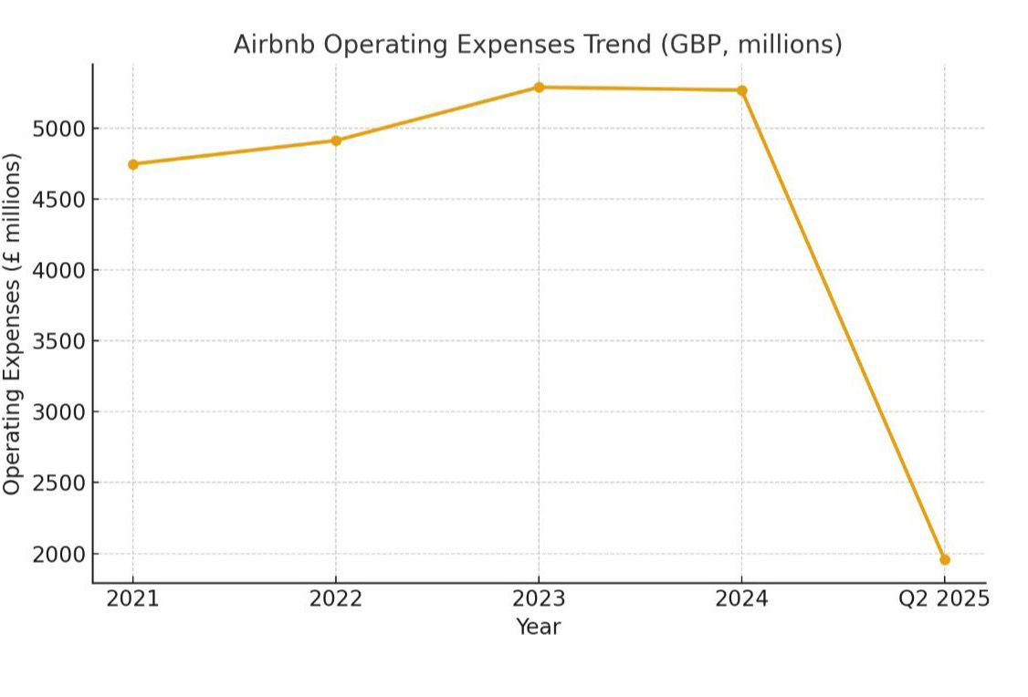

Performance Measurement and Decision-Making
Measurement is deeply important at Airbnb as it seeks to match strategy with results. The company discloses a variety of financial and non-financial Key Performance Indicators (KPIs) to consider scale, efficiency and long-term sustainability. There are 5 specific KPIs that stand out most. Firstly, Gross Booking Value (GBV), representing the total value of transactions on a platform, indicating overall market penetration and demand (Airbnb, 2024a). Second, Airbnb Nights and Experiences Booked captures the usage intensity and span of consumer engagement with both lodging and activity services (Airbnb, 2024a). Third, by measuring operating profitability, Adjusted EBITDA and EBITDA margin account for Airbnb’s cost management and efficiency as well as economy of scale effects (Airbnb, 2024b). Juventus also used the tool of Free Cash Flow (FCF) to emphasize liquidity and financial freedom, to fund growth and return value to shareholders (Yahoo Finance, 2025). The number of active listings is also a relevant non-financial KPI as it reflects the strength of the platform’s supply side and supports its network effects (SEC, 2025).
Various strategic decisions are guided by these KPIs. For example, ever-increasing growth in active listings and nightly bookings has driven Airbnb’s international expansion to venture into new countries such as Latin America and Asia-Pacific thus diversifying the geography of its platform (Rental scaleup, 2024). Equally, GBV and FCF have influenced the company’s policies in the realm of capital allocation: Airbnb began buying back shares in 2025 with a buyback program of over $800 million, evidence of management’s faith in its ability to generate cash and commitment to generating shareholder value (Airbnb, 2025). Internal cost discipline has also been impacted by adjusted EBITDA margins. In attempt to combat inflationary pressures, management has chosen to stress marketing efficiency which includes minimizing performance-based advertising and relying more on brand-based campaigns which had an effect of reducing customer acquisition costs (Reuters, 2024).
Non-financial KPIs also play significant role in strategic decision making. For instance, growth data for hosts has enabled Airbnb to implement onboarding and host protection instruments that are designed at maintaining the pace of supply growth (SEC, 2025). In addition, understanding of consumer behaviour gained in the “Experiences” category stimulated diversification beyond accommodation and thus a wider revenue base, increasing customer retention (Dolnicar, 2019).
Airbnb performance measurement system combines some financial indicators such as EBITDA and FCF together with non-financial indicators including active listings. Pull these together and Airbnb can facilitate strategic initiatives such as expansion into new markets, pricing, marketing investment and capital allocation. This perspective underscores how financial and non-financial information jointly influence the strategic direction of contemporary platform-oriented businesses.
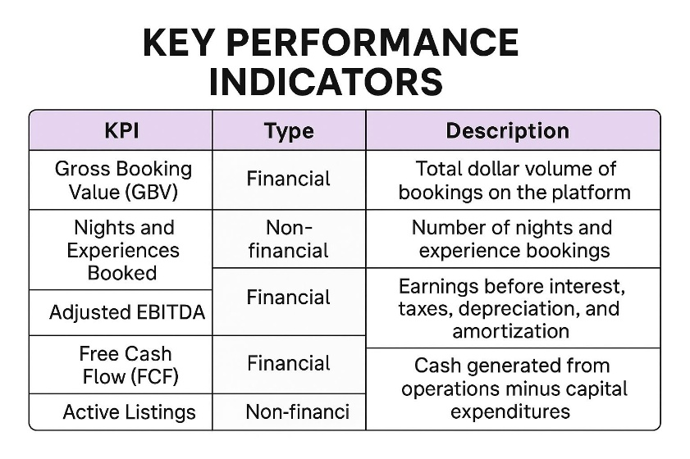

Sustainability and Ethical Considerations

Sustainability has become a central component of Airbnb’s financial and strategic decision-making. Unlike traditional hospitality businesses that often invest heavily in physical assets, Airbnb’s platform model is inherently less resource-intensive, as it leverages existing housing infrastructure rather than constructing new properties (Guttentag, 2015). This contributes to a lower direct environmental footprint. However, Airbnb has also adopted explicit sustainability initiatives that influence its financial planning. For example, the company has committed to achieving net zero carbon emissions for corporate operations by 2030, requiring budget allocations for renewable energy procurement, sustainable office operations, and carbon accounting systems (Airbnb, 2023). Furthermore, investment in product features such as energy-efficient home certification and sustainability filters for travellers reflects how financial decisions integrate long-term environmental considerations while enhancing brand reputation (Airbnb, 2023).

Ethical considerations also shape Airbnb’s cost management and pricing strategies. One ethical challenge concern ensuring affordability and fairness while maintaining profitability. Airbnb has faced criticism for contributing to rising rents and gentrification in popular cities, raising questions about the broader social costs of its pricing model (Dolnicar, 2019). From a management accounting perspective, balancing host income, company service fees, and guest affordability is an ethical dilemma. Airbnb has responded by increasing pricing transparency, displaying breakdowns of service fees, cleaning charges, and taxes upfront to enhance customer trust (Reuters, 2023).

In terms of cost management, the ethical dimension arises from labour practices and regulatory compliance. While the company avoids the large staffing costs of hotels, it relies on outsourced customer service and gig-economy hosts. Ensuring fair treatment of these stakeholders, including timely payments and clear contractual conditions, is crucial for ethical financial management (Niemietz, 2022). Likewise, complying with local regulations and tax obligations, even where enforcement varies, reflects Airbnb’s commitment to ethical business conduct.

Airbnb integrates sustainability into financial decision-making through carbon reduction initiatives and environmentally focused investments, while ethical considerations in cost and pricing strategies emphasise transparency, fairness, and compliance. This dual focus helps Airbnb sustain legitimacy, reduce reputational risk, and align with evolving stakeholder expectations.
Conclusion and Recommendations
In conclusion, has been discussed the business model, budgeting, performance measurement and sustainability aspects of Airbnb in terms of the management accounting perspective. The results indicate that revenue is driven through service fees, and the asset-light nature of the platform shows up to result in the presence of a cost structure with fixed technology & marketing investments along with variable transaction costs. The former informs resource allocation and variance analysis, the later. Financial and non-financial KPIs such as gross booking value, nights booked, free cash flow are the foundation for strategic decisions. There is a growing recognition that sustainability and ESG issues are factored into good financial planning, especially as it relates to carbon commitments and pricing visibility.
Three suggestions are presented from a management accounting perspective. First, Airbnb is going to have to improve its scenario-based budgeting approach to become more resistant against macroeconomic wild rides (Drury, 2018). Second, non-financial KPIs (such as carbon footprint per booking) should be extended to integrate financial planning into CSR-related objectives (Nuhu et al., 2016). 3] Third, using an activity-based costing system for customer support and compliance costs would possibly enhance transparency of cost and facilitate equitable pricing practices.

REFERNCES:
- Airbnb (2023) About us.
- Dolnicar, S. (2019) ‘A review of research into paid online peer-to-peer accommodation’, Annals of Tourism Research, 75, pp. 248–264.
- Drury, C. (2018) Management and Cost Accounting. 10th edn. Andover: Cengage Learning.
- Guttentag, D. (2015) ‘Airbnb: disruptive innovation and the rise of an informal tourism accommodation sector’, Current Issues in Tourism, 18(12), pp. 1192–1217.
- Nuhu, N.A., Baird, K. and Appuhami, R. (2016) ‘The adoption and success of contemporary management accounting practices in the public sector’, Asian Review of Accounting, 24(4), pp. 451–472.
- Airbnb (2024a) Q4 2024 Shareholder Letter.
- Airbnb (2024b) Form 10-K Annual Report.
- Airbnb (2025) Q1 2025 Financial Results
- Dolnicar, S. (2019) ‘A review of research into paid online peer-to-peer accommodation’, Annals of Tourism Research, 75, pp. 248–264.
- Rental scaleup (2024) Airbnb strategy for 2024 and beyond.
- Reuters (2024) Airbnb launches new global marketing strategy.
- SEC (2025) Airbnb Inc. Form 10-K (2024 results filed 2025).
- Yahoo Finance (2025) Airbnb Inc. Key Financial Metrics.

