

Master of Business Administration

Human Capital Management
LCMB7023

Assessment component 1: Individual report – HR strategy

ALIGNING PEOPLE AND PERFORMANCE: RE-ENGINEERING PERFORMANCE MANAGEMENT AND JOB DESIGN AT AETHER INNOVATIONS

Lecturer Names: Dr. Lakshani Mendis

Student Name: Nareshbhai Parmar
Student ID: 2518462

Word Count: 2686

Submission Date: 20/03/2026

Executive summary

The current report evaluates the current performance management practice and job design within the technology firms, including Aether Innovations. It particularly suggests a comprehensive HR policy to boost the engagement, innovation and organisational performance at Aether Innovations. Knowledge management systems are observed to enhance employee performance because the employees would have increased access to information and expertise. With a well-established role and performance goals tied to performance, employees are in a better position to realise the difference in their contribution to organisational goals. Finally, it is evaluated that AI technologies may assist organisations such as Aether Innovations to make workforce management choices in a faster and more accurate way.
Table of Contents
1. Introduction 6
PART 1 – HR Strategy Proposal 6
2. Current Performance Management and Job Design Practices in Tech Companies 6
2.1 Performance Management in Technology Firms 6
2.2 Job Design Trends in Technology Organisations 7
2.3 Challenges for Aether Innovations 8
3. Proposed Modern Performance Appraisal System 9
3.1 Objectives and Key Results (OKRs) 9
3.2 360-Degree Feedback 9
3.3 Continuous Performance Conversations 10
4. Job Analysis and Job Design for Key Leadership Roles 10
5. Integration of Performance Management and Job Design 11
PART 2 – Reflective Learning 12
6. Reflective Learning Using Gibbs Reflective Cycle 12
6.1 Description 12
6.2 Feelings 13
6.3 Evaluation 13
6.4 Analysis 14
6.5 Conclusion 14
6.6 Action Plan 14
7. Staying Relevant in the Age of AI 15
7.1 AI Impact on HR and Management 15
7.2 Using AI as an Augmentation Tool 15
7.3 Human Skills That Remain Critical 15
8. Conclusion 15
References 16

List of Figures

Figure 1: Data-Driven HR 6
Figure 2: 360-Degree Feedback Model 8
Figure 3: Job Characteristics Model (Core HR Theory) 9
Figure 4: Integrated HR Strategy Model (Linking Performance + Job Design) 10

1. Introduction
Aether Innovations is a technology company with 300 employees that is facing high turnover, poor growth, and low customer satisfaction. Human capital management is vital to the success of organisations operating in the knowledge-intensive industries. Unless employee roles, motivation and performance systems are aligned with organisational objectives, productivity and innovation may be drastically reduced. It is therefore necessary to have strategic human capital to enhance organisational performance. To improve employee engagement and innovation, current HR practices focus on continual feedback, informed use of data, and sound job design.

PART 1 – HR Strategy Proposal

2. Current Performance Management and Job Design Practices in Tech Companies

2.1 Performance Management in Technology Firms
Digital transformation and the rising use of data-driven decision-making have transformed the nature of performance management practices in technology organisations in a number of ways. Continuous performance management systems, which serve as regular feedback of performance and align the goals of employees to organisational strategy, are slowly replacing traditional annual appraisals. By 2030, the global market of employee performance management is estimated to increase to USD 18 billion. This will show the increasing the significance of sophisticated HR systems in organisations (Mordor Intelligence, 2025).
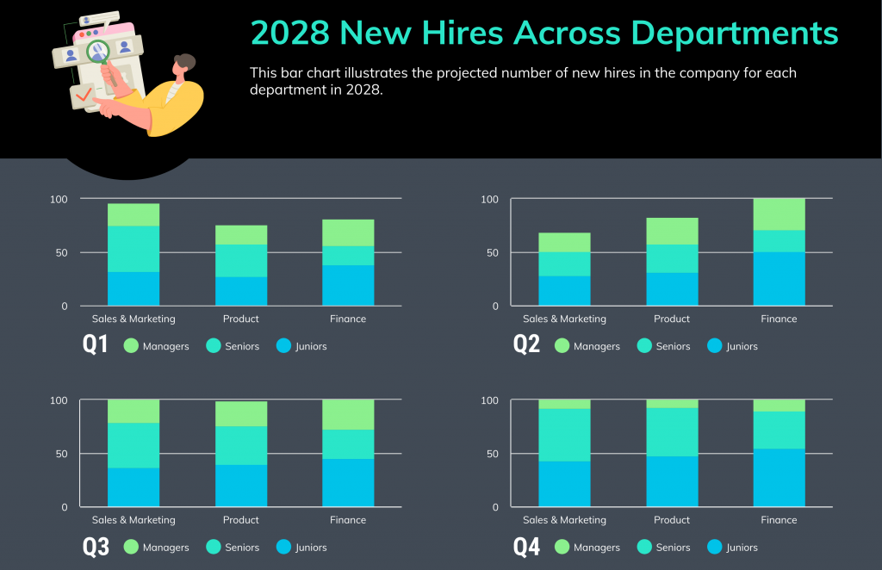

Figure 1: Data-Driven HR
(Source: Madhuri and Kumar, 2025)
OKRs are becoming popular, as they represent a way to set quantifiable performance targets and track team performance. Companies that have structured the performance management systems record an increase of approximately 30% higher productivity compared to those that use the traditional appraisal systems (Market Biz, 2025). 360-degree feedback has also become a critical evaluation tool, as it allows the evaluation of performance to be conducted involving various stakeholders. According to Leavitt et al., (2025), algorithmic performance management systems combine managerial judgement with digital analytics to enhance trust in the judgement. HR analytics also enhances decision-making, and organisations have reported a 25% accuracy in decision-making in the workforce with regard to performance monitoring that is grounded in data (Madhuri and Kumar, 2025).

2.2 Job Design Trends in Technology Organisations
The modern technology organisations have also developed in job design. Organisations increasingly organising work around cross-functional teams that give impetus to agility, flexibility and innovation. The strategic human resource management models underscore the need to create jobs that allow workers to exploit various skills as well as be involved in the innovation processes in organisations. According to Purwanto and Siagian (2025), proper strategic human resources practices enhance the competitiveness of organisations by matching the employee capacities with the dynamic technological environments. The main peculiarities of modern job design structures are autonomy and empowerment. The decision-making process when integrated in the operations of Aether Innovations will enable better delegation, thereby empowering employees to find innovative solutions to difficulties and to be involved in product development processes. Fangni (2025) further added that organisations that plan their roles in order to ensure optimal use of skills by employees are able to achieve much in terms of talent retention and performance.
The issue of digital transformation has also changed the nature of job roles in most organisations. Wang (2026) insists on the idea that jobs are often redesigned by enterprises that face digital transformation as a chance to combine technological skills, collaborative and innovative duties. The redefined roles help employees to play a bigger role in creating organisational knowledge and problem-solving. The modern job design is also supported by knowledge management systems. Knowledge management when combined with digital technologies leads to a better organisational learning experience (Mahmoud et al. 2025).

2.3 Challenges for Aether Innovations
Although there are high-level HR practices, most organisations are finding it difficult to adopt both integrated performance management and job design frameworks. Aether Innovations is currently struggling with several issues that decrease the organisational performance and employee engagement. Lack of clear performance measures that bring employees' activities to organisational strategy is one of the major problems. In the absence of clearly set objectives, employees might fail to develop an idea of what is expected and their input into individual organisational achievement. Role ambiguity also influences the productivity of employees since the lack of clarity in responsibilities lowers accountability and efficiency in decision-making. According to Kim et al., (2025), strategic human resource management needs to combine managerial leadership and digital technologies to establish clear performance systems to increase the level of trust and organisational performance of the employees. The other issue is the low level of innovation in the organisation. Employee creativity and teamwork are essential to technology companies, but the wrong roles and inflexible evaluation systems can lead to the discouragement of experimentation and the sharing of knowledge. Consequently, there is a likelihood of organisational performance declining and employee lack of engagement.

3. Proposed Modern Performance Appraisal System

3.1 Objectives and Key Results (OKRs)
The implementation of a performance management system based on the use of OKR might assist Aether Innovations in aligning the goals of the employees with the organisational strategic objectives. OKRs enable organisations to establish specific performance objectives and flexibility to enable employees to innovate and test new solutions. Strategic human resource management frameworks also state that the performance measures and organisational goals alignment enhance the productivity and strategic decision making (Purwanto and Siagian, 2025). Another way that the OKRs can help organisations to monitor is by the output of innovation, project completion and customer satisfaction levels, which are measurable.

3.2 360-Degree Feedback
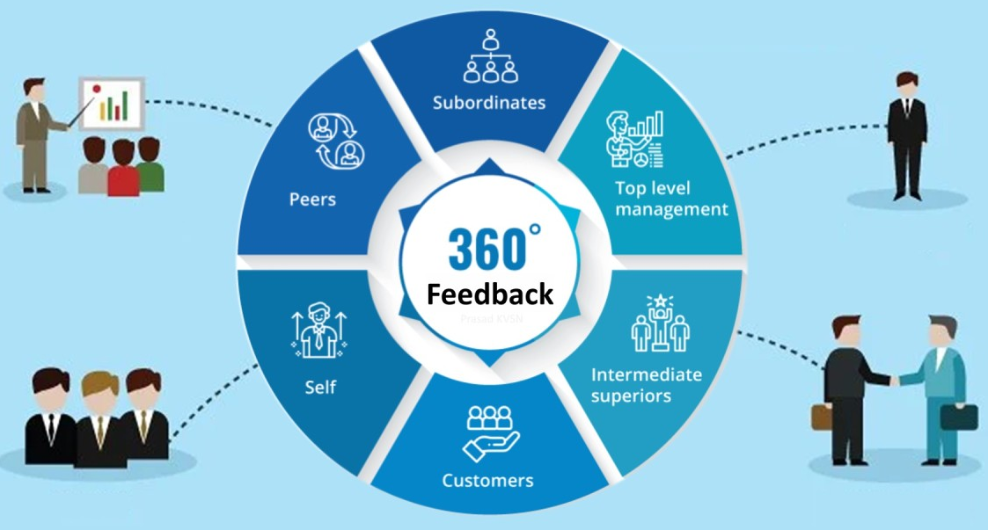

Figure 2: 360-Degree Feedback Model
(Source: Inspired by the ideas of Leavitt et al., 2025)
The application of the 360-degree feedback can be an important measure for Aether Innovations of enhancing leadership growth and teamwork in the organisation. The system enables the employees to get feedbacks through the supervisors, peers and subordinates, which gives a complete analysis of the performance. The study by Leavitt et al., (2025) suggests that integrating managerial judgement with algorithm-based performance evaluation can enhance the trust of the employees in the performance management systems and promote the transparency of the organisation. Another way that multi-source feedback systems help employees to build communication skills and collaborative behaviours is through multi-source feedback.

3.3 Continuous Performance Conversations
Another significant characteristic of contemporary performance management systems is the continuous performance conversations. Organisations are undertaking quarterly performance discussions as a form of employee development and improvement rather than using annual reviews, leaving behind scopes for Aether Innovations. HR analytics systems facilitate such discussions by providing managers with real-time workforce performance data. As Madhuri and Kumar (2025) noted, the data-based performance monitoring will allow managers to detect the skill gaps and apply the specific training programs more efficiently. Continuous feedback systems also enhance employee engagement, as there will be free communication between the managers and the employees.

4. Job Analysis and Job Design for Key Leadership Roles
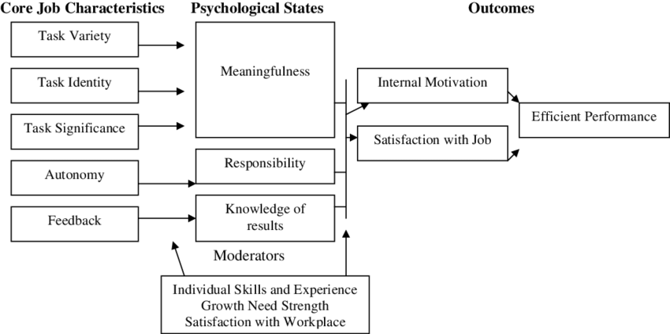

Figure 3: Job Characteristics Model (Core HR Theory)
(Source: Inspired by Rane et al., 2024)
Job design plays a role in the improved performance of leadership and organisational innovation. The five major dimensions of job that determine motivation and productivity as per Hackman and Oldham Job Characteristics Model are the following dimensions: skill variety, task identity, task significance, autonomy, and feedback. The employment of job design can enhance employee motivation and productivity by up to 35 percent when job design includes these features, implying the topicality of job design in modern organisations (Rane et al., 2024). Diversity of the skills required necessitates the dissimilar skills of leadership, i.e. strategic planning, digital skills and people skills. Task identity also offers accountability to the leaders since they are in-charge of a project to a certain end hence improving accountability and alignment.
Task significance focuses on organisational consequences of leadership decisions. Independent decision-making is supported by autonomy, and continuous improvement is supported by feedback. Real-time data insights can enhance the efficiency of HR analytics systems based on AI by approximately 20-25% in terms of efficiency in decision-making by leadership (Huang et al., 2023). In Aether Innovations, innovation and collaboration are encouraged by leadership positions. The CEO sets the strategic direction, the CFO oversees financial resources, the CTO oversees technology development; the CIO facilitates the innovation process, the HR Director oversees talent strategies and the Head of R&D leads product development. Organised leadership of innovation can increase innovation output by up to 30% (Rane et al., 2024).

5. Integration of Performance Management and Job Design
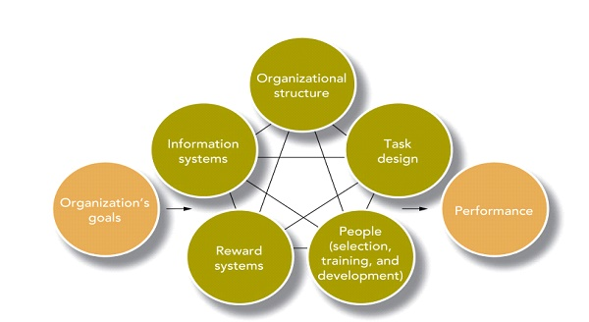

Figure 4: Integrated HR Strategy Model (Linking Performance + Job Design)
(Source: Taken from the ideas of Kim et al., 2025)
A high-performance organisational culture is impossible to develop without integrating performance management practices with job design practices. Job design structures that are innovation-centred are also known to make employees own their duties. The strategic HR systems point out that the process connecting job roles with organisational strategy enhances productivity and organisational competitiveness (Kim et al., 2025). Job performance systems and job roles can also be combined so that knowledge sharing and collaboration can be enhanced. As explained by Mahmoud et al. (2025), organisational learning and innovation capabilities can be enhanced by organisations that combine the implementation of knowledge management practices with performance evaluation systems. When performance management systems reward employees based on their contributions, they are more likely to share expertise. Finally, incorporating performance management systems and an effective job design helps organisations to ensure better accountability, a culture of collaboration and an innovative culture. This type of alignment enables organisations like Aether Innovations to enhance employee engagement, enhance productivity and sustain organisational growth.

PART 2 – Reflective Learning

6. Reflective Learning Using Gibbs Reflective Cycle
Reflective learning is an important process that assists the individuals in reflecting on what was happening to them and improving the level of professional competence. The Gibbs Reflective Cycle is not an exception and is a well-known structured reflective model because it encourages the systematic analysis of the experiences of the learners in six steps, description, feelings, evaluation, analysis, conclusion and action plan. The studies specify that the model by Gibbs promotes critical thinking, communication, and professional awareness, as it provokes the consideration of the learning process (Ahmadpour et al., 2025).

6.1 Description
Under the Human Capital Management module, I came across various concepts pertaining to strategic human resource management, job design strategies, and performance management systems that can be applied in the current situations of Aether Innovations. This assessment was based on the manner in which organisations such as Aether Innovations can ensure the alignment of workforce capabilities with strategic objectives in order to improve organisational performance. Other HR models and systems were also considered including Job Characteristics Model, performance appraisal systems and talent management strategies. It involved solving actual organisational problems and knowing how HR can be used to increase employee engagement and organisational performance. Reflective learning models, including Gibbs model, can be effective in assisting learners to connect theoretic knowledge with the actual experiences, as well as achieve better professional learning outcomes (Praveena et al., 2025).

6.2 Feelings
My initial perception of human capital management was the most limited at the beginning of the module, with the focus on the traditional HR practices, such as recruitment and training. However, I realised that the sphere of organisational performance of strategic HR management is much broader, which I examined based on the case study analysis of Aether Innovations. The content on the performance management systems, HR analytics, and job design strategies helped me to determine the effects of the HR choices on the organisational productivity and innovation. The other aspect that made me conscious about the importance of leadership and communication in the management of employees was by highlighting such aspects in reflective learning exercises. Aneeis Hashim et al. (2023) claimed that, individuals should analyze their emotions and experiences to achieve an increased professional consciousness and learning skills.

6.3 Evaluation
The other invaluable part of the module was the presence of a chance to study how HR strategies can solve actual problems within organisations. The module has provided me with an insight into how organisations can make use of performance management systems and leadership models in order to improve employee engagement and organisational performance. The other advantage of the reflective learning strategy is that I am able to critique management practices and critically translate theoretical concepts into practice. Research indicates that reflective learning models improve intellectual abilities of learners by stimulating analytical thinking and problem-solving by encouraging them to evaluate their experience positively and negatively (Mukhanova and seitimova, 2025). However, the part of the learning process that I considered to be problematic was the capacity to get adjusted to the analytical aspect of reflective writing. First, it was not possible to critically analyse personal learning experience which described it only. Over time, I was more adept at reflective thought and felt more confident in evaluating outcomes of learning.

6.4 Analysis
Reflective analysis helped me to understand the importance of matching HR strategies and organisational goals of Aether Innovations. Strategic HR practices such as performance management, leadership development and job design can contribute to employee motivation and organisational productivity greatly. Using the Gibbs Reflective Cycle, it became possible to structure my learning experience and consider additional issues of HR theories and their implementation. Wang (2025) indicates that structured reflective learning models have been known to enhance professional development through actionable learning. This consideration has shown me that technological advances in HR management today are taking a greater role. HR strategies of organisations need to be constantly adjusted to the business environment that is in constant movement.

6.5 Conclusion
Overall, the Human Capital Management module assisted me in better understanding strategic HR practices and impact on the organisational performance. The application of the Gibbs Reflective Cycle assisted me in becoming a more critical learner in the analysis of my learning experiences. Reflective learning allowed me to connect theoretical material with real problems in the field of HR and gave me an opportunity to create a useful assessment of the ways to manage issues.

6.6 Action Plan
To keep on developing my professional capabilities, I will invest in advancing my knowledge of strategic HR management, leadership development, and HR analytics. I will also engage myself in other reflective learning to improve my decision making and problem solving skills. Professional development and life-long learning will empower me to put the theories of HR to practice in a real organisational environment.

7. Staying Relevant in the Age of AI

7.1 AI Impact on HR and Management
Most processes within organisations, including the human resources management and the decision-making process by leaders, is being revolutionised by artificial intelligence. Using AI technologies to process workforce information, monitor employee performance, and assist with recruitment is a growing trend (Singh and Sinha, 2025).

7.2 Using AI as an Augmentation Tool
Whereas AI might be used to automate most of the routine HR tasks, it must not be viewed as a replacement of human managers, but as an assistive technology. The AI-based analytics can also be useful as they can provide managers with data insights to improve strategic planning, workforce, and performance management.

7.3 Human Skills That Remain Critical
It is a fact that AI technologies are gaining more and more popularity. Nonetheless, there are still many other human skills that cannot be overlooked in success as a leader and manager. Emotional intelligence, strategic thinking, creativity and ethical decision making are some of skills that artificial intelligence systems can hardly replicate. Managers ought to combine technological skills with human-oriented leadership skills to make them useful in the modern organisations.

8. Conclusion
To conclude, human capital management is essential in improving organisational performance and innovation at Aether Innovations. The report pointed out that the existing trends in performance management, including constant feedback, OKRs, and 360 feedback, can support the feeling of responsibility and strategic thinking in employees. It also demonstrated the importance of job design, which is determined by the Job Characteristics Model, in generating motivation to lead, collaboration, and decision-making. In case of well-organised leadership positions that are applied to performance management systems, a culture of innovation and engagement can be developed. The implementation of HR strategies would help Aether Innovations to boost the productivity of employees, the organisational coordination, and the sustainable increase of the organisational growth in a competitive technological environment.

References
Ahmadpour, N., Shariati, A. and Moghadam, M.P., (2025). Effect of narrative writing based on Gibbs’ reflective model on the empathy and communication skills of nursing students. BMC Medical Education, 25(1), p.10. https://link.springer.com/article/10.1186/s12909-024-06593-7
Aneeis Hashim, S.N., Yaacob, A., Suryani, I., Mohd Asraf, R., Bahador, Z. and Supian, N., (2023). Exploring the Use of Gibbs’ Reflective Model in enhancing in-Service ESL teachers’ reflective writing. Arab World English Journal (AWEJ) Volume, 14. https://papers.ssrn.com/sol3/papers.cfm?abstract_id=4497558
Buhalis, D., O’Connor, P. and Leung, R., (2023). Smart hospitality: from smart cities and smart tourism towards agile business ecosystems in networked destinations. International Journal of Contemporary Hospitality Management, 35(1), pp.369-393. https://www.emerald.com/ijchm/article/35/1/369/127025
Fangni, L., (2025). From Boardroom to Stadium: How International Sports Organizations Recruit Talent. International Journal of Scientific Research and Management (IJSRM), 13(01), pp.52-79. https://www.researchgate.net/profile/Fangni-Li-2/publication/387749802_From_Boardroom_to_Stadium_How_International_Sports_Organizations_Recruit_Talent/links/67c6c84ef5cb8f70d5c6acea/From-Boardroom-to-Stadium-How-International-Sports-Organizations-Recruit-Talent.pdf
FBI, (2025). Human Resource [HR] Technology Market Size, Growth 2032. Available at: https://www.fortunebusinessinsights.com/human-resource-hr-technology-market-105437 [Accessed: 5 March 2025]
Huang, X., Yang, F., Zheng, J., Feng, C. and Zhang, L., (2023). Personalized human resource management via HR analytics and artificial intelligence: Theory and implications. Asia Pacific Management Review, 28(4), pp.598-610. https://www.sciencedirect.com/science/article/pii/S1029313223000295
Kim, S., Khoreva, V. and Vaiman, V., (2025). Strategic human resource management in the era of algorithmic technologies: key insights and future research agenda. Human Resource Management, 64(2), pp.447-464. https://onlinelibrary.wiley.com/doi/abs/10.1002/hrm.22268
Leavitt, K., Barnes, C.M. and Shapiro, D.L., (2025). The role of human managers within algorithmic performance management systems: A process model of employee trust in managers through reflexivity. Academy of Management Review, 50(4), pp.745-767. https://journals.aom.org/doi/abs/10.5465/amr.2022.0058
Madhuri, A. and Kumar, B.R., (2025). HR analytics and decision-making: A data-driven approach to employee performance management. Journal of Neonatal Surgery, 14(7s). https://www.researchgate.net/profile/Br-Kumar/publication/390477819_HR_Analytics_and_Decision-Making_A_Data-Driven_Approach_to_Employee_Performance_Management/links/67fcfa7cbd3f1930dd5d8dd2/HR-Analytics-and-Decision-Making-A-Data-Driven-Approach-to-Employee-Performance-Management.pdf
Mahmoud, M., Shma, T., Aziz, A. and Awad, A., (2025). Integrating knowledge management with smart technologies in public pharmaceutical organizations. Knowledge and Performance Management, 9(1), p.31. https://www.researchgate.net/profile/Abdelrehim-Nader-Abdelrehim-Awad-2/publication/388023078_Integrating_knowledge_management_with_smart_technologies_in_public_pharmaceutical_organizations/links/6787d9d555274940f128eab0/Integrating-knowledge-management-with-smart-technologies-in-public-pharmaceutical-organizations.pdf
Market Biz, (2025). Performance Management Statistics and Facts (2026). Available at: https://market.biz/performance-management-statistics/ [Accessed: 5 March 2025]
Mordor Intelligence, (2025). Employee Performance Management Market Size. Available at: https://www.mordorintelligence.com/industry-reports/employee-performance-management-market [Accessed: 5 March 2025]
Mukhanova, A. and Seitimova, A., (2025). Reimagining Differentiation: A Reflective Inquiry Using Gibbs’ Model. https://library.camtree.org/entities/publication/ba66a815-270a-4cd2-86de-dad9f2d1b44c
Praveena, K.S., Juslin, F., Patil, C.M. and Bhargavi, K., (2025). Using gibb's reflective model approach for enhancing project-based learning among students through reflective assessment. Journal of Engineering Education Transformations, pp.148-155. https://journaleet.in/index.php/jeet/article/view/2071
Purwanto, S. and Siagian, F., (2025). Strategic human resources management in the global era: Navigating opportunities and challenges. Centurion MSPD Journal, 1(1). https://www.academia.edu/download/124660912/StrategicHRMinGlobalEra.pdf
Rane, N.L., Paramesha, M., Choudhary, S.P. and Rane, J., (2024). Artificial intelligence, machine learning, and deep learning for advanced business strategies: a review. Partners Universal International Innovation Journal, 2(3), pp.147-171. https://puiij.com/index.php/research/article/view/143
Singh, M.V.K. and Sinha, K., (2025). How AI Is Reshaping Recruitment, Personalized Learning, Performance Tracking and Workforce Planning. INTERNATIONAL JOURNAL OF ENGINEERING DEVELOPMENT AND RESEARCH, 13(4), pp.294-317. https://rjwave.org/ijedr/papers/IJEDR2504041.pdf
Wang, D., (2025). Practice and Exploration of a Clinical Nursing Student Teaching Model Based on the Combination of Flipped Classroom, MOOCs, and Gibbs’ Reflective Cycle: A Case Study of The First Affiliated Hospital of Anhui Medical University. Pacific International Journal, 8(4), pp.176-184. https://www.rclss.com/pij/article/view/866
Wang, J., (2026). A Literature Review of Enterprise Strategic Management in the Context of Digital Transformation. Economics and Management Innovation, 3(1), pp.71-78. http://www.gbspress.com/index.php/EMI/article/view/588

