
UWTSD
Critical Evaluation of Braun’s Multiplier and Wallace Tree Multiplier
ACDA6001
Daniel Richards (2216244)
15/01/2024

Table of Contents
Introduction 3
1.0. Main Body 4
1.1 Background Research 4
1.2 Types Of Multipliers 4
1.3 Braun Multiplier 5
1.4 Wallace Tree Multiplier 6
1.5 Booth Multiplier 6
1.6 Half Adder 7
1.7 Full Adder. 8
1.8 The conclusion drawn from the research. 8
Task 1 9
Task 2 13
Task 3 19
What is the longest delay in both of the Multipliers? 21
Compare the overall delay of the Multipliers 23
Which of the implementations consumes more power, and why? 24
Flow chart of the System Operations 25
Further Recommendations 26
2.0. Conclusion 27
References 28
Appendices 29
Braun 8x8 Code 29
Wallace 8x8 Code 36

Table of Figures

Figure 1 - Half Adder Truth Table 7
Figure 2 - Half Adder Logic Gate 7
Figure 3 - Full Adder Logic Gate 8
Figure 4 - Full Adder Truth Table 8
Figure 5 - Multiplier Comparison Table 8
Figure 6 - Braun Multiplier 8x8 Program 9
Figure 7 - Braun 8x8 Dot Diagram Template 10
Figure 8 - Braun 8x8 Dot Diagram 10
Figure 9 - Braun 8x8 Structure Diagram 11
Figure 10 - 08 x 07 Hex Value 12
Figure 11 - 56 x 2A Hex Value 12
Figure 12 - FE x EA Hex Value 13
Figure 13 - Wallace 8x8 Multiplier Program 14
Figure 14 - Wallace 8x8 Half and Full Adder Template 15
Figure 15 - Wallace 8x8 Dot Diagram 15
Figure 16 - Wallace 8x8 Structure Diagram 16
Figure 17 - 08 x 07 Hex Value 17
Figure 18 - 56 x 2A Hex Value 17
Figure 19 - FE x EA Hex Value 18
Figure 20 - Sequence of events to complete procedure of both Multipliers 20
Figure 21 - Longest Delay Path, Braun Multiplier 21
Figure 22 - Longest Delay Path, Wallace Multiplier 22
Figure 23 - Maximum Delay Graph, Braun Multiplier Figure 24 - Maximum Delay Comparison Table, Braun Multiplier 23
Figure 25 - Maximum Delay Comparison Table, Wallace Multiplier Figure 26 - Maximum Delay Graph, Wallace Multiplier 23
Figure 27 - Braun & Wallace Maximum Delay Comparison Table 23
Figure 28 - Power Consumption, Wallace Multiplier 24
Figure 29 - Power Consumption, Braun Multiplier 24
Figure 30 - System Operation Flowchart 25
Figure 31 - Further Recommendations Comparison Table 26

Introduction

Multipliers play a crucial role in numerous applications globally. This document focuses on the two widely used multipliers - the Braun Multiplier and the Wallace Tree Multiplier.

We begin by introducing both multipliers and the Booth Multiplier, highlighting their strengths and limitations, with an overall comparison table.
Next, we delve into the intricate details by designing, simulating, and synthesizing an 8-bit Braun Multiplier and an 8 x 8 Wallace Tree Multiplier using the Xilinx Vivado software program. Task 1 and Task 2 encompass the completion of these intricate tasks.

In Task 3, we perform an exhaustive evaluation and analysis of the performance of both multipliers, with a particular focus on overall delay and power consumption.

Main Body

1.1 Background Research

A binary multiplier is a combinational logic circuit or digital device used for multiplying two binary numbers. The two numbers are more specifically known as multiplicand and multiplier and the result is known as a product.
The multiplicand & multiplier can be of various bit sizes. The product’s bit size depends on the bit size of the multiplicand & multiplier. The bit size of the product is equal to the sum of the bit size of the multiplier & multiplicand.
Binary multiplication method is the same as decimal multiplication. Binary multiplication of more than 1-bit numbers contains 2 steps. The first step is single bit-wise multiplication known as partial product and the second step is adding all partial products into a single product. [1]

A binary multiplier is a combinational logic circuit used in digital systems to perform the multiplication of two binary numbers. These are most commonly used in various applications especially in the field of digital signal processing to perform the various algorithms.
Commercial applications like computers, mobiles, high-speed calculators, and some general-purpose processors require binary multipliers. [2]

1.2 Types Of Multipliers

Digital multipliers are implemented using various techniques, including Booth Multiplier, Combinational Multiplier, Wallace Tree Multiplier, Array Multiplier, and Sequential Multiplier. Each technique offers unique advantages and disadvantages in terms of speed, area, and power consumption, which makes them ideal for different applications in digital signal processing and computer arithmetic. [3]

A high-performance multiplier is a critical component that needs to meet certain essential requirements to function optimally. Its primary function is to produce precise and reliable results consistently. Additionally, it should operate at high speeds to enable fast and efficient computation of complex arithmetic operations. Furthermore, it should be designed to utilize minimal hardware resources, thereby reducing the amount of space required to implement it. Finally, the ideal multiplier should be highly energy-efficient, and capable of delivering superior performance while consuming minimal power, thus contributing to an eco-friendly environment. [3]

An efficient multiplier should have following characteristics:-
Accuracy:- A good multiplier should give correct result.
Speed:- Multiplier should perform operation at high speed.
Area:- A multiplier should occupies less number of slices and LUTs.
Power:- Multiplier should consume less power [3]

1.3 Braun Multiplier

It is simple parallel multiplier that is commonly known as carry array multiplier. This also suitable for only unsigned numbers. It consists of array of and gates and adders in iterative structure and it does not require logic registers. This is also known as non-additive multiplier since it does not add an operand to the result of multiplication. [4]
If the number of bits increases then the number of adders and AND gates components also increases, which may result in increases the power consumption, occupy more area, and take more time. Hence suitable for only less than 16-bit. One of the major drawbacks is delay of Braun multiplier ‘I’ is dependent on the delay of the full adder cell and also a final adder in the last row. (the speed and power of the full adder is very important for large arrays). [4]

Area Overhead: While Wallace tree multipliers are scalable, the area required for implementation increases with the bit-width of the operands. This can make them less area-efficient for smaller bit-width multiplications. [5]
Non-Optimal for Small Multipliers: For small multiplications, where the benefits of parallelism may not be fully utilized, Wallace tree multipliers might be overkill. Simpler multiplier architectures might be more efficient in terms of area and power consumption for such cases. [5]
Critical Path Issues: The critical path in a Wallace tree multiplier is determined by the longest path through the carry-save adders and other circuitry. This can result in higher latency for certain input patterns. [5]

1.4 Wallace Tree Multiplier

Wallace tree multiplier designs capitalize on the concept of carry save adder. It is like multiplier designs in the sense that they generate and sum partial products in parallel, but improve critical path through the multiplier. [4]
A Wallace tree multiplier is an efficient hardware implementation of a digital circuit that multiplies two integers devised by an Australian computer scientist Chris Wallace in 1964. Wallace Tree reduces the no. of partial products and uses a carry select adder for the addition of partial products. [4]
Wallace tree has three steps:-
Step 1. Multiply each bit of multiplier with the same bit position of multiplicand. Depending on the position of the multiplier bits generated partial products have different weights.
Step 2. Reduce the number of partial products to two by using layers of full and half adders.
Step 3. After the second step we get two rows of sum and carry, add these rows with conventional adders. [3]

1.5 Booth Multiplier

Mr. Andrew Booth invented the booth multiplier code in 1951. The Booth Multiplier has low power complexity and it consumes low power. But when the radix number increases it becomes cumbersome. [3]
Booth’s multiplication algorithm is an algorithm which multiplies 2 signed integers in 2’s complement. This approach uses fewer additions and subtractions than more straightforward algorithms. [6]

1.6 Half Adder

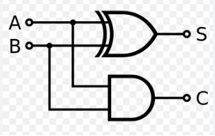
A | B | Sum | Carry
0 | 0 | 0 | 0
0 | 1 | 1 | 0
1 | 0 | 1 | 0
1 | 1 | 0 | 1
Figure 1 - Half Adder Truth Table

Figure 2 - Half Adder Logic Gate

A half adder is a type of adder, an electronic circuit that performs the addition of numbers. The half adder is able to add two single binary digits and provide the output plus a carry value. It has two inputs, called A and B, and two outputs S (sum) and C (carry). The common representation uses a XOR logic gate and an AND logic gate. [7]
A half adder is used to add two single-digit binary numbers and results into a two-digit output. It is named as such because putting two half adders together with the use of an OR gate results in a full adder. In other words, it only does half the work of a full adder. [7]
The adder works by combining the operations of basic logic gates, with the simplest form using only a XOR and an AND gate. This can also be converted into a circuit that only has AND, OR and NOT gates. This is especially useful since these three simpler logic gate ICs (integrated circuits) are more common and available than the XOR IC, though this might result in a bigger circuit since three different chips are used instead of just one. [7]

1.7 Full Adder.

A | B | Carry In | Sum | Carry Out
0 | 0 | 0 | 0 | 0
0 | 0 | 1 | 1 | 0
0 | 1 | 0 | 1 | 0
0 | 1 | 1 | 0 | 1
1 | 0 | 0 | 1 | 0
1 | 0 | 1 | 0 | 1
1 | 1 | 0 | 0 | 1
1 | 1 | 1 | 1 | 1
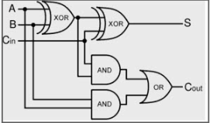

Figure 3 - Full Adder Logic Gate

Figure 4 - Full Adder Truth Table
A full adder is a digital circuit that performs addition. Full adders are implemented with logic gates in hardware. A full adder adds three one-bit binary numbers, two operands, and a carry bit. The adder outputs two numbers, a sum and a carry bit. The term is contrasted with a half adder, which adds two binary digits.
A full adder takes two binary numbers plus a carry or overflow bit. The output is a sum and another carry bit. Full adders are made from XOR, AND, and OR gates in hardware. Full adders are commonly connected to each other to add bits to an arbitrary length of bits, such as 32 or 64 bits. A full adder is effectively two half adders, an XOR and an AND gate, connected by an OR gate. [7]

1.8 The conclusion drawn from the research.

Based on the research conducted, the Braun Multiplier, Wallace Tree Multiplier, and Booth Multiplier are all techniques for multiplying two numbers in digital circuits. They each have their advantages and disadvantages, and the choice of which one to use depends on the specific requirements of the application. When it comes to comparison, the Braun Multiplier is known for its simplicity, while the Wallace Tree Multiplier is known for its efficiency in terms of speed, efficiency, and overall performance, which is shown in the table below. The Booth Multiplier is particularly useful for the multiplication of signed numbers and accuracy.
Multiplier | Efficiency | Accuracy | Speed/Performance | Area
Braun Multiplier | Low | Medium | Low | Low
Wallace Tree Multiplier | High | Medium | High | High
Booth Multiplier | Medium | High | Medium | Medium
Figure 5 - Multiplier Comparison Table

Task 1

Design a m x n Parallel Array Braun’s Multiplier.
To create the code for the Braun program, the first step is to draw out the 8 x 8 multiplier. This involves mapping out each Half and Full adders, along with their corresponding sum and carry. You can refer to Figure 7 for a visual representation of this process.
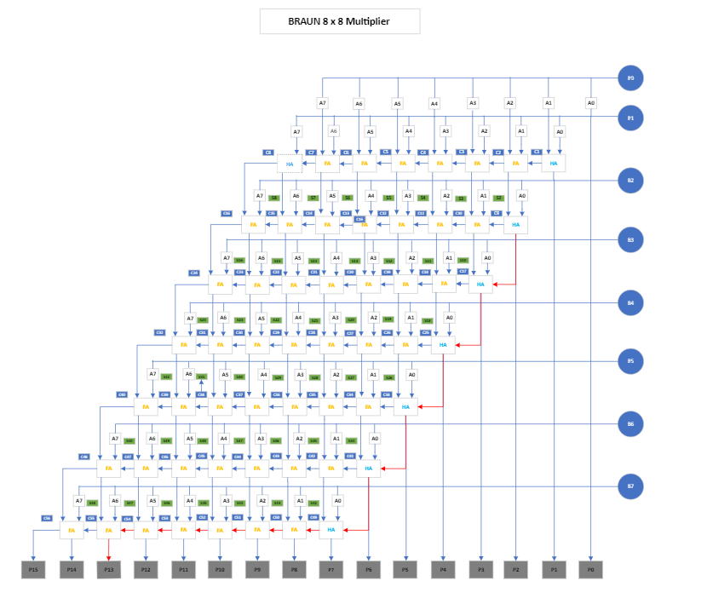

Figure 6 - Braun Multiplier 8x8 Program

The code for this multiplier is shown within the appendices

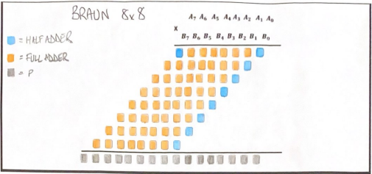

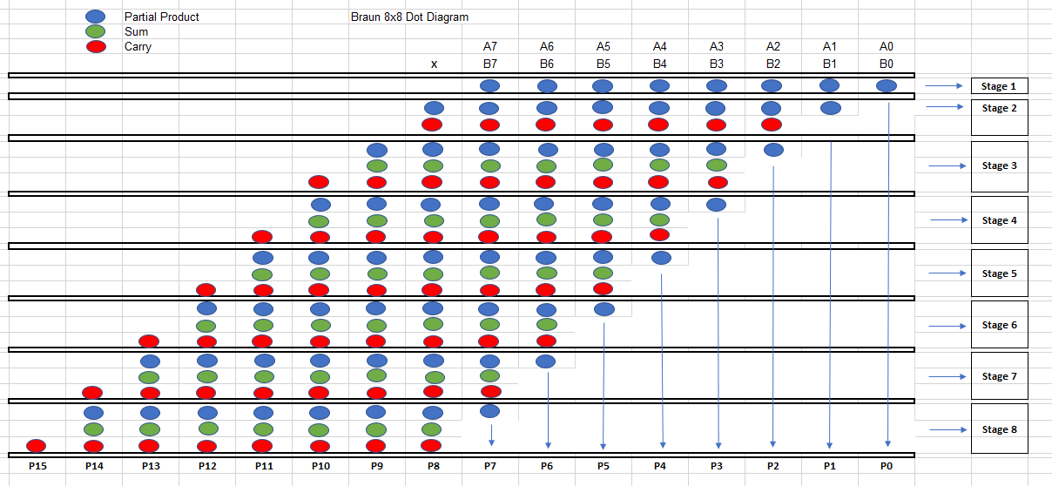
Figure 7 - Braun 8x8 Full and Half Adder Template
Figure 8 - Braun 8x8 Dot Diagram

Figure 8 show a dot diagram for the Braun 8x8 structure, the dots are depicted as follows, Blue – Partial Products, Green – Sum, and Red – Carries.
Figures 6, 7 & 9 depict Half adders as Blue and Full adders as Orange.
There are a total of 9 Half adders within the Braun 8 x 8 structure.
There are a total of 55 Full adders within the Braun 8 x 8 structure

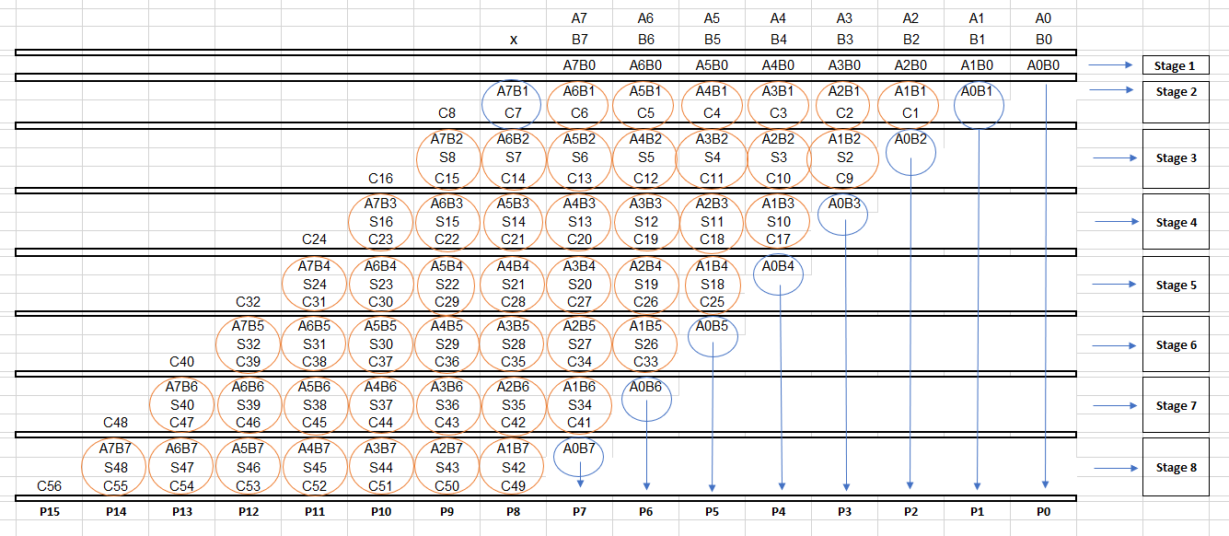
.
Figure 9 - Braun 8x8 Structure Diagram

After implementing the code into the Xilinx Vivado software, the program was tested using a Hex calculator. The Hex value was converted to a binary value, and the software was expected to generate the same binary value as the one obtained from the Hex calculation.
To demonstrate that the code was generated accurately, the following calculations were used.
08 x 07 = 38
56 x 2A = 0EIC
FE x EA = E82C
The screenshots shown in Figures 10, 11, & 12 provide evidence to support this.

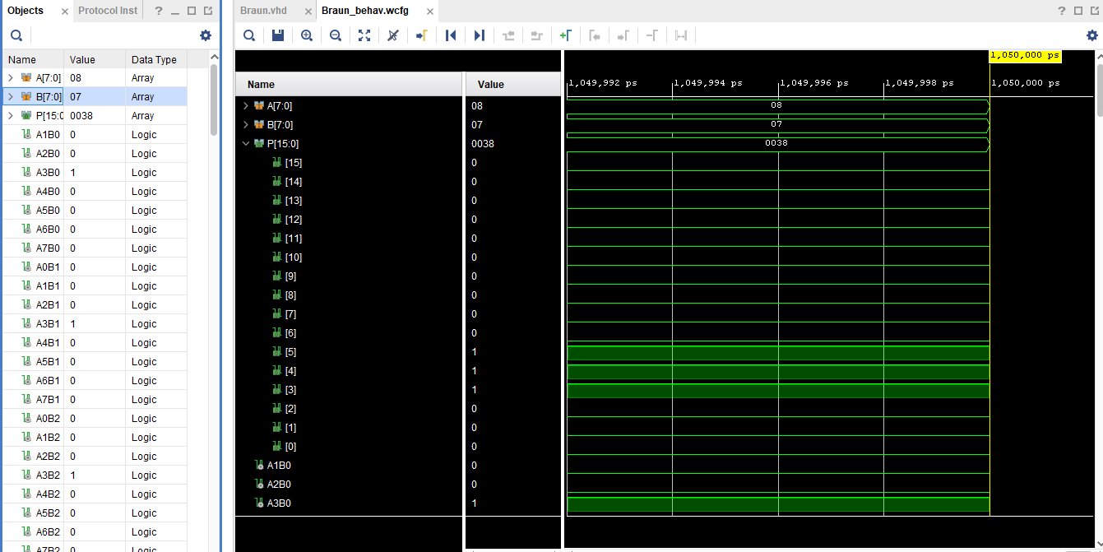
Figure 10 - 08 x 07 Hex Value
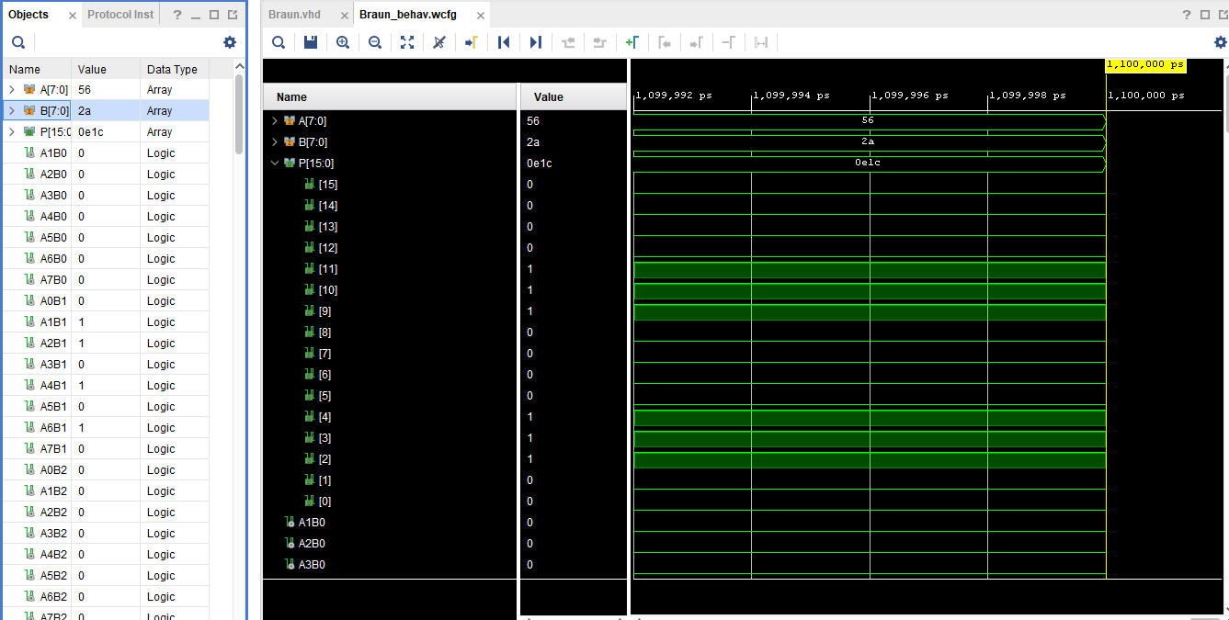
Figure 11 - 56 x 2A Hex Value

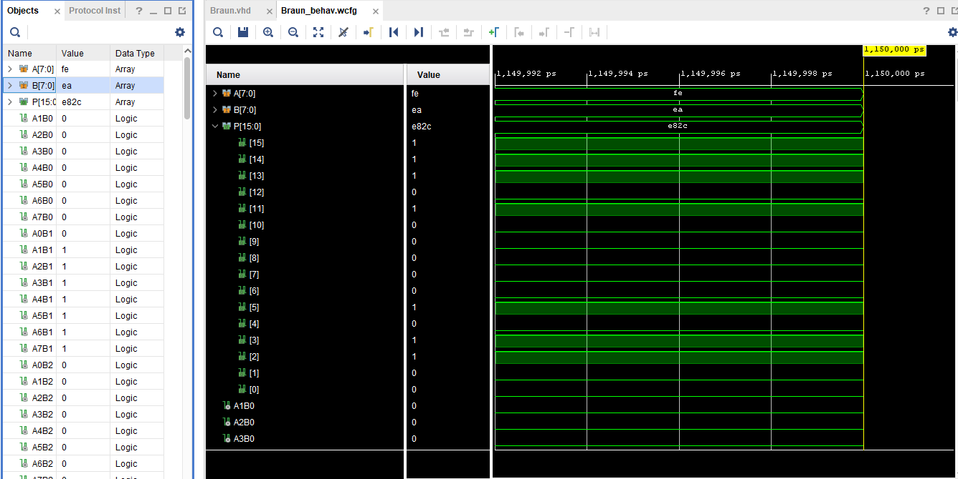
Figure 12 - FE x EA Hex Value

Task 2

An 8 x 8-bit unsigned number is to be designed using parallel multiplication for the diagram given within the assignment brief, implemented using a Wallace Tree Multiplier.
As with task 1, the code for the Wallace 8 x 8 multiplier follows the same procedure. The multiplier is generated, as illustrated in Figure 13 below.

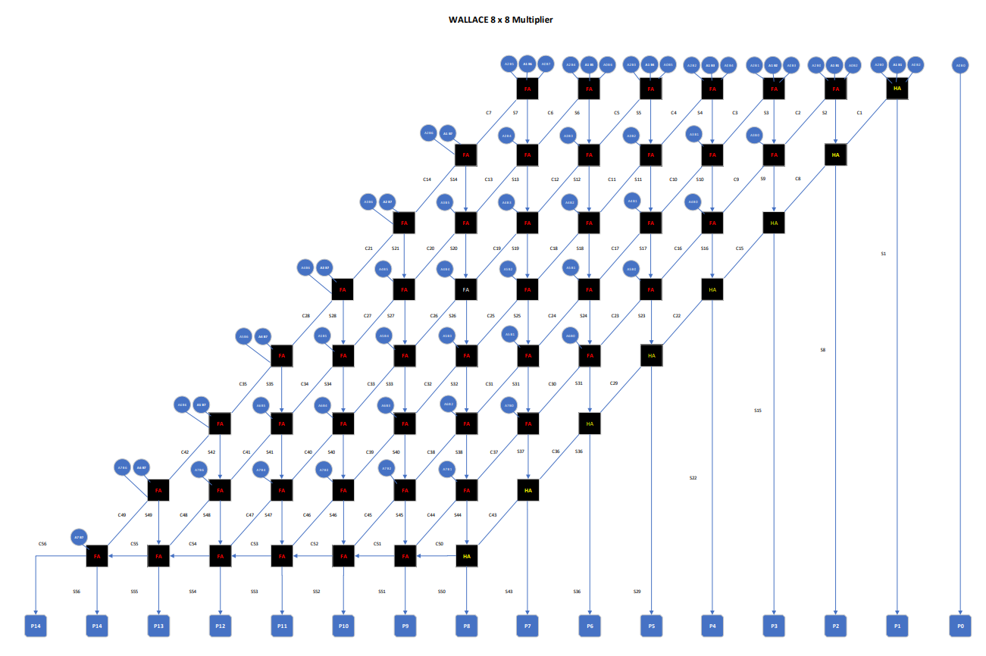
Figure 13 - Wallace 8x8 Multiplier Program

The code for this multiplier is shown within the appendices

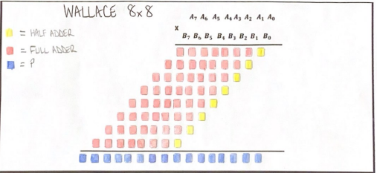

Figure 14 - Wallace 8x8 Half and Full Adder Template
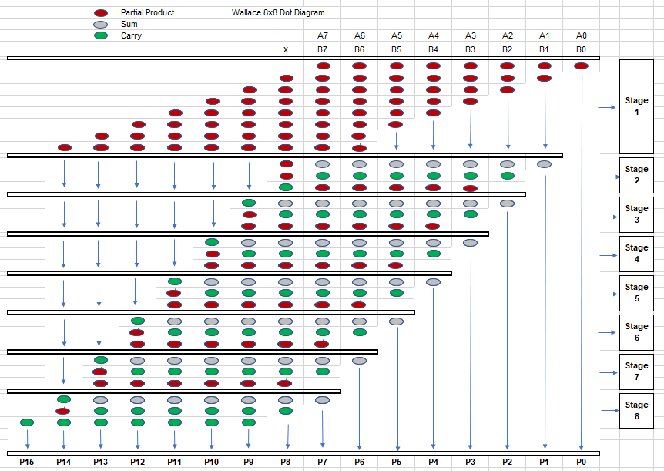
Figure 15 - Wallace 8x8 Dot Diagram
Figure 15 show a dot diagram for the Wallace 8x8 structure, the dots are depicted as follows, Red – Partial Products, Grey – Sum, and Green – Carries.

Figures 13,14 & 16 depict Half adders as Yellow and Full adders as Red.
There are a total of 8 Half adders within the Wallace 8 x 8 structure.
There are a total of 56 Full adders within the Wallace 8 x 8 structure.
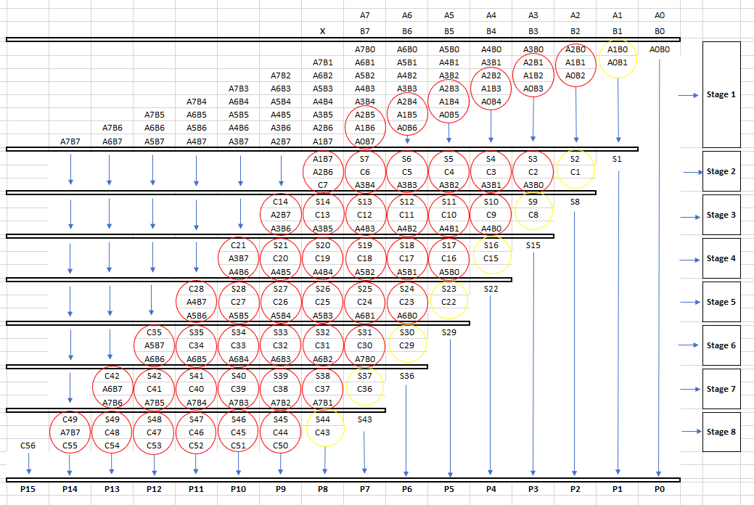
Figure 16 - Wallace 8x8 Structure Diagram

The calculations applied to the Wallace program were the same as those used in the Braun program. The results can be seen in Figures 17, 18, & 19.
To demonstrate that the code was generated accurately, the following calculations were used.
08 x 07 = 38
56 x 2A = 0EIC
FE x EA = E82C
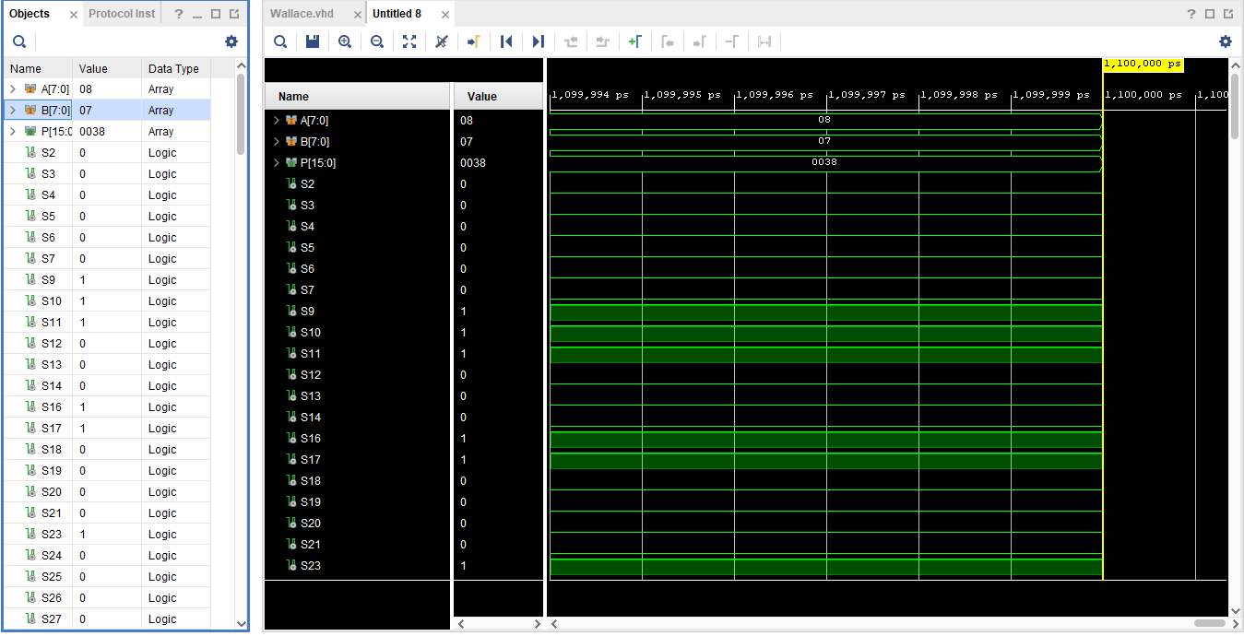
Figure 17 - 08 x 07 Hex Value
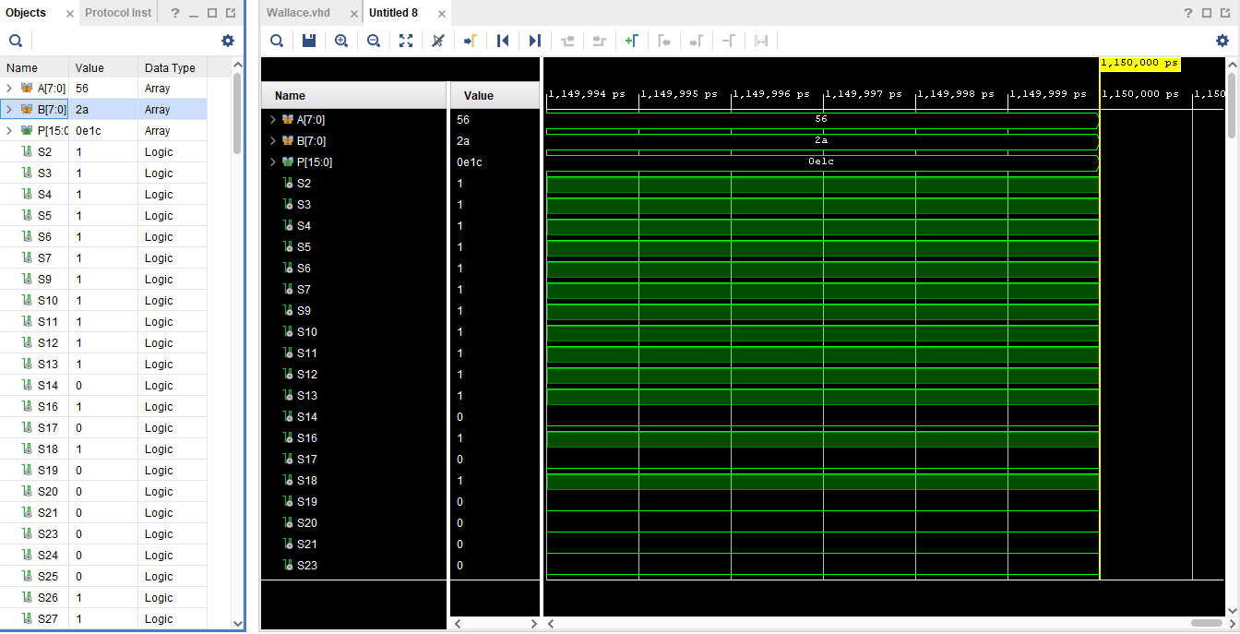
Figure 18 - 56 x 2A Hex Value

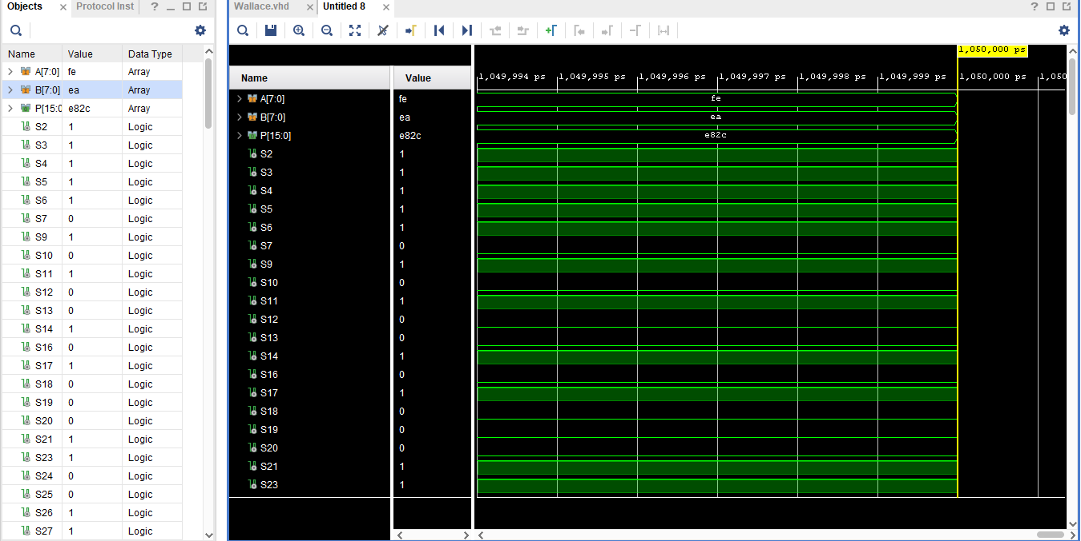

Figure 19 - FE x EA Hex Value

Task 3

Task 3 involved evaluating the performance of both multipliers for power consumption, the overall delay of each multiplier, and the longest delay within both multipliers.
Figure 20 below shows the steps taken to obtain this information are shown in the left hand column, highlighted in Blue,
First, the schematic diagram is generated; this is the software equivalent of what was created initially to allow code to be written, as seen in Figures 6 & 13.
The project Utilisation and Design Timing Summary are received as a result, allowing the procedure to move forward and determine the maximum delay of each multiplier, which was compared on page 23.

The power consumption of each multiplier is obtained as a result of this; as previously stated, two different values were utilised to obtain the information, 0.25W for Braun and 0.5W for Wallace, respectively.
Bringing us to the last stages of the procedure when the RTL Analysis and I/O Planning are created.

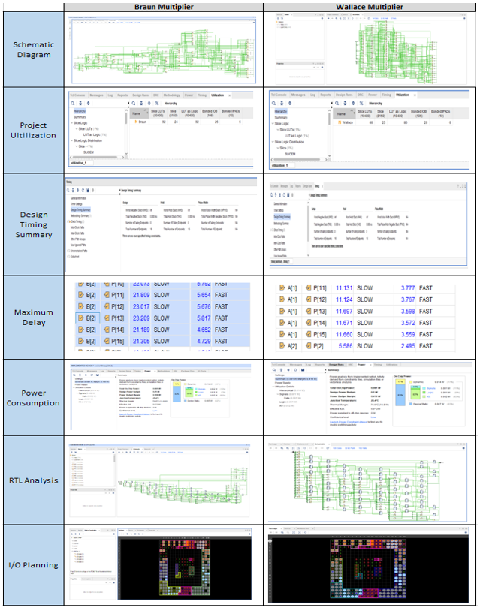
Figure 20 - Sequence of events to complete procedure of both Multipliers

What is the longest delay in both of the Multipliers?

For the calculation, the values of the AND gate are taken as $t_{g}=1ns$, the values of the full adder and half adder are $t_{ad}=2ns$

Braun Multiplier – Longest Delay Path
The longest delay path (critical path) is highlighted with Red arrows in Figure 17, showing the path from B(2) to P(13).
For the Braun Multiplier, there are a total of 6 Full Adders = 12$ns$ 6 Half Adders = 12$ns$, and 1 AND Gate = 1$ns.$ Giving an overall total delay of $25ns$.
Comparing the longest delay within the Vivado software which was B(2) – P(13) = 23.209 to the longest delay as a calculation, the results are as follows.
Vivado software = 23.209ns
Calculation = 25.000ns
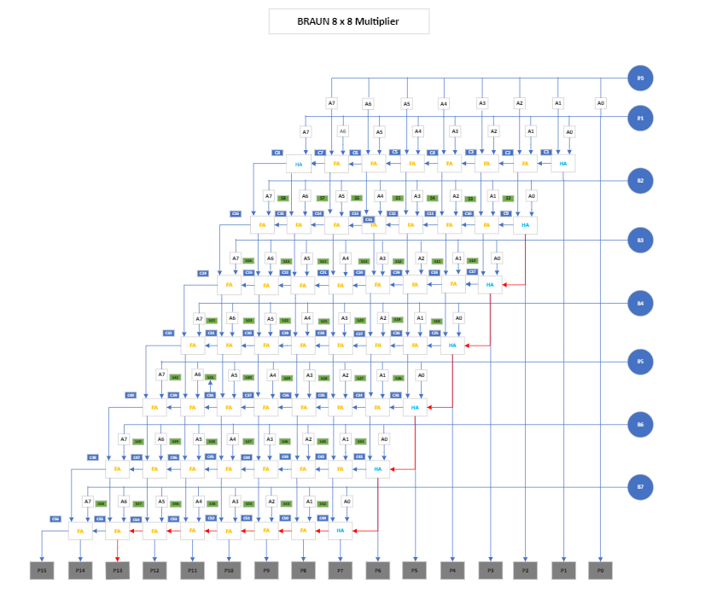
Difference = 1.791ns
Figure 21 - Longest Delay Path, Braun Multiplier
Wallace Multiplier - Longest Delay Path

The longest delay path (critical path) is highlighted with Yellow arrows in Figure 18, showing the path from B(4) to P(13).
For the Wallace Multiplier, there are a total of 5 Full Adders = 10$ns$ 5 Half Adders = 10$ns$, and 1 AND Gate = 1$ns.$ Giving an overall total delay of $21ns$.
Comparing the longest delay within the Vivado software, which was B(4) – P(13) = 18.286 to the longest delay as a calculation, the results are as follows.
Vivado software = 18.286ns
Calculation = 21.000ns
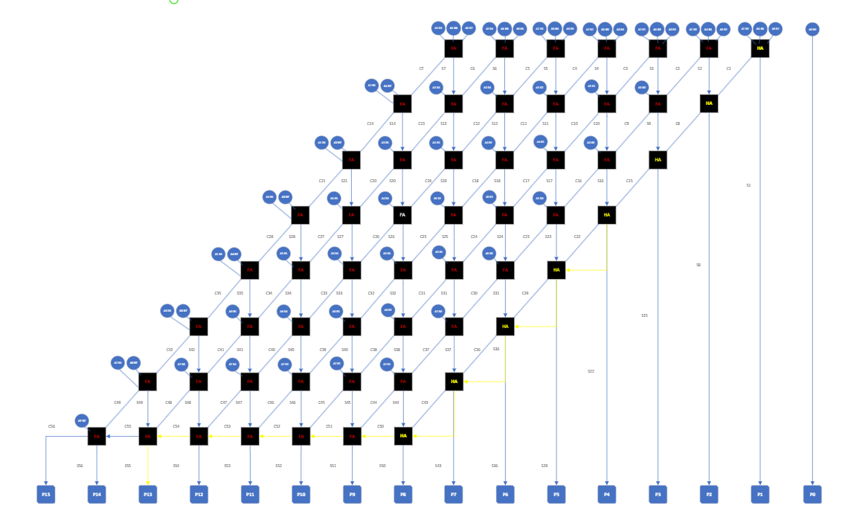
Difference = 2.714ns
Figure 22 - Longest Delay Path, Wallace Multiplier

Compare the overall delay of the Multipliers

The table below displays a comparison of the overall delay between selected points from the Braun Multiplier and the Wallace Tree Multiplier. The comparison was based on 5 points.

BRAUN
From Port | To Port | Max Delay | Min Delay
A[0] | P[4] | 10.16 | 3.02
A[1] | P[6] | 18.61 | 4.86
A[2] | P[5] | 17.49 | 5.23
A[4] | P[8] | 20.17 | 6.00
A[7] | P[15] | 14.78 | 2.06
The table below shows the overall delay of the Braun Multiplier.
Figure 23 - Maximum Delay Graph, Braun Multiplier Figure 24 - Maximum Delay Comparison Table, Braun Multiplier
The table below shows the overall delay of the Wallace Multiplier.
WALLACE
From Port | To Port | Max Delay | Min Delay
A[0] | P[4] | 8.82 | 3.00
A[1] | P[6] | 13.48 | 4.68
A[2] | P[5] | 13.62 | 4.90
A[3] | P[8] | 15.08 | 5.67
A[7] | P[15] | 9.47 | 2.06
Figure 25 - Maximum Delay Comparison Table, Wallace Multiplier Figure 26 - Maximum Delay Graph, Wallace Multiplier
The difference between the two multipliers can be seen in the table below.
DIFFERENCE IN DELAY BETWEEN BRAUN & WALLACE
From Port | To Port | Difference in Max Delay | Difference in Min Delay
A[0] | P[4] | 1.34 | 0.02
A[1] | P[6] | 5.13 | 0.17
A[2] | P[5] | 3.87 | 0.33
A[3] | P[8] | 5.10 | 0.33
A[7] | P[15] | 5.30 | 0.00
Figure 27 - Braun & Wallace Maximum Delay Comparison Table
As can be seen in the tables above, the max delay is greater for the Braun multiplier than the Wallace multiplier, this is has an effect on the overall power consumption.

Which of the implementations consumes more power, and why?
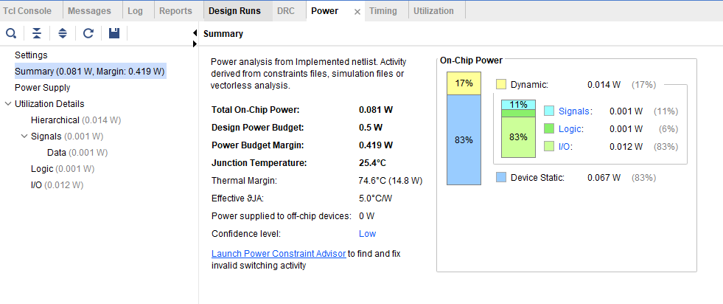
Figure 28 - Power Consumption, Wallace Multiplier
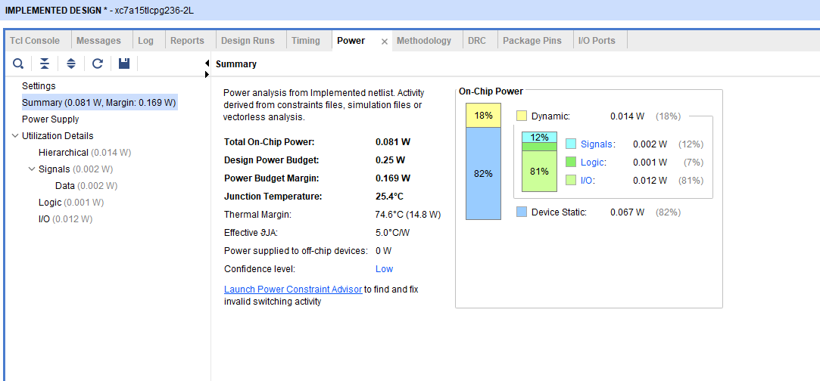
The above screenshot show the power consumption for the Wallace multiplier, with a total on-chip power of 0.081W.
Figure 29 - Power Consumption, Braun Multiplier
The above screenshot show the power consumption for the Braun multiplier, with a total on-chip power of 0.081W.
As can be observed from Figures 28 & 29 above, both Multipliers consume the same amount of power, 0.081W, but the Braun multiplier had a smaller design power budget, 0.25W, compared to the Wallace Multiplier's 0.5W, indicating that the Braun multiplier consumes more power than the Wallace multiplier.
Comparing the results of the maximum delay of the multipliers, Figures 24,25 & 27, the Braun Multiplier consumes more power than the Wallace Multiplier since the Braun has a greater overall max delay, which means the Braun needs more power than the Wallace because it has to perform more work to get from point A to point B.

Flow chart of the System Operations

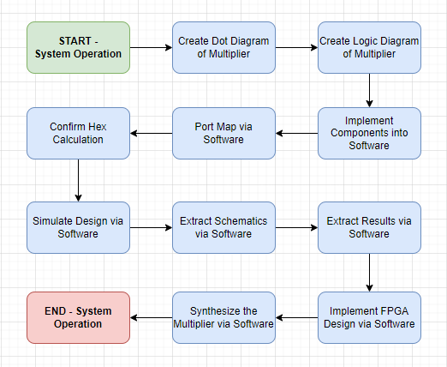
Figure 30 - System Operation Flowchart

Figure 30 illustrates the system operation using a flowchart.

Further Recommendations

This section explores the options available for improving the speed and power of both Braun and Wallace multipliers.
Optimising the architecture, reducing critical paths, and minimising power-consuming elements improve the speed and power efficiency of multipliers.

How to improve the speed and power of Braun and Wallace Multipliers
Braun | Wallace
Advanced Adder Designs: It is recommended to use fast adder architectures such as carry-lookahead adders or carry-skip adders. Additionally, it is suggested to consider utilising high-speed and low-power adder cells. | Low-Power Techniques: During idle periods, clock gating can be applied to disable the clock to unused components, reducing power consumption. Also, low-power flip-flops can be used in the design.
Bit-Level Optimization: Efficient flip-flops and logic elements are utilised for bit-level operations within the multiplier, to minimise the number of logic levels in the critical path. | Adder Optimisation: High-speed adder architectures, such as carry-lookahead or carry-skip adders, can reduce critical path delay and improve overall speed.
Advanced Coding Techniques: It's important to use efficient coding techniques, like factoring and common subexpression elimination, to reduce operations and increase multiplier efficiency. | Optimized Partial Product Generation: Optimised adder designs like carry-save adders improve partial product generation. Compression techniques can also reduce partial product count.
Figure 31 - Further Recommendations Comparison Table
[8] [9] [10]

Conclusion

Based on the processes described in this study, we may infer that both the Braun and Wallace multipliers have advantages and disadvantages.
Overall, the Wallace multiplier appears to be the more reliable and efficient of the two multipliers in terms of speed, power production, and overall performance, as seen by the results of the respected maximum delays and total power usage.
On the whole, I consider this project to be a success as I was able to write the code for both the Braun and Wallace multipliers, build a logic / structure diagram for both, and then implement the code into the Vivado software, delivering the correct end results. Though it wasn’t without a few teething problems with the coding, such as, one number was entered incorrectly in the Braun code, which called for me to explore through the coding to find the error, and a full stop incorrectly entered in the Wallace code, which again required me to search through the coding to find the error.
If I were to do this report again, I would make sure to give both multipliers the same value of the design power budget; this was an error on my part, and while it had no overall effect on the power output figures, having a consistent approach would have been advantageous.
With more time, I'd create a 16 x 16 multiplier for both the Braun and Wallace multipliers, and compare the overall maximum delay and output power to that of the 8 x 8, to see if the results double, or even exceed, that of the 8 x 8.

References

[1] | “Electrical Technology,” [Online]. Available: https://www.electricaltechnology.org/2018/05/binary-multiplier-types-binary-multiplication-calculator.html. [Accessed 20 Dec 2023].
[2] | “ElectronicsHub,” [Online]. Available: https://www.electronicshub.org/binary-multiplication/#:~:text=Binary%20Multiplier%20Using%20Shift%20Method,-Alternatively%20to%20the&text=The%20multiplication%20process%20starts%20with,to%20the%20right%20one%20bit.. [Accessed 20 Dec 2023].
[3] | “A Review of Different Type of Multipliers and Multiplier-Accumulator Unit.,” Soniya, Suresh Kumar, 2013.
[4] | “COMPARISON OF DIFFERENT TYPES OF MULTIPLIERS WITH RESPECT TO SPEED, AREA AND POWER,” Ph.D Scholar, AcSIR, 2017.
[5] | “Geeks For Geeks,” [Online]. Available: https://www.geeksforgeeks.org/booths-multiplication-algorithm/. [Accessed 20 Dec 2023].
[6] | “Virtual Labs,” [Online]. Available: http://vlabs.iitkgp.ernet.in/coa/exp7/index.html. [Accessed 20 Dec 2023].
[7] | “Techopedia,” [Online]. Available: https://www.techopedia.com/definition/7509/half-adder#:~:text=Techopedia%20Explains%20Half%20Adder,work%20of%20a%20full%20adder.. [Accessed 20 Dec 2023].
[8] | “Design and Implementation of Braun Multiplier using Parallel Prefix Adders,” vol. 9, no. 4, p. 4, 2020.
[9] | “Implementation of Low Power Wallace Tree Multiplier using Carry Select Adder with BEC,” vol. 7, no. 4, p. 6, April 2018.
[10] | “Faster and Low Power Twin Precision Multiplier,” V. Sreedeep, B. Ramkumar and Harish M Kittur, 2011.
[11] | [Online]. Available: Binary Multiplier - Types & Binary Multiplication Calculator (electricaltechnology.org).

Appendices

Braun 8x8 Code

architecture Behavioural of Braun is

component Fulladder
port (A : in STD_LOGIC;
B : in STD_LOGIC;
Cin : in STD_LOGIC;
Sum : out STD_LOGIC;
Cout : out STD_LOGIC) ;
end component;

component Halfadder
port (A : in STD_LOGIC;
B : in STD_LOGIC;
Sum : out STD_LOGIC;
Cout : out STD_LOGIC) ;
end component;

signal A1B0, A2B0, A3B0, A4B0, A5B0, A6B0, A7B0 : std_logic;
signal A0B1, A1B1, A2B1, A3B1, A4B1, A5B1, A6B1, A7B1 : std_logic;
signal A0B2, A1B2, A2B2, A3B2, A4B2, A5B2, A6B2, A7B2 : std_logic;
signal A0B3, A1B3, A2B3, A3B3, A4B3, A5B3, A6B3, A7B3 : std_logic;
signal A0B4, A1B4, A2B4, A3B4, A4B4, A5B4, A6B4, A7B4 : std_logic;
signal A0B5, A1B5, A2B5, A3B5, A4B5, A5B5, A6B5, A7B5 : std_logic;
signal A0B6, A1B6, A2B6, A3B6, A4B6, A5B6, A6B6, A7B6 : std_logic;
signal A0B7, A1B7, A2B7, A3B7, A4B7, A5B7, A6B7, A7B7 : std_logic;

signal C1, C2, C3, C4, C5, C6, C7, C8 : std_logic;
signal C9, C10, C11, C12, C13, C14, C15, C16 : std_logic;
signal C17, C18, C19, C20, C21, C22, C23, C24 : std_logic;
signal C25, C26, C27, C28, C29, C30, C31, C32 : std_logic;
signal C33, C34, C35, C36, C37, C38, C39, C40 : std_logic;
signal C41, C42, C43, C44, C45, C46, C47, C48 : std_logic;
signal C49, C50, C51, C52, C53, C54, C55, C56 : std_logic;

signal S2, S3, S4, S5, S6, S7, S8 : std_logic;
signal S10, S11, S12, S13, S14, S15, S16 : std_logic;
signal S18, S19, S20, S21, S22, S23, S24 : std_logic;
signal S26, S27, S28, S29, S30, S31, S32 : std_logic;
signal S34, S35, S36, S37, S38, S39, S40 : std_logic;
signal S42, S43, S44, S45, S46, S47, S48 : std_logic;

begin

A1B0 <= A (1) and B (0) ;
A2B0 <= A (2) and B (0) ;
A3B0 <= A (3) and B (0) ;
A4B0 <= A (4) and B (0) ;
A5B0 <= A (5) and B (0) ;
A6B0 <= A (6) and B (0) ;
A7B0 <= A (7) and B (0) ;

A0B1 <= A (0) and B (1) ;
A1B1 <= A (1) and B (1) ;
A2B1 <= A (2) and B (1) ;
A3B1 <= A (3) and B (1) ;
A4B1 <= A (4) and B (1) ;
A5B1 <= A (5) and B (1) ;
A6B1 <= A (6) and B (1) ;
A7B1 <= A (7) and B (1) ;

A0B2 <= A (0) and B (2) ;
A1B2 <= A (1) and B (2) ;
A2B2 <= A (2) and B (2) ;
A3B2 <= A (3) and B (2) ;
A4B2 <= A (4) and B (2) ;
A5B2 <= A (5) and B (2) ;
A6B2 <= A (6) and B (2) ;
A7B2 <= A (7) and B (2) ;

A0B3 <= A (0) and B (3) ;
A1B3 <= A (1) and B (3) ;
A2B3 <= A (2) and B (3) ;
A3B3 <= A (3) and B (3) ;
A4B3 <= A (4) and B (3) ;
A5B3 <= A (5) and B (3) ;
A6B3 <= A (6) and B (3) ;
A7B3 <= A (7) and B (3) ;

A0B4 <= A (0) and B (4) ;
A1B4 <= A (1) and B (4) ;
A2B4 <= A (2) and B (4) ;
A3B4 <= A (3) and B (4) ;
A4B4 <= A (4) and B (4) ;
A5B4 <= A (5) and B (4) ;
A6B4 <= A (6) and B (4) ;
A7B4 <= A (7) and B (4) ;

A0B5 <= A (0) and B (5) ;
A1B5 <= A (1) and B (5) ;
A2B5 <= A (2) and B (5) ;
A3B5 <= A (3) and B (5) ;
A4B5 <= A (4) and B (5) ;
A5B5 <= A (5) and B (5) ;
A6B5 <= A (6) and B (5) ;
A7B5 <= A (7) and B (5) ;

A0B6 <= A (0) and B (6) ;
A1B6 <= A (1) and B (6) ;
A2B6 <= A (2) and B (6) ;
A3B6 <= A (3) and B (6) ;
A4B6 <= A (4) and B (6) ;
A5B6 <= A (5) and B (6) ;
A6B6 <= A (6) and B (6) ;
A7B6 <= A (7) and B (6) ;

A0B7 <= A (0) and B (7) ;
A1B7 <= A (1) and B (7) ;
A2B7 <= A (2) and B (7) ;
A3B7 <= A (3) and B (7) ;
A4B7 <= A (4) and B (7) ;
A5B7 <= A (5) and B (7) ;
A6B7 <= A (6) and B (7) ;
A7B7 <= A (7) and B (7) ;

PO : P (0) <= A (0) and B (0) ;

P1 : Halfadder port map (A1B0, A0B1, P (1), C1) ;

S2_1 : Fulladder port map (A2B0, A1B1, C1, S2, C2) ;
P2 : Halfadder port map (A0B2, S2, P (2), C9) ;

S3_1 : Fulladder port map (A3B0, A2B1, C2, S3, C3) ;
S10_1 : Fulladder port map (A1B2, S3, C9, S10, C10) ;
P3 : Halfadder port map (A0B3, S10, P (3), C17) ;

S4_1 : Fulladder port map (A4B0, A3B1, C3, S4, C4) ;
S11_1 : Fulladder port map (A2B2, S4, C10, S11, C11) ;
S18_1 : Fulladder port map (A1B3, S11, C17, S18, C18) ;
P4 : Halfadder port map (A0B4, S18, P (4), C25) ;

S5_1 : Fulladder port map (A5B0, A4B1, C4, S5, C5) ;
S12_1 : Fulladder port map (A3B2, S5, C11, S12, C12) ;
S19_1 : Fulladder port map (A2B3, S12, C18, S19, C19) ;
S26_1 : Fulladder port map (A1B4, S19, C25, S26, C26) ;
P5 : Halfadder port map (A0B5, S26, P (5), C33) ;

S6_1 : Fulladder port map (A6B0, A5B1, C5, S6, C6) ;
S13_1 : Fulladder port map (A4B2, S6, C12, S13, C13) ;
S20_1 : Fulladder port map (A3B3, S13, C19, S20, C20) ;
S27_1 : Fulladder port map (A2B4, S20, C26, S27, C27) ;
S34_1 : Fulladder port map (A1B5, S27, C33, S34, C34) ;
P6 : Halfadder port map (A0B6, S34, P (6), C41) ;

S7_1 : Fulladder port map (A7B0, A6B1, C6, S7, C7) ;
S14_1 : Fulladder port map (A5B2, S7, C13, S14, C14) ;
S21_1 : Fulladder port map (A4B3, S14, C20, S21, C21) ;
S28_1 : Fulladder port map (A3B4, S21, C27, S28, C28) ;
S35_1 : Fulladder port map (A2B5, S28, C34, S35, C35) ;
S42_1 : Fulladder port map (A1B6, S35, C41, S42, C42) ;
P7 : Halfadder port map (A0B7, S42, P (7), C49) ;

S8_1 : Halfadder port map (A7B1, C7, S8, C8) ;
S15_1 : Fulladder port map (A6B2, S8, C14, S15, C15) ;
S22_1 : Fulladder port map (A5B3, S15, C21, S22, C22) ;
S29_1 : Fulladder port map (A4B4, S22, C28, S29, C29) ;
S36_1 : Fulladder port map (A3B5, S29, C35, S36, C36) ;
S43_1 : Fulladder port map (A2B6, S36, C42, S43, C43) ;
P8 : Fulladder port map (A1B7, S43, C49, P(8), C50) ;

S16_1 : Fulladder port map (A7B2, C8, C15, S16, C16) ;
S23_1 : Fulladder port map (A6B3, S16, C22, S23, C23) ;
S30_1 : Fulladder port map (A5B4, S23, C29, S30, C30) ;
S37_1 : Fulladder port map (A4B5, S30, C36, S37, C37) ;
S44_1 : Fulladder port map (A3B6, S37, C43, S44, C44) ;
P9 : Fulladder port map (A2B7, S44, C50, P(9), C51) ;

S24_1 : Fulladder port map (A7B3, C16, C23, S24, C24) ;
S31_1 : Fulladder port map (A6B4, S24, C30, S31, C31) ;
S38_1 : Fulladder port map (A5B5, S31, C37, S38, C38) ;
S45_1 : Fulladder port map (A4B6, S38, C44, S45, C45) ;
P10: Fulladder port map (A3B7, S45, C51, P(10), C52) ;

S32_1 : Fulladder port map (A7B4, C24, C31, S32, C32) ;
S39_1 : Fulladder port map (A6B5, S32, C38, S39, C39) ;
S46_1 : Fulladder port map (A5B6, S39, C45, S46, C46) ;
P11: Fulladder port map (A4B7, S46, C52, P(11), C53) ;

S40_1 : Fulladder port map (A7B5, C32, C39, S40, C40) ;
S47_1 : Fulladder port map (A6B6, S40, C46, S47, C47) ;
P12: Fulladder port map (A5B7, S47, C53, P(12), C54) ;

S48_1 : Fulladder port map (A7B6, C40, C47, S48, C48) ;
P13: Fulladder port map (A6B7, S48, C54, P(13), C55) ;

P14: Fulladder port map (A7B7, C48, C55, P(14), C56) ;
P15: P(15) <= C56 ;

end Behavioural;

Wallace 8x8 Code

entity Wallace_Tree is
Port ( A : in STD_LOGIC_VECTOR (7 downto 0);
B : in STD_LOGIC_VECTOR (7 downto 0);
P : out STD_LOGIC_VECTOR (15 downto 0));
end Wallace_Tree;
architecture Behavioral of Wallace_Tree is
component Fulladder
port (A : in STD_LOGIC;
B : in STD_LOGIC;
Cin : in STD_LOGIC;
S : out STD_LOGIC;
Cout : out STD_LOGIC) ;
end component;
component Halfadder
port (A : in STD_LOGIC;
B : in STD_LOGIC;
S : out STD_LOGIC;
Cout : out STD_LOGIC) ;
end component;
signal S2, S3, S4, S5, S6, S7 : std_logic;
signal S9, S10, S11, S12, S13, S14 : std_logic;
signal S16, S17, S18, S19, S20, S21 : std_logic;
signal S23, S24, S25, S26, S27, S28 : std_logic;
signal S30, S31, S32, S33, S34, S35 : std_logic;
signal S37, S38, S39, S40, S41, S42 : std_logic;
signal S44, S45, S46, S47, S48, S49 : std_logic;
signal C1, C2, C3, C4, C5, C6, C7 : std_logic;
signal C8, C9, C10, C11, C12, C13, C14 : std_logic;
signal C15, C16, C17, C18, C19, C20, C21 : std_logic;
signal C22, C23, C24, C25, C26, C27, C28 : std_logic;
signal C29, C30, C31, C32, C33, C34, C35 : std_logic;
signal C36, C37, C38, C39, C40, C41, C42 : std_logic;
signal C43, C44, C45, C46, C47, C48, C49 : std_logic;
signal C50, C51, C52, C53, C54, C55 : std_logic;
signal A1B0, A2B0, A3B0, A4B0, A5B0, A6B0, A7B0 : std_logic;
signal A0B1, A1B1, A2B1, A3B1, A4B1, A5B1, A6B1, A7B1 : std_logic;
signal A0B2, A1B2, A2B2, A3B2, A4B2, A5B2, A6B2, A7B2 : std_logic;
signal A0B3, A1B3, A2B3, A3B3, A4B3, A5B3, A6B3, A7B3 : std_logic;
signal A0B4, A1B4, A2B4, A3B4, A4B4, A5B4, A6B4, A7B4 : std_logic;
signal A0B5, A1B5, A2B5, A3B5, A4B5, A5B5, A6B5, A7B5 : std_logic;
signal A0B6, A1B6, A2B6, A3B6, A4B6, A5B6, A6B6, A7B6 : std_logic;
signal A0B7, A1B7, A2B7, A3B7, A4B7, A5B7, A6B7, A7B7 : std_logic;
begin
A1B0 <= A (1) and B (0) ;
A2B0 <= A (2) and B (0) ;
A3B0 <= A (3) and B (0) ;
A4B0 <= A (4) and B (0) ;
A5B0 <= A (5) and B (0) ;
A6B0 <= A (6) and B (0) ;
A7B0 <= A (7) and B (0) ;
A0B1 <= A (0) and B (1) ;
A1B1 <= A (1) and B (1) ;
A2B1 <= A (2) and B (1) ;
A3B1 <= A (3) and B (1) ;
A4B1 <= A (4) and B (1) ;
A5B1 <= A (5) and B (1) ;
A6B1 <= A (6) and B (1) ;
A7B1 <= A (7) and B (1) ;
A0B2 <= A (0) and B (2) ;
A1B2 <= A (1) and B (2) ;
A2B2 <= A (2) and B (2) ;
A3B2 <= A (3) and B (2) ;
A4B2 <= A (4) and B (2) ;
A5B2 <= A (5) and B (2) ;
A6B2 <= A (6) and B (2) ;
A7B2 <= A (7) and B (2) ;
A0B3 <= A (0) and B (3) ;
A1B3 <= A (1) and B (3) ;
A2B3 <= A (2) and B (3) ;
A3B3 <= A (3) and B (3) ;
A4B3 <= A (4) and B (3) ;
A5B3 <= A (5) and B (3) ;
A6B3 <= A (6) and B (3) ;
A7B3 <= A (7) and B (3) ;
A0B4 <= A (0) and B (4) ;
A1B4 <= A (1) and B (4) ;
A2B4 <= A (2) and B (4) ;
A3B4 <= A (3) and B (4) ;
A4B4 <= A (4) and B (4) ;
A5B4 <= A (5) and B (4) ;
A6B4 <= A (6) and B (4) ;
A7B4 <= A (7) and B (4) ;
A0B5 <= A (0) and B (5) ;
A1B5 <= A (1) and B (5) ;
A2B5 <= A (2) and B (5) ;
A3B5 <= A (3) and B (5) ;
A4B5 <= A (4) and B (5) ;
A5B5 <= A (5) and B (5) ;
A6B5 <= A (6) and B (5) ;
A7B5 <= A (7) and B (5) ;
A0B6 <= A (0) and B (6) ;
A1B6 <= A (1) and B (6) ;
A2B6 <= A (2) and B (6) ;
A3B6 <= A (3) and B (6) ;
A4B6 <= A (4) and B (6) ;
A5B6 <= A (5) and B (6) ;
A6B6 <= A (6) and B (6) ;
A7B6 <= A (7) and B (6) ;
A0B7 <= A (0) and B (7) ;
A1B7 <= A (1) and B (7) ;
A2B7 <= A (2) and B (7) ;
A3B7 <= A (3) and B (7) ;
A4B7 <= A (4) and B (7) ;
A5B7 <= A (5) and B (7) ;
A6B7 <= A (6) and B (7) ;
A7B7 <= A (7) and B (7) ;
PO : P(0) <= A (0) and B(0);
hall: Halfadder port map (A1B0, A0B1, P(1), C1) ;
fa12: Fulladder port map (A2B0, A1B1, A0B2, S2, C2) ;
fa13: Fulladder port map (A2B1, A1B2, A0B3, S3, C3) ;
fa14: Fulladder port map (A2B2, A1B3, A0B4, S4, C4) ;
fa15: Fulladder port map (A2B3, A1B4, A0B5, S5, C5) ;
fa16: Fulladder port map (A2B4, A1B5, A0B6, S6, C6) ;
fa17: Fulladder port map (A2B5, A1B6, A0B7, S7, C7) ;
ha21: Halfadder port map (S2, C1, P(2), C8) ;
fa22: Fulladder port map (A3B0, S3, C2, S9, C9) ;
fa23: Fulladder port map (A3B1, S4, C3, S10, C10) ;
fa24: Fulladder port map (A3B2, S5, C4, S11, C11) ;
fa25: Fulladder port map (A3B3, S6, C5, S12, C12) ;
fa26: Fulladder port map (A3B4, S7, C6, S13, C13) ;
fa27: Fulladder port map (A2B6, A1B7, C7, S14, C14) ;
ha31: Halfadder port map (S9, C8, P(3), C15) ;
fa32: Fulladder port map (A4B0, S10, C9, S16, C16) ;
fa33: Fulladder port map (A4B1, S11, C10, S17, C17) ;
fa34: Fulladder port map (A4B2, S12, C11, S18, C18) ;
fa35: Fulladder port map (A4B3, S13, C12, S19, C19) ;
fa36: Fulladder port map (A3B5, S14, C13, S20, C20) ;
fa37: Fulladder port map (A3B6, A2B7, C14, S21, C21) ;
ha41: Halfadder port map (S16, C15, P(4), C22) ;
fa42: Fulladder port map (A5B0, S17, C16, S23, C23) ;
fa43: Fulladder port map (A5B1, S18, C17, S24, C24) ;
fa44: Fulladder port map (A5B2, S19, C18, S25, C25) ;
fa45: Fulladder port map (A4B4, S20, C19, S26, C26) ;
fa46: Fulladder port map (A4B5, S21, C20, S27, C27) ;
fa47: Fulladder port map (A4B6, A3B7, C21, S28, C28) ;
ha51: Halfadder port map (S23, C22, P(5), C29) ;
fa52: Fulladder port map (A6B0, S24, C23, S30, C30) ;
fa53: Fulladder port map (A6B1, S25, C24, S31, C31) ;
fa54: Fulladder port map (A5B3, S26, C25, S32, C32) ;
fa55: Fulladder port map (A5B4, S27, C26, S33, C33) ;
fa56: Fulladder port map (A5B5, S28, C27, S34, C34) ;
fa57: Fulladder port map (A5B6, A4B7, C28, S35, C35) ;
ha61: Halfadder port map (S30, C29, P(6), C36) ;
fa62: Fulladder port map (A7B0, S31, C30, S37, C37) ;
fa63: Fulladder port map (A6B2, S32, C31, S38, C38) ;
fa64: Fulladder port map (A6B3, S33, C32, S39, C39) ;
fa65: Fulladder port map (A6B4, S34, C33, S40, C40) ;
fa66: Fulladder port map (A6B5, S35, C34, S41, C41) ;
fa67: Fulladder port map (A6B6, A5B7, C35, S42, C42) ;
ha71: Halfadder port map (S37, C36, P(7), C43) ;
fa72: Fulladder port map (A7B1, S38, C37, S44, C44) ;
fa73: Fulladder port map (A7B2, S39, C38, S45, C45) ;
fa74: Fulladder port map (A7B3, S40, C39, S46, C46) ;
fa75: Fulladder port map (A7B4, S41, C40, S47, C47) ;
fa76: Fulladder port map (A7B5, S42, C41, S48, C48) ;
fa77: Fulladder port map (A7B6, A6B7, C42, S49, C49) ;
ha81: Halfadder port map (S44, C43, P(8), C50) ;
fa82: Fulladder port map (S45, C44, C50, P(9),C51) ;
fa83: Fulladder port map (S46, C45, C51, P(10), C52) ;
fa84: Fulladder port map (S47, C46, C52, P(11), C53) ;
fa85: Fulladder port map (S48, C47, C53, P(12), C54) ;
fa86: Fulladder port map (S49, C48, C54, P(13), C55) ;
fa87: Fulladder port map (A7B7, C49, C55, P(14), P(15)) ;
end Behavioral;

