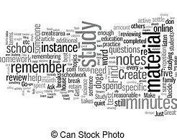
How essential skills for academic study and employment will help me in my chosen career. The skill of writing is essential way of communication and can be scrutinize by others and also influence them to [1].This will help me be able to write reports and assessments efficiently and effectively to get the best outcome for my project and to get the best academic result as well. The engineering setting is changing to a more technological approach so I need to adapt quickly and efficaciously, this is where academic skills come in to play by, the ability to send of reports of a high standard and to make me look more employable to the employer by being multidiscipline in in IT and academia [2]. Critical thinking is also an important skill to have as it gives the ability to understand other viewpoint and to think in-depth about augments and objectives, setting aside own personal beliefs and own biasness [3]. Time management is another key skill for both setting as at university and my career to plan out deadlines and when papers need to be finished, so I don’t get it piling up and over stressed to get it in on the deadline [3]. Overall these are some key skill I will develop at university and many more to aid me in my choses career, by giving me desirable overarching skills that both academia and employers are looking for.
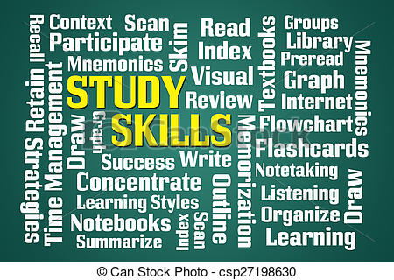

References

[1] | S. Cameron, The business student’s handbook : skills for study and employment, vol. Seventh edition, Harlow, England: Pearson Education, Limited, 2021.
[2] | S. K. M. a. D. Mishra, "ESSENTIAL EMPLOYABILITY SKILLS OF ENGINEERING STUDENTS FOR IT SECTOR," International journal of management research and reviews, vol. 8, no. 11, p. 14, 2018.
[3] | r. nedalman, "what are the 6 essential skills for university students?," uniadmissions, [Online]. Available: https://www.uniadmissions.co.uk/application-guides/6-essential-skills-for-university-students/. [Accessed 04 11 2022].

