Title: Marketing plan
Student name: Constantin Alexandru Toma
Student ID number: 2234760
Module: Marketing Essentials
Module code: BMIH4005
Lecturer’s name: Ruth Taylor Davies
Word count: 1239
Report
Table of Contents
1 Introduction 2
2 Situation Analysis 2
2.1 Company – SWOT 2
2.2 Customers – Segmentation and Targeting 3
2.3 Competitors 3
2.3.1 Perceptual Map - Positioning 3
2.3.2 Bowman Strategy Clock 4
2.4 Collaborators 4
2.5 Climate 5
3 Objectives 6
4 Strategy 6
5 Tactics 7
5.1.1 Marketing Mix 7
6 Action 8
7 Control 8
8 Conclusion 8
9 References 10
10 Appendix 12
10.1 Component B 12

Introduction
The marketing plan has been developed for Raffles operating in the UK hotel industry. The purpose is to develop a new strategy for the hotel to compete effectively in the market. For this purpose, different frameworks have been incorporated to analyse the current environmental conditions and their suitability for the hotel, such as SOSTEC and the 4 Ps.

Situation Analysis

Company – SWOT
SWOT analysis is conducted for analysing internal environmental conditions impacting an organisation (Benzaghta et al., 2021).
Strengths  - Strong development history  - One of the dominating hotels in the UK  - Provision of luxury services and amenities  - Customer loyalty results in revenue generation (Raffles, 2023) | Weaknesses  - Less international presence  - Do not have first mover benefit  - Incorporation of outdated methods  - Facing issues in cutting overhead costs (Raffles, 2023)
Opportunities  - Spread awareness among consumers using social media platforms  - Incorporate new methods to serve customers  - Emphasise including new technology to low expenses (Chan et al., 2020)  - Work on advanced as well as ecologically friendly functions | Threats  - Changing demographics and priorities of the customers  - Increasing demand for new technology  - Increasing competition  - New products and services introduced by others (Shin et al., 2019)

Customers – Segmentation and Targeting
Segmentation | Targeting
Geographic | London – UK
Demographic | Age – 18 years and above  Income – preferably high-income earners
Psychographic | Individuals that prefer luxury  Frequent travellers
Behavioural | Prefer comfort wherever they stay  Prefer high-quality services

Competitors

Perceptual Map - Positioning
The perceptual map below represents the positioning of the hotel relative to its competitors.
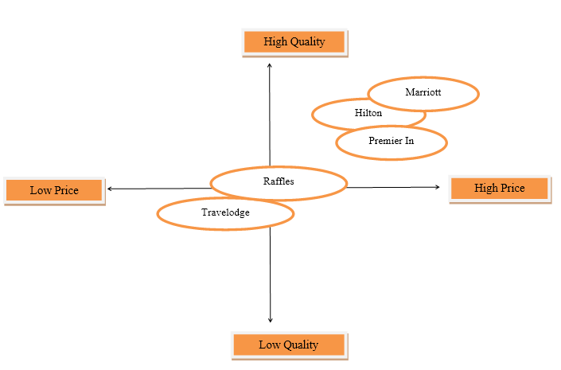

Bowman Strategy Clock
Bowman's strategy clock also represents the positioning of a company within the marketplace (Nunes et al., 2021). As mentioned before, Raffles has emphasised offering high-quality and luxury services to its customers, along with a good environment to stay in (Raffles, 2023). For this reason, in accordance with Bowman's clock, the hotel has adopted a differentiation strategy. However, at the same time, it is also undeniable that the hotel is still behind in several ways when compared with other competitors. Despite this, Raffles has loyal customers that prefer staying at the hotel.

Collaborators
Raffles hotel is operating while forming collaborative partnerships with its other stakeholders, such as franchises, restaurants and others, to ensure better provision of services to the customers. The hotel has currently introduced a new brand campaign that is named "Hotel Royalty" in order to pay tribute to the iconic history of the brand (Dobson, 2021).

Climate
PESTLE
Pestle analysis is conducted for the examination of other factors influencing an organisation (Achinas et al., 2021).
Political | The UK has an overall stable political environment  Current situations after the pandemic have negatively impacted industries  A 12.5% VAT tax has been imposed by the government on the hotels (Li et al., 2021)
Economic | Inflation is continuously increasing, thereby impacting the environment negatively.  A decrease in wages and an increase in unemployment rates are reported (Li et al., 2021)
Social | After the pandemic, the preferences and expectations of customers have changed.  Increased reliance on digital media is observed for reviews and feedback (Ntounis et al., 2022)
Technological | Technology is positively impacting the hotel and hospitality sector  Development is evident in the form of AI and the incorporation of smart technologies (Canhoto and Wei, 2021)
Legal | The UK government regulates the hotel industry  Hotels are required to show compliance with Health and Safety Act, along with Patent Act 1888 (Le and Phi, 2021)
Environmental | It is undeniable that hotels are also negatively impacting the environment in terms of waste generation.  It has become crucial to emphasise and incorporate sustainable initiatives (Le and Phi, 2021).

Objectives
The objectives to be achieved include,
- To incorporate SEO strategy and enhance customer engagement through the website by 15% in the time period of one year.
- To enhance customer interaction by 18% through social media platforms, preferably Instagram, in the time period of one year.
- To increase the hotel's profit generation by at least 10% in the time period of one year.

Strategy
For Raffles hotel, the focus is on improving customer services while ensuring the better provision of a welcoming and comfortable experience. It is undeniable that considering the pandemic situation, customers have become more inclined towards safety, hygiene and sustainable operations (Pantano et al., 2021). Therefore, the emphasis should be on the incorporation of a differentiation-focused strategy. As a part of this strategy, the value proposition of the hotel will be its elegance and hospitality. The hotel will present itself as an iconic brand with gracious and discreet services that will be promoted through the website and social media platforms. The aim is to better target the highlighted segment of the market based on emotional luxury.

Tactics

Marketing Mix
The marketing mix is a framework that is used for developing suitable strategies for companies to compete effectively (Lahtinen et al., 2020).
Product
Raffles hotel is famous for its luxury services and experience and has a personality that is intimate. The hotel also takes pride in making its guests feel special. The major products, services or offers include rooms, suites and even villas, with a tailor-made experience. In this manner, Raffles is providing its customers with the opportunity to make their lives worth living. Furthermore, special packages to stay at the hotel are also provided for special occasions.
Price
As mentioned before, Raffles is targeting luxury customers and, therefore, is adopting a premium marketing strategy. The hotel will pursue the same strategy to target high-class customers. In this manner, it would be possible to continue offering high-quality services to the targeted guests.
Place
Raffles hotel is situated in a well-recognised location in London and, therefore, is well-known by almost everyone. The guests can either visit the hotel directly to make bookings using websites. Furthermore, the staff can also be contacted by telephone to get any further information.
Promotion
The hotel is currently focusing on different traditional and digital marketing channels for promoting its products. However, the company needs to specifically emphasise developing its SEO and social media strategy while incorporating the RACE model. RACE is a framework that has been developed to help digital marketers to manage their activities (Suh and Chow, 2021). In this regard, images, videos and reels will be posted on social media platforms. Furthermore, the hotel will also emphasise incorporating a keyword strategy so as to be at the top of search engine rankings.

Action
The implementation of a marketing strategy requires accurate planning first (Graham and Wilder, 2020). The following plan will be followed by Raffles hotel.
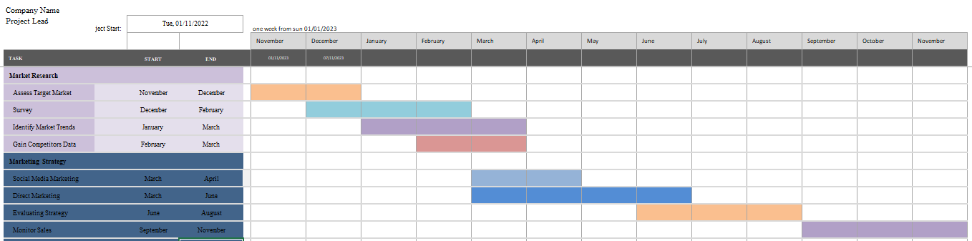

Control
The USP of Raffles will be its exceptionally high-quality services; however, the emphasis will remain on customer interaction, satisfaction and engagement. For this purpose, the main focus will be on measuring the interaction through the website and social media. Therefore, the success will be measured in terms of the extent to which the hotel will be able to achieve the desired marketing objectives, specifically in terms of the success of digital marketing strategies. Furthermore, the positive attitude of customers towards the hotel will also indicate success.

Conclusion
The marketing plan for Raffles has been developed for improving and strengthening its overall position in the hotel and hospitality industry. However, it is also undeniable that the hotel is facing some extreme challenges from other competitors in the market. For this purpose, the emphasis will be on differentiation based on high-quality products and services, along with the presence and interaction through digital marketing channels.

References
Achinas, S., Horjus, J., Achinas, V. and Euverink, G.J.W., 2019. A PESTLE analysis of biofuels energy industry in Europe. Sustainability, 11(21), p.5981.
Benzaghta, M.A., Elwalda, A., Mousa, M.M., Erkan, I. and Rahman, M., 2021. SWOT analysis applications: An integrative literature review. Journal of Global Business Insights, 6(1), pp.55-73.
Canhoto, A.I. and Wei, L., 2021. Stakeholders of the world, unite!: Hospitality in the time of COVID-19. International Journal of Hospitality Management, 95, p.102922.
Chan, E.S., Okumus, F. and Chan, W., 2020. What hinders hotels’ adoption of environmental technologies: A quantitative study. International Journal of Hospitality Management, 84, p.102324.
Dobson, J., 2021. Raffles Hotel launches stunning new campaign featuring actual royalty. [online] Forbes. Available at: <https://www.forbes.com/sites/jimdobson/2021/11/02/raffles-hotel-launches-stunning-new-campaign-featuring-actual-royalty/?sh=4b747d6f3904> [Accessed 7 Mar. 2023].
Graham, K.W. and Wilder, K.M., 2020. Consumer-brand identity and online advertising message elaboration: effect on attitudes, purchase intent and willingness to share. Journal of Research in Interactive Marketing. 93, pp.10-21.
Lahtinen, V., Dietrich, T. and Rundle-Thiele, S., 2020. Long live the marketing mix. Testing the effectiveness of the commercial marketing mix in a social marketing context. Journal of Social Marketing, 10(3), pp.357-375.
Le, D. and Phi, G., 2021. Strategic responses of the hotel sector to COVID-19: Toward a refined pandemic crisis management framework. International Journal of Hospitality Management, 94, p.102808.
Li, Y., Yao, J. and Chen, J., 2021. The negative effect of scarcity cues on consumer purchase decisions in the hospitality industry during the COVID-19 pandemic. International Journal of Hospitality Management, 94, p.102815.
Ntounis, N., Parker, C., Skinner, H., Steadman, C. and Warnaby, G., 2022. Tourism and Hospitality industry resilience during the Covid-19 pandemic: Evidence from England. Current Issues in Tourism, 25(1), pp.46-59.
Nunes, B.C., Pimentel, J., Malheiro, J., Ferreira, M.R. and Proença, J.F., 2021. Life in a Bag: Sustainability, Green Economy, and Business Strategy–A Case Study. In Handbook of Research on Nascent Entrepreneurship and Creating New Ventures (pp. 335-350). IGI Global.
Pantano, E., Priporas, C.V., Devereux, L. and Pizzi, G., 2021. Tweets to escape: Intercultural differences in consumer expectations and risk behavior during the COVID-19 lockdown in three European countries. Journal of business research, 130, pp.59-69.
Raffles, 2023. Our Hotels. [online] Raffles website . Available at: <https://www.raffles.com/> [Accessed 7 Mar. 2023].
Shin, H., Perdue, R.R. and Kang, J., 2019. Front desk technology innovation in hotels: A managerial perspective. Tourism Management, 74, pp.310-318.
Suh, T. and Chow, T.E., 2021. Developing a digital marketing tool for ethnic ventures' mixed business model and market-shaping: A design scientific approach of web demographics. Industrial Marketing Management, 93, pp.10-21.

Appendix

Component B


