Dissertation Proposal: Has photo manipulation damaged photography?
Photo manipulation refers to the alteration of photographs typically done through post editing using various techniques and softwares. The most popular and widely recognised photo editing software being Photoshop. Photoshop is very often criticised for its deception of truth and is largely associated with the arguably damaging influx of flawlessly edited models and celebrities seen within mainstream media publications. Photo manipulation has also meant for the fabrication of historical photographs that have then become famous and therefore deemed unethical for its inaccurate portrayal of history. However, photo manipulation has also allowed room for more creativity within photography as an art form and does not strictly refer to just digital editing softwares. Photo manipulation can also be done using techniques such as darkroom exposure.
Beauty
“Fifteen percent of 18 to 24-year-olds surveyed, were convinced that the images of models and celebrities in advertisements, magazines and billboards accurately depict what these women look like in real life. Differentiating between Photoshop and real life is hard enough when a woman is aware of the airbrushing that probably went on; it becomes much harder when she isn’t even given the basic facts.” - Huffington Post
Photoshop has received long standing accusations of damaging the self esteem of the public, particularly young women, and sparking masses of poor mental health in regards to one's own body image. Photoshop is religiously used within mass media in order to accentuate models and celebrities features and adhere to the typical conventional beauty standards. Photo manipulation is therefore held responsible for the masses of unrealistic beauty standards seen in todays society and mainstream publications and advertisements. As technology advances and photo editing software becomes easier to use and way more accessible (with the development of Photoshop and mobile phone apps such as FaceTune) the promotion of ideal and unrealistic beauty standards is becoming more and more of an issue. As oppose to decades ago when manipulating the appearance of a person within a photograph would require skilled dodging and burning and retouching through paints and gelatine we now live in an era where literally anyone with a mobile phone can edit their photos and "selfies" as they please. Alongside this, we have the rise of photo sharing app Instagram where everyone from famous celebrities to local school girls are sharing and posting each day. Comparing selfies and lifestyles all across the world. When researching I found that for young girls, it is more common to post photo manipulated pictures of themselves than completely unedited photos of themselves. I also found that frequent use of social media apps such as Instagram had a link to poor mental health and low self esteem. Low self esteem is also found to have a positive correlation among young girls with tendencies to bully, drink, smoke, self harm or develop eating disorders. One study showed that 70% of high school girls felt "they don't measure up or feel good enough when it comes to their appearances, performance at school and personal relationships". We live in a society obsessed with beauty and perfection that only seems to spiral us more and more into a deep rooted mutual insecurity.
Many feminists have also spoken out about the unrealistic beauty standards and this particular use of photo manipulation has become a big topic within feminism and has inspired somewhat of a feminist movement. Celebrities such as Lili Reinhart, Camila Mendes, Bella Thorne and Emily Ratajkowski have spoken out and taken a stand against being photoshopped without their consent within mainstream magazines. Actress Lili Reinhart used her public Instagram to expose how images of herself and co star Camila Mendes had been photoshopped for Cosmopolitan Philippines magazine. Reinhart spoke out about how herself and Mendes had both worked very hard to feel good about their bodies given the society and industry they have been immersed in and to see their bodies edited without consent was both shocking and insulting. Bella Thorne is another actress who specifically asked to not have images of herself photoshopped or touched up when doing a shoot for GQ Mexico magazine.
History
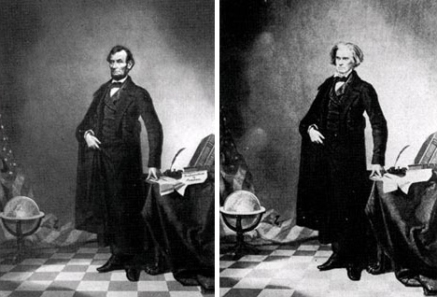
“I am far from saying that a photograph must be an actual, literal and absolute fact...but it must represent truth.” - Henry Peach Robinson
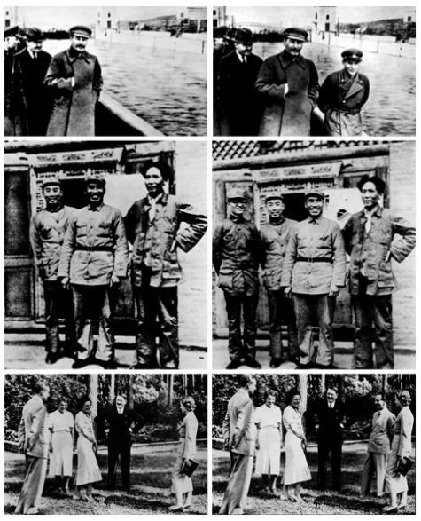
The ability to manipulate historical images means that history itself can be retold and manipulated to a certain extent. As a result of this, we often begin to question the validity of historical photographs we see. An example of this can be shown within a very famous image of US President Abraham Lincoln (shown to the right) in which Abraham Lincoln's head has been edited onto the body of somebody else. Even the words on the Newspaper shown have been manipulated. The images to the left all show examples of political leaders having people air brushed out of photographs after falling out with these leaders and becoming somewhat of an enemy. The first two images show Joseph Stalin having a commissar removed from an image. Air brushing people out of photographs was said to be a regular doing employed by Joseph Stalin. The second two show former chairman of the Chinese communist party Mao Tse-Tung having Po Ku removed, whilst the last two show Hitler having Nazi politician Joseph Goebells removed from the original photograph for reasons unknown.
Examples of manipulated photographs can often be seen within politics especially. During presidential elections, images of potential candidates in questionable scenarios often appear. This is quite blatantly an attempt to make certain candidates look bad and therefore lose favour of the public audience. In particular, during the 2004 US election an image of George Bush supposedly reading a book upside down was spread in attempt to make George Bush appear dim witted and unfit as a President. An image of John Kerry supposedly bonding with founder of the Church of Satan, Anton LaVey, was also spread around. Both these images were later established to be very obviously manipulated for the sake of damaging the reputation of both candidates. Similar photo manipulated images of Sarah Palin and Barack Obama were spread just as quickly during the 2008 US election. I would definitely argue this to be supremely unethical as these images are spread with vicious intent and aim to purposefully deceit audiences.
Creativity
"Dodging and burning are steps to take care of mistakes God made in establishing tonal relationships." - Ansel Adams
As previously mentioned, photo manipulation can refer to various non digital techniques such as dodging and burning. Dodging and burning is a darkroom technique in which you can "burn in" (allow more light to pass through) certain spots of an image or "dodge" (hold light back / block it) from other spots. This therefore enhances lighting or decreases exposure depending on your desired outcome. Dodging and burning was a very popular technique among photographers such as Ansel Adams and Imogen Cunningham and is an example of how the art of photo manipulation has benefited photography.
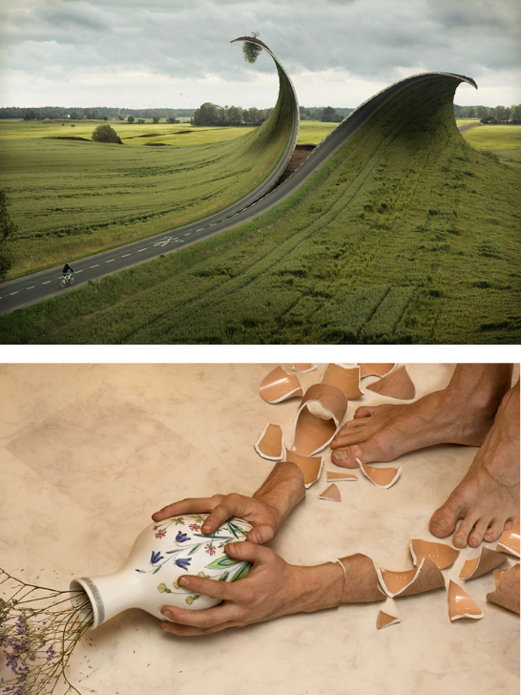
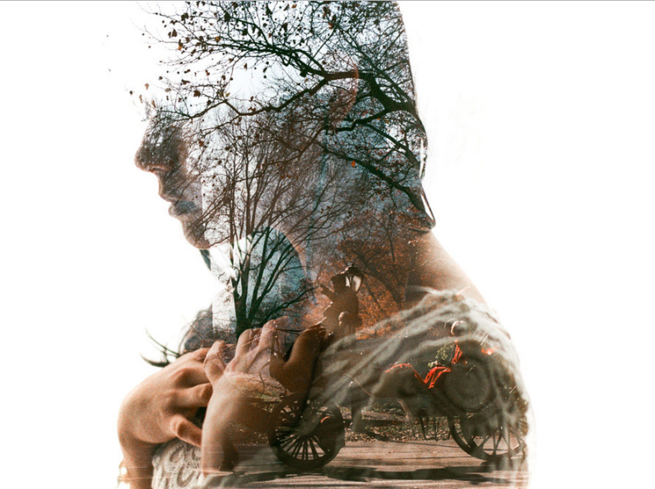
Multiple exposure refers to combining and layering multiple photographs. It is a technique that has been used long before the days of digital cameras in order to manipulate a photograph. Through film cameras this can be achieved by exposing the film multiple times via opening the camera shutter multiple times. This can often be done accidentally or with intent when aiming to achieve certain artistic purposes. The image shown to the right has been taken by photographer Eric James using 35mm film and shows an example of multiple exposure used with artistic intent. The existence of this photo manipulation technique allows for a fascinating and captivating image. This technique can also be done digitally via superimposing / layering images over each other and has been used favourably by artists such as Andreas Lie, Dan Mountford, Laurence Winram, Brandon Kidwell and so forth. Double exposure can most definitely be used as an argument as to how photo manipulation has allowed room for more creativity within photography.
Erik Johansson's work is also a perfect example of how photo manipulation can benefit photography and be used creatively and artistically. Erik Johansson shoots digitally and then vastly edits his photos in Photoshop using a range of required techniques in order to create surreal, fantasy like images that also, thanks to the aid of photo manipulation, look so real. Examples of his work can be seen to the left. Photo manipulation allows for creative, surreal ideas to be achieved, meaning an artist's imagination can run freely with no limitations. Other photo manipulation artists include Riccardo Bagnoli, Christophe Gilbert, Erik Alms, Frank Uyttenhove and Andric Ljubodrag. Photographers such as Erik Alms and Andric Ljubodrag also do a lot of work in advertising due to the eye catching illusive images they create. Erik Alms has created work for brands such as Microsoft, Toyota and Nike. Where we now branch into the topic of photo manipulation within photography is where questions begin to get raised on how ethical it is, or rather is this producing deceitful advertising? I find this to be a very interesting topic that I do intend to touch somewhat upon within my final dissertation.
Conclusion
In conclusion, I feel that photo manipulation is an incredibly interesting subject. There is definitely a wide enough range of different sub categories within this topic that I feel like I could do a lot of very in-depth research on it and cover a lot within my dissertation. In particular, I am mostly interested in the moral / ethical standpoint on photo manipulation. I do feel that photo manipulation has been incredibly damaging in terms of editing people to fit a western beauty ideal and therefore heavily push this beauty standard within mass media. However, this is because people have used photo manipulation in a damaging way. Photo manipulation has been incredibly beneficial in terms of breaking down creative limitations. The question really lies with, do the cons outweigh the pros? This is something I intend to really delve into within my dissertation. I feel this will be incredibly educational to me and very fascinating to research into.

