
Customer Warranty Concern
Six Sigma Green Belt

March 31, 2023
University of Wales Trinity Saint David – Adam Evans 2005959

Table of Contents
Table of Figures 1
Introduction 2
Company introduction 2
Assignment introduction 3
Define Phase 4
Measure 7
Tubeplate Castellation’s 8
End castellation 8
Side Castellation’s 9
Plastic Foot measurements 10
Functional Gauge check 11
Over foot measurement 13
Analysis 15
Hypothesis 1 18
Hypothesis 2 19
CAE Result 19
Hypothesis 3 22
Improve 23
Control 25
References 28

Table of Figures
Figure 1 -Marelli 3
Figure 2 - Image of leak area 6
Figure 3 -Test information 7
Figure 4 - Helium test information 7
Figure 5 - End Castellation Information 8
Figure 6 - Right end of tubeplate 9
Figure 7 - Left end of tubeplate 9
Figure 8 - Side clench 9
Figure 9 - Tank foot information 10
Figure 10- Top Tank measurements 10
Figure 11- Bottom Tank measurements 11
Figure 12 - QMS 214 example 12
Figure 13 - Over foot gauge check 12
Figure 14- Over Castellation gauge check 12
Figure 15 -Over foot measurement 13
Figure 16 - Table of results 13
Figure 17 - Table of result for returned cores. 14
Figure 18 - Rested core 15
Figure 19 - Ishikawa diagram 16
Figure 20 - CAE - Pressure Pulsation 19
Figure 21 - CAE on the tube plate 20
Figure 22 - stain gauge proposal 20
Figure 23 - part retested underwater. 22
Figure 24 - end clench 23
Figure 25 - 5mm to 9mm 23
Figure 26 - FEA Results 24
Figure 27- CAE 5mm to 9mm 24
Figure 28 - 9mm Tab 25
Figure 29 - pro type gauge 25
Figure 30- PFMEA 26
Figure 31- example control plan 27
Figure 32- extract from the SOS 27

Introduction

Company introduction
Marelli is currently the ninth largest independent automotive supplier, the factory shown in figure 1 below is of the South Wales facility which is part of the thermal solution division. This site was previously known as Calsonic Kansei but as part of a merger in 2019 with a company called Magnneti Marelli it became Marelli. Figure 1 -Marelli
The product base has stayed the same specialising in automotive heat transfer product in the form of engine cooling systems known as radiators and air conditioner components known as condensers. These are supplied to a range of customers which include Jaguar & Land Rover, VAG, Nissan and Stellantis.

Figure 1 -Marelli

Assignment introduction
When faced with a problem there are many tools and techniques which can been used to help solve the problem, these can provide structed approaches guiding you to follow and apply methods of problem solving, hopefully providing you with your desired outcome which would be identifying what is causing the problem. So that focus can then be applied to preventing the problem from happening or introducing something which can identify the problem within the process allowing you to deal with it accordingly.
One of these approaches and which is going to be used throughout this assignment is the six-sigma approach following the DMAIC structure.
DMAIC is the problem-solving approach that drives Lean Six Sigma. It’s a five-phase method—Define, Measure, Analyze, Improve and Control—for improving existing process problems with unknown causes. DMAIC is based on the Scientific Method and it’s pronounced “duh-may-ik.”
(goleansixsigma, 2017)

By using this approach and applying the five-phases-method Define, Measure, Analyse, Improve and control it will provide structure and a clear guide for fault finding as shown in Figure 1- DMAIC five-phase-method.
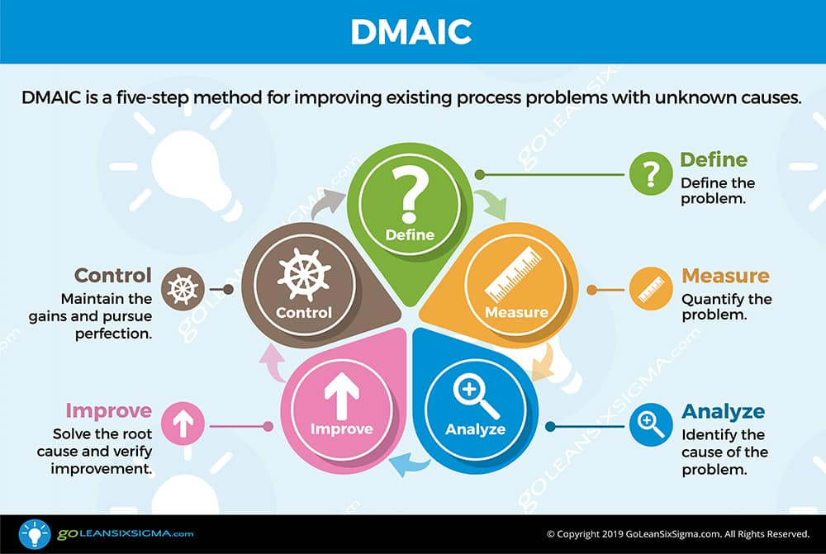
Figure 1- DMAIC five-phase-method

Define Phase

When defining the issue, it needs to be a short sentence which explains what the issue is, this sentence should be the path which guides you and should be refereed to as you progress through the problem-solving process, ensuring that you remain focused on solving the problem you set out to solve.
To do this the problem description which has been made by the person experiencing the issue, in this case a customer is expanding using the data provided to give a more defined description to focus on.
“A customer in the automotive industry has identified a trend in warranty failures.”
Using data which can be found on the customer portal, the statement made above stage can be quantified to show trend lines for recent years exposing the time in service to failure which component X has experienced. The graph below (Figure 2 - R/1000 Data for the last 7 years) shows the R/1000 data of the last 7 years, the image has been blurred due to sensitive information.

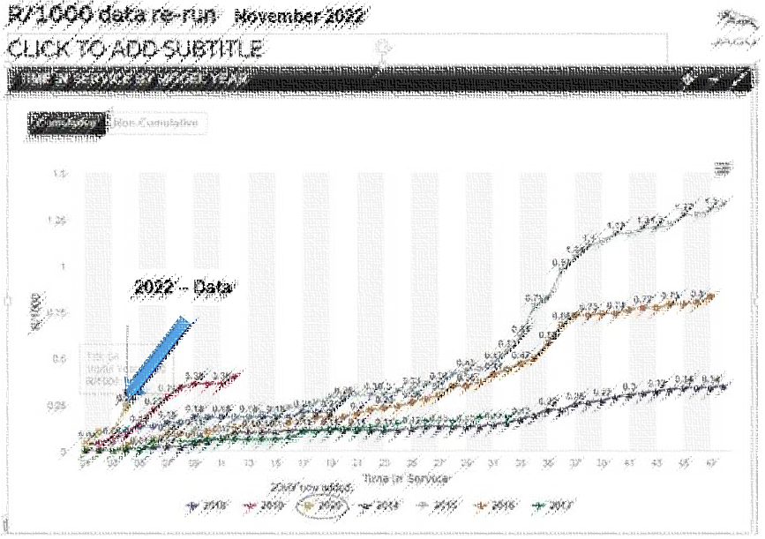
Figure 2 - R/1000 Data for the last 7 years

Other information which has been provided is the time in service for the 2 years which have been highlight for an unusual trend, this information along with the raw data shown in Figure 2 - R/1000 Data for the last 7 years, a full time line could be established of all the rejections globally during this time frame by plotting it in a simple bar graph. (Figure 3 - Time line 2021 and 2022)

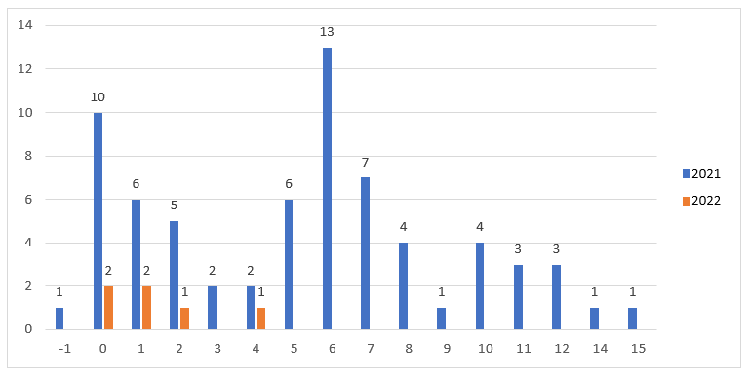
Figure 3 - Time line 2021 and 2022

What this graph (Figure 3 - Time line 2021 and 2022) shows is that all the failures have happened within the first 15 months of service spiking between with the first month of service and the sixth month.
Also provided were several components which has failed during the time in service. These were subjected to basic analysis to firstly confirm if they were leaking and secondary where the leak was coming from. To do this the returned cores is submerged under water and pressurised to 20 PSI for a maximum 3 minutes, stopping when bubbles start appearing from the leak area. Shown in Figure 4 - Image of leak area is where the bubbles appeared during this test.
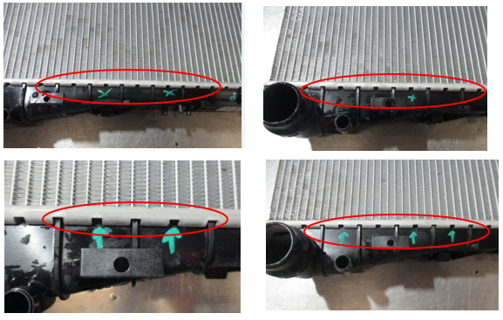
Figure 2 - Image of leak area

Also on the cores was identification that the parts had been end of line tested and passed in the form of a blue spray and also a pass barcode. This means that during the time they were manufactured and supplied to customer they were sound cores.
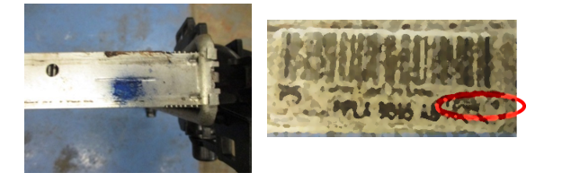
Figure 3 -Test information
With this information a strong define statement can be established.
“A customer in the automotive industry has identified a trend in warranty failures these are happening within the first 15 months of service effecting cars produced 2021 and 2022, the failure on the product is a leak coming from the clench area”.
Now that the issue has been defined a team can now be set up to work through the next stages of the DMAIC process, this will include engineering, process, R&D , customer STA , manufacturing and quality. The reason for such a diverse team is due to this being a warranty concern which spans over a length of time information will possibly be needed from all departments.

Measure

Using the above statement and knowing the dates of the failure the first item to check was to ensure that that the testing facilities are functioning correctly now and were they functioning correctly at the time the failures started happening.
Helium test data from the time of the concern originating shows it was functioning correctly and failing the calibrated reference leak during each shift startup check. Figure 6 - Helium test information, this test is performed on components prior to main assembly.
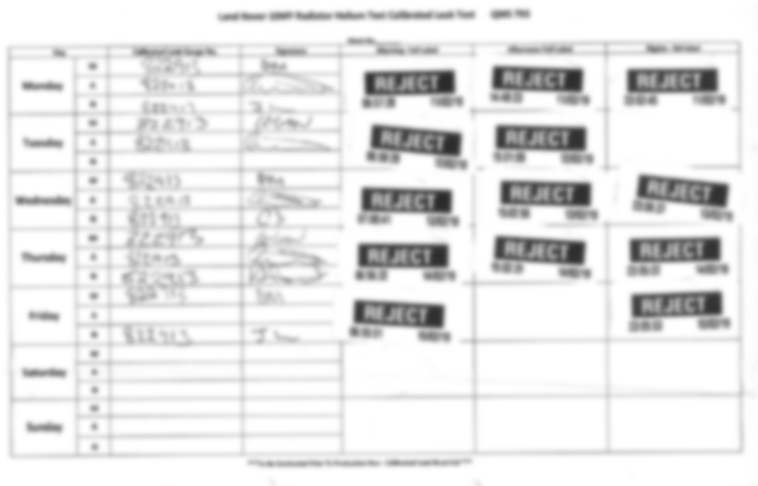
Figure 4 - Helium test information

The final test, which is a dry test or pressure test, is performed after the component is fully assembled prior to shipping. This is again is checked at shift start up and is done to ensure it is functioning correctly. Figure 7 - Dry test information
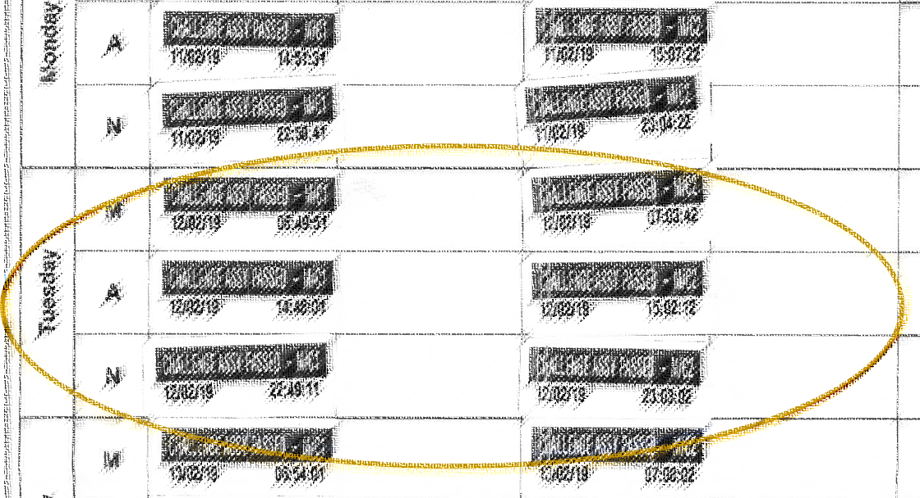
Figure 7- Dry test Information
Knowing that the testing machines are functioned correctly the components which make up the radiator and which could contribute to the failure seen need to be reviewed, this review will consist of the following
- Review of components that make up the sealing
- Tubeplate Castellation
- Plastic tank Foot height and Width
- Review of Clench Condition
- Functional Gauge Check
- Over Foot Measurement
- Seal Compression Check

Tubeplate Castellation’s

Breaking the tube plate down there are two measurements, which make up tubeplate castellation analysis this is the end castellation height and the side castellation height.

End castellation
Looking at the engineering drawing for the tubeplate and selecting the most recent version the spec could be established and the location where to measure.
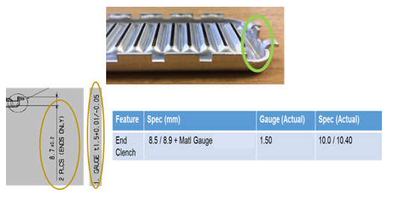
Figure 5 - End Castellation Information

Knowing the information shown in Figure 8 - End Castellation Information 30 parts were measured to give an N = value of 30, this will provide good sample size to conduct capability analysis on which N is a standard value.
“For Ultra’s capability studies, we inspect a series of parts for specific dimensions and then do a statistical analysis on the readings to determine if the manufacturing process is stable enough to hold the dimensions within spec consistently. The standard practice is to perform capability studies on 30 pieces”
(Swenson, 2020)
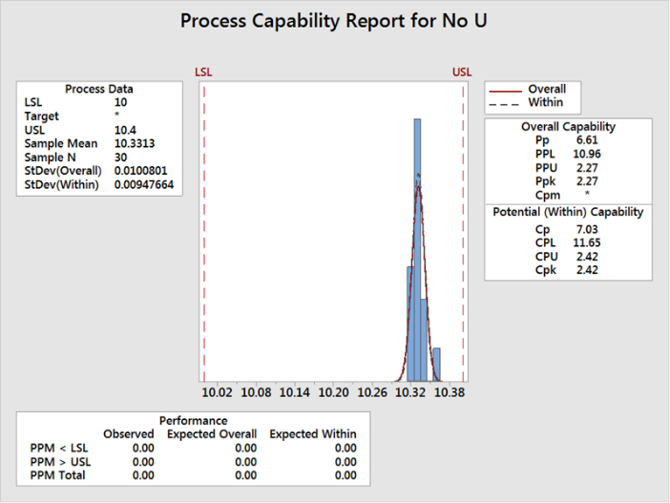
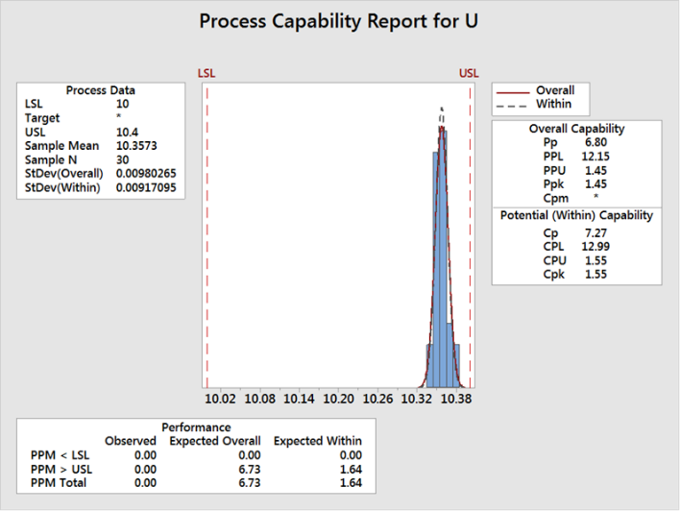
Figure 6 - Right end of tubeplate
Figure 7 - Left end of tubeplate
When the information is plotted to understand the capability of the part it is clear to see that both parts are repeatable although on the high end of the spec. With this being a pressed part, this is normal as the tools are made to top spec to allow wear in the steals allowing the full spec range to be used up during its life.

Side Castellation’s
Focusing on the area of concern identified during the define stage the location of the leak path was measured. The same process was followed as the end castellation measurement.
Figure 8 - Side clench
Again, the same profile was displayed in this graph as with the castellation being to the top end of the spec but capable.

Plastic Foot measurements

Component X is made up of two tanks, an inlet tank and an outlet tank these are both going to be measured as individual components.
Following a similar process as the castellation analysis, firstly the engineering drawings need to be obtained ensuring they are of the latest level from these the measurements and the tolerances can extracted.
For the plastic foot measurements, the key areas are going to height of the foot and the foot width
Foot height – this can govern the amount of pressure which is applied to the seal as if the height is less than the spec the tubeplate castellation’s won’t apply enough pressure when clenched, and the opposite can accrue if the height was higher than the spec.
Foot Width – having a larger foot width it could prevent the tank entering the tubeplate preventing seal compression.
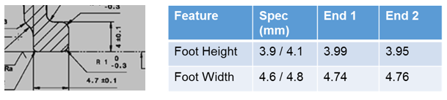
Figure 9 - Tank foot information

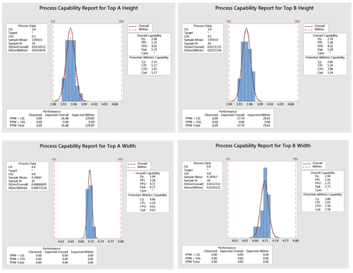
Figure 10- Top Tank measurements

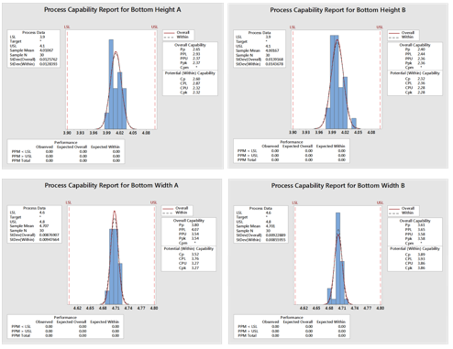
Figure 11- Bottom Tank measurements

The sample size was kept to N=30, these samples were also split into side A and side B of the tank to understand if there was a difference which might have been lost by combining the information.
What can be seen is that all the measurements are in spec, however on the top tank height it is skewed to the bottom of the tolerance but still has a good reparability. Like the castellation measurements a moulding process will work in reverse where sizes will grow as the tool wears due to abrasive materials used.

Functional Gauge check
On the production line there are two gauges which are used, and these are both GO /NOGO gauges these will provide an operator a direct answer to weather a part is in spec and not in spec. These are used to inspect over clenched castellation and over tank foot and will be conducted at the start of every shift or if there has been any maintenance intervention to the process.
As confirmation the check has been done the operator will complete their QMS 214 document which is their daily docket, as shown in Figure 15 - QMS 214 example.
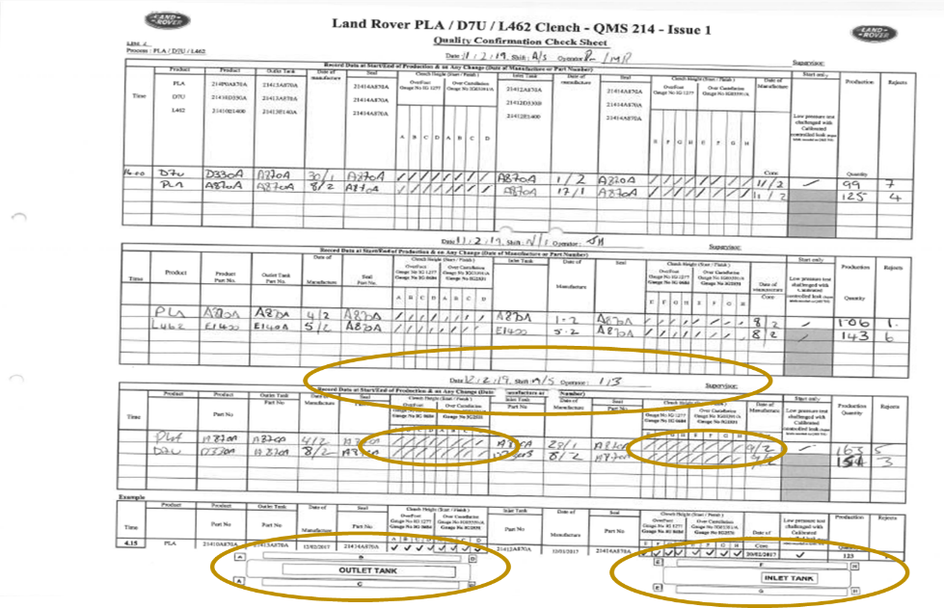
Figure 12 - QMS 214 example

These gauge checks were conducted on current production cores and also on the returned cores which were tested during the define stage.
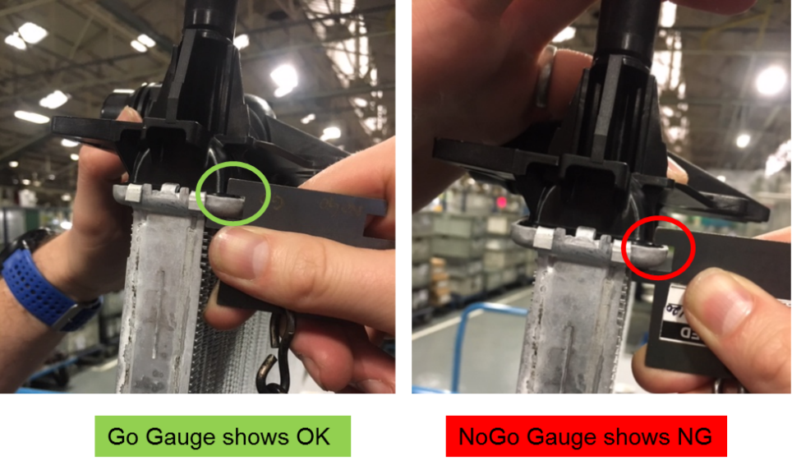
Figure 13 - Over foot gauge check

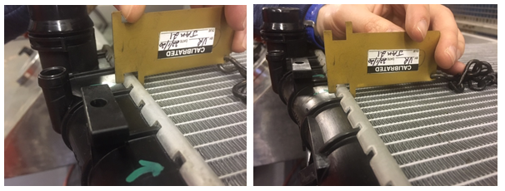
Figure 14- Over Castellation gauge check

During this check all the current production cores passed the gauge check, however the parts which were returned failed over castellation gauge in the location where the leak was witnessed during the air underwater testing in the define stage.

Over foot measurement
To provide more accurate information measurements were done using a vernier calliper on all four concerns of the cores as shown in Figure 14 -Over foot measurement
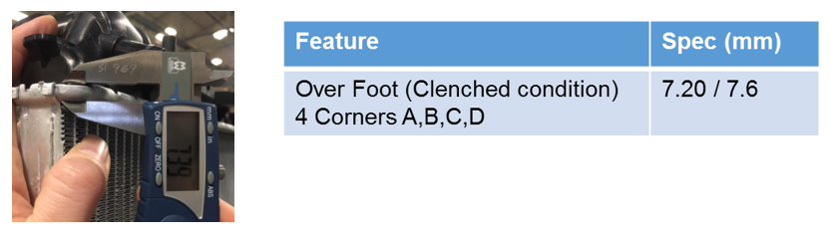
Figure 15 -Over foot measurement
For this check only 10 cores were measured which wouldn’t provide enough information for capability but an only good understanding of the condition we are seeing as show in Figure 15 - Table of results
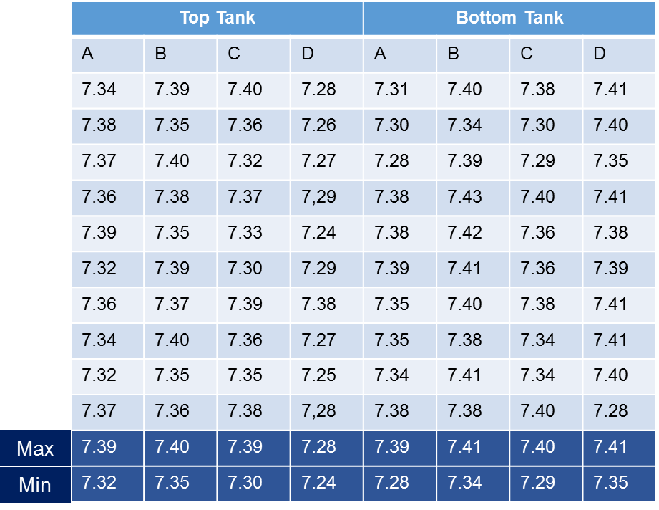
Figure 16 - Table of results
The same measurement was conducted on the returned cores but only in the area of the leak path
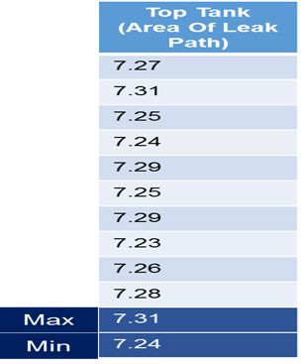
Figure 17 - Table of result for returned cores.
Seal compression
The final area to measure is the seal compression, the reason why this is done last is that the core has to be sectioned and possibly will prevent any other analysis on the core from taking place.
Below are images of a current production core and a returned core which have been sectioned in the area where the leak path was identified during the define stage. The spec which needs to be achieved is 1.9±0.2mm this is obtained from the engineering drawing.

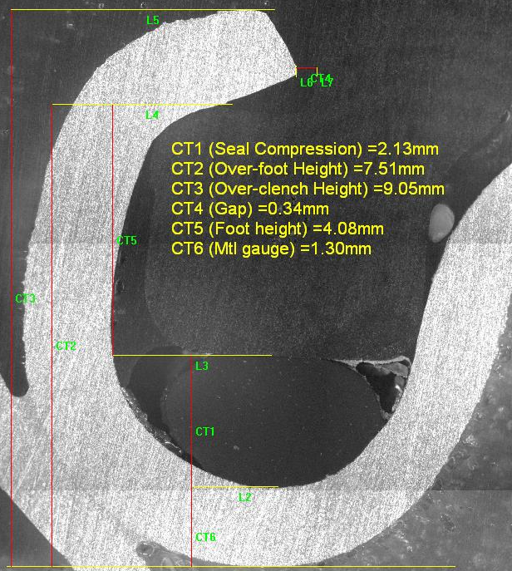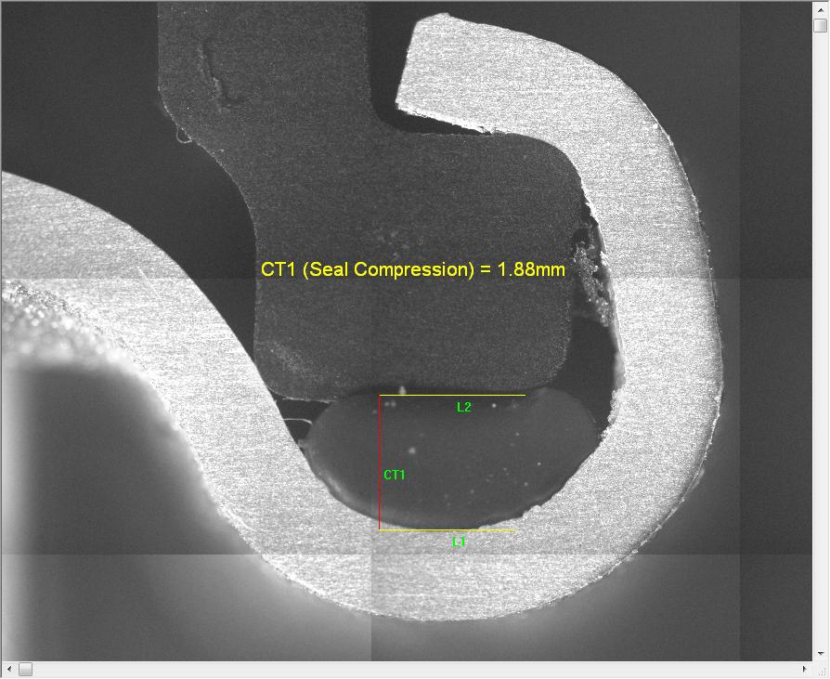

Review of the measurement stage
- Review of components that make up the sealing.
- Tubeplate Castellation – Complete
- Plastic tank Foot height and Width – Complete
- Review of Clench Condition
- Functional Gauge Check - Complete
- Over Foot Measurement – Complete
- Seal Compression Check – Complete

Analysis

Looking at the information which we have obtained during the measurement stage and it is clear that the part left MLUK as a sound product with no leaks present, current production cores pass online gauges after being through the clenching process. All currently production child parts have been measured are with spec.
The parts which have been returned have all failed the clench gauges which indicates that the clench has opened.
To prove this hypothesis a retuned core which had the known failure of leaking in the area of the clench was re-clenched at MLUK and then retested air under water, this information is shown in Figure 17 - Rested core
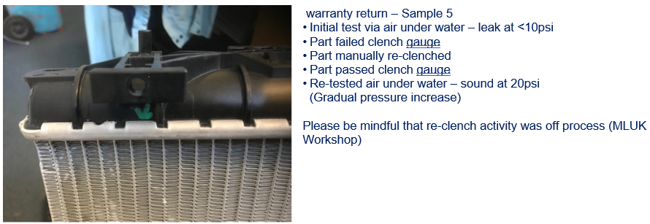
Figure 18 - Rested core
Form this analysis the it has been confirmed that the leak path was coming from the clench due to it being opened up.
To understand how this could be happening an Ishikawa diagram is going to done using the 6 main heading Method, Machine, Man power, Environment, Materials and Measurements this is shown in Figure 18 - Ishikawa diagram.
The fish bone has also been split into 3 separate categories which will chlorate the position where the radiator would be in the process.
- Manufacturing process – contrubited to poor clench
- Manufacturing process – After clench
- In-vehicle
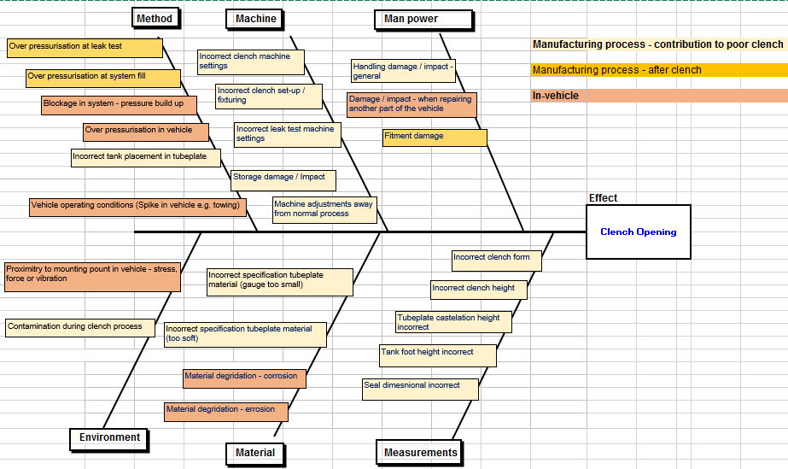
Figure 19 - Ishikawa diagram

Following on from the Ishikawa diagram each item which was identified under the manufacturing process – contribution to the poor clench window has been analysed. These have been displayed in the following images using the subheading for each concern cause, current control, and evidence.
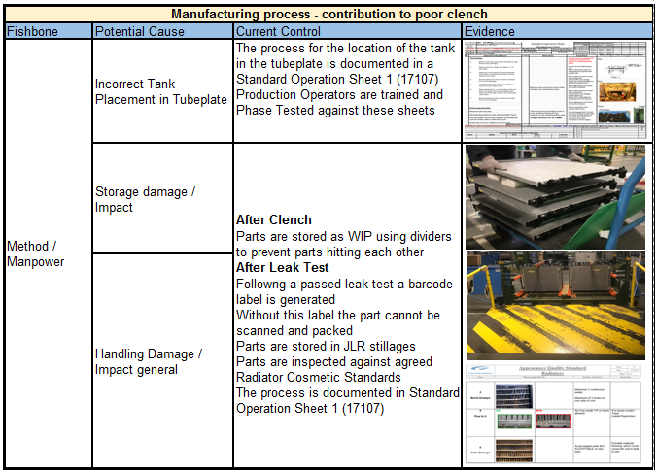
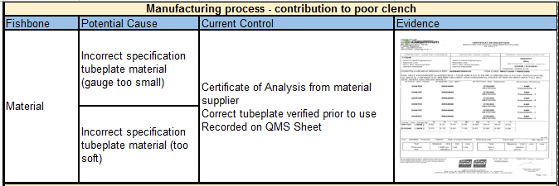
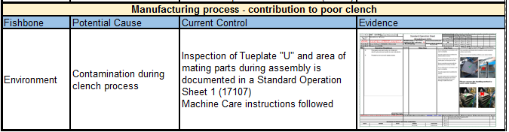
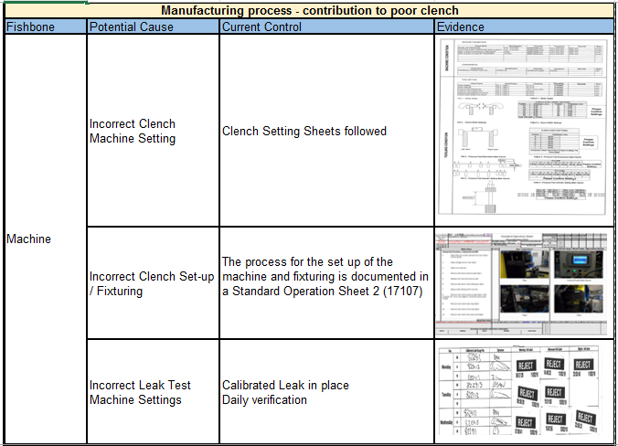
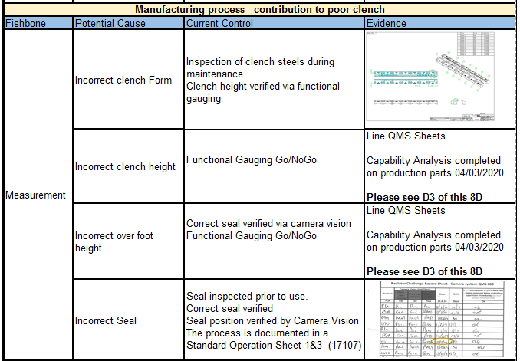

When each highlighted potential cause had been analysis, a review took place with the customer and the data so far was presented.
From this meeting several hypotheses were generated.

Hypothesis 1
All returned UK market parts are manufactured on 3 specific dates in February 2022 therefore variability of clench process on those days was root cause.
- Fishbone analysis previously completed and verified regarding normal production conditions – Line quality data and leak test machines records verified.
- Fishbone revisited to again verify the potential root cause of a change to the clench machine away from the normal process at the time of parts manufacture – machine setting and maintenance records verified that no changes were made to normal machine setting during the time of manufacture

All of the above point have been answered however the Hypothesis will be again reviewed if another part is returned to MLUK

Hypothesis 2
Part are all failing in a localised area on radiator therefore this is root cause
Using a simple Is / Is Nots to expand this hypothesis.
IS | IS Not
Top tank only | Bottom tank
One side of the top tank | Both sides of the top tank
Localised in the area of mounting point | Is not scattered along the clench

MLUK plan: -
- Re-run CAE to confirm high stress locations.
- Measure radiator samples from Plant
- Strain gauge above samples
- Run test and record strain results.

CAE Result
Boundary Conditions – Pressure Pulsation Spec: - Temp 120° C, Pressure 3 bar
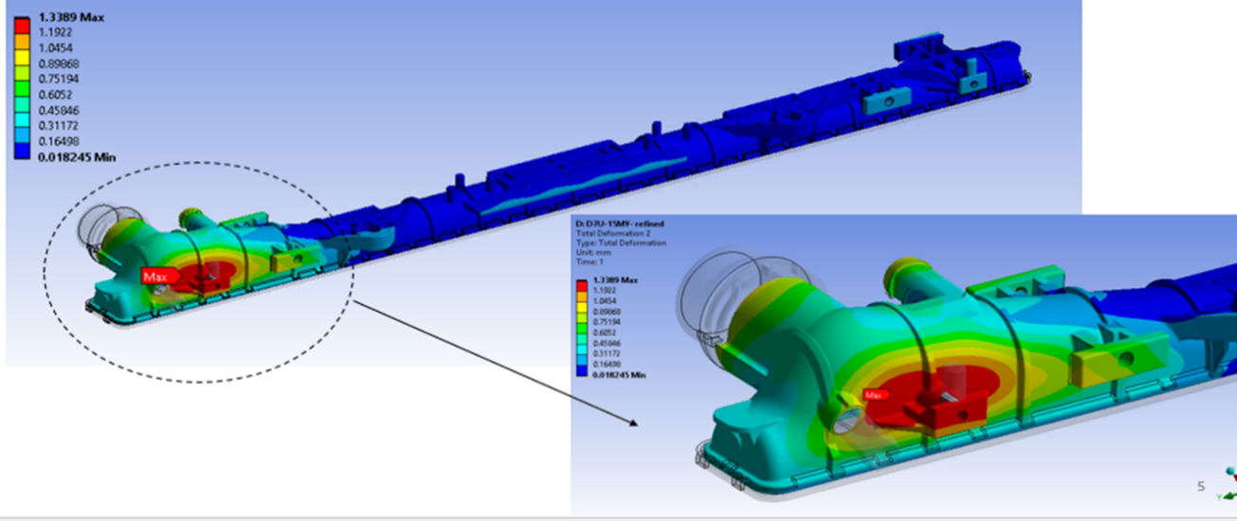
Figure 20 - CAE - Pressure Pulsation

From this analysis it is clear to see that there is a high stress point on one of the mounting points located directly behind an inlet port on the tank. This collocates to the location where the leak path is being seen.

Looking at the tube plate during the same CAE analysis also shows that the castellation tabs receive the highest level of stress in this location. Figure 21 - CAE on the tube plate

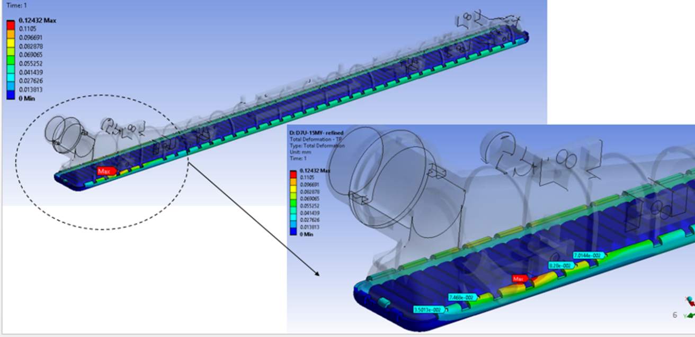
Figure 21 - CAE on the tube plate

Following on from the CAE analysis strain gauges were added to suspected area on a core and this was subjected to the customer specification of thermos cycling and pressure pulsation. Two positions to how the strain gauge was going to be positioned were proposed, but option one was chosen shown in Figure 22 - stain gauge proposal due to the result of the failure mode was the tabs lifting upwards.
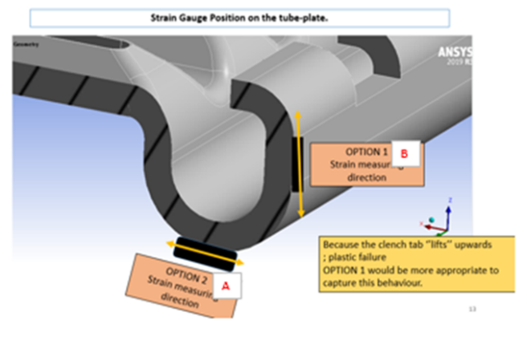
Figure 22 - stain gauge proposal

The results from the strain gauging were plotted onto a simple bar graph so that the coloration can be easily seen.

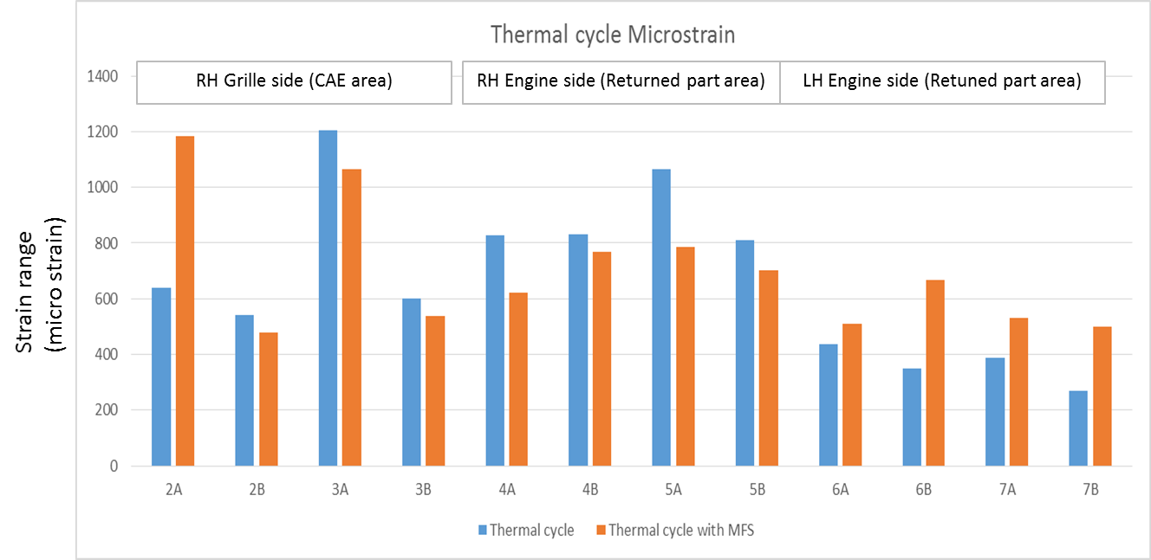

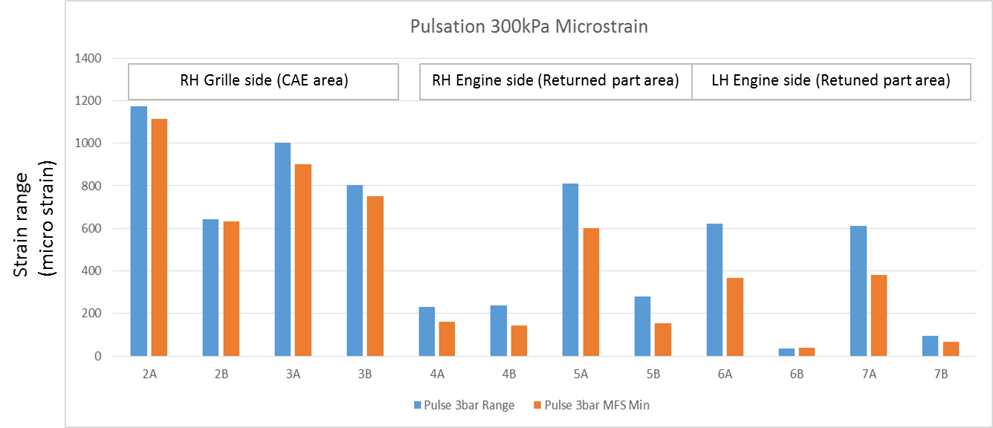

Conclusions
- Strain in field return area is lower than CAE area.
- Highest strain seen is in same area as CAE highest strain (inlet tank-pipe, grill side)
- No significant change in strain when MFS is added.
- Design is fit for purpose and shows no abnormalities.
- Hypothesis Rejected

Hypothesis 3

The customer offered to take a rejected part back and conduct a CT scan of the whole top tank and clench area, the outcome from this has provided very valuable information.
The side clench in the areas identified via air under water testing shows good seal compression, whilst there is no leak at the end clench with limited seal compression.
The actual Leak path is not in the area identified – it is starting at end clench and tracking along radiator to an escape point as seen, therefore this is the root cause.
Team proposal: -
- Conduct air under water leak test on next return parts to again pinpoint long side leak points - MLUK.
- Pressurize above radiator at temperature (with long side leaks) with coolant, check leak location – MLUK / Customer
- Install above radiator into car and run vehicle, check leak location – Customer.
- To manufacture part away from process with no end clench
- To conduct thermal shock test and monitor leak path.

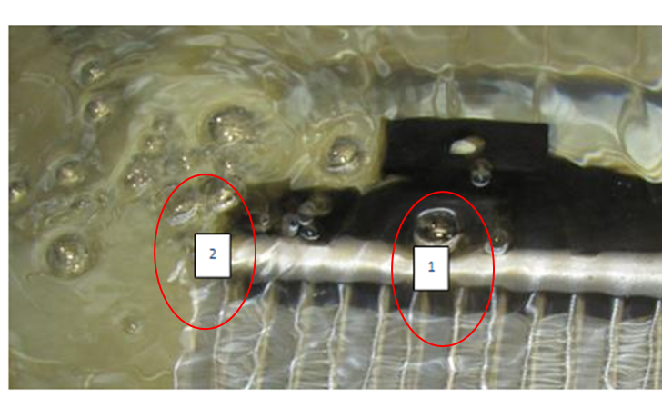
Figure 23 - part retested underwater.
Keeping the part under water for a longer period of time identified when it was pressured showed that the bubbles started off in the area as shown previously indicated by a number one in Figure 23 - part retested underwater. But then tracked along the tubeplate and became evident to be coming from position two, which is the area identified by the customer in the CT scan.

A part made replicating no end clench presence and subjected to thermal shock, the part failed this test and leaked in the area of the end clench proving the importance of this feature. Figure 24 - end clench
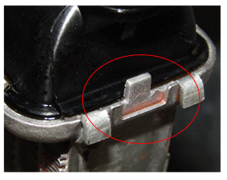
Figure 24 - end clench

Improve

What we now know
- All the returned parts from the UK market have all been subjected to end TAB clenching.
- At the time of the concern parts being made on the process were checked using online gauging and passed.
- All returned parts have been though and passed all line testing.
- All parts had been through and passed system fill at the customer.
This information shows that the end TAB is opening when the core has been fitted to vehicle and is being used by the end user. Meaning that the end TAB clench is robust enough for its designed operation.
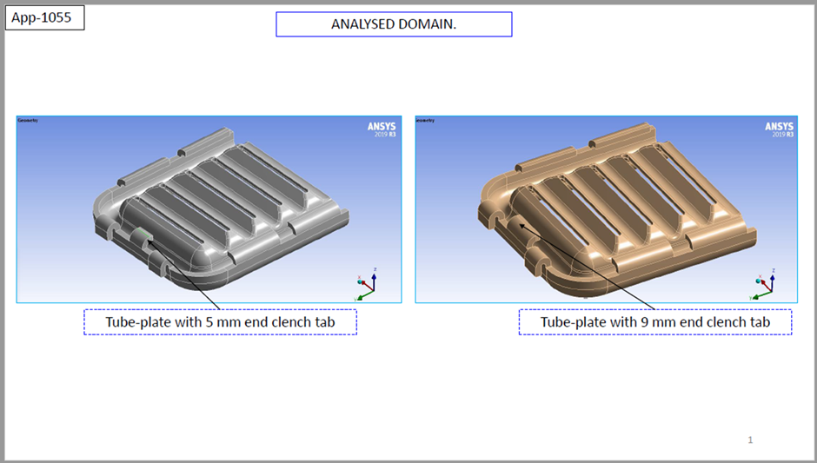
Figure 25 - 5mm to 9mm
The current process uses a 5mm end TAB if this was increased to a 9mm TAB as shown Figure 25 - 5mm to 9mm , the amount of deflection would decrease by 35% shown in Figure 26 - FEA Results. Also, in the deformation CAE analysis Figure 27- CAE 5mm to 9mm

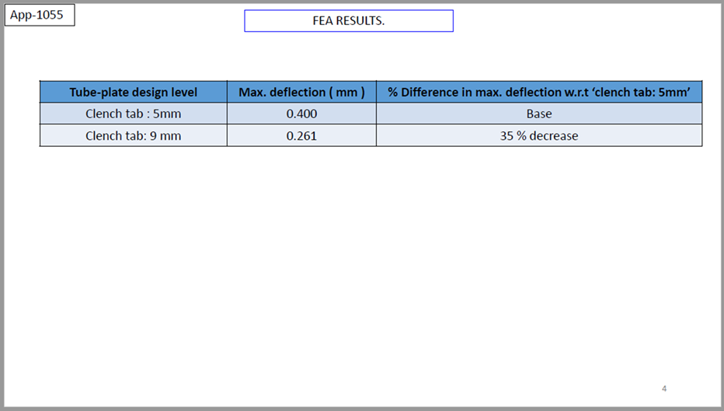
Figure 26 - FEA Results
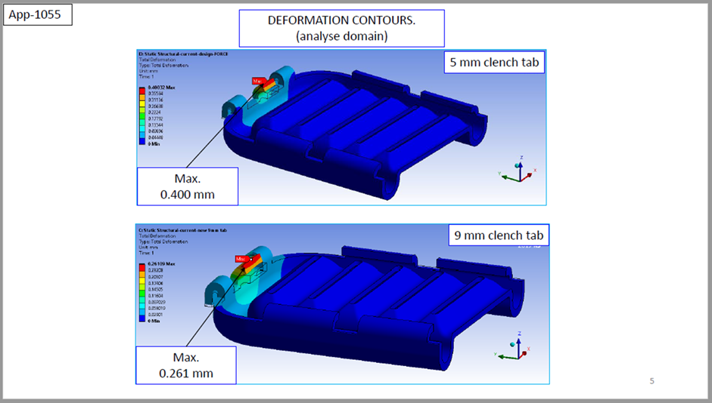
Figure 27- CAE 5mm to 9mm
Using a tubeplate with a 9mm will provide a MLUK with a better part, from this evidence the decision was made to modify the press tooling and produce a sample part so that testing could be conducted, and measurement studies done.
When sample tubeplates were made these were used to build sample cores and sent for sent for testing, these included pressure pulsation testing and thermocycling
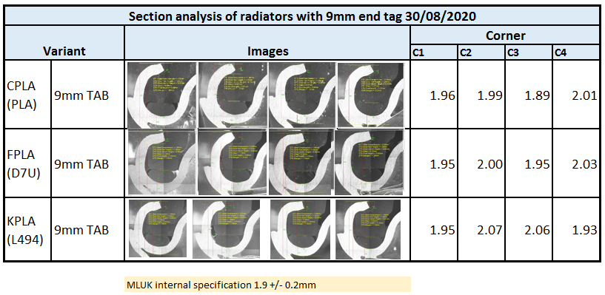
Figure 28 - 9mm Tab
When the core had finished and passed these tests, they were subjected to measurement analysis shown in Figure 28 - 9mm Tab, this shows that the cores are within spec after all testing has been completed.
All this information is currently with the customer as this need to be approved by several function.

Control

To ensure this failure mode is captured in the future a lesson learnt document will be updated which will be reviewed at the DFMEA stage of the process.
Additional gauging could be looked at which has more focus on the end tab condition as currently this feature is not specifically checked to ensure it is clenched over correctly, prototype has been made and is shown below Figure 29 - pro type gauge. This check will be updated onto the operator QMS sheet to ensure this check is done at the start of every shift.
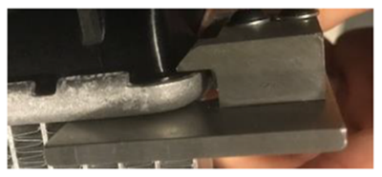
Figure 29 - pro type gauge
When approved the following will be updated
- DFMEA
- Drawing
- PFMEA – example of updated PFMEA - Figure 30- PFMEA
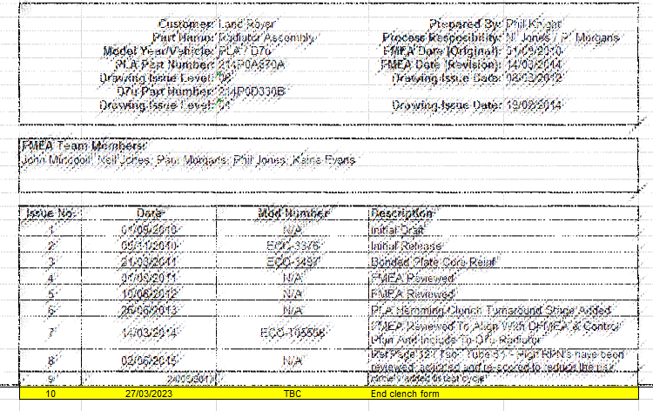
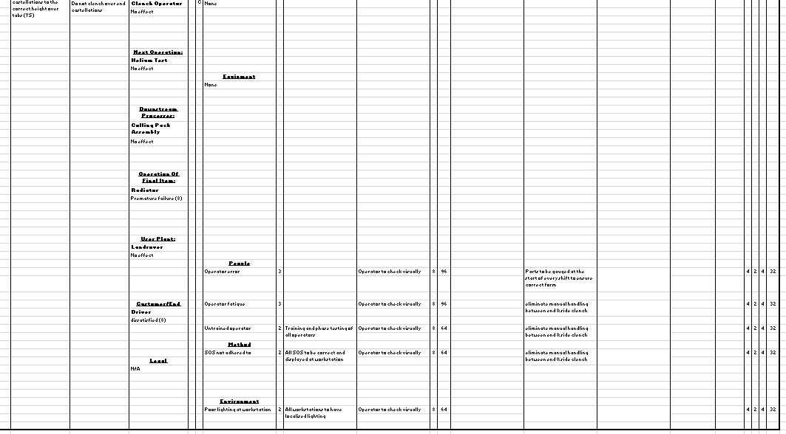
Figure 30- PFMEA
- Process Flow Charts
- Control Plan – example of updated control plan - Figure 30- example control plan

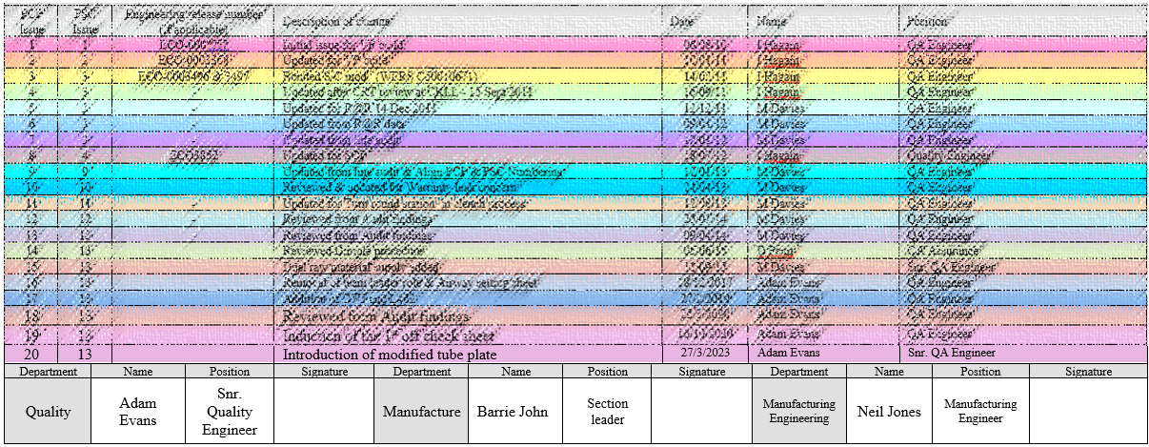
Figure 31- example control plan
- Work instruction - Figure 31- extract from the SOS
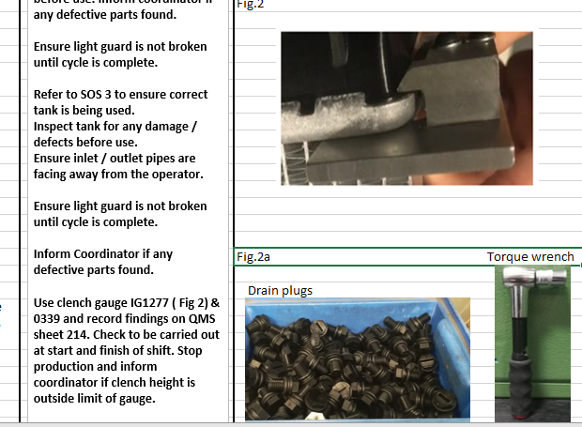
Figure 32- extract from the SOS

References
goleansixsigma, 2017. https://goleansixsigma.com. [Online]
Available at: https://goleansixsigma.com/dmaic-five-basic-phases-of-lean-six-sigma/#:~:text=DMAIC%20is%20the%20problem%2Dsolving,duh%2Dmay%2Dik.%E2%80%9D
[Accessed 11 March 2023].
Swenson, A., 2020. https://www.ultratoolmfg.com. [Online]
Available at: https://www.ultratoolmfg.com/how-a-capability-study-verifies-your-metal-part-is-ready-for-production/
[Accessed 1 3 2023].
Terry, K., 2022. https://www.isixsigma.com/new-to-six-sigma/dmaic/what-dmaic/. [Online]
Available at: https://www.isixsigma.com/new-to-six-sigma/dmaic/what-dmaic/

