UNIVERSITY OF WALES: TRINITY SAINT DAVID PRIFYSGOL CYMRU: Y DRINDOD DEWI SANT

Unit Code: LCBB4004
Marketing Fundamentals

Nike Inc.

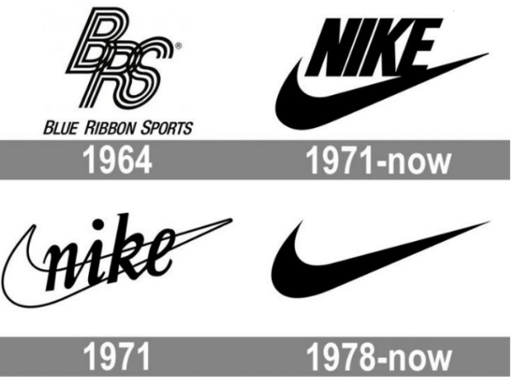

Student name | Ionut Adrian Voinea
Student ID | 2008573
Assignment title | Individual Report: The Effect of Globalisation on an Organisations’ Marketing Strategy
Lecturer’s name | Efua Adams
Submission date | 05th of April 2021

Introduction
Global economy trends
The global economy trends shown significant changes since the Cold War ending, noticing movements as China rise starting with 1980s, the development of digital economy al global level starting with 1990s, declining political cohesion in EU staring with 2016, reinforcement of climate policies, weaknesses in the role of international organizations, these events shaping a new global order (Welfens, 2020). In EU the main trend and political focus was on China rise, the ASEAN countries developed towards a single market becoming a considerable partner for EU. A first agreement between US and China was concluded in January 2020 but its implementation was highly impacted by the COVID worldwide crisis started in beginning of 2020. With a weakened Western world and less leadership form US, following 2020 elections, BREXIT added significant economic costs on UK and EU 27. Therefore, a global recession for several multinational companies is foreseen as these organizations will face lower domestic sales and negative investment and sales consequences (Cravino and Levchenko, 2017). Additional influences of COVID 19 crisis are visible in the products trade being should up by the new border controls and export barriers in 2020 first semester. As example, 75 countries added barriers for the export of medical suppliers and COVID 19 related medical equipment in early 2020 (FT, 2020). Following US November 2020 elections result, new trends are visible in the global economy: UL will look to set favourable trade agreements with ASEAN countries, intensifying the UK – EU rivalry through EU-ASEAN relationships. COVID 19 crises revealed the weaknesses of UK health system and government policies towards it, comparing the deaths in UK (40 000) in comparison with Germany (9 000) or Spain, Italy, and Belgium. An expected positive trend is linked to the ASEAN countries, in terms of reaching per capita income comparable with eastern European countries by 2030 (Welfens, 2020), these countries becoming a better candidate for political and economic cooperation.
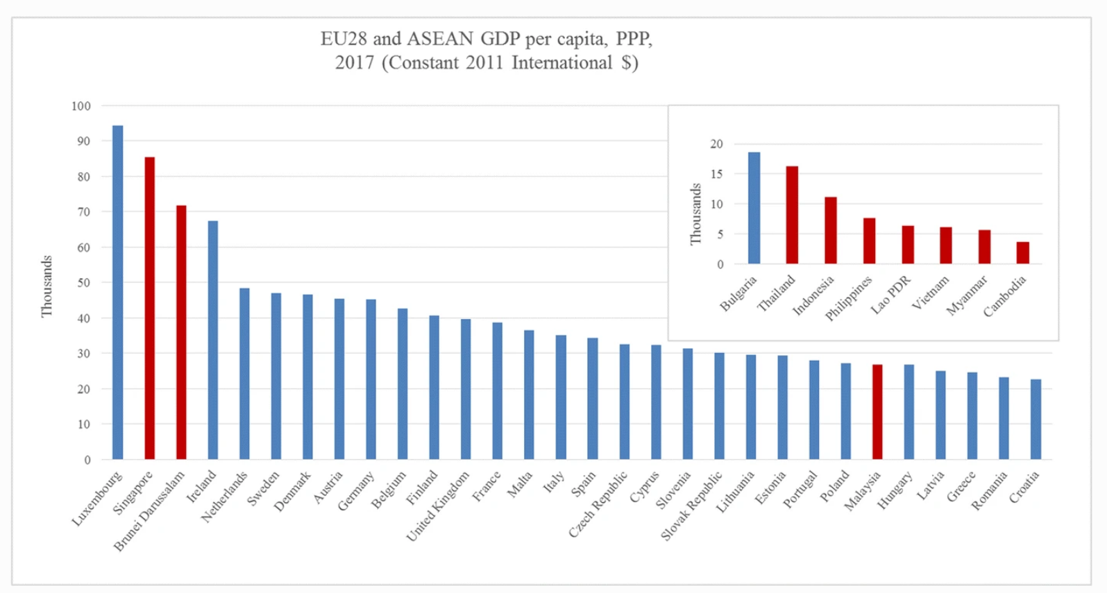
Figure 1: Per capita income (World Development Indicators, 2020)
The BREXIT will weaken the British pound international role (Eichengreen 2019), the ones that will benefit being US and Eurozone. Germany, an important EU economy shown an economic slowdown, negative effects are expected in Ireland, Belgium and Netherlands that are important export zones for Germany. The historical data from statistics shows that 45% of UK exports were directed toward EU27, therefore trade agreements between EU and UK will be a focus for UK negotiations, while EU will notice the challenges of lower UK corporate taxes. Expected trend is to see UK exports to Asia, EU-UK competition in ASEAN.
Related to the financial stability in global economy, the risk of COVID 19 to bring new financial market deregulations in UK and US is seen as a trend, fact that will add more pressure on EU countries to align with additional deregulation measures (Welfens, 2020).
Nike Inc. – organization details
The current essay is focused on Nike Inc. as chosen global organization, presenting in detail the marketing directions took in the global context to reach the current position of worldwide leader of apparel accessories and sports equipment industry.
Funded by William Jay Bowerman and Philip H. Knight on January 25, 1964 with headquarters in Beaverton, Oregon. Nike is the most valuable apparel brand in worldwide with a brand value estimated in 2020 at 34.8 billion U.S. with a 2 billion USD increase compared with 2019 (Statista, 2021).

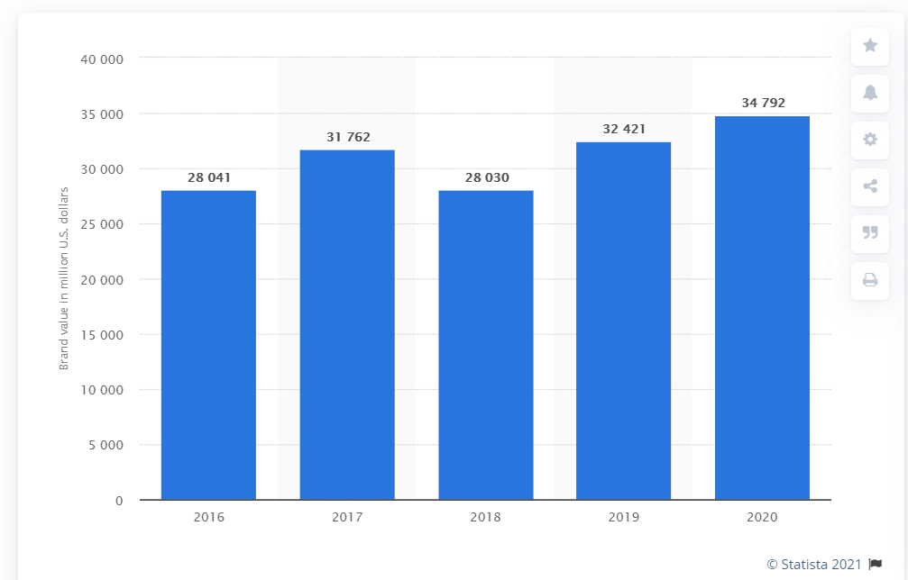
Figure 2: Nike brand value 2016 – 2020, in million USD (Statista, 2021)
Between 1964 and 1978 the company was known as Blue Ribbon Sports, Nike (coming from the Greek goddess symbolizing victory) becoming the new company name in 1978 and in 1980 become a public company, Nike Inc. (Britannica, 2021). The curved check mark as logo is recognized worldwide, the company operates with its outlets in 170 countries. The business was expanded starting with 1980s with a diversification in product line and acquisitions, mentioning here: Converse Inc. (2003), Umbro (acquired in 2008 and sold in 2012), Canstar Sports (1994).
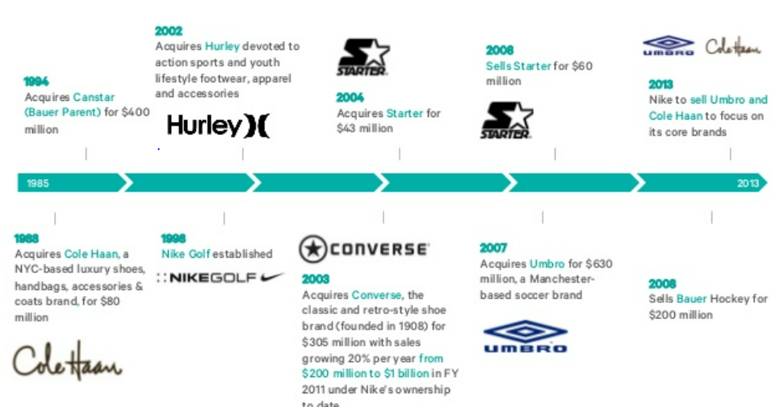
Figure 3: Nike acquisitions

As a separate line of business, in 1996 Nike ACG (All Condition Gear) was developed to market dedicated products for extreme sports. Beginning of 21st century and its technological developments shown new products on Nike portfolio, as heart rate monitors (portable) and wrist compasses for high altitude (Nike, 2021). During years Nike was endorsed by famous sportsmen, mentioning here Michael Jordan, Roger Federer, Tiger Woods, Mia Hamm. Some negative impact on company image was added in 1990’s by the information revealed in regard with poor working conditions in some of Nike factories (Britannica, 2021). From revenue perspective, in 2020 Nike generates 41% of its total revenues from America (14.5 billion USD), followed by EMEA (26%), China (19%) and APLA – Asia, Pacific, Latin America (14%). (Statista, 2021).
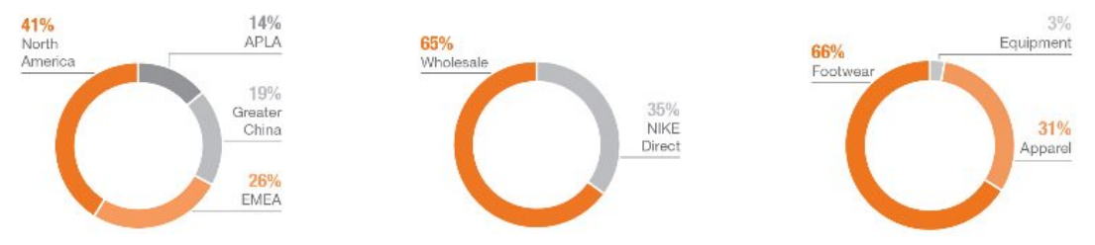
Figure 4 Nike brand revenues 2020 (Nike Annual Report, 2020)

Nike acts in a highly competitive global market, its main rival being Adidas, followed by Puma and Under Armour, Nike being the market leader worldwide.
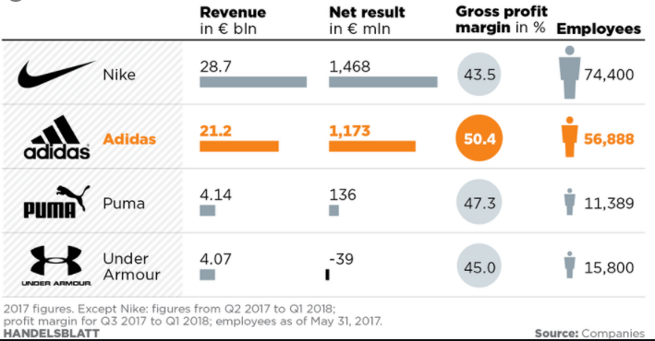
Figure 5: Big sports rivals
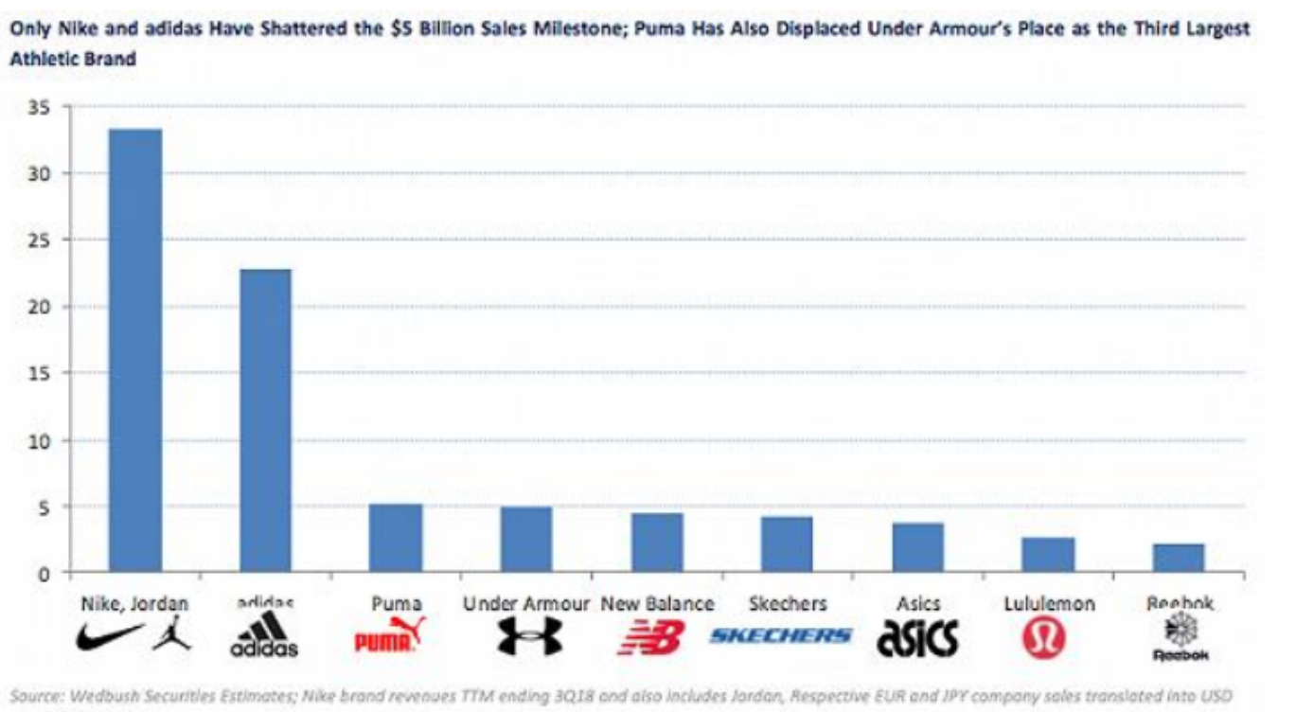
Figure 6: Nike competitors
According to Statista (2021), Nike brand value worldwide in 2020 was 34.8 billion USD, while Adidas (main competitor) was ranked at a half brand value, 16.5 billion USD in the same year.
2020 shown a 33.52% maker share for Nike worldwide, while its competitors reached 66.48% (CSI Market Stocks, 2021).
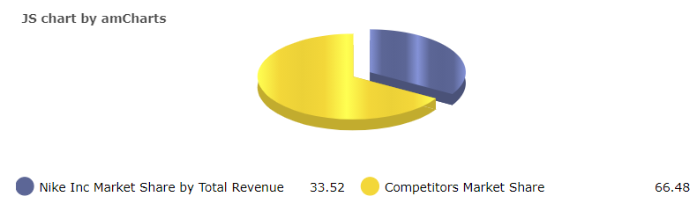
Figure 7: Nike market share 2020 (CSI Market Stocks, 2021)

The global economic factors affecting Nike are linked mainly by the uncertainty of global economy and financial market conditions, mentioning here: declines in consumer spending, access to the capital markets at reasonable rates, risk of currencies fluctuations, volatility of commodities and raw material prices (cotton and derivates from petroleum), retailers decline due to the 2020 lockdown conditions (Nike, 2021).
Globalization details
Globalization is a day-to-day reality in human lives, being understood as the movement of ideas, people, money, goods, weapons, biological threats (viruses), started centuries ago with the network trade routes between India, Europa, China, and Afro Asian landmarks. The news added by globalization nowadays resides in the enlarged scale, fastness, and the range of movements across borders, with complex effects in people and organizations lives. As example, technology allows nowadays people to be in contact with friends across the globe and be in line with worldwide news. The international supply chains evolved rapidly, the technological development and automatization are universally used in manufacturing processes, significantly influencing the labour market. Crisis, financial or medical are expanded also globally, reminding here the 2008 financial crisis and 2020 COVID 19 medical crisis. The impact of globalization is a reality today with both positive and negative outcomes, still governments can initiate actions to respond, actions completed by the international organizations. As example, governments can support or block trade investments, people migration, communication, and internet traffic. International market environment is characterized by additional factors in comparison with the ones influencing local environment (Ghauri and Cateora, 2016). The controllable (SWOT) and uncontrollable (PESTLE) factors from the domestic environment are completed by the additional factors from uncontrollable foreign environment.

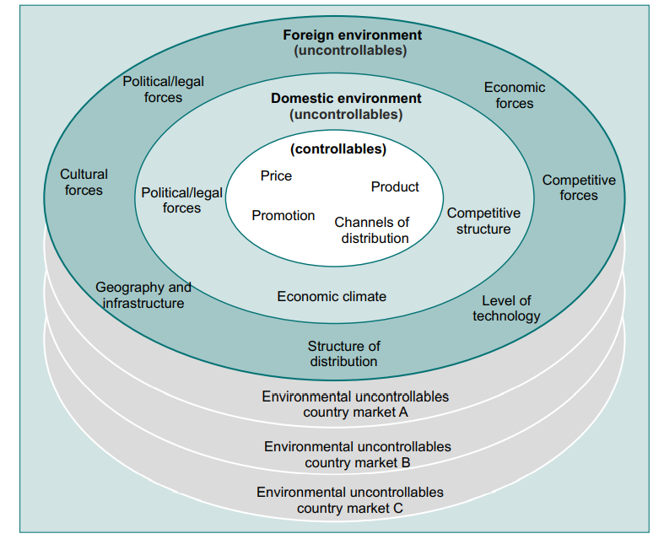
Figure 8: International marketing (Ghauri and Cateora, 2009)
An evaluation of advantages and disadvantages of globalization for Nike Inc.is presented in below table:
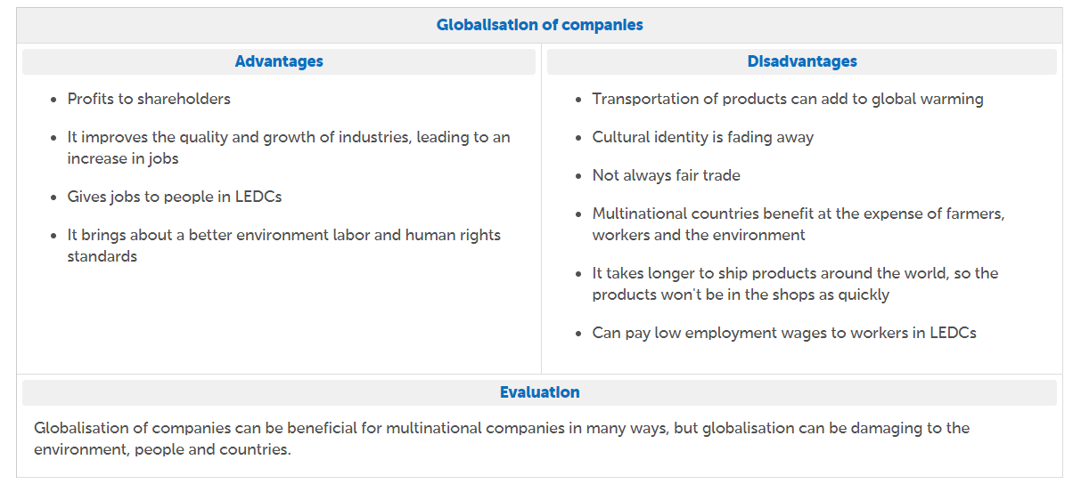
Figure 9: Globalization advantages and disadvantages, Nike Inc. (designed by author)

Main body
Marketing Directions adopted by Nike Inc. in global context
From the product and brand perspective, Nike was criticised by the anti-globalization representatives, still its efforts to promote an image that become is an international success, becoming a symbol that goes beyond borders and languages and took all opportunities of globalization. Both standardization and the local approaches were embraced under Nike shared values and attachment to the brand from emotional perspective. Originally, Nike was known by customers as a manufacturer of sport shoes, helping the company to build the organization ethos. Initially phase, 1964 – early 1970s, the company, known as Blue Ribbon Sports, was a distributor for running shoes manufactured by other companies (including ones from actual competitor, Adidas). In 1971 the company took two important actions: changed the name into Nike and develop the business towards designing, promote and distribute own products – running shoes (Gratton et al. 2012, 58). A new logo was designed in 1972 by a student to sustain differentiation strategy, Nike Swoosh being adopted as the main logo of the company.
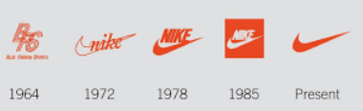
Figure 10: Nike logo evolution (Nike, 2021)
The initial values Nike promotes were linked to the credibility of the products - linked to the university athletics – were later expanded towards the athletes’ market as a niche adopting specific marketing tools in terms of product distribution, sponsorship and strategic advertising that valued the products in the elite competition. Nike visibility in that era was ensured by the gifts offered to the athletes competing in American Olympic trials (1972) positioning Nike as a an elite one in sports, generating additional demand for the products from different disciplines. In 1973 Nike concluded the first sponsorship for a athlete (Steve Prefontaine), opening the long road of start endorsements in company evolution (Nike, 2021). Same year marked the movement of the brand at international level when Romanian tennis player Ilie Nastase become number 1 worldwide player in tennis wearing Nike equipment, two objectives being accomplished: moving towards another sport and allow the brand to be known at international level.
Thus, a main strategy of Nike to become a global player in sports equipment market was to extend the sponsorships with sportive from the global elite. As example, in basketball in 2012 Nike sponsored two out of four final teams, 54 teams in NCAA division 1 and 10 out of 16 national championship teams (Jessop, 2012).
Product
From the marketing mix perspective (4Ps), Nike adopted global strategies to growth, adopting a strategy to continuously invest in research and development of new products and improved versions of the current ones. Thus, the company used 2 or more strategies from Porter’s (1980) generic model, cost leadership and differentiation strategies being the most used ones (Gregory, 2017). Using the cost generic strategy Nike minimized production costs to increase profitability or reduce price. In the 1990s reduced selling prices and costs for the category of athletic shoes with result in regaining its competitiveness against Adidas. The differentiation strategi was used by Nike through launching unique products, mentioning here the cutting-edge designs for the sport shoes (Nike, 2021). Combining these two strategies allowed Nike to boost its position at global level, continuing to follow the cost leadership strategy by integrating latest technologies in its manufacturing process in order to decrease the costs. Growth strategies adopted by Nike are linked to:
- product development (add new products in portfolio) to increase revenues from sales
Thus, Nike statement - “to bring inspiration and innovation to every athlete in the world” (Nike, 2021) outlines the innovation adoption in the design and manufacturing of its products
- market penetration is the second Nike growth strategy by increasing the revenues in the existing markets. As example, the increased number of stores and retailers in US aims to sell more products to the American customers and the increased number of authorized retailers expands Nike presence in existing markets worldwide
- market development, by continuously targeting new markets or customer segments. As example Africa and Middle East were considered as new entry points for Nike to generate additional revenue from athletic shoes sales
- diversification is the less applies strategy by Nike, referring at development of new business, being a strategy adopted by Nike in its early years when moved from the athletic towards other sports (tennis, basketball) (Gregory, 2017)

Place
There is a range of clear places were Nike made available its products: retail stores, Nike online store, Nike town retail outlets (owned by Nike Inc.). the retailers were the key significant distribution points for Nike to achieve its global objectives, including in its supply chain retailers As Walmart, Amazon, local and regional stores (Gregory, 2017).

Promotion
The tactics adopted by Nike to communicate with targeted customers implies a communication mix including advertising, personal selling, direct marketing, sales promotions, and public relations. Celebrities’ endorsements and important sponsorship contracts with recognized champions contributed in a significant way to the promotion of Nike as a global brand.
Price
The value-based pricing and premium pricing strategies are the two main strategies adopted by Nike, by influencing the customer perceptions about its products value. Thus, the perception of valuable products allowed company to set maximum prices for its products.
STP
From the segmentation perspective, positioning map shows high quality associated with high prices for Nike products, with Adidas, Puma, Under Armour, reebok as followers.
In its segmentation strategy, demographic factor is one of the adopted one, dividing the market by gender and age (Lutz, 2015). Geographic segmentation is also used, Nike customers being placed in various locations worldwide: Asia, Europe, Africa, North America. China, Japan, India is also considered with specialized products and=d marketing mix (Ahmed, 2016).
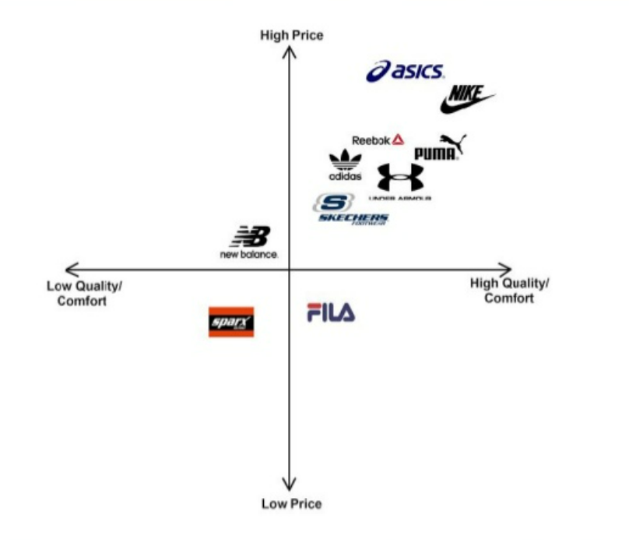
Figure 11: Nike positioning map

Based on PESTLE analysis for Nike, the company must follow an increased aggressive approach towards international expansion making use of the free trade policies available especially in high growth developing areas. Implementing this action Nike can overcome the potential decline in China. An important recommendation for Nike is linked to the negative publicity related to work conditions and sustainability, by addressing local regulatory concerns.

References

ASEAN (2018), EU-ASEAN Action Plan 2018–2022, [online] Available at https://asean.org/storage/2017/08/ASEAN-EU-POA-2018-2022-Final.pdf Accessed 25th of March 2021
Britannica (2021) Nike Inc. [online] Available at: https://www.britannica.com/topic/Nike-Inc Accessed 26th of March 2021

CNN Business (2021) Nike Inc. [online] Available at: https://money.cnn.com/quote/profile/profile.html?symb=NKE Accessed 25th of March 2021
CSI Market Stocks (2021) Nike market share, [online] Available at: https://csimarket.com/stocks/compet_glance.php?code=NKE Accessed 25^{6h} of March 2021
Cravino J, Levchenko A (2017) Multinational Firms and International Business Cycle Transmission. Quarterly Journal of Economics 132(2):921–962. https://doi.org/10.1093/qje/qjw043
Dess, G. G., & Davis, P. S. (1984). Porter’s (1980) generic strategies as determinants of strategic group membership and organizational performance. Academy of Management Journal, 27(3), 467-488.
Gregory, L. (2017), Nike Inc. Generic Strategy & Intensive Growth Strategies [online] Available at: http://panmore.com/nike-inc-generic-strategy-intensive-growth-strategies Accessed 28th of March 2021
Eichengreen B (2019) The international financial implications of Brexit. International Economics and Economic Policy 16:37–50. https://doi.org/10.1007/s10368-018-0422-x
Statista (2021) Nike brand value [online] Available at: https://www.statista.com/statistics/632210/nike-brand-value/ Accessed 25th of March 2021
Welfens, P.J.J. (2020). Trump’s Trade Policy, BREXIT, Corona Dynamics, EU Crisis and Declining Multilateralism. Int Econ Econ Policy 17, 563–634 https://doi.org/10.1007/s10368-020-00479-x
Youtoube (2021) What is globalization [online] Available at: https://www.youtube.com/watch?v=wLNp3kgBuuQ Accessed 20^{6h} of March 2021

