Name: Paul Richards

Student No: 0251968

Course: Applied Computer Networks and Cybersecurity

Module: Internet Technology and Security (ACCA4018)

Date: 22nd July 2019

Contents

Abstract 3
Requirements 4
Implementation 5
Validation 14
Validation of html page 14
Validation of the CSS page 17
Evaluation 20
Recommendations 22
Search Engine Optimization Techniques 23
Web Accessibility 24
Bibliography 34
Appendix 35
Attributions list 35

Abstract

The report covers the design of a beauty therapy website. The website is designed using HTMLv5,CSSv3 and bootstrapv4. The website will be tested to make sure it complies with HTML and CSS standards using the W3C organisation validators. It will also be tested to make sure it meets WCAG 2.1 accessibility standards using WAVE (Web accessibility evaluation tool) and google responsiveness tool.

Requirements

The website is based on a fictitious beauty therapy business. It is aimed at any member of the public who desires beauty treatment services.

The requirements of the website:

To promote the business and attract more customers.

To provide background to the business.

To provide a list of services offered by the business.

To provide a means for users to communicate with the business.

To provide information on the location of the business.

Implementation

Below are screenshots of the beauty therapy website. They cover all eight visible pages, index.html, about.html, treatments.html, gallery.html, makeuptip.html, contact.html, locaton.html, attributions.html. They also include the confirmation.html page, which is linked to the contact.html page.

Index.html

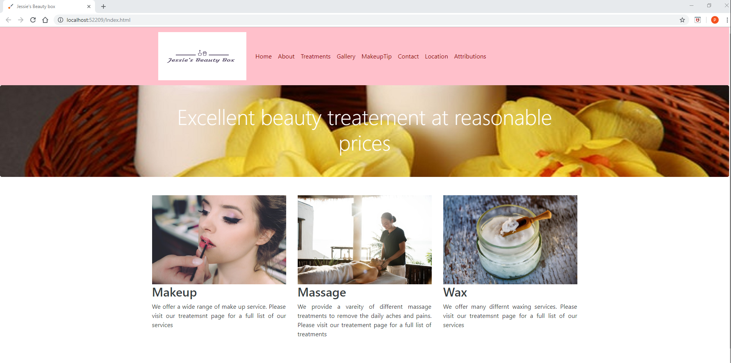


About.html

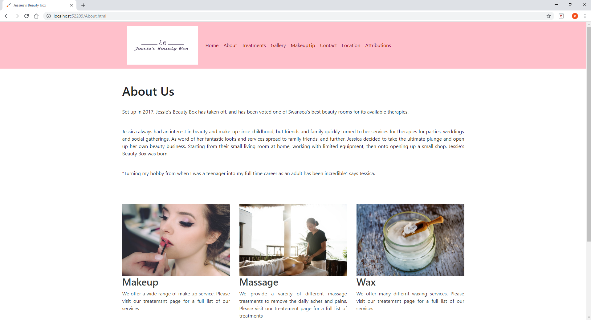


Treatments.html
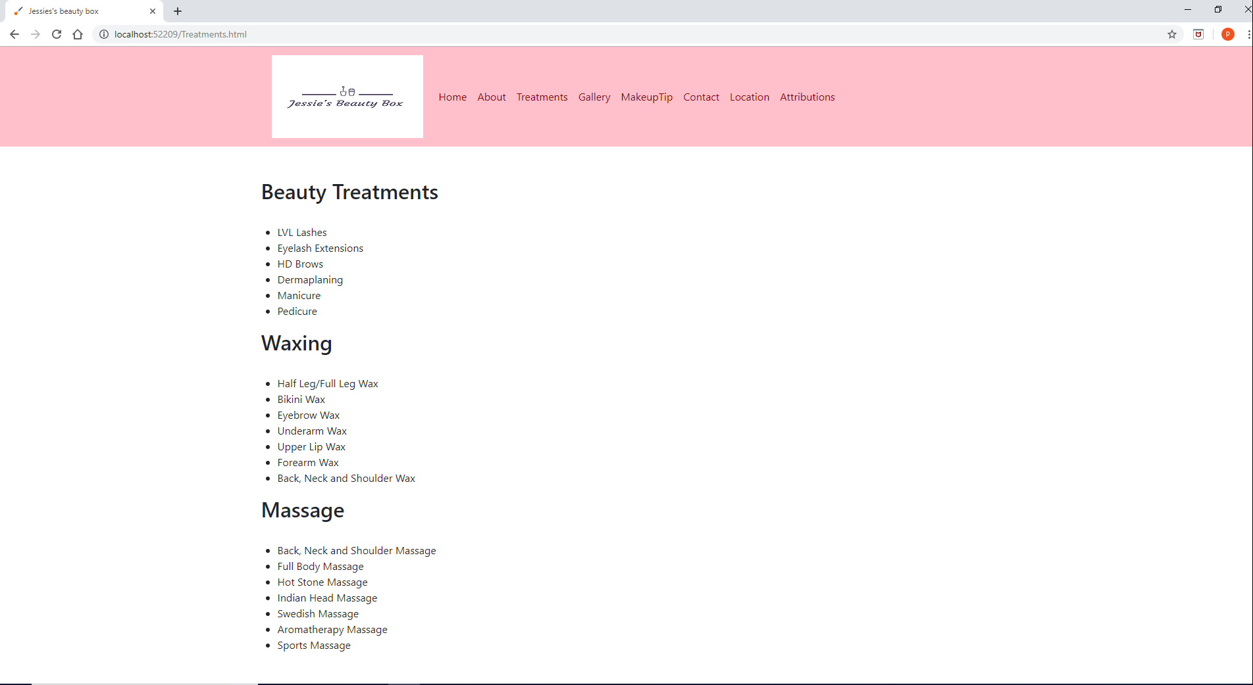

Gallery.html

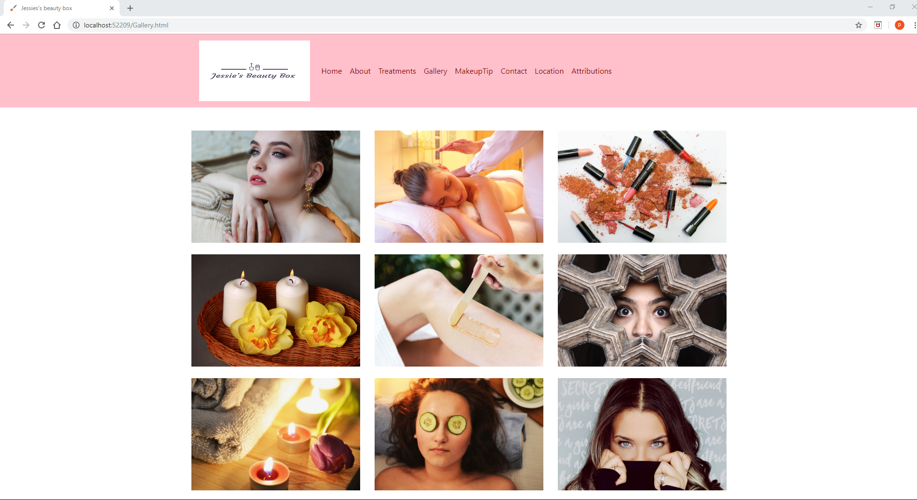

Makeuptip.html
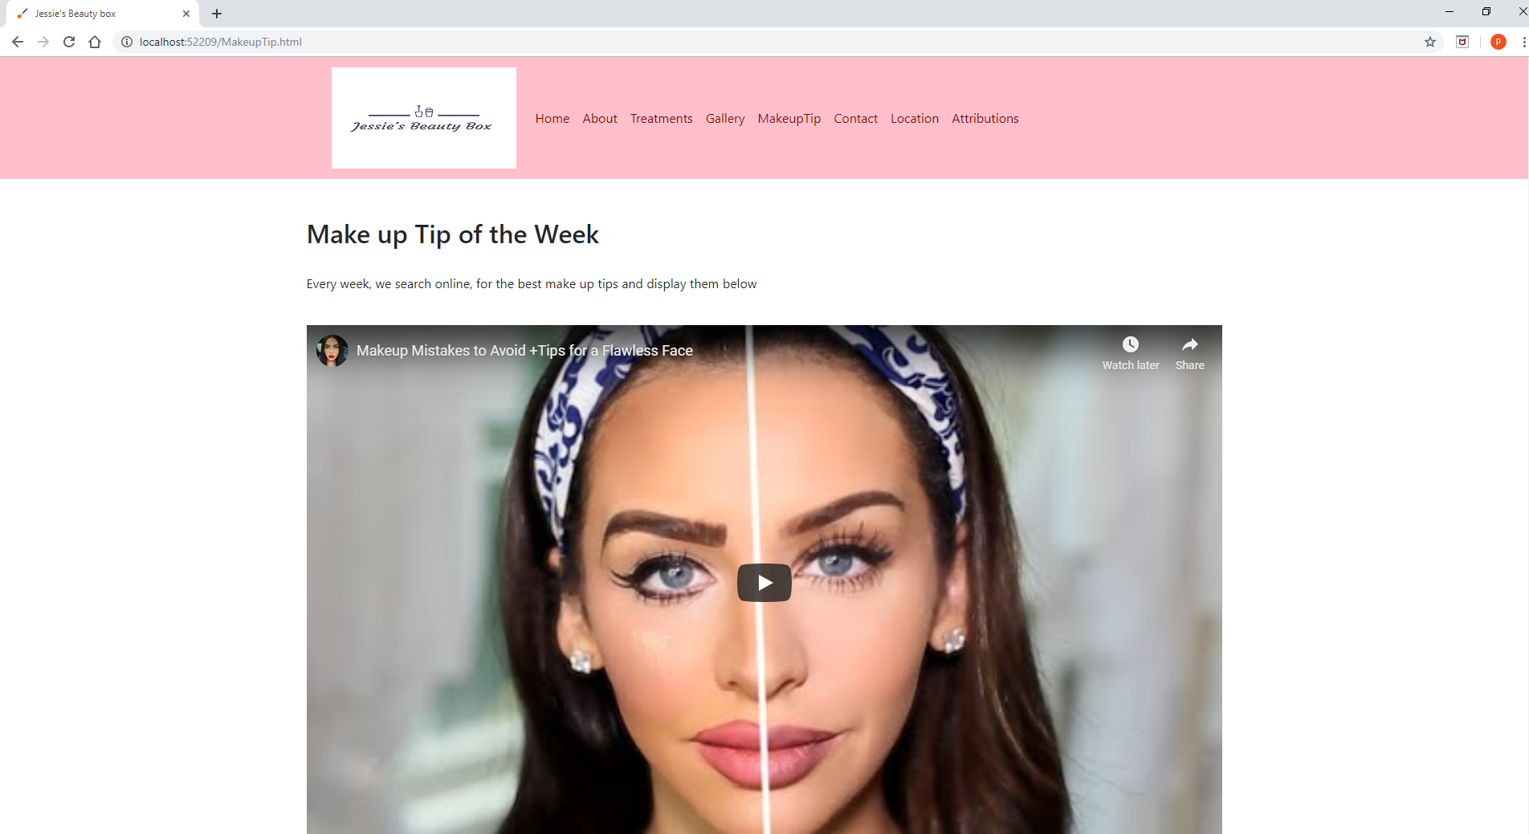

Contact.html and Confirmation.html

Contact.html

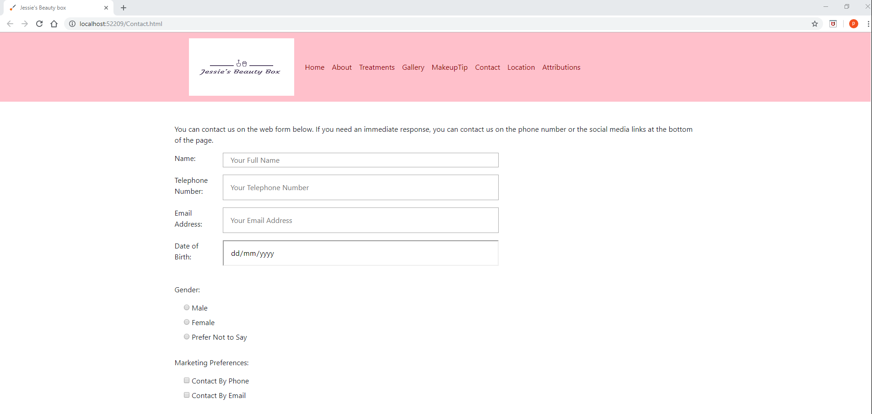
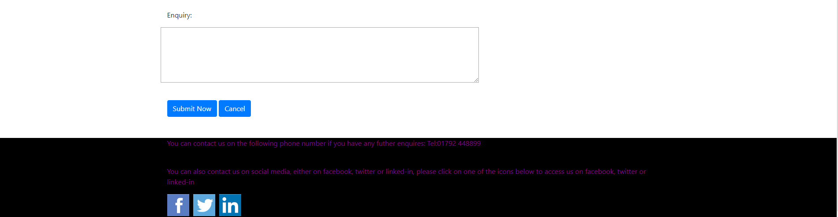

Confirmation.html

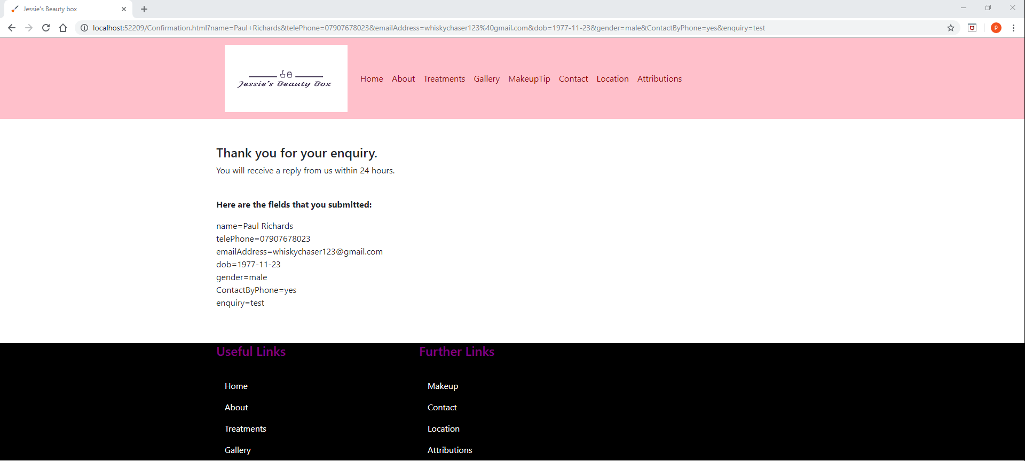

Location.html

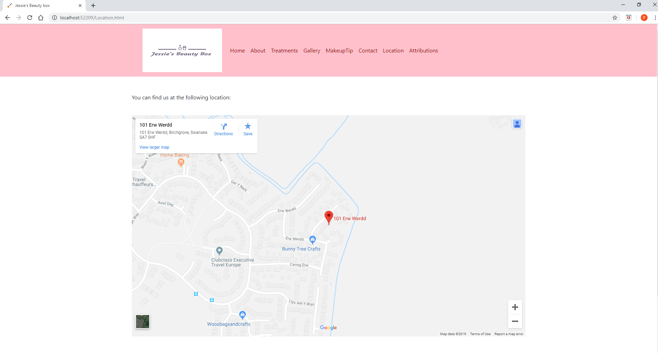

Attributions.html

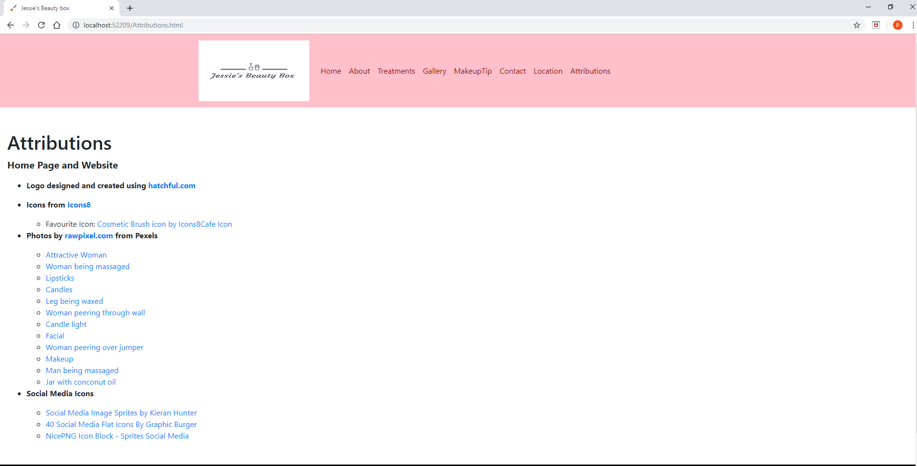

Validation

Validation of html page

Below is the HTML validation results of the home page or index page.

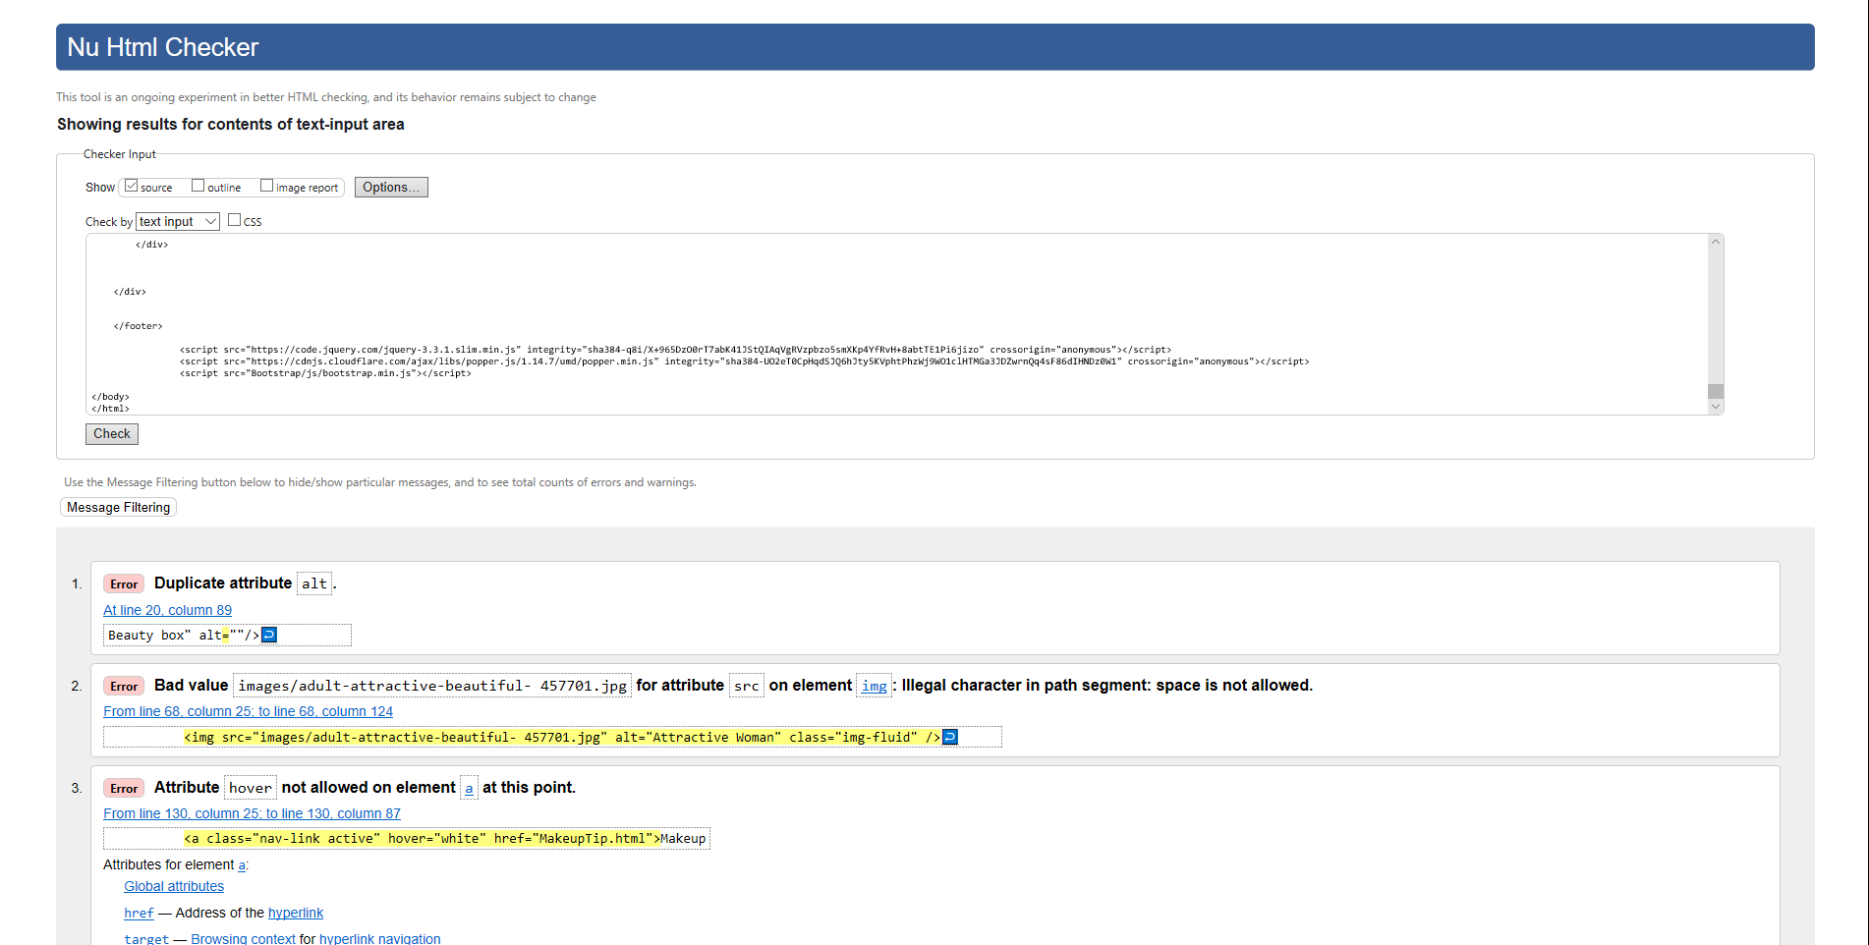

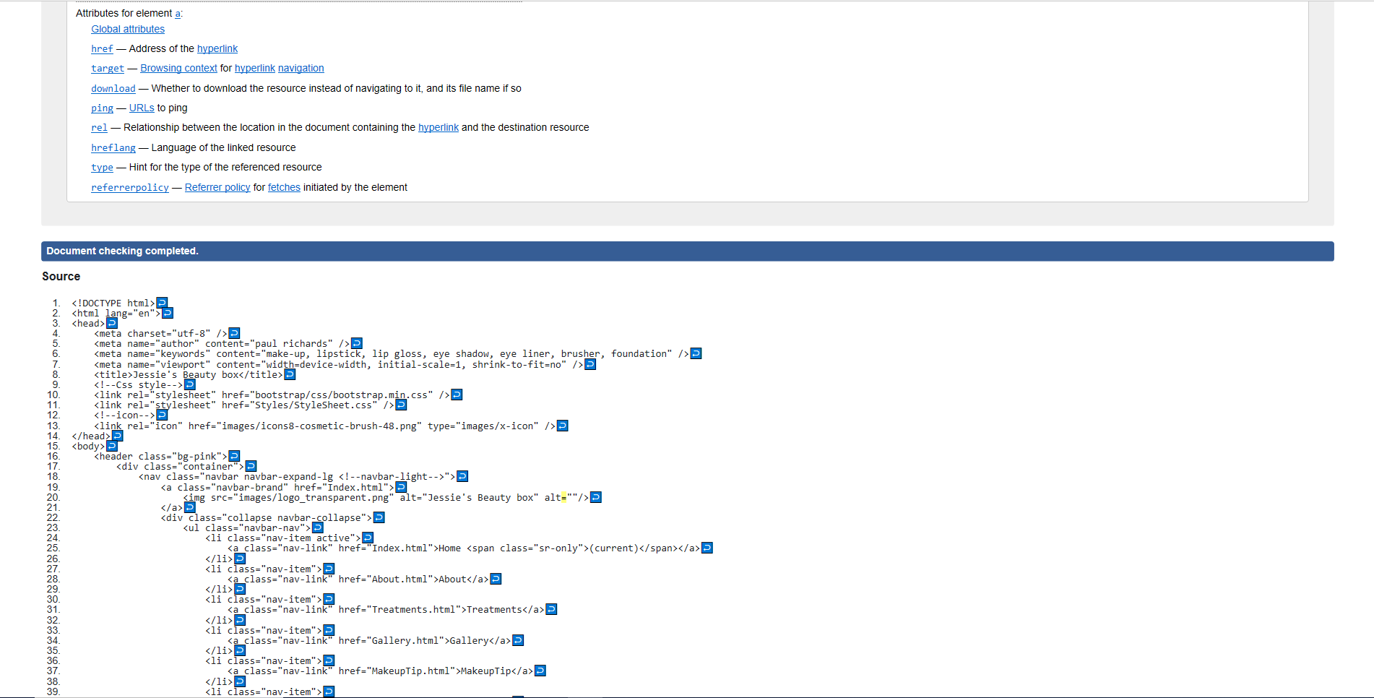

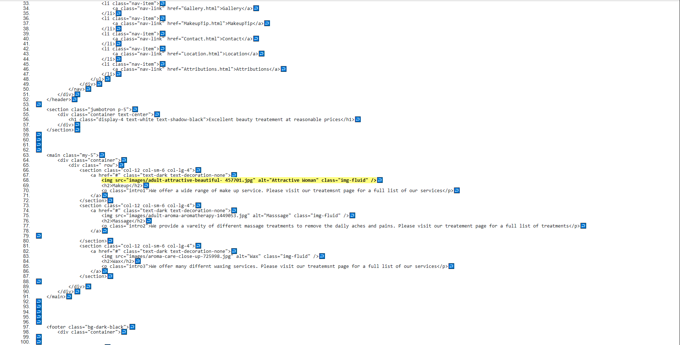

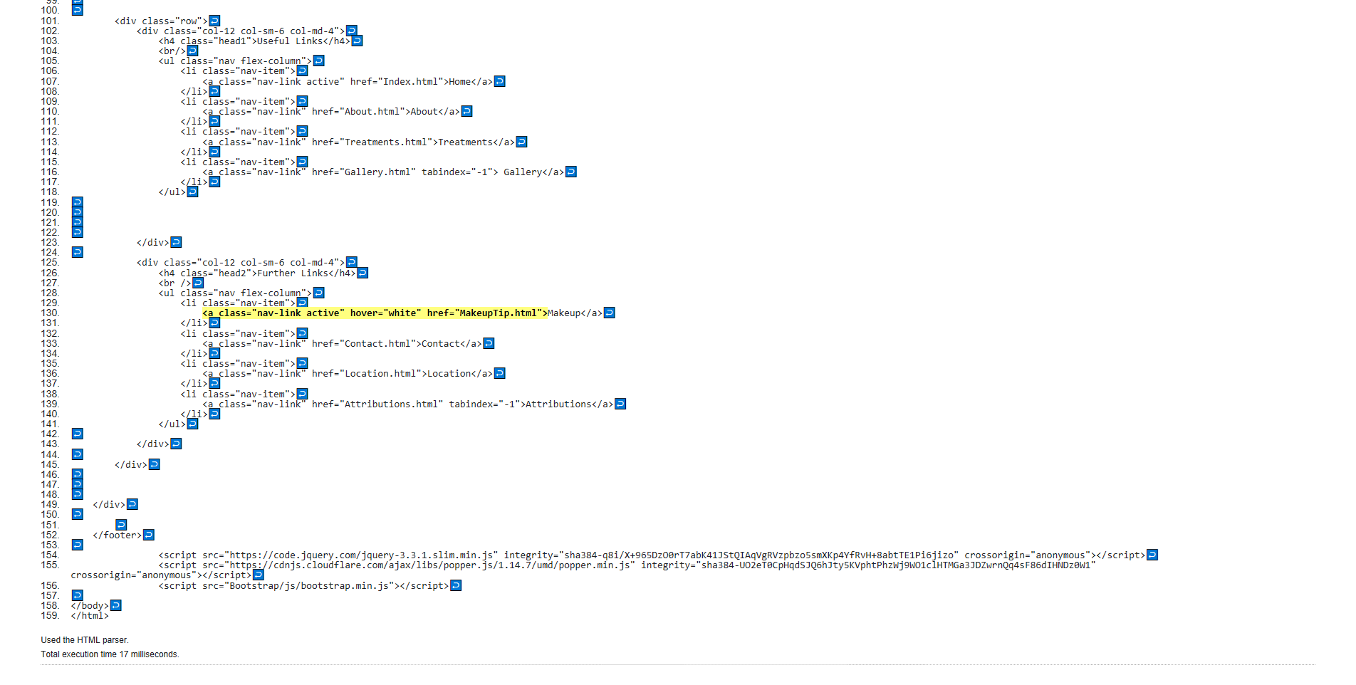
There were 3 errors which are listed below, with the resolutions used to correct them.
- There was a duplicate alt tag on line 20, removed the duplicate alt tag.
- There was a space in the file name on line 68, removed the space in the file name in the images folder and in the filename on the index webpage.
- There was a hover tag in line 130, removed the hover tag in the affected html.
Rerun the validator again with the amended html in the index page, received no errors, see screenshot below:

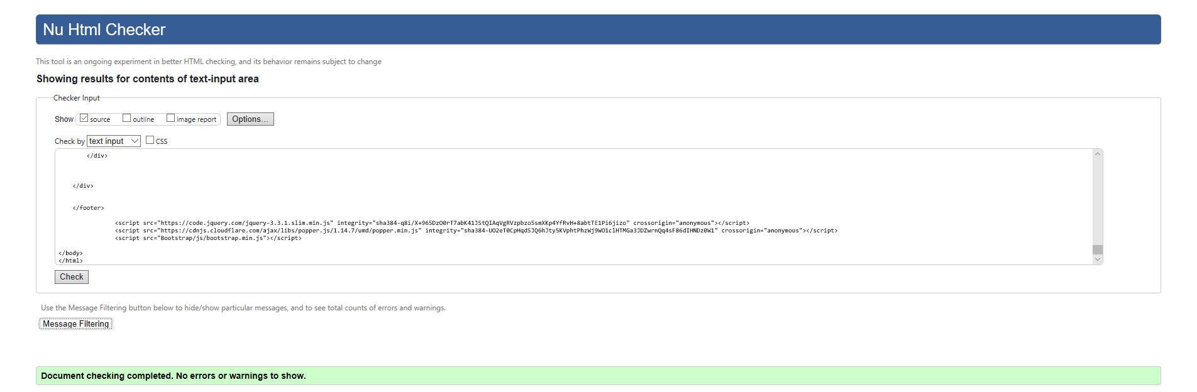

Validation of the CSS page

No errors were found in the CSS stylesheet, see screenshots below.
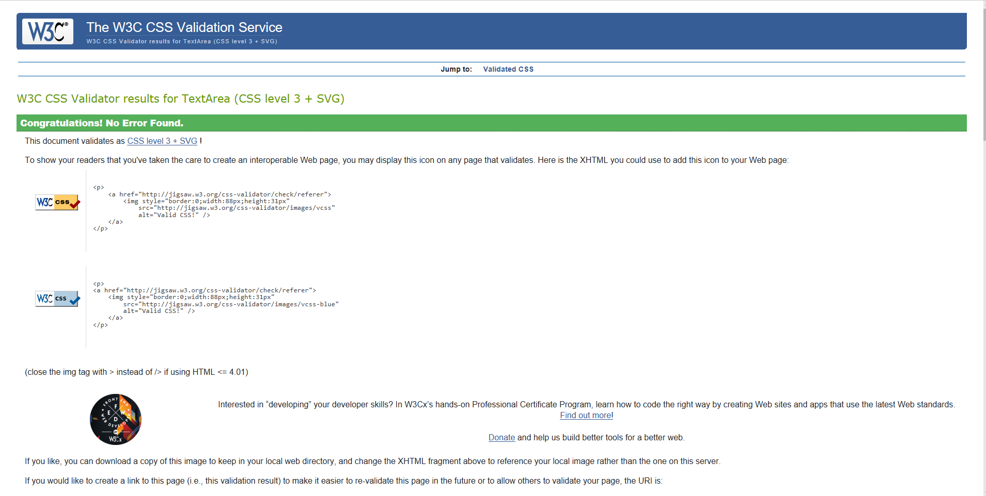

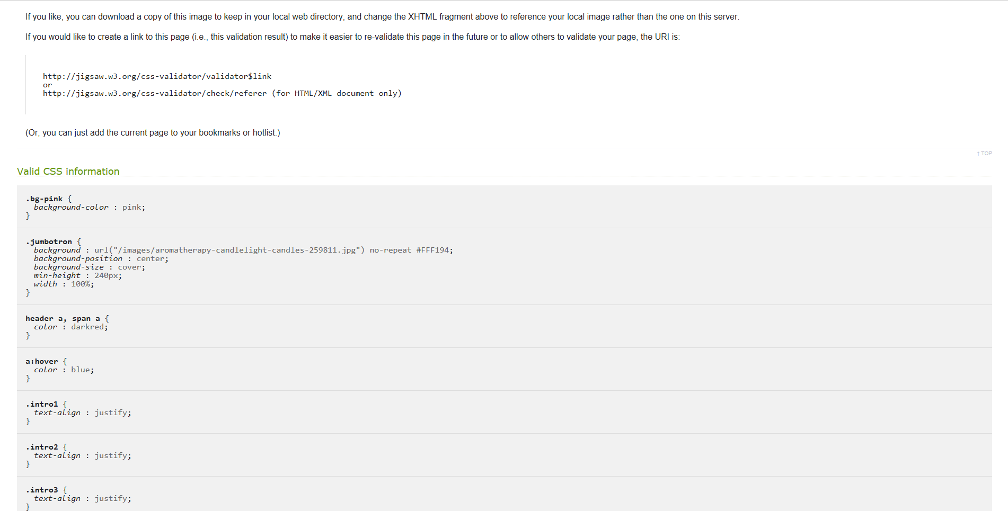

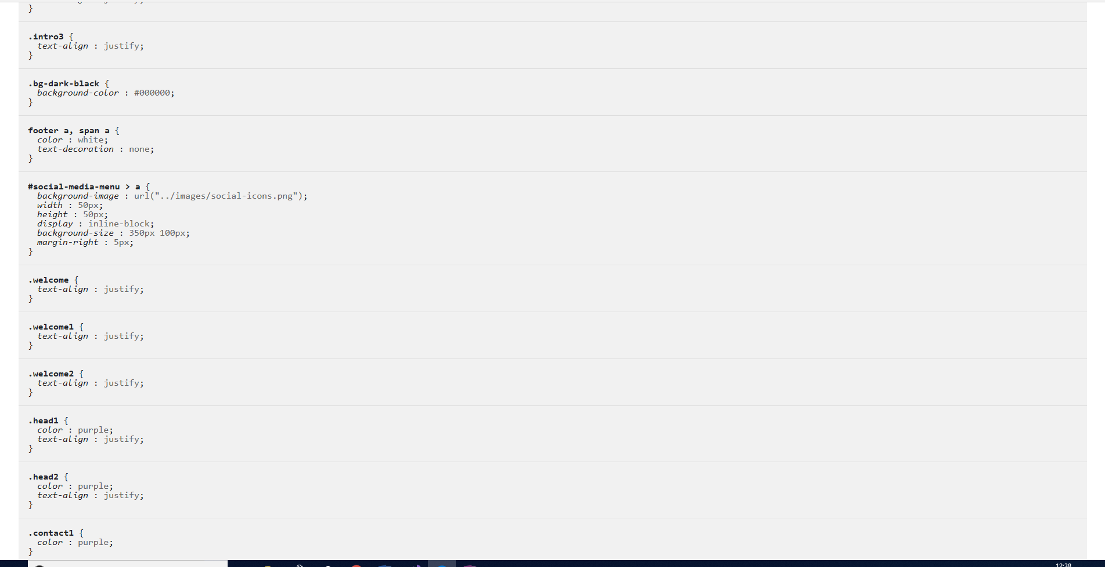

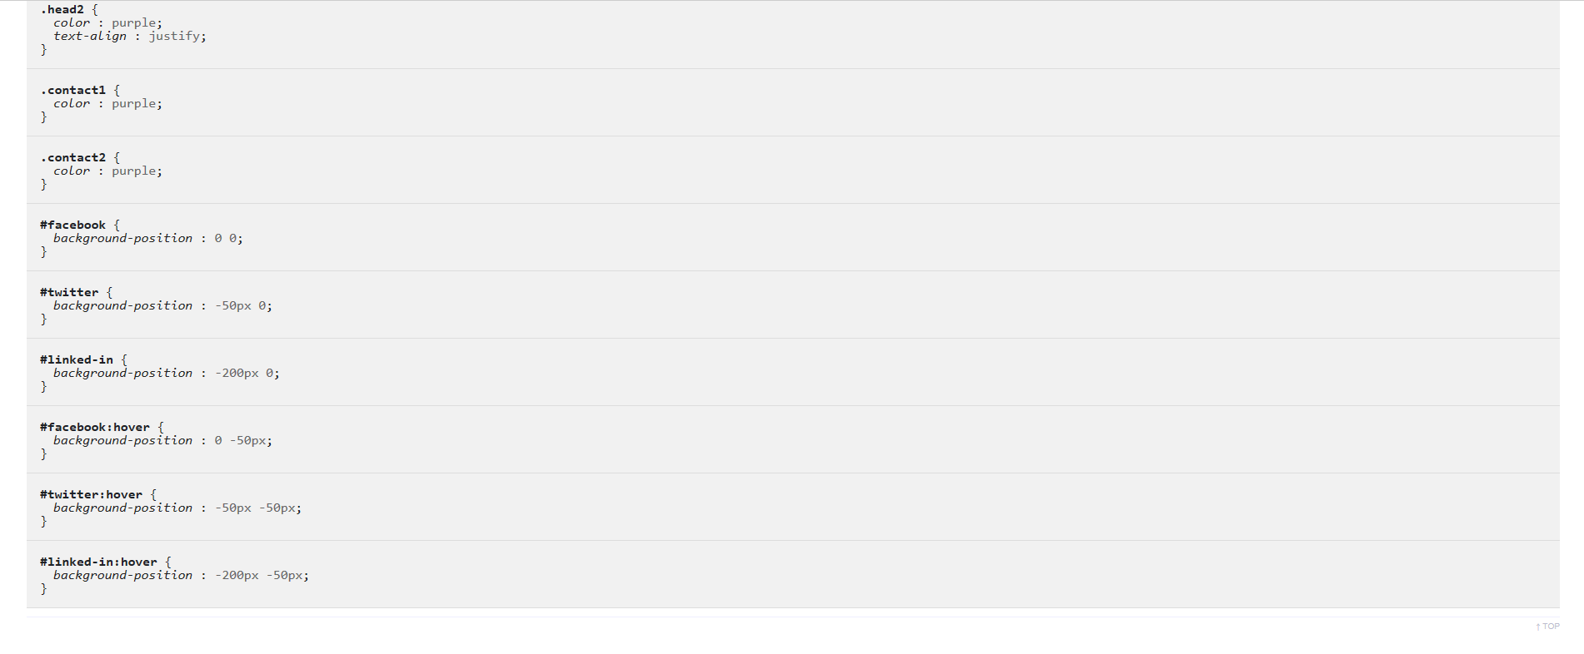

Evaluation

Appearance- Theme and Images

- Theme - The header has been set to a pink background, to distinguish it from the rest of the webpage. The links have been set to red in the header, so they stand out from the background and are easy for the user to read. The colour of the links turn blue, when the mouse hovers over the link to indicate which link the user is on. In the body, the background has been left as white to make it easier to view the images and black text, used for the content. Headings such as h2 have been used to distinguish the titles from the main content on the webpage. The footer has been set to a black background to distinguish it from the rest of the webpage. The links have been set to white in the footer, so they stand out from the background and are easy for the user to read. The colour of the links turn blue, when the mouse hovers over the link to indicate which link the user is on. The text in the footer has been set to purple to distinguish it from the links and background. Where appropriate headings such as h2 have been set to indicate different sections which contain different URLs.

- Images - All the images in the body of the website, have been set to 640x426 to provide enough spaces for multiple images to be stored on the web pages. The jumbotron has been setup on the home page to 240 pixels in height, and to the whole width of the page with a message to catch the users attention. The logo has been setup to be transparent to compliment the background and to display the name of the business. An icon of makeup brush has been setup on each tab. The images, jumbotron, icon, logo have been setup to make the site as eye catching as possible.

Functionality - Navigation & Contact Form

- Navigation - The website has been created with links at the top header, to allow users to navigate between web pages. The links change colour when the user hovers over a link to indicate which link they are on. The footer, has links that repeat the links in the header, to save the user scroll up the page to get to the header. If they are the bottom of the page, they can click on the links at the bottom of the page. The links in the footer, change to a different colour, when the user hovers over them to indicate the link they are on.

- Contact Form - A webpage has been setup to allow users to contact the business through social media, or to ring the number supplied or through a web form. The contact page, has been setup with a web form, so if the user does not fancy phoning the business or wishes to contact them out of business hours, they can use the web form and it will provide a confirmation screen with the information submitted. Social Media links have been setup to allow user to contact the business through Facebook, twitter or linkedin. The icons turn white, when you hover the mouse over them, to indicate which icon you are on.

Content

The content has been setup to represent the requirements of the website.

To promote the business and attract more customers. To meet this requirement, a home page has been setup to give an introduction to the business and a gallery of images showing the types of services offered, also a page that links to YouTube videos to give users free beauty tips.

To provide background to the business. A about page has been setup to give information about the business.

To provide a list of services offered by the business. A treatment page, provides information about the services offered.

To provide a means for users to communicate with the business. A contact page, that allows the user to contact the business either through a web form, social media or phone. Also a confirmation webpage has been created when a user submits a enquire through the web form on the contact page, to confirm their enquiry has been sent, and the information in the enquiry.

To provide information on the location of the business. A webpage, has been setup to provide directions to locate the business.

Recommendations

Fixed Navigation Bar or Header

I would have liked to have set the header to stayed fixed when scrolling down the page, to save the user searching for links. This can be achieved by using CSS positioning and the fixed attribute. However, this conflicted with the jumbotron image on my homepage. I would need to find a way of combining the two together.

CSS Transition effects

I also would have liked to add more CSS transition effects to the images, to make the images expand when you hover over them in the gallery, so the user knows what image they are hovering over and to make the images easier to view. Due to time restrictions this was not feasible to implement.

Search Engine Optimization Techniques

The guidelines form the webfx site [1], have been used to help build the website to maximize search engine optimization.

The homepage has been named index.html, which makes it easier for search engines to find the website, and avoids the need to type the specific URL to find the website.

The title of the website is set to Jessie’s Beauty Box, to help make it easier for users to find the beauty therapy site through a search engine.

Words like wax and massage in the keywords metadata tag have been set on the website, to make it easier for users to find the beauty therapy site through a search engine.

The alt tags have been named to reflect the beauty therapy images. For example, using alt tag to describe a massage images. This will help users to find the beauty therapy site through a search engine.

Externalised as much scripts outside of the website as possible, this reduces the number of code the search engine needs to go through. The Cascading Style Sheet, is contained in a separate style sheet, and is not contained in the html web pages. The JavaScript has been limited to references the bootstrap 4.0 folders that were downloaded from the bootstrap site (https://getbootstrap.com/) to run web functions.

The content refers to beauty therapy services and products and does not deviate away from the purpose of the business, this will help users find the beauty therapy business through a search engine.

The code has been kept clean and meets the W3C (World Wide Web Consortium) standards. It has been validated using the (http://validator.w3.org) and CSS (http://jigsaw.w3.org/css-validator/) validators. Clean and compliant code makes it easier for the search engine to search through the webpage.

Web Accessibility

According to W3C org [2]:

‘Web accessibility means that websites, tools, and technologies are designed and developed so that people with disabilities can use them.’

The website has been assessed on the four principles of web accessibility as defined by WCAG 2.1, which are perceivable, operable, understandable and robust (POUR).

Perceivable - Is the user ability to read the website.

Operable - Is the user ability to use the controls and features of the website, if they click on link does it take you the webpage.

Understandable - Does the site make sense, is the navigation consistent throughout the site to make it easy for the user to understand how to navigate through the site.

Robust – This refers to being able to use a website with different technologies, such as mobile devices and different browsers.

I have used the Wave accessibility tool and the google responsiveness tool to assess the web accessibility of the website.

Wave

When running the Wave tool, most of the alerts and errors were the same across the majority of webpages. On the styles and no styles sections it did not pick up any errors, but picked up 5 alerts, see screenshots below:

Styles section
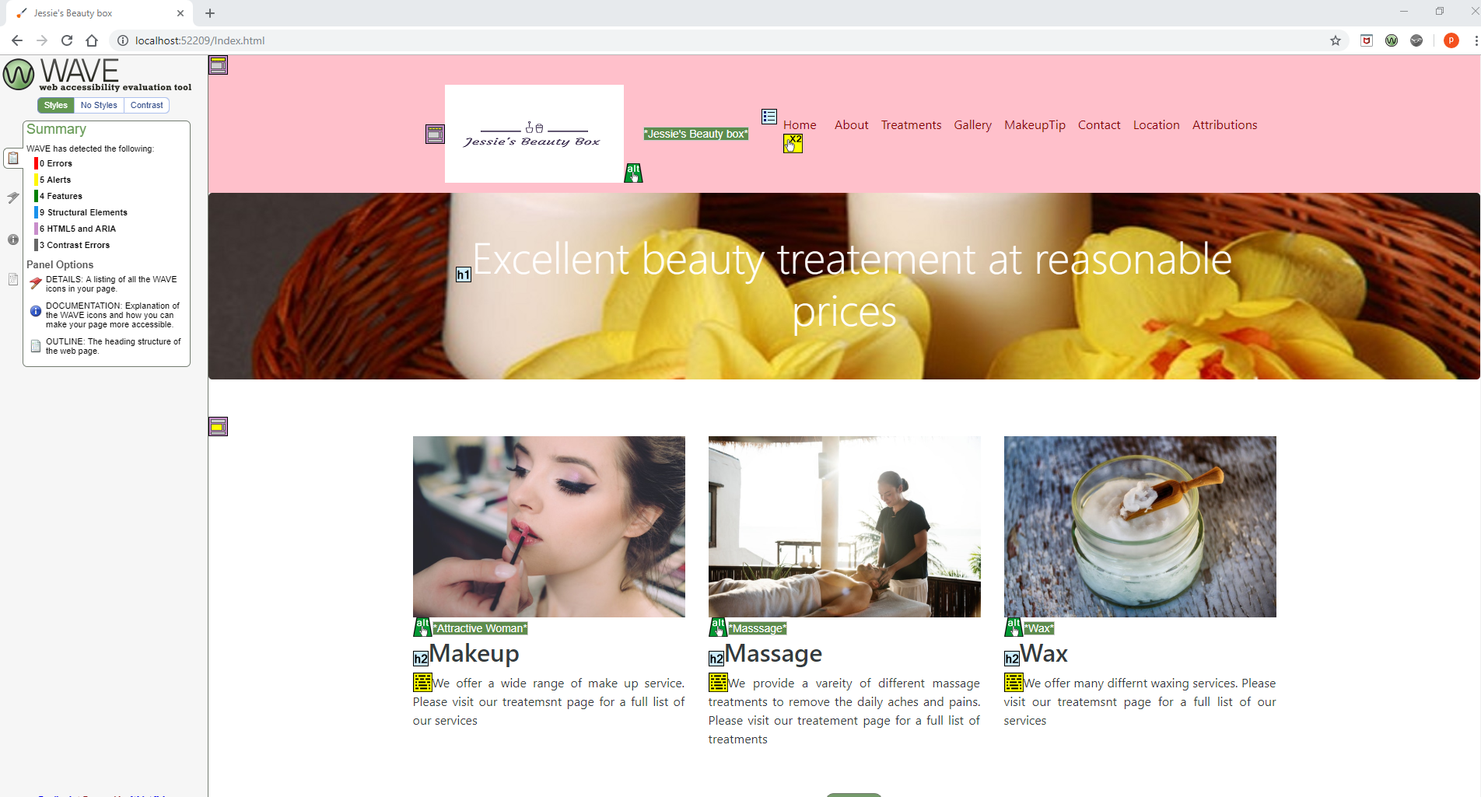

No Styles section

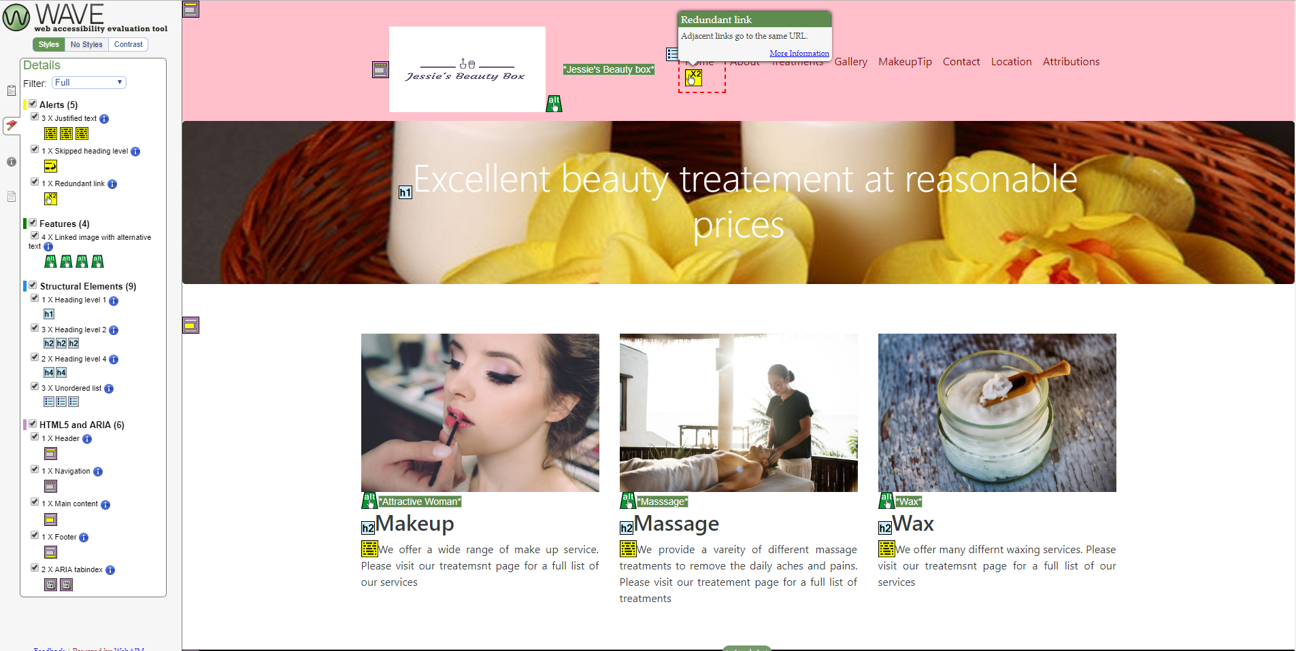

The alerts mention a redundant link, a skipped heading level and justified text. These errors would cause inconvenience to the user, but would not prevent the user interacting with the site.

The contrast section pointed out 3 errors, which would affect the perceivable of the site, which infringes POUR. This would make it hard for the user to read the wording on the site and make it less accessible. Wave recommended alternative colours, as shown in the screenshot below:

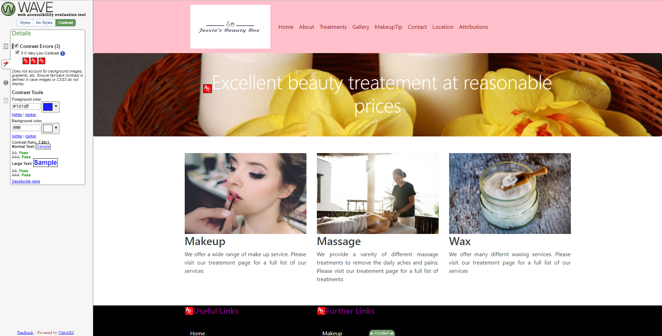

On the contact form, it picked up 4 alerts in the style and no styles section.

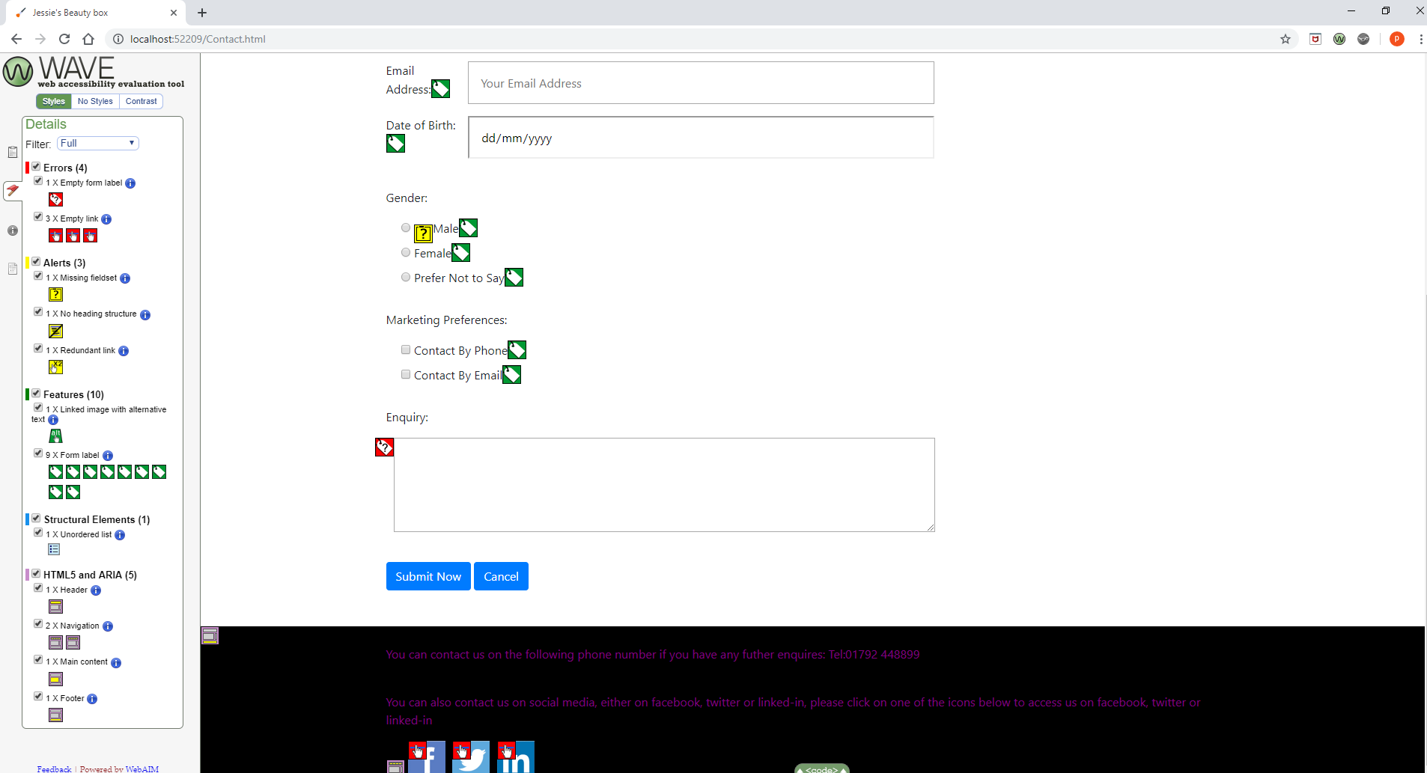

One alert was related to an empty label. This was caused by the way the site was formatted. This will effect perceivable, because when using a screen reader they cannot read the label for the control, so the user will be unsure how to interact with the control.

The other error was related to empty links in the social link icons. The links contained no text or labels to describe the function of the social link icons, and the link will not be presented to the user. This will effect perceivable, because the a user with a screen reader will not be able to read the control. They will not know how to interact with the control.

Most of the website after testing it through WAVE appears to meet most of the requirements of WCAG 2.1 or the POUR principle, but there are still areas that need working on as mentioned above.

Google Responsiveness Tool

When testing for web responsiveness, the guidelines from the hobo website [3], were used as the criteria to test for mobile screen resolutions. According to the hobo website, the most common mobile screen resolution is 360 pixels x 640 pixels.

I noticed the links in the header were no longer visible when testing for web responsiveness using the screen resolution from the hobo website. See screenshot below:

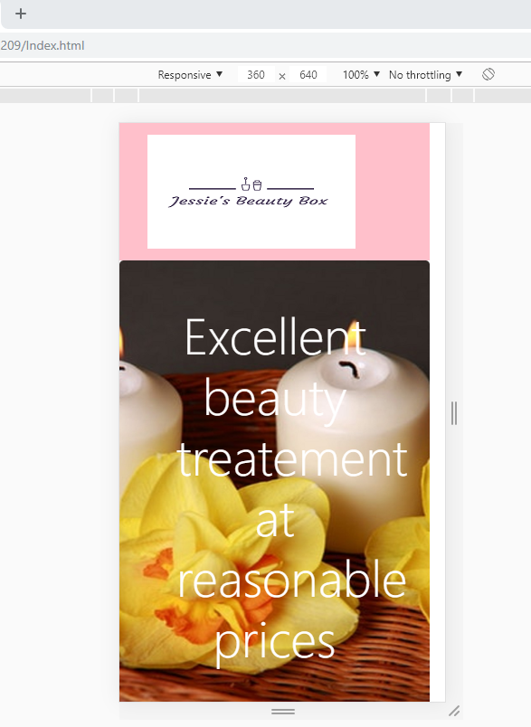
Although the links are visible in the footer, and can be accessed by scrolling down the webpage, see screenshot below:

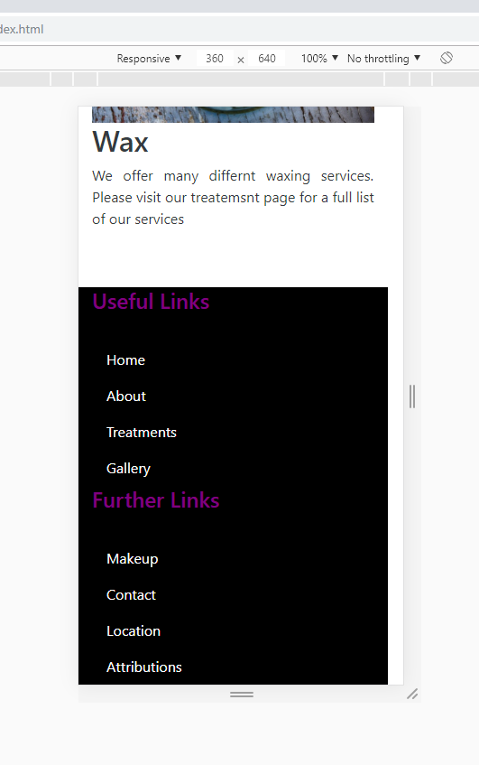
I would still like to make the links at the top of the page visible when viewing them from a mobile phone.

When testing for web responsiveness on the mobile phone, the images on the gallery appeared to be stacked to close together. I would have preferred to have setup spaces between the images, to make it easier to view on a mobile phone, see screenshot below.

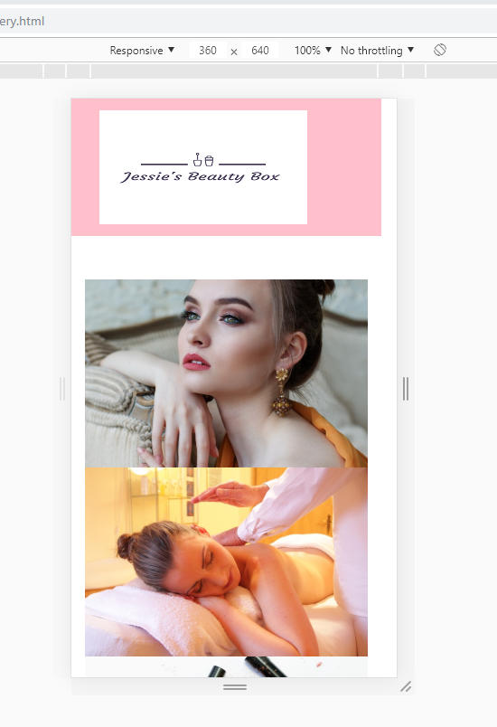

When testing for web responsiveness, the guidelines from the hobo website [3] were used as the criteria to test for tablet screen resolutions. According to the hobo website, the most common tablet screen resolution is 768 pixels x 1024 pixels.

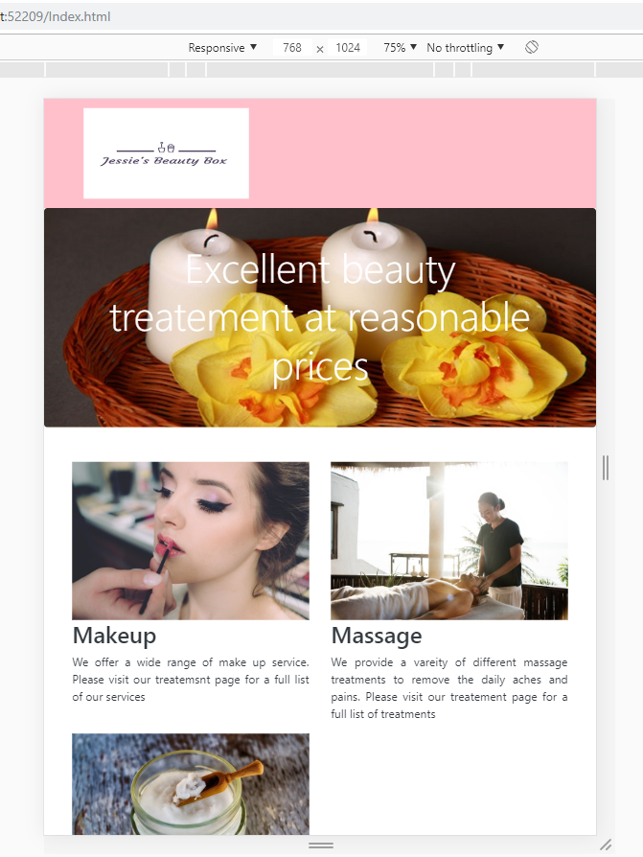
I would have liked to make the links in the header visible on the top of the page, when viewing from a tablet.
When testing for web responsiveness on the tablet, some of the images on the gallery appeared to be stacked to close together. It would have been preferable to have setup spaces between the images, to make it easier to view on a tablet, see screenshot below.

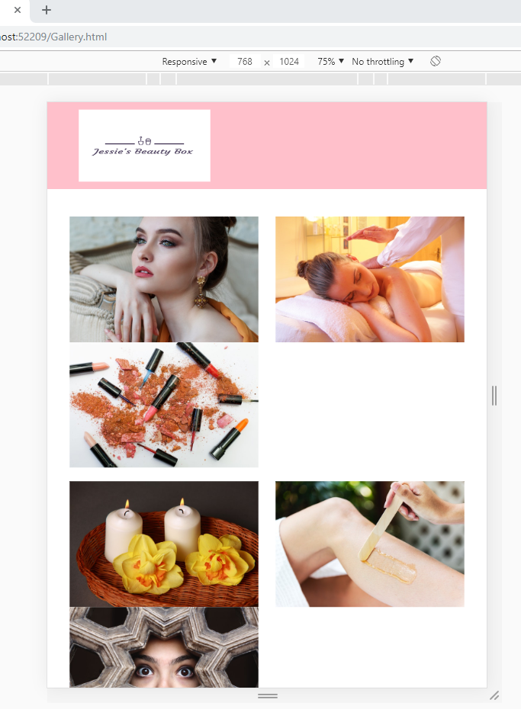
When testing for web responsiveness, the website tended to failed on the on the robustness principle of POUR or WCAG 2.1 guidelines. Being able to use the site on other devices apart from a desktop e.g. mobiles devices. This needs to be rectified by redesigning the header on the website.

Bibliography

[1] | C.William, “10 Excellent SEO tips that will improve your website design,” 21 July 2019. [Online]. Available: https://www.webfx.com/blog/web-design/seo-tips-improve-web-design/. [Accessed 21 July 2019].
[2] | W3C, “Introduction to Web Accessibility,” 5 June 2019. [Online]. Available: https://www.w3.org/WAI/fundamentals/accessibility-intro/. [Accessed 21 July 2019].
[3] | S.Anderson, “What it the best screen size to design for in 2019?,” 13 February 2018. [Online]. Available: https://www.hobo-web.co.uk/best-screen-size. [Accessed 21 July 2019].

Appendix

Attributions list
<section class="col-12">
<h1>Attributions</h1>
<p class="lead font-weight-bold">Home Page and Website</p>
<ul>
<li>
<p class="font-weight-bold">Logo designed and created using <a href="https://hatchful.shopify.com/" target="attribution-hatchful">hatchful.com</a></p>
</li>
<li>
<p class="font-weight-bold">Icons from <a href="https://icons8.com/icons" target="attribution-icons8">Icons8</a></p>
<ul>
<li>Favourite Icon: <a href="https://icons8.com/icon/18161/cosmetic-brush">Cosmetic Brush icon by Icons8</" target="attribution-icons8">Cafe Icon</a></li>
</ul>
</li>
<li>
<p class="font-weight-bold">Photos by <a href="https://www.pexels.com/@rawpixel?utm_content=attributionCopyText&utm_medium=referral&utm_source=pexels" target="attribution-pexels">rawpixel.com</a> from Pexels</p>
<ul>

<li><a href="https://www.pexels.com/photo/attractive-beautiful-beautiful-girl-beauty-458766/" target="attribution-pexels">Attractive Woman</a></li>
<li><a href="https://www.pexels.com/photo/woman-relaxing-relax-spa-56884/ " target="attribution-pexels">Woman being massaged</a></li>
<li><a href="https://www.pexels.com/photo/assorted-cololr-lipsticks-1377034/" target="attribution-pexels">Lipsticks</a></li>
<li><a href="https://www.pexels.com/photo/aromatherapy-bamboo-basket-candlelight-259810/" target="attribution-pexels">Candles</a></li>
<li><a href="https://www.pexels.com/photo/close-photography-of-human-leg-1288486//" target="attribution-pexels">Leg being waxed</a></li>
<li><a href="https://www.pexels.com/photo/person-sneak-peeking-693816/" target="attribution-pexels">Woman peering through wall</a></li>
<li><a href="https://www.pexels.com/photo/love-romantic-bath-candlelight-3188/" target="attribution-pexels">Candle light</a></li>
<li><a href="https://www.pexels.com/photo/woman-girl-beauty-mask-3192/" target="attribution-pexels">Facial</a></li>
<li><a href="https://www.pexels.com/photo/woman-in-purple-sweater-covering-her-face-905913/" target="attribution-pexels">Woman peering over jumper</a></li>
<li><a href="https://www.pexels.com/photo/adult-attractive-beautiful-beauty-457701/" target="attribution-pexels">Makeup</a></li>
<li><a href="https://www.pexels.com/photo/man-lying-on-bed-1449053//" target="attribution-pexels">Man being massaged</a></li>
<li><a href="https://www.pexels.com/photo/clear-glass-container-with-coconut-oil-725998/" target="attribution-pexels">Jar with conconut oil</a></li>
</ul>
</li>
<li>
<p class="font-weight-bold">Social Media Icons</p>
<ul>
<li><a href="http://kieranhunter.co.uk/blog/social-media-image-sprites" target="attribution-social-media">Social Media Image Sprites by Kieran Hunter</a></li>
<li><a href="https://graphicburger.com/40-social-media-flat-icons/" target="attribution-social-media">40 Social Media Flat Icons By Graphic Burger</a></li>
<li><a href="https://www.nicepng.com/ourpic/u2q8e6a9a9t4i1r5_icon-block-sprites-social-media/" target="attribution-social-media">NicePNG Icon Block - Sprites Social Media</a></li>
</ul>
</li>

