October 2012, 2013
Interfaces and generics
Distributed Enterprise Applications
Tim Bashford


Interfaces
An interface is a set of properties and methods that a class exposes. It is a contract that guarantees to a client how a class will behave. An interface defines only the signature of such properties and methods (member name, number and type of each parameter, and type of return value), while a class can implement that interface by providing actual code for those properties and methods as necessary. When a class implements an interface, it must implement all parts of that interface; in effect the class as “I agree to fulfill the contract defined by this interface”. The convention for naming interfaces is to start the name with a capital I. This convention is not enforced by Visual Studio, but is most useful for identifying interface objects.

Defining the Interface

- Create a new Console application and name it AnimalInterface
- Ensure the following Using statements are present:
using System;
using System.Collections.Generic;
using System.Linq;
using System.Text;

- Now create the following interface as the first statements in the workspace:
//Interface Declaration
public interface IAnimal
{
//No access modifiers, all methods are public
//No implementation
void MakeSound();
int animalAge { get; set; }

}

Implementing the Interface

- Directly after the interface declaration, create a class named Hawk that implements IAnimal:
public class Hawk : IAnimal

The interface may be implemented by hovering over “IAnimal”, selecting “Options to implement Interface” and “Implement interface IAnimal”
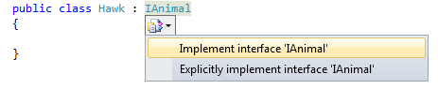
Following this selection, the following code should be automatically created:
public class Hawk : IAnimal
{

public void MakeSound()
{
throw new NotImplementedException();
}

public int animalAge
{
get
{
throw new NotImplementedException();
}
set
{
throw new NotImplementedException();
}
}
}

Note that the NotImplementedException implies that an error will occur if the method is called. Upon utilising an interface, all methods should be implemented.

An example of a “not implemented” exception:
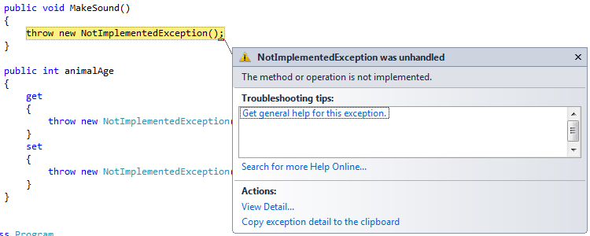
Implement these functions as follows:
public class Hawk : IAnimal
{

int age;

public void MakeSound()
{
Console.WriteLine("Screech");
}

public int animalAge
{
get
{
return age;
}
set
{
age = value;
}
}
}

As such, calling these methods should result in the following output:
Hawk Henery = new Hawk();
Henery.animalAge = 5;
Henery.MakeSound();
Console.WriteLine("Henery is " + Henery.animalAge.ToString() + " years old.");
Console.ReadLine();

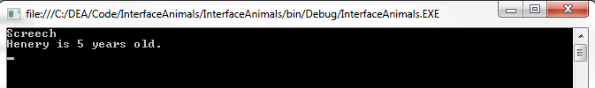

Implementing a second Interface
We will now create a second interface and implement it along with the first in a class.
- Create the IPrey interface:
public interface IPrey
{
float escapeSpeed { get; set; }
float Flee();
}

- Create a new class named Cricket and reference the IPrey class in addition to the IAnimal class:
public class Cricket : IAnimal, IPrey

- Implement both of these interfaces. The IAnimal interface should follow the format of that implemented in the Hawk class. The IPrey interface could be implemented as follows:
float _escapeSpeed;
Random rng;

public Cricket()
{
rng = new Random();
_escapeSpeed = 1.0f;
}

public float escapeSpeed
{
get
{
return _escapeSpeed;
}
set
{
_escapeSpeed = value;
}
}

public float Flee()
{
return escapeSpeed * (float)rng.NextDouble();
}

Note that a method may take an interface as a parameter, in which case it may take any class which implements that interface and access the methods within that interface.
- Implement the IPredator interface:
public interface IPredator
{
float attackSpeed { get; set; }
bool Attack(IPrey prey);
}

- An additional interface may be implemented retroactively in an existing class as long as no functionality overlaps with existing methods. Reference and implement the IPredator interface in the Hawk class.
float _attackSpeed;
Random rng;

public Hawk()
{
rng = new Random();
}

public float attackSpeed
{
get
{
return _attackSpeed;
}
set
{
_attackSpeed = value;
}
}

public bool Attack(IPrey prey)
{
float predSpeed = attackSpeed * (float)rng.NextDouble();
float preySpeed = prey.Flee();

if (predSpeed > preySpeed)
return true;
else
return false;
}

Note that any class which implements the IPrey interface may be passed to Attack(), however only methods encapsulated by that interface may be accessed from this method. This is a weak form of casting. If, for example, a Cricket object was passed to the Attack() method, neither MakeSound() or animalAge may be accessed as they do not form part of the IPrey interface; an attempt to do so would result in a compiler error.

Testing the Program
Implement the following main function to test the program:
Hawk Henery = new Hawk();
Henery.animalAge = 5;
Henery.MakeSound();
Henery.attackSpeed = 3;

System.Threading.Thread.Sleep(50); //To ensure a different RNG seed

Cricket Jiminy = new Cricket();
Jiminy.animalAge = 2;
Jiminy.MakeSound();
Jiminy.escapeSpeed = 1;

if (Henery.Attack(Jiminy))
{
Console.WriteLine("Hawk catches cricket.");
}
else
{
Console.WriteLine("Cricket escapes from hawk.");
}

Console.ReadLine();

Build and run the application making a note of the output:
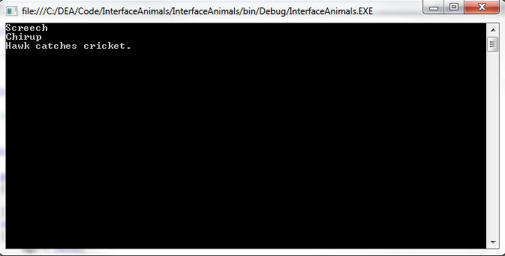

Exercise
- Create a new class, “Snake”
- Reference and implement the IAnimal, IPredator and IPrey interfaces.
- Test this implementation with the following test harness:
Hawk Henery = new Hawk();
Henery.animalAge = 5;
Henery.MakeSound();
Henery.attackSpeed = 3;

System.Threading.Thread.Sleep(50); //To ensure a different RNG seed

Cricket Jiminy = new Cricket();
Jiminy.animalAge = 2;
Jiminy.MakeSound();
Jiminy.escapeSpeed = 1;

System.Threading.Thread.Sleep(50); //To ensure a different RNG seed

Snake Kaa = new Snake();
Kaa.animalAge = 10;
Kaa.MakeSound();
Kaa.attackSpeed = 4;
Kaa.escapeSpeed = 2;

if (Henery.Attack(Jiminy))
{
Console.WriteLine("Hawk catches cricket.");

if (Henery.Attack(Kaa))
{
Console.WriteLine("Hawk catches snake.");
}
else
{
Console.WriteLine("Snake escapes from hawk.");
}
}
else
{
Console.WriteLine("Cricket escapes from hawk.");

if (Kaa.Attack(Jiminy))
{
Console.WriteLine("Snake catches cricket.");
}
else
{
Console.WriteLine("Cricket escapes from snake.");
}

if (Henery.Attack(Kaa))
{
Console.WriteLine("Hawk catches snake.");
}
else

{
Console.WriteLine("Snake escapes from hawk.");
}
}

Console.ReadLine();

Output should appear similar to the following:
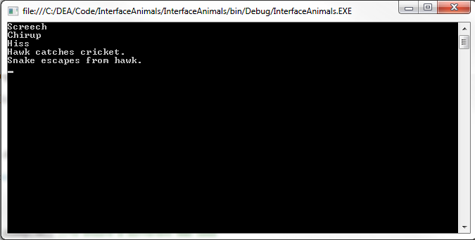

Advanced Exercise
- Close the AnimalInterface application and create a new Windows Forms Application named “TrigInterface”.
- Create the following interfaces:
public interface ITrigTriangle
{
double Hypotenuse(double adj, double op);
double Adjacent(double hyp, double op);
double Opposite(double adj, double hyp);
}

public interface ItrigCircle
{
double Area(double rad);
double Circumference(double diam);
}

- Implement these interfaces in a single class named TrigCalculator.
  - If unsure of the maths required, see Appendix 1.
  - C#’s square root function can be utilised through Math.sqrt(num).
  - Pi may be obtained through Math.PI().
- Create an appropriate UI to allow users to access these methods. The details of the implementation are up to you.
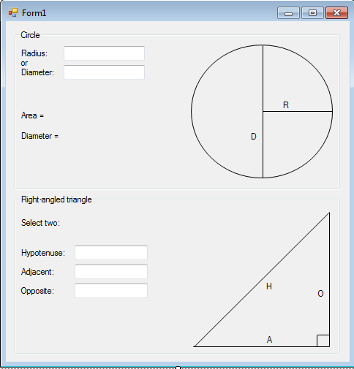

Advanced exercise 2:
Create a new C# project which utilises generics to create methods to do the following:
- Add three numbers of the same generic data type and return the result as that data type (i.e. one template parameter).
- Multiply two numbers of the same generic data type and return a double (i.e. one template parameter)
- Add three numbers of different generic data types and return a the result in the format of the first parameter (i.e. three template parameters)
- Copy and modify the trigonometry exercise methods from above and implement them as templates. Do not utilise the interface for the purpose of this exercise
- Create an appropriate test harness to test your code.

Appendix 1: Trigonometry operations
The following are a reminder on trigonometric functions which are required for the advanced exercise:

Circle

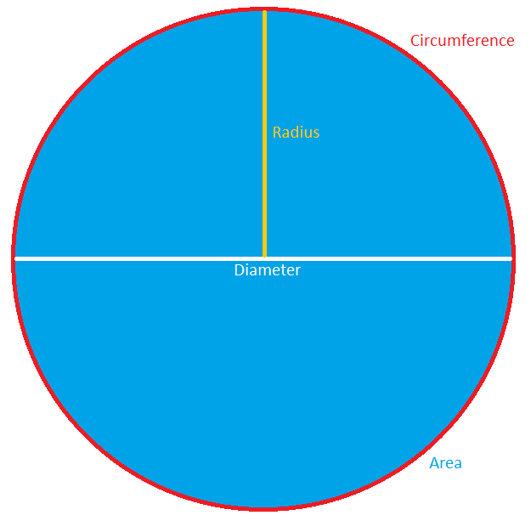

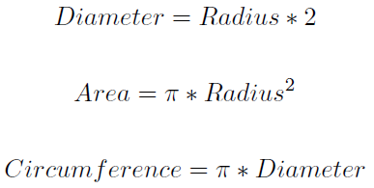

Triangle
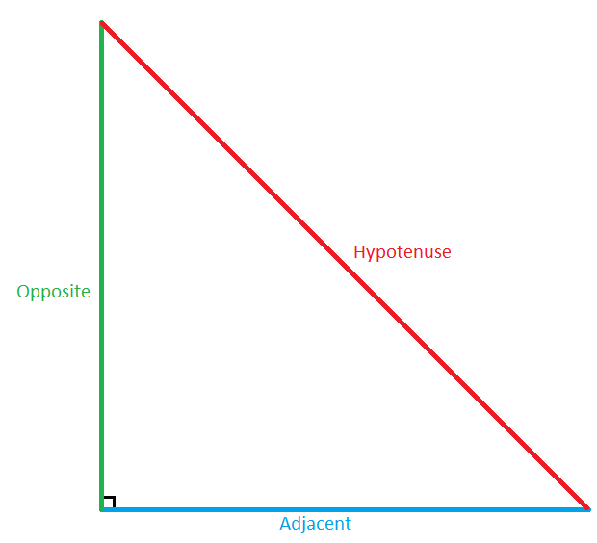

Hypotenuse
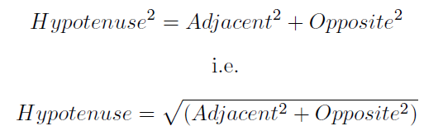

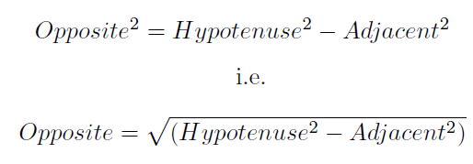
Opposite

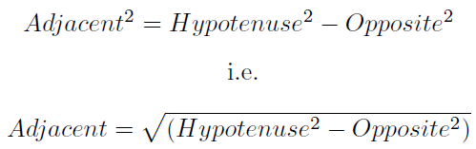
Adjacent

