Module Title: Marketing Fundamentals
Module Code: LCBB4004
Student Name: Petya Petrova Zlatkova
Student Number: 2028785
Assessment 1



Sony Corporation
History and Background

Sony - world’s most widely known electronic company was found in 1946, Japan under the name Tokyo Telecommunications Engineering corporation by Akio Morita and Masaru Ibuka. From a Walkman to OLED TV, Sony’s innovation has made profitable company since the day is founded.
Starting with less than £1,500 in less than a year the company released its first product- Megaphone. First Tape recorder was released in 1950, Japan.

The name “Sony” came from combining the words “sonus” and “sonny” because the initials TTK were already taken when the company looked to go global. In 1958 the name of the company was officially changed to Sony Corporation.

Products

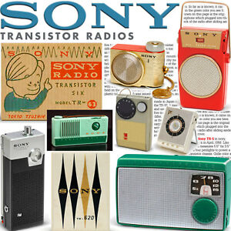

Japan’s first transistor radio the TR-55 was introduced in 1955 by Sony. Not long after was launched a pocket-sized transistor radio. The world’s first direct-view portable TV was released in 1960.
The company continued introducing technologies following by the Handycam in 1989, the world’s first Blu-ray disc player in 2003.

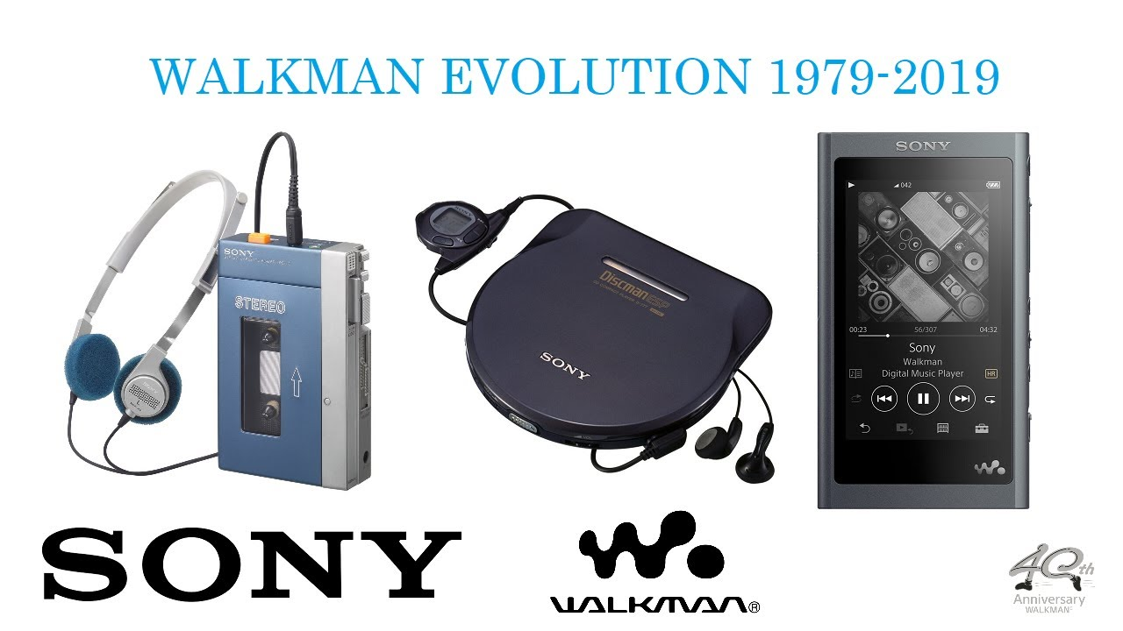

The Walkman first released in 1979 is Sony’s most influential product. The lightweight tape player creates a revolutionary individual experience when listening to music. In 1984, the first portable CD player - Discman was created. Sony has two divisions Sony Music and Sony Pictures, making it a major player in the music and film industries. In 1988, Sony Music became a wholly owned subsidiary of Sony Corp.

Sony Computer Entertainment is a new division formed in 1993 after Nintendo and Sega revived the gaming console market and Sony sees potential in this area.
Its Playstation line of consoles and their portable counterparts have proven to be reliable money-makers for the company.

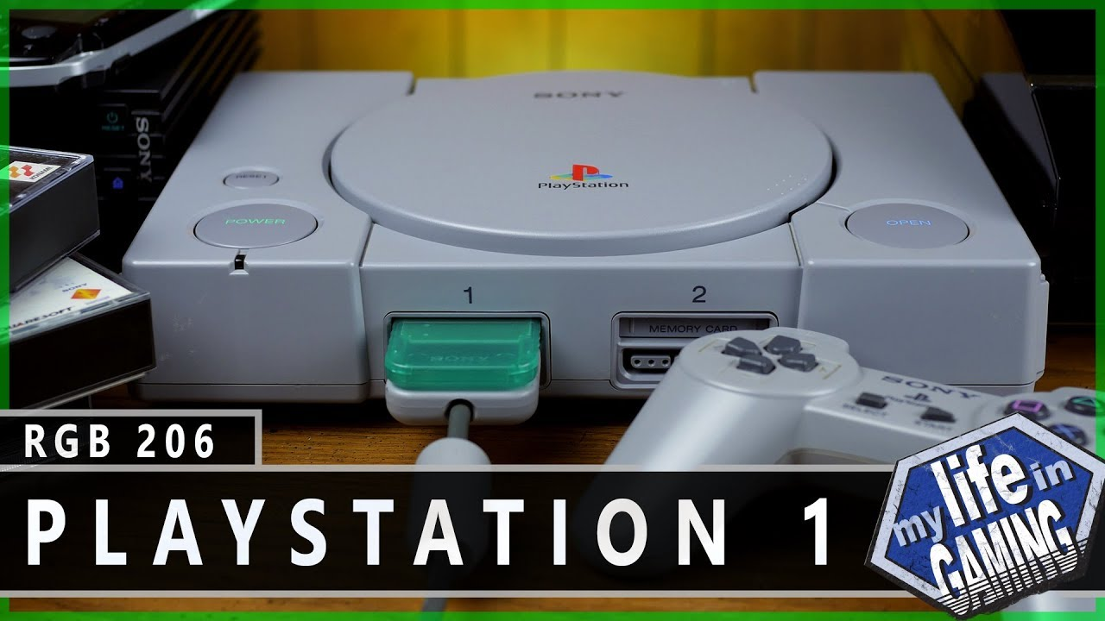

PlayStation 1
PlayStation - PS One was launched in Japan and the United States in 1994 and 1995. It is one of a new generation of 32-bit consoles that uses CDs. The sales exceed all expectations , stores are running out of stock every day, and players line up in front of stores. The launch of the PlayStation in Europe and Australia broke the competition and surpassed the events and Sega Saturn in the first year of its launch. The price of the PlayStation is $199, there is a large storage capacity from other consoles and games such as Ridge Racer, Wipeout and Tekken are becoming very popular.
The most famous of these are Crash Bandicoot, Persona, Mortal Combat, Silent Hill, Final Fantasy, Street Fighter, Tomb Raider and Grand Theft Auto. Sony is starting the trend of annual editions of sports titles such as FIFA, NBA, Formula One, Madden and others, most of which are published by Electronic Arts - EA. Thanks to the Fantasy VII, the console is sold in even greater quantities around the world.
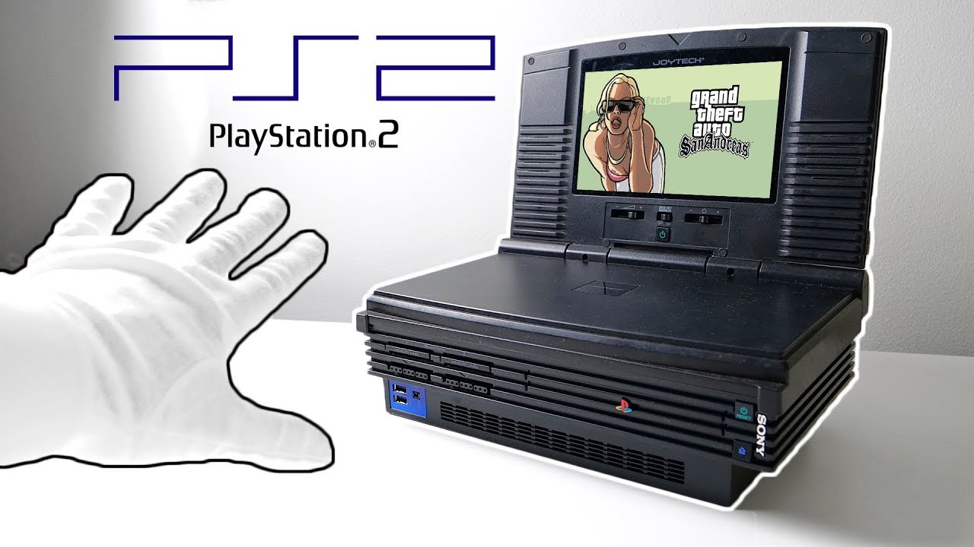
PlayStation 2
In 1999 at the Tokyo Game Show, Sony introduced the PlayStation 2, which is also able to play DVDs and connect to the Internet.
In the year 2000, the PS2 was released and in a few days sales exceeded millions. Sega is withdrawing from the market, meanwhile the PlayStation 2 becoming particularly popular and surpassing sales of 155 million units.
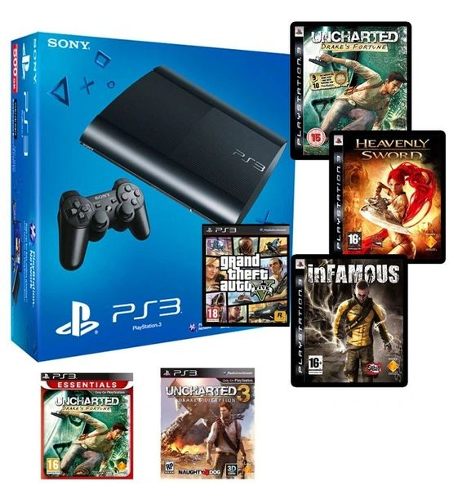

PlayStation 3

The PlayStation 3, Sony's seventh-generation console, is not as popular as the previous PS2, due to its high price of £ 599, Microsoft's competition with the Xbox 360 and the fact that it has been released in two editions - 20GB and 60GB. The 20GB version has less storage space, no HDMI port and Wi-Fi internet connection.
However, the 60GB version has a wireless controller (Sixaxis). A feature that comes from the PlayStation Network, through which players can buy their games online and store them through the PlayStation Store.
PlayStation Plus is a subscription service that allows you to store files for online game saving and two free games each month.
Grand Theft Auto V is the best-selling PS3 game with over 21 million copies.

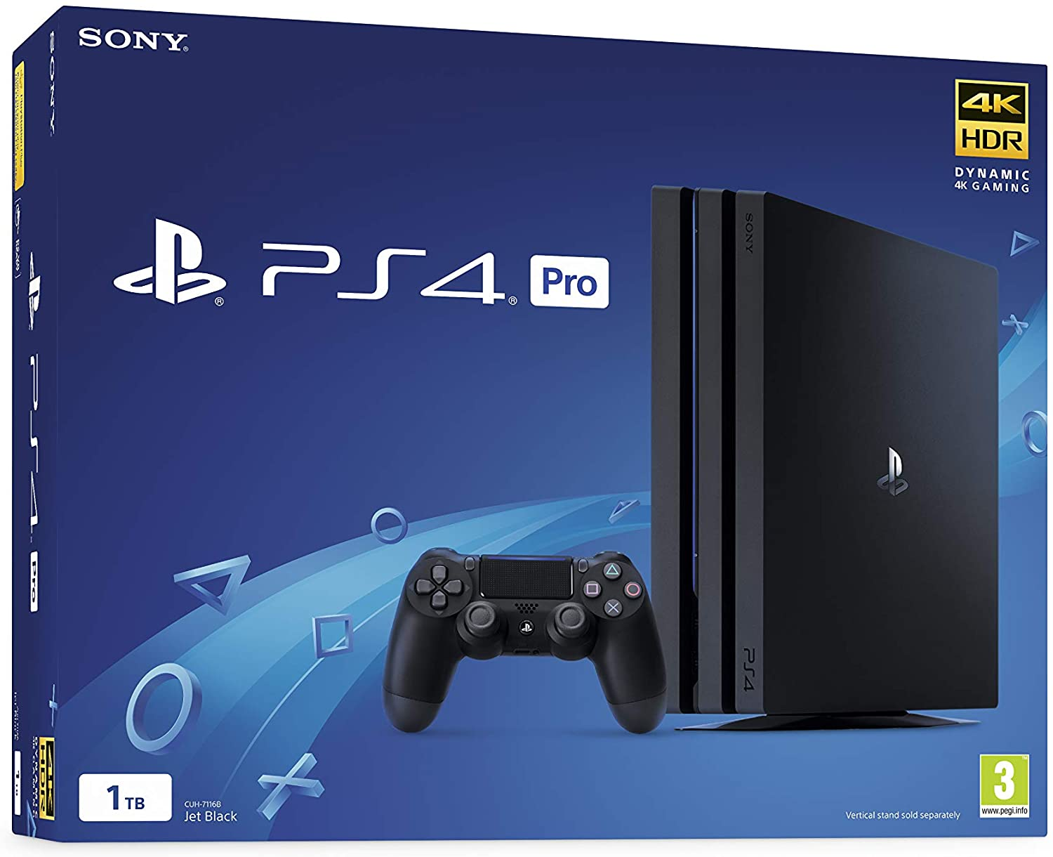
PlayStation 4
After the release of the PlayStation3, its high selling price and all the criticism, Sony decided to create their most powerful console to date. Sony aims to bring all players together and give them a memorable experience.
PlayStation 4 began development in 2008 and was first introduced in 2013 at “Future Of PlayStation”, an event hosted by Sony. It is officially released in November in Canada and the US, and later in the rest of the world. The success of the PlayStation 4 is similar to the first console released by Sony, players line up in front of stores, and the product ends before it is officially released. It surpasses its biggest competition Xbox from Microsoft, both because of the reasonable price of £ 399 and because of all the new features. The communication between the players has been improved, the players' achievements have been shared via the "Share" button from the new Dual Shock 4 controller, and players can also watch other players live around the world. PS4 also provides players with amazing experiences through higher-end visuals and soundtracks.
Sony's new console exceeds 113 million sales by 2020.
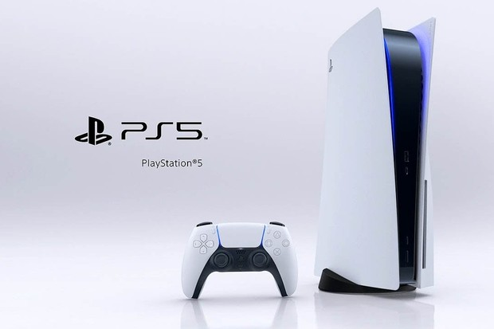
PlayStation 5
March 31st 2019 Sony announced its new PlayStation 5 product and its new features which are an 8-core processor, a 16-threaded processor. The graphics processor is a customised version with a microarchitecture that includes support for hardware acceleration of the image with beam tracking. Unlike the PlayStation 4, Sony improves the energy saving time of the PlayStation 5.
A new Dual Sense controller is also released, which creates a better connection between the players and the game.

Recognised as a global leader in interactive and digital entertainment, Sony Interactive Entertainment (SIE) is responsible for the PlayStation® brand and family of products and services.

The PlayStation family of products and services include PlayStation®5, PlayStation®4, PlayStation®VR, PlayStation™Store, PlayStation®Plus, PlayStation™Now, and acclaimed PlayStation software titles from PlayStation Studios.
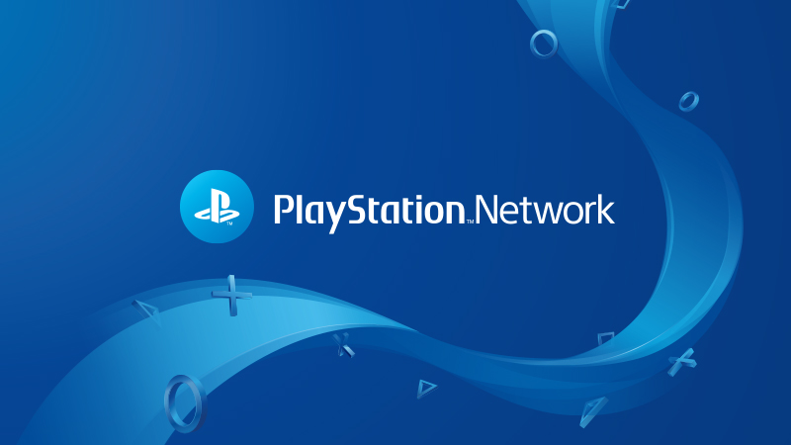

Playstation Network

Sony Computer Entertainment provides an online service called PlayStation Network, which was released in 2006. The service is used in PlayStation 3, PlayStation Portable, PlayStation 4 and PlayStation 5.
Other services that Sony Entertainment Network presents are PlayStation Home, PlayStation Store and Throphies.
The services have over 103 monthly users.
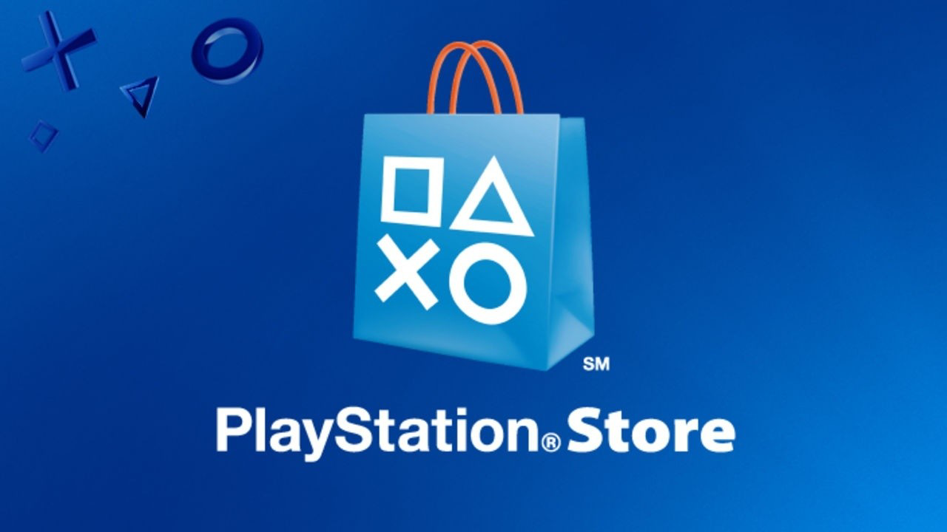
Playstation store

Users of PlayStation 3, PlayStation 4, PlayStation 5 and PlayStation Portable also use a service called PlayStation Store, which is an online virtual marketplace.
Game content can be purchased and downloaded for free from it, which is updated every Tuesday. Not only gaming content is available in the PlayStation Store, there is also video content such as TV shows and movies. There have been more than 600 million downloads from the PlayStation Store worldwide.

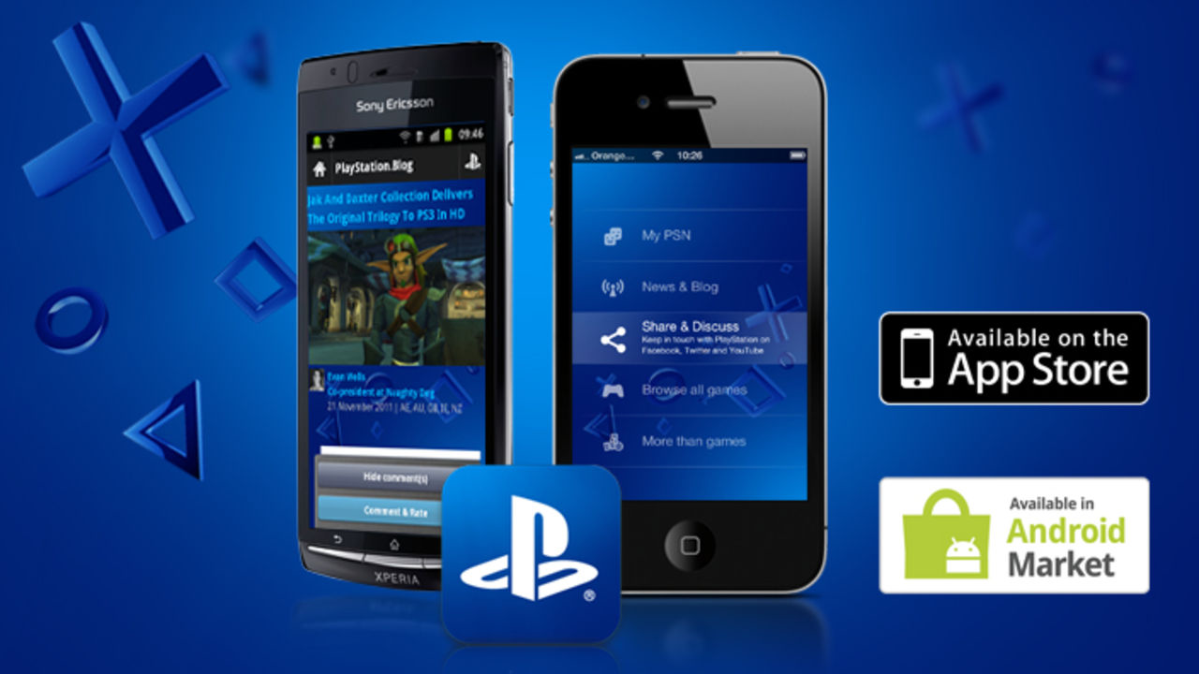

PlayStation App

Installed more than 3.6 million times by March 2014, the PlayStation App was released on January 11, 2011 in most European countries for iOS and Android.
The service allows the users to read up to date information about PlayStation, view their trophies and see which of their PlayStation friends are online.

Supply chain
To keep transport emissions as low as possible, Sony transports its goods by water and rail in bulk and avoids air freight. Reduce the number of transport containers used in transport as most peripherals are packed locally and shipped in bulk from China.

The following review states
“Worth the wait
The Sony Playstation 5 is an amazing game console, and since it's release in 2020 a very difficult item to find for a reasonable price. The console itself is a huge improvement over the previous Sony line with the PS4 and PS4 Pro. Gone are the loud jet fans that wind up quickly and are apparent during any gaming session. The PS5 sports a gen 4 NVME SSD drive that is light years beyond the spinning discs of the last-gen, so boot times are almost non-existent in many titles. The addition of 4K up to 120fps are welcome with the new hardware. Also, optional ray tracing adds a performance hit to many games so many offer performance or quality settings. But still, options are good. As far as a games library, the library is starting to build, with many games patching to add PS5 features. With this the internal storage (and with a recent update optional internal NVME upgradability) is the only way to play PS5 games. Fortunately, if you do have a large library you can connect a USB 3 hard drive to store and play PS4 titles, as well as store and transfer back later PS5 titles you don't currently have room for. This is great for the games that you might not want to redownload because of data caps, but plan to get back to later. As far as accessories, bring all of your current PS4 games and controllers as they are nearly all supported. In fact, PS4 Dual Shock controllers pair and work with PS4 titles on the system. And many of the issues with PS4 titles have been worked out on PS5, so unstable FPS or other issues with many games have been patched to just perform better on PS5. I can't think of a single game that performs worse, so for me the PS5 was a replacement for my PS4 Pro. Also the PS5 camera is nearly worthless as it only supports web streaming and not PSVR, so hold onto your old PS4 Camera. For new accessories, I highly recommend grabbing the Sony dual controller charger and maybe a second controller if you play local multiplayer on any PS5 games. But that is about it. All around the Sony Playstation 5 is a great console that feels next-gen especially if you have been with Sony for a while now. Unfortunately, these will likely be hard to find for at least another year, but when you do find one it will be worth the wait.”
Nico07 · Reviewed on Best Buy

Which shows customer satisfaction with Sony products. Sony is definitely a well-established brand in the market and justifies its revenue of over $ 7.5 billion since 2014.

References :

Bizfluent. 2021. Sony Corporation History & Background. [online] Available at: https://bizfluent.com/about-5176244-sony-corporation-history-background.html

Info, C. and History, C., 2021. History of Sony Interactive Entertainment. [online] SIE.COM. Available at: https://www.sie.com/en/corporate/history.html

Encyclopedia Britannica. 2021. PlayStation | Console and Games. [online] Available at: https://www.britannica.com/topic/PlayStation

Medium. 2021. A Brief History of the PlayStation. [online] Available at: https://superjumpmagazine.com/a-brief-history-of-the-playstation-602e0a64e363?gi=8d6ea368cb89

En.m.wikipedia.org. 2021. PlayStation - Wikipedia. [online] Available at: https://en.m.wikipedia.org/wiki/PlayStation

PlayStation. 2021. PlayStation® & the environment | What we're doing to reduce our global impact. [online] Available at: https://www.playstation.com/en-gb/corporate/playstation-and-the-environment/
PlayStation. 2021. About Us. [online] Available at: https://www.playstation.com/en-gb/corporate/about-us/

