LOUISE DAVIES 1906903 (BMSP4005)

Distinctiveness and regeneration

INTRODUCTION
Blaenavon Big Pit has marked 30 years as an industrial mining museum, this took place in April 2013. Blaenavon opened as an ironworks in 1788 and then went on to distribute coal and by 1913 had become the largest exporting coal port in the world, with Cardiff as the second biggest. Blaenavon was one of the biggest companies and employed a large amount of people from men and women and children as young as 6 years old including boys and girls.

Blaenavon started off as a steelwork industry in a small village in Wales 1789 but was only supplying iron on a small scale. Producing metal and mining (black gold) that was found in large quantities within the Rhondda valleys. Merthyr Tydfil was well known throughout the world as the iron capital of world, exporting iron railways to Russia and south America, this then expanded a multitude of canals ,roads, and railways with a huge growth in population, creating new towns with many terraced houses that then took away the natural beauty, that was then left looming with a veil of smoke. (Appraisal & Management Plan, 2017).
The Hanbury family manufacturers of Pontypool exercised their mineral rights over the common lands of the lordship of Abergavenny to supply their charcoal fired furnaces. Iron ores, fireclay, coal, and limestone was also used. Smelting pig iron tapped was used at the base of the furnaces. Blaenavon then had several furnaces. By 1796 Blaenavon was producing iron at 5,400 per year. Blaenavon then had several furnaces and produced 14,220 tonnes of pig iron. Thomas Newcomen had designed the prototype for the use of the first steam train, there was also 2,000 miles of canals that was used to carry metal and coal across Britain by 1815. Then by 1859 the sixth furnace was built together with a rolling mill, and then the Big Pit was sunk so it could be supplied with coal. In 1864 when Blaenavon iron and coal then went into liquidation it was then bought by Blaenavon iron and steel in 1870 and was then converted into steel production at a much higher cost, as steel was at a high demand. With the use of adding lime with the pig iron and blowing the molten metal would make this unusable phosphoric iron ores that would have been used in bulk steel making. (welsh government, 2019).
In 1904 Blaenavon ironworks finally ceased production, followed by the closure in1960s, then after being saved by the nation in 1974, The Big Pit was still going until it then closed in 1980,( BBC news, 2013).

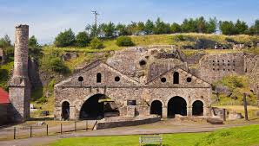
BLAENAVON IRON

Blaenavon ironworks first attached power of steam to blow air into its huge blast furnaces in 1789. Ten years later it was here that Sidney Gilchrist Thomas altered the world’s steel industry by originating a method to remove phosphorus from iron ore.

From as far back as the second world war, external abstraction of coal was found at Blaenavon, this was in November 1941 with the use of equipment and trained men within the Canadian Army, then in 1941 when it was nationalised by the national coal board who then took over the mine from Blaenavon co. ltd, who employed 789 men. (Williams, 2002)

Many people had moved to a new location for work, from small rural areas to cities as there was limited transport to be had at the time, middle class and stranded class people there living standard increased where the working class continued to struggle. ( Rene,2019).

Blaenavon was a small village with most people that worked in the mines housed there, These houses was built mainly so the workers lived close by as they was working a 12 hour days, and with not much money around at the time and not much transport it made things easier for all the workers. Without the use of transport and machines to carry the coal they had to rely on pit ponies to do most of the carrying and pulling of carts as a way of moving the coal around, these pit ponies was the housed down in the mine where they was feed and looked after not seeing the light of day, the pit ponies was only let out on a filed for 2 weeks a year where they would go wild with having plenty of room to run around, the pit ponies was very well looked after more so than the workers as they was a very big part of Blaenavon and was very much needed with in the industry. ( Evans ,2020).

Men woman and children as young as 6 years old worked 12 hour shifts in the mine with only candle light to keep them from the darkness , until it was said that only men and boys from the age of ten was aloud to work within the mines, this meant family’s with sons could earn more money than those with daughters.

Blaenavon then re-opened as a museum in 1983
The furnaces are still standing today alongside the foundry, cast house and the water balance tower that would have raised wagons 80 feet in the air.
While visiting Blaenavon recently was able to go down the Big Pit and have the experience of what it was like back in the days as a miner and the conditions that the men woman and children had to work in,

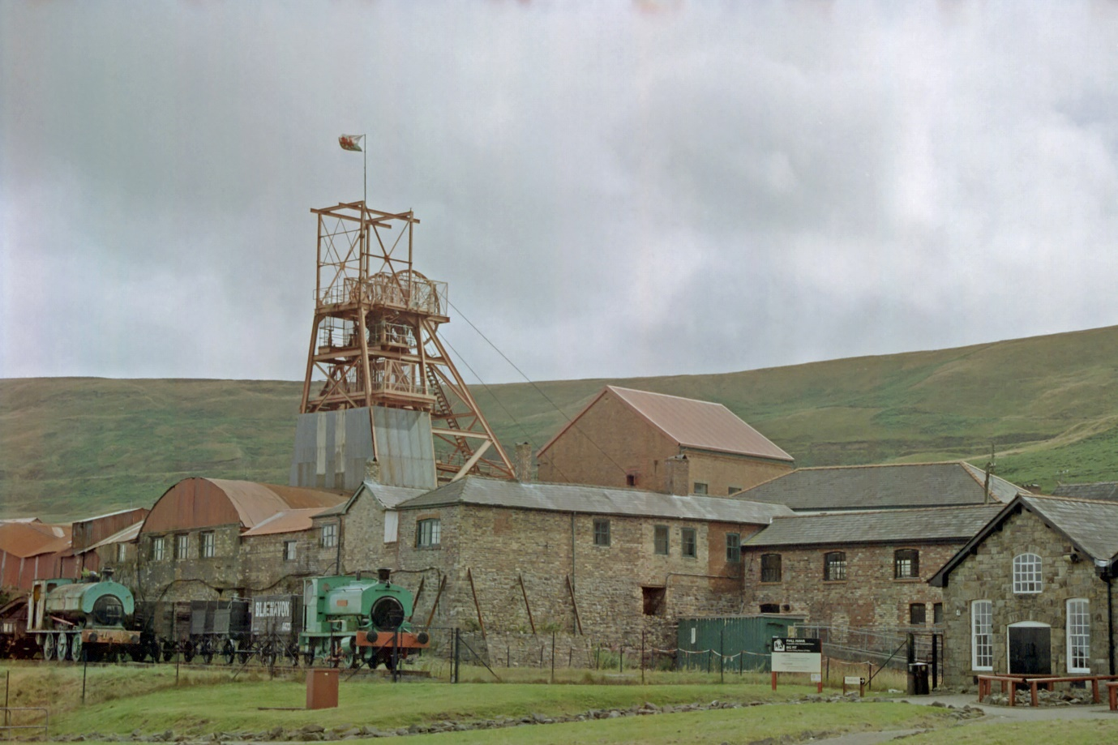

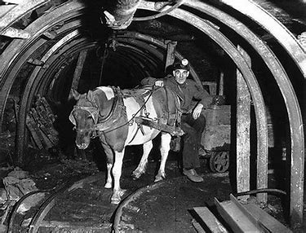
BLEANAVON PIT PONY

References

Appraisal & Management Plan. (2017). Blaenavon. Available: https://www.visitblaenavon.co.uk/en/Publications/Blaenavon-Townscape-Heritage-Programme/Blaenavon-Town-Centre-Conservation-Area-Appraisal-and-Management-Plan-2017-2022.pdf. Last accessed 19/02/2020
BBC news. (2013). big pit Blaenavon. Available: https://www.bbc.co.uk/news/uk-wales. Last accessed 19/02/2020.
Evans, J. (2020). BLAENAVON IRONWORKS. Available: http://cadw.gov.wales/daysout/blaenavonironworks/?lang=en.
Last accessed 01/03/2020.
Rene, O (2019). Blaenavon. Available: https://www.heritagefund.org.uk/news/25-years-restoring-prosperity-and-pride-blaenavon. Last accessed 19/02/2020.
welsh government. (2019). hot metal 'black gold'. Available: https://cadw.gov.wales/learn/sites-through-centuries/industrial-wales. Last accessed 26/02/2020.
Williams.P (2002). Blaenavon. Available: http:/welshcoalmines.co.uk/Gwent/bigpit.htm. Last accessed 19/02/2020.

