Arry Jaffa (1605599)
LECTERER: Husam ALHarahsheh
Pathway Project 1
EMPL4013

Table of Contents
Introduction 2
Topic studied/Skills developed 2
Observations 3
Conceptualisation 4
Active Extermination 4
Conclusion 5
Appendix A 6
Learning Log 7
References 8

Sustainability and global citizenship self-reflective

Introduction

This case study was very engaging especially as it was based on group work and allowed individuals to work well on their own initiative as well in a team. It allowed individuals to develop in areas such as communicational skills and progress with future performance for the work they carry out. My group consisted of five individuals including myself, also being the group leader. As a group, we had to come together, deciding what section we were going to work on and present for the assignment. Before staring the assignment and performing any research myself as well as in the group, I ensured that the sector we wanted to research ones a group and perform for the assignment, ensuring that it was suitable for the section we picked as a group. This assignment allowed individuals to research on certain areas linked to the topic, giving me and my group enough time to get the work completed and have full understanding of our section we picked which was leadership and entrepreneur. This case study was a bit distressing at times for me as well as one or two individuals in the group as we had to ensure that we completed the work regardless to anyone not carrying out as much work as another individual, therefore, there was no reason for any excuses not to have the work done. Also, as an individual I certainly did not want to let myself down by not carrying out extra tasks or giving individuals tasks to complete for a specific date. In This self-reflective report will include all areas I developed in as well as the group.

Topic studied/Skills developed

Our group included of five members and we were all give specific tasks to accomplish in order to get the work completed as a group and understand the assignment as best as we possibly could. Reflecting on my role as ‘team leader’, I knew at the time that I was delegated with this role by the group that there was going to be so much responsibility I carry for myself as well as the group. The most challenging part of being chosen for this role was setting myself and the group high expectations in order to achieve the best results possible as well as gain full understanding on our topic chosen which was leadership and entrepreneur. I also found it difficult at times to communicate with others in my group, allowing me to be more organised by preparing extra research in additional sectors ensuring all the topic areas were covered. It was also difficult to provide individuals with specific research to carry out as some individuals were not happy with their sections, so we had to decide who felt most effective in the section they wanted to perform for the group presentation. The group dynamics involved the interactions and processes of a team and influenced the topic to which individuals feel a part of the goal and mission. It can be seen by (Tuckman, 2005)Developmental in small groups, ‘storming’ transpires as members within the group come to know each other and communicate more effectively, achieving success in a freely manor. I developed in many key areas by being appointed team leader especially the topic we focused on as a group was based on successful leadership and entrepreneurship. With my role, as ‘Team leader’, I took on the role as I was appointed by my group, however, if the group does not accept their role as a Leader, the assignment could of proved too challenging, which was the case at certain times, nevertheless, individuals still carried tasks that were set out and additionally covering other aspects of the group as we had to be prepared to cover sections on the presentation day in case an individual could not make it for whatever reason, which was also the case on the day of our presentation. Consequently, we communicated very effectively throughout this progress and in summary, evidently helped us in completing the course and reaching our overall group objectives.

Observations

Being capable to resolve disputes can obstruct performance, which is another benefit to reflection. At the time of coming together as a group, individuals had noticed that it was very difficult to provide specific tasks to certain team members, which people was finding very frustrating as certain individuals would perform as well as other individuals around them, getting the best out of the person by providing feedback when necessary. It could also be seen that time management was a key factor that seemed to hamper myself as well as other individuals especially carrying out additional work when required to. The reason for this was down to work rotas, conflicting schedules or any other commitments such as children for example. This is where organization sector was developed by myself as well as others, as we needed to ensure that we covered individuals by communicating effectively, in order to succeed as a group. Additionally, we appeared to experience ma few challenges in our time management (Ellis, 2012) discusses that assigning individuals with specific tasks can compromise significant time keeping when carrying out group work, however, this is something we should of all taken on board as we frequently did not consider individuals strengths or weaknesses in our team before assigning individuals with tasks to accomplish.

Conceptualisation

This case study has helped me gain a great deal of understanding in sustainability and global citizenship, with so insufficient knowledge before starting the topic. The understanding of group work has also been a key lesson to me, ensuring that I will be prepared in the future by using methods such as adequate planning and time lines set out, ensuring that were more organized when working as a group, succeeding with accomplishing tasks in an achievable time frame. Everyone was allowed the opportunity to express their ideas and have input when necessary. As a group we were very motivating, being positive, in order to encourage individuals and get the best out of each and every one of us. Everyone in the group had a responsibility which was being capable of performing with their assigned workload, and ways of communicating this was arriving on time to group meeting but also replying to messages or any e-mail from myself as well as anyone else in the group. Additionally, there was a few situations were individuals had feelings, for example, some individuals felt they were doing more work than others, which can often produce less effective work and lower quality learning for the group. However, as a leader I took on the duty to inspire and motivate individuals by networking via the phone to ensure they understood their section and the topic itself. Moreover, I also performed one to one meetings helping the group, the individual and myself gain extra understand but also provide positive feedback as well as advice, in order to gain the best performance by each and every individual in the group.

Active Extermination

Group work is an exceptional method to improve vital skills that are essential to working in a business environment. A few of the key skills I developed whilst undertaking group work were decision-making, social, communication, listening, organization, leadership, networking, time management and reflective thinking. I could use all of the skills and knowledge I gained from this case study and use them in the workplace, socially as well as professionally. Being capable of partaking in meetings where my group’s decisions, actions and future strategies are critically discussed and this would give individuals the advantage to gain confidence for when in the workplace, they may have meetings with professionals, at a high level one day. A team worker is someone that brings informality to the group with exceptional organisation skills and great experience with working in a team. They can be seen as the individual who brings informality to the group. However, I was extremely surprised at these results of my group as they can consider myself to be an exceptional team leader, with a great sense of encouragement and motivation. The reason being is they believed that I make my thoughts very clear, show exception leadership skills by providing support when necessary and also taking charge in a professional manor. It can be seen that as we all helped one another and come together as a team we were successful with all the work we performed in a specific time frame, allowing everyone to gain full knowledge of the topic. Moreover, on the day of our presentation we was asked to perform a presentation, which was to be no longer than fifteen minutes giving the individuals around four minutes each, ensuring that they cover all of their sections. The presentation was completed by myself and another group member (see Appendix A), as we had to ensure we communicated effectively and we both knew what the focus of the topic was, helping me gain a great sense of understanding on the topic.

Conclusion

In summary, this assignment allowed me to gain a full understanding of what skills and tools are required to be a successful leader. Additionally, I also now know the difference between entrepreneurial and conventional leaders or managers. Research that I carried out was appropriate for me as I was the group leader, so when I found it hard to help someone or give someone advice, I referred to how to be a successful leader as well as what appropriate skills are required to ensure that the leader we focused on was successful and viable for the assignment. Overall, I will ensure that all of the knowledge I gained and sectors that I developed within, that I will put in place and use in the workplace as well as my future in general.

Appendix A

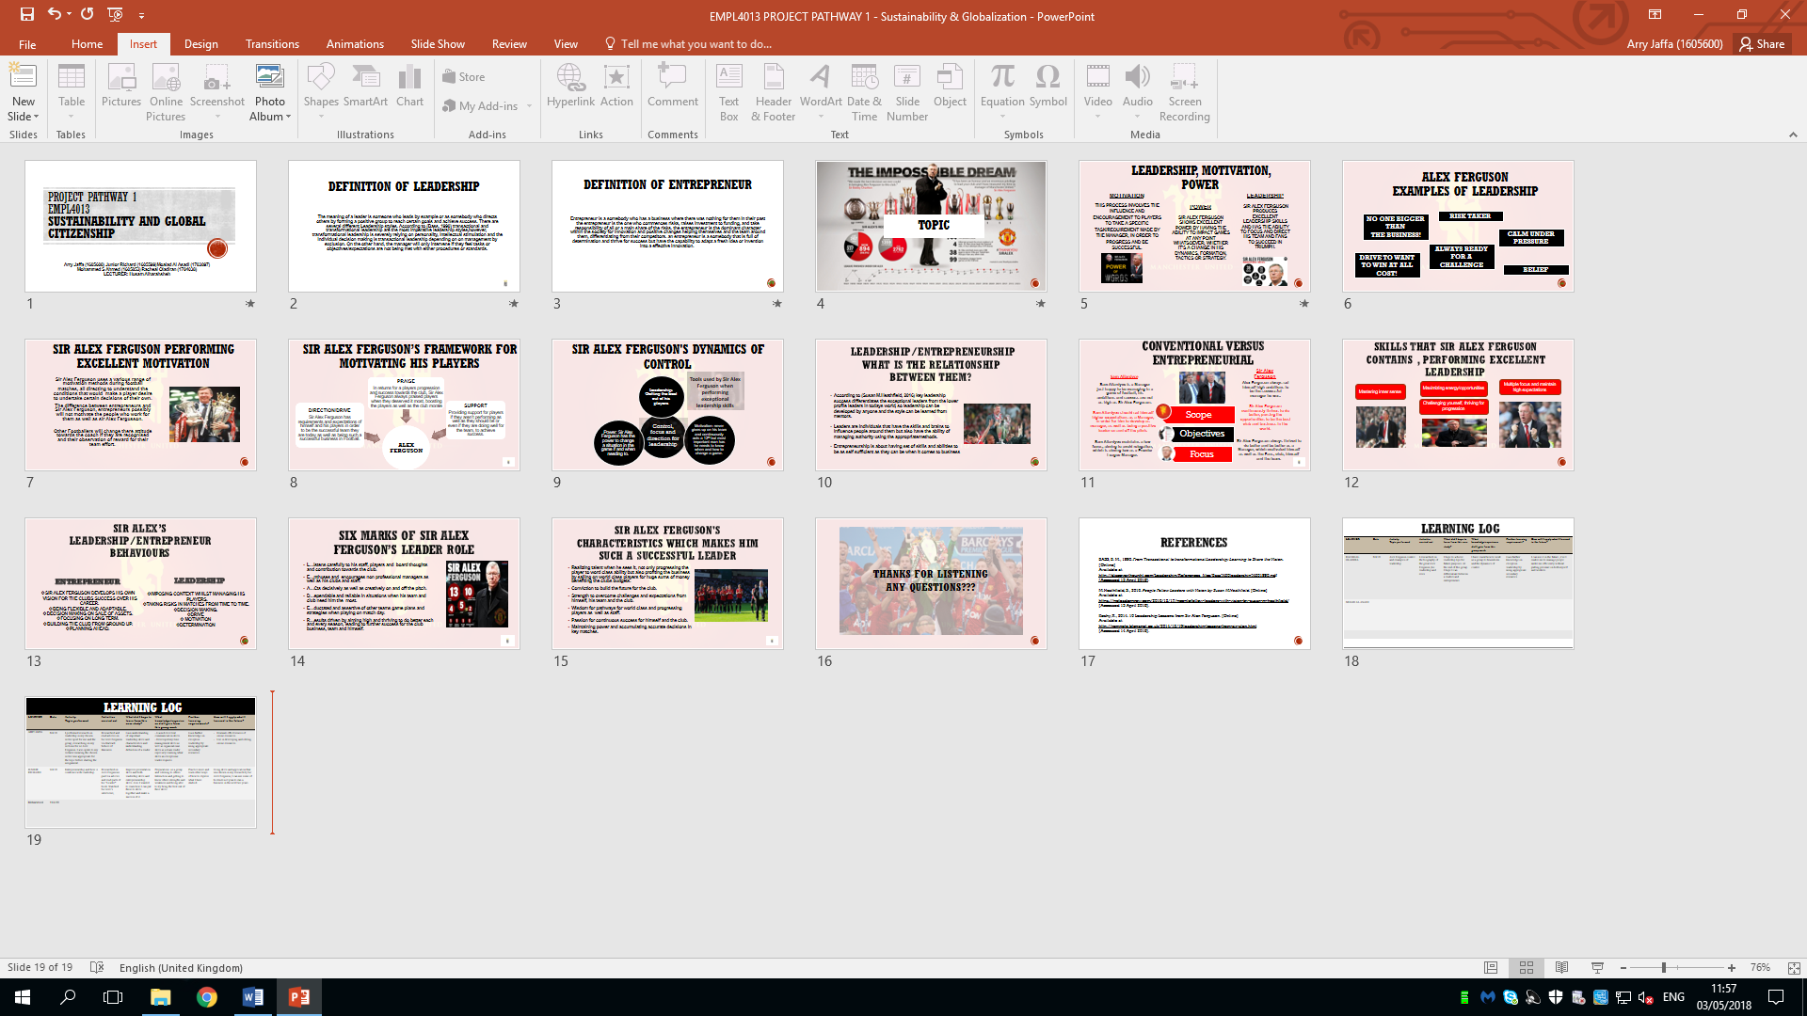

Learning Log

Student name and ID number: Arry Jaffa (1605600)

Date: 8/4/18

Activity Topic performed:

I performed research on leadership in my chosen sector sport for me and the group, researching on my sections for sir Alex Ferguson. I also spoke to my lecturer ensuring the chosen sector was appropriate for the topic, before starting the assignment.

Activities carried out:

Researched and read articles on Sir Alex Ferguson via Harvard School of Business.

What did I hope to learn from this case study?

Gain understanding of important leadership skills and characteristics and understanding definition of a leader.

What knowledge/experience did I gain from the group work?

- Gained excellent communication skills.
- Developed my time management skills as well as organisational skills as a team leader especially learning what skills an exceptional leader requires.

Further learning requirements:

Gain further knowledge on exceptional leadership by using appropriate secondary resources.

How will I ally what I learned for the future?

-Evaluate effectiveness of online resources.
-Developing and editing online resources.
-Become a successful leader and motivator in my chosen sector that I’m willing to progress and move forward in the future.

References
Ellis, G., 2012. people exeter. [Online]
Available at: people.exeter.ac.uk
[Accessed 29 04 2018].
Tuckman, B., 2005. infed. [Online]
Available at: infed.org
[Accessed 28 04 2018].

