Hotel standards, Reputation management and Service Culture
Student name: Alexandru Badea
Student id: 2208275
Lecturer: Charlotte Joyner
Module: BMIH4003
Hospitality and Guest Services

Executive Summary
The report is all about Hotel standards, Reputation management and Service Culture. The ability of the personnel to gauge consumer behaviour enables them to provide appropriate customer service. Because it sets businesses apart from one another, customer service is crucial in the hotel sector. The key discussions will answer the key questions that includes the purpose of brand consistency standards, How can hotels manage their reputation effectively, What is the importance of effective guest reviews management, What is the impact of negative reviews, What is service culture, How does this differ from corporate culture, Why is this important in the hotel industry etc.
Table of Contents
Executive Summary 2
Introduction 4
Hotel standards 5
What is the purpose of brand consistency standards? 5
Do all hotels have the same standards? 5
Reputation Management 6
How can hotels manage their reputation effectively? 6
What is the importance of effective guest reviews management? 7
What is the impact of negative reviews? 7
Service culture: 9
What is service culture? 9
How does this differ from corporate culture? 10
Why is this important in the hotel industry? 11
Conclusion 12
References 13

Introduction
Providing the greatest services is crucial for this industry in the hospitality industry. The topic of this assignment is hospitality and guest services. The importance of guest services and empowerment, the spectrum of hospitality services, the relevance of guest services methods, and awareness of their usage in understanding visitor demands are only a few of the subjects discussed. One of the well-known accommodations in England is the "Hotel industry," which offers its guests high-quality services. These subjects assist the business hotel industry in raising the quality of its offerings and luring more clients (Ghosh, 2022).

Hotel standards

What is the purpose of brand consistency standards?
From the perspective of a customer, logo requirements serve as the minimum bar for what is expected of services and goods. They provide an inn or resort the sense of belonging that it needs to prosper. The needs of the consumer are evolving daily. Therefore, hotel industry requires a clause that enables it to adapt to the shifting demands of its customers. (Mariani et al., 2021)
Hotel Standard means both the operational standards (for example, staffing, amenities offered to guests, advertising, etc.) and the physical standards (for example, the quality, condition and utility of the Fixtures and Leased Personal Property, etc.) Tourism and travel make up the greatest portion of the hospitality sector. A substantial number of people travel annually. A further possibility for the hotel industry is the chance to serve customers. A company's ability to deliver top-notch services depends on its understanding of its operational systems and resource allocation (Mariani et al., 2021).
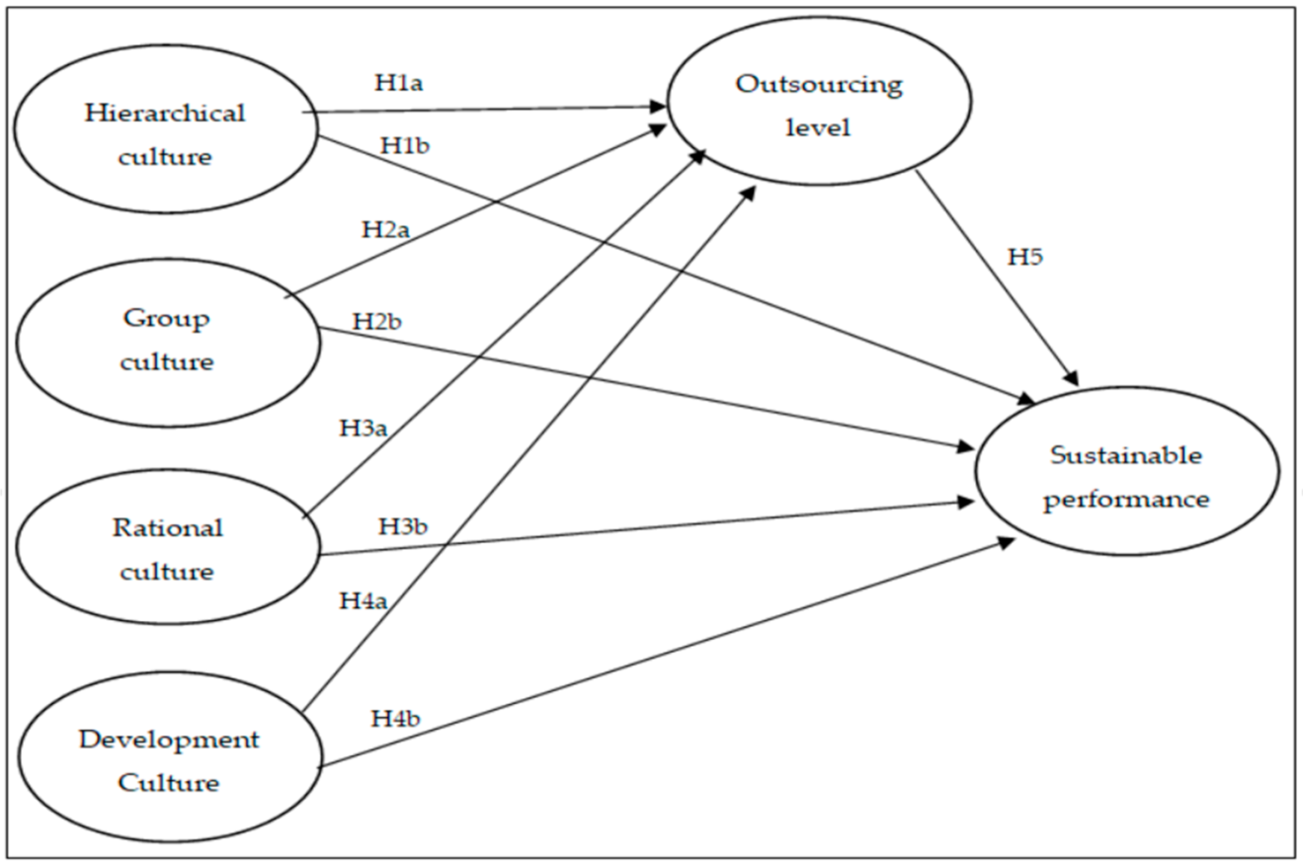
Figure: Hotel Brand-consistency standards (Huang et al, 2021)

Do all hotels have the same standards?
3-star: Three-star accommodations are considered to be cutting-edge and include unique amenities in addition to top-notch service. Without operational systems and resource availability, a firm cannot provide the best service to the company (Setyowati et al., 2021). Additionally, it assists the corporation in running its operations effectively and making the most use of its resources (Altinay et al., 2021).
4-star: Resorts that get this designation are typically recognized for their opulent amenities and unmatched comfort. The reason is that if a business is not offering their finest services, then tourists and consumers will be dissatisfied and look elsewhere. Therefore, providing the greatest services to the clients is crucial for the hotel industry (Sheth, 2020).
5-star: An institution with a rating of five stars offers exceptional guest services in a modern environment. Among hospitality services, travel and tourism make up the majority. In addition to this, the hospitality sector encompasses a larger variety of businesses, including those in leisure, meetings, and events. The whole industry is particularly advantageous to the business hotel industry (Sazu Sardar et al., 2021).
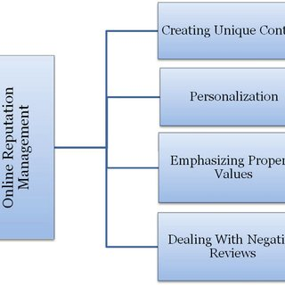
Figure: Hotel standards (Mariani et al., 2021).

Reputation Management

How can hotels manage their reputation effectively?
Step 1: Monitoring on standing
Because there are several methods that a corporate organisation might provide hospitality services, the scope of the sector is relatively broad (Valk et al., 2021). Analyze the variety of hospitality services a business may provide to consumers (Ritter et al., 2020).
Step 2: Create a plan of action in step two.
In order to increase the company hotel industry' reputation and ensure that customers are happy with the hotel's services, the company must properly empower its employees (Altinay et al., 2021).
Step 3: Carefully handle critical remarks.
Employees might have more confidence in their job via this empowerment. Customers won't be happy with the hotel's services if staff members don't appropriately gauge their needs. (Rangarajan and colleagues, 2021)
Step 4: Respond to reviews on media
Respond to reviews on media can be supportive to ensure effective Reputation Management. At the moment of decision-making, this empowerment is also in effect. Employees may manage their customers' experiences with the support of this empowerment, and they can also make their own choices that can help them become experts in guest services (Mariani et al., 2021).
Step 5: Continue and assess outcomes
The firm has to empower both the customer and the staff when it comes to customer service. Therefore, the hotel industry organisation must empower its staff appropriately so that they can accurately measure guests and provide the greatest services (Huang. et al., 2021).

What is the importance of effective guest reviews management?
Increase traffic and bookings
Reputation management is the process of influencing, controlling, boosting, or burying a person's or a group's reputation. Public relations are where the expression first appeared. The workers are not currently abiding by any norms or laws, which is essential for providing top-notch services. When it comes to changing client demand, operational systems, and resource suppliers, hotel industry has to make a special provision. For example, Special provisions and house rules- 1) Pets are not allowed. 2) Minimum stay of 1 month with a maximum of 6 months. 3) The hotel will clean the guest's room etc. (Mariani et al., 2021)
By providing the greatest services and focusing on client satisfaction, the business hotel industry will be able to the hospitality industry is linked to the food and beverage industry since doing so may make customers happy. Customers of this company could be given food and beverages while being made to feel welcome at a hotel like the hotel industry As a result, a considerable chunk of hospitality services are offered here (Rescalvo-Martin et al., 2021).

What is the impact of negative reviews?
Direct Loss of Revenue
A large number of individuals travel annually. Additionally, the opportunity to provide the clients their services is available to the hotel business. Additionally, you have the opportunity to acquire hotel industry and effectively use it. Another crucial component of hospitality services is the hotel sector. (Mariani et al., 2021)
Damage to Reputation
Since organisational culture affects how effectively the hotel functions, it bears the burden of developing a successful company. When clients are traveling from one nation or location to another, hotels like hotel industry may provide accommodation options including hotels, vacation rentals, and bed & breakfasts to them. Additionally, by doing this, the clients get the services, and the business also makes money (Huang et al., 2021).

Service culture

What is service culture?
Service culture definition refers to the fact that the basic definition for service culture is an environment where employees are obsessed with providing superior customer service to clients. The company hotel industry needs to provide the staff with the appropriate empowerment so that they can work on their style and experiences that will help them measure the customers accurately and make the right decisions that will improve the company's reputation and the customers' satisfaction with the hotel services (Altinay et al, 2021).
Logo criteria are essential for developing emblem identity and fairness. For the organisation, requirements provide uniformity. Therefore, for the organisation "Hotel industry," picking the ideal methods is crucial (Rescalvo-Martin et al., 2021). By supplying food and drink, this business may serve its clients and provide a warm welcome at a hotel like the hotel industry As a result, the hotel services industry is quite large (Rescalvo-Martin et al., 2021).
Developing and maintaining loyalty, including industry shifts and how we must modify to keep up with them e.g. Understanding Increasing & maintaining allegiance, When making a sale, emphasize case studies, Be consistent with expectations, Regularly communicate the outcomes, Lay up a plan for the future of the connection, Create lasting recollections of your triumphs, Request input, then take action based on it (Huang et al, 2021).

How does this differ from corporate culture?
Become adept at handling ambiguity and uncertainty
The effective application of strategies is a crucial component of hospitality and guest services. For instance, the hotel industry chooses the finest customer service tactics in the hopes that the firm would attract more clients as a result. Westmont Hospitality Group owns and operates this hotel (Huang et al, 2021)
Take an entrepreneurial attitude
There are 165 rooms in this hotel, which has 8 floors overall. The hotel industry features seven suites, one restaurant, and several other amenities (Pavlovna et al., 2022). However, the business is not implementing the strategy adequately. And as a consequence, the business cannot host the anticipated customer. (Huang et al, 2021)
Enhancing the organisation
Therefore, it can be concluded that in order to meet the demands of the company's hotel industry guests, it is crucial to not only choose the finest methods but also to use them in the right way (Sazu Sardar et al., 2021).

Why is this important in the hotel industry?
Hotel industry, a corporation, has to use the right techniques if it wants to provide its consumers the greatest possible guest services. The explanation is that if the business hotel industry does not choose the suitable tactics, it will not provide its guests with adequate services, and its clients won't be satisfied with its performance. (Huang et al, 2021). For every company, establishing and maintaining loyalty is crucial (Mariani et al., 2021).
The ability of the personnel to gauge consumer behaviour enables them to provide appropriate customer service. Because it sets businesses apart from one another, customer service is crucial in the hotel sector. There is no way to provide a lesser level of service in the tourist sector. The fundamental reason is that other businesses might outperform one if it offers worse service and attract more clients. Customer service is thus crucial (Valk et al., 2021).

Conclusion
At the conclusion of the assignment, it may be argued that it is crucial to provide the highest quality guest service in the hospitality sector. Any firm, like "Hotel industry," must provide the highest calibre services to its customers if it is to succeed in this market. And as a result, the visitor will be happy and return to the hotel industry to take advantage of its top-notch services. In this situation, hotel industry must empower staff members and have a special provision that enables the business to use its operational systems and resources flawlessly (Chen et al., 2021).

References
Altinay, L. and Arici, H.E., (2021). Transformation of the hospitality services marketing structure: a chaos theory perspective. Journal of Services Marketing.
Chen, Y.A. and Chen, C.L., (2021). Case study of sustainable service design in the hospitality industry. Chinese Management Studies.
Ghosh, K., (2022). When and how employees cross the line for the job in hospitality firms. International Journal of Hospitality Management, 103, p.103187.
Huang, A., Chao, Y., de la Mora Velasco, E., Bilgihan, A. and Wei, W., (2021). When artificial intelligence meets the hospitality and tourism industry: an assessment framework to inform theory and management. Journal of Hospitality and Tourism Insights. FB
Johnson, E.M.S., Thompson, E.G.M. and Paul, N.I., (2022). Preparing the post-pandemic workforce for the cruise and hospitality industry. Worldwide Hospitality and Tourism Themes.
Mariani, M. and Borghi, M., (2021). Customers’ evaluation of mechanical artificial intelligence in hospitality services: a study using online reviews analytics. International Journal of Contemporary Hospitality Management.
Pavlovna, R.T., Igorevna, K.A. and Vladimirovna, T.E., (2022). Classification of Hospitality Enterprises as a Course of State Regulation of the Quality of Hospitality Services in the Russian Federation: Prospects and Challenges. ECS Transactions, 107(1), p.18559.
Rangarajan, D., Sharma, A., Lyngdoh, T. and Paesbrugghe, B., (2021). Business-to-business selling in the post-COVID-19 era: Developing an adaptive sales force. Business Horizons, 64(5), pp.647-658
Rescalvo-Martin, E., Gutierrez-Gutierrez, L. and Llorens-Montes, F.J., (2021). The effect of paradoxical leadership on extra-role service in the hospitality industry. International Journal of Contemporary Hospitality Management.
Ritter, T. and Pedersen, C.L., (2020). Digitization capability and the digitalization of business models in business-to-business firms: Past, present, and future. Industrial Marketing Management, 86, pp.180-190.
Sazu Sardar, D., Hossain, M.E., Kamruzzaman, M. and Ray, R., (2021). ICT APPLICATIONS IN TOURISM AND HOSPITALITY INDUSTRY OF BANGLADESH: A RESEARCH REVIEW.
Setyowati, W., Widayanti, R. and Supriyanti, D., (2021). Implementation Of E-Business Information System In Indonesia: Prospects And Challenges. International Journal of Cyber and IT Service Management, 1(2), pp.180-188.
Sheth, J., (2020). Business of business is more than business: Managing during the Covid crisis. Industrial Marketing Management, 88, pp.261-264.
Valk, R. and Yousif, L., (2021). “Going beyond to deliver hip hospitality”: exploring motivation and job satisfaction of hospitality workers in Dubai. International Journal of Organisational Analysis.

