Leadership Reflection
UWTSD | Operational and Strategic Leadership in Policing
BMPO7005 – Leadership and the individual
2022380 – Oliver Petty
2022
Contents
ABSTRACT 2
INTRODUCTION 3
LEADERSHIP 5
REFLECTION 1 – Personal Leadership 8
REFLECTION 2 – Leadership of Others 15
LEARNING & FUTURE CHALLENGES 19
CONCLUSION 21
Bibliography 22

ABSTRACT
This paper is a reflective report submitted as part of the ‘Leadership and the Individual’ module, which forms part of the MSc in Operational and Strategic Leadership.
The paper will outline where the theory of leadership has stemmed from, the different styles of leadership, and the important traits or behaviours associated with it, before providing some context on leadership in policing.
The context will assist when the paper concentrates on reviewing incidents personal to me, from my time as a Police Sergeant at Gwent Police. During the reflections, the paper will also discuss theories of motivation and learning, which are inextricably linked to leadership.
In reviewing the incidents, the paper has sought to use the Gibbs Reflective Cycle (Gibbs, 1988). The cycle, shown below as Figure 1, provides structure on reviewing experiences, especially where those experiences concern leadership.
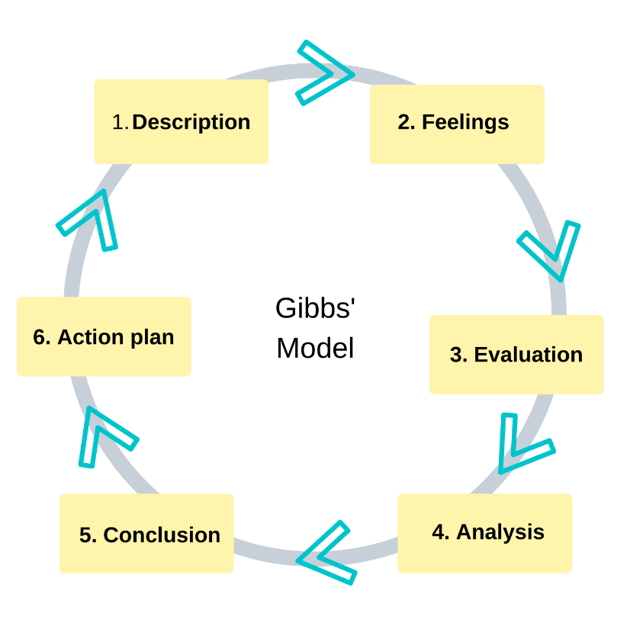
Figure 1, (Gibbs, 1988).

INTRODUCTION
The close of the first quarter of the 21st century is fast approaching, and on reflecting upon notable controversies, you would be forgiven for wishing that the second quarter will be a far more positive affair.
A collection of conflicts, recessions, referendums, and most recently a global pandemic, has divided nations, neighbourhoods, and even families. Whether discussions concern the wearing of marks, or the benefits of Brexit, the impact has been damming. The direct cost of human life caused by the aforementioned topics is difficult to measure, with the indirect cost even more so.
Although some of the issues in the last two decades have seemed inevitable, it is hard not to question the impact leadership, or a lack thereof, has impacted on such hardships.
In 2003, Operation Iraqi Freedom saw the aerial bombardment of Baghdad, in an apparent show of force by George Bush and Tony Blair (President of the United States and Prime Minister of Great Britain respectively), which reignited war in the Middle East (BBC News, 2016). And although Blair has been regarded as a transformational leader, Bush’s inability to waiver in his approach saw catastrophic costs and consequences (McHugh, 2010). The war, based on the false pretext that Saddam Hussein had fast access to weapons of mass destruction, is said to have been a primary cause of death of over 500,000 thousand people (Hagopian, et al., 2013).
While those on these shores were primarily concerned with the cost of human life, others were mindful of the price to the public purse. A public purse whose strings were drawn tighter than ever with the financial crash of 2007, which is said to have been caused by an abundance of recklessness by executive bankers, with perverse motivations and an overindulgent self-confidence - poor traits for any type of leader (Bradshaw, 2011).
Further economic woe then entailed, with the Brexit saga, where the country has seemingly imposed economic sanctions upon itself by voting ‘Leave’ (O'Brien, 2020).
And whilst the economy made attempts to mend itself, the Covid-19 pandemic then struck, with latest estimates putting the cost of the virus at £339 billion (Pope, et al., 2021). The leadership displayed by Prime Minister Boris Johnson during this period was called into question from the outset, with it being reported that he missed several of the COBRA meetings (the committee that is convened to handle matters of national emergency or major disruption), that were scheduled prior to the virus ravaging Britain (Stern, 2020).
Furthermore, the policies that Johnson’s government have put in place to combat the damage caused by the pandemic, have impacted the poorest members of society the most (Waitzan, 2020).
Although saddening, my focus on these issues is to demonstrate how leadership is ever present in our lives and how it impacts us in considerable ways. It has also demonstrated just some of the varying styles at play. Be it, authoritarian, transformational, or laissez-faire – to name but a few.
These styles will be explored throughout the paper, but beforehand it is important to understand where the notion of leadership once started, the traits associated with good and bad leadership, and lastly – before personal reflection – the context of leadership in policing in the current day.

LEADERSHIP
Literature on leadership is vast and wide ranging. It can relate to leading whole organisations, a collection of individuals, or even just leading oneself to live life in a certain way (Robbins, 2022). Moreover, it is seen in all walks of life from the political arena, across public services, and even the sporting world.
But where did it all start, and what did the early notions of leadership entail?
Early debates in leadership were concerned with whether individuals were born to lead or not (Burgoyne, 2016). Known as ‘The Great Man Theory’ this early theory suggested that great leaders could not be developed or nurtured, but rather were born with the relevant traits. The founder of such a notion, Carlyle (1888), firmly believed that people were sent to earth by God to lead and were provided with the relevant intellect and courage to do so. Although panned in the modern era for its lack of empirical evidence (Gosling, et al., 2012), its ties to religion, and its obvious sexist connotation, there have been those that believe such people do exist, with Bailey (1988) suggesting war time leaders in particular fit the theory, with Sir Winston Churchill (former British Prime Minister) and Mussolini (former Italian Prime Minister), offered as examples.
In the current day, more respected theories revolve around the following areas: situational leadership, transactional leadership, and transformational leadership – instances of which will be reflected upon in part two of this paper.
Before then, rather than examining which theories are important, it is beneficial to examine which characteristics are. ‘The Great Man Theory’ suggested that good leaders are born with the important and necessary traits required, a notion that has since been totally refuted. It is far more reasonable to suggest our early childhood, our upbringing, and a whole other host of issues such as schooling, friendship, and social interactions, develop us into leaders throughout our formative years. Whilst these experiences can help people to develop positive leadership traits, for many people they can also have negative effects. Adverse Childhood Experiences, or ACEs as they are commonly referred to, having substantial impacts on us as individuals, with 1 in 3 diagnosed mental health conditions in adulthood directly related to ACEs (Manchester University NHS Foundation Trust, 2022).
Moreover, these experiences which present themselves by way of characteristics or traits of personality, are what form the basis of any style. But what are the good and bad traits of leadership? And are they any different when looking from a policing context, where large expanses of my personal leadership experiences have come from.
As a leader in a professional capacity as a Police Sergeant, and in a social capacity as club captain of the local rugby team, I have always based my leadership around four core traits:
Honesty
Respect
Courage
Commitment
These values are not surprising. I feel they form the basis of human decency, which should be the foundation for all we do as police officers and is now more important than ever within policing. It is probably why they are reflected in the policing Codes of Ethics and Standards of Professional Behaviour set out in the College of Policing (2014) as charter for all employees to adhere too.
Leadership in policing has followed a similar pattern to that of standards of behaviour and the theory of leadership itself, in that it has taken large strides forward in the past 10-20 years (Hoggett, et al., 2019).
Such has been the advancement with the drive for professionalisation, the progression of technology, and the continual diversification of the rank and file, one fixed style of leadership is no longer enough to lead others successfully.
On inspecting the leadership in policing, the recent headlines make for poor reading, with overall confidence in policing at an all-time low. Some of the actions taken during the pandemic, such as the breaking up of birthday parties and fining individuals for walking their dogs too far from home, have certainly been unhelpful in this regard (BBC News, 2020). However, these instances are negligible when we see the reputational damage caused by other matters, including the racist and misogynistic WhatsApp group made up of officers from Charing Cross Station, which was unearthed following the senseless killing of Sarah Everard by a serving Metropolitan Police Officer, which was the final catalyst in the sacking of the Commissioner, Dame Cressida Dick (Swinford, et al., 2021).
But what does leadership in policing look like on the ground? Given the context of the type of work, and the structure of rank, policing has long been one of authoritarian leadership. A style where clear direction and order is given, and where clarity and discipline is of great benefit. Authoritarian leaders, such as those commanding firearms incidents or those involving critical risk will use a legitimate power, such as the power awarded to them by rank, but will rarely take time to get to know and build trust with those that work under them (Gosling, et al., 2012). This lack of personalness can leave authoritarian leaders in a lonely position, one which over time can cause both the team and the leader to supress thoughts and feelings, potentially leading to despondency and poor performance (Ting-Ju Chiang & Chen, 2021).
Although we have noted that the structure of the organisation for which I work benefits at times from the above style, there has been ambitious attempts to revolutionise leadership by the College of Policing (2015) , and ensure it is embedded across not only those who sit at the top of the hierarchy, but throughout the entire workforce. This is something I have seen first-hand whilst being Staff Officer to the NPCC Workforce Co-ordination Committee, which undertakes work to improve capabilities of the workforce for the future (Kelly, 2020).
These improvements have been to strip out, where appropriate, direct leadership, replacing it with a strategy to develop more fluid and flexible leaders. Although only having been in policing for six years, I have led and been led by a wide range of leaders.
The next chapter of this paper concentrates on my time as a member of the police over the last six years, with two prominent instances used to demonstrate real evidence of the state of leadership in policing, its impact on people’s wellbeing, performance, motivations, and the overall health of the organisation.

REFLECTION 1 – Personal Leadership

Description
As part of my supervisor responsibilities, I regularly conduct individual face-to-face meetings with my staff. These meetings cover a wide range of topics but mainly focus on the management of the officers’ investigations and their welfare, as I have found these often go hand-in-hand.
My general approach outside of these meetings has been to reinforce the mission and values of the police force for which we work, and link these to our work, providing some context as to how the team and I can play a huge part in the organisational goal.
With one staff member (Person A) the monthly meetings followed a similar pattern: they would arrive highly stressed, with a high volume of crimes. I would then sit down with them and review the investigations, using my Sergeant’s rationale to discern which investigations we could close, due to there being no further actions available to take.
During these reviews, I would talk to Person A and explain how I would come to a decision and demonstrate to them how they needed to personally review the investigations and attempt to either justify further lines of enquiry, or close the matter themselves, so that I could see they understood the investigation process. I also explained that improvements in work would highlight to me not only their abilities, but their desire, and in turn would result in rewards, which could include attending further training courses, such as blue light driving and taser.
These meetings took place once every 21 days, and after successive meetings I found that the individual was reliant on me to complete the rationales required to close crimes, had very little willingness to work, and their outlook on work and life in general was diminishing.
After countless conversations about the method of reviewing criminal investigations, the outcome did not change, and I found to improve their wellbeing I would relent and complete the reviews myself. I also decided to stop short in formalising the lack of effort and progress shown by the individual in the form of a disciplinary process.
The individual has since gone on a period of long-term sickness, and I have recently learnt they have decided to leave policing – citing the stressful nature of their role and their inability to meet its demands.
Feelings
Before the last meeting with the individual, I still believed I had the necessary skills and traits to improve their performance and morale, but during it I questioned whether the required desire on their behalf was present.
As a result of the individual leaving the organisation, I feel deep regret at not being able to have done more. I have continually questioned my approach, not just for this scenario but all other interactions with despondent staff, especially those who I know have moved on from the organisation. Reflecting on this has made me realise that I often dwell on my abilities and potential, with colleagues noticing elements of ‘imposter syndrome’ in how I present to them.
On a positive note, the individual on conducting an exit interview with the organisation was complimentary as to the support given by me, explaining that if it was not for my interventions, they feel they would have left the organisation sooner, or felt their mental health would be far worse.
Evaluation
The positive aspects of my contribution in this scenario, although limited, was my leadership style. Although the execution of this style is questionable and is analysed in the next section, I believe that my recognition of deeper lying issues affecting performance, coupled with the empathy displayed and my use of potential rewards, was admiral. I also believe that taking an all-encompassed approach that attempted to highlight a future vision for the individual, team, and organisation was beneficial.
However, in almost contradictory fashion, the empathy shown clouded my judgement, and after the meeting I realised it had led to me overstepping. Although I was trying to influence Person A to do the work, it demonstrably failed, as I did too much of the work myself, undermining my whole approach.
Furthermore, in terms of motivation, it is pleasing to see when we look at McGregor’s X and Y theory, that I appear to have assumed the Theory Y position. McGregor proposed that an individual’s style of management was dependent on their predisposition towards a person’s attitude and behaviour, with X and Y poles apart. The theory posits that X people are lazy, dislike work, lack ambition, and have a distain for the organisation; whereas Y people believe individuals are committed, seek responsibility, and have problem solving capabilities (McGregor, 1987) .
Analysis
Leadership
On first reflection, I was assured that in this instance I was displaying transformational leadership. Transformational is where the leader is highly engaged with their staff (Thomas & Cangemi, 2021). Leaders who exude the transformation traits, motivate staff to be forward thinking, ensuring they have the necessary skills to continually improve as individuals and as a team.
On further reflection, hints of transactional leadership are also at play – demonstrated by my desire that Person A would complete their work on the basis that they would be rewarded. This flitting between transformational and transactional, although not perverse, can be difficult for employees to understand. This is particularly true of transformational leadership, as for it to work you must inspire extraordinary effort and outcomes, rather than elicit competent performance (Bass & Riggio, 2005).
Motivation
As for my personal motivations, it was clear that Person A was experiencing difficulties in their personal life. As a result, I found I was empathising with them, and lightening their workload to lessen their stress. I did this in the hope of making them feel more positive about their role, and providing an uplifting time in work, so as to ensure they did not become so unwell that they reported absent through sickness. Secondly, I wanted to prove to myself that I could solve the problem and be creative in getting the individual to completely change their outlook on how they approached their work.
It is difficult to talk about motivations without viewing Maslow’s hierarchy of needs: one of the founding theories of motivation. The hierarchy suggests that as individuals we need the very basics in life, described as physiological things, such as food and water before we feel we can address more complex needs.
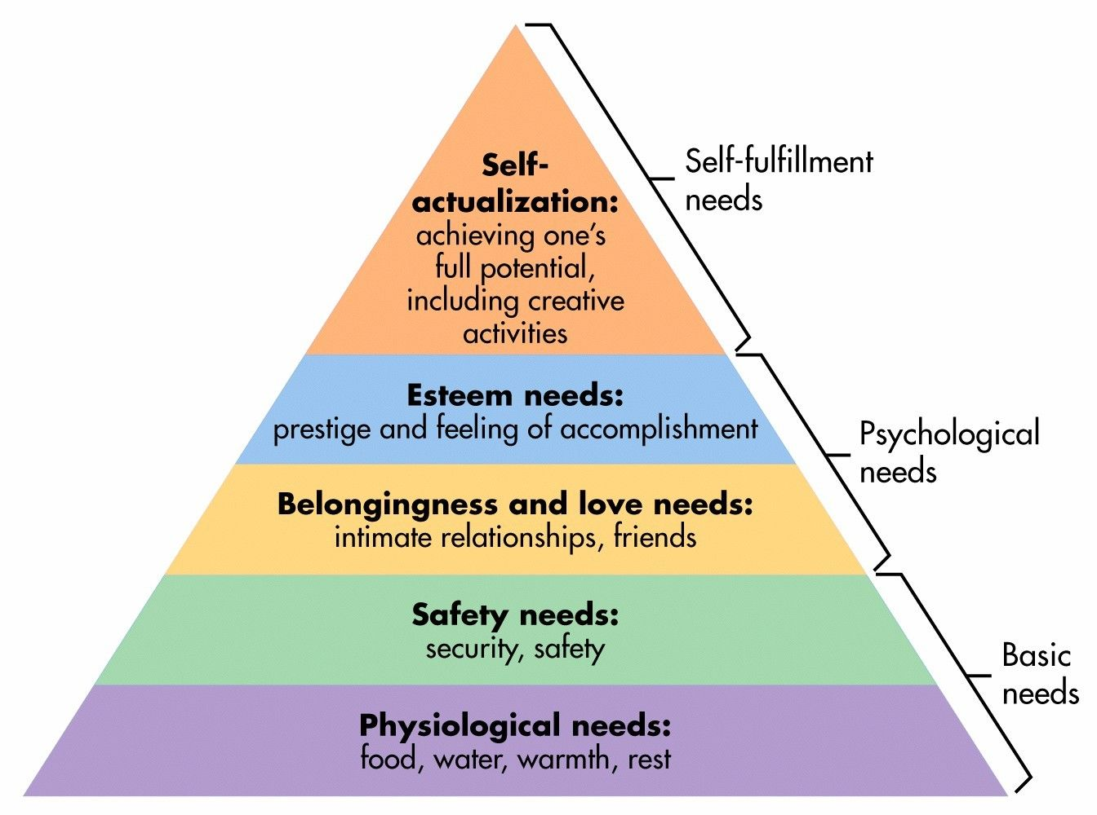
The hierarchy, seen below as Figure 2, illustrates the other more complex needs, and the middle ground in between.

Figure 2 (McLeod, 2022)

Fortunately, I feel that I have fulfilled the first four basics steps in so far as I have the very basic physiological requirements, coupled with a secure home, job, and a healthy lifestyle. In addition, the presence of a loving family, a strong friendship group, along with relative success in not just work but academia and sport, provide me with confidence.
In viewing the above example through the lens of Maslow’s hierarchy, it is now easy to see that the motivation of Person A would have been vastly different to my own.
Turning to the hierarchy of needs, I am confident that Person A had the physiological requirements, described as the most basic needs (Stoianov, 2017). However, I am unsure of whether they would feel that they had the growth needs, such as security of family, health, and property. And given that each level usually rests on the prior satisfaction of the one below, my ambition to have Person A operate at the highest level of the hierarchy was ill-judged.
Adair (2006) wrote that as one desire is satisfied, another arrives, however there is a requirement that these are ticked off in the order in which they appear, and to move from satisfying physiological needs to self-actualization is not possible.
From the discussion with Person A, it was clear that their home life was disrupted with relationship problems. According to Stoianov (2017), love is perhaps the biggest thwarter of climbing the ladder, given the psychological and emotional drain such matters can have on individuals, and this is none more evident than in this scenario.
Conclusion
We are taught by police crime scene investigators of Locard’s Principle, that every contact leaves a trace. Although a principal rule in the world of forensic science, it has reminded me how important even the smallest of interactions with team members are, and how they can have lasting impacts.
Furthermore, the realisation of being unable to ‘save’ or ‘transform’ all team members so as to create or mould perfect team members, has been an awakening. Bass (2005) wrote that the strongest effects of transformational leadership are on the employee’s attitudes and commitment to leader and organisation. If this is the case, then having Person A leave shortly after our interaction, is a damming indictment on my performance.
However, the incident has taught me that given the influx of officers brought about by Operation Uplift (Gwent OPCC , 2021) – the Government programme to increase police officer numbers by 20,000 – and the changing demographic which comes with the PEQF programme of recruitment, one fixed style of leadership is no longer appropriate.
In response policing, it will always be advantageous to have direct, autocratic leadership at times, but the diversity of the workforce and the modernisation of policing, requires flexibility – a degree of which is illustrated in this scenario.
Action Plan
If the situation was to arise again, I would begin by assessing the motivation levels of the individual I was speaking to. Then, before assessing a specific issue, I would make attempts to address the root cause.
I appreciate on this occasion, that personal issues were a significant cause, and the individual may not have wanted to discuss them, but efforts should have been made. At the very least, the individual could have benefited from signposting to support services, such as occupational health.
As for my leadership style, I would think less of trying to subscribe or force a particular style of leadership, but rather concentrate on the issue at hand, utilising the values I have relied upon thus far, and have conviction in my ability to problem solve and communicate well. This will enable a leadership style to develop itself over time.

REFLECTION 2 – Leadership of Others
Description
As part of a team of Sergeants, we are led by a Duty Inspector. The Inspector has direct line management responsibility for six sergeants, and therefore second line management responsibility for up to 50 police constables.
As a team of Sergeants, we differed vastly in terms of experience and knowledge, and would often seek support from the Inspector. On approaching the Inspector on several occasions for assistance in relation to matters not only relating to policing but to my personal life, I found that he would continually signpost me to either one of my peers, online resources, and on occasions simply ignore my request.
I raised this with another Sergeant, whom I was aware was close friends with the Inspector, so as to ascertain if they had the same problem. My colleague was surprised at my experiences and insisted that they had not had the same issues.
Given I needed support on several matters, I challenged the Inspector in as polite a way as possible but was meet with a challenging and unimpressed line manager who accused me of questioning their integrity.
Since this interaction, the Inspector has provided me with answers to my queries but rather than face-to-face meetings, our conversations have been documented on email, with their answers being short, direct, and at times rude.
As a result, I have requested a move to another shift and documented the reasons to high ranks. I have since been moved, with the Inspector left in their current position.
Feelings
During the incident I believed that the approach of the Inspector was one of a laid-back approach, and on several occasions gave the matter the benefit of doubt, before approaching colleagues to verify the matter.
On realising that the approach taken by the Inspector was different for different Sergeants, I felt extremely disappointed. Disappointed that as a senior leader, the Inspector dealt with his staff subjectively, and seemingly favourably dependent on a prior knowledge and relationship with them.
I still felt that with my ability to manage upwards and having conviction in my honesty and courage, I could challenge the behaviour and improve the relationship between us.
As it became clear that my challenge had little effect, I was further dejected on realising I would be the one to move to a different team. Having spent time and effort improving the performance of the constables under my command., I was not the issue in this scenario, and although I have never been labelled with that title, by being the party that was moved, I was concerned that others would assume that I was the cause of the problem.
Analysis
Leadership
However difficult the leadership style is to define in this situation, I feel my line manager has fallen foul of a staunch leadership rule, which supposes that leaders and managers, cannot be friends, because it will inevitably lead to favouritism (Daskal, 2022).
Although a school of thought shared by many, Daskal (2022) does suppose situations where friendship and line management relationships can be successful, citing that friendship and leading share similar traits, including loyalty and honesty. The operative word in this instance being ‘share’, and although my line manager could have been a successful leader for his friends, and their common traits may have flourished, it clearly held back his ability to lead when it came to this incident, as he displayed a clear lack of fairness in terms of ‘sharing’ those traits with all.
It is difficult to comment on how my line manager should consider improving his leadership style, although it is clear that the friendship element which is heavily intertwined with this scenario must change. Stark (2020) suggests that being friendly, rather than friends, is the answer. Whilst on the surface, this appears to be seemingly sound advice, I know that working in a relatively small organisation it is difficult not to find employment in a role where you have no prior knowledge or friendship with others on the team.
The answer I feel is having conviction in the traits and values which you have forged through your formative years, or developed through your leadership journey, so that you lead without compromising current relationships or undermining newer ones (Daskal, 2022) .
Not only has this reflection made me think about my line manager’s behaviour, but also about my own personal friendships with team members. Early in my career I was promoted from Constable to Sergeant on the same team, and it concerns me that perverse behaviours as to the incident above could have featured in my leadership style. However, I know that with my closest of friends, I made sure to make my new role clear, and set ground rules about what expectations and boundaries to expect moving forward, something which is paramount if friendships and leaderships are to work (Swales, 2021).
In trying to define the leadership style, I feel that the Inspector made no attempt to empower me as an individual, having never alluded to any development or goal. Moreover, there was no room for negotiation, no recognition of good work, and although order was maintained by the reinforcement of clear rules and procedures, in the general day-to-day business they were largely invisible. This leads me to suggest their style is a somewhat hybrid - absent bureaucratic one, which maintained order to an extent but did little else in terms of inspiring and developing, a key feature of the new policing leadership strategy.
When talking of leadership and management, Mullins (2019) talked of basic managerial philosophies – which included, but were not limited to – involvement, availability, fair and equitable treatment, and recognition; none of which were present.
Motivation
I have always had both intrinsic and extrinsic motivators, in as much as I achieve personal satisfaction with challenging myself to do better, but also welcome rewards in terms of promotion and pay, which means I can do more outside of work with my family, again an intrinsic element.
In terms of further motivation theory, it affected me how another team member of mine was treated, demonstrating that equity theory at play.
Equity theory relates to fairness; fairness of what is given to the individuals, in comparison to what is provided to others. Adams (1965) suggested that if employees can find a balance between how much effort they give or put in, compared to the reciprocal outcome of praise, reward, or recognition, then a high yield of productivity would likely occur. This resonates with me not only for this scenario but also several others which have played out during my career and is probably why I ensure fairness and honesty is high on my agenda when leading.
Conclusion
I firmly believe that visible leadership is key. Most of this incident took place remotely, and although remote working is convenient, and conversations can occur instantaneously, important discussions and challenges should take place in person. Studies post-pandemic have illustrated that we learn better when face-to-face (Tomasik, 2021). Whilst I was unable to find any similar studies concerning management/leadership, I strongly believe that in-person discussions versus remote discussions would likewise yield similar results.
Action Plan
Going forward, I would look to learn from the mistakes I feel my superior made; seemingly abandoning any core values and being blinded by friendship has caused a ripple effect and has taken me away from the team that I had been building for some time. This was a team that had high levels of retention at the time, high morale, and successful development programs in place for staff – all positive indicators of effectiveness (Mullins, et al., 2019).
To ensure I never behave in the same manner, I have become even more ridged in terms of friendships in the workplace. Despite earlier discussions of the potential benefits of friendship in the workplace, and whilst still believing that friendships are possible, I am concerned as to the pitfalls, especially ones to which I may be blind too.

LEARNING & FUTURE CHALLENGES
The very nature of a reflection is to learn and improve. It is clear from the past pages that we all have different levels of motivation and emotional intelligence, and we clearly lead people in different ways. But we also learn in different ways.
Learning, just like leadership, is hard to nail down to one particular definition. One of the more favoured interpretations is that of Mayer (1982) who describes it as a permanent change in a person’s knowledge or behaviour due to experience. However, there are several different theories as to how the experiences affect us.
On closer inspection of the two reflections above, I believe that I acted in the manner I did due to my previous experience under a transformational leader, who left a marked impression on me. Moreover, I have also witnessed people being treated less favourably by way of nepotism, which has led me to being more thorough and marked in my want to display absolute fairness.
Essentially, the behaviours I have displayed have been constructed from a back catalogue of experiences, coupled with information from leadership courses, as well as my awareness of policies, such as fairness at work in the instance of reflection B. This suggests I subscribe to constructivism theory, whereby knowledge is built layer upon layer.
Despite being aware that my actions align me with constructivism, I am cognisant of the fact that there is weakness in subscribing or preferring only one theory of learning. I note from Reflection A, that advocating the humanistic learning theory would have brought huge benefits. This theory is based around Maslow’s Hierarchy of Needs, where learning is a way to fulfil potential. There isn’t a focus on individual targets or set goals, but rather there is a focus on the person as a whole to ensure they learn and progress to self-actualisation, where development can progress.
Personal challenges I have now set myself revolve around improving my emotional intelligence, and further understanding motivations of staff, especially as I look to progress to middle management and senior management teams in the coming years.
Emotional intelligence is regarded as someone’s ability to manage personal emotions and recognise the feelings of those around you. The higher the level of emotional intelligence, the better someone can understand how emotions can play out in difficult situations. In recent times, this has become a key aspect of leadership, with some labelling it more important than intellectual intelligence (Ainomugisha, 2020). Having undertaken an emotional intelligence study as part of a development programme, I know that although I have a moderate to high level, further improvements can be made, and I have recently undertaken online training to further my levels.

CONCLUSION
Leadership theory cannot be read alone. An individual’s motivation, individual learning styles, and an individual’s emotional intelligence all play a part in how leaders lead, and how subjects are led.
Significantly, I have learnt from this review that not all individuals are ready to be led by a transformational leader, and that given it is one of the newer and most coveted styles, its role in front line policing with inexperience, stressed, and demotivated officers, is questionable.
What is also questionable is what I refer to as ‘my leadership journey.’ From discussion with mentors and senior leaders from within and outside the organisation, the focus has been on me personally and what I need to do, and when I need to do it to develop as a leader. Throughout these talks there has been little context given to my current role, and more specifically my current staff, as I cannot enforce styles and systems on staff where they are not appropriate for the audience I hold.
Finally, the reflections have shown that individuals are the most important part of every team, irrelevant of rank, and that the overall health of the team is vital to all, a realisation which brings sense to the words of one my idols of leadership, Phil Jackson (2016), record breaking coach of the Chicago Bulls Basketball Team when he stated, ‘the strength of the team is each individual member, the strength of each member is the team.’

Word Count: 5309

Bibliography
Adair, J., 2006. Leadership and Motivation - the Fifty-Fifty Rule and the Eight Key Principles of Motivating Others. London: Kogan Page.
Adams, J. S., 1965. Equity Theory. 1st ed. London: VDM Publishing.
Ainomugisha, G., 2020. Emotional Intelligence in Leadership. [Online]
Available at: https://inside.6q.io/emotional-intelligence-in-leadership/
[Accessed 2 April 2022].
Bailey, F. G., 1988. Humbuggery and Manipulation: The Art of Leadership. 1sr ed. s.l.:Cornell Unviersity Press.
Bass, B. & Riggio, R., 2005. Transformational Leadership. 2nd ed. London: Taylor & Francis Group.
BBC News, 2016. Timeline: Iraq War. [Online]
Available at: https://www.bbc.co.uk/news/magazine-36702957
[Accessed 3 March 2022].
BBC News, 2020. Coronavirus Isle of Man: Dog walker fined £1,000 for picking up his girlfriend. [Online]
Available at: https://www.bbc.co.uk/news/world-europe-isle-of-man-52427068
[Accessed 12 April 2022].
Bradshaw, P., 2011. Inside Job:how bankers caused the financial crisis. [Online]
Available at: https://www.theguardian.com/film/2011/feb/17/inside-job-financial-crisis-bankers-verdicts
[Accessed 19 April 2022].
Burgoyne, J., 2016. An overview and history of leadership and leadership development, Lancaster: The Business & Management Collection.
College of Policing , 2014. Code of Ethics. [Online]
Available at: https://assets.college.police.uk/s3fs-public/2021-02/code_of_ethics.pdf
[Accessed 18 March 2022].
College of Policing, 2015. Leadership Review. [Online]
Available at: https://paas-s3-broker-prod-lon-6453d964-1d1a-432a-9260-5e0ba7d2fc51.s3.eu-west-2.amazonaws.com/s3fs-public/2021-03/cop-leadership-review-2015.pdf
[Accessed 13 June 2021].
Daskal, L., 2022. The Fine Line Between Friendship and Leadership. [Online]
Available at: https://www.lollydaskal.com/leadership/the-fine-line-between-friendship-and-leadership/
[Accessed 27 March 2022].
Gibbs, G., 1988. Learning by Doing, A Guide to Teaching and Learning Methods. Great Britain: Further Education Unit.
Gosling, J., Jones, S. & Ian, S., 2012. Key Concepts in Leadership. 1st ed. London: Sage Publications.
Gosling, J., Jones, S. & Sutherland, I., 2012. Authoritarian Leadership and Participative Leadership. In: Key Concepts in Leadershp . London: Sage Publications, pp. 9-14.
Gwent OPCC , 2021. Operation Uplift. [Online]
Available at: https://www.gwent.pcc.police.uk/en/news-room/operation-uplift/
[Accessed 21 March 2022].
Hagopian, A. et al., 2013. Mortality in Iraq Associated with the 2003–2011 War and Occupation: Findings from a National Cluster Sample Survey by the University Collaborative Iraq Mortality Study. PLOS Medicine , 10(10), pp. 1-15.
Hoggett, J., Redford, P., Toher, D. & White, P., 2019. Challenges for Police Leadership: Identity, Experience, Legitimacy and Direct Entry. Journal of Police and Crminal Psyhcology, Volume 34, pp. 145-155.
Jackson, P., 2016. Phil Jackson on Teamwork. [Online]
Available at: https://www.youtube.com/watch?v=smaWY-VJtsU
[Accessed 27 April 2022].
Kelly, P., 2020. National Police Chiefs Council - Workforce. [Online]
Available at: https://www.npcc.police.uk/NPCCBusinessAreas/CoordinationCommittees/Workforce.aspx
[Accessed 15 April 2022].
Manchester University NHS Foundation Trust, 2022. Adverse Childhood Experiences (ACEs) and Attachment. [Online]
Available at: https://mft.nhs.uk/rmch/services/camhs/young-people/adverse-childhood-experiences-aces-and-attachment/
[Accessed 14 April 2022].
Mayer, 1982. The Behaviorist Perspective on Learning. New York: s.n.
McGregor, D., 1987. The Human Side of Enterprise. 3rd ed. London: Penguin.
McHugh, K., 2010. Bush, Blair and the War in Iraq: Alliance Politics and the Limits of Influence. Political Science Quarterly, 125(3), pp. 465-491.
McLeod, S., 2022. Maslow's Hierarchy of Needs. [Online]
Available at: https://www.simplypsychology.org/maslow.html
[Accessed 28 March 2022].
Mullins, Laurie & McLean, 2019. Managing People at Work. In: 2nd, ed. Organisational Behaviour in the Workplace. London: Pearson Education .
O'Brien, J., 2020. Youtube - James O'Brien's Best Briexit Moments of 2020. [Online]
Available at: https://www.youtube.com/watch?v=tA2_pBebOxA
[Accessed 20 April 2022].
Pope, T., Tetlow, G. & Grant, D., 2021. The cost of coronavirus. [Online]
Available at: https://www.instituteforgovernment.org.uk/explainers/cost-coronavirus
[Accessed 6 June 2021].
Robbins, T., 2022. What is Leadership?. [Online]
Available at: https://www.tonyrobbins.com/what-is-leadership/
[Accessed 4 March 2022].
Stark, P. B., 2020. Friendship and Leadership - The Do's and Dont's. [Online]
Available at: https://peterstark.com/friendship-and-leadership-the-dos-and-donts/
[Accessed 15 March 2022].
Stern, S., 2020. The Conversation - Leadership expert: Boris Johnson is failing the national in coronavirus response. [Online]
Available at: https://theconversation.com/leadership-expert-boris-johnson-is-failing-the-nation-in-coronavirus-response-146863
[Accessed 14 June 2021].
Stoianov, S., 2017. An analysis of Abraham Maslow's a theory of human motivation. London: Routledge.
Swales, C., 2021. Friends vs Friendly: Which is the Best Leadership Strategy?. [Online]
Available at: https://www.monster.com/career-advice/article/work-friendships-for-leaders
[Accessed 17 March 2022].
Swinford, S., Fiona, H. & Courea, E., 2021. Cressida Dick: Met chief's job contract 'unlikely' to be extended. [Online]
Available at: https://www.thetimes.co.uk/article/cressida-dick-met-chiefs-job-contract-unlikely-to-be-extended-b5627dl92
[Accessed 6 June 2021].
Thomas, A. & Cangemi, J., 2021. Authoritatian, Transactional, and Transformational Leadership Styles in Law Enforcement. Organization Development Journal, 39(1), pp. 33-44.
Thomas, C., 1888. On Heros, Hero-Worship and the Heroic in History. 1st ed. New York: Frederisk A Stokes.
Ting-Ju Chiang, J. & Chen, X.-P., 2021. We have emotions but can't show them! Authoritarian leadership, emotion suppression climate and team performance. Human Relations, 74(7), pp. 1082-1111.
Tomasik, M., 2021. Educational gains of in-person vs distance learning in primiary and secondary schools: A natural ecperiment during the Covid-19 pandemic school closures in Switzerland. International Journal of Psychology, 56(4), pp. 566-576.
Waitzan, E., 2020. Covid-19: Impact on People Living in Poverty. [Online]
Available at: https://lordslibrary.parliament.uk/research-briefings/lln-2020-0093/
[Accessed 19 April 2022].
Whitehead, M., Barr, B. & Taylor-Robinson, D., 2021. Poverty, health, and covid-19. British Medical Journal, pp. 372-376.

