Personal Digital Identity Management

In this essay I will begin by defining digital identity then I will find and discuss two well-known famous influential people who use social media to project their digital identity; one who uses it in a polished professional way and one who uses it poorly. I will then compare what each of the famous people is doing right/wrong, based on best practice. Then I will hypothetically think of the consequences stemming from how each portrays their digital self across the social media platforms they use.

What is digital identity?
In accordance with the website Just Ask… Gemalto “digital identity is the network or Internet equivalent to the real identity of a person or entity (like a business or government agency) when used for identification in connections or transactions from PCs, cell phones or other personal devices.” (Just Ask, 2019) This means that a digital identity is the online equivalent to a real person.

Main Body
For my essay I have chosen to discuss Gary Vaynerchuk (Gary Vee) as a good example of professional use of social media and Jack Maynard as an example of how not to use social media. I will now include a brief description of the two people I chose to discuss.

Who is Gary Vee?
Gary Vaynerchuk is best known for his work in digital marketing and social media as the chairman of New York-based communications company, VaynerX, and as CEO of VaynerX subsidiary, VaynerMedia. He is a confident, driven, friendly, ambitious and knowledgeable individual with skills in marketing. Also, Gary Vee is an investor. (Gary Vaynerchuk, 2019)

Who is Jack Maynard?
Jack, 23, was born on 23rd November 1994, and is a YouTuber from Brighton. He is famous for his self-titled channel where he posts vlogs, challenges, and occasional comedy skit videos for his 1.2 million subscribers (Twitter, 2019).
Gary Vee
After researching suitable people who use social media in a professional way, I discovered that Gary Vee was a good individual to discuss in this essay because his organisation helps other businesses to take advantage of social media (Gary Vaynerchuk, 2019).
According to garyvaynerchuk.com (2019), Gary Vee has 5 core values of business, they include;
- Stop trying to convert your customers
- Don’t hesitate with making the sale
- Make valuable content
- Work harder and faster in business
- Give with no expectation of return
To begin with, on Gary Vee’s website he uses a Facebook messenger chatbot to build a loyal fanbase of followers, he calls it his VIP messaging service. All you must do is sign up and answer a few questions. This allows him to build an audience of people who consume his content and to collect data on them. This is an excellent way of engaging with users of the website; it allows him and his team to collect data on his followers and it means they are likely to return to the website and consume his content. Below is a screenshot of Gary Vee’s VIP messaging service.
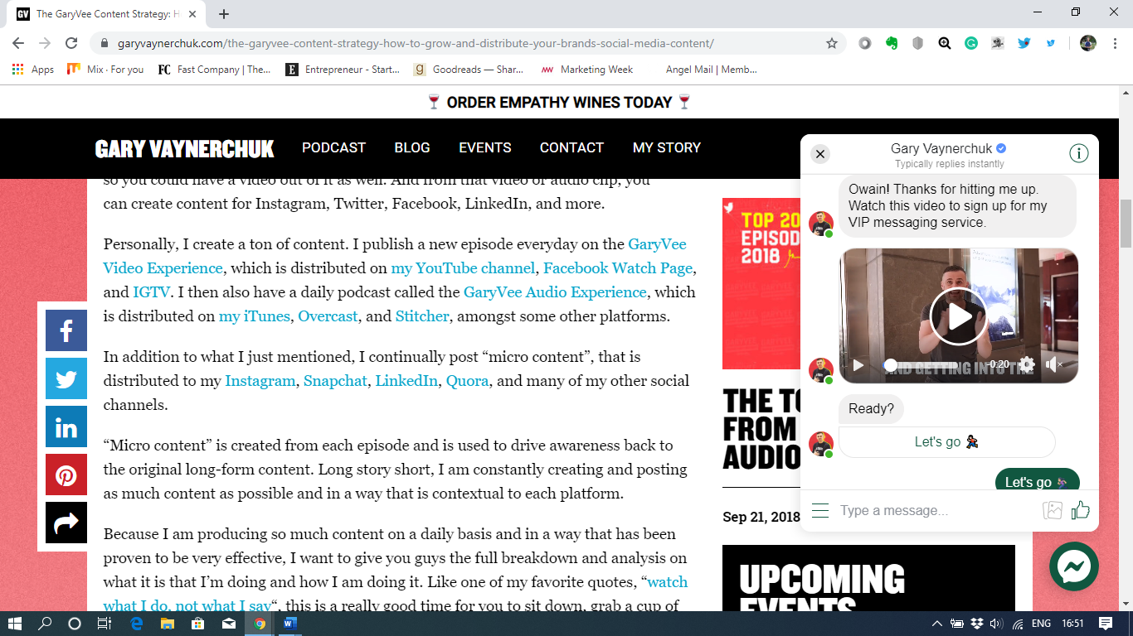

(Vaynerchuk, 2019)

As you can see the VIP messaging service used by Gary Vee is very effective as it is optional, so it gives the user a choice as to whether they want to engage with it. Also, it makes it that bit more personal and unique to you by using your name to address you on the messaging service, which is very professional.

Gary Vee collects data on his clients by looking at the answers from the questions asked on the messaging service as seen in the picture below.

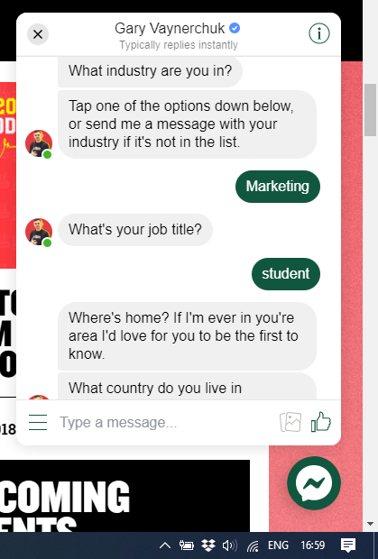
The messaging service asks you questions like what country do you live in currently? Where do you prefer to consume my content? Do you want to receive a daily motivational quote from me to kickstart your day? I would love to come with you on your commute or workout? Want to receive my daily podcast? (Vaynerchuk, 2019)

(Vaynerchuk, 2019)

These questions allow Gary Vee and his team to gather data on his customers and consumers. You might ask why data collection is important to businesses, well according to Grow.com (2019) Businesses can harness data to:
- Find new customers
- Increase customer retention
- Improve customer service
- Better manage marketing efforts
- Track social media interaction
- Predict sales trends
According to ITChronicles (2019) there are several ways organisations collect data, for example:
- Asking for it
- Websites, Cookies and Web Beacons
- Company Records and Social Media
- Email Tracking, Apps, and Third-Party Trackers
- Data companies
ITChronicles (2019) state that “most firms will be asking customers directly for data at some point – usually early on – in their relationship with them. When someone subscribes to a service, registers with a website or buys something online for the first time, a form usually needs to be filled out.” As in the example with Gary Vee this is one of the methods, he uses to collect data. The website also states that “Big companies are also adept – as they have the technology to be so – at pulling in customer data from a whole plethora of online sources. The most obvious place, of course is from their own websites, most of which are now equipped with cookies and web beacons.”
This is not the only strategy Gary Vee uses to promote his content. Gary Vee states on ‘The Gary Vee Content Strategy: How to Grow and Distribute Your Brand’s Social Media Content’ that “Personally, I create a ton of content. I publish a new episode every day on the GaryVee Video Experience, which is distributed on my YouTube channel, Facebook Watch Page, and IGTV. I then also have a daily podcast called the GaryVee Audio Experience, which is distributed on my iTunes, Overcast, and Stitcher, amongst some other platforms.” (Vee, 2019).

This shows how active Gary Vee is on all types of social media platforms; he creates a ton of content. He publishes a new episode on the GaryVee Video experience daily, which is then shared on his Youtube channel, Facebook Watch Page, and IGTV. He states that he also has a podcast called the GaryVee Audio Experience, which is shared on his iTunes, Overcast and Stitcher, alongside other platforms. (Vee, 2019).

Gary Vee uses social media very effectively especially in terms of meeting his brand values since he makes valuable content almost all day every day, an example is below.

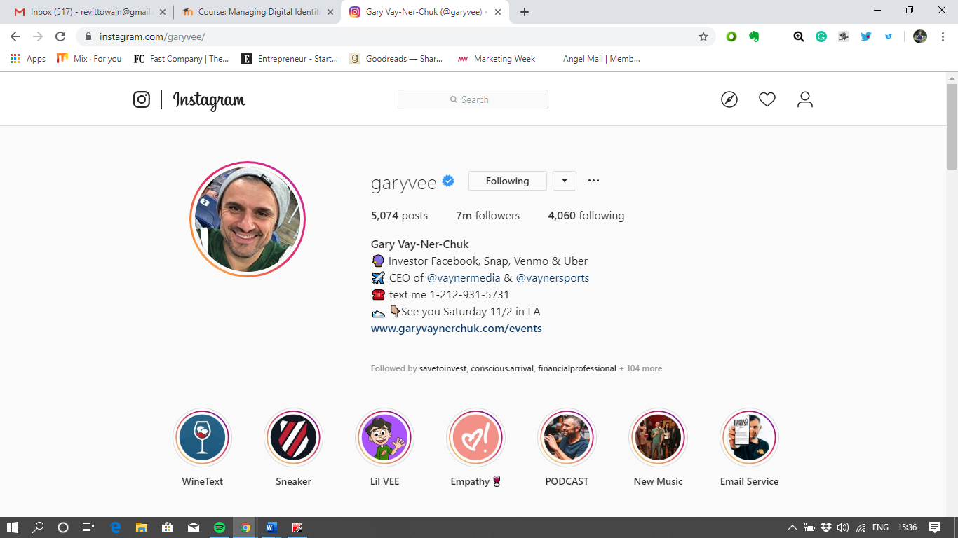
(Instagram, 2019)

Above is a picture of Gary Vee’s Instagram bio. As you can see his profile is extremely professional; he has listed his investments ie, “Investor Facebook, Snap, Venmo & Uber.” This is effective because it states clearly what organisations he has invested in. He also states the organisation he CEOs, “CEO of @Vaynermedia & @Vaynersports.” (Instagram, 2019)
Again, this is very effective because it lets his audience know what he does as a profession. He also tags @Vaynermedia and @vaynersports in his bio which allows those who are on his page to visit those pages, which is likely to drive a lot of traffic for those pages daily.

Gary Vee also states his number on his bio “Text me 1-210-931-5731.” (Instagram, 2019) I’m sure this works well because it allows any potential consumers to stay in touch with Gary. The way he has worded this piece of information is great because he sounds very friendly and like someone you can trust. He finishes his bio by saying “See you Saturday 11/2 in LA” (Instagram, 2019) with a link to his website, this is excellent marketing and a great piece of information to put on your bio because it sounds very clinical and professional. I’m sure many people would be interested in seeing him if they had the opportunity.

Gary also takes advantage of Instagram’s highlights section, as you can see below.

(Instagram, 2019)
Instagram’s highlights section is all about highlighting specific posts from the past onto you profile. Gary takes full advantage of this section by creating the following highlights:
- WineTest
- Sneaker
- Lil Vee
- Empathy
- PODCAST
- New Music
- Email Service

On Gary Vee’s Instagram (2019) he posts a variety of different content including; quotes, videos and pictures. He also posts links to his podcasts on Instagram too. So, he is keeping his audience inspired throughout the whole day, every day which is a very strong way of using social media. Below is an example of one of Gary’s posts on Instagram.
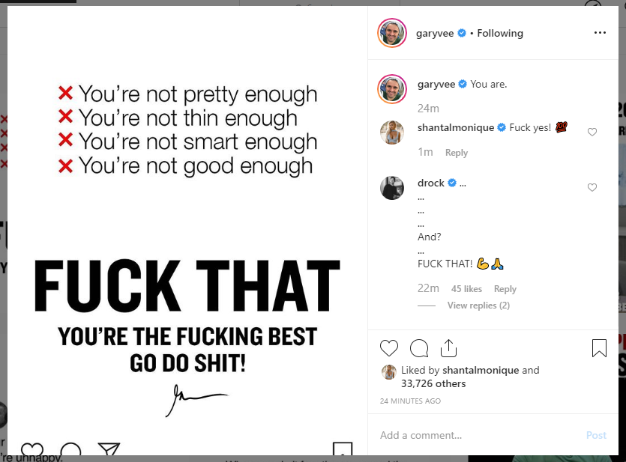

(Instagram, 2019)

As you can see, his language might not be appropriate to all audiences since a lot of people are likely to be offended after reading this post. They may even find it so offensive that they unfollow his Instagram page which would have a negative effect on his reputation.
On the other hand, however, people could find this post very captivating and powerful because of the language used. This is the reason why I wanted to include this post out of a thousand others is because Gary’s target market is businesspeople, professionals, entrepreneurs, and students. Therefore, this works extremely well for Gary, as you can see this post alone has had over thirty-three thousand likes.

Jack Maynard

However, there are still people who use social media poorly, take Jack Maynard for example. Jack Maynard left the I’m a celebrity jungle due to his misuse of social media. The Sun reports “that as well as racist and homophobic tweets Jack had sent, he had also begged a 14-year old fan to send him nude pictures.”(The Sun, 2019) According to the Mirror, the YouTube sensation, 23, told her that her "boobs are so nice" and "would look good in a bra shot" but later branded her a "bore" and "ugly freak", when she refused to share pictures. (The Mirror, 2019.)

The Sun (2011) states, in one racist tweet, posted online in June 2011, he said he was “At Alices with my n****s!” He also repeatedly calls people “retards”(The Sun, 2011). In another post, he tweeted pictures of people with deformities with comments “in his prime” and “Ahahahaha! Sooo funny!” (The Sun, 2011) On one image of a black man with bulging eyes he added: “looking greatttt!!” As the ITV show launched, Jack admitted the words he used were “inflammatory and “insulting” (The Sun, 2011). Immediately following the emergence of his tweets, a spokeswoman for Jack said: “Jack is ashamed of these tweets, many were deleted a long time ago. “He would never use that language now and realises this kind of retaliatory, inflammatory, insulting language is completely unacceptable. (The Sun, 2011)

However, it’s not all negatiity when it comes to Jack’s use of social media. Despite his poor misuse of social media in the past, he seems to have matured and learnt from his previous mistakes. Below is a screenshot of Jack’s Twitter Bio.

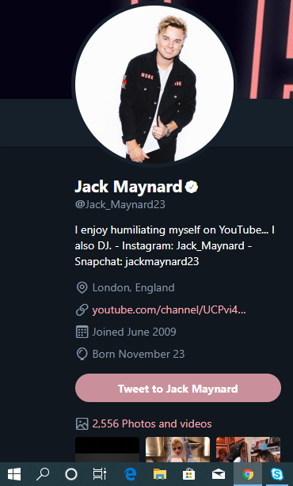

As you can see, he states “I enjoy humiliating myself on Youtube… I also DJ.” This is an effective bio which states exactly who he is and what he does.

Jack has made some mistakes using social media through using it in a poor manner, and this would have affected his reputation. Through poor misuse of social media, he was almost forced to leave the I’m a celebrity get me out of here jungle (The Sun, 2011). I’m sure his fans were upset to hear the news, and this would have affected his image as a youtuber and DJ.

(Twitter, 2019)
Conclusion
To conclude, the way individuals use social media is vitally important. A person’s reputation could be degraded so easily through poor use of social media. Gary Vee’s managed to build a successful online identity through proper and professional use of social media. Gary Vee also collects data on his customers using an interactive messenger bot, which enables him to find new customers, increase customer retention, improve customer service, better manage marketing efforts, track social media interaction and predict sales trends.
On the other hand, Jack’s poor misuse of social media meant his rude tweets appeared on news sites which meant his reputation was almost tarnished completely, but it looks like he has learnt from his past mistakes.

References

Gary Vaynerchuk, (2019), 5 Core Values of Business from GaryVee. Retrieved from:
https://www.garyvaynerchuk.com/5-core-values-of-business-from-garyvee/

Gary Vaynerchuk, (2019), The Gary Vee Content Strategy: How to grow an distribute
your brand’s social media
Content. Retrieved from:
https://www.garyvaynerchuk.com/the-garyvee-content-strategy-how-to-grow-and-distribute-your-brands-social-media-content/

Grow, (2019), Why is Data Important for your business? Retrieved from:
https://www.grow.com/blog/data-important-business

Instagram, (2019), Gary Vay-Ner-Chuk on Instagram. Retrieved from:
https://www.instagram.com/garyvee/

Instagram, (2019), Gary Vay-Ner-Chuk on Instagram: “You are.” Retrieved from:
https://www.instagram.com/p/B4Sawq9gDtu/

ITChronicles, (2019), How do big companies collect customer data? Retrieved from:
https://www.itchronicles.com/big-data/how-do-big-companies-collect-customer-data/#:~:targetText=There%20are%20essentially%20three%20different,acquiring%20it%20from%20other%20companies.&targetText=Most%20firms%20will%20be%20asking,in%20their%20relationship%20with%20them.

JustAskGemalto, (2019), What is digital Identity? Retrieved from:
https://www.justaskgemalto.com/en/what-is-digital-identity/#targetText=Digital%20identity%20is%20the%20network,phones%20or%20other%20personal%20devices.

The Sun, (2011), Who is Jack Maynard, why did he leave I’m a celebrity 2017. Retrieved from:
https://www.thesun.co.uk/tvandshowbiz/4868110/jack-maynard-im-a-celebrity-2017-tweets-messages-danielle-sellers-love-island/#targetText=Who%20is%20Jack%20Maynard%3F,for%20his%201.2%20million%20subscribers.

Twitter, (2019), Jack Maynard (@Jack_Maynard23). Retrieved from:
https://twitter.com/Jack_Maynard23?ref_src=twsrc%5Egoogle%7Ctwcamp%5Eserp%7Ctwgr%5Eauthor

