How does poverty effect physical development?

My personal experience.
Growing up as I child me and my family were never really well off where money was concerned, we lived on a little council estate and struggled to make ends meet sometimes. Life was not easy being 10 and struggling, not for me as an individual or for my family. Things then took massive turn for the worst when my father felt the only way that he could cope was by taking heroin. One hit here, one hit there turned into a downward spiral of him being severely addicted to that said drug resulting in him stealing from my mother and his own children. Thus, then causing us to get deeper and deeper into the poverty line, we had poor diets, we were getting sick more often and the house was cold all because of one thing that led to the other and my father took the wrong path in life.

The impact of growing up in poverty.
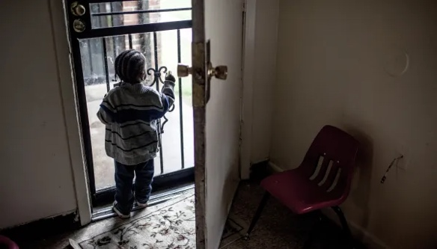
Many individuals and families experience aspects of poverty but what I want to explore is how poverty will affect the child’s physical development as a whole. Growing up in low-income households can cause the child involved many drawbacks through life such as ill health that could potentially follow them in to their adulthood.
Living in poverty can have a detrimental impact on physical development not only in the sense of ill health but can also cause the children and their families to be living in poor housing conditions (again which could cause ill health), poor education in children / employment opportunities for adults and over all stressful situations.
(Boghani, 2017)

Here are some health risks that children from money deprived areas may experience.
- Ill health in general.
- Low mental well being.
- Poor dental hygiene.

According to the British Medical Association (BMA) in the United Kingdom between 2011 and 2014 32.5% of the population had at least once encountered what it was like to live in poverty. It is also said that most of the infants born into these areas are around 200 grams lighter than the infants born in to richer areas, due to this this can cause the individual to have a shorter life expectancy and it is also putting them in a position where there is a higher risk of them passing away in the first year of them being born. Not only are the children born at such different weights with uncertain times ahead, conditions like asthma and other chronic illnesses are way more prevalent in those born into poverty, but they may also experience a lot more dietary related issues such as diabetes, malnutrition, obesity and dental decaying.
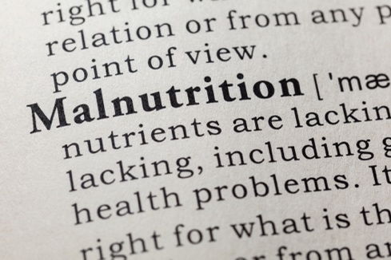
Living in a constant state of poverty can also bring an incredible amount of stress on to the young individuals who are involved, this can have a negative and damaging impact on the early stages of their brain development, often known as toxic stress. As a result of these poverty struck conditions it can also increase the child developing mental health and or behavioural issues. Alongside these issues, children living in houses where there is a lack of food and proper recourses may not receive the proper nutrition needed, which can contribute to physical difficulties such as diabetes and obesity. The malnutrition can also cause issues in the inability of the child to thrive through the early years.
(nutraingredients.com)

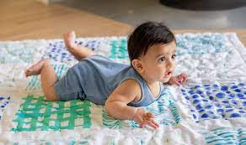
After researching more into this topic, I have found children living in a lower income household can be delayed in the development of their motor skills, this is because they are unable to access sufficient space due the minimal amount that may be in their environment. For example, families may live in apartment building or flats, this then removes the use of stairs for the child during the stages of life where they would be learning to climb and balance, causing them to be more unsure and nervous to crawl or even shuffle around areas containing stairs. There are also more developmental milestones that can be missed as families who are more deprived may have less knowledge about said milestones and will not know how to support them. For example, more children are spending time on screens as families cannot afford to take them to multiple different activities, because of this their environments are less stimulating, and the children are less likely to get up and go to do activities involving physical play. For the younger infants this could be the case of parents not properly being educated on important developmental practices like tummy time and messy plays.
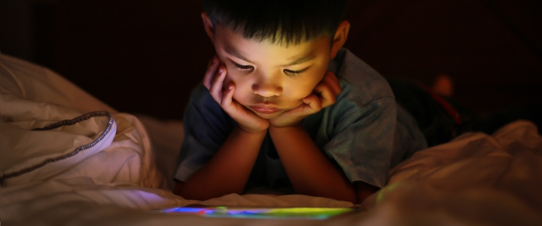
(Lovevery, 2020)
(Cross, 2019)

In my opinion, I believe that families living in poverty need to be supported just that little bit more. Especially if it is going to benefit the children in all stages of their lives until adulthood. This could be by showing them a budget friendly lifestyle that could really benefit them as a new parent, or even helping them by showing them what is essential in order to make sure the infant has a healthy up bringing. We could even help by giving them a little extra support in the education side of what is good for a child to help with their motor development as a young one and even by promoting things they can do to improve the children’s general physical development in all aspects of their lives, examples of this couple be to play ball with them or even to get them to draw you a nice picture.
‌
References:

Boghani, Priyanka. “How Poverty Can Follow Children into Adulthood.” FRONTLINE, 22 Nov. 2017, www.pbs.org/wgbh/frontline/article/how-poverty-can-follow-children-into-adulthood/. Accessed 20 Jan. 2023.

British Medical Association. Health at a Price Reducing the Impact of Poverty a Briefing from the Board of Science. June 2017.

Cross, Jennifer. “What Does Too Much Screen Time Do to Kids’ Brains?” NewYork-Presbyterian, Health Matters, 8 Aug. 2019, healthmatters.nyp.org/what-does-too-much-screen-time-do-to-childrens-brains/. Accessed 21 Jan. 2023.

Heffron, Claire. “Effects of Poverty on Child Development.” The Inspired Treehouse, Claire Heffron, 17 Nov. 2016, theinspiredtreehouse.com/effects-poverty-child-development/. Accessed 20 Jan. 2023.

Librarian, OACAS. “OACAS Library Guides: Poverty and Child Welfare: Effects of Poverty on Children.” Oacas.libguides.com, oacas.libguides.com/c.php?g=702168&p=4990142. Accessed 21 Jan. 2023.

Lovevery, Team. ““Swimming” in Tummy Time Yet?” Lovevery, 20 May 2020, lovevery.com/community/blog/child-development/swimming-in-tummy-time-yet/. Accessed 21 Jan. 2023.
‌
nutraingredients.com. “Lancet Study Highlights “Shocking” Malnutrition Findings.” Nutraingredients.com, Nikki Hancocks, 1 Dec. 2022, www.nutraingredients.com/Article/2022/12/01/lancet-study-highlights-shocking-malnutrition-findings. Accessed 21 Jan. 2023.

Public Health Scotland. “Impact of Child Poverty.” Healthscotland.scot, 24 Dec. 2021, www.healthscotland.scot/population-groups/children/child-poverty/child-poverty-overview/impact-of-child-poverty. Accessed 20 Jan. 2023.
‌

The effects of social modelling on moral development.

What is social modelling?
Social modelling is a theory that is said we learn to copy other people by observing how the behave, by doing this we then start to learn and behave in certain ways by watching them. For example, a child could hear and see what a parent or older sibling may do and try to imitate what has happened and develop the mannerisms witnessed, it could be that a younger teenager has seen that one of their friends has started to go out to parties and drinks alcohol and now wants to do the same. Either way the individual has now started to behave in a new way just because somebody else has done so prior.
Before Albert Bandura started talking about the theory and backing it up with supporting studies, social modelling was not acknowledged or discussed.

What is moral development?
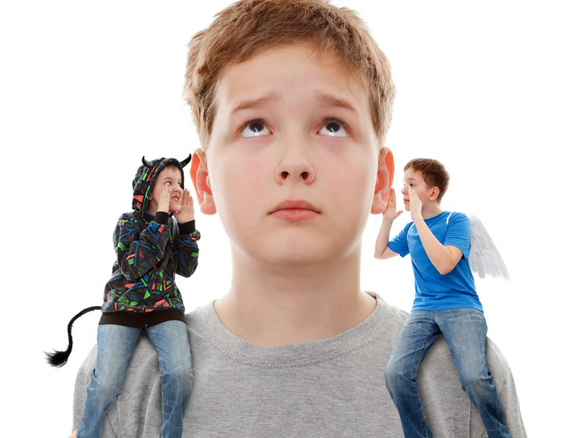
Moral development is the process by which children internalise and acquire their society’s norms for right and wrong based on the cultural, social and legal standards. Teaching a child what is right from wrong can be extremely hard, especially with the social modelling aspects coming in to play.
Jean Piaget explored moral development and found how children made decisions and that they just be giving them rules they would follow them just by reading them.
Lawrence Kohlberg also explored the same thing but believed that moral development was a slower process than what was said, as according to Kohlberg people advance by perfecting each level one step at a time.
(Crimston and Neldner), 2018

Bandura Social Modelling Theory. The Bobo doll experiment.
The social modelling theory or also known as the social learning theory was created by phycologist Albert Bandura, this was also backed up an experiment called the Bobo Doll Experiment. In the 1960s a series of experiments were conducted from Stanford University Nursery School with 72 individuals ranges between the ages of 3 and 6 years old 36 girls and 36 boys. During this test the young children were observed to see how aggressive thy ere and got scored on 5 point rating scales, from this they were then put into smaller groups with the ones that matched their aggression.
A toy called the Bobo doll was brought out into the individual groups and the method behind the whole experiment started. There were 3 groups of children, all made up of 24 individuals. 1 group getting an aggressive role model, 1 getting a non aggressive role model and the last group not having a role model at all.
There were 3 stages of this experiment along with the results: stage 1- modelling, stage 2 - aggression arousal and stage 3 - test for delayed imitation.
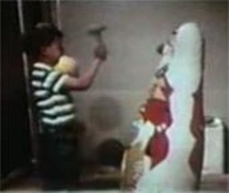
In stage 1 the children had to witness either their older role model act and behave in an aggressive manner, a subtle and unobtrusive way or were not displayed any form of role model at all, depending on which group the child fell into. During the time spent with the said models and the Bobo dolls the children were left to their own devices with multiple different toys and pictures while the adult in question (if there was one at all) was showing the mannerisms stated above.
In the aggression arousal stage, which would be stage 2, every participating child encountered mild aggression arousal, and were then later taken separately to play with some child friendly toys that the experimenter had told them were her best toys.
(“Psychology Classics: Guns and Dolls –– the Bobo Studies”)

Following from this was stage 3, the testing for delayed imitation. After leaving the children play with the child friendly toys, they were then taken to a new room and introduced to a whole new host of toys some seen as non aggressive, such as crayons and farm animals and some seen as aggressive, these would have been a mallet, guns and of course the Bobo doll. The children were then left to play for 20 minutes and were observed in 5 second intervals.
As a result of this whole experiment, they found that the individuals who had the more aggressive role models were more inclined to show and imitate aggressive behaviour than the other 2 groups. This then showed that children are more than able to learn through observing others and watching their behaviours.
(“Figure 3: “Nature vs. Nurture”: Bobo Doll Experiment.”)

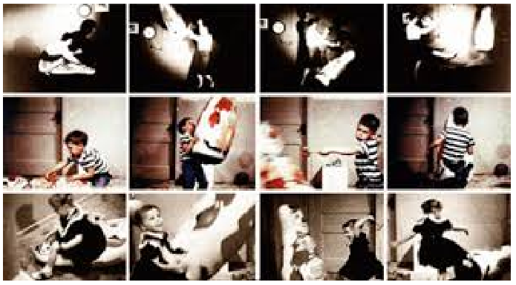

After looking at the definitions above I think that social modelling has an immense impact on the child’s moral development as children do tend to copy adults, especially their parents, so all depending on how they act is how their children would then interpret their behavioural mannerisms in their own day to day lives.
Speaking from personal experiences I grew up with my mother, father, and older brother. Me and my brother grew up being the total opposite as we both watched and imitated a different parent. For example, my father made some silly decisions in life and wasn’t the best person to be around sometimes. In turn of these events my brother then started to do similar things, such as lash out at minor inconveniences, sneak out and get in trouble with the police. My mother on the other hand was the total opposite and tried her best to hold us together for as long as she could and worked around the clock the give me and my brother what we needed. As a result of this I started to imitate and take on the behaviours of her, I tried my best and worked to the best of my ability to get where I am today, even if that meant working terrible jobs just to stay afloat.

References:

Crimston, Charlie, and Karri Neldner. “Moral Development: Children Become More Caring and Inclusive as They Age.” The Conversation, 11 June 2018, theconversation.com/moral-development-children-become-more-caring-and-inclusive-as-they-age-97465. Accessed 21 Jan. 2023.
‌
Encyclopedia of Children's Health. “Moral Development - Symptoms, Stages, Definition, Description, Common Problems.” Healthofchildren.com, 2014, www.healthofchildren.com/M/Moral-Development.html. Accessed 21 Jan. 2023.

“Figure 3: “Nature vs. Nurture”: Bobo Doll Experiment.” ResearchGate, www.researchgate.net/figure/Nature-vs-Nurture-Bobo-doll-Experiment_fig3_338208828.

McLeod, Saul. “Piaget’s Theory of Moral Development | Simply Psychology.” Simplypsychology.org, 2015, www.simplypsychology.org/piaget-moral.html. Accessed 21 Jan. 2023.

Mcleod, Saul. “Bobo Doll Experiment.” Simply Psychology, 5 Feb. 2014, www.simplypsychology.org/bobo-doll.html. Accessed 21 Jan. 2023.

‌ “Psychology Classics: Guns and Dolls –– the Bobo Studies.” Psychology in Action, 26 Feb. 2013, www.psychologyinaction.org/psychology-in-action-1/2013/02/26/guns-and-dolls-the-bobo-studies. Accessed 23 Jan. 2023.

“Social Modeling: Theory, Overview - Video & Lesson Transcript | Study.com.” Study.com, 2016, study.com/academy/lesson/social-modeling-theory-lesson-quiz.html. Accessed 21 Jan. 2023.

The impact of poor nutrition on physical development.

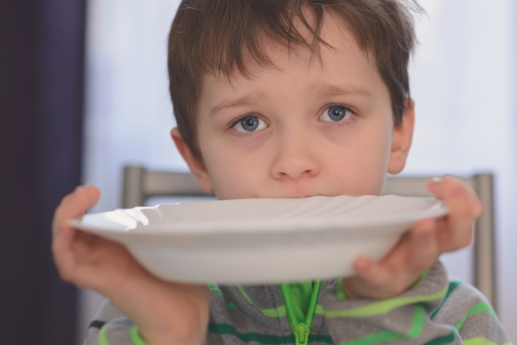
What is poor nutrition?
Poor nutrition is usually believed to be about a diet where the individual does not get enough food and or nutrients for them to flourish and grow. This is not the case, being malnourished happens when the individual does not have the right diet containing the necessary nutrients needed, malnutrition is a very dangerous disorder.
(foodnavigator.com)

An individual’s diet can be undernutrition and overnutrition
Having a poor nutrition diet can be both under nutritious meaning they are not getting what they need and need to up their nutrients, or over nutritious meaning they are getting far too many than is needed.

Malnutrition refers to deficiencies or excesses in nutrient intake, imbalance of
essential nutrients or impaired nutrient utilization. (World Health Organization).

What is physical development?
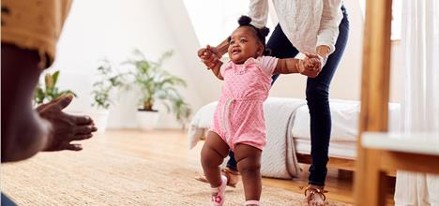
This type of development is all about the growth of the body and the brain through out infancy. Physical development improving motor control and spatial awareness as well as overall body and brain development. This motor control is used daily for a range if things, these can be simple things like speaking. Physical development is making progress towards and not defining youth by age, it more stage not age meaning their skills will develop at their own pace, they may just need some encouragement.

The impact of poor nutrition on physical development.
In 2019 1 in 3 children under the age of 5 were said to be in a state of malnourishment, they were either underweight or obese and 2 in 3 between the ages of six months and two years age do not receive the proper nutrients in their food and diet to support their swift growth of both their body and brain, increasing the risks of poor development, limited learning ability, lack of immunity and in some cases death.
- 149 million children are stunted, or too short for their age,
- 50 million children are wasted, or too thin for their height,
- 340 million children – or 1 in 2 – suffer from deficiencies in essential vitamins and nutrients such as vitamin A and iron,
- 40 million children are overweight or obese
- (UNICEF, 2023)
Poor nutrition is introduced in to a child’s diet way to early as when they are weaned off of milk and are transitioning to solid foods, most of them are get the wrong diet and a refused the nutrients that are needed. 45% of children globally do not get the food such as fruits and vegetables for the correct supplement and almost 60% do not consume dairy products such as eggs and chese such as eggs and cheese. Extreme or constant undernutrition can cause something called stunting. Stunting is described as low height for an individual’s current age which is frequently linked to poverty inadequate nutrition and parental health, recurrent sickness, and unsuitable feeding for young children in their early years. Stunting. Keeps children from developing to their full physical and intellectual potential.
Upon reading the information provided to me poor nutrition in my opinion would most definitely impact physical development in negative way. The reason being is that there seems to be a lot of negative evidence around the whole ordeal, especially in the early years of childhood, such as the 1 in 3 children under the age of 5 said to be in a state of malnourishment or that 45% of children do not get the proper nutrients in the food they are provided.

References:

Early Movers. “What Is Physical Development?” Www.earlymovers.org.uk, 2022, www.earlymovers.org.uk/about-pd. Accessed 22 Jan. 2023.

foodnavigator.com. ““With Food Prices Increasing Less People Will Achieve a Balanced Diet”: Data Highlights “Shocking” Extent of Malnutrition.” Foodnavigator.com, 7 Dec. 2022, www.foodnavigator.com/Article/2022/12/07/data-highlights-shocking-extent-of-malnutrition. Accessed 23 Jan. 2023.

“Is Your Baby’s Physical Development on Track?” HealthyChildren.org, 2019, www.healthychildren.org/English/ages-stages/baby/Pages/Is-Your-Babys-Physical-Development-on-Track.aspx. Accessed 22 Jan. 2023.
‌
NHS Choices. “Overview - Malnutrition.” NHS, NHS, 7 Feb. 2020, www.nhs.uk/conditions/malnutrition/.

UNICEF. “Poor Diets Damaging Children’s Health, Warns UNICEF - Unicef UK.” Unicef UK, 15 Oct. 2019, www.unicef.org.uk/press-releases/poor-diets-damaging-childrens-health-warns-unicef/. Accessed 21 Jan. 2023.
‌
World Health Organization. “Malnutrition.” Www.who.int, 2022, www.who.int/health-topics/malnutrition#tab=tab_1.
‌

