I confirm that I have not used any AI tools in the research and creation of this assignment. I confirm that I have not presented any AI generated materials as my own work. I confirm I have copies of my drafts, notes, and other resources I used, which I may be asked to provide in evidence.
Natesha Lewis-Campbell (2134545)
Tutor: Tristan Hawkins
Business Report-Comparison of two Hospitality Organisations
BMIH5007-International Hotel Management
Word Count: 2007
EXECUTIVE SUMMARY
In this report, the comparison of two different types of hotels will be explained in full details. The factors surrounding both hotels revenue, market position and their growth potential. This was research and studied to provide concrete evidence to back up any arguments. A little background information will be provided on each organisation so that readers may understand their income and why. Shangri-la has a good revenue and they suffered a big loss when covid hit but they came back strong when the borders for travel opened after the covid lockdown. Premier Inn has a revenue that has been increasing over the years but when covid came they had a huge loss over 60%. Slowly they came back with increasing numbers. After looking into both revenue, Premier revenue is higher than Shangri-la. Both hotels have a market position, where a comparison was not able to carry out due to the difference in hotel and services they provide. Bowman’s clock theory will be used as an example to explain how these hotels fit in the current market. Their own competitors will be used to help explain their position on the clock. Their growth potential has increase and both hotels are growing in their own way. Shangri-la is expanding in the middle east and Premier wish to keep expanding in the UK and in Germany due to the increase in travel and the increase in demand for budget hotels that provides food and beverages. Shangri-la has a mission to help the planet and they wish to go 50% plastic free by 2026, but Premier inn wish to do this in 2025. Each organisation is working on helping the planet and help their customer have a peace of mind know that their supporting an environmentally friendly business. To conclude this, no real comparison can be made between Shangri-la hotel resorts and Premier inn hotel. Shangri-la is luxury and premier inn is budget friendly. A recommendation for Shangri-la hotel, is a brand expansion to the island of Jamaica and a recommendation for Premier inn is a brand expansion in France to maintain similar customer based and increase revenue.

Contents Table
INTRODUCTION 3
MAIN BODY 3
CONCLUSION 7
RECOMMENDATION……………………………………………………………………………………………………………….8
REFERENCES…………………………………………………………………………………………………………………………….9

INTRODUCTION
Shangri-La hotels and resort and Premier Inn Hotels are the two-hospitality organisation that will be compared against each other to know how they performed over the years and how they survived covid 19. Their financial statement will be researched to gain an understanding on their market position to analyse their revenues to see whether there is any room for growth concerning both organisations. Their market position will also be discussed, bowman’s clock will be used an example to understand each hotels position in the current market. Premier Inn is the leading budget hotel in the UK, is this true, this will be looked at in more details to understand where they sit with supply and demand. The financial commitment to the corporate social responsibility will be analysed to get a look how they manage their commitment to the CRS organisation. There is no real comparison between both organisation as they provide different services for different customers, so it is no comparison. All evidence will be concluded, and recommendations will be added based on research finding.

MAIN BODY
  - TOTAL REVENUE
Shangri-La hotels and resorts is five-star Chinese multinational hospitality organisations. The first hotel opened in Singapore before they branch off to other parts of Asia, Africa, middle east and Europe. They have over 100 hotel and resorts, with over 40,000 rooms. The comfort and satisfaction of all their guest is a priority at Shangri-la hotel and resorts. “Shangri-la (2024)”. That is their motto and their aim to stay on top of being the best for hospitality. According to the financial statement “in the year ending 2023, Shangri-la made a 46.5% increase of $2,141.80m (£1631.90m) compared to the ending of 2022 where they made $1,462.1m (£1114m)”. (Hong Kong 2024). Reading through the financial statement of 2023, Shangri-la wrote about their recovery from covid-19. In the first half of 2020, according to (CPPLuxury 2020) “Shangri-La hotel suffered a massive decrease in revenue by a 62.1% loss due covid-19”. In July of 2020 business increase slightly but it was not until February of 2021 before they began to see real progress. Looking at their previous years before covid-19 in 2020, “Shangri-la made $384.6m in the year ending 2018, (£293.05m) which was a 6.2% increase compared to the ending of 2017 where they made $362.2m (£275.99m)”. (Financial statement 2018). In 2019 Shangri-la made a “2.2% loss in revenue, turnover was $376.2m (£286.57m) compared to 2018” (Financial statement 2019).
Premier Inn is a budget hotel based in the United Kingdom, own by a company called Whitbread. They have 850 hotels across the UK, and they also have branched out in Germany. Their aim is for their guest to have a comfortable night sleep in a king-size bed. (Whitbread 2024). In 2023 premier inn UK accommodation sales were 55 % ahead of 2022. “According to the financial year report for 2023, premier inn is Whitbread biggest source of income generating 50% revenue increase comparing to 2022 and 2020. Room rates has decrease in 2022 from 2020 but increase in 2023”. (Financial statement 2023). As one of the strongest growing budget hotels in the UK and with increase in estates, premier inn has an advantage for continuous growth in revenue and that’s how they make their money. (Annual report 2019/2020). “In 2021 premier inn made a 71.5 % loss in revenue, which means they made £589.4m compared to the £2.1bn in the previous year. The company only survived on the government grant to cover all their furlough and pay out to staff members” (D.Jagger 2021). the information above shows how different each revenue is for both hotel and how they both make their money. There is no way to compare the organisations because their customer base is different which also differs in the type of service they offer. The room prices are also different. It may seem like Shangri-la makes more in revenue but the fact truth is that, they are seasonal and there isnt a demand for such luxury all year. From the research, it shows that Premier inn makes more in revenue as there is a demand for budget hotels. The similarity between both hotels, is that they both has a good revenue, they both do well in their country of origin. They both are in the hospitality industry but one is luxury and one is not luxury. From the revenue explain above, Premier inn makes more in revenue than Shangri-la hotels.
  - MARKET POSITION
2020 was the year covid -19 hit the world and the hospitality sector faced challenges all around the world. One of the key elements to Shangri-la marketing strategy, is “their growth strategy and how they target the middle- and upper-class customer with extremely high income” (N.Sheridan 2024). “The strength of Shangri-la is their brand recognition, which is their luxury hospitality in the Asian hospitality industry, that keeps customers coming back for more. Their weakness is the ties they have to the global travel economy and the diverse accommodation that is new to the hospitality market, such as air bnb and budget hotels. The new way of social media is also a weakness that Shangri-la must keep making adaptation to keep up with all the social media trends. Expending into new markets such as Africa and south America is an opportunity for Shangri-la to move their business to new area for new sales and business expansion as these areas are now taking on the world of luxury. The threats they face are failed economy such as covid-19 or anything that affects the hospitality market”. (swot analysis 2024).
Premier Inn marketing strategy is to target cities and provide rooms that is enough for a good night’s sleep for customers who are just looking for a good night. The strength of the premier inn is the demand for budget hotel in the UK and they are supplying it without any issues. Their weakness is like Shangri-la as both hotels would struggle if there was another lock down. “The Bowmans clock is a strategy use to compare companies and their competitors, on their market positions” (H.Bhasin 2019). They are two charts below to explain Premier INN on diagram A and Shangri-la on-Diagram B on the bowman’s clock theory. When it comes to market position there is no comparison between Premier Inn and Shangri-la because they are two different hotel and its impossible to compare the two. As Travelodge is a competitor for premier inn, they were used as an example on the clock. Six Sense is also a competitor for Shangri-la so they were use as an example on the bowman’s clock theory. Comparing these two organisation on their market position, is impossible because they provide two separate service and they have different clients and they are in different part of the world in different parts of cities.

Diagram A
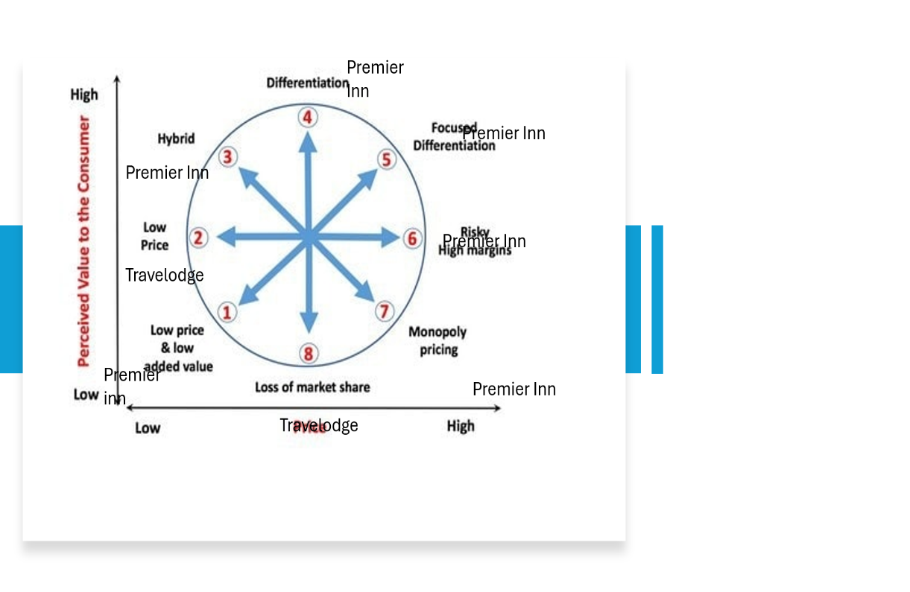
Diagram B
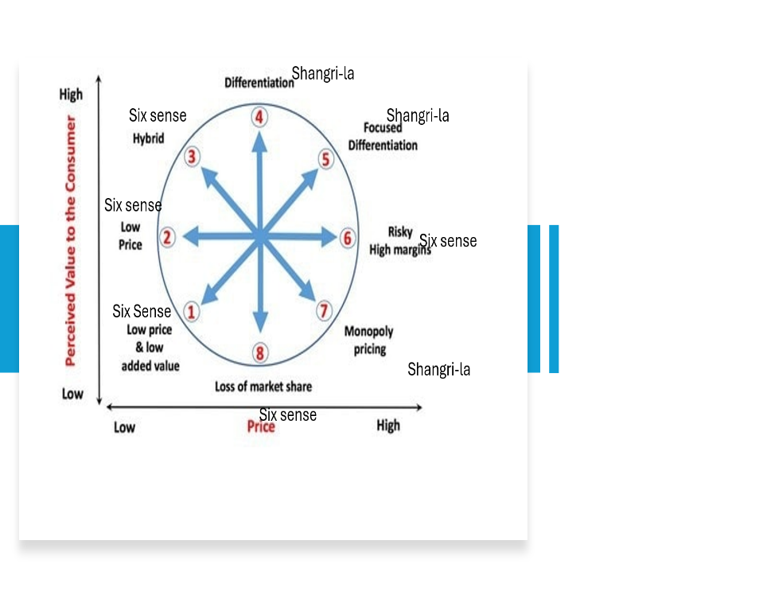
(H.Bhasin 2019)

  - GROWTH POTENTIAL
Shangri-la growth will expand on the borders opening in mainland China, the chairwoman for the company states that “we are cautiously optimistic that on the return of Chinese outbound travel as the next growth potential will roll out in our favour, with visa free opportunity for Chinese travellers that was done by other countries in Asia” (Kevin He 2024). “Shangri-la plans on expanding geographically in the middle east, Australia and Africa. They have set up teams in those area to manage these projects” (GlobalData 2021). As a UK based company Premier Inn has branched off into Germany and they are doing well. “They are putting plans into expanding more in Germany and upgrading most of their UK based hotels. The UK sales are set to increase significantly with the demand of budget hotels needed across the UK” (Financial statement 2023). Premier Inn is expanding because they wish to spread their brand and keep the title of leading budget hotel in the UK. “With hospitality on the rise and Whitbread income increasing, demand for budget hotel, premier inn is taking over, share price also rising” (E. Mathews 2023)
“The law of supply and demand speaks of when a supply is needed and when a product is in demand” (YouTube video 2022). The chart shows fours ways in which the market can go and with this chart you will see where premier inn and Shangri-la stands in the market. Premier Inn has an increase in supply because they are building new hotels across the UK to keep up with the demands of the service they offer. Shangri-la increases in demand as there is a demand for luxury in Asia and Shangri-la has the reputation for providing the best luxury experience in Asia.
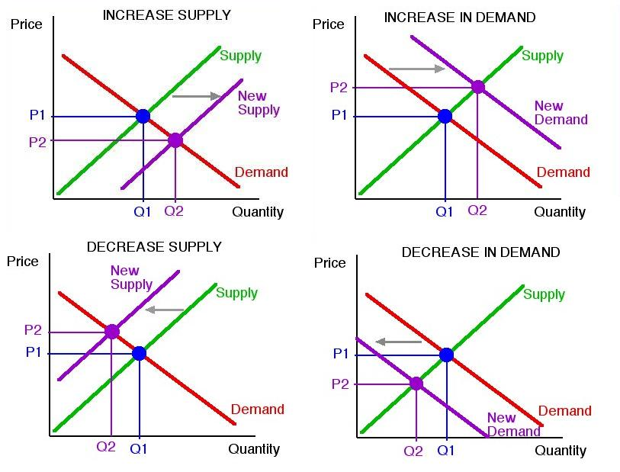
vamosarema.com
  - FINANCIAL COMMITMENT TO CSR
CSR is the corporate social responsibility business that acquire sustainability reports from companies. “Shangri-la sustainability report for 2021 explains how they have invested in reducing the use of plastic by 50% by 2026”. (Sustainability report 2021). “During the year of 2022 Shangri-la joined partnership with Engie to save around 7 tonne of CO2 in their properties, in order to save energy while running the hotel” (Sustainability 2022). “Premier Inn use 100% renewable energy to power all of its properties and they also have set plans to reduce carbon emissions by 2025” (V.Gowera 2023). Premier has more commitment to CSR than Shangri-la. They are getting the carbon emissions lowered sooner than Shangri-La, this is possible because premier inn has committed themselves in helping the planet. “They will move to using no gas in the new hotels, use green gas in all hotels and keep using renewable energy” (Premier inn 2018). Premier Inn is doing this to make sure their guest rest easy, knowing they are an environmental business, who is trying to help the planet. This strategy is business and just simple helping the planet. Whilst Shangri-la is trying to reduce plastic, as a luxury hotel they are certain thing that might pose difficulty when trying to save the planet. An example of this will be the luxury lights they use, the amount of time they do laundry and so much more. Being efficient is a little more challenging for Shangri-la than it is for Premier Inn. Premier Inn has this commitment because it helps their business keep cost down and this is essential for them and it keeps the customers happy.

CONCLUSION
In conclusion to this report, we have seen the similarities between Premier Inn and Shangri-la and we have also seen that is it hard to compare the two. This is because they are two different brands in the hospitality industry. From the research we have seen that Premier Inn is doing well in the UK, in fact, it’s the leading hotel for price, location and food. Whether this is fact or not, the revenue shows how well they are doing. Shangri-la is also doing well in Asia, they are the leading brand for luxury, and they are ready to spread that luxury across the world. Their weakness in the hospitality industry is very similar as they both fear another covid19 could ruin their business. The observation shown here is that the hotel business is a high-risk business that pays well, or does it? Both organizations seem to do well financially, or do they?

RECOMMENDATIONS
Recommendation for Shangri-la, they should consider moving their brand to the Island of Jamaica. This move will help their brand expand to the Caribbean and with Shangri-la meaning paradise and peace, this will work perfectly. Jamaica was chosen because their economy is partly run by Chinese who moved there to expand their businesses. Shangri-la is a Chinese owned hotel, I feel they could do good business there. Jamaica is already the most popular Caribbean Island with the most successful in tourism, they got the award for number one in hospitality and tourism.
Recommendation for Premier Inn, they should branch off to France in the Paris the capital. This would increase their revenue and expand their brand in Europe. Most business customers who travel will appreciate a budget hotel, with the same customer card to make their life easier. This will also maintain a good customer base.

REFERENCES
CPPLuxury ( 2020) website, available at:Shangri-La Group reports revenues down 62,1% in the first half of 2020 – CPP-LUXURY [accessed on 3 October 2024]

D.Jagger (2021), ‘Premier Inn looses 1BN during covid lockdown’ article, available at: Premier Inn loses £1 billion during Covid lockdowns | Bradford Telegraph and Argus (thetelegraphandargus.co.uk) [Accessed on 10 October 2024]

E. Mathews (2023) ‘Owner enjoys steady demand’ article, available at: Whitbread's profits jump as Premier Inn-owner enjoys steady demand | Reuters [accessed on 15 October 2024]

H.Bhasin (2019), ‘what is bowman strategy clock’ article, available at: Bowman’s Strategy Clock - What is Bowman’s Strategy Clock? (marketing91.com) [accessed on 12 October 2024]

Financial statement (2018) website, available at: 2018-Final-Results-Announcement.pdf (shangri-la.com) [accessed on 3 October 2024]

Financial Statement (2019) website, available at: https://sitecore-cd.shangri-la.com/-/media/Project/Shangri-La-Group/Investor/Files/Public-Disclosures/Financial-Information/Results-Announcements/2020-03-27-Financial-results---Final-results-2019.pdf [Accessed on 3 October 2024]

Financial statement (2023) Whitbread , available at: Final-FY23-RNS-Final-Combined.pdf (whitbread.co.uk) [accessed on 10 October 2024]

GlobalData (2021) Article, ‘Shangri-la steps up hiring in line with expansion plans in Asia and Middle east, finds global data. Available at: Shangri-La Steps Up Hiring In Line With Expansion Plans In Asia And Middle East, Finds GlobalData (hospitalitynet.org) [accessed on 9 October 2024]

Hong kong (2024) website, available at: 2024-03-22-Final-Results-Announcement_E.pdf (shangri-la.com) [Accessed on 3 October 2024]

K.He (2024) Article, ‘Shangri-la returned to profit in 2023 as revenue jumped 47% on travel recovery’ available at: Shangri-La Returned to Profit in 2023 with 47% Revenue Jump - Mingtiandi [accessed on 9 October 2024]

N.Sheridan (2024), Shangri-la marketing strategy 2024: case study, website, available at: Shangri-La Hotels Marketing Strategy 2024: A Case Study – Latterly.org [accessed on 5 October 2024]

Premeir Inn (2018) ‘Our earth day commitment to cut our carbon emmissions intensity by 50%’ website, availabe at: Cutting our carbon emissions 50% by 2025 (premierinn.com) [Accessed on 12 October 2024]
Vamosarema, image, available at: Supply And Demand Graph Maker Free at Alicia Core blog (vamosarema.com) [accessed on 13 October 2024]

Shangri-la (2024) website available at: About Shangri-La Rasa Sayang, Penang [accessed on 3 October 2024]

Swot analysis (2024), Shangri-la hotels swot analysis, website available at: Shangri-La Hotels SWOT Analysis - The Strategy Story [accessed on 06 October 2024]

Sustainability report (2021) Shangri-la report, available at: https://sitecore-cd.shangri-la.com/-/media/Project/Shangri-La-Group/OurStory/Files/Community-And-Social-Impact/Sustainability-Reports/2021_SustainabilityReport.pdf [accessed on 09 October 2024]

Sustainability report (2022) Shang Property, available at: SEC-Form-17-A-for-FY-2022-Part-3.pdf (shangproperties.com) [accessed on 9 October 2024]

V.Gowera (2023), ‘Swot analysis of Premeir Inn (Premeier Inn Swot), article available at: SWOT analysis of Premier Inn (Premier Inn SWOT) - www.howandwhat.net [ Accessed on 12 October 2024]

Whitbread (2024) Our brands, website, available at: Our brands - Whitbread PLC [accessed on 10 October 2024]

Whitbread (2019/20) Annual report, available at: whitbread-ar-19-20-1.pdf [accessed on 10 October 2024]
YouTube video (2022) ‘supply and demand’ available at: Law of Demand and Supply - YouTube [accessed on 13 october 2024]

