Strategic Change Plan

Strategic Change Plan for Jaguar Land Rover (JLR): Accelerating AI-Driven Smart Manufacturing and Electrification in the UK Automotive Industry

Laurentiu Lisman – 2322353

Executive Summary
In response to radical changes in the global auto landscape brought about by AI, Industry 4.0 technologies, electrification and more stringent environmental regulations, Jaguar Land Rover (JLR) is transforming itself structurally. With premium automotive manufacturers racing to develop smart, connected and zero-emission vehicles, JLR must quickly capitalize on AI-driven smart manufacturing whilst ramping up electric vehicle (EV) production in order to retain competitive advantages. While the Reimagine Strategy lays out a long-term vision of modern luxury mobility for the company, achieving this ambition is associated with transformation in manufacturer processes, digital capabilities and workforce skills as well leadership practices (Jaguar Land Rover 2024; International Energy Agency (IEA) 2024).

Table of Contents

Executive Summary 2
1. Introduction 4
2. Analysis of the Need for Strategic Change 5
3. Change Management Models 8
4. Leadership & Culture 15
5. Strategic Change Plan 19
6. Conclusion 24
7. References 25
8. Appendix 26

- Introduction

1.1 Background of Jaguar Land Rover
Jaguar Land Rover (JLR) is located in the U.K. and a major premium automaker producing luxury vehicles under the Range Rover, Defender, Discovery and Jaguar brands After becoming a 100% owned subsidiary of Tata Motors in 2008, the company's meteoric rise as vertical global automotive business with manufacturing plants, engineering centers and sales operations operating across really more than 120 countries around. Since its inception, JLR has built a reputation for engineering excellence and high-quality design with technological innovation that inspires credibility in the mobility industry as well as an integral part of UK manufacturing sector and national;(Jaguar Land Rover —2019; Tata Motors—2020).

But business has been mixed for JLR across the last ten years due to shifting market circumstances, global supply chain headaches leading into and through a pandemic, semi-conductor shortages darkening future production prospects as well as challenges brought on by Brexit uncertainty and massive shift towards electric mobility. Nevertheless, the organisation has remained committed to investing heavily in R&D (research and development), battery technologies, software-defined vehicles and digital manufacturing capabilities. TheReimagine Strategy launch is JLR's long-term approach for establishing itself as a leader inmodern luxury electric mobility, with accelerated electrification,sustainability and advanced manufacturing technologies powered by artificial intelligence (AI).

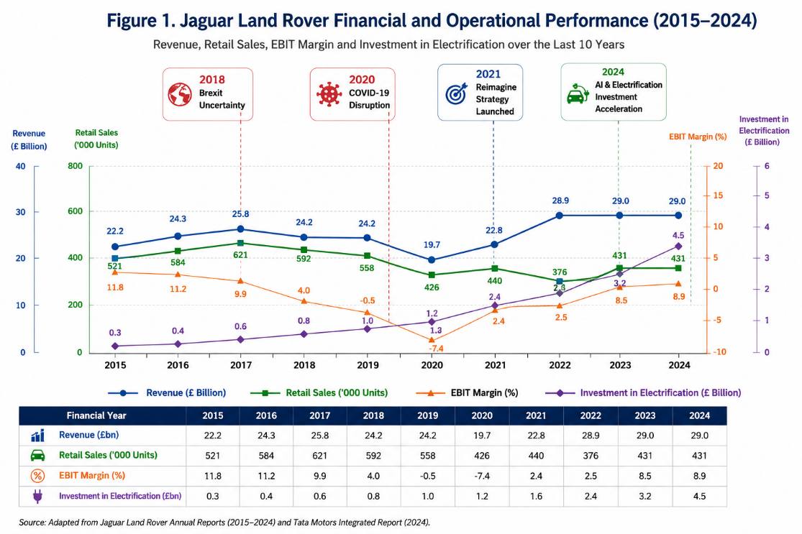
Figure 1. Financial and Operating Performance for Jaguar Land Rover (2015-2024) — Insert line chart showing Revenue (£bn), Retail Sales ('000 Units), EBIT margin (%) & Investment into Electrification from the last decade

- Analysis of the Need for Strategic Change
2.1 Introduction
Jaguar Land Rover (JLR) is one of the most advanced and possibly fastest changing industries in the world. The evolution of artificial intelligence (AI), electrification, Industry 4.0 technologies, and digital manufacturing as well as ever stricter environmental regulations has fundamentally changed the competitive landscape in which automotive OEMs operate. Nowadays, the competition among premium vehicle manufacturers is shifting beyond product quality and brand image but goes to digital innovation, manufacturing flexibility (the flexible production lines), software capabilities (with many vehicles based on a common architecture) sustainable improvement performance as well customer experience. As a result, JLR now needs to drive organisational change faster than ever in order not only to meet the aims of its new Reimagine Strategy (Jaguar Land Rover, 2024; International Energy Agency (IEA), 2024) and position itself as global leader for modern luxury electric mobility.
This chapter employs established strategic management tools—such as PESTLE Analysis, SWOT Analysis and Porter's Five Forces—to examine the external environment of business impacting JLR's future course in terms of strategic direction.
2.2 PESTLE Analysis
PESTLE is the tools which gives you a complete analysis of macro environment components affecting strategic transformation in JLR.
Factor | Strategic Impact on JLR
Political | UK and EU Zero Emission Vehicle (ZEV) mandates, trade policies following Brexit, and government incentives for EV production require JLR to accelerate electrification and localise critical supply chains.
Economic | Inflation, high interest rates, volatile raw material prices, and global economic uncertainty increase production costs while affecting consumer purchasing power and investment decisions.
Social | Consumers increasingly demand environmentally sustainable, digitally connected, and technologically advanced luxury vehicles with personalised customer experiences.
Technological | AI, robotics, Industrial Internet of Things (IIoT), digital twins, autonomous manufacturing, cloud computing, and predictive analytics are reshaping automotive production and operational efficiency.
Legal | Carbon emission regulations, battery recycling legislation, data protection requirements, and vehicle cybersecurity regulations require continuous technological adaptation and compliance.
Environmental | Net-zero commitments, ESG expectations, circular economy initiatives, renewable energy adoption, and sustainable manufacturing practices are becoming central competitive requirements.
Table 2.1 PESTLE Analysis of Jaguar Land Rover
The political and regulatory milieu is no bed of roses for JLR. UK Government's Zero Emission Vehicle Mandate: this mandates an increasing percentage of electric vehicles sales over the coming years as well, whilst Europe contributes further with a tightening up carbon emission standards. Regulatory changes require significant investments in battery technology, software development and sustainable manufacturing processes (UK Department for Transport 2024; European Commission 2024).

2.3 SWOT Analysis
Internal organisational capabilities significantly influence JLR's ability to implement strategic transformation successfully.
Strengths | Weaknesses
Globally recognised luxury brands | Legacy manufacturing infrastructure
Strong engineering expertise | High dependence on premium vehicle segment
Tata Motors' financial support | Workforce digital skills gap
Significant investment in R&D | Supply chain vulnerability
Established global distribution network | High capital expenditure requirements
Opportunities | Threats
Growth of global EV market | Tesla, BYD, BMW and Mercedes competition
AI-driven smart manufacturing | Semiconductor shortages
Government EV incentives | Cybersecurity threats
Digital supply chain transformation | Economic slowdown
Sustainable mobility demand | Rapid technological disruption

Several competitive advantages are also still in favour of JLR, such as premier brands known worldwide; extensive engineering know-how and capabilities in research & development support. Plus financial backing from the globally owning Tata Motors (considering how influential their capital market strength is). These are strong roots upon which to build AI-enabled manufacturing and fast-track electrification.

2.4 Porter's Five Forces Analysis

Porter's Five Forces further demonstrates the competitive pressures driving strategic change.

Force | Impact
Competitive Rivalry | Very High
Threat of New Entrants | Moderate
Threat of Substitutes | Moderate
Bargaining Power of Suppliers | High
Bargaining Power of Buyers | High
Table 2.3 Porter's Five Forces

BMW, Mercedes-Benz, Audi, Tesla and others have shifted gears quite aggressively in their electrification strategies as well the digital transformation of premium automotive sector has been intense with plenty to overtake for companies like Volvo and BYD. At the same time, suppliers of batteries, semiconductors and advanced electronic components have lost some bargaining power due to stressed global supply.

2.5 Business Performance
Despite JLR proving prudent in its financial response to COVID-19, the organisation is still being presented with structural changes as a result of both technological disruption and global market uncertainty. While this recent transformation in revenue and profitability is significant, sustainable growth will require continued investment to drive our next stage of innovation through new technologies including AI, electrification and battery technologies as well as digital manufacturing strategies while upskilling the workforce needed for a more resilient supply chain.

- Change Management Models
3.1 Introduction
Successfully implementing AI-driven smart manufacturing and accelerating electrification at Jaguar Land Rover (JLR) requires more than technological investment; it demands effective organisational change management. Large-scale transformation frequently encounters employee resistance, leadership challenges, operational disruption, and cultural barriers, making structured change management essential for achieving sustainable outcomes. Research indicates that organisations adopting formal change management frameworks are significantly more likely to achieve successful transformation than those relying solely on technological implementation (Prosci, 2023; Burnes, 2020).
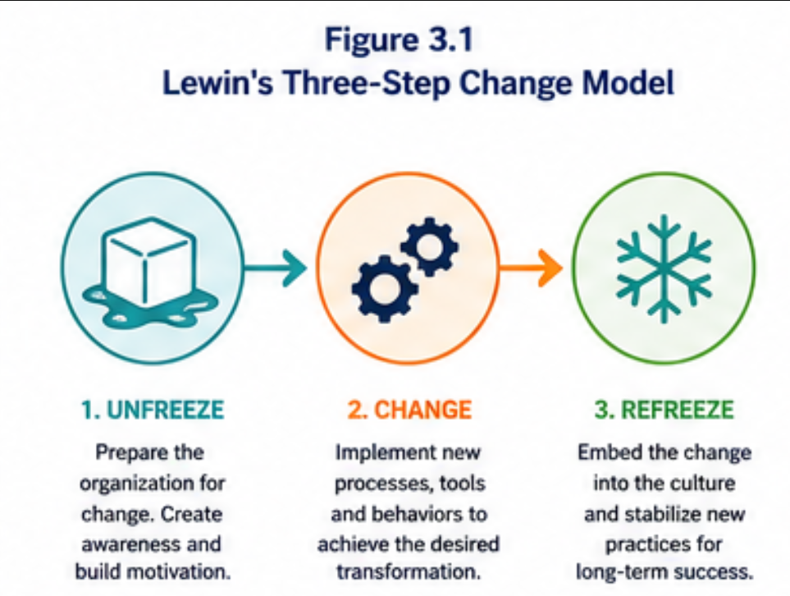
Given the complexity of JLR's strategic transformation, this chapter critically evaluates four widely recognised change management models: Lewin's Three-Step Model, Kotter's Eight-Step Model, McKinsey 7S Framework, and the ADKAR Model. Their suitability for supporting JLR's transition towards AI-enabled manufacturing, digital transformation, and sustainable mobility is assessed before recommending the most appropriate framework.

3.2 Lewin's Three-Step Change Model
Developed by Kurt Lewin (1951), the Three-Step Change Model remains one of the foundational frameworks for organisational transformation. The model comprises three sequential stages:
- Unfreeze – Prepare employees by creating awareness of the need for change.
- Change – Implement new processes, behaviours, and technologies.
- Refreeze – Embed new practices into organisational culture to ensure long-term sustainability.
For JLR, the Unfreeze stage would involve communicating the urgency of digital transformation, explaining market pressures such as electrification, AI adoption, and global competition. Leadership would need to build employee awareness regarding why existing manufacturing practices must evolve.
The Change stage would involve implementing AI-powered quality inspection systems, predictive maintenance, digital twins, intelligent robotics, and employee digital upskilling programmes across manufacturing facilities.
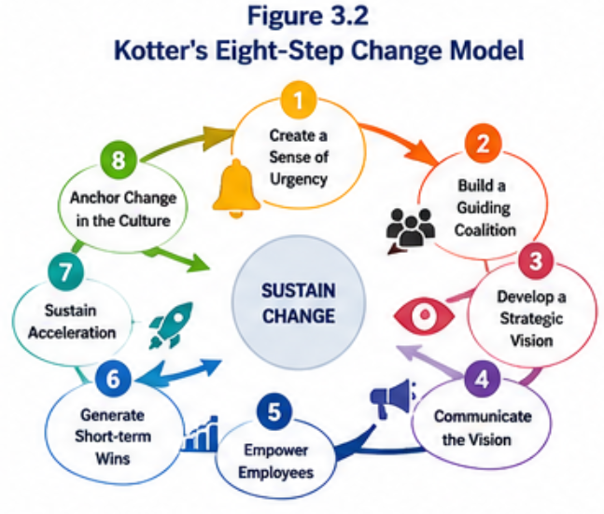
Finally, during the Refreeze stage, new digital practices would become integrated into organisational routines through revised performance management systems, continuous learning programmes, leadership reinforcement, and digital performance metrics.

Strengths
- Simple and easy to understand.
- Suitable for structured organisational transformation.
- Encourages employee preparation before implementation.
- Reinforces long-term behavioural change.
Limitations
- Assumes change occurs in distinct stages rather than continuously.
- Less suitable for organisations experiencing constant technological disruption.
- Limited emphasis on leadership communication and stakeholder engagement.
Although Lewin's framework provides a useful foundation for managing change, it lacks sufficient flexibility for JLR's ongoing digital transformation, where innovation and continuous improvement remain permanent organisational priorities (Burnes, 2020).

  - Kotter's Eight-Step Change Model

John Kotter's (2012) Eight-Step Model provides a more comprehensive framework for leading complex organisational transformation by emphasising leadership, communication, stakeholder engagement, and cultural integration.

The eight stages include:
- Create a sense of urgency.
- Build a guiding coalition.
- Develop a strategic vision.
- Communicate the vision.
- Empower employees.
- Generate short-term wins.
- Sustain acceleration.
- Anchor change within organisational culture.

Kotter's framework aligns closely with JLR's AI-driven transformation. The increasing adoption of electric vehicles, Industry 4.0 technologies, and intelligent manufacturing creates a compelling sense of urgency for organisational change. Senior executives can establish a cross-functional leadership coalition involving manufacturing, engineering, information technology, supply chain, human resources, and sustainability teams to coordinate implementation.
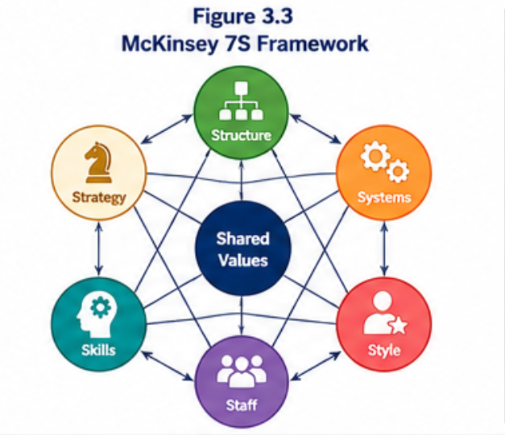
Effective communication would help reduce employee uncertainty regarding automation while digital skills training would empower staff to operate AI-enabled manufacturing systems. Early pilot projects—such as predictive maintenance in selected production lines—would generate measurable short-term successes, building confidence before wider implementation across all manufacturing facilities.
Strengths
- Strong leadership focus.
- Excellent stakeholder engagement.
- Promotes continuous communication.
- Encourages cultural integration.
- Particularly suitable for enterprise-wide transformation.
Limitations
- Time-intensive.
- Requires sustained leadership commitment.
- Complex implementation across multinational organisations.
Overall, Kotter's model provides JLR with a structured yet flexible framework capable of managing technological, operational, and cultural transformation simultaneously (Kotter, 2012).

  - McKinsey 7S Framework

The McKinsey 7S Framework argues that organisational change succeeds only when seven organisational elements remain aligned:
- Strategy
- Structure
- Systems
- Shared Values
- Style
- Staff
- Skills

For JLR, the framework highlights that AI implementation extends beyond technology. Manufacturing systems, organisational structures, leadership styles, workforce competencies, and corporate values must evolve together to support smart manufacturing.
For example:
- Strategy focuses on AI-enabled electrification.
- Systems incorporate digital twins and predictive analytics.
- Skills require workforce reskilling in AI, robotics, and data analytics.
- Shared Values reinforce innovation, sustainability, and customer-centricity.
Strengths
- Provides a holistic organisational perspective.
- Highlights organisational alignment.
- Useful for diagnosing implementation gaps.
- Supports long-term transformation.
Limitations
- Does not specify implementation stages.
- Less effective as a standalone change process.
- Requires complementary leadership models.

Consequently, McKinsey's framework is particularly valuable for ensuring organisational alignment throughout JLR's transformation rather than serving as the primary implementation methodology.

3.5 ADKAR Model
Developed by Prosci, the ADKAR Model focuses on individual behavioural change through five sequential components:
- Awareness
- Desire
- Knowledge
- Ability
- Reinforcement
At JLR, the model supports workforce transformation by helping employees understand why AI adoption is necessary, motivating participation, developing digital competencies, enabling practical application of new technologies, and reinforcing continuous improvement.
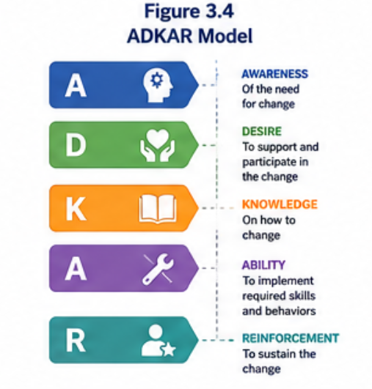
Given that employees are central to the success of smart manufacturing, ADKAR provides an effective framework for managing resistance while improving workforce engagement.
Strengths
- Employee-centred approach.
- Excellent for digital skills development.
- Supports behavioural change.
- Reduces resistance to technological transformation.
Limitations
- Focuses primarily on individuals.
- Does not fully address organisation-wide strategic transformation.
- Should complement broader organisational frameworks.

3.6 Comparative Evaluation of Change Management Models
Model | Leadership | Employee Engagement | Organisational Alignment | Suitability for JLR
Lewin | Moderate | Moderate | Moderate | Medium
Kotter | Excellent | Excellent | High | Very High
McKinsey 7S | High | Moderate | Excellent | High
ADKAR | Moderate | Excellent | Moderate | High
Table 3.1 Comparative Evaluation of Change Models
The comparison demonstrates that Kotter's Eight-Step Model offers the strongest overall framework for JLR because it combines strategic leadership, employee engagement, communication, cultural integration, and continuous improvement. However, combining Kotter's implementation process with McKinsey's organisational alignment framework and ADKAR's employee-focused approach creates a more comprehensive transformation strategy.

3.7 Chapter Summary
The evaluation demonstrates that no single model fully addresses the complexity of JLR's digital transformation. Lewin's model provides a valuable foundation for structured change, McKinsey's 7S Framework ensures organisational alignment, and ADKAR facilitates workforce adoption of new technologies. However, Kotter's Eight-Step Model is identified as the most appropriate primary framework because it offers a structured roadmap for managing large-scale organisational transformation while embedding change into organisational culture.

- Leadership & Culture
4.1 Introduction
Effective leadership and a supportive organisational culture are critical determinants of successful strategic change. While advanced technologies such as artificial intelligence (AI), digital twins, robotics, and predictive analytics can improve manufacturing performance, their successful implementation depends on leadership capability, employee commitment, and an organisational culture that embraces innovation and continuous learning. Research consistently demonstrates that organisational transformation is more likely to succeed when leaders communicate a compelling vision, engage employees throughout the change process, and create a culture that encourages collaboration and adaptability (Kotter, 2012; Northouse, 2022).
For Jaguar Land Rover (JLR), the transition towards AI-driven smart manufacturing and accelerated electrification requires transformational leadership capable of guiding employees through technological disruption while reinforcing the company's strategic objectives under the Reimagine Strategy. This chapter examines the role of transformational leadership, employee engagement, organisational culture, and communication in enabling successful strategic change.
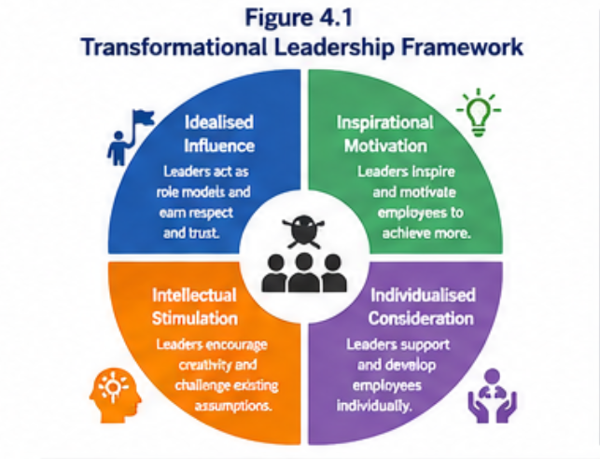
4.2 Transformational Leadership
Transformational leadership focuses on inspiring employees to exceed organisational expectations by promoting innovation, shared vision, intellectual stimulation, and individual development (Bass and Riggio, 2006). Unlike transactional leadership, which emphasises routine performance and rewards, transformational leaders motivate employees to embrace change and contribute to long-term organisational success.
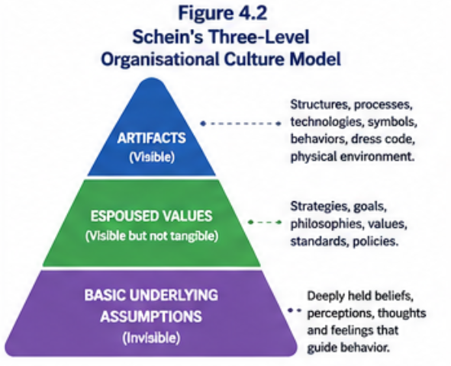
At JLR, transformational leadership is essential because the adoption of AI-enabled manufacturing technologies represents a fundamental shift in operational practices. Senior executives must articulate a clear strategic vision that demonstrates how AI, automation, and electrification will enhance operational efficiency, sustainability, and customer value while creating opportunities for workforce development rather than replacing employees.

4.3 Managing Employee Resistance to Change
Resistance to organisational change is one of the most significant barriers to successful digital transformation. Employees may fear job displacement due to automation, increased performance expectations, or uncertainty regarding new technologies. Without effective leadership and communication, resistance can reduce productivity, delay implementation, and increase operational risk (Burnes, 2020).
To minimise resistance, JLR should adopt several employee-centred initiatives:
- Communicate the purpose and benefits of AI adoption transparently.
- Involve employees in planning and pilot projects.
- Provide continuous digital skills training and professional development.
- Establish AI champions within manufacturing facilities.
- Recognise and reward employee participation in innovation initiatives.
These initiatives align with Kotter's emphasis on communication and empowerment while supporting the behavioural change principles outlined in the ADKAR Model. By involving employees throughout the transformation process, JLR can build confidence, improve technology adoption, and strengthen organisational commitment.
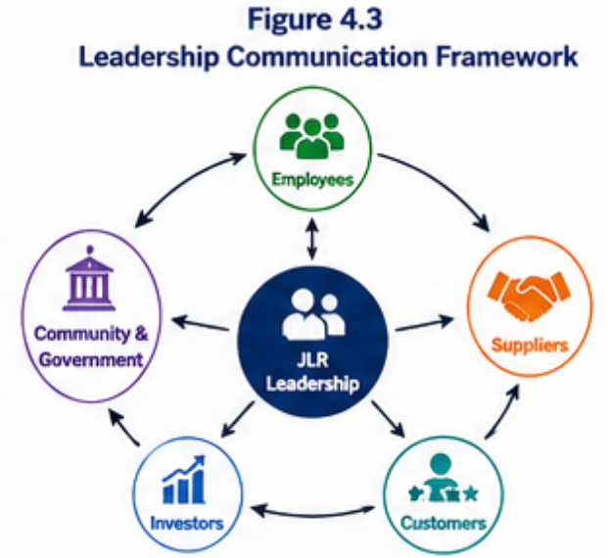

4.4 Organisational Culture: Schein's Three-Level Model
Edgar Schein's Organisational Culture Model explains that organisational culture consists of three interconnected levels:
- Artifacts – Visible organisational structures, technologies, workplace design, and employee behaviours.
- Espoused Values – Organisational strategies, goals, ethical standards, and corporate vision.
- Basic Underlying Assumptions – Deeply embedded beliefs that influence employee behaviour and decision-making (Schein and Schein, 2021).
For JLR, organisational culture must evolve from traditional manufacturing practices towards a digitally enabled culture characterised by innovation, agility, collaboration, sustainability, and continuous learning. Visible artefacts should include AI-enabled production systems, digital dashboards, collaborative workspaces, and advanced robotics. Organisational values should reinforce innovation, customer focus, environmental responsibility, and operational excellence, while underlying assumptions should encourage experimentation, data-driven decision-making, and continuous improvement.
Embedding these cultural attributes will support long-term adoption of AI technologies while enhancing organisational resilience and competitiveness.

4.5 Leadership Communication Strategy
Effective communication is fundamental to maintaining employee engagement during strategic change. Employees require clear, consistent, and timely information regarding organisational objectives, implementation progress, expected benefits, and their individual roles within the transformation process.
Table 4.1 Leadership Communication Matrix
Stakeholder | Communication Method | Frequency | Purpose
Executive Leadership | Strategic meetings | Monthly | Review strategic progress and decision-making
Senior Managers | Leadership workshops | Monthly | Coordinate implementation activities
Employees | Town hall meetings, digital newsletters, intranet | Bi-weekly | Explain progress, address concerns, and encourage engagement
Suppliers | Partnership meetings | Quarterly | Improve supply chain collaboration and technology integration
Investors | Financial reports and annual briefings | Quarterly | Communicate transformation progress and business performance
A structured communication strategy increases transparency, reduces uncertainty, and strengthens employee confidence throughout the implementation process. Regular feedback mechanisms, including employee surveys, workshops, and digital collaboration platforms, should also be used to monitor engagement and identify emerging challenges (Prosci, 2023).

4.6 Chapter Summary
Leadership and organisational culture play a pivotal role in determining the success of JLR's strategic transformation. Transformational leadership provides the vision, motivation, and collaboration required to implement AI-driven smart manufacturing and accelerate electrification. Simultaneously, a culture that values innovation, sustainability, continuous learning, and employee empowerment creates an environment where technological change can be successfully embedded into daily operations.
By combining transformational leadership with Schein's organisational culture principles and a comprehensive communication strategy, JLR can reduce employee resistance, strengthen stakeholder engagement, and improve the long-term sustainability of its digital transformation. These leadership and cultural foundations provide the organisational capability required to implement the strategic initiatives presented in the next chapter.
Transition: The following chapter presents the Strategic Change Plan, outlining the implementation roadmap, strategic objectives, resource requirements, timelines, risk management measures, communication plan, and key performance indicators for accelerating AI-driven smart manufacturing and electrification at Jaguar Land Rover.
- Strategic Change Plan
Jaguar Land Rover (JLR) is known to lead within one of the world’s most competitive and advanced industries where digital innovation, sustainability, and electrification are rapidly changing what it means to have a competitive advantage. Although the Reimagine Strategy aims to create a clearer path to premium electric mobility, the company will need to further pivot its organization to an integrated, AI (artificial intelligence) driven smart manufacturing system as a necessary condition for achieving sustainably profitable growth. The strategy change plan, aims to accelerate the integration of AI system across manufacturing, the supply chain, quality assurance, workforce, and production, and is intended to meet the growing demand for electric vehicles (EV). This JLR integration plan is consistent with the zero-carbon and operational excellence goals and aims to strengthen JLR’s position as the global leader within the modern luxury mobility segment (Jaguar Land Rover, 2024; International Energy Agency (IEA), 2024).
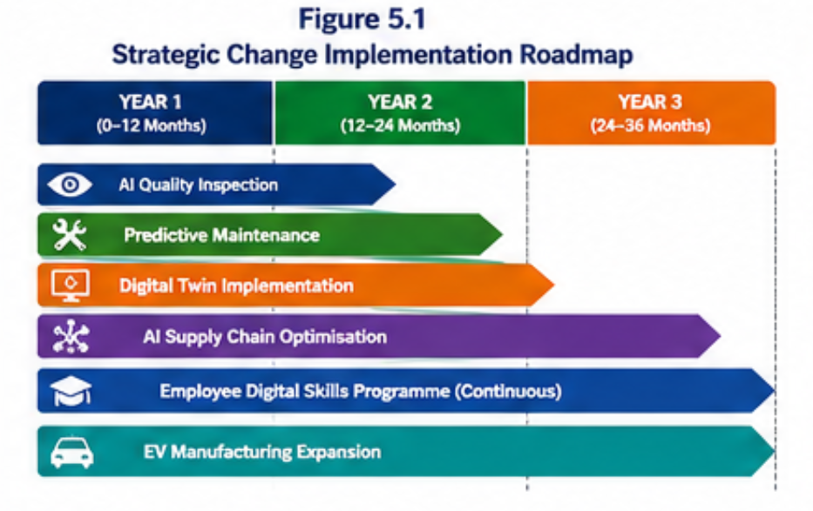
The goal is for JLR to lead the world in automotive manufacturing that is smart, sustainable, and connected, and for JLR to become synonymous with the intelligent use of AI and other advanced technologies that define the fourth industrial revolution (McKinsey & Company, 2024; Deloitte, 2024).

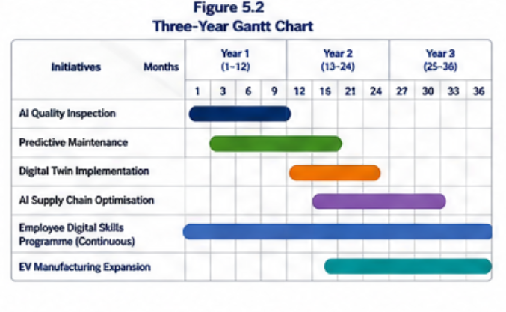
Introducing predictive maintenance across production equipment is the goal of the second strategic initiative. This incorporates the use of artificial intelligence alongside the Industrial Internet of Things (IIoT). With this initiative, sensors will be added to the production machinery. These sensors will collect data related to vibration, pressure, and temperature, as well as the operational performance of the machinery. With the data collected, machine learning algorithms will be able to forecast equipment failures prior to failures and breakdowns. Maintenance can be scheduled by the maintenance teams, which will be a benefit to the business. With predictive maintenance, a decrease in unplanned downtime will result. This, as well as an anticipated increase in the lifespan of the equipment and a decrease in the optimization of maintenance costs, will lead to a boost in the overall manufacturing efficiency and maintain focus on the production of electric vehicles (PwC, 2024; Deloitte, 2024).
The deployment of artificial intelligence to enhance each segment of the supply chain from procurement to inventory management, logistics, and supplier collaboration is the goal of the third initiative. The disruption of the global supply chains, as well as the shortage of semiconductor supplies, has highlighted the vulnerabilities that exist in the forecasting systems used by the automotive industry. To improve procurement and inventory planning in this initiative, AI will assist in the formulation of new demand forecasts. These forecasts will take into consideration historical data for production, market and supplier data, and the customer as well as the geopolitical environment. Along with optimization of the transportation and logistics networks and warehouse operations, this initiative will help shorten supply chains and improve operational resilience. With this initiative the costs of inventory will be reduced, production delays will be minimized, and the supply chain will be more responsive to the fluctuations in demand (McKinsey & Company, 2024; Capgemini Research Institute, 2024).
Another important element of the strategic change plan is the application of digital twin technology to JLR’s entire manufacturing operation. Digital twins are tools that replicate manufacturing facilities in a digital environment. Engineers can run manufacturing simulations, test different iterations of manufacturing scenarios, and optimize how well the systems perform in a manufacturing environment without ever having to stop or disrupt the systems. Since digital twins are constantly monitoring and simulating the systems in the real world, they improve how and when things are manufactured in the most energy and resource efficient way possible. Along with AI-based analytics, digital twin technology will disproportionately improve the quality of decisions made in the manufacturing arena, while also supporting JLR’s efforts to continuously improve their manufacturing operations (World Economic Forum, 2023; Accenture, 2024).
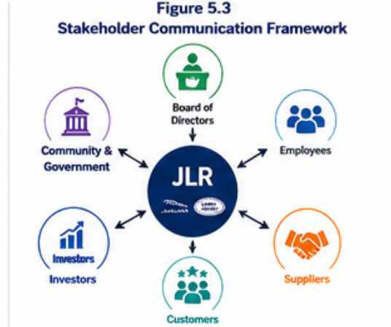
These tech initiatives will require digital knowledge within the workforce to create a more impactful investment. Therefore, digital workforce change will be required at an organizational level. Employees within manufacturing, engineering, maintenance, and management will require training with AI, robotics, cyber security, data, and digital automation and manufacturing. JLR (Jaguar Land Rover) leadership should further develop the capability of JLR to focus on innovation by developing innovation labs and cross functional teams, working to develop and integrate solutions, simultaneously creating a learning environment for the organization (Prosci, 2023; Northouse, 2022).
The strategic change program should be implemented according to a defined sequence (road mapping) with the goal of minimizing the impact of business disruption and enabling the business to adapt to the change over the next three years. The first phase will be focused on readiness to implement change for the business and the stakeholders, engagements in the change, readiness of the workforce, and the AI tech implanting trials. The second phase will implement AI technologies for quality inspections, predictive maintenance, and digital twin models. Employee training and change management will be included in this phase. The last phase will introduce the active management of supply chains and the use of collaborative robotics and big data within the enterprise. The tech will be integrated and the business will operate as a unified entity for the purpose of enabling longterm sustainability of the business. Active management of the technologies will provide improvements and optimize the functions of the business (Kotter, 2012; Hayes, 2022).
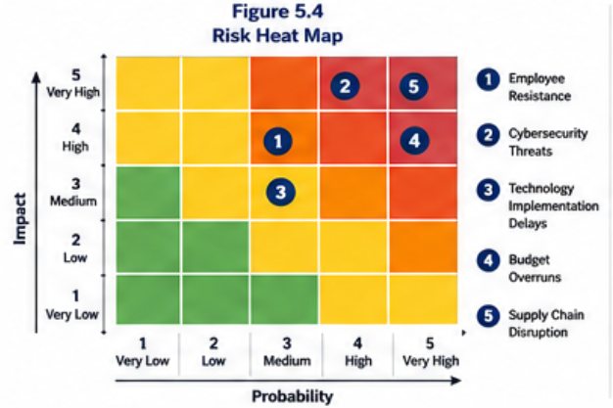

Your strategy plan covers the financial aspect of the change plan primarily building the case for the investment on the digital infrastructure, AI, robotics, cloud computing, security, and sensor technologies, as well as training and dev. The costs for the first digital transformation cycle will be high, but the costs will be offset through higher productivity from the manufacturing process, lower operational and maintenance costs, less downtime, and better quality products along with improved resources and supply chain. From a cost perspective, the digital transformation of the supply chain and electric vehicle production along with government support will lead to sustainable innovations (UK Department for Business and Trade, 2024; Deloitte, 2024).
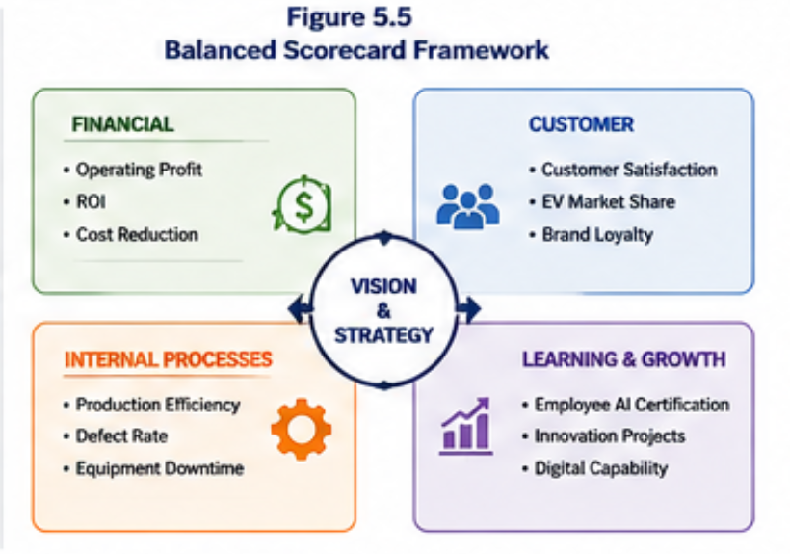
For the successful implementation of the strategic change plan, ongoing observation and assessment of the plan will be important. KPI’s (Key Performance Indicators) should be implemented for JLR, and should include metrics for; productivity levels in the manufacturing process, Overall Equipment Effectiveness (OEE), AI adoption, downtimes, defect levels, positions in the supply chain, volumes of EV production, levels of carbon emissions, customer satisfaction, employee digital competency, and the financial bottom line. Projection of these KPI’s in a Balanced Scorecard approach will aid JLR in observation and assessment for continuous improvement. Performance evaluations of these KPI’s will be implemented quarterly. . (Kaplan and Norton, 1996; McKinsey & Company, 2024).

6.Conclusion

Changing its approach is essential for Jaguar Land Rover (JLR) to maintain a competitive edge in the ever-changing UK automotive market. AI, Industry 4.0, and the combined effects of technology and modern consumers have changed the nature of competition. Within this environment JLR has developed a strong position and strategic framework via the Reimagine Strategy. However, to create long term smart manufacturing and digital infrastructure, JLR will need to adopt a more aggressive AI strategy (Jaguar Land Rover, 2024; IEA, 2024).
This report has identified both internal and external drivers of change. Legacy manufacturing, capabilities, and supply chain within the organisation, combined with externally driven competition, technology, disruption, and regulation, are JLR's main challenges. Using established change management frameworks, the report identified Kotter's Eight-Step Change Model as the most applicable framework for JLR, alongside the McKinsey 7S framework and the ADKAR Model. The report also discussed the importance of innovation and transformational leadership to change the culture of the organisation, reduce resistance, and implement improvement as an on-going process (Kotter, 2012; Burnes, 2020; Schein and Schein, 2021).

7.References
Accenture (2024) Technology Vision 2024: Human by Design. Available at: Accenture Technology Vision 2024 (Accessed: 24 June 2026).
Bass, B.M. and Riggio, R.E. (2006) Transformational Leadership. 2nd edn. Mahwah, NJ: Lawrence Erlbaum Associates.
Burnes, B. (2020) Managing Change. 8th edn. Harlow: Pearson Education.
Capgemini Research Institute (2024) The Automotive Industry in the Era of Generative AI. Available at: Capgemini Research Institute (Accessed: 30 June 2026).
Cummings, S., Bridgman, T. and Brown, K.G. (2016) ‘Unfreezing change as three steps: Rethinking Kurt Lewin's legacy for change management’, Human Relations, 69(1), pp. 33–60.
Deloitte (2024) 2024 Global Automotive Consumer Study. Available at: Deloitte Global Automotive Consumer Study (Accessed: 3 July 2026).
European Commission (2024) Fit for 55: Delivering the European Green Deal. Available at: European Commission – Fit for 55 (Accessed: 4 July 2026).
Hayes, J. (2022) The Theory and Practice of Change Management. 6th edn. London: Red Globe Press.
Hiatt, J. (2006) ADKAR: A Model for Change in Business, Government and Our Community. Loveland, CO: Prosci Learning Center Publications.
International Energy Agency (IEA) (2024) Global EV Outlook 2024. Available at: IEA Global EV Outlook 2024 (Accessed: 4 July 2026).
Jaguar Land Rover (2024) Annual Report 2023/24. Available at: Jaguar Land Rover Annual Report (Accessed: 4 July 2026).
Jaguar Land Rover (2024) Reimagine Strategy. Available at: Jaguar Land Rover Reimagine Strategy (Accessed: 5 July 2026).
Kaplan, R.S. and Norton, D.P. (1996) The Balanced Scorecard: Translating Strategy into Action. Boston, MA: Harvard Business School Press.
Kotter, J.P. (2012) Leading Change. Revised edn. Boston, MA: Harvard Business Review Press.
Lewin, K. (1951) Field Theory in Social Science. New York: Harper & Row.
McKinsey & Company (2024) The State of AI in Early 2024. Available at: McKinsey – State of AI (Accessed: 7 July 2026).
Northouse, P.G. (2022) Leadership: Theory and Practice. 9th edn. Thousand Oaks, CA: Sage Publications.
Prosci (2023) Best Practices in Change Management – 12th Edition. Available at: Prosci Research (Accessed: 7 July 2026).
PwC (2024) Driving Value through Digital Transformation in Automotive. Available at: PwC Automotive Insights (Accessed: 4 July 2026).
Schein, E.H. and Schein, P. (2021) Organizational Culture and Leadership. 6th edn. Hoboken, NJ: John Wiley & Sons.
Tata Motors (2024) Integrated Report 2023–24. Available at: Tata Motors Annual Reports (Accessed: 12 July 2026).
UK Department for Business and Trade (2024) Advanced Manufacturing Plan. Available at: UK Department for Business and Trade (Accessed: 12 July 2026).
UK Department for Transport (2024) Zero Emission Vehicle (ZEV) Mandate Guidance. Available at: UK Government ZEV Mandate Guidance (Accessed: 12 July 2026).
Waterman, R.H., Peters, T.J. and Phillips, J.R. (1980) ‘Structure is not organisation’, Business Horizons, 23(3), pp. 14–26.
World Economic Forum (2023) Shaping the Future of Advanced Manufacturing and Value Chains. Available at: World Economic Forum – Advanced Manufacturing (Accessed: 13 July 2026).
Maslej, N. et al. (2024) Artificial Intelligence Index Report 2024. Stanford University. Available at: Stanford AI Index Report 2024 (Accessed: 13 July 2026).

- Appendix



