

LCHS7007 Population Health and Digital Health Promotion

Component 1
Task 1- Blog
Task 2- Poster

Student Name: HARSH CHAUHAN
Student ID: 2413608

Lecturer: Dr Ping Wu

Blog 1 - Quit Genius: Can Your Smartphone Really Help You Quit Smoking?
Quit Genius makes quitting smoking feel achievable with personalised support right at your fingertips.

Why Smoking Matters: A Personal and Public Health Challenge
W

e have all heard about how smoking is harmful, but did you know it is still one of the top preventable killers worldwide? According to the World Health Organisation, tobacco use causes over 8 million deaths each year, that’s about one death every four seconds (WHO, 2023). Smoking does not just hurt lungs; it damages the heart, weakens human immune system, and significantly increases the risk of serious diseases like lung cancer and stroke (Taucher et al. 2022). Also, Europeans shares the highest smoker population as in 2024, 24.8% Europeans were smokers and which is projected to reduce to 23.2% (Elflein, 2024).
Meet Quit Genius: Your Digital Coach for Quitting
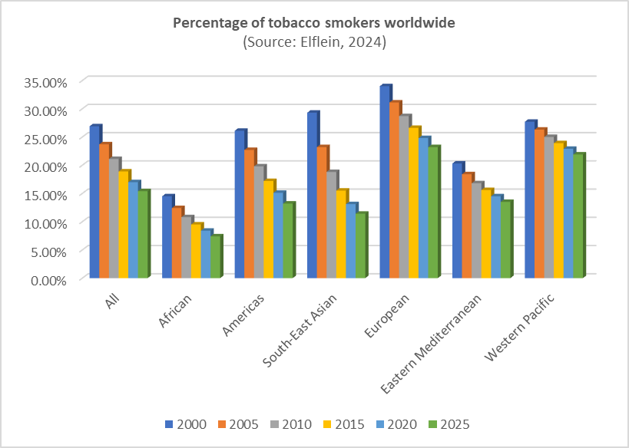
Quit Genius is a user-friendly smartphone app designed specifically to help people stop smoking by tackling the habit from both psychological and practical angles (Rajani, Mastellos and Filippidis, 2021). Unlike traditional methods that focus only on physical cravings, Quit Genius uses techniques based on cognitive behavioural therapy (CBT) essentially teaching smokers new ways of thinking and acting to help smokers quit for good (Webb et al. 2022).

So, what makes this app special?

- Personalised Plans: When users first sign up, they answer questions about smoking habits, triggers, and lifestyle. The app then creates a personalised quit plan tailored to their needs.
- Daily Support & Motivation: Quit Genius regularly checks in with motivational messages, tips, and daily tasks to keep users on track.
- Interactive & Engaging Tools: From interactive quizzes to short videos explaining why quitting matters, the app makes the quitting journey engaging rather than overwhelming.

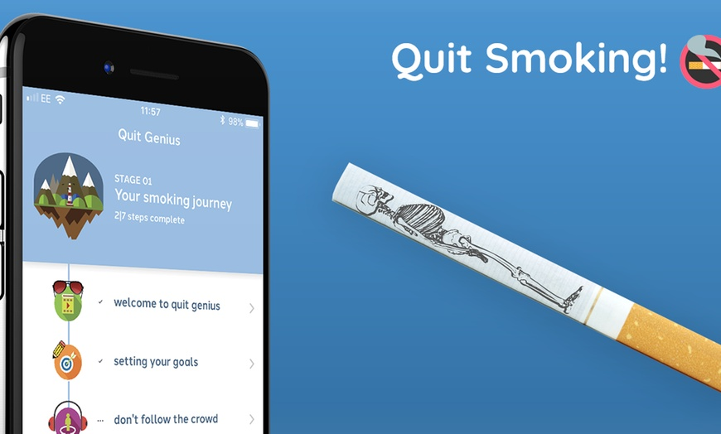
Evidence of Health Promotion Impact
Research shows Quit Genius is genuinely effective (Rajani, Mastellos and Filippidis, 2021). Users who stick with the app typically have higher quit rates than those using traditional quitting methods alone. According to recent studies, around half of the people who actively use Quit Genius manage to reduce or stop smoking within a few months significantly (Pelago, 2020).

The Upsides & Downsides: Is Quit Genius for Everyone?

Benefits include:
- Convenient and available anytime, anywhere.
- Provides emotional and psychological support beyond just physical cravings.
- Highly personalised to their own quitting journey.
However, there are some challenges:
- Staying motivated can become tougher once the novelty wears off.
- Not everyone feels comfortable using apps or technology.
- Subscription costs could limit accessibility, particularly for lower-income individuals.

How Quit Genius Could Improve Further
Quit Genius already does a great job, but to reach even more people, it could:
- Offer free or subsidised memberships through public health partnerships, ensuring cost is not a barrier.
- Combine app-based coaching with occasional face-to-face support groups, blending digital convenience with human connection.
- Provide simple in-app tutorials to help less tech-savvy users navigate the digital space easily.

Blog 2 - SmokeFree Buddy: Your Friendly Companion on the Journey to Quit Smoking
SmokeFree Buddy helps make quitting smoking easier with personalised support and motivation from real people.
SMOKEFREE
Buddy
The Tough Reality of Quitting Smoking
Q
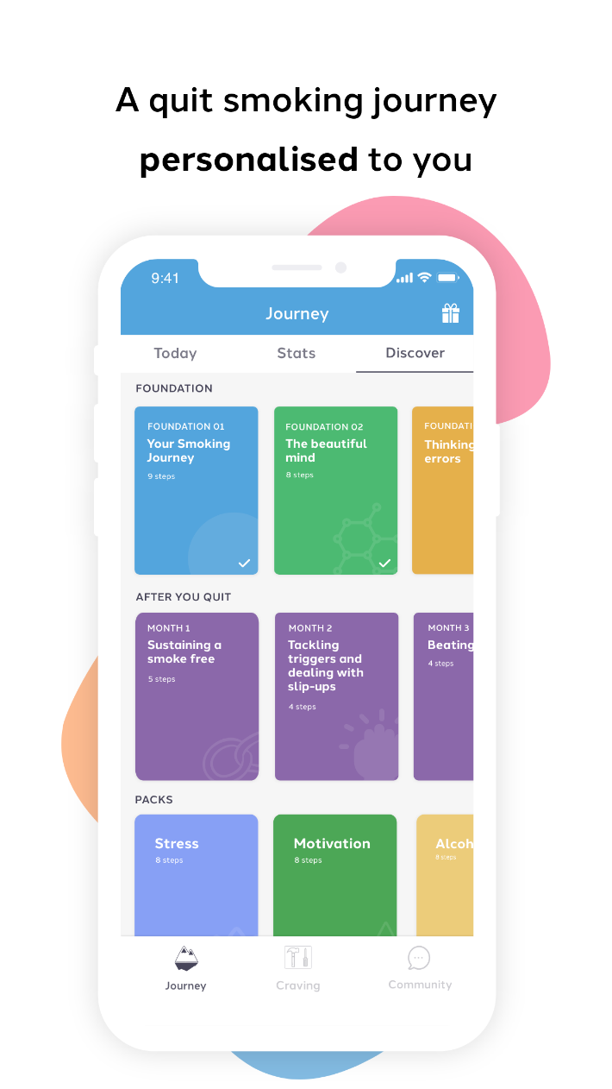
uitting smoking is incredibly challenging. Despite knowing the serious health risks, millions struggle daily to break free from nicotine addiction. Globally, smoking continues to cause over 8 million deaths every year (WHO, 2023). Traditional quitting methods, like nicotine patches or counselling, can help, but they're not always effective or accessible (García-Pazo et al. 2021). This is where innovative digital tools can step in and it is why SmokeFree Buddy is being designed.
What is SmokeFree Buddy?
SmokeFree Buddy will be a user-friendly smartphone app designed to support people who want to quit smoking through personalised planning, social connection, and rewarding motivation. It will blend proven quitting strategies with engaging digital technology to make quitting smoking both manageable and sustainable.
Key Features Include:

- Personalised Quit Plans: Users complete an initial assessment, allowing the app’s artificial intelligence to create a customised quit strategy tailored to personal smoking triggers, lifestyle, and goals (Bendotti et al. 2022).
- Buddy System (Social Support): The app connects users with others who are also quitting or have successfully quit smoking, forming a supportive community. Users can exchange messages, share tips, and encourage one another.
- Gamified Rewards: Each smoke-free day earns virtual points and badges, turning quitting into a rewarding and fun challenge.
- Mindfulness and Stress Management: SmokeFree Buddy includes short guided mindfulness exercises designed specifically to manage cravings and reduce stress-related relapse.

How SmokeFree Buddy Can Make a Difference
SmokeFree Buddy applies Social Cognitive Theory effectively by building user confidence (self-efficacy) through personalised quit plans and progress tracking, making quitting achievable step-by-step (Rahman, Sofija and Sebar, 2023). The integrated buddy system enables observational learning, as users see and imitate the successful quitting behaviours of peers, increasing motivation. Additionally, the gamified rewards and positive feedback provide reinforcement, continuously encouraging smoke-free behaviours. Garey et al. (2021) states that social support and personalised feedback can improve the motivation to quit smoking while it can also reduce relapse risks. The app’s combination of personalised planning and interactive motivation can help users build lasting smoking cessation habits, improve their confidence, and maintain their motivation long-term. Together, these theory-driven elements create an empowering and supportive environment, helping users feel capable, connected, and motivated key factors in achieving lasting smoking cessation and healthier lifestyle choices.
Addressing the Shortfalls
To address these issues, SmokeFree Buddy could introduce:

- Hybrid Support: Combining digital support with in-person meet-ups to maintain user motivation.
- Simple In-app Tutorials: Enhancing digital literacy, ensuring accessibility for less tech-savvy users.
- Balanced Rewards: Gradually shifting from virtual rewards to intrinsic motivation strategies, building lasting self-confidence.

References
Bendotti, H., Lawler, S., Ireland, D., Gartner, C., Hides, L. and Marshall, H.M., 2022. What do people want in a smoking cessation app? An analysis of user reviews and app quality. Nicotine and Tobacco Research, 24(2), pp.169-177.
Elflein, J. (2024). Smoking prevalence by region worldwide 2000-2025. [online] Statista. Available at: https://www.statista.com/statistics/937324/tobacco-smoking-prevalence-globally-by-region/ [Accessed 2 Apr. 2025].
García-Pazo, P., Fornés-Vives, J., Sesé, A. and Javier Perez-Pareja, F., 2021. Apps for smoking cessation through Cognitive Behavioural Therapy. A review. Adicciones, 33(4).
Garey, L., Smit, T., Neighbors, C., Gallagher, M.W. and Zvolensky, M.J., 2021. Personalized feedback for smoking and anxiety sensitivity: A randomized controlled trial. Substance use & misuse, 56(7), pp.929-940.
Pelago (2020). Results from Quit Genius clinical trial reveal 52% quit rate | Pelago. [online] Pelagohealth.com. Available at: https://www.pelagohealth.com/blog/results-from-quit-genius-clinical-trial-reveal-a-52-quit-rate/ [Accessed 1 Apr. 2025].
Rahman, N., Sofija, E. and Sebar, B., 2023. Examining intention to quit vaping among Australian young adults using Social Cognitive Theory: a cross-sectional survey analysis. Youth, 4(1), pp.31-41.
Rajani, N.B., Mastellos, N. and Filippidis, F.T., 2021. Self-efficacy and motivation to quit of smokers seeking to quit: quantitative assessment of smoking cessation mobile apps. JMIR mHealth and uHealth, 9(4), p.e25030.
Taucher, E., Mykoliuk, I., Lindenmann, J. and Smolle-Juettner, F.M., 2022. Implications of the immune landscape in COPD and lung cancer: smoking versus other causes. Frontiers in Immunology, 13, p.846605.
Webb, J., Peerbux, S., Ang, A., Siddiqui, S., Sherwani, Y., Ahmed, M., MacRae, H., Puri, H., Majeed, A. and Glasner, S., 2022. Long-term effectiveness of a clinician-assisted digital cognitive behavioral therapy intervention for smoking cessation: secondary outcomes from a randomised controlled trial. Nicotine and Tobacco Research, 24(11), pp.1763-1772.
WHO (2023). Tobacco. [online] World Health Organization. Available at: https://www.who.int/news-room/fact-sheets/detail/tobacco [Accessed 2 Apr. 2025].

Task 2 Poster


