Financial Management for the Hotel Industry
Report Case Study: The City Hotel
Module Lead: Tristan Hawkins
Student Name: Carmen Celina Gheorghe
Student ID: 2246329

I acknowledge the use of Grammarly and Quillbot (https://www.grammarly.com/) (https://quillbot.com/paraphrasing-tool) on 04.11.2024; 09.11. 2024 and 12.11.2024 to check my work using the prompt(s): 1. Please check the following text for readability, grammar and syntax. I confirm that I have not presented any AI-generated text as my own work. I confirm I have copies of my drafts, notes, and other resources I used before, and after the use of AI tools which I may be asked to provide in evidence
Executive Summary
The venture named The City Hotel has showcased certain issues related to the downfall in profitability, revenue and consumer satisfaction over the past three consequent years. The case study evaluated below has analyzed various significant issues such as greater operating costs, alarming consumer behavior and debt pressures caused due to financial shifts and after-pandemic shifts. To strengthen its financial health, the venture needs to develop a comprehensive turnaround strategy. It has effectively shed light on improving consumer experience and exploiting digital marketing. With the help of such measures, the venture focuses on balancing operations, improving cash flow and reinstating its reputation in the competitive urban hospitality sector.

Table of Contents
Introduction 4
Financial position Analysis 5
Overview of Income statement 5
Overview of the Balance Sheet 6
Showcasing the trend and patterns of the hotel's monetary performance over the past three Years 7
Identification of the important reasons behind the decline in profitability 10
Forming strategies for the venture to improve its overall financial health 12
Conclusion 14
References 15

Introduction
The following case study will shed its focus on a company named The City Hotel. The hotel comes with a restaurant, bar and event facilities and is located in the urban landscape. It will focus on the venture's downfall in revenue, profitability and consumer satisfaction. An evaluation will be done regarding the trends and patterns in The City Hotel’s monetary performance over the line of three consequent years. Identification of the areas will be initiated stating the important reason due to which a decline in overall profitability took place. It will be done by considering real-world events and the present economy. A comprehensive turnaround strategy will be formed to strengthen the monetary health and restore brand awareness.

Financial position Analysis

Overview of Income statement
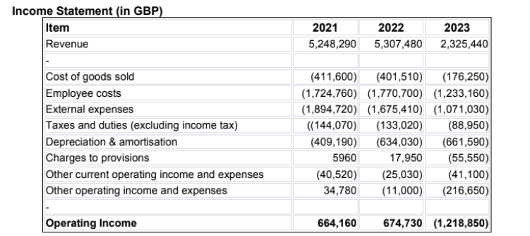
Figure 1: Income Statement
Source: (Corporate Finance Institute, 2024)
The financial information of the City Hotel shows a disturbing drop in overall performance from 2021 to 2023. Revenue fell sharply from £5.3 million in 2022 to £2.3 million in 2023, suggesting a lack of enterprise momentum that would be attributed to inefficiencies in operations, heightened opposition, or outside market conditions. Operating profits became £1.2 million in 2023 after being positive in 2021 and 2022 (£664,160 and £674,730, respectively). This indicates the urgent want for a turnaround plan. Even though revenue declined in share to the price of products sold, employees' charges and other costs persevered to soak up a large amount of income. For example, in 2023, employee costs (£1.2 million) accounted for over 50% of overall revenue, indicating they want to optimise labour charges and staffing (Forbes, 2023). The growth in depreciation and amortisation from £409,190 in 2021 to £661,590 in 2023 indicates the presence of growing old assets or large capital investments that have no longer produced returns. The declining trend in other running income and prices (including -£216,650 in 2023) factors to either useless asset control or operational inefficiencies. Moreover, the increasing expenses associated with provisions draw attention to further monetary stress. To repair profitability, the inn needs to at once take steps to govern expenses, increase revenue, or restructure its operations because it will now not be able to generate enough operating profits in 2023 due to liquidity problems.

Overview of the Balance Sheet
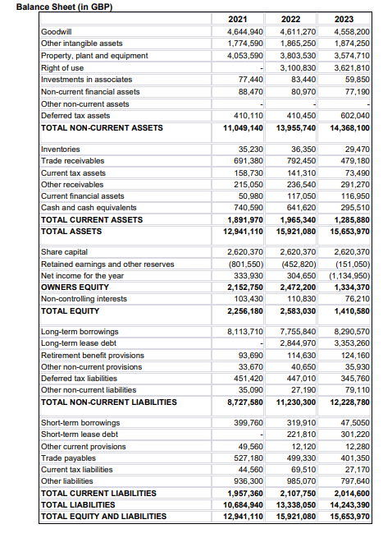
Figure 2: Balance Sheet
Source: (Corporate Finance Institute, 2024)
From 2021 to 2023, The City Hotel's balance sheet gives a blended photograph of balance and growing monetary stress. From £15.9 in 2022 to £15.6 million in 2023, the overall assets had been relatively solid. However, goodwill has been increasingly declining, indicating a decreased or impaired brand cost, which can be a result of difficulties maintaining marketplace function and consumer satisfaction. Lease debt elevated to £3.3 million in 2023, at the same time as lengthy-term borrowings multiplied from £7.8 million in 2022 to £8.3 million in 2023. This factors into an increasing reliance on debt financing, which would possibly make it tougher for the restaurant to pay its debts (Corporate Finance Institute, 2024). A decrease in cash equivalents from £741,620 in 2021 to £295,510 in 2023 shows feasible problems with liquidity. While brief-term borrowings dropped significantly to £47,505 in 2023, probably as a result of debt restructuring, contemporary liabilities reduced slightly. The organisation still has plenty of quick-time period obligations, although, with trade payables at £401,350 and different liabilities at £797,640. Owners' equity declined through the years, mainly because of the £1.1 million net earnings loss in 2023, from £2.5 million in 2022 to £1.3 million in 2023. The diminishing fairness foundation underscores the worsening monetary condition and the necessity of taking calculated measures to reinstate profitability and bolster investor guarantee. The venture’s sustainability may be an issue if movement is not taken due to the increasing debt load and declining equity.

Showcasing the trend and patterns of the hotel's monetary performance over the past three Years
Revenue trends
The year 2021 and 2022 showcased that the hotel's sales were steady at £5.25 million and £5.3 million, respectively. However, in 2023, it fell precipitously to £2.3 million. This 56% decline shows significant disruptions, which may be caused by external modifications following a virus, a downturn inside the economic system, or heightened competition. Lower occupancy charges, fewer buyers travelling to the restaurant and bar, or ineffective marketing campaigns are all indicated by means of the revenue decline. The surprising decline in sales emphasises how urgently techniques that attract both local and foreign visitors are needed (Corporate Finance Institute, 2024).
Expense Patterns
Although not in keeping with the decline in sales, fees decreased in 2023 together with revenues. While employee prices fell to £1.2 million in 2023 from £1.7 million in 2021 and 2022, they nevertheless accounted for over 50% of overall revenue, suggesting that labour costs are not flexible enough to preserve up with declining income. Although they decreased from £1.89 million in 2021 to £1.07 million in 2023, external costs have been still inadequate to ward off substantial losses (Guilding, (2014). With new investments or a growing old asset base, depreciation and amortisation expanded progressively from £409,190 in 2021 to £661,590 in 2023. The inn's economic stability can be further strained with the aid of cost increases that are specific to the state, together with elevated utility quotes or salary laws. The lodge's problems with profitability have been made worse by way of this disparity between declining revenue and excessive constant cost.
Profitability Analysis
Over the path of the three years, profitability declined precipitously. Operating profits saw a benefit in 2021 (£664,160) and 2022 (£674,730), however in 2023 it made a £1.2 million loss. In a similar manner, net profits decreased in 2023 from £304,650 in 2022 to a lack of £1.13 million. This reflects declining consumer satisfaction and susceptible marketplace positioning in addition to operational inefficiencies (Wild J, 2018). To perceive the basic causes of those losses, it is imperative to investigate prospective adjustments in demand for as well as competitor pastimes in the nation's resort area, given the hotel’s declining profitability.
Liquidity Trends
Cash and financial equivalents fell from £741,620 in 2021 to £295,510 in 2023, indicating clean liquidity troubles. This lower suggests that the resort is having trouble preserving its running capital. Additionally, change receivables fell from £792,450 in 2022 to £479,180 in 2023, indicating problems receiving payments from customers. Trade payables, which accounted for £401,350 in liabilities in 2023, introduced pressure on cash flow (Guilding, (2014). Ineffective coin control is evident in the disparity among contemporary assets and liabilities. If liquidity does not enhance, the hotel runs the hazard of no longer making staff and dealer payments on time, which may negatively affect business operations even more.
Solvency Trends
A rise in lengthy-term borrowings from £7.75 million in 2022 to £8.29 million in 2023 indicates a weakening of the City Hotel's solvency. In 2023, lease debt additionally elevated to £3.35 million. Given that the hotel finds it tough to produce sufficient cash flow to pay off its debt, its growing reliance on debt is an indication of financial fragility (Jagels, 2007). A most important aspect of the decline in owners' equity from £2.47 million in 2022 to £1.33 million in 2023 turned into cumulative losses. Regarding the inn's lengthy-term viability, the growth in debt obligations is regarding. Macroeconomic variables that affect the entire country, like growing interest prices or inflation, may additionally have an effect on the motel's potential to pay down its debt

Identification of the important reasons behind the decline in profitability
Downfall in sales due to changed consumer behavior
Hotels are likely much less full nowadays due to post-pandemic shifts in customer possibilities, like extra human beings working from home and fewer enterprise trips. Maintaining revenue streams has become tough for many urban hotels that rely heavily on company events, meetings, and commercial enterprise visitors (Teru et al., 2019). There is a chance that the popularity of staycations has driven individuals away from city hotels like The City Hotel and in the direction of rural getaway spots. Furthermore, there may be now extra opposition from websites for short-term rentals, like Airbnb.
Inflation pressure and increasing costs
The cost of food, utilities, and substances three essential costs related to hitting a hotel have extended due to the economy's latest intense inflation. Even though constant charges like depreciation and hire bills saved going up, the enterprise turned into nevertheless not able to offset declining sales with these discounts in a team of workers and outside costs (Hicks, 2023). In many provider industries across the country, inflation-driven salary increases have contributed to the price burden and made labour expenses rather constant.
Increased debt and interest pressure
The hotel’s financial situation has gotten worse because of its improved reliance on rent obligations and borrowings, as evidenced by the rise in long-term debt from £7.75 million in 2022 to £8.29 million in 2023. Debt overload makes a person more prone to interest costs that will increase and trace cash flows (Tranter et al., 2014). The hotel possibly faces better debt servicing costs as a result of recent financial regulations in many nations which have raised interest charges to combat inflation, which puts extra strain on profitability.
Minimised consumer spending and economic uncertainty
Consumer spending has been undermined by financial downturns in some locations, inclusive of viable recessions. Visitors are deciding on greater low-cost alternatives in place of flexible spending on things like consuming out and holidays. Furthermore, organisations have cut back on their tour spending, which affects the inn's capability to draw in commercial enterprise visitors and activities (Corporate Finance Institute, 2024).

Forming strategies for the venture to improve its overall financial health
Improving cost management and cash flow
The resort needs to improve liquidity and cut back on wasteful spending in an effort to stabilise operations. Staffing may be rebalanced by means of the education group of workers to carry out multiple roles and scheduling according to occupancy forecasts. To reduce prices from outside assets, renegotiate rentals and supplier contracts (Tranter et al., 2014). Put power-saving strategies into exercise to decrease software charges. Speak with creditors approximately debt restructuring or interest price discounts to lessen the monetary load. Improve forecasting and inventory manipulation to lessen waste in food and beverage operations. By taking those movements, you can improve cash to go with the flow to repay debt and lower operating prices without sacrificing the vacationer experience.
Wide revenue streams and country-focus initiatives
Offer reductions on eating places or weekend getaways to locals as a part of launch applications. Using the bar and restaurant facilities to the advantage, host meetings, weddings and business gatherings to usher in extra money. To draw tourists from both home and foreign resources, paintings with online travel organisations and regional tourism boards (Teru et al., 2019). To encourage reservations for the duration of off-peak instances, create seasonal promotions, loyalty plans, and reductions. Through imposing these strategies, the inn can expand its foot traffic and expand its sales streams out of doors of room sales.
Improved consumer experience and reputation management
Improving the offerings supplied is vital to regaining the hotel's popularity and raising customer satisfaction. Assigning a group of workers members with important talents to offer tremendous guest experiences and personalise services. Recognise pain factors and offer instant solutions by the use of consumer comments. Initiate an online marketing campaign emphasising consumer testimonials and advantageous critiques to spotlight service enhancements.
Leveraging marketing and technical area
Streamlining approaches and enhancing digital presence are methods to implement smart technologies and enhance visitor reviews. To reduce reliance on 1/3-birthday celebration systems, offer incentives for direct bookings. Engage customers with occasions and unique gives by way of the use of social media websites like Facebook and Instagram (Seal W et al., 2008). Personalised gifts, crafty room controls, and digital check-ins are methods to attract tech-lover travellers. The hotel can modernise its operations and appeal to a much broader consumer base by way of integrating time and strategic advertising.

Conclusion
The above case study has showcased the concept and idea of The city hotel which is a restaurant cum bar as well as consists of various event facilities. It has effectively evaluated the idea and contrasted the three years' worth of data extracted from the income statement and balance sheets. Other than this, the idea regarding the decline in profitability has been presented which includes an explanation of the issues faced by the venture in terms of profitability generation. Additionally, the case study has shed its focus on developing strategies for the venture to effectively enhance its overall performance, especially in the area of profit generation and sales.

References
Corporate Finance Institute, (2024). Analyzing Financial Statements: Key Metrics and Methods. [Online] Available at: https://corporatefinanceinstitute.com/resources/accounting/analysis-of-financial-statements/ [Accessed 14 October 2024].
Corporate Finance Institute, (2024). Balance Sheet. [Online] Available at: https://corporatefinanceinstitute.com/resources/accounting/balance-sheet/ [Accessed 14 October 2024].
Forbes, (2023). Mastering The Basics Of Business Finance Management. [Online] Available at: https://www.forbes.com/sites/melissahouston/2023/03/22/mastering-the-basics-of-business-finance-management/ [Accessed 14 October 2024].
Guilding,C. (2014) (3rd Edition) Accounting Essentials for Hospitality Managers, London, Routledge
Hicks, C., (2023) How Inflation Affects Your Cost Of Living. [Online] Available at: https://www.forbes.com/advisor/investing/inflation-cost-of-living/#:~:text=Inflation%20occurs%20when%20changes%20throughout,imbalances%20in%20supply%20and%20demand. [Accessed 14 October 2024].
Jagels, M. (2007) Hospitality Management Accounting, London, Wiley.
Seal W, Garrison RH, Noreen E (2008) Management Accounting, McGraw Hill
Teru, S.P., Idoko, I.F. and Bello, L., (2019). The impact of E-accounting in modern businesses. International Journal of Accounting & Finance Review, 4(2), pp.1-4.
Tranter, K. Stuart-Hill, T. Parker, J. (2014) Introduction to Revenue Management for the Hospitality Industry, London, Pearson
Wild J (2018) Fundamental Accounting Principles, New York, McGraw Hill

