
Anna Szulc
UK Tourism and Leisure Industry
Assignment 1
Essay
Tourism and Leisure aimed at the International Tourism Market

Wales
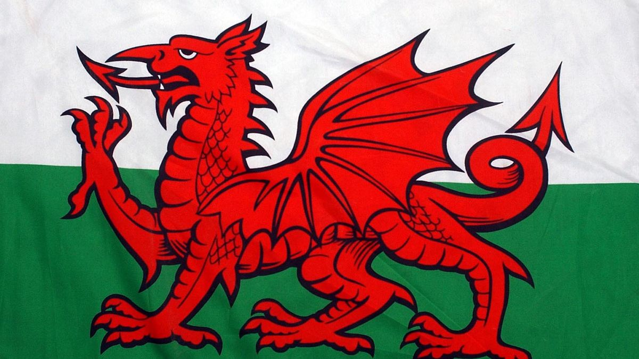
https://www.walesonline.co.uk/news/wales-news/reason-wales-great-big-red-15433821
International tourism market has grown rapidly, since commercial air lines opened in 1950`s. In 21st century travel industry became the largest in the world, creating whole new employment sector in global economy. ‘’Historians suggest that the advent of mass tourism began in England during the industrial revolution with the rise of the middle class and relatively inexpensive transportation.’’ (William F. Theobald, 2005) World Tourism Organisation (WTO) was formed in 27th September 1970 in Mexico. https://www.unwto.org/history#1970 WTO is the biggest global travel organisation, including 138 countries, with headquarters in Madrid. Mission statement is to promote and develop international travel and tourism sector. https://www.hospitalitynet.org/organization/17001427/unwto.html
United Kingdom is attracting tourism destination thanks to rich history, heritage and culture. Beautiful and unique landscapes around whole island are tempting tourists around the world. Great Britain is well known from Royal Family history, castles and museums. Build heritage is class as 4th out of 50 countries by visitors in different age categories. Most popular form of holiday are city tours, where visitors are attracted by free museums, British pubs and cuisine, sport events and facilities. (Culture and heritage topic profile, 2010) www.visitbritain.org/research
Wales is a country placed on the west from England. Cardiff is a capitol of Wales, situated on South East coast. Population of Wales is 3.1 million people which is 4,8% of United Kingdom population. National symbols are: red dragon (part of Welsh flag), daffodil and leeks. Welsh citizens are bilingual, according to government survey in 2019, 29.6% of nation can speak Welsh language. Second more popular language is English. https://gov.wales/welsh-language-data-annual-population-survey-july-2018-june-2019 The Royal Mint of United Kingdom is placed in Llantrisant in South Wales. https://www.wales.com/about/facts-about-wales
Wales is well known form beautiful landscapes and amazing range of mountains. Welsh key locations are 3 National Parks: Snowdonia, Pembrokeshire Coast and Brecon Beacons. https://www.visitwales.com/things-do/nature-landscapes/national-parks Snowdonia National Park is one of the most popular Welsh destinations for hiking trips enthusiasts, attracting about 4 million tourists every year. Snowdon is the highest peak in Wales and England – 1085m. Visitors can chose one of 6 different routs to climb to submit. https://www.visitsnowdonia.info/snowdon-walking-routes https://www.visitpembrokeshire. The Pembrokeshire Coast Path includes 299km of walking paths along breath taking coast line full of beautiful beaches, cliffs, valleys and volcanic headlands.com/explore-pembrokeshire/coast-path In 2019, 11 beaches were awarded with Blue Flag Award for the most beautiful beaches and marinas around the world. https://www.pembrokeshirecoast.wales/about-the-national-park/ Pembrokeshire is a birth place of St. David, the Patron Saint of Wales. Pembrokeshire National Park is a source of Bluestones from historic Stonehenge. https://holiday-pembrokeshire.co.uk Brecon Beacons National Park is full of waterfalls, lakes, valleys and forest walking paths. The most famous mountain is Pen y Fan (886m). First Welsh UNESCO Global Geopark(2015), was shaped in Ice Age and it is the largest open hill across 20 miles. https://www.visitwales.com/en-us/things-do/nature-landscapes/national-parks/brecon-beacons-national-park Popular forms of tourism in Brecon Beacons National Park are walks, cycling, water sports, exploring caves, and fishing. Rich wildlife and wide panoramic views are attracting enthusiast of painting and photography. https://www.visit-brecon-beacons.co.uk/brecon-beacons-national-park.shtml Next popular tourism destination in Wales is Cardiff. The capitol city is well known from Cardiff Castle, one of the best preserved and majestic castles in United Kingdom. Visitors can also explore Castell Coch (The Red Castle) and Caerphilly Castle placed on city countryside. Cardiff Bay is attractive for all tourists not only because of beautiful walk path and coastline views but also thanks to all luxury hotels and best restaurants in the city. Perfect travel destination for families with kids is offering friendly and interactive experience in Techniquest science centre, Wales Millennium Centre art facility and multiple numbers of shops with local and handmade products. City centre is offering majestic Arcades shopping centre placed in landmark Royal Arcade, High Street Arcade and Castle Arcade. This place is recognisable thanks to prestige boutiques and art galleries. The Cardiff Market is perfect place for fresh and organic food lovers. Visitor seeking for cultural and heritage experience can explore National Museum Cardiff full of historic exhibits including archaeology, weapons and art collections. Principality Stadium is a home of Welsh rugby culture. Most popular sport in Wales is attracting rugby fans from around the world, lunching unforgettable rugby games and events. https://www.planetware.com/tourist-attractions-/cardiff-w-sg-cardiff.htm
According to Visit Wales survey the biggest number of overseas visitors is from America 16%, Australia 14% and Germany 12%. International tourists are mostly choosing trips to South Wales 57%, second less popular part of Wales is North Wales 19%. Comparing international tourists to English, statistic look differently. English visitors are choosing mostly North Wales 46% and Mid Wales 23%. Age group of visitors shows that all generations are visiting Wales but for different reasons. Group 1 includes tourist aged 25-44 years old and that is 33%, second group age is 45-65+ which is 59% of visitors. Contrasting age groups are seeking for different kinds of holiday attractions. Younger group is choosing outdoors activities, visiting beaches and landscapes and sporting matches, events or concerts. Older group is attracted by historical places, countryside walks and visiting relatives. The most visitors are couples and groups of friends 54%, families with children 24%. Low number of families with children is caused by international tourists in statistic because of the costs of flight tickets and accommodation for whole family. https://www.walesonline.co.uk/news/wales-news/heres-visitors-wales-come-reasons-11242142 878words
Covid-19 pandemic impacted tourism industry around the world. First lockdown in UK od the end of March was hard for tourism and leisure facilities, thanks to Furlough pay help program businesses kept most of the stuff. Unfortunately, tourist attractions, hotels and restaurants lost a lot of clients, international and British. New restrictions and safety measurements from government required changes in tourism facilities. Reduced number of visitors caused by social distancing was not the biggest problem, visitors cancelled holidays because they did not feel safe and traveling was on hold. On summer time Welsh tourist destinations were back in business, taking mostly British tourists on staycations. Number of visitors was in decrease comparing to years before when tourism in Wales was growing every year. https://www.google.com/url?sa=t&source=web&rct=j&url=https://gov.wales/sites/default/files/statistics-and-research/2020-05/tourism-barometer-coronavirus-covid-19-impact-survey-wave-3-2020.pdf&ved=2ahUKEwi-3-GNxbTtAhVIVsAKHaNoAUsQFjADegQIChAI&usg=AOvVaw28V9aYKjtntnRQwq15A-sp
Major Stakeholders including 3 groups: Public, Private and Voluntary sector.
Welsh public sector is connected to part of economy that is supervised and funded by local or national government. Administration, social security, social care and health, defence and policing, education is a part of Welsh public sector. Welsh government is responsible for NHS Wales, civil servants and education. Tourism is very important sector in Welsh economy, worth £6.9 billion a year. Since 2005 is growing every year and creating new job places on big scale. Promoting and advertising tourism destinations in Wales is very important part of government mission. Visit Wales website is specialising in marketing of tourism and leisure facilities on national and international market. Visit Britain website was not promoting Welsh destinations very well, excluding Wales from advertising, that is why Welsh government invested in their own website, to promote national tourism independently and in the better way. Visit Wales and Visit Britain, both cooperate to improve quality of information and promotion of Wales to international tourism and leisure market. Welsh government is also supporting local businesses and promoting local products like Penderyn whisky and Welsh food for tourists. Public sector in Wales is cooperating and guiding tourism destinations like: Pembrokeshire Tourism, National Museum Wales, Arts Council of Wales, Federation of Small Businesses Wales, Wildtrust Wales, National Parks Wales and Wales Tourism Alliance. Welsh government is involved in preparing and promoting main events like: Ironman Wales, WOMEX 2013, 2015 Rugby World Cup and 2016 World Half Marathon Championships. Welsh private sector is committed and deeply involved in supporting and promoting tourism destinations and facilities in Wales. https://www.google.co.uk/url?sa=t&source=web&rct=j&url=https://senedd.wales/laid%2520documents/cr-ld10004%2520-%2520report%2520by%2520the%2520enterprise%2520and%2520business%2520committee%2520on%2520tourism/cr-ld10004-e.pdf&ved=2ahUKEwihopSrzrTtAhVGaRUIHT03Dx4QFjACegQIChAB&usg=AOvVaw2J6wRKJ8vsFUnGv8yQ9ky_
Private sector is more focused on making money and profiting business owners, than promoting Wales. Impact on Welsh economy is positive because this sector is creating job places and attracting potential visitors. Examples of private sector facilities and events:
- theme parks (Oakwood and GreenWood) https://www.visitwales.com/things-do/attractions/adventure-parks-theme-parks-and-rollercoasters
- concerts (Foals in Cardiff Castle) https://www.seetickets.com/event/foals/cardiff-castle/1446758
- casinos (Grosvenor Casino Cardiff) https://www.grosvenorcasinos.com/local-casinos/cardiff
- shopping centres (St David`s Shopping Centre Cardiff) https://www.walesonline.co.uk/news/wales-news/wales-biggest-shopping-centre-attracted-1806494

Voluntary sector is non-profit sector focused on charity activity, not on making money. Voluntary organisations provide campaign and services for social purposes like healthcare, education or housing. (Linda Milbourne, 2013)
National Trust is Welsh conservation charity specialised in care and protection of historical and natural places. https://www.nationaltrust.org.uk/features/about-the-national-trust
Shelter Cymru is non-profit organisation helping homeless and living in bad condition people to find new, safe home. https://sheltercymru.org.uk
Welsh Core Industries:
- Advanced Materials and Manufacturing,
- Creative Industries,
- Financial and Professional Services,
- Energy and Environment,
- Food and Drink,
- Life Sciences,
- Technology,
- Tourism.
https://tradeandinvest.wales/key-industries

