DS 1

Ana Da Costa 23.10.26

My Screenshots/Photos

Laptop
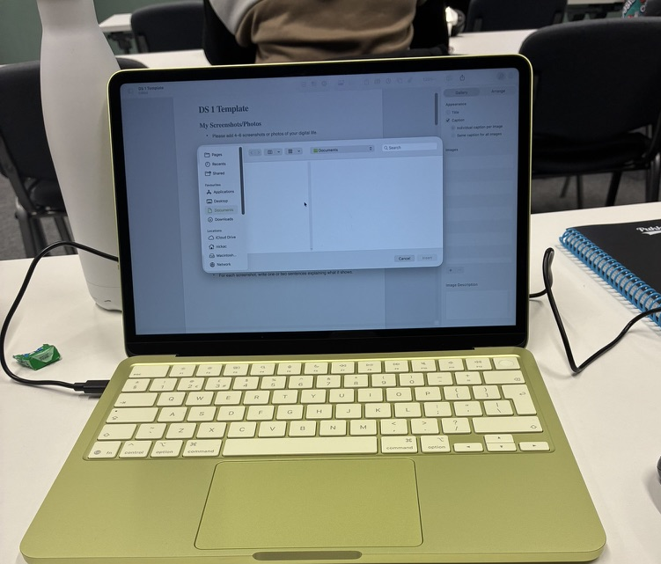
I use my laptop daily for work, for university work, writing assignments, read my emails, make online shopping, researching information.

Computer Mouse
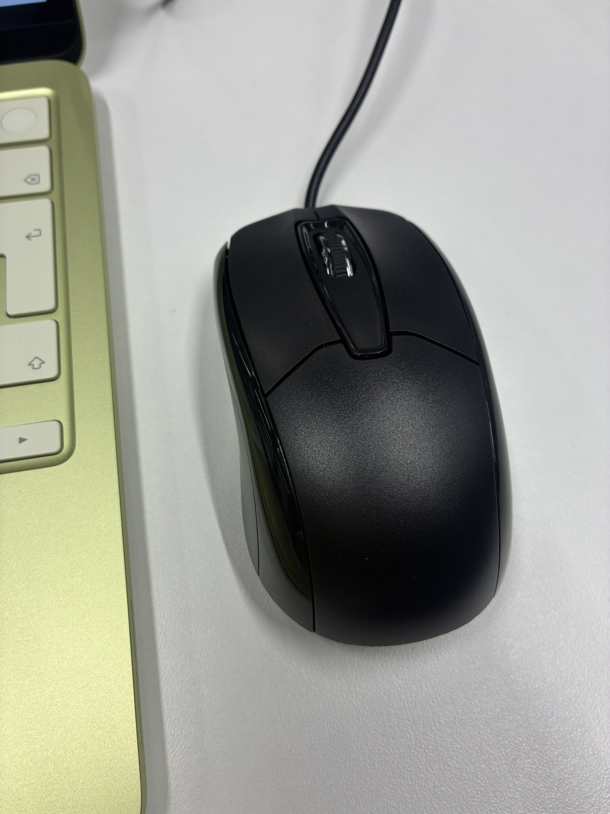
I use to computer mouse to axialite me scroll, select wording or pictures that I need to copy and paste, I think it’s easier using a laptop with a mouse.

Scanner / Photocopier
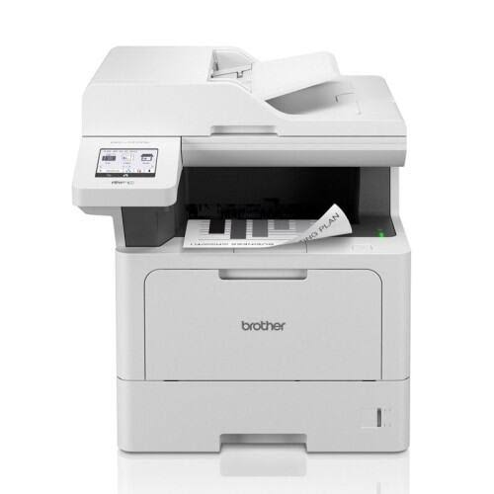
I use a scanner / photocopier to make copies and scan materials for work and university
Shop bar code Scanner
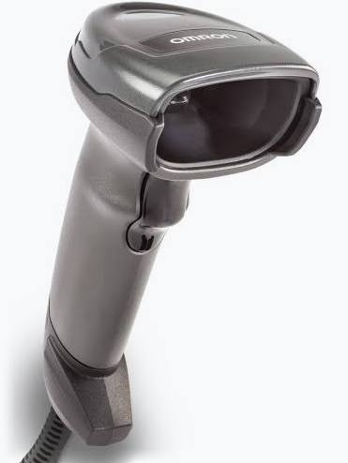
I use barcode scanner when shopping in a supermarket or shop, it helps and saves me time queuing to the tills.

Headphones
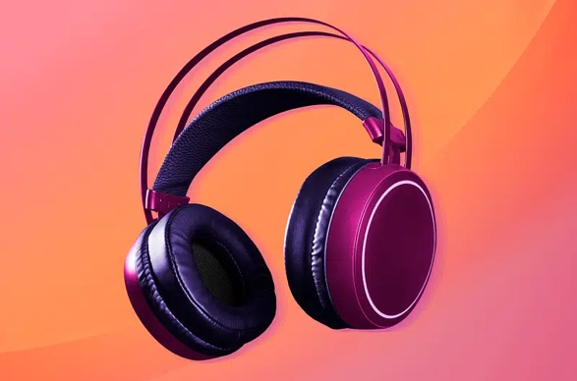
I use my headphones to listen to music in privacy without disturbing other people.
Ring Doorbell
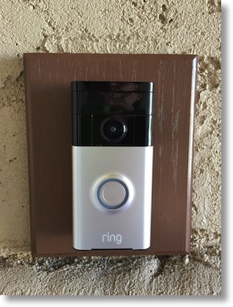

I use a smart video doorbell to see who is in my front door, answering respond to couriers or any guests when I’m not available to open the door, as well as security.

Mobile App

I use UberEATS app to order food and groceries online. It allows me to choose a ready meal from different restaurants, saves me from going out cook and washing up...

My Short Reflection
I use Digital Tools every day, for work, university assignments and homework.
To search information, read the news.

I also use my smartphone to make phone calls, access my online banking, check emails, use WhatsApp messages, check the weather, make notes, access my University Module, my iPad, my iWatch, my CarPlay.

Digital tools are very important and beneficial, they make my life easy, I think that everybody needs digital tools nowadays.
There are lots of things that I need to learn, to improve my confidence and improve my skills to help me in a possibility of a future career.

Some digital tools look very difficult to use makes me feel nervous.

I would love to improve my skills in Microsoft Word and Excel.

I want to learn more about all new technology is so important.
I would also love to know how to use my laptop with more confidence, millions of things that I need to learn and improve.

I hope the module will help me with my studies and become more confident using new technology, I still struggle using module.

Digital skills are very important to keep up with the speed that technology is progressing, nothing is possible without digital tools and soon will probably be mandatory, by the way technology is developing so fast.

Submission Checklist
Before you submit, please check:
​​​ ☒ I added 4–6 screenshots
☒ I wrote short sentences for each screenshot
☒ I wrote my short reflection
☒ My work is my own
☒ My file opens correctly
​​

