5/5/2024
Assessment
Portfolio Report on Contemporary Software Applications for Business

Assessment
Portfolio Report on Contemporary Software Applications for Business



Module NaMe: Software solutions for business
Module Code: ACCA 4026
Name Catherine Gordon
Student id: 2435425
Lecturer: balendran kandasamy

Table of Contents
Introduction 2
Main Body 3
Task 1 3
e-Commerce Website builders/software solutions 3
Task 2 4
Mind-map of Contemporary Software Applications 4
Task 3 7
Office Applications for Creating, Storing, Presenting, and Analysing Data 7
a. 14
b. 16
Task 4 20
Communication and Collaboration applications 20
a. 20
b. 22
Appendices 25

Introduction

Main Body

Task 1

e-Commerce Website builders/software solutions
(Approx. 500 words) Wix works best for small business owners who want something clean and functional without a lot of tech setup.
The Wix Website Editor is a popular tool for creating websites that caters to both beginners and experienced users. Its drag-and-drop interface simplifies the design process, allowing users to customize their sites easily without the need for coding skills (Wix, 2023). Users can choose from a wide variety of templates and design elements, enabling them to create a unique online presence that reflects their brand or personal preferences (Wix, 2023). Furthermore, the editor provides features such as galleries, contact forms, and social media integrations, which enhance user interactivity and engagement. The platform also focuses on SEO optimization tools, helping users improve their website's visibility on search engines. Overall, the Wix Website Editor is designed to empower users, making it possible to build professional-quality websites efficiently. Website Builder.
Who Is WordPress Best For?
WordPress stands out as one of the most powerful and versatile content management systems (CMS) available today, making it an excellent choice for anyone looking to create and manage a website. Its popularity among bloggers, businesses, and organizations is no accident; here’s why WordPress should be your go to platform. User Friendly Experience WordPress is designed with user accessibility in mind. Whether you’re a tech novice or an experienced web developer, you'll find its intuitive dashboard allows you to effortlessly create pages, publish posts, and upload media without any coding required. Unmatched Customizability: With a vast array of themes and plugins at your disposal, WordPress offers remarkable flexibility. You can easily tailor the look and functionality of your site to fit your specific needs, from striking visuals to powerful features such as e-commerce and SEO tools. Enhance Your Visibility: WordPress is inherently optimized for search engines, significantly boosting your site's potential for higher rankings. Utilize powerful plugins, such as Yoast SEO, to ensure your content stands out in search results and drives more traffic to your site. Robust Community Support: Joining WordPress means you’re supported by a massive global community. With countless forums, tutorials, and resources, help is always at your fingertips, making troubleshooting and learning an effortless experience with WordPress. Superior Security: With a commitment to security, WordPress regularly updates its core system to defend against potential threats. Additionally, a variety of security plugins are available, offering advanced protection features like firewalls, malware scans, and secure login options. Mobile Responsiveness: In today’s mobile-driven world, having a site that looks great on all devices is a must. WordPress themes are designed to be mobile-responsive, automatically adjusting to any screen size and ensuring a seamless user experience. In conclusion, WordPress is not just a tool; it’s a gateway to building a powerful online presence. Its combination of ease of use, extensive customization options, community support, and security features makes it the ideal choice for novices and seasoned professionals alike. Don’t miss the opportunity to harness the full potential of your website with WordPress. [1]

Task 2

Mind-map of Contemporary Software Applications
(Approx. 500 words)

Mind Mapping in Business Operations: Benefits and Applications

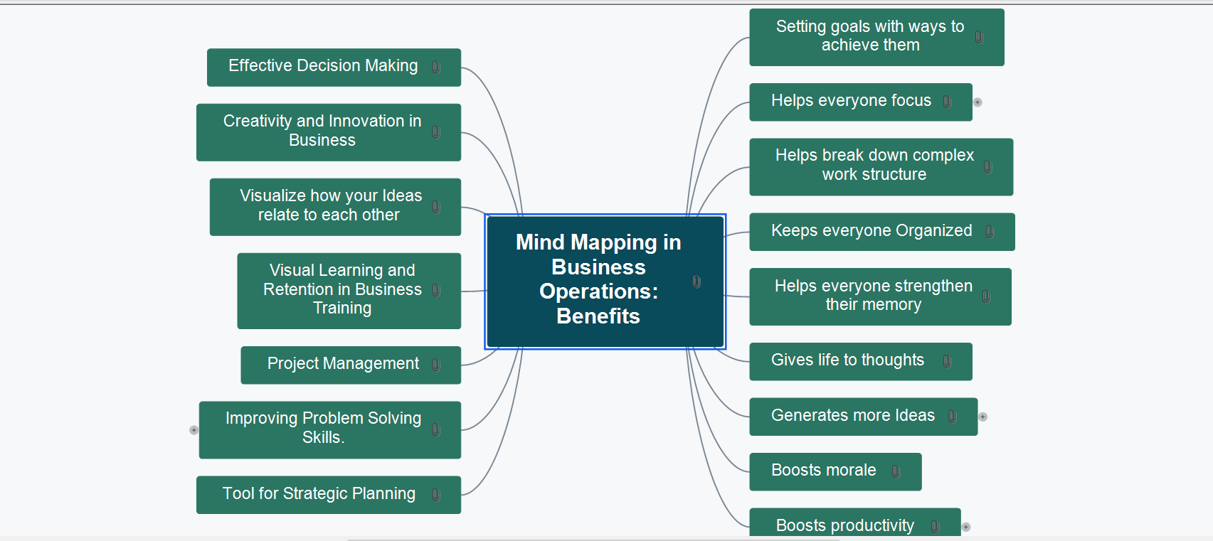
Made on “matchware mind view”
- Mind mapping is a visual thinking tool that assists in the organization of information and ideas in a structured manner. It begins with a central concept and branches out into related topics or subtopics. Using keywords, images, and colours to represent ideas enhances the ability to recognize connections and relationships among various pieces of information. In practice, a mind map starts with a central topic in the middle of a page or screen, with radiating branches for key themes, and further branches for details. This method engages both the left brain (logic, structure) and right brain (creativity, imagery), making it a powerful tool for learning, planning, and problem-solving. [3]
Benefits of Using Mind Mapping in Business Operations
- Improved Clarity and Focus
By breaking down complex information into manageable parts, mind maps facilitate a clearer understanding of goals and tasks. This visual structure helps prevent information overload, enabling a focus on key elements. [3] [4] [5]

Better Collaboration
Mind mapping fosters collaboration among team members. It provides a platform for everyone to contribute ideas, share perspectives, and build on each other's contributions, leading to more comprehensive solutions
Effective Project Planning
Mind maps can outline project phases, tasks, and responsibilities visually. This aids in tracking progress, identifying dependencies, and allocating resources more efficiently. Mind mapping is particularly effective for goal setting and strategic planning. By laying out the objectives visually, teams can create a clear roadmap for achieving their goals. This not only aids in defining short term and long-term objectives but also helps to align the individual goals of team members with the overall business vision. Furthermore, it allows for the easy identification of potential challenges and opportunities, enabling proactive strategic adjustments. [3] [4]

Enhanced Memory and Retention:
Visual representations can significantly improve recall and retention of information. Mind maps assist individuals in remembering details and concepts, beneficial during presentations, meetings, or training sessions. Training and Development Programs. Mind maps can augment training materials, helping participants visualize content and engage with learning materials more effectively. They can also serve as study aids for employees looking to retain complex information. [3] [4]

Furthermore, mind maps can enrich training materials by providing participants with a visual framework that encourages deeper engagement with the content. This can lead to a more interactive learning experience, as individuals are better able to connect concepts and see relationships between ideas. Additionally, mind maps serve as valuable study aids for those seeking to retain complex information, offering a method of organizing thoughts that enhances understanding and recall. By incorporating mind maps into learning and development strategies, organizations can foster improved retention and stimulate meaningful discussions, ultimately contributing to a more knowledgeable and skilled workforce. [2] [3] [4]

B Canva can be a powerful tool for businesses.
It’s a user-friendly Interface. Canva’s drag-and-drop features make it easy to design mind maps without needing advanced graphic design skills. You can quickly create visually appealing maps.
Templates: Canva offers a variety of mind map templates that can serve as a starting point. This saves time and inspires layout and design. [2] [3]

brand or theme. This is useful for presentations to clients or team members.
Collaboration: Canva allows team members to collaborate in real-time. You can share your mind map with colleagues, who can add comments or make edits, promoting teamwork and input.
Visual Elements: Incorporate icons, images, charts, and other visual elements to enhance your mind map, making it easier to understand and more engaging. [2] [3]

Export Options: After creating your mind map, you can easily export it in various formats, such as PDF, for sharing or printing. [2] [3] [4]

Integration with Other Tools: Canva can integrate with other platforms and tools for collaboration and sharing across different media.
Using Canva for mind mapping can help businesses organize and visualize their thoughts effectively, facilitating better planning and communication. [2] [3] [4]

Task 3

Office Applications for Creating, Storing, Presenting, and Analysing Data
(Approx. 2000 words)
Microsoft Office Applications for Data Management
Microsoft Office has a range of applications that help individuals manage data effectively. Each application serves a different purpose, helping users to create information, organize it safely, present it clearly, and analyze it to find patterns. Let’s break down how each program contributes to these essential tasks in a student friendly way. [6]

Microsoft Excel
Create
Excel is great for making spreadsheets. You can enter numbers, text, and formulas that perform calculations. It’s especially helpful for creating budgets and forecasts, which is perfect for financial planning or managing projects. [6]

Store
Excel's organizational features allow users to manage data efficiently with worksheets and workbooks. You can keep everything in one place, making it easy to access and update information when needed. This is useful for tracking budgets or analyzing survey results. [6]

Present
Excel allows you to transform complex data into easy to understand charts and tables. This visual representation helps others to grasp the information more easily, whether you’re giving a report or sharing findings in a group project. [6]

Analyze
With features like formulas, functions, and pivot tables, Excel is powerful for data analysis. You can spot patterns and style, helping you make informed decisions based on your findings.
Microsoft Access

Create
Access helps you create custom databases with tables that are interlinked. This is essential for managing large sets of related data, allowing you to easily navigate and extract information. [6]

Store
Access is designed for storing large amounts of related data in a structured manner. This minimizes errors and keeps your information organized, which is especially handy in group projects where multiple people may need to input data. [6]

Present
You can build forms and reports in Access to make data entry and presentation straightforward. Forms simplify the data entry process, while reports display information clearly, making it easier to understand. [6]

Analyze
Access lets you use queries to filter and search your data effectively. You can create specific queries to answer questions like "What products sold the most?" or "Which orders are still open?" This aids in identifying trends and potential issues. [6]

Microsoft PowerPoint
Create
PowerPoint is made for creating engaging presentations. You can use text, images, charts, and even videos to communicate your ideas effectively. You can also bring in data from Excel to enhance your slides. [6]

Store
While it's primarily a presentation tool, PowerPoint allows you to store several versions of your slides in one file, making it easier to manage different elements of your presentation. [6]

Present
PowerPoint is perfect for visually presenting information. Features like slide transitions and animations keep your audience engaged and help organize your content clearly. [6]

Analyze
Although PowerPoint isn't an analytical tool, you can use it to showcase analyzed data by incorporating charts and tables from Excel or Access, helping explain your conclusions. [2] [2]

Microsoft Word
Create
Word is ideal for writing documents such as reports, letters, and essays. It offers various formatting tools to help you create polished and structured content. [6]

Store
You can integrate different types of data, such as tables, charts from Excel, and images, making it convenient to collect information from various sources into a single document. [6]

Present
Word enhances the visual presentation of your documents with formatting options like headings and bullet points, ensuring your information is clear and easy to navigate. [6]

Analyze
While Word doesn't analyze data like Excel, it plays a critical role in presenting your findings. You can incorporate charts and tables from other programs to support your analysis. [6]

Microsoft OneNote
Create
OneNote acts like a digital notebook where you can capture and organize information creatively. You can take notes, draw, insert pictures, and compile various types of files. [6]

Store
Information in OneNote is organized into notebooks, sections, and pages, making it easy to keep your research materials in order and accessible across devices. [6]

Present
Although OneNote isn’t primarily for presentations, you can share your organized ideas in meetings or send them to others, helping effectively convey your insights. [6]

Analyze
OneNote supports analysis by serving as a reference point. You can store notes from your findings and keep track of insights while working on data from programs like Excel or Access.
Data management. Let's explore how each Microsoft Office application contributes to these essential tasks in detail. [6]

Microsoft Excel
Create
Excel is widely known for its ability to create spreadsheets that can organize and manipulate data. You can enter various types of data, including numbers, text, and formulas that perform complex calculations. For students, Excel is particularly useful for crafting budgets for personal projects, tracking expenses, managing student loans, and even forecasting future expenses based on historical data. Learning how to use functions like SUM, AVERAGE, and IF can empower you to manage finances smartly. [6]

Store
One of Excel's most significant advantages is its organizational capabilities. Users can manage their data using multiple worksheets within a workbook, allowing for a structured approach to data storage. For instance, a student could create one worksheet for their semester budget, another for grades, and yet another for project resources. This organization makes it easy to access and update information when needed, especially when tracking your budget or analyzing results from a survey conducted for a class project. [6]

Present
Excel enables users to present their data in visually appealing formats. By using charts and tables, complex data can be simplified into more digestible pieces. Whether you're crafting a report, sharing your findings in a group project, or conducting a presentation, the ability to represent data visually can make your points clearer and more impactful. Learning to create bar graphs, pie charts, and line graphs can enhance any presentation, making the information more accessible to your audience. [6]

Analyze
Excel is a powerful tool for data analysis, equipped with features like formulas, functions, and pivot tables. These functionalities allow users to uncover patterns and trends in their data swiftly. For instance, a student analyzing survey results can use pivot tables to summarize responses by different demographics, helping them identify preferences or issues among peers. Moreover, the ability to apply various statistical functions gives students valuable insights for their research projects. [6]

Microsoft Access
Create
Access takes data management a step further by allowing users to create custom databases that store large sets of related data. Unlike Excel, which is more suited for individual tables, Access lets you build interlinked tables, making it easier to handle extensive data sets. Students working on group projects can benefit from Access by establishing a database that tracks contributions from each group member, roles assigned, and progress made on tasks, making collaborative efforts more organized. [6]

Store
The primary design of Access is to store large amounts of related data efficiently. This structured storage minimizes data errors and maintains organization, which is crucial in environments where multiple users are inputting data. For example, in a research project involving numerous variables, Access can keep your related data—like participant information, responses, and outcomes—well organized, ensuring accuracy and reliability throughout your project. [6]

Present
Access makes data entry and presentation easy through forms and reports. Forms enable users to input data into the database efficiently while making the process less prone to errors. Reports generated in Access can present the data clearly, showcasing it in a format that’s easy to read and interpret. A student could create a report that summarizes their research findings, complete with tables and charts that help explain their data visually. [6]

Analyze
Access's query capabilities allow users to filter and search data effectively. You can create specific queries to answer critical questions about your data, such as which products were the most popular in a survey or tracking outstanding orders for a case study. This feature aids in identifying trends, making it easier for students to pinpoint issues or successes in their projects. [6]

Microsoft PowerPoint
Create
Creating engaging presentations is where PowerPoint excels. Its multifaceted platform allows students to integrate text, images, charts, and even video clips to effectively communicate ideas. For school projects, you can import data from Excel to bolster your slides with real-time calculations. Additionally, using PowerPoint's design templates can help create visually appealing presentations that can enhance your delivery during class or group discussions. [ [6]

Store
While primarily a presentation tool, PowerPoint provides a practical solution for storing multiple versions of your slides in one file. This feature can be particularly useful if you're refining your presentation elements. You can keep track of different iterations of your project and easily revert to previous versions if needed, saving time and ensuring you always have your latest changes handy. [6]

Present
PowerPoint's core strength lies in its ability to present information visually. The addition of animations and transitions can maintain your audience’s attention and facilitate clearer organization of your content. By utilizing effective visual aids, you can make your points more compelling while enhancing audience engagement. A well-prepared PowerPoint can leave a lasting impression, ensuring that your research or project shines. [6]

Analyze
Although PowerPoint isn’t primarily analytical, it serves as an excellent medium for showcasing data analysis. By incorporating charts and tables from Excel or Access, you can visually present your insights and conclusions, supporting your analysis with compelling imagery. This synthesis of data and visuals can reinforce your arguments during presentations or discussions. [6]

Microsoft Word
Create
For document creation, Microsoft Word is unparalleled. It's ideal for writing essays, reports, letters, and any text-heavy document. With various formatting features available, students can structure their written content to present it in a polished and professional manner. Word provides templates for reports and essays, making it easier for students to adhere to academic standards. [6]

Store
Word also offers the ability to integrate various data types, such as tables, charts from Excel, and images, into a single document. This consolidation is convenient for collecting information from various sources, allowing for comprehensive document creation. For students, the ability to keep all related materials within one document enhances organization, ensuring that everything you need for a project is in one place. [6]

Present
With a focus on visual presentation, Word enhances the format of your documents using options like headings, bullet points, and indentation. These features help ensure clarity and navigability in your writing. Learning to use styles effectively can make your work visually appealing and easier to read, which is particularly important when presenting written assignments or handing in reports. [6]

Analyze
While Word may not analyze data as Excel does, it plays a crucial role in summarizing and presenting research findings. You can include charts and tables from Excel to support and strengthen your arguments or conclusions. The ability to reference and incorporate analytical data improves the quality of your documents, allowing you to present a well-rounded analysis in written form. [6]

OneNote serves as a digital notebook that is excellent for capturing and organizing ideas and information. You can take notes, draw diagrams, insert pictures, and compile files in an organized manner, which is beneficial during lectures and study sessions. Students can create separate notebooks for different subjects, enabling easy access to class notes and projects.
Store
Information in OneNote is marketed by its organizational structure, which includes notebooks, sections, and pages. This hierarchy makes it easy to maintain your research materials in an orderly fashion, ensuring that you can find what you need quickly. Additionally, since OneNote syncs across devices, you can access your notes on your laptop, tablet, or phone, making it a versatile tool for studying on the go. [6]

Present
Although OneNote isn't primarily a presentation tool, it allows you to share your organized ideas effectively. You can share your notebooks with classmates for collaborative projects or send your notes to peers, making it easier to convey insights and information. Its flexibility in integrating various media forms enhances the sharing experience. [6]

Analyze
While OneNote may not provide analytical tools like Excel or Access, it serves as an excellent reference point for storing and tracking insights you gained from your findings. You can use OneNote to jot down notes while researching data, allowing you to reflect on concepts and synthesize your ideas into practical applications. This supportive role is essential for students who must keep track of multiple analytical resources. [6]

Explain four office software solutions for business operations (MS Word, MS PowerPoint, MS Excel, and MS Access), highlighting their major features, benefits, and limitations (if there are any). You can use some images in addition to text (approx. 4/5 sources). Word, Microsoft PowerPoint, Microsoft Excel, and Microsoft Access. Each tool boasts distinct features, advantages, and areas for improvement that can be leveraged for optimal performance in a business context.

a. Electing the right office software is vital for enhancing business operations and fostering productivity. This overview explores four essential applications: Microsoft
Microsoft Word: Offers extensive text formatting and styling options, advanced spell check and grammar checking tools, and collaboration capabilities such as track changes and comments. With a wide variety of templates available for different document types and seamless integration with other Microsoft Office applications, Word is both powerful and versatile. One of its key advantages is its intuitive interface, which caters to both novice and experienced users. The comprehensive formatting tools also facilitate the creation of polished, professional documents. However, newcomers may feel overwhelmed by the multitude of features, and businesses should be mindful of ongoing subscription costs, which can be a concern for smaller operations seeking budget-friendly options. [5] [6]

Microsoft PowerPoint: Provides a variety of presentation templates and design options, multimedia support for images, videos, and sound, and features that enhance audience engagement, such as animation and transition effects. It also offers presenter notes and interactive tools for engaging audiences, along with smooth integration with other Microsoft Office applications. The advantages of PowerPoint lie in its ability to enhance visual storytelling, making it easier for presenters to captivate and retain audience attention. The creative freedom in presentation design allows users to customize their messages to meet various needs. However, it is important to avoid overuse of animations or effects, which can distract from the main message. Furthermore, the effectiveness of presentations can sometimes diminish if they are not thoughtfully structured and delivered. [5] [6]

Microsoft Excel: Stands out with its advanced data analysis tools, including formulas, functions, and pivot tables. It offers charting tools for effective visual data representation, as well as data validation and conditional formatting features that enhance usability. Real-time collaboration capabilities allow for shared editing, and Excel seamlessly integrates with other Microsoft applications and external data sources. The advantages of using Excel are significant, as it excels at managing and analysing substantial datasets efficiently. Its flexible functions enable tailored solutions that can meet diverse business needs, while strong visual tools enhance data interpretation and decision-making. On the downside, users may encounter a steep learning curve when trying to master advanced functions, and complex spreadsheets may become cumbersome without thoughtful organization. [5] [6]

Microsoft Access is a robust database management tool that allows for creating and overseeing databases efficiently. It features user-friendly forms for streamlined data entry, as well as powerful querying tools for effortlessly filtering and sorting data. Access also provides reporting tools that offer detailed summaries and analysis, and it is compatible with various data formats and other Microsoft applications. This software is particularly ideal for businesses requiring a customized approach to data management, as user forms significantly reduce the risk of data entry errors. Moreover, Access offers robust data analysis and reporting capabilities to support informed decision-making. However, it is best suited for small to mid-sized databases; performance may vary with larger datasets. Additionally, a certain level of technical knowledge is required to establish and maintain Access effectively. [5] [6]

b.

Test some (Two different functions/tools from two different software applications. Show the process step by step through screenshots) business-related features of Office Applications (e.g., Mail merge, IF Function, VLOOKUP, Pivot Table, Goal Seek, Database concept using MS Access) and document several screenshots with accompanying description to provide evidence of practical use.
-Note: This task is based on your own practical activity.
Step-by-Step Process of Mail Merging

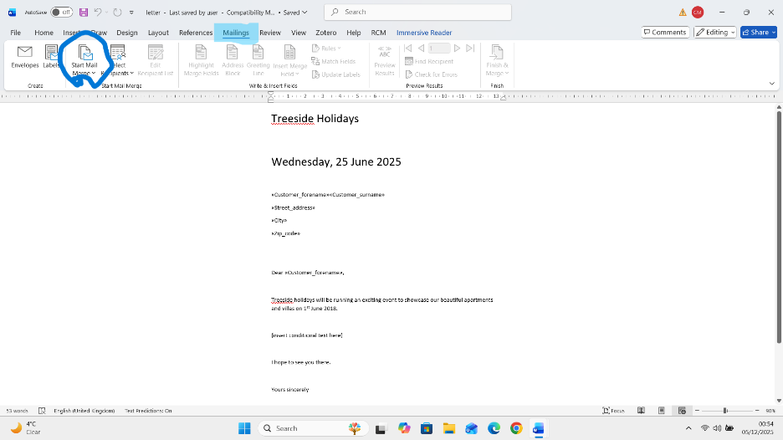
Step 1.
Go to the mailings tab then select start mail merge.

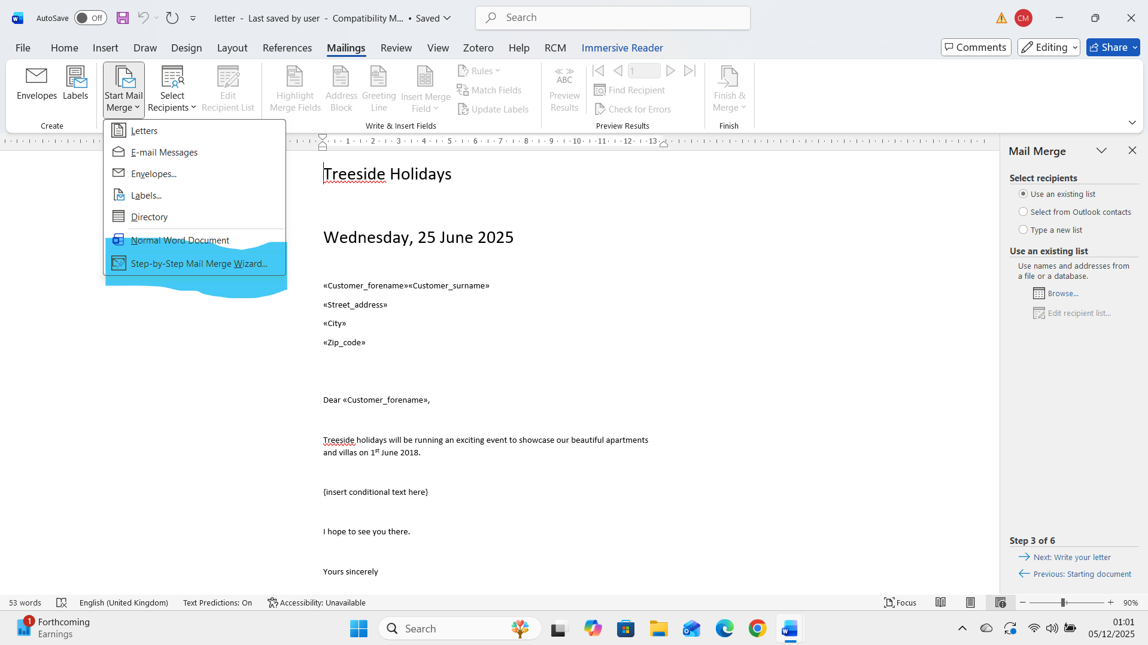
step 2
select step by step mail merge wizard

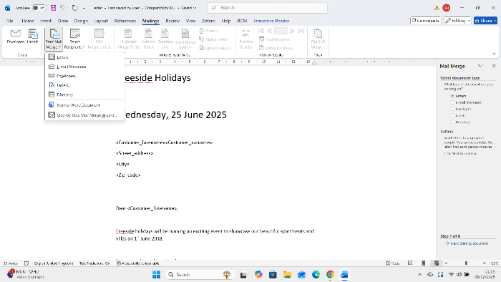

step 3
Using the list on the right select the document you wish to use which is letters. Then select next to continue.

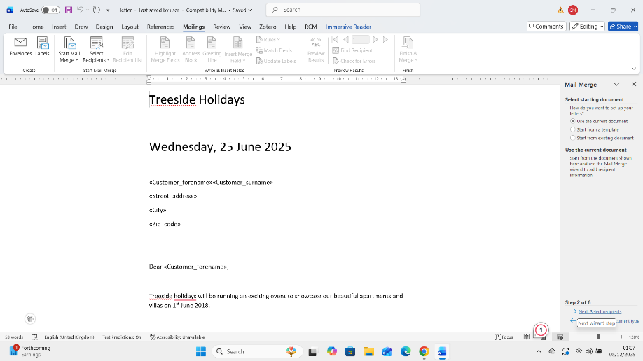

Step 4
Stick with current document
Step 5
Use an existing list then browse to find it.

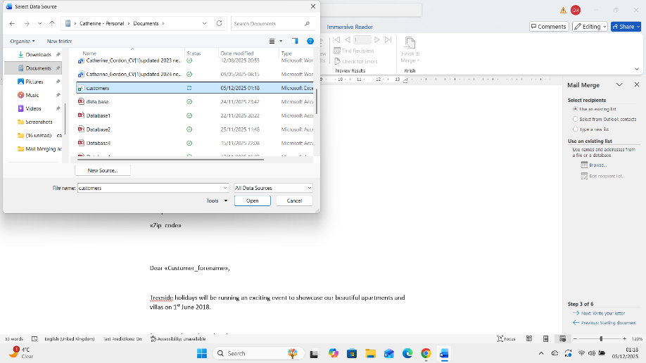

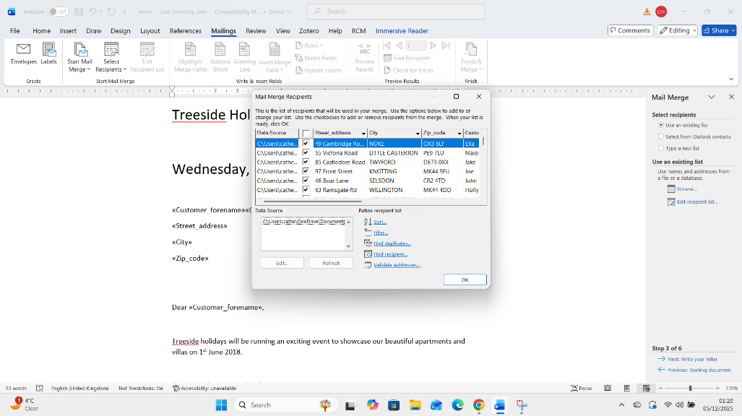

Step 6
Open and select the worksheet that contains the list. You can check and uncheck recipients you would like or not like to be included. Select ok when done

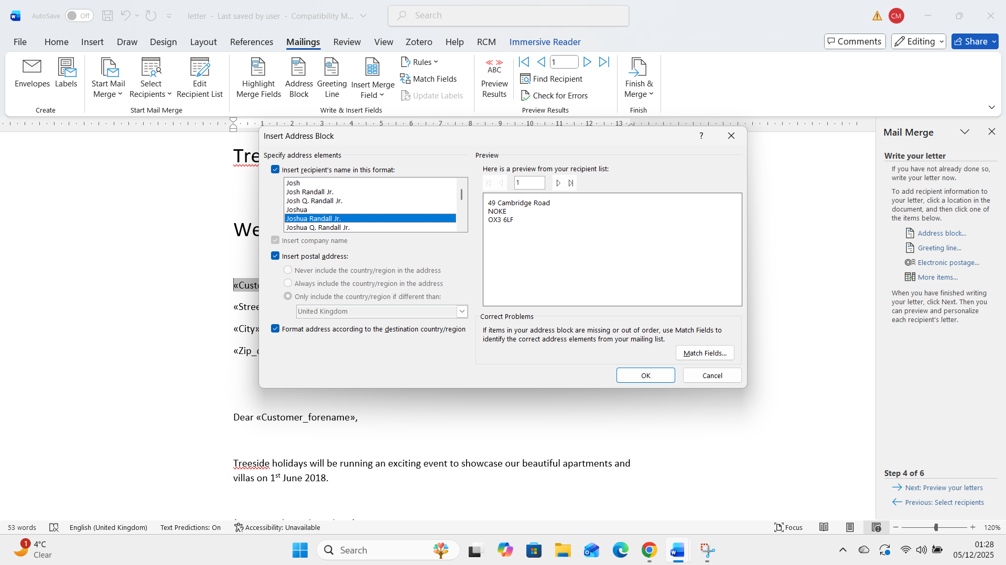

Step 7
Select write your letter. You can start by adding an address block first. And a greeting line.

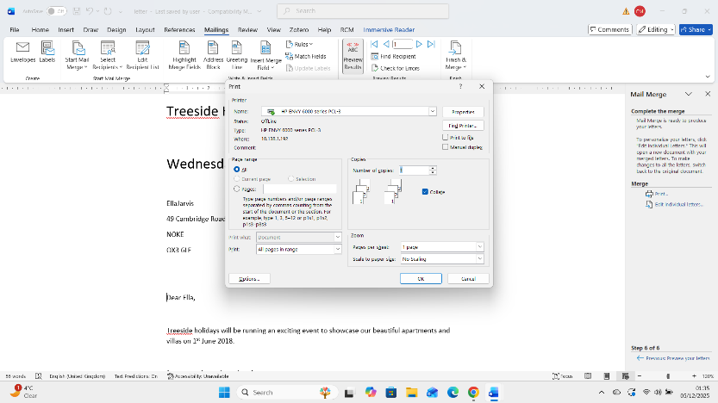

Step 8
Finally preview the letter. Then complete the merge and print.

Task 4

Communication and Collaboration applications
(Approx. 1000 words)

a.
Analysis of Communication and Collaboration Tools in Modern Business
Communication Tool: Microsoft Teams

Key Features: Analysis of Communication and Collaboration Tools in Modern Business
In today's business world, tools like Microsoft Teams and SharePoint play crucial roles in assisting communication and collaboration. While both have their unique features and limitations, they ultimately enhance productivity when teams are connected and used effectively. As businesses continue to evolve, utilizing these tools will be crucial for success in a digitally connected environment. In today's business environment, tools like Microsoft Teams and SharePoint are important for communication and collaboration. Both tools have unique features and limitations, but they can boost productivity and teamwork when used well. [5] [6]

Microsoft Teams enables instant messaging and video calls, making it easy for team members to talk quickly and connect face to face, which is especially useful for remote work. [5] [6]

SharePoint is a strong platform for managing and storing documents. It helps teams organize, share, and work on files together easily. Its addition with Microsoft Office allows for real-time document collaboration. [5] [6]

By using these tools effectively, businesses can adapt in the digital world. This enhances teamwork and improves processes, which is essential for success. To stay competitive, companies need to use platforms that support easy communication and efficient project management. [5] [6]

Communication Tool: Microsoft Teams

Key Features: Chat Functionality
Microsoft Teams provides real time messaging functionality that improves seamless one to one and group conversations. This instant communication ensures that team members can quickly share ideas, ask pressing questions, and convey updates, dramatically reducing delays commonly encountered with traditional email exchanges.

Video Conferencing: With the state of art video conferencing capabilities, Teams supports high definition video calls for both intimate meetings and large gatherings. This feature is pivotal for remote workforces, as it allows for meaningful face to face interactions that strengthen relationships and enhance understanding among team members. [5] [6]

File Sharing: The ability to share files directly within conversations streamlines workflow and ensures relevant documents are always easily accessible. Furthermore, Teams’ integration with cloud storage services like SharePoint and OneDrive allows for effortless access to files, eliminating the frustration of sifting through an endless flow of emails to find crucial documents.
Microsoft 365 Apps: One of the defining strengths of Microsoft Teams is its flawless blend with other Microsoft applications, including Word, Excel, and PowerPoint. This team allows for real time document collaboration directly within the Teams interface, significantly boosting productivity. [5] [6]

Customizable Channels: Teams enables users to create tailored channels for different projects or topics, providing structure to communications. This organizational feature helps maintain focus and relevance in discussions, preventing information overload in communication streams. [5] [6]

Task Management: The addition of task assignments and tracking through Microsoft Planner empowers teams to manage workloads and meet deadlines with precision. This unification ensures clarity regarding project timelines and responsibilities, keeping everyone on the same page [5] [6]

b.
Test some features of a freely available Communication (1) and Collaboration (1) application and document several screenshots with brief accompanying description to provide evidence of practical use.
-First you need to consider one communication and one collaboration application. Then discuss one use (How they are getting used in the business world) of each application, showing the process step by step through screenshots

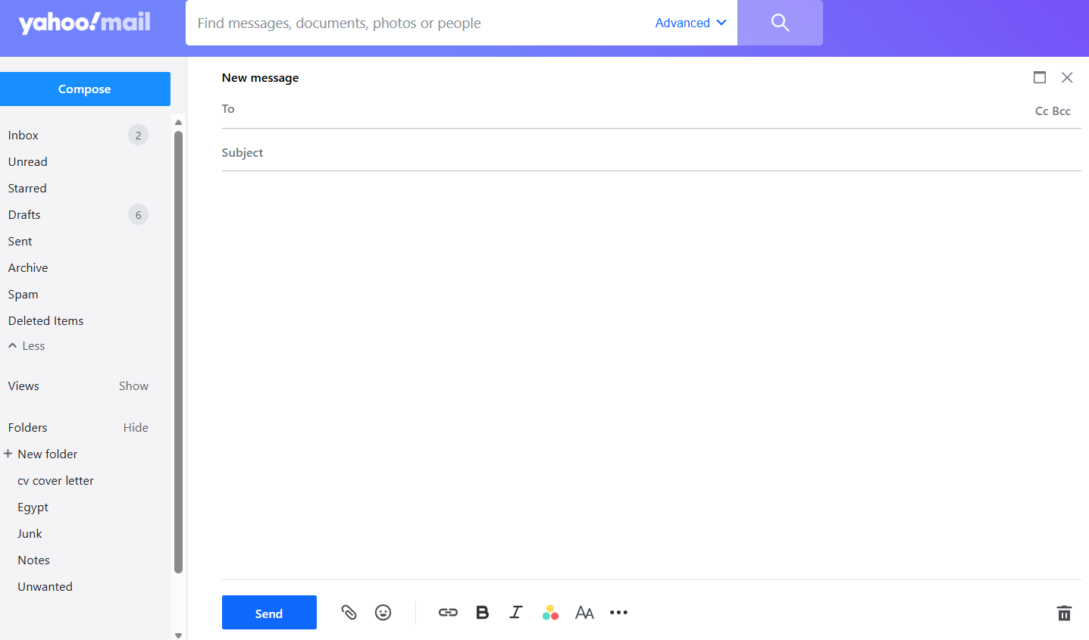
Step 1: First, go to the E-mail App. And open it. Click on Compose.

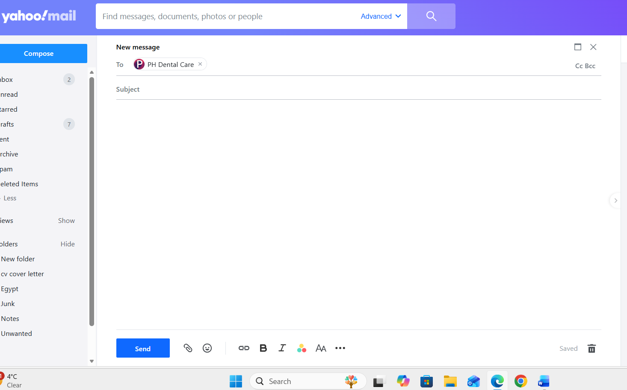
Step 2: Click on TO. This is the person who you want to send the e-mail too.

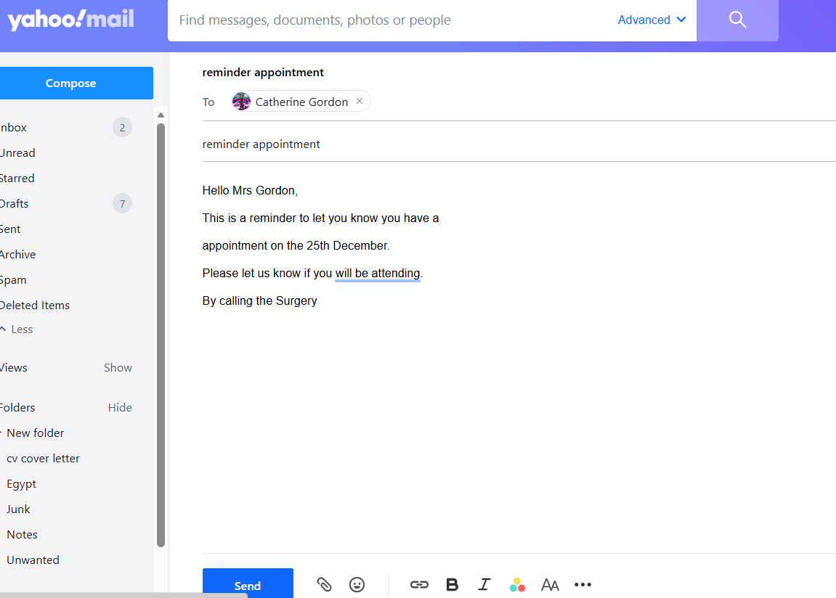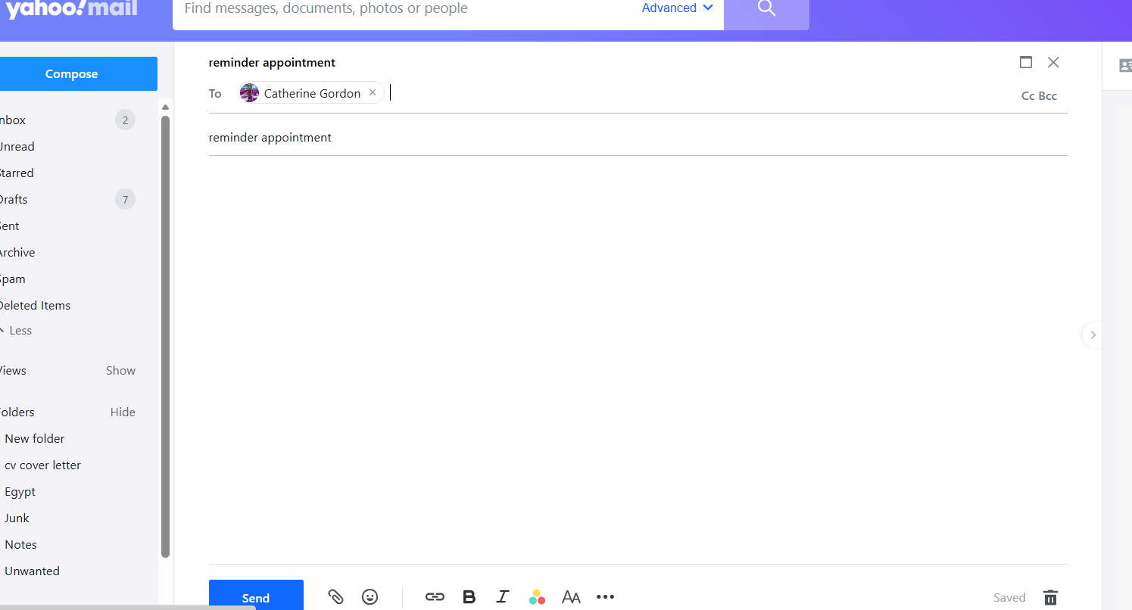
Step: 3 Now click on Subject. So you can write about what the e-mail is about?

Now Step:4 You have your subject? Underneath the line write the body of your email.

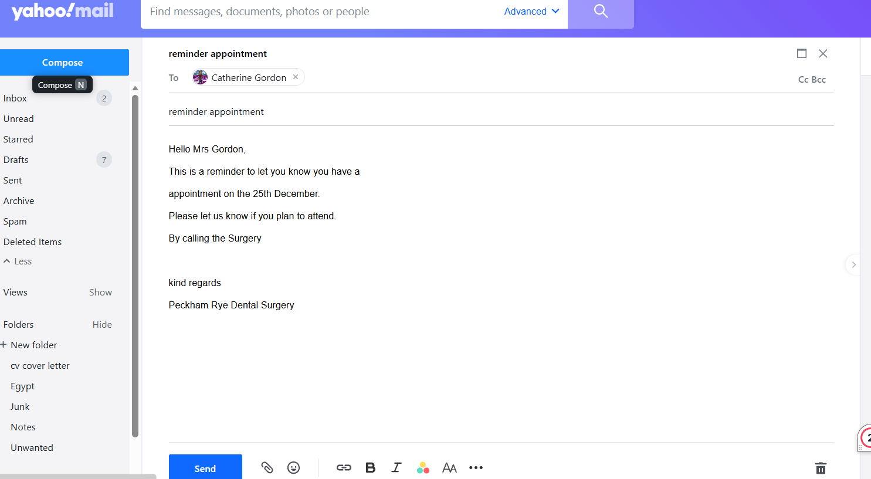
Step 5. Write a closing greeting, and who it's from? Then click on send. You have now finished your e-mail.

- Companies/ Businesses communicate with their patients/customers through emails, for a quick and efficient communication. One way is clinics can send a reminder, Informing patients about their upcoming appointments. This will help patience's and the clinic. Sending out reminder emails helps patents to remember their upcoming appointments. This reduces missed visits, appointments. And keeps the dental practise. Running smoothly and on time. This will reduce the amount of time spent on the telephone calling patients and reminding them of their upcoming appointments. [5]

Conclusion
In conclusion, Microsoft Teams is a vital tool for any business looking to enhance its communication and collaboration efforts. Its powerful features include instant chat, high definition video conferencing, integrated file sharing, and task management, helping teams with everything they need to succeed. By recognizing the potential of Microsoft Teams and understanding the value it brings, organizations and businesses can also benefit. In summary, companies that want to improve communication and teamwork, management. These tools will help teams work together more effectively. By understanding the benefits of Microsoft Teams, organizations can confidently use this platform to boost productivity and collaboration. [5] [6]

Reference
[1] G. Keen, Getting Started with WordPress: A Guide for Beginners. Tech Publishing. W3Techs. 2023.
[2] R. Sutton, 12 Benefits of Canva and w hy you should use it. Accessed December, 7 2025. [Online] Available: https://roysutton.co.uk/benefits-of-canva/
[3] T. Buzan, The Mind Map Book: Unlock your creativity, boost your memory, change your life. Plume. 2010
[4] T. Buzan, The Mind Map Book: Unlock your creativity, boost your memory, change your life. Plume. 2010
[5] J. Smith, “The Impact of Communication Tools on Business Productivity” Journal of Business Communication, 45(3), 124-132. 2023.
[6] Microsoft. “Microsoft Teams Features.” Accessed May, 5, 2024. [Online] Available: https://www.microsoft.com/en-us/microsoft-teams/group-chat-software

Appendices
-Supplementary information
An appendix page/section can be used to include relevant supplementary information such as indirect supporting information to task answers, tutorial activity answers, any other evidence.
NB: Also, look at your assessment brief to see the guidance for students in completion of the tasks section, students’ feedback form for overall marking criteria and assessment criteria to understand your level of work for grading.
Thanks, and good luck.

