

Augusta-Roxana Toth (2226559)
BMIH5005
Personnel Resourcing and Development
LEVEL 5
Module Lead: Helen Lee

Hospitality HR’s perspective

Contents
Introduction 3
Economic Stability and Job Security: 3
Employee Motivation and Well-being: 4
Flexible Work Arrangements: 4
Training and Development Opportunities: 4
Employee Recognition and Rewards: 4
Diversity and Inclusion: 4
Communication and Transparency: 4
High staff turnover rates 5
Prioritise HR Management Strategies 5
Pestel Analysis Pic 7
Challenges: 7
Privacy Concerns 7
Cultural Sensitivity 7
Employee Management in Different Work Modes: 7
Examples of Monitoring in Different Work Modes: 7
Front Desk Operations 7
Housekeeping: 7
Food Services 8
Potential Solutions: 8
Balancing Privacy and Performance 8
Cultural Training 8
Ethical Guidelines 8
Continuous Feedback 8
Average Customer Retention By Industry 8
Why is performance management important? 8
The Future of the Hospitality Industry 5 years 9
Conclusion 9
References 11

Introduction
HR professionals play a vital role in the hospitality industry, as they are responsible for hiring, training, and supporting the proper individuals to supply the best possible service to their customers.
The HR department ensures that regulations and laws are upheld. This includes developing policies and procedures designed to promote a safe and inclusive workplace.
In the hospitality industry, HR professionals manage administering employee benefits and compensation plans, creating training initiatives to advance workers' abilities and performance, and advocating for inclusion and diversity within the workplace.
According to Hansson and colleagues, functioning employees are regarded as vital factors that contribute to the productivity and value creation of a knowledge-based society (Jones, 2023).
One of the most crucial factors that employers consider when it comes to improving the well-being of their employees is the balance between their job demand and their resources. This concept can be used to decide the proper level of resources that employees should be able to obtain.
The comparative analysis of seven countries' characteristics can help organizations implement effective management strategies that are tailored to their specific cultures and environments.
Analysing the impacts of socioeconomic forces on employees' performance management and monitoring in different work modes, particularly from the perspective of Hospitality Human Resources (HR), involves considering a variety of factors. Socioeconomic forces encompass a range of social and economic influences that can shape the work environment and impact employees' performance. Here are some key considerations:

Economic Stability and Job Security:
During periods of economic instability, such as a recession or economic downturn, employees in the hospitality industry may face increased job insecurity.

Employee Motivation and Well-being:
Socio-economic factors can influence employees' motivation and well-being. Economic pressures can lead to increased stress and anxiety among employees, affecting their performance. HR needs to focus on employee well-being initiatives, including mental health support and stress management, to ensure sustained performance levels.

Flexible Work Arrangements:
Socio-economic trends, such as the rise of remote work and flexible schedules, have become more prominent. HR in the hospitality sector may need to adapt performance management practices to accommodate various work modes, including hybrid and remote work.

Training and Development Opportunities:
Economic conditions can impact the availability of resources for employee training and development. In challenging economic times, organizations may cut back on training budgets, affecting employees' skills and performance.

Employee Recognition and Rewards:
Socio-economic forces can influence the organization's ability to provide competitive salaries and benefits. HR needs to devise strategies for recognizing and rewarding employees, even in times of economic uncertainty, to maintain motivation and performance levels.

Diversity and Inclusion:
Socio-economic factors can also influence the composition of the workforce. HR professionals need to ensure that performance management practices promote diversity and inclusion, recognizing the impact of socioeconomic forces on different demographic groups.

Communication and Transparency:
During periods of economic uncertainty, clear communication from HR is crucial. Transparent communication about the organization's financial health and its impact on employees can help build trust and manage performance expectations.
Embracing social class backgrounds as a part of diversity can help the hospitality sector cultivate a more inclusive atmosphere and improve its recruitment and promotional efforts.
The findings of this study supply valuable insight into how Generation Z's social cognitive processes affect their career choices. The study's unique approach also challenges the assumptions about the socioeconomic makeup of the hospitality sector (Yu, 2023).

High staff turnover rates
The high turnover rates experienced by employees in the hospitality industry pose a challenge for HR managers. According to the Bureau of Labor Statistics, the rate of employee turnover in the industry in 2020 was 130.7%. This issue resulted in higher training and recruitment expenses for both restaurants and hotels (Nikolovska, 2024).

Prioritise HR Management Strategies
HR problems can have a significant effect on the morale of employees and the satisfaction of customers in today's hospitality sector. To succeed in this competitive environment, companies must prioritize their strategies to develop and implement effective HR management.
HR professionals in hospitality industries should adopt technology to improve their efficiency and effectiveness. Modern tools such as payroll software, employee intranets, remote file transfers, and VoIP technology can help them cut down on administrative tasks and improve communication with their customers. These also help minimize data security and increase data entry speed.

If you are a frequent traveller who likes to go somewhere new, then you must have checked into a Hilton hotel. The company is one of the most prominent hotel chains in the U.K.
For over a hundred years, Hilton has been supplying excellent services to its customers all around the world. It is regarded as one of the most prominent hotel chains in the industry (Howarth, 2023).
A SWOT analysis was conducted earlier on Hilton to find the company's weaknesses, opportunities, threats, and strengths. But, today, we are going to perform a PESTLE analysis on Hilton to find out what external factors can affect its operations.
Before we start with the PESTLE analysis of Hilton, let us first talk about its history. The company's roots can be traced all the way back to 1919, when Conard Hilton bought his first hotel.
Hilton's first hotel was set up in 1925 in Dallas. People started visiting the hotel at once after it opened due to how modern it was.
Due to the company's rapid growth, Hilton International was created to oversee the expansion of the hotel chain. It continued to expand its operations both internationally and domestically.
Following the acquisition of Hilton Hotels by the Blackstone Group in 2007, the company became private. In 2010, it changed its name to Hilton Worldwide. The new name of the company included several Hilton hotels (Christophe, 2023).
Following the company's public debut in 2013, Hilton Worldwide expanded its operations into other regions of the world. As of today, it has over 584 hotels and resorts all across six continents.
In 2022, Hilton had about 159,000 employees. Since it is one of the leading hotel chains in the world, it was able to generate revenue of almost $9.34 billion in 2023.
Following the discussion of the company's history and how it evolved, let us look into the scope of a PESTLE analysis (Momin, 2023).
Companies utilize an enterprise PEST analysis to determine how numerous factors, such as social, environmental, and technological, affect their operations.

Pestel Analysis Pic
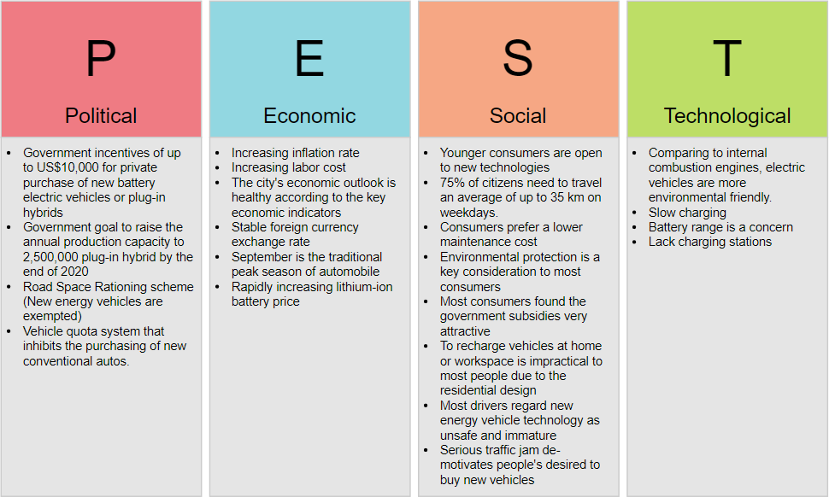(Momin,2023).

Challenges:
Privacy Concerns: Research has consistently raised concerns about the invasion of employee privacy through extensive monitoring. Striking a balance between monitoring for performance and respecting employees' privacy is a challenge.
Cultural Sensitivity: In international hotel chains, cultural differences must be considered when implementing monitoring strategies. What may be acceptable in one culture could be perceived as intrusive in another.

Employee Management in Different Work Modes:
International hotel brands typically have employees working in various modes, including front desk operations, housekeeping, and food services. Monitoring strategies need to adapt to these diverse work environments.

Examples of Monitoring in Different Work Modes:
Front Desk Operations: Monitoring here may involve tracking the efficiency of check-in/check-out processes, managing guest inquiries, and measuring the accuracy of information provided.
Housekeeping: Monitoring housekeeping staff may involve evaluating the time taken to clean rooms, the thoroughness of cleaning, and adherence to hygiene standards.
Food Services: In restaurants or catering services, monitoring could include tracking order processing times, customer satisfaction with the dining experience, and adherence to food safety protocols.

Potential Solutions:
Balancing Privacy and Performance: Implement monitoring systems that strike a balance between tracking performance metrics and respecting employees' privacy. Transparent communication about monitoring practices can help alleviate concerns.
Cultural Training: Provide cultural sensitivity training to management teams to ensure that monitoring strategies align with cultural expectations and norms.
Ethical Guidelines: Establish clear ethical guidelines for employee monitoring, ensuring that the methods employed are not only legal but also ethically sound. This may involve input from employees, unions, and legal experts.
Continuous Feedback: Instead of relying solely on surveillance, incorporate regular feedback sessions and performance reviews. This allows for a more holistic evaluation and fosters a culture of continuous improvement (Labs, 2023).

Average Customer Retention By Industry
Professional services and media companies had the highest customer retention rates in 2024. In contrast, the hospitality, travel, and restaurant sectors had the lowest retention rate at 55%. Email was the top method used for customer retention, with an average of 87% (Turner,2023).
Prioritized inclusion and diversity initiatives can foster an environment wherein workers are motivated to contribute to the success of the company. Understanding the financial repercussions of turnover can help organizations devise effective retention strategies.
Addressing the early departure of workers can help boost the company's retention rate and cultivate a more loyal and thriving workforce.

Why is performance management important?
According to a Harvard Business Review study, more than half of chief executive officers consider productivity as a key business goal, and they are investing in employee development, performance management, and engagement. Yet only 31% claim that their organizations have seen a direct benefit from these efforts.
- Performance management is essential for a variety of reasons.
- Clear expectations and regular feedback can help employees become more engaged and committed to their work.
- Performance dialogue can help workers align their efforts with the company's goals.
- Workers have clear pathways toward professional development, which can help enhance their skills and career opportunities.
- The more frequent communication between management and workers fosters trust and a greater understanding of one another.
- A well-designed performance management system can help organizations achieve success. It can help workers align themselves with the company's goals.
- A consistent assessment can help find areas of need for training. It can also guide where efforts should be focused.
- A culture that values and encourages contributions from employees can help keep highly skilled individuals.
- Performance management can also help make informed decisions about pay raises and promotions (Arora, 2023).

The Future of the Hospitality Industry 5 years
The hospitality industry has been one of the main drivers of the country's services sector growth over the years. It is tied to the tourism industry, as both domestic and foreign tourists are a vital part of its expansion.

Conclusion
In conclusion, these human resources department plays an essential role in the effective functioning of a company. In this report, we talked about the history of Hilton Hotel, its PESTLE analysis the importance of changing each sector over time, and what we could improve on the hospitality side.
Performance management is a vital part of any organization, as it can influence every member of staff and help guide the company's success. It is a tool that empowers individuals to improve their work and encourage teamwork.
Performance management can affect various aspects of an organization's operations, such as the performance of staff members, the efficiency of teams, and the overall progress of the business (Ranjan, 2021).
In summary, the impacts of socio-economic forces on employees' performance management in the hospitality industry necessitate a dynamic and adaptive approach from HR professionals. By understanding the broader economic and social context, HR can develop strategies that foster employee well-being, motivation, and performance across different work modes.

(Burgess, 2015).

References
- Arora A.( 2023). The Impact of Remote and Hybrid Work on Productivity: Embracing the Future of Work. Available at: https://www.linkedin.com/pulse/impact-remote-hybrid-work-productivity-embracing-future-arora/ (Accessed 17 January 2024).
- Boogaard K. (2023). Redesigning performance management for a hybrid workplace. Available at: https://www.cultureamp.com/blog/redesigning-performance-management-hybrid/ (Accessed 17 January 2024).
- Beatson M. (2023). Impact of performance management on employees. Available at: https://www.cipd.org/uk/views-and-insights/thought-leadership/cipd-voice/impact-performance-management-employees/ (Accessed 19 January 2024).
- Christophe A. (2023). Four principles for HR success from the hospitality industry. Available at: https://hrexecutive.com/what-hr-can-learn-from-the-hospitality-industry-4-principles-for-success/ (Accessed 16 January 2024).
- Christiansen T. (2023). How has the hotel industry changed in the past 10 years? . Available at: https://www.torrens.edu.au/blog/how-has-the-hotel-industry-changed-in-the-past-10-years/ (Accessed 17 January 2024).
- Dopson E. (2022). Ecommerce Customer Retention Marketing: How to Use Emails, Loyalty Programs & Communities to Improve Retention. Available at: https://www.shopify.com/enterprise/ecommerce-customer-retention/ (Accessed 16 January 2024).
- EHL (2023). 2023 Top Hospitality Industry Trends. Available at: https://hospitalityinsights.ehl.edu/hospitality-industry-trends/ (Accessed 15 January 2024).
- Gupta D. (2022). How to Improve Employee Performance (+Root Causes). Available at: https://whatfix.com/blog/improve-employee-performance/ (Accessed 16 January 2024).
- Howarth J.(2023). Average Customer Retention By Industry (2024). Available at: https://explodingtopics.com/blog/customer-retention-rates/ (Accessed 15 January 2024).
- Jones I. (2023). Diversity and Inclusion in Hospitality: The Power of Human Resources. Available at: https://www.linkedin.com/pulse/diversity-inclusion-hospitality-hr-unlocking-success-welcoming-jones/ (Accessed 17 January 2024).
- Karkara N. (2022). Performance Management Approaches, Models, & Frameworks: The Ultimate Guide for HR .Available at: https://blog.darwinbox.com/performance-management-models-approaches-frameworks/ (Accessed 18 January 2024).
- Lee E. (2023). What is Staff Turnover? Available at: https://cpdonline.co.uk/knowledge-base/business/staff-turnover/ (Accessed 16 January 2024).
- Lytle T. (2020). Top HR Challenges in the Hospitality Industry. Available at: https://www.shrm.org/topics-tools/news/hr-magazine/top-hr-challenges-hospitality-industry (Accessed 17 January 2024).
- Labs C. (2023). MONITORING WORK AND AUTOMATING TASK ALLOCATION IN RETAIL AND HOSPITALITY. Available at: https://crackedlabs.org/dl/CrackedLabs_Christl_Work-Retail-Hospitality.pdf/ (Accessed 31 January 2024).
- Momin A. (2023). Hilton PESTLE Analysis: Tourism is not the Only Factor Affecting Hotels . Available at: https://pestleanalysis.com/hilton-pestle-analysis/ (Accessed 15 January 2024).
- Nikolovska V. (2024). High Turnover Rate: What Does It Mean for Your Organisation? Available at: https://factorialhr.co.uk/blog/high-turnover-rate/ (Accessed 31 January 2024).
- Pedagog (2023). Navigating Employee Retention in 2023: Insights and Trends. Available at: https://www.linkedin.com/pulse/navigating-employee-retention-2023-insights-trends-pedagog/ (Accessed 16 January 2024).
- Ranjan R. (2021). Performance Management: Six Best Practices In The New Normal. Available at: https://www.forbes.com/sites/forbesbusinesscouncil/2021/02/12/performance-management-six-best-practices-in-the-new-normal/ (Accessed 16 January 2024).
- Sheth A. (2015). The Future of the Hospitality Industry 5 years from now. Available at: https://www.linkedin.com/pulse/future-hospitality-industry5-years-from-now-ankita-sheth/ (Accessed 17 January 2024).
- Turner J. (2023). 9 Ways to Manage Hybrid Employees for Better Productivity. Available at: https://www.gartner.com/smarterwithgartner/9-tips-for-managing-remote-employees/ (Accessed 16 January 2024).
- Workday (2023). The Future of Hospitality: 5 Realities Changing the Industry. Available at: https://blog.workday.com/en-us/2023/future-hospitality-5-realities-changing-industry.html/ (Accessed 16 January 2024).
- Yu H. (2023). Socioeconomic diversity in the hospitality industry: the relationship between social class background, family expectations and career outcomes. Available at: https://www.researchgate.net/publication/371693736_Socioeconomic_diversity_in_the_hospitality_industry_the_relationship_between_social_class_background_family_expectations_and_career_outcomes/ (Accessed 18 January 2024).
- Xian H. (2016). THE IMPACT OF SOCIO-ECONOMIC AND JOB CHARACTERISTICS, AND MOTIVATIONAL VALUES ON EMPLOYEES’ WELL-BEING: A MULTI-COUNTRY COMPARISON. Available at: https://repositorio.iscte-iul.pt/bitstream/10071/12777/1/Hoadong_all%20chapters_final%20version-5.pdf/ (Accessed 17 January 2024).

