Cloud-Based Web Services
ACCA6024 – MD

Isobel Sutcliffe – 1808257
1808257@student.uwstd.ac.uk

Content
Section 1 – Introduction 1
Section 2 – Cloud Computing 2
Section 3 – Virtualisation and Containerisation 8
Section 4 – Development Evaluation 11
Section 5 – eCommerce Application 18
Section 6 – Conclusion 19
References 20

Section 1 – Introduction
This report looks at cloud computing and its rise in the world of computing, evaluating the benefits and drawbacks of deploying applications in the cloud.
Consideration of the cost implications, reliability and scalability when looking at the principles of cloud computing will be included. To examine the process, a deployment of an application will be produced with an evaluation of the process.

Section 2 – Cloud Computing

Cloud Computing

What is Cloud Computing?
The wider definition of cloud computing is that it is a model for enabling ubiquitous, convenient, on-demand network access to a shared pool of configurable computing resources, these resources can be rapidly provisioned and released with minimal management effort or service provider interaction, the services include [1]:
- networks,
- servers,
- storage,
- applications, and
- services.
Cloud computing is the practice of delivering computing services – servers, storage, databases, networking, software, analytics and more – on-demand over the Internet. It is a means of providing computing services as a utility to consumers in the same way as other utilities such as gas and electricity. Companies offering these computing services typically charge for cloud computing services based on usage. [1]
Cloud computing is the on-demand delivery of IT resources over the Internet with pay-as-you-go pricing. Instead of buying, owning, and maintaining physical data centres and servers, you can access technology services, such as computing power, storage, and databases, on an as-needed basis from a cloud provider like Amazon Web Services (AWS). [2]
There are three classification types of cloud computing, they are:
- Infrastructure as a Service (IaaS)
IaaS refers to a combination of hosting, hardware provisioning and basic services needed to run a cloud. [3]
To examples of IaaS are Microsoft Office 365 [4] and Dropbox [5].
- Platform as a Service (PaaS)
PaaS refers to the provision of a computing platform and the provision and deployment of the associated set of software applications (called a solution stack) to an enterprise by a cloud provider. [3]
An example of PaaS is Google App Engine [6].
- Software as a Service (SaaS)
SaaS refers to a software distribution model in which applications are hosted by a vendor or service provider and made available to customers over a network. [3]
An example of SaaS is IBM Cloud

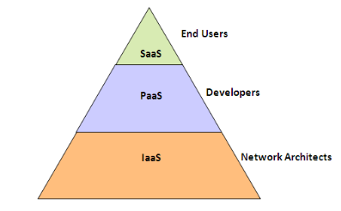
Figure 1 - Cloud Computing Service Model [7]

Benefits of Cloud Computing

There are many benefits and gains to be gained from cloud computing including:
- Cost Savings – Capital expenditure can be decreased, whilst using revenue expenditure to increase computing capabilities. This provides a lower entry barrier and fewer in-house IT resources to provide system support. [8]
- Scalability – Firms can start with a small operation and grow as quickly as demand needs, with the ability to reduce back if required. [8]
- Flexibility – Due to scalability there is an ability to use extra resources during peak times, enabling customer demands to be always met. [8]
- Reliability – Firms that continue to utilise multiple redundant sites can ensure support for businesses continuity and enable disaster recovery. [8]
- Maintenance – Cloud service providers will do any system maintenance, this is accessed via application programming interfaces (API’s), which do not require application installations on PS’s. Further reducing maintenance requirements. [8]
- Mobile Accessible – Mobile workers have increased productivity, with access to systems in their infrastructure available from anywhere. [8]
- Strategic Edge – By implementing a cloud solution to a firm’s IT, they give themselves access to latest applications without spending time on installations. [9]
- Automatic Software Integration – Software integration occurs automatically within a cloud set-up; this means that no more resources are required to integrate applications as per the preferences of the organisation. [9]

Drawbacks of Cloud Computing

The drawbacks of cloud computing include:
- Security Threats, including:
  - Attacks targeting shared-tenancy environment; [8]
  - VM-based malware; [8]
  - Botnet hosting; [8]
  - Launch pad for brute force and other attacks. [8]
- Performances can vary – Despite all best efforts, if there is any greedy behaviour on the tenant being used/shared, it could affect the performance seen by a firm. [9]
- Technical Issues – All technologies are prone to outages, despite maintaining high standards of maintenance. [9]
- Downtime – Any cloud working should have a consideration around downtime, as this is not controllable by the firm, but a third party, who may be experiencing power loss, low internet connectivity and service maintenance. [9]
- Internet Connectivity – Good connectivity is important when considering any cloud computing, as this is essential to ensure access to any data or applications stored in a cloud service environment. [9]
- Lower Bandwidth – Service providers may have a limit as to the bandwidth an organisation can use, it is important to bear this in mind. If the limit is exceeded, it could result in costly additional charges. [9]
- Lack of support – Most service providers provide a FAQ or online support only and for the non-technically minded this can be inadequate and tedious. [9]
- Regulation and governance – The policies of a service provider need to be a consideration when looking at any cloud service, as the privacy and confidentiality of any data stored must be adhered to in accordance with any laws and regulations that govern the organisation itself. [8]

Costs Implications of Cloud Computing

When comparing the cost of cloud IaaS to on-premises infrastructure it is quite complex as there is a need to compare apples with apples, as it were. Even with simplified assumptions the ability to compare will vary depending on the specifics that are being deployed within a system. [10]
Calculating cloud prices for three of the larger players Amazon Web Services (AWS), Azure and Google is quite difficult, as the firms are constantly changing their prices. [11]
When looking at price comparisons it is important to consider the same regions. In the example below, the following are the assumptions [11]:
- Region – US East – North Virginia
- Operating System – Linux and Windows
- vCPUs/Cores – 4
Types of instances/VMs:
- General Purpose
- Compute Optimised
- Memory Optimised
- Accelerated Computing
This is the price comparison for cloud on-demand
Instance Type | AWS |  | Azure |  | Google
Instance Type |  | Price per Hour |  | Price per Hour |  | Price per Hour
General Purpose | m6g.xlarge | $0.154 | B4MS | $0.166 | E2-standard-4 | $0.156
Compute Optimised | o6g.xlarge | $0.136 | F4s v2 | $0.169 | C2-standard-4 | $0.235
Memory Optimised | r6g.xlarge | $0.202 | E4a v4 | $0.252 | m1-ultramem-40 | $6.303
Accelerated Computing | p2.xlarge | $0.90 | NC4as T4 v3 | $0.526 | A2-highcpu-1g | $3.839

Figure 2 - On-Demand price comparison between AWS, Azure and Google Cloud [11]

Instance Type | AWS |  | Azure |  | Google
Instance Type |  | Price per Hour |  | Price per Hour |  | Price per Hour
General Purpose | m6g.xlarge | $0.0924 | B4MS | $0.0974 | E2-standard-4 | $0.0137
Compute Optimised | o6g.xlarge | $0.0816 | F4s v2 | $0.0816 | C2-standard-4 | $0.0229
Memory Optimised | r6g.xlarge | $0.1212 | E4a v4 | $0.1212 | m1-ultramem-40 | $0.0265
Accelerated Computing | p2.xlarge | $0.54 | NC4as T4 v3 | $0.3367 | A2-highcpu-1g | $2.419

Figure 3 - Discounted Price Comparison (1 year) for AWS, Azure and Google Cloud [11]
As can be seen between the two tables, it is more cost effective to sign up for a year with discounted hourly rate, than to use by the hour ad-hoc. To make the most cost-savings with regards to cloud computing there must be some thought around the business model and how the company is planning on progressing through the year.

Scenarios and Examples of Cloud Computing

There are several cloud providers that can be utilised, including:
- Dropbox
- Google Drive
- YouTube
- Facebook
- Skype
- Gmail
- Amazon Web Services (AWS) - IaaS

The most obvious example for using cloud computing is Netflix, who run selective processes through Amazon Web Services (AWS). They use:

Service Type | AWS Service
Hosting | EC2
Storage | S3
Content Delivery Network | Cloudfront
Database (prerequisite for analysis) | Relational Database Service (RDS), DynamoDB
Events driven programming | Lambda

Figure 4 – Example of the services that Netflix use from AWS [12]
More and more firms are joining up to the cloud computing ethos in terms of everyday lives, some will go more slowly, but others embrace it. The past year has seen a boom in online meetings, classes, and even just general catch ups. These would not have been possible without the likes of Zoom, Teams and Skype helping to allow people to stay connected.
There are so many areas that are looking to employ cloud computing, or have already employed partial cloud computing, but the two most significant areas are:
Education, platforms such as Moodle, Hwb and Google Classroom have allowed the continuation of learning through the past year – through online lessons, ability to submit homework online – bringing about no more “My dog ate my homework”.
Health has seen a surge in the use of cloud computing, pushing it faster towards the visions of so many, to enable patients to provide care closer to home with online consultations. In-patients maintaining access to their loved ones when in hospital using their own on devices or in some cases having access to hospital devices. Using clinicians further afield to support local commitments, for example, using radiographers to look at x-rays from a local hospital, who may live 50 -100 miles away. There is also a significant level of investment coming through to help healthcare in the UK to improve itself with cloud computing technologies. [13]

Reliability and Scalability of Cloud Computing

Two of the benefits mentioned with regards to cloud computing is the ability to be flexible and scalable. These are important in a world where things change in an instant, and the ability to provide more resources in terms of scalability in an instant is the one huge advantage cloud computing has over on-premises computing. Gaining resources through on-premises can be difficult, expensive and time consuming, but cloud computing allows the customer to receive the service in an instant as there is no need to wait.
Reliability comes about due to the ability to utilise redundant sites, for disaster recover, ensuring no loss to the consumer. If a firm only had one on-premise server and that went down, then the business would be out of commission for a few hours or even days, depending on the seriousness of the outage. Whilst, most business do try to build in redundancy, costs can escalate resulting in corners getting cut.

Section 3 – Virtualisation and Containerisation
To refer to virtual machines, virtualisation and containerisation in terms of the driving forces of Docker, it would be preudent to explain what the terms mean.
- Virtual Machine (VM) – is at its core an emulation of a computer system, it can be categorised into 4 types depending on the level of abstraction and the scope of emulation, the four types are [14]:
  - Full Instruction Set Architecture (ISA) virtual machine – provides a full computer system emulaltion; [14]
  - Application Binary Interface (ABI) virtual machine – provides a guest process ABI simulation; [14]
  - Virtual ISA virtual machine – provides a runtime engine so that applications in the virtual ISA can execute on it; [14]
  - Language virtual machine – provides a runtime engine that executes programs expressed in a guest language. [14]
- Virtualisation – is the name given to the “technology” which is used to simulate the physical hardware of a computer as a separate machine. [15] It has its own:
- Guest OS;
- Kenel;
- Process and;
- Drivers.
It is considered to be a hardware level of virtualisation, see figure 5 for an overview of the structure of a visualistion setup.
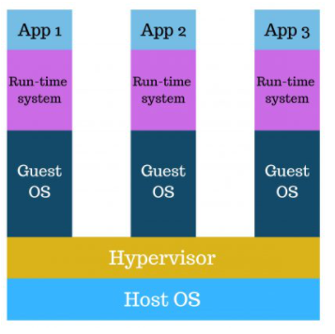
Figure 5 - Overview of Virtualisation Architecture
Virtualisation was seen as a revelation when it was first introduced as it allowed for a number of benefits, but it was not without its drawbacks, see figure 6 for an overview:
Virtualisation | Benefits | Drawbacks
Virtualisation | Multiple Operating Systems (OS) could be run at the same time. [16] | Performance could be unstable when running multiple VMs. [16]
Virtualisation | Ease of recovery and maintenance in the event of a condition of failure. [16] | The efficentcy of hypervisors are not considered to be as good as the host OS. [16]
Virtualisation | Ownership costs to be reduced due to less useage or need for infrasturcture. [16] | There can be long boot up times. [16]
Figure 6 - Benefits and Drawbacks of Virtualisation

- Containers – are a single packages’ of software that are abstracted away from the host OS, to stand alone, allowing for portability with a freely running application in any environment. [17]
- Containerisation – is the name given to OS-level virtualisation which is used to simulate the OS hardware of a computer allowing for muliple aplications to share the OS kernel. [15]. It allows developers to create and deploy applications faster and more securely. [17]

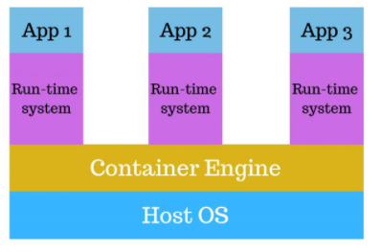
Figure 7 - Overview of Containerisation Architecture

Containerisation has introduced a numberof benefits, but is not without its drawbacks, see figure 8 for an overview:
Containerisation | Benefits | Drawbacks
Containerisation | Lightweight, fast and with isolated infrastructure. [18] | If the OS kernel becomes vulnerable, the containers could become vulnerable. [18]
Containerisation | Easy solution for migrating applications. [18] | Good network connections are needed when working with containers. [18]
Containerisation | Average contianer size is approx. 100MB (less than a virtual machine). [18] | Managing containers can be harder than on a virtual machine. [18]
Containerisation | Can help decrease operating and developing costs. [18]
Figure 8 - Benefits and Drawbacks of Containerisation

The differneces between virtualisation and containerisation can be seen in the collation of figure 9. [15]
 | Virtualisation | Containerisation
Definition | Technology to simulate the physical hardware and viewed as a separate machine. | OS-level virtualisation, it does not simulate the physical machine.
Detaching Layer | Uses hypervisers to detach the physical machine. | Uses a docker engine.
Isolation Layer | Hardware level isolation. | Process level isolation.
Lightweight | No – consider heavyweight | Yes.
Portable | No. | Yes – can be used to build, ship and run anywhere.

Figure 9 - Comparative overview of Virtualisation and Containerisation
The most common visualisation technology is VMware and VirtualBox, whilst the most common containerisation technology is Docker.
Virtualisation
VMware
VMware Infrastructure abstracts the operating system from the hardware it’s running on, providing standardised virtual hardware for OSs and their applications that enables the virtual machines to run simultaneously and independently on one or more shared processors. [19]
VirtualBox
Oracle VM VirtualBox is a cross-platform virtualisation application, it installs on your existing Intel or AMD-based computers, whether they are running Windows, Mac OS X, Linux, or Oracle Solaris operating systems (OSes). While extending the capabilities of your existing computer so that it can run multiple OSs’, inside multiple virtual machines, at the same time. [20]
Containerisation
Docker
Docker is an open platform that can be used for developing, shipping and running applications. It is considered a PaaS product that uses containers to deliver software, this allows many containers to be run simutaneaously. It is considered to be fast and allows applicatiosn to be run from on premises sites, via the cloud or a hybrid of both. [21]

Section 4 – Development Evaluation
Part of the development process was to create relevant scripts within a containerisation technology to create a webservice/webserver.
Technologies/Software used for the in-class development included:
Docker – Empowering App Development for Developers | Docker
Docker helps developers bring their ideas to life by conquering the complexity of app development. They simplify and accelerate development workflows with an integrated dev pipeline and through the consolidation of application components. Actively used by millions of developers around the world, they provide unmatched simplicity, agility, and choice. [22]
Git – Git for Windows
Git for Windows focuses on offering a lightweight, native set of tools that bring the full feature set of the Git SCM to Windows while providing appropriate user interfaces for experienced Git users and novices alike. [23]
Node.js – Node.js (nodejs.org)
As an asynchronous event-driven JavaScript runtime, Node.js is designed to build scalable network applications. Many connections can be handled concurrently. Upon each connection, the call-back is fired, but if there is no work to be done, Node.js will sleep. [24]
Specifically using the expressjs framework.[25]
PostgreSQL – PostgreSQL: The world's most advanced open-source database
PostgreSQL is a powerful, open-source object-relational database system with over 30 years of active development that has earned it a strong reputation for reliability, feature robustness, and performance. [26]
Postman – Postman | The Collaboration Platform for API Development
Postman is a collaboration platform for API development. Postman's features simplify each step of building an API and streamline collaboration so you can create better APIs—faster. [27]
Never having used any of the above before starting the cloud module, it was evident that there was going to be a lot of reading and research to try and understand what each element of the process was doing, I still fear that my understanding is not as it should be, and so evaluating the process is also a little difficult.
Overall, following instructions, is easy enough, but when something goes aray, it can be difficult to understand what you are looking at and follow the path, I will admit when the docker was running, it was very useful in telling me where it thought the issues were, not sure how reliable it was, but nonetheless it was extremely useful. I have discovered I am definiately a “it works, just leave it” type of person, for fear of breaking something beyond repair. With so many componants to look at, it was difficult to know on occassions where the issue was.
The first thing that was expected was to create the expressjs directory (folder, I may switch between the two) which would contain the code needed for the webserver/webservice.
Added into the directory were the files:
- docker-compose
- Dockerfile
- dockerignore
Along with a further two directories:
- nodewebserver
- nodewebservice
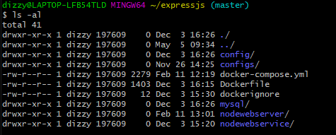
Figure 10 – Image of the list of directories and files contained in expressjs in Git Bash environment
Once these had been created then a further directory was added:
- configs – this where the file tscompileoptions.json was added
Switching to the nodewebservice directory, the tsconfig.service.json file was added and there was a need to create the package.json file, this was done through the Git Bash environment, by using the command line “npm init” – node package manager (npm) where a series of questions were asked and then added to the file.
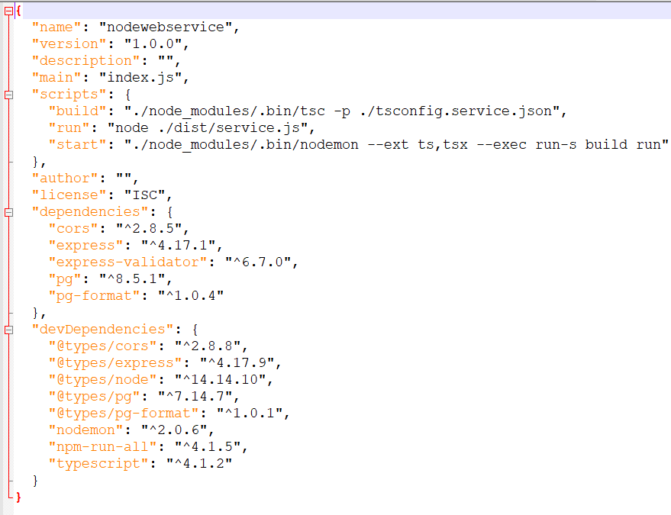
Figure 11 – Image of the package.json file in Notepad++
Then the class went on to install:
- express,
- express-validator,
- cors,
- pg and
- pg-format
within the nodewebservice, these can be seen as dependencies in figure 11, by adding them to the package.json file it means that both the express.js framework and the Postgres database can be used.
Other tools were also added to aid the development of the webserver/webservice, these included:
- --save-dev nodemon
- --save-dev npm-run-all
- --save-dev typescript
- --save-dev @types/node
- --save-dev @types/express
- --save-dev @types/cors
- --save-dev @types/pg
- --save-dev @types/pg-format
Can be seen in figure 10 as devDependancies.
By changing the line
` “test”:”echo\”Error: no test specified\”&& exit 1”
within scripts to:
"build": "./node_modules/.bin/tsc -p ./tsconfig.service.json",
"run": "node ./dist/service.js",
"start": "./node_modules/.bin/nodemon --ext ts,tsx --exec run-s build run"
It enables the package.json file to compile the type scripts and run the service. This can then be tested with the Postman environment. Postman is currently assigned to localhost:1339
A student database was created through Postgresql
To access the browser for the database localhost:8080 was inputted into the browser:
Figure 12 –
A login page then pops up, allowing the user to input their login details:
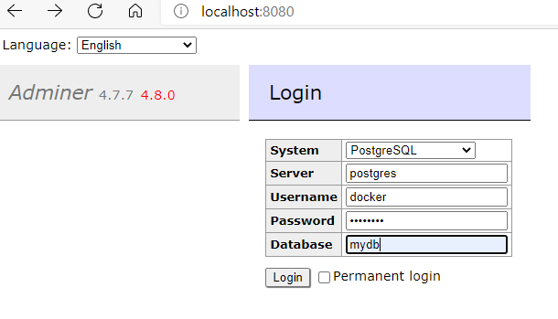
Figure 13 -
Once logged in there is the ability to create database tables, this was a little easier for myself, as I have created databases before and do work with them daily. There were a few syntax variations to note between PostgreSQl and other SQL implementations:
Table names are interpreted as lower-case names, for example, SELECT * FROM Student reads from the table student;
If the table name has a capital letter, the table needs to be encased in double quotation marks, for example, SELECT * FROM “Student” reads from the table Student;
String values must be included in single quotes, for example, SELECT * FROM “Student” WHERE “Name”=‘Isobel’, this is because Postgres-format automatically places single quotation marks around string values.
To use the database with the webservice there was a need to add the details into the Client Class, this is the simplest approach. Worth noting that the best approach would be the connection pool.
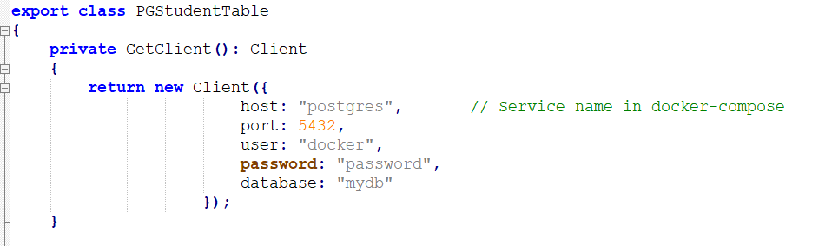
Figure 14 –
This was the end of the initial set up of the Webservice.
With the webserver element several directories and packages created/installed within the nodewebserver directory, along with various tools:
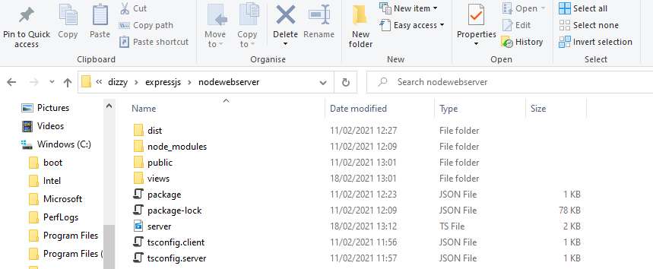
Figure 15 –
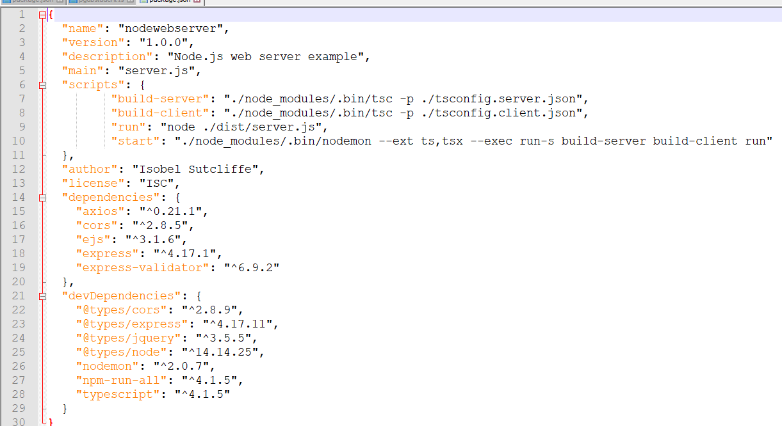
Figure 16 –
Within the package.json file the
“test”:”echo\”Error: no test specified\”&& exit 1”
line was replaced with the following to allow the service to run:
"build-server": "./node_modules/.bin/tsc -p ./tsconfig.server.json",
"build-client": "./node_modules/.bin/tsc -p ./tsconfig.client.json",
"run": "node ./dist/server.js",
"start": "./node_modules/.bin/nodemon --ext ts,tsx --exec run-s build-server build-client run“
Then the server.ts file was created.
When starting the webservice, webserver and database the command line that is required is:
Docker-compose up
Figure 17 –
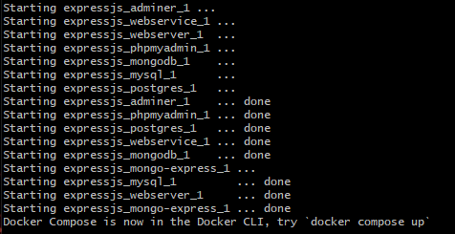
Figure 18 -
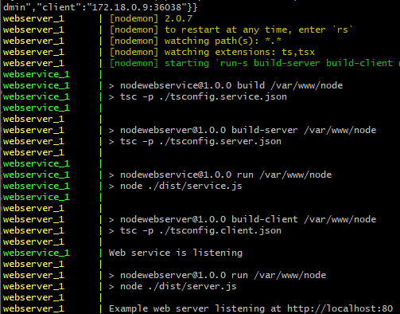
Figure 19 -
To stop the docker from running, Ctrl+C need to be pressed:
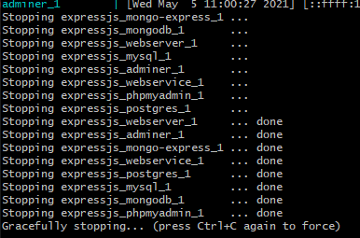
Figure 20 -
From here, the class went on to create the following functions for the database
- GET
- POST
- DELETE
The database can be tested through Postman to check if the service element of the application is working.

Section 5 – eCommerce Application
Images of the e-commerce application:

Section 6 – Conclusion
Overall cloud computing is an area that most business are going to have to get on board with, there is so much to be gained from pooled resources, in terms of cost savings, reliability and scalability. However, there does need to be some assurance around security and access before the world can embrace the benefits that could be gained.
Whilst health is pushing hard on the boundaries, with regards to cloud computing, there are many that have serious doubts as to the safety and security of personal data that may be stored within cloud applications. Which is surprising as many financial institutions are already looking to the cloud for storage and remote working whilst day to day business is becoming more readily available through applications on smart phones, yet this does not seem to have people quite as agitated as their health data.
Education is an area that could easily be given over to technology, allowing teachers to embrace this could have so many benefits to them and the children they teach, most children have a love and enthusiasm for technology that far out-strips their parents and grandparents understanding. It has certainly proven itself in recent months and hopefully like health it can continue to develop and continue enabling all children to access some form of education.
References
[1] “An introduction to web applications architecture: 1.1 Client–server architecture - OpenLearn - Open University - TT284_1,” The Open University, [Online]. Available: https://www.open.edu/openlearn/science-maths-technology/introduction-web-applications-architecture/content-section-1.1.
[2] “What is Cloud Computing.” https://aws.amazon.com/what-is-cloud-computing/ (accessed Mar. 18, 2021).
[3] S. S. Manvi and K. Shyam, “Resource management for Infrastructure as a Service (IaaS) in cloud computing: A survey,” 2013, doi: 10.1016/j.jnca.2013.10.004.
[4] “Office 365 Login | Microsoft Office.” https://www.office.com/ (accessed May 01, 2021).
[5] “Dropbox - Dropbox Business.” https://www.dropbox.com/business/landing-t61fl?_tk=paid_sem_bing_biz_b&_camp=382292131&_kw=dropbox|e&_ad=||c&msclkid=3f056cc0ecfe18ea8c310c4d8e52c5f1 (accessed May 01, 2021).
[6] “App Engine Application Platform | Google Cloud.” https://cloud.google.com/appengine/ (accessed May 01, 2021).
[7] “(PDF) CLOUD COMPUTING WITH REAL LIFE CASE STUDIES AND A NEW APPROACH OF SOLVING SECURITY ISSUES AND PUTTING DATA IN CLOUD.” https://www.researchgate.net/publication/235950351_CLOUD_COMPUTING_WITH_REAL_LIFE_CASE_STUDIES_AND_A_NEW_APPROACH_OF_SOLVING_SECURITY_ISSUES_AND_PUTTING_DATA_IN_CLOUD#fullTextFileContent (accessed May 01, 2021).
[8] E. Gurpinder Singh, S. Sant Baba Bhag Singh University, and Mt. Scholar Sant Baba Bhag Singh University, “Cloud Computing Risks and Benefits,” 2017. Accessed: Apr. 25, 2021. [Online]. Available: www.ijarcs.info.
[9] “Advantages and Disadvantages Of Cloud Computing.” https://www.guru99.com/advantages-disadvantages-cloud-computing.html (accessed Mar. 18, 2021).
[10] “Cloud vs. On-Premises – Hard Dollar Costs.” https://www.linkedin.com/pulse/cloud-vs-on-premises-hard-dollar-costs-greg-deckler (accessed May 03, 2021).
[11] “Cloud Pricing Comparison 2021: AWS vs Azure vs Google Cloud.” https://www.simform.com/compute-pricing-comparison-aws-azure-googlecloud/ (accessed May 03, 2021).
[12] “Case Study: How Netflix uses Cloud for Innovation, Agility and Scalability - Cloudsine.” https://www.cloudsine.tech/news-trends/case-study-how-netflix-uses-cloud-for-innovation-agility-and-scalability/ (accessed May 06, 2021).
[13] “Transforming healthcare through cloud technology | Health Business.” https://healthbusinessuk.net/features/transforming-healthcare-through-cloud-technology (accessed May 06, 2021).
[14] “(PDF) CRC.Advanced.Design.and.Implementation.of.Virtual.Machines.146658260X | Xu Shen - Academia.edu.” https://www.academia.edu/31977025/CRC_Advanced_Design_and_Implementation_of_Virtual_Machines_146658260X (accessed Apr. 30, 2021).
[15] “Difference between virtualization and containerization.” https://www.tutorialspoint.com/difference-between-virtualization-and-containerization (accessed Apr. 30, 2021).
[16] “Containerization vs Virtualization | Everything you need to know.” https://www.cloudmanagementinsider.com/containerization-vs-virtualization/ (accessed Apr. 30, 2021).
[17] “Containerization Explained | IBM.” https://www.ibm.com/cloud/learn/containerization (accessed May 01, 2021).
[18] “Containers & Containerization – The Pros and Cons.” https://spin.atomicobject.com/2019/05/24/containerization-pros-cons/ (accessed May 01, 2021).
[19] “Building the Virtualized Enterprise with VMware Infrastructure.” Accessed: May 01, 2021. [Online].
[20] “VirtualBox – Oracle VM VirtualBox.” https://www.virtualbox.org/wiki/VirtualBox (accessed May 01, 2021).
[21] “Docker overview | Docker Documentation.” https://docs.docker.com/get-started/overview/ (accessed Apr. 30, 2021).
[22] “About Docker - Management & History | Docker.” https://www.docker.com/company (accessed May 05, 2021).
[23] “Git for Windows.” https://gitforwindows.org/ (accessed May 05, 2021).
[24] “About | Node.js.” https://nodejs.org/en/about/ (accessed May 05, 2021).
[25] “Express - Node.js web application framework.” http://expressjs.com/ (accessed May 05, 2021).
[26] “PostgreSQL: The world’s most advanced open source database.” https://www.postgresql.org/ (accessed May 05, 2021).
[27] “Postman | The Collaboration Platform for API Development.” https://www.postman.com/ (accessed May 05, 2021).

