

An exploration into policing pressures and the impact they have on police officers’ mental health.

Name of student – Ryan Matthews
Student number -1920678
BSc (Hons) Professional Policing Practice

Declaration
This work has not previously been accepted in substance for any degree and is not being concurrently submitted in candidature for any degree.
Signed: R Matthews
Date: 09/01/2023

STATEMENT 1
This dissertation is being submitted in partial fulfilment of the requirements for the degree of BA.
Signed: R Matthews
Date: 09/01/2023

STATEMENT 2
This dissertation is the result of my own independent work/investigation, except where otherwise stated.
Other sources are acknowledged by footnotes giving explicit references. A bibliography is appended.
Signed: R Matthews
Date: 09/01/2023

STATEMENT 3
I hereby give consent for my dissertation, if accepted, to be available for photocopying and for interlibrary loan, and for the title and summary to be made available to outside organisations.
Signed: R Matthews
Date: 09/01/2023

STATEMENT 4
I hereby give consent for my dissertation, if accepted, to be available on the university’s IT system to those who have consent to use the system.
Signed: R Matthews
Date: 09/01/2023

Abstraction
This paper will explore the pressures that are faced by front line police officers on a day-to-day basis and whether said pressures can have a negative effect on an individual officer’s mental health. The paper will review relevant sources of information.
It will also explore what pressures officers have faced during the recent pandemic and whether the pandemic has exacerbated issues surrounding the mental health of police staff.
Due to the emotive subject of this paper, an anonymous questionnaire has been sent to police officers of South Wales Police and has asked officers to reflect on front line policing and whether the global pandemic has had a negative impact on their mental health.

Chapters;
- Introduction Page 5
- Literature Review Page 6 - 12
- Methodology Page 13 - 16
- Analysis of results Page 17 - 27
- Conclusion and recommendations Page 28 - 34
- Questionnaire Appendix A Page 35 - 44
- Bibliography Page 44 - 49

Introduction
During recent years, policing within the United Kingdom has had to evolve and create innovative measures in order to cope with fast changing times which has put huge pressures on police officers as individuals. From a global pandemic to further budget cuts, these pressures have resulted in local police forces and officers stretched to capacity and finding themselves working in unknown territories. I plan to explore multiple pressures which have arisen and research the effects they have had, and continue to have, on individuals’ mental health.

In 2019, Prime Minister Boris Johnson announced plans to recruit 20,000 police officers across England and Wales. Introducing the recruitment campaign, Mr Johnson said: “my job as Prime Minister is to make our streets safer.” (Politics.co.uk). Within my evaluation I will consider if the government’s 2019 plan to recruit more police officers has relieved any pressures felt by those at the forefront in the fight against crime. I will explore what pressures are felt within this fast-paced, high-risk job and discuss what effect they have on an individual’s mental health. Whilst there are previous statistics regarding mental health in the police force, for example “a Police Federation survey of 17,000 officers in 2016 showed an alarming set of statistics around mental health of officers, with 39% seeking help with mental health issues” (Police Federation), I would consider them out of date. In this particular case, in 2016 they have reported that 39% of officers have reached out and asked for help, however this survey was conducted pre-pandemic, meaning they are no longer a true reflection.

Literature review
During this section of the dissertation, the author will analyse and review available and relevant literature in order to highlight any shortcomings and potential gaps that there might be prior to conducting their own research. Whilst information and literature on this topic is available from across the globe, I will primarily be focusing on research in relation to police forces from within the United Kingdom, although I will consider including any relevant information available from outside of the UK if I deem this appropriate. The main aim of this literature review is to take an in-depth look into British policing and explore how aspects of policing within the United Kingdom can have an adverse effect on the mental health of those who are in law enforcement. I will also look at how the pressures of a global pandemic may affect an officer’s mental health and resilience. To do this, I will review existing articles and studies that have looked at both emergency responders’ mental health and how the incidents that they deal with on a day to day basis may have a negative effect on individuals. To conclude my literature review I aim to highlight the shortcoming of available articles which should assist to highlight my own areas of research that will fully address the research topic of – ‘An exploration into policing pressures and the impact they have on police officers’ mental health’.

Police officers and first responders are often at the forefront of major incidents. The incidents that officers respond to can vary, from simple calls such as basic anti-social behaviour, to extreme incidents such as sudden deaths and murders. The Illinois Criminal Justice Authority have highlighted the dangers and stresses that officers face on a day-to-day basis, “The nature of police work may at times involve stressful situations such as the threat of, and actual, physical harm and witnessing the human toll of violence. The stress of the job combined with organizational stressors may severely impact police officers and their work. (Illinois Criminal Justice Authority, 2022). Officers usually have little idea of what or who they will be faced with when attending the call and for this reason it can be argued that this lack of insight can often place officers under stress from the very start of a call.

According to statistics, “Close to one in five police officers and staff in the UK have symptoms consistent with either post-traumatic stress disorder or what is known as “complex PTSD”- yet over two-thirds of those suffering are unaware”. (University of Cambridge, 2019). An essential quality for an officer to have to be able to continue working after numerous distressing incidents is resilience. AXA Health define resilience as, “the ability to bounce back when things get tough. It’s a skill we can learn and hone throughout life. It can help manage or even ward off conditions, such as depression and anxiety, and improve your mental health overall” (AXA HEALTH,2022). Having resilience and general good mental wellbeing is key to dealing with these incidents and assist an individual in the ability to process and debrief what they may have seen or had had to deal with. If an officer finds their mental health deteriorating it can have a major impact on their ability to conduct themselves within a professional manner. The mental health charity Mind state “Good mental health means being generally able to think, feel and react in the ways that you need and want to live your life. But if you go through a period of poor mental health, you might find the ways you're frequently thinking, feeling or reacting become difficult, or even impossible, to cope with” (MIND, 2020). For the purpose of this literature review I will look at research which has been conducted regarding possible causes for a decline in an officer’s mental health and resilience.

A factor which may have an impact on police officers’ mental health is the sheer volume of incidents that they are expected to attend and deal with on a daily basis, which has worsened within the last year due to overall crime within the United Kingdom increasing. According to CrimeRate.co.uk, in the year 2021-2022 the crime rate in the United Kingdom was 79.52 per 1,000 meaning that the overall UK crime rate saw a 1.18% increase from the previous year in 2020. This increase in crime will likely increase the probability of the exposure of officers to more potentially distressing violent or emotionally difficult incidents to deal with. Moreover, this increase in crime will place pressure on officers’ day to day tasks as those attending will have less time to deal with each call during their tour of duty. The lack of time can have a detrimental effect on mental health as it can lead to stress and anxiety that the job was not completed to the desired standard and officers may take these worries home with them.

As well as the increase in calls to the police regarding crimes, research has shown that there has been a sharp increase in the amount of non-crime calls being made, meaning that officers are witnessing and attending a dramatic increase in incidents related to poor mental health, for instance suicidal members of the public, missing individuals and sudden deaths due to suicide. “It is estimated that approximately 70% to 80% of calls now relate to non-crime issues including vulnerable people and mental health”. (Michael Alun, 2018). Officers are finding that they are often stretched dealing with these non-crime related incidents, often due to inadequate training to provide them the skills and knowledge that allow them to deal with incidents such as mental health in an acceptable and impactful manner. The academic Jones writes how in response to the growing number of emotive and mental health related calls, a watchdog was set up by the UK government and found a number of concerns, “In November 2018, the watchdog said it had "grave concerns" about the extent to which officers were involved in mental health call-outs pointing out they often lacked the skills needed to deal with such complex issues. The effect is that people in crisis don't always get the right help, while dealing with such troubled individuals can take a heavy emotional toll on police themselves” (Jones, 2019). Being pushed to deal with complex calls such as mental health on top of ongoing crime with often limited resources can have a detrimental effect on police officers and staff’s mental health and wellbeing. research suggests that dealing with endless people in crisis can often have a negative effect on the police officer trying to help. Officers are increasingly having to assist society’s most vulnerable in crisis’s, often those intent and actively trying to take their own life. MIND state “having to constantly support someone else can affect your mental health and make it harder to stay well. Although you may truly want to care for them, you may also find it difficult and upsetting” (MIND, 2022). Officers are dealing with these types of calls on a regular basis, and due to lack of officers and time, do not have the ability to take time to process and unwind which is often required in order to maintain resilience and good mental health. Whilst officers are not caring for these individuals per se, officers have a duty of care and need to provide support to these individuals and do what is best for them.

In addition to the aforementioned literature highlighting how the attendance of non-crime calls are impacting on officers’ mental health, existing academia and statistics also highlight how attending violent calls whereby officers are assaulted on duty can further impact on an individual’s mental health. According to the Government website, “in the year ending March 2021 there were almost 37,000 assaults on police officers in England and Wales (including British Transport)” (Gov.uk, 2021). Due to the nature of the job, officers have unfortunately often faced individuals who intentionally attack or harm police staff, “Since an act of parliament, in 1792, which created the first salaried constables, almost 4,000 Police officers have been killed on duty, often in brutal circumstances. (National Police Memorial, 2022). With an average of 17 officers a year being killed from 1792 to the present day and 37,000 being assaulted while on duty, officers have to be extremely vigilant at every situation or with each individual that they deal with, which can be very taxing on the human mind and lead to potential hypervigilance; “Your brain is designed to be aware of potential dangers in your surroundings. It's how early humans survived. Sensing the presence of predators or other threats helped them stay safe. But our brains shouldn't be in this excited state of extra-sensitivity all of the time. This is known as hypervigilance. (WebMD, 2021).

With officers being in this hypervigilant state, and often being mistrusting or suspicious of every person that they deal with this in itself, can cause problems with both public perception and officers mental health. The academic Gilmartin writes “At a societal level, hypervigilance will demonstrate itself in increasing police alienation. A loss of capacity to discriminate which citizens are genuinely threatening to the officer's safety and which are not, will cause the officers to lump all non-police types into the same untrustworthy category. This category, a product of over generalization, will be labelled with whatever "in vogue" term is currently being used in the police culture to describe anyone who is not exactly like "me and my partner officers"”. (Kevin M. Gilmartin, Ph.D., 1986). This us and them state has never been more evident than during the height of the coronavirus pandemic, when officers were used to enforce the governments lockdown laws. The pandemic has challenged the way that policing views its role; “Dealing with a virus is very different to handling crime, and at the start of the pandemic there was almost no time to prepare for the new laws that police were expected to enforce. (College of Policing, 2021). Officers suddenly found themselves dealing with the extreme policing pressures presented by the pandemic, which has been exacerbated by low staffing levels, either as a direct result of covid with colleagues forced to isolate with the virus or finding themselves unable to attend work due to shielding for different reasons.

On top of the ever changing, quickly derived laws and the lack of staff, the pandemic meant that Police officers have also had to deal with the constant worry of contracting the virus and taking the virus back to their homes and loved ones. It can be argued that this would have played heavily on police officers mental health and the potential to add considerable stress and anxiety to both work life and home life. In their work, Edwards and Kotera describe how ‘the role of police officers during the coronavirus (COVID-19) pandemic is challenging, faced with the difficult task of keeping communities safe and preventing the spread of COVID-19 while putting their physical and mental health at risk. Emerging evidence points to the stress experiences of officers during the COVID-19 pandemic (Edwards and Kotera, 2021). With officers putting themselves in harm’s way for the greater good of the general public, public support and cooperation is desired in order for officers to remain resilient and to manage stress levels thus allowing for good general mental health. However, during the pandemic this did not appear to be the case. At the time of their writing, the UK was still in the height of the pandemic and Edwards and Kotera state that “community confidence in the handling of the COVID-19 pandemic is at an all-time low. As such, the police will be the first to encounter angry exchanges from the general public, who feel aggravated about the present situation, and stressed and worried about the possibility of infection” (Edwards and Kotera, 2021). Coming face to face with angry and often hostile persons whilst dealing with a global pandemic, on top of the low staffing levels presented as a biproduct of the virus, low public confidence and the worry of contacting coronavirus themselves, all added unprecedented pressures on individual police officers and forces and unsurprisingly saw a decline in the mental health of officers. Whilst we are now arguably in a better place, the virus has not gone away and officers are still seeing colleagues contracting the virus and having to isolate, resulting in low staffing levels and added stress.

Before the pandemic, a variety of surveys and questionnaires have been conducted by researchers and completed by officers, of which the responses have been collated and analysed. The shocking yet unsurprising truth is that within the police service a large number of officers and police staff have or are currently suffering with a mental health issue which can be directly linked to serving within the police, be it a traumatic incident that they have attended or investigated or the sheer pressure of working in an environment where a member of the public’s life could be effected by the split second decisions that you make as an officer. A Cambridge University research team found that ““90% of police workers who responded had been exposed to trauma. Of these, one in five reported experiencing either PTSD or Complex PTSD symptoms in the past four weeks.” (University of Cambridge, 2019). The research above that has been quoted is from 2014 and is before the added stresses and strains of a pandemic, therefore it is likely that even more officers would have reported experiencing these symptoms. Through their research with the general population as their target group, Mind found “More than two thirds of adults with mental health problems reported that their mental health got worse during lockdown. As a direct consequence of the pandemic and all that follows, many people who were previously well will now develop mental health problems” (MIND, 2020). This adverse effect on the general population’s mental health as well as those who are on the front line of the emergency services will need to be address by both governments and employers. Cambridge University researchers explain that their study suggests that overall PTSD rates in law enforcement are almost five times higher than general UK population levels, last estimated at 4.4% in 2014 (University of Cambridge, 2019). It is alarming that almost a decade ago research found that police officers are five times more likely to suffer with a mental health issue than the general population and that when considering the mental health charity’s warning that the number of the general population suffering with mental health issues since the pandemic is set to increase, that there has been little to no research since the pandemic on how police officers are feeling and coping with the day-to-day pressures that they face.

While conducting research for this literature review, I have found that there is a vast quantity of information surrounding police officers and the effects that the “job” can have on the mental wellbeing of those who are within law enforcement. Although this research is largely out of date, I believe that is still extremally relevant; the issues raised within this literature review surrounding officers’ mental health would not of resolved themselves and have the potential to be worse than previously found. Through conducting this literature review, a gap within the current research and literature has been identified regarding the effects that policing within a pandemic has had on an officer’s mental health and how these pressures may have adversely affected individuals. As discussed, police officers and staff have worked tirelessly throughout the pandemic, often with reduced numbers of officers whilst continuing to come up against the same policing pressures that presented pre pandemic. Officers have had to go to work with the added stress of knowing they could potentially be dealing with individuals that may unknowingly have the virus and risk-taking said virus home and subsequently infecting loved ones whilst at the same time feeling that public confidence had dropped due to the ever-changing legislation. I am interested to conduct my own up to date and local research to see how the pandemic has impacted my fellow response officers, however I appreciate that not all pressures have been created as a product of the pandemic and thus I wish to explore multiple factors which may be a direct cause of poor officer mental health.

Methodology
During the literature review it has been idented that there is a gap in research relating to how officers’ mental health can, and potentially have been, affected in a negative way due to pressures of their day to day role and whether these have been exacerbated by the global pandemic; Covid-19. It is evident that there has been extensive research into how the role of a police officer and the daily pressures that they face can negatively impact on an individual’s mental health, however it became extremely apparent that very little research has been conducted to explore the effects of the pandemic on individual officers and if these pressures have had an adverse effect on officers.

During this chapter the author will discuss research methods and methodology and discuss how they intend to conduct relevant research. This research will then be evaluated to identify any gaps within the current research.

For the purpose of this chapter the definition provided by Western Sydney University will be used who state that ‘research can be defined as the creation of new knowledge and/or the use of existing knowledge in a new and creative way so as to generate new concepts, methodologies and understandings. This could include synthesis and analysis of previous research to the extent that it leads to new and creative outcomes.” (Western Sydney University). Research can be split into two different categories; quantitative or qualitative methods and Grand Canon University have explained the difference between these two types of research, “As qualitative and quantitative studies collect different data, their data collection methods differ considerably. Quantitative studies rely on numerical or measurable data. In contrast, qualitative studies rely on personal accounts or documents that illustrate in detail how people think or respond within society.” (Hoover).

The research topic that has been chosen can be perceived as an emotive subject, when considering the most suitable method type to obtain responses, it was noted that respondents may hide their emotions either from fear of judgement from other staff members or through fear of being honest in case of any retaliation by the force as an employer. Moreover, as highlighted within the previous research, some officers may not even be aware that they are suffering with a mental health issue until asked, as this research is to identify any issues that may have been exacerbated by the pandemic, which officers may not yet have reflected upon. Therefore, for the reasons stated, it was decided to conduct the research using an anonymous survey using the online company SurveyMonkey. Holleran, a consolation company who specialise in research, are quoted highlighting the benefits of an anonymous survey, “When someone doesn’t feel like their responses can be traced back to their identity, they are more likely to give real, unbiased feedback. This also means that their responses will more accurately reflect how they are actually feeling.” (Holleranconsult). It was felt in this instance, this level of anonymity is key as it will allow participates to answer freely and provide true and accurate answers, without fear of any repercussions, which should in turn allow the collection of representative data.

To conduct the research, an anonymous survey will be sent via email to a desired sample; hundreds of police officers within South Wales Police, central Basic Command Unit (BCU). It is hoped that this method will produce quantitative data which can be analysed and should produce clear and precise data that will be easy to interpret in order to meet the aims of the identified research objectives. Moreover, in order to produce current research which fills the current gap identified within literature review, a further aim of this research method is to capture data which may highlight and identify negative issues that have arisen due to the extra pressures brought about by the pandemic. The survey will allow participants to answer a number of set questions with set responses however there will be a comments box at the end of each question which will allow participants to elaborate and add comments if they so wish.

This type of data collection method using set questions with set responses but also allowing participants to add comments if they so wish, will in turn produce both quantitative and qualitative data. The numerical data collected via the questionnaire can then be analysed, with the quantitative data from the closed questions being used to produce a graph, which in turn, will show any possible trends within officer’s mental health. The comments box at the end of each question will produce qualitative data, which may be harder to analyse. The University of Huddersfield have highlighted the problem with qualitative data, “The challenge for qualitative researchers is to present a cohesive representation of the data, which can be ‘vast’, and ‘messy’ and needs to make sense of diverse viewpoints or complex issues” (Noble and Smith). Whilst the comments provided by participants may be more difficult to interpret, it is important to include in the research to allow officers to be heard and should provide a more in-depth insight into how officers are feeling and any other issues that might arise.

Whilst it is anticipated that the decision to utilise an anonymous survey to gather the desired data, there is an awareness that these types of questionnaires and surveys have their disadvantages. Halleran state, “If a specific issue or allegation is raised on an anonymous survey, you will not be able to identify who the response came from, preventing you from following up to see if the situation has been rectified” (Holleranconsult). As this research topic is an emotive subject and could evoke an emotional response from participants, signposted support will be offered to all at the end of the questionnaire which will allow officers who feel they need assistance to engage with the named help if they so wish. A further issue which may arise when using an anonymous survey method to collect data, is a potential lack of interaction from officers that have been contacted, resulting in a low response rate. Moreover, in the case of this research, due to the subject being a sensitive topic, the participants may be less likely to want to answer or may not be entirely honest in their responses despite it being anonymous. In the event of a low response rate, this will produce both low and inadequate data for analysis. A final issue which may arise is the length of time that the qualitative data collected via the comments sections may take to read and interpret due to the potential varying responses however it is anticipated that this can be achieved.

Analysis of results chapter.

During this chapter the results from the anonymous survey will be analysed. The survey was sent out within the Mid Glamorgan BCU and achieved a response total of 65 participants. The survey asked participants a total of ten questions, allowing those who wished to partake to complete the survey within three minutes. In addition to each question, a text box was included which allowed participants to add comments if they so wished. The survey was completed anonymously by participants and has allowed the collection of both quantitative and qualitative data. During this analysis, quantitative data will be displayed as pie charts whereas the qualitative data will be summarised, used as direct quotes, or displayed in Annex A. The aim of the data collected is to conduct a response to; an exploration into policing pressures and the impact they have on police officers’ mental health.

As a reminder, the literature review highlighted shocking statistics around the mental health of police officers; “close to one in five police officers and staff in the UK have symptoms consistent with either post-traumatic stress disorder or what is known as “complex PTSD”- yet over two-thirds of those suffering are unaware”. (University of Cambridge, 2019). For the purpose of this dissertation, the survey itself revolved around the potential impacts that front line policing may have on police officers’ mental health. Due to the sensitive nature of the survey, it was important to allow those taking part to be open and honest and this has been achieved by allowing those taking part to do so anonymously. The following questions were put to the participants.

- What is your length of service within the police? This question was designed to gauge the length of service of officers completing the survey. It was also relevant in order to establish the quantity of participants that had been in the role of a police officer pre and post pandemic. The results show that 90% of participants had potentially policed both before and during the pandemic.

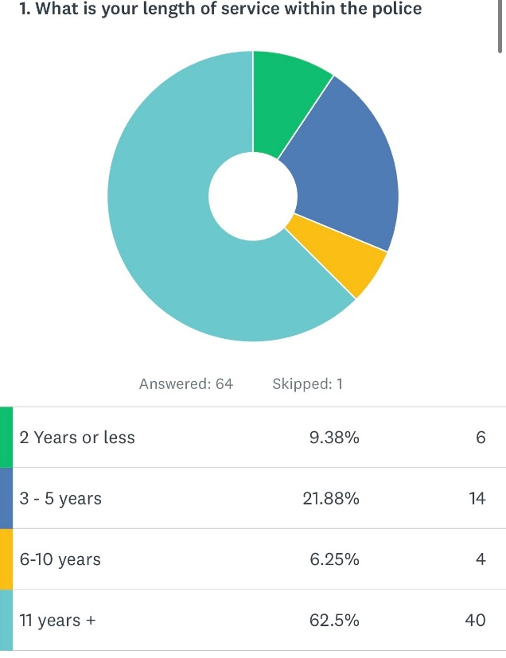

- Looking back at the Covid-19 pandemic, I would describe the pressures that I faced as a front-line officer as – The participants had four responses that they could select from. The aim of the question was to establish if officers had felt an added pressure that they hadn’t felt before the pandemic. During question one it was established that many of the officers who have answered this question had relevant experience policing pre pandemic.

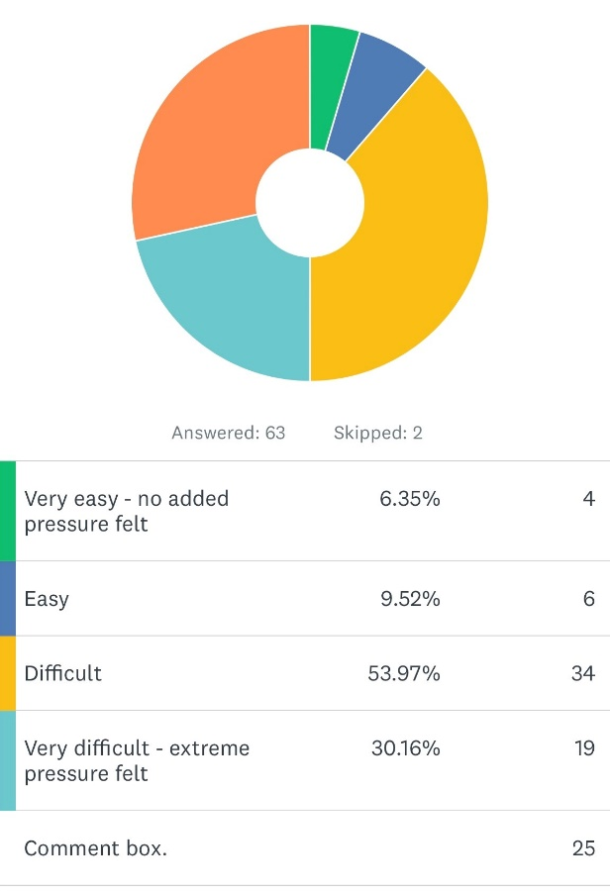

84% of respondents answered this question stating that during the pandemic they either found the pressures they faced as difficult or very difficult with extreme pressure felt. There were 25 comments left for this question, some of which are highlighted in Annex A.

Questions 3 and 4 were designed as follow up questions to question 2, with officers asked to reflect on the added pressures that police officers faced during front line policing and the potential impact that this might have had on their family life, as well as the risk of being infected with Covid-19 or infecting family members with the virus.

- Front line policing of the pandemic affected my home/ family life in a negative way-

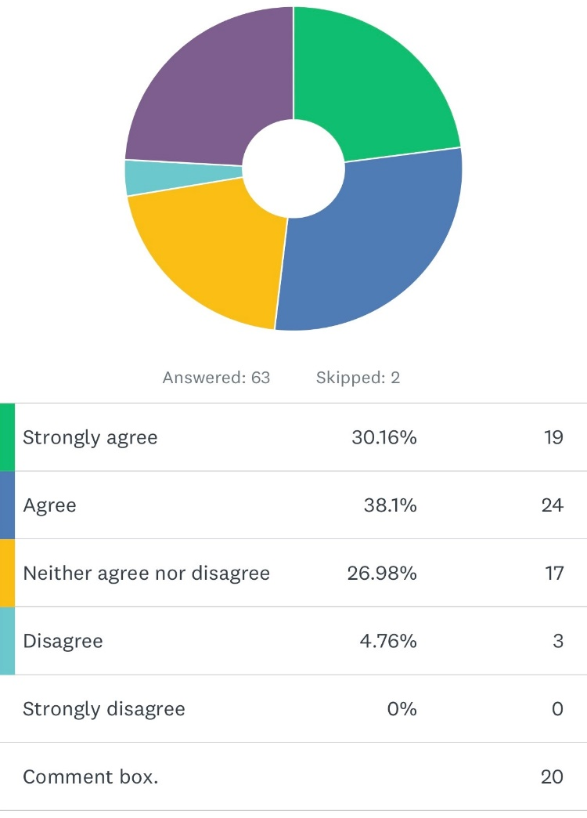

- During the pandemic, following my shift I would go home and think about the potential risk during the day/ the potential exposure to covid- 19 that I might have had.
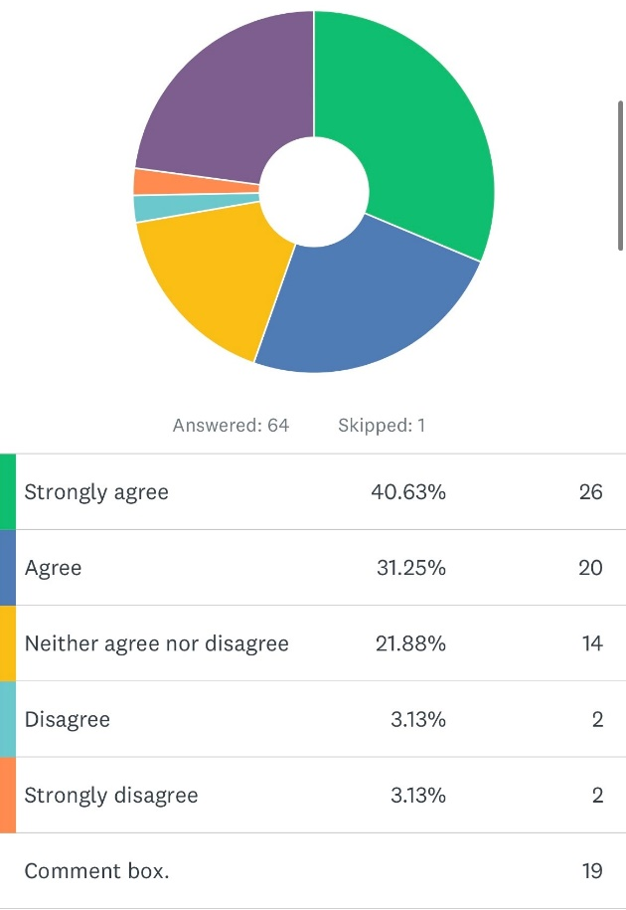
Both questions received high percentages of participants agreeing that policing within the pandemic affected their family/home life. 71.78% of participants either strongly agreed or agreed that they would finish work and reflect on the potential exposures to covid-19 that they might have had during that shift. There are however 4 participants that either disagreed or strongly disagreed with the statement.

Within the comments boxes corresponding to these questions there were a number of responses that highlight pressures that officers faced, as well as comments from the participants that stated that they disagreed with the statements, these can be found in Annex A.

Questions 5 and 6 were direct questions relating to incidents that officers have dealt with and the impact that these might have had on individuals’ mental health and how this might have affected an officer after coming off duty and trying to sleep and recuperate between shifts.

- Within the last year I have dealt with an incident that has negatively impacted on my mental health.
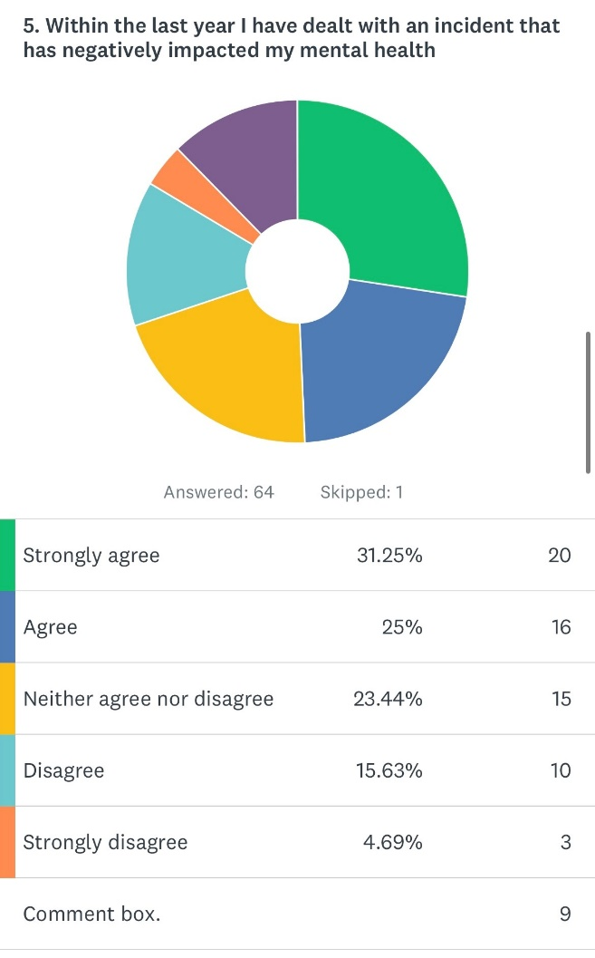
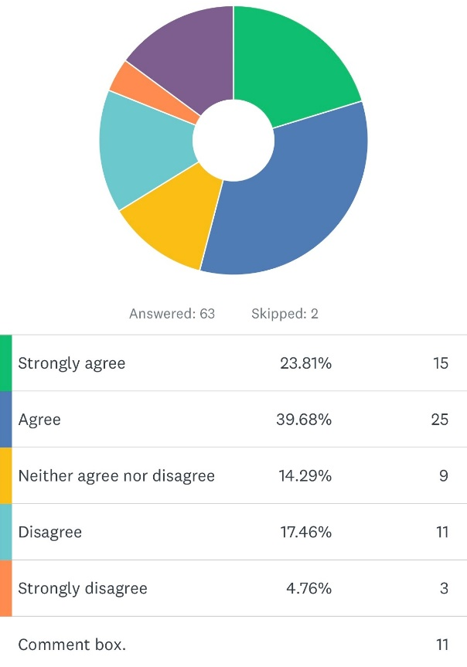
- During the last year I have struggled to sleep after dealing with an incident in work

The results to both of these questions show that 58% percent of officers felt that they have dealt with an incident that has negativly impacted on their mental health and have, as a result, struggled to unwind when not in work. Within the comments box there are a number of responses detailing what incidents officers have attended that have affected them in this way. Moreover, in response to these two questions, eleven comments have been left by participants, all of which highlight the negative impact that incidents have had on their mental health. They include comments such as ““Quite often but this does not stop me sleeping it stops me functioning way passed sleep - almost makes you think the job is not worth the risk.” and “Whilst working within the CAIU I constantly dealt with incidents that would keep me awake at night.” Comments such as these highlight the pressues that officers felt from the establishment, with officers unable to sleep due to worrying that they have missed vital information during an incident. All eleven comments made by participants are of a negative nature and highlight the pressues felt by though who took the time to respond to the survey.
Questions 7 to 9 of the survey revolve around the current workload that officers carried and the amount of police officers that make up individual departments and how this can affect individuals’ mental health.

- The workload that I currently carry has a negative impact on my mental health.

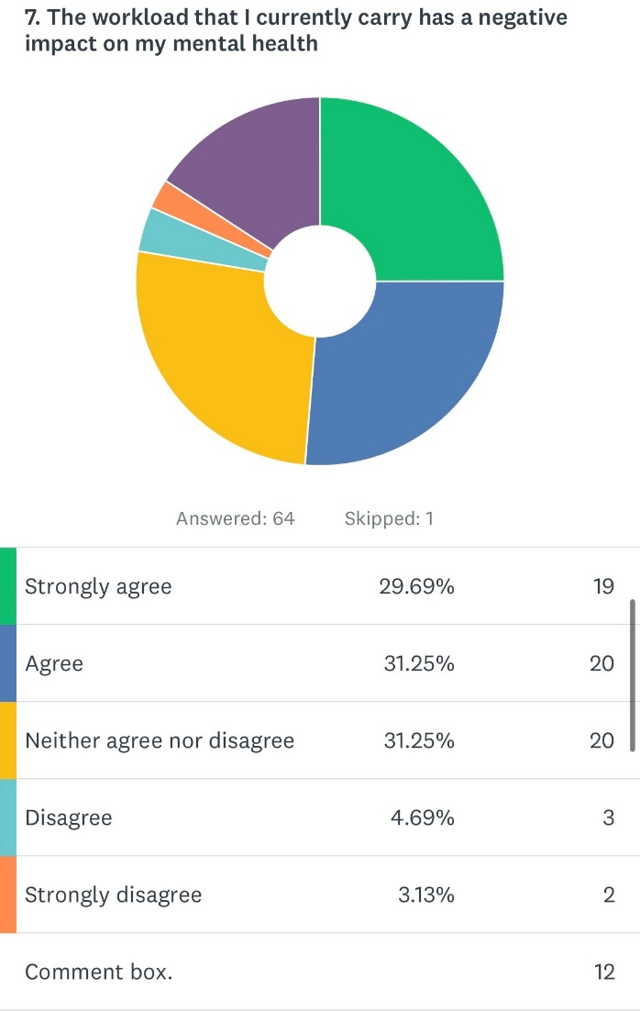

- I believe that there are enough police officers within the immediate team that I work within.
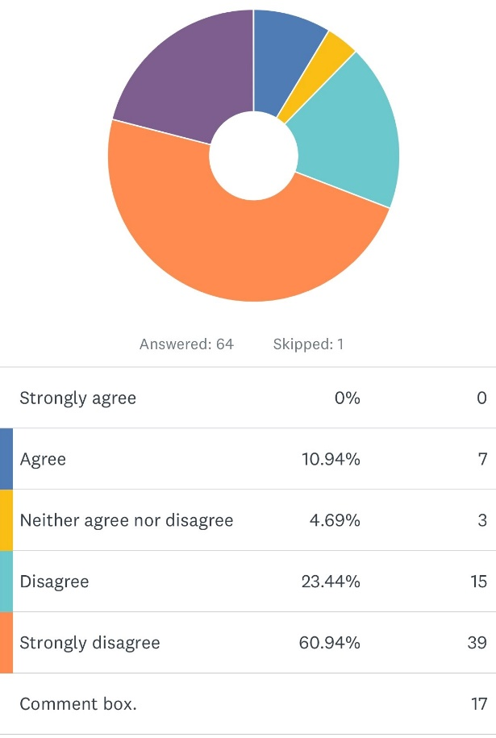

- My mental heath has improved since the recruitment of new officers has increased.
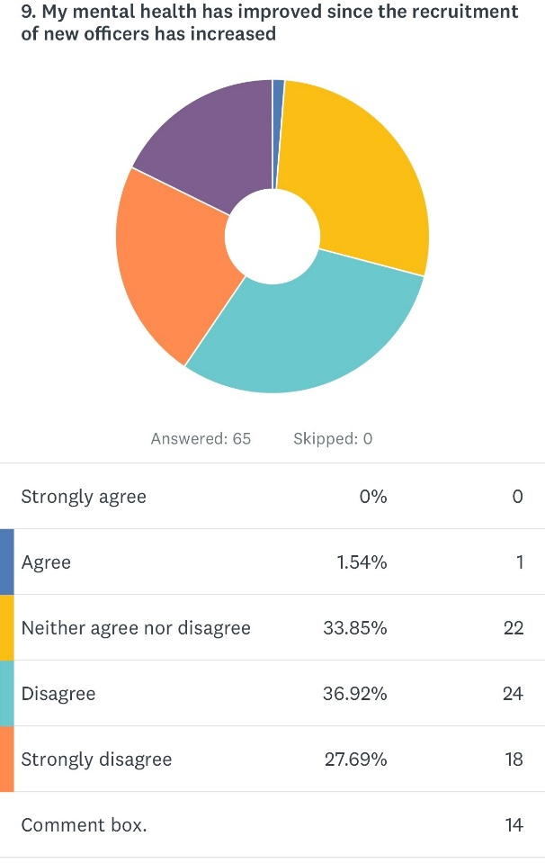

The response to these three questions were overwhelming, with over 60% of participants feeling that the workload that they carried at the time of the survey had a negative impact on their mental health. When asking participants about the current number of officers on their teams and if the recruitment drive set out by government had eleviated any pressuers that they felt, 84% of participants stated that there were not enough officers within the department they worked within, with 64% of participents stating that the current level of recruitment has had no positive impact on their mental health.

- I am aware of how to access support for my mental health if I feel that I need it and how to access this support.
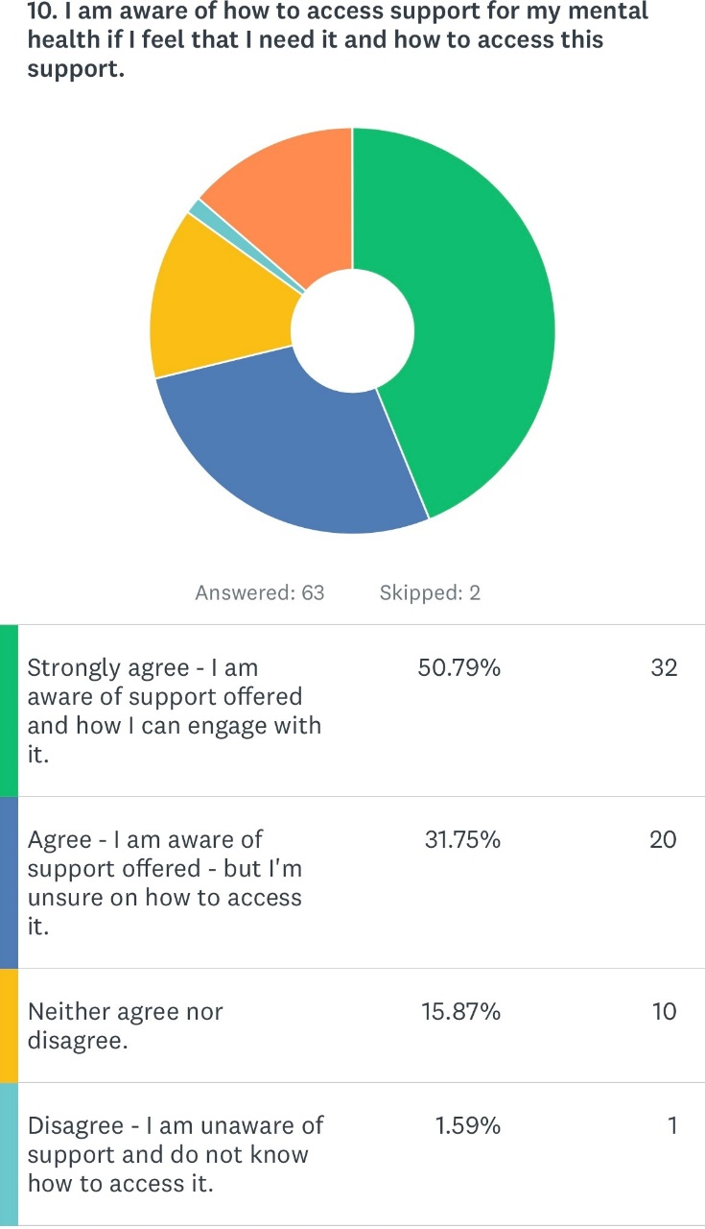

The response to question 10 highlights another issue, with 50% of respondents either unsure of how to access the support that they need or unaware of what support is available.

Within the survey, participants provided honest responses to both difficult and personal questions and the replies that have been collected have highlighted the potentially negative impact that front line policing can have on an individual’s mental health. The survey responses have also identified a potential widespread lack of knowlegde regarding available support and how to acces it.

Conclusion
The object of this dissertation was to highlight the effect that front line policing may have on individual police officers’ mental health and how this could have been further affected by the COVID-19 global pandemic. It was hoped that the research conducted would highlight both the short comings and potential positives regarding the support and systems that have been put in place by South Wales Police, as well as the wider government. By reviewing existing literature surrounding the problems that front line police officers face, as well as conducting a survey within South Wales Police’s Mid Glamorgan BCU, it is hoped that this paper will provide an insight into the current feelings regarding mental health within our Police force.

The research was undertaken to address and find answers for the following points, each of which will be discussed below-
- The pressures that police officers face day to day and how this can affect their mental health.
- Has the introduction of new officers alleviated any pressure?
- What support is there for police officers suffering with poor mental health?

- The pressures that police officers face day to day and how this can affect their mental health.

Within recent years policing has changed and has become more complex; police officers have had to adapt and do more with less. Within the literature reviewed for this dissertation there has been a number of quotes that highlight the shocking statistics that front line police officers face, “Close to one in five police officers and staff in the UK have symptoms consistent with either post-traumatic stress disorder or what is known as “complex PTSD”- yet over two-thirds of those suffering are unaware”. (University of Cambridge, 2019). This again has been highlighted when conducting the survey for this dissertation, using officers from South Wales Police as the respondents. A number of the questions asked within the survey were designed to ask participants about their current mental health and how their current role within the police might have affected this in either a positive or negative way.

The survey ran for two weeks and received sixty-five responses from individual participants, with a vast array of experience stretching from a year to twenty plus years’ worth of service. This has allowed for a collection of data from very experienced to fairly inexperienced officers. The survey has highlighted a number of issues surrounding officers’ mental health which has reinforced the data previously highlighted in the literature review; Cambridge University researchers explain that their study suggests that overall PTSD rates in law enforcement are almost five times higher than general UK population levels, last estimated at 4.4% in 2014 (University of Cambridge, 2019). When taking a broad look and summarising the outcome of the survey, it is evident that the majority of participants have been negatively affected by front line policing, with 56% of participants stating that they had dealt with an incident within the last year that had negatively affected their mental health.

There appears to be a distinct lack of literature regarding policing during the covid-19 pandemic which became apparent when conducting the literature review; there was little to no literature that covered the extra pressures that police officers may have faced during these times. When participating in the survey, participants were asked a number of questions surrounding the pandemic and how this had affected both their mental health and their family life. There were a number of shocking and concerning responses, with 71% agreeing or strongly agreeing that after working a shift during the pandemic they would return home and think about the potential risk that they could have been exposed to during that day. Participants of the survey were also asked what added pressure(s) they felt during the pandemic; 84% have described the pressure in which they felt as extreme or difficult, with participants responding with comments such as “become lonely” and “unable to see my daughter for periods of time due to involvement with persons with covid”. It has been established that officers are at a higher risk of suffering with PTSD, therefore adding the additional pressures of a pandemic to normal policing has, in this survey, categorically affected officers in a negative way.

- Has the introduction of new officers alleviated any pressure on front line officers?

There has been a number of promises made by the previous prime minister Boris Johnson, who stated that the government intended to employ an extra twenty thousand police officers within the United Kingdom, the reason for this was allegedly to lessen the pressure that front line police officers felt on a day-to-day basis. Within the literature review, it was highlighted that the general crime rate within the United Kingdom is increasing year on year; according to CrimeRate.co.uk, in the year 2021-2022 the crime rate in the United Kingdom was 79.52 per 1,000 meaning that the overall UK crime rate saw a 1.18% increase from the previous year in 2020. With the promised increase of new officers well under way, participants of the survey were asked if the new increase of officers has had any positive impact on their mental health and whether the current department in which they work contains enough members of staff.

Across the two questions, 73% of participants responded in a negative way; when asked if the participant believed that the department within which they worked had enough officers, 84% of respondents stated that they did not believe there was enough officers within their department. Of those who responded to this question it has been highlighted how the lack of experienced staff has had a negative impact on the individual and their mental health. There were a number of responses left within the comments box such as the following: “There is a clear experience and knowledge gap. Inexperienced officers are gaining promotion with no service length/experience. There are student officers tutoring new student officers. Rather than new officers being trained up gradually, they are almost immediately treated as another number and are dispatched as if they are equipped to deal with matters when, in reality, they are not.”

This is just one of the quotes left within the comments box which highlights one of the pressures that police officers deal with; attending incidents that they are too inexperienced to deal with in an effective manner adds pressure to the experienced officer dealing with that incident, as well as the wider colleagues that they are working with, and their supervisors. This can cause friction amongst the team and may harbour resentment from existing officers.

- What support is there for police officers suffering with poor mental health?

There are a large number of support agencies and support networks available to those police officers or staff that feel that they may need it. After dealing with a traumatic incident officers and staff members within South Wales Police are offered support, this is in the form of a TRiM referral (Trauma Risk incident Management) and there are a variety of out of force charities that police officers can engage with. During the survey, participants were asked if they knew what support was available to them and how to access this if they needed it. This was the most positive response that the survey had, with 82% of participants aware of what support was available for them, although there was a number of alarming responses, two of which are included the following quotes: “It is difficult to get counselling appointments. I had to wait over a year after referral as no appointments available” and “I've had counselling and spoken with a MH practitioner who believes I have complex PTSD. I was apparently put forward for further assessment with MH but never heard from them. I won’t chase it up as I don’t really want to go down that rabbit hole”.
These responses are very concerning; both police officers have acknowledged support was required and as a result engaged with said support yet have never received responses from the mental health support providers. If officers are engaging with these services, they should receive the support that they require and deserve within an efficient timeline.

Reflecting back over the dissertation as a whole, the literature addressed had highlighted the potential negative effects on police officers’ mental health, which has been emphasised by the results from the anonymous survey conducted within South Wales Police. There is however a major gap within the existing literature and previously conducted research that hasn’t taken into account the global pandemic and what affects this may have had on front line officers. Participants of the survey have been asked their views on the recruitment of new officers and it is clear from the responses given that this has had little to no effect on front line departments and has had very little effect on eliminating pressures felt by officers. There is both positive and concerning data collected regarding support that is offered to officers, the positive is that the majority of officers are aware and know how to engage with this support. However, there are a number of occasions where officers have asked for support yet have been left waiting for spaces for counselling or have been forgotten about, which needs to be addressed by force leaders. Moreover, it is apparent that the global pandemic has had a negative impact on those who have participated in the survey as well as their families.

Recommendations
The survey has been sent out within the Mid Glamorgan Basic Command Unit and has gained 65 responses. In order to further explore the issues that have arisen from the pandemic and to identify if the current recruitment drive that has been promised by the government has been successful, the survey could be sent force wide to cover a wider group of officers and to obtain a larger response.
Of the 65 responses, just over 84% of participants either strongly disagreed or disagreed when queried about having enough police officers within their immediate team. This would suggest that the current working levels are felt to be non satisfactory and could be a starting point for South Wales Police as an institute when looking at ways to improve general moral. However, in cases where new officers had been recruited, the survey attracted negative responses, with only 1.5% of respondents stating that they agreed that this recruitment had led to an improvement within their mental health. Amongst those who disagreed, from the qualitative data gathered it was clear that there is an issue with staff retention, with majority of teams formed of young in-service officers, causing concern amongst the participants. Therefore, it is recommended that South Wales Police source a solution to retain experienced officers.
MIND, the mental health charity, have previously been quoted highlighting the issues that the lockdown has had on the general public, “More than two thirds of adults with mental health problems reported that their mental health got worse during lockdown. As a direct consequence of the pandemic and all that follows, many people who were previously well will now develop mental health problems” (MIND, 2020). From the survey it has been established that front line police officers who, as the literature review explains, as a collective are already at a higher risk of developing a mental health problem, have found the pandemic extremely hard.
It is vital that officers that are suffering with their mental health seek the help that they need. Fortunately, within the survey, 82% of officers who responded have stated that they are aware of how to seek help if they require it. However, numerous concerning comments from officers were made, for example “I've had counselling and spoken with a MH practitioner who believes I have complex PTSD. I was apparently put forward for further assessment with MH but never heard from them. I won’t chase it up as I don’t really want to go down that rabbit hole.” It is essential that Supervisors and officers have regular and easily accessible up to date training to help identify and signpost people that may be struggling to access or move forward with support that they might require.

Annex A – The responses below are direct quotes made by participants in the comments boxes after each question. The quotes provde qualitative data, reinforcing the analysis above.

Question 1 –
- “I was fortunate enough to be in a role where I could work from home. This minimised the impact of covid for me compared to others. However, my partner is also a police officer, who was coming into contact with MoP on a daily basis, risking bringing covid back into our home with our young children.”

- “Policing was different, sometimes difficult and sometimes the calls were just ridiculous.”

- “Limited services to attend calls, and police filled the gaps with little PPE.”

- “At the time afraid dealing with suspects. Having to be hands on with little PPE and then having to go home to family afraid that they would contract COVID and out them at risk.”

- “As a response officer at the time, I showed up, did my job and went home. There were pressures when shift members went off with covid (including myself) but they were short term.”

- “My dad is vulnerable - and cared for by my mam. my mother-in-law cares for her mother, who is also vulnerable. usually the mothers would assist with my childcare but because of the risks of me going to work, they rightfully couldn’t help me with childcare. south Wales police weren’t interested in my childcare problems - even though I was promised a role where I could work from home (if I worked from home my mother’s would have had the kids, as no risk to me). SWP just wanted me back at work, which meant my husband had to take 6 months from work. this affected us financially and put a massive strain on our family life.”

- “Having to attend work during a time when the advice was to stay home and deal with members of the public who mainly disregarded government instructions putting themselves and attending/dealing officers at risk.”

Question 2
- “Shift work as normal. Only extra pressure was when schools were closed and parents had to home school children.”

- “Caught covid ended up in hospital.”

- “Everyone I knew was working from home and safe with their families as I was constantly isolated from family to safeguard them or threatened with disciplinary action.”

- “Made ill for weeks and haven’t fully recovered - yet felt obliged to have to return to work.”

- “I personally was unable to see my daughter for periods of time due to my potential involvement with persons with Covid.”

- “Because I was not able to self-isolate to the level of 'normal' members of the public, I had to isolate myself from members of my own household, my son as asthma and was at risk.”

- “Times where I would go to someone deceased that may have been through covid. I would need to automatically isolate from my family. before the stringent rules came in. also people would not say straight away they have covid so you only find out later and need to isolate again.”

- “I caught covid, no doubt whilst on duty because we couldn't go anywhere else. This was then in turn passed to other members of my household who suffered its effects. Also cancelled rest days to cover shifts that had been hit by covid was a regular thing and disproportionally impacted response teams as other departments were rarely utilised to cover the vacant response slot. This was pure laziness on behalf of those planning resilience as its easier to cancel response RD's than fight to get other departments to do front line policing.”

Question 3
- “Became lonely.”

- “We were still active on the frontline and worried about catching COVID and bringing it home, my family avoided me as much as possible to stay safe.”

- “Although there was a consistent fear of the virus, my family unit was strong and if anything brought us closer together.”

- “Partner is vulnerable with no spleen. Slept in separate rooms and avoided contact throughout pandemic.”

- “I caught covid, no doubt whilst on duty because we couldn't go anywhere else. This was then in turn passed to other members of my household who suffered its effects. Also cancelled rest days to cover shifts that had been hit by covid was a regular thing and disproportionally impacted response teams as other departments were rarely utilised to cover the vacant response slot. This was pure laziness on behalf of those planning resilience as its easier to cancel response RD's than fight to get other departments to do front line policing.”

- “Times where I would go to someone deceased that may have been through covid. I would need to automatically isolate from my family. before the stringent rules came in. also people would not say straight away, they have covid so you only find out later and need to isolate again.”

- “Because I was not able to self-isolate to the level of 'normal' members of the public, I had to isolate myself from members of my own household, my son as asthma and was at risk.”

- “I personally was unable to see my daughter for periods of time due to my potential involvement with persons with Covid.”

- “Made ill for weeks and haven’t fully recovered - yet felt obliged to have to return to work.”

- “Everyone I knew was working from home and safe with their families as I was constantly isolated from family to safeguard them or threatened with disciplinary action.”

- “Caught covid ended up in hospital.”

Question 4
- “Yes as above, I was worried sick about passing COVID on to my family and did not visit my parents for months which had a huge effect on my mental health and theirs.”

- “There' two through processes to deal with in this question. The first is the virus itself and how it would affect myself and my family. The second is that it gives you perspective and makes you thankful for what you have.”

- “Attended a number of calls with covid positive people, including at a covid ward. This had knock on implications with my family life due to having to do extra tests and mitigating risks to vulnerable family members.”

- “Colleagues’ children dying of covid . also not being able to visit a parent during her final months of life.”

- “Daily. Before interacting with family when getting home, I immediately 'decontaminated' by showering and putting my work clothes straight into the washing machine.”

Question 5
- “Dealing with mental health calls are draining especially when it is regular customers who are under the influence and not genuine.”

- “Child death.”

- “The work that’s expected with the minimal staff has caused a great stress for me.”

- “Yes - SWP have been the cause due to lack of support and or help - not the actual incident.”

- “Welfare check on a male attended and male was found hanging in his house. Appeared he had been there for around a week.”

Question 6
- “Whilst working within the CAIU I constantly dealt with incidents that would keep me awake at night.”

- “I've never had issues with mental health prior to joining the police.”

- “Sort of, I always struggle to sleep, its not so much the incidents that would keep me awake, its the concern if I missed anything, or forgot to do something that causes anxiety as that would let loose the morning after squad and their cronies to tear you apart.”

- “Suicide on main line train tracks without any proper support from SMT on the day.”

- “I was investigated by PSD following an incident. This still causes suffering three years later.”

- “Quite often but this does not stop me sleeping it stops me functioning way passed sleep - almost makes you think the job is not worth the risk.”

Question 7
- “Workloads are UNMANAGEABLE! The demand on police, coupled with us taking on responsibilities that, in my opinion, should belong to other agencies is unsustainable. This, coupled with society’s inability to take responsibility for their own actions, resulting in constant “arse covering” in case someone complains etc. takes too much time and prevents me from being able to do my job effectively.”

- “The workload is huge and our net demand and responsibilities are forever expending where it seems as other departments of the police force is shrinking in comparison to response.”

- “Well not so much now as I'm off response but when I was on its insane. Most problems are caused by the insanely difficult file building process these days and the gremlins in the case progression unit who bounce files based on mostly opinion.”

- “My workload is manageable within the unit I currently work. However, this wasn't the case when I was a response Sergeant which, in my opinion, is the hardest and most stressful role here is!”

Question 8
- “Short of Officers is common. The PLT, training days for student Officers (2 a month in most cases), reduces numbers even more. 4 out of 7 on my shift are student Officers.”

- “Very understaffed across all front-line policing.”

- “Now there are however this is only within the last couple of weeks. These are all probationers and are regularly abstracted due to attachments training and university work.”

- “The requirements and targets set by the SMT are unrealistic with the resources at our disposal.”

Question 9
- “There is a clear experience and knowledge gap. Inexperienced officers are gaining promotion with no service length/experience. There are student officers tutoring new student officers. Rather than new officers being trained up gradually, they are almost immediately treated as another number and are dispatched as if they are equipped to deal with matters when, in reality, they are not.”

- “An increase in new officers will not have a positive effect on my mental health.”

- “They are not posted within my role so the only impact of new officers is having to train them alongside my own work when they do attachments.”

- “While there may be new officers coming through, they are barely covering those that we naturally shed due to retirement and role changes. plus they still have to learn the ropes and that can take 5 years on response. we are nowhere near running on full strength.”

- “There is a high turnover due to officers being recruited into other departments. It does not feel like there has been an increase of officers on response. Instead it feels like everyone is brand new and lacking experience.”

- “The damage has already been done.”

- “The new recruitment doesn't show an accurate picture. Yes there appears to be more numbers however, those new officers have commitments outside of the role which means the abstractions involved makes the situation worse than it was before the recruitment campaign. The experience lost from the front line is catastrophic which means the foundations are not strong enough for the police to provide the best possible service to the community we serve.”

Question 10
- “Diagnosed with complex PTSD from work related incidents PC with 20-year service.”

- “It is difficult to get counselling appointments. I had to wait over a year after referral as no appointments available.”

- “There is support in force and I know how to access it but there are capacity issues.”

- “I've had counselling and spoken with a MH practitioner who believes I have complex PTSD. I was apparently put forward for further assessment with MH but never heard from them. I won’t chase it up as I don’t really want to go down that rabbit hole.”

Bibliography
Police Federation. “Mental Health.” Www.polfed.org, 2016,
Available at: www.polfed.org/our-work/wellbeing/mental-health/. Accessed: 09.06.2022

Politics.co.uk. “Police Numbers - All You Need to Know.” Politics.co.uk, Mar. 2021,
Available at: www.politics.co.uk/reference/police-numbers-and-recruitment/#:~:text=In%202019%2C%20Prime%20Minister%20Boris. Accessed: 09.06.2022

AXA HEALTH. “Homepage.” AXA Health, 2022, available at –
www.axahealth.co.uk/health-information/mental-health/resilience/#:~:text=Psychological%20resilience%20is%20the%20ability. Accessed 20 July 2022.

College of Policing. “COVID-19: An Appraisal of the Police Response to the Pandemic.” College of Policing, 2021, available at
www.college.police.uk/article/covid-19-appraisal-police-response-pandemic.

CrimeRate.co.uk. “UK Crime and Safety Statistics | CrimeRate.” available at
Crimerate.co.uk, 2022, crimerate.co.uk/.

Edwards, Ann-Marie, and Yasuhiro Kotera. “Policing in a Pandemic: A Commentary on Officer Well-Being during COVID-19.” Journal of Police and Criminal Psychology, 24 July 2021, available at 10.1007/s11896-021-09469-4. Accessed 29 July 2021.
Gov.uk. “Annex: Statistics on the Number of Police Officers Assaulted in the Year Ending March 2021, England and Wales.” GOV.UK, 28 July 2021,
available at www.gov.uk/government/statistics/police-workforce-england-and-wales-31-march-2021/annex-statistics-on-the-number-of-police-officers-assaulted-in-the-year-ending-march-2021-england-and-wales.

Jones, Laura. “Police “Dealing with More Mental Health Incidents.”” BBC News, 2 Sept. 2019, available at www.bbc.co.uk/news/uk-49317060.

Kevin M. Gilmartin, Ph.D. “HYPERVIGILANCE.” Emotionalsurvival.com, 1986, available at emotionalsurvival.com/hypervigilance.htm.

Michael, Rt Hon Alun. Policing and Partnership in Wales. 2018.
MIND. “What Are Mental Health Problems?” Www.mind.org.uk, 2022, available at www.mind.org.uk/information-support/types-of-mental-health-problems/mental-health-problems-introduction/about-mental-health-problems/?gclid=EAIaIQobChMIod-Z2YOH-QIVkYBQBh0mpQbiEAAYAiAAEgIrp_D_BwE.

Mind. The Mental Health Emergency. June 2020.
National Police Memorial. “National Police Memorial Day.” Www.nationalpolicememorialday.org, 2022, available at www.nationalpolicememorialday.org/history.html. Accessed 23 July 2022.

University of Cambridge. “Police Workforce: Almost One in Five Suffer with a Form of PTSD.” University of Cambridge, 9 May 2019, available at www.cam.ac.uk/policeptsd.

---. “Police Workforce: Almost One in Five Suffer with a Form of PTSD.” University of Cambridge, 9 May 2019, available at www.cam.ac.uk/policeptsd#:~:text=Close%20to%20one%20in%20five.

WebMD. “What Is Hypervigilance?” WebMD, 2021, available at www.webmd.com/mental-health/what-is-hypervigilance#:~:text=disrupt%20that%20process.-. Accessed 23 July 2022.

AXA HEALTH. “Homepage.” AXA Health, 2022, available at www.axahealth.co.uk/health-information/mental-health/resilience/#:~:text=Psychological%20resilience%20is%20the%20ability. Accessed 20 July 2022.

College of Policing. “COVID-19: An Appraisal of the Police Response to the Pandemic.” College of Policing, 2021, available at www.college.police.uk/article/covid-19-appraisal-police-response-pandemic.

CrimeRate.co.uk. “UK Crime and Safety Statistics | CrimeRate.” Crimerate.co.uk, 2022, available at crimerate.co.uk/.

Edwards, Ann-Marie, and Yasuhiro Kotera. “Policing in a Pandemic: A Commentary on Officer Well-Being during COVID-19.” Journal of Police and Criminal Psychology, 24 July 2021, available at 10.1007/s11896-021-09469-4. Accessed 29 July 2021.

Gov.uk. “Annex: Statistics on the Number of Police Officers Assaulted in the Year Ending March 2021, England and Wales.” GOV.UK, 28 July 2021, available at www.gov.uk/government/statistics/police-workforce-england-and-wales-31-march-2021/annex-statistics-on-the-number-of-police-officers-assaulted-in-the-year-ending-march-2021-england-and-wales.

Jones, Laura. “Police “Dealing with More Mental Health Incidents.”” BBC News, 2 Sept. 2019, available at www.bbc.co.uk/news/uk-49317060.

Kevin M. Gilmartin, Ph.D. “HYPERVIGILANCE.” Emotionalsurvival.com, 1986, available at emotionalsurvival.com/hypervigilance.htm.

Michael, Rt Hon Alun. Policing and Partnership in Wales. 2018.
MIND. “What Are Mental Health Problems?” Www.mind.org.uk, 2022, available at www.mind.org.uk/information-support/types-of-mental-health-problems/mental-health-problems-introduction/about-mental-health-problems/?gclid=EAIaIQobChMIod-Z2YOH-QIVkYBQBh0mpQbiEAAYAiAAEgIrp_D_BwE.

Mind. The Mental Health Emergency. June 2020.
National Police Memorial. “National Police Memorial Day.” Www.nationalpolicememorialday.org, 2022, available at www.nationalpolicememorialday.org/history.html. Accessed 23 July 2022.

University of Cambridge. “Police Workforce: Almost One in Five Suffer with a Form of PTSD.” University of Cambridge, 9 May 2019, available at www.cam.ac.uk/policeptsd.
---. “Police Workforce: Almost One in Five Suffer with a Form of PTSD.” University of Cambridge, 9 May 2019, available at www.cam.ac.uk/policeptsd#:~:text=Close%20to%20one%20in%20five.

WebMD. “What Is Hypervigilance?” WebMD, 2021, available at www.webmd.com/mental-health/what-is-hypervigilance#:~:text=disrupt%20that%20process.-. Accessed 23 July 2022.

Illinois Criminal Justice Authority (2022). ICJIA | Illinois Criminal Justice Information Authority. [online] icjia.illinois.gov. Available at: https://icjia.illinois.gov/researchhub/articles/understanding-police-officer-stress-a-review-of-the-literature. - Accessed 05 August 2022.
Holleranconsult. “The Pros and Cons of Anonymous Surveys.” Holleran, 19 Feb. 2020, available at holleranconsult.com/2020/02/the-pros-and-cons-of-anonymous-surveys/.

Hoover, Lissie. “What Is Qualitative vs. Quantitative Study?” GCU, 1 June 2021 available at, www.gcu.edu/blog/doctoral-journey/what-qualitative-vs-quantitative-study#:~:text=Quantitative%20studies%20rely%20on%20numerical.

Noble, Helen, and Joanna Smith. “Qualitative Data Analysis: A Practical Example.” Evidence Based Nursing, vol. 17, no. 1, 20 Nov. 2013, available at pp. 2–3, ebn.bmj.com/content/17/1/2, 10.1136/eb-2013-101603.

Western Sydney University. “Definition of Research.” Westernsydney.edu.au, John H. Gonzaga, 2019, available at www.westernsydney.edu.au/research/researchers/preparing_a_grant_application/dest_definition_of_research.

