Contents
Assignment Brief 3
Review of portable weather systems 3
Market Products 4
Component Selection 8
Temperature Sensor 8
Humidity sensor 9
Wind Speed 11
Air Borne Particle Sensor 13
Sunlight Brightness Sensor 14
UV Sensor 15
VOC Sensor 16
GPS Sensor 17
Sensor Calculations and Timings 17
Non-volatile memory 18
Microcontroller selection 19
Casing 20
Connectors 20
Battery 21
System layout & PCB design 21
PIC, SD, USB, GPS, START/STOP 22
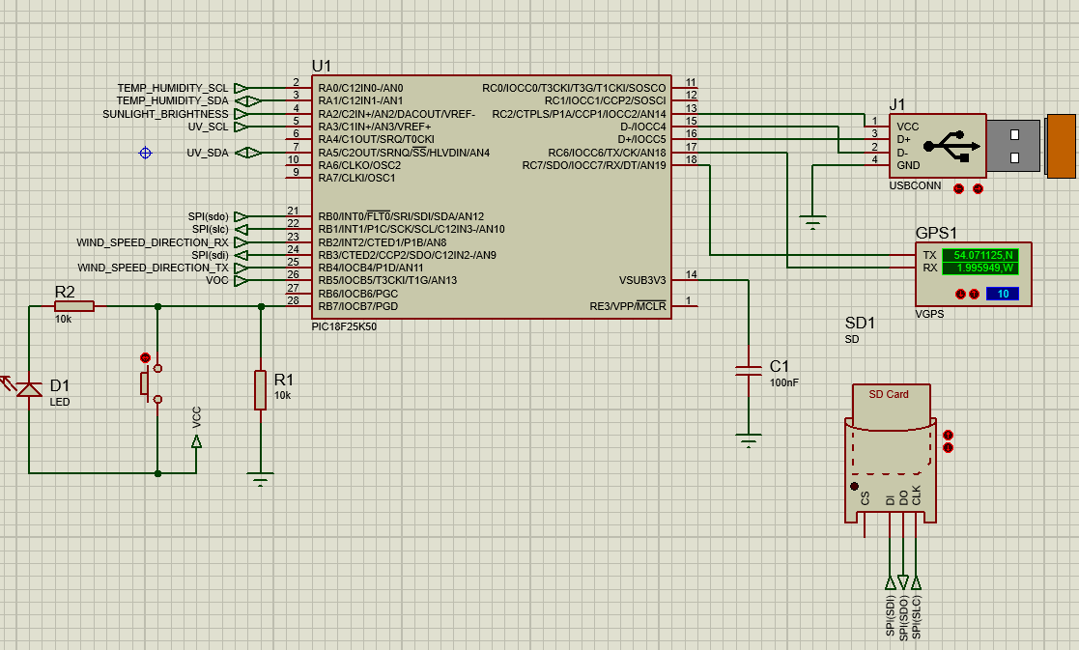 22
Sunlight, Air borne 22
VOC 23
Temp&humidity, wind speed&direction, UV 23
Voltage Reg 24
EasyPC 24
Costing 30
PCB Quote 31
Improvements of Spec 31
LCD Display 31
Solar charger 31
Tripod 32
References 32

Assignment Brief

You are required to design a simple microcontroller-based weather and air quality monitor/logger which takes measurements and logs the data over a 14-day period.

The data acquisition system is intended for use by amateur weather forecasters to aid in their predictions. The system must be portable and adaptable for any number of potential monitoring sites.

The following data will be acquired during the 14-day cycle:-
- Temperature
- Humidity
- Wind Speed
- Wind direction
- Air borne particle count
- Sunlight brightness
- UV levels
- GPS position
- VOC level

Review of portable weather systems

Portable weather systems, are comprised of a number of sensors, that measure different parameters of weather. For example, temperature, humidity, wind speed, etc. These systems are designed with the intended purpose of being placed in an outdoor area, and left for a period, to collect, and sometimes transmit, data about the weather in that area. They are designed to run via a microcontroller. Because of this, and the harshness of the environments which they are placed in, good weather systems are built with outdoor protection, to IP standards. They also need to be collapsible, easily setup, and lightweight. Ideally they are supplied with a carrying case that holds all components.

Market Products
In order to understand some of the commonalities between market weather systems, a comparison of some market leading products has been made. This can be seen below.
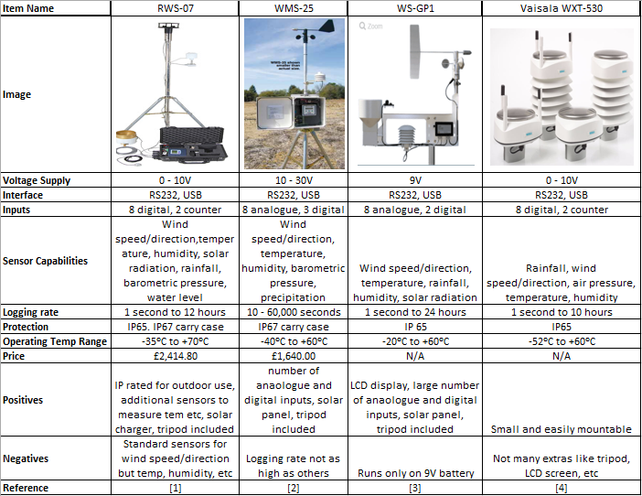

RWS-07
The RWS-07, available at Omni Instruments, utilises RS232 and USB interfaces. It has the ability to use eight digital and two analogue inputs, giving a wide range to the sensing options. These options include, wind speed/direction, air temperature, humidity, solar radiation, rainfall, barometric pressure, and water level. It has a wide range of logging, and at its peak can take readings every 12 hours. This diverse logging range allows for different accuracies of data being collected, and prevents needless data being collected in some fields. This system includes a tripod for better wind readings, and has IP65 rated components, and an IP67 carry case. It is highly suitable to harsh weather. One downside of this system is that not all of its sensors are standard, they are add-ons. The systems utilises an LCD display to track real time data.
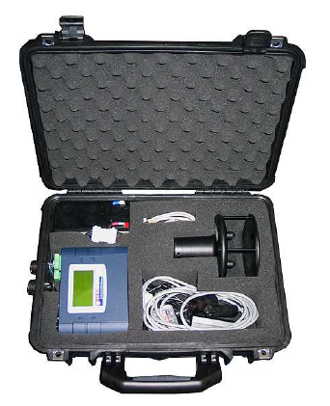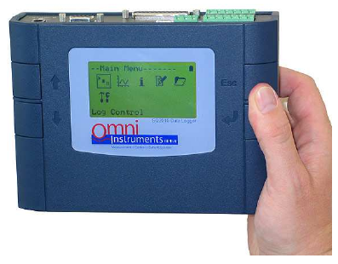

WMS-25

The WMS-25 uses RS232 and USB interfaces. Like the previous system, it has eight digital inputs, but includes a higher three analogue inputs. It measures for temperature, humidity, wind speed/direction, barometric pressure, and precipitation. Unlike the RWS-07, this system has a much lower logging range. It ranges from one second to 60,000 seconds, giving less spread in its readings, therefore it must take a reading at least every 60,000 seconds. In the case of something like GPS coordinates, this is not very useful. The WMS-25 also has a higher voltage range than any of the others compared, so components in this system will certainly have been attenuated. Extras included in this system are a tripod, and IP67 rated carry case. Below is a view of how data is displayed via a PC terminal.
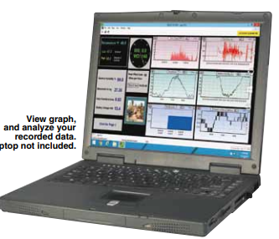

WS-GP1

Like the previous systems, the WS-GP1 uses RS232 and USB interface, and eight digital, two analogue inputs. It measures wind speed/direction, temperature, humidity, and solar radiation. This system has the highest logging range of any of the compared systems. All components involved are IP65 rated,. Extras included in this system are a tripod, and LCD display. One drawback of this system is that it only runs on a 9V battery, which could be limiting.

Vaisala WXT-530

This system uses RS232, USB, and a mixture of eight digital, two analogue inputs, to provide a range of data. Data collected includes rainfall, wind speed and direction, air pressure, and humidity. The logging rate is one second, to ten hours. Unlike the other systems, this is not a complete package as it does not include a carry case, tripod, LCD display etc. It does include all relevant sensors, all IP65 rated, but these must be setup in conjunction with additions that need to be provided via a second tier supplier.
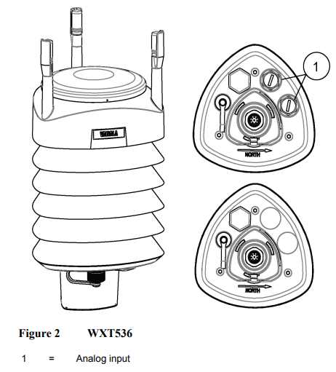
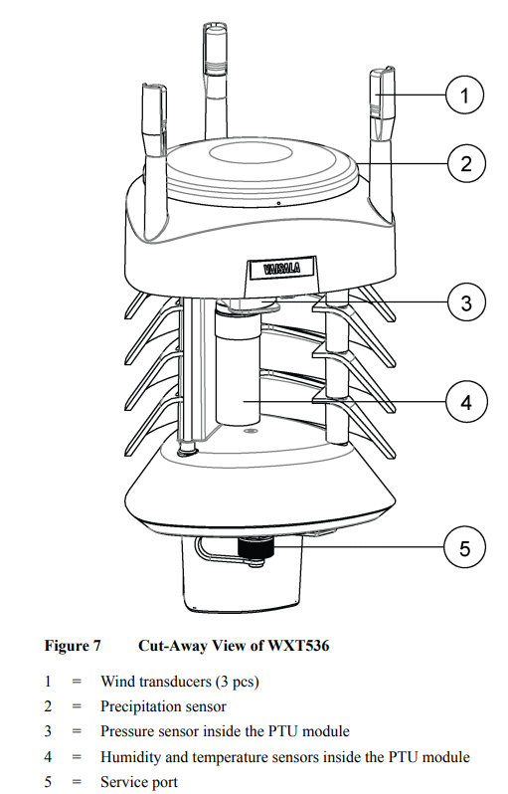

Component Selection

In order to select the appropriate sensor, for each function, a comparison was made for each field, looking at different attributes of the sensors. From this, an appropriate sensor has been selected for all data fields. The compared factors of each table have been chosen in relation to what is important when reading each field of data. Below are the comparison of each sensor type.

Temperature Sensor
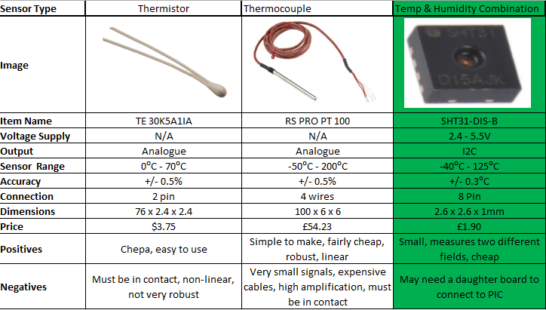

The above table shows different types of sensors that could be used to measure air temperature. In order to perform this task, a combination sensor, that would measure temperature & humidity, was chosen. The reasoning behind this was to reduce the number of sensors within the PCB. These sensors are also small and cheap, and can be connected via a daughter board, and I2C, to link with the main PCB. The sensor will need to be placed on the outside of the casing, facing towards the ground. This is so that it can be in ambient air to take proper readings of both temp and humidity, but needs to be facing downwards so that it is shielded from rain. If rain were to collect on the surface, it would provide a false reading of air humidity.
Thermocouples and thermistors were also considered for use. They were discounted as they were not as robust, and might not survive the elements, coupled with only being able to perform one function.
After the combination sensor had been chosen for use, an analysis of other combination sensors was made, to make a better choice on the correct sensor to use. This table can be seen below.

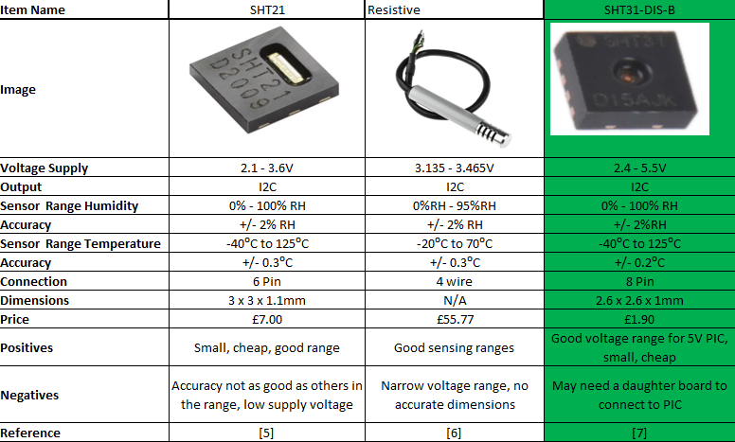
The above table shows three combination sensors that were considered for use. The SHT31 DIS-B was chosen for use in this project. It was chosen for the following reasons.
- Higher voltage range than others, will not need to be attenuated to such a degree
- Very small, will not take up much room on PCB
- Full range of relative humidity
- Good operational temperature range, more than capable of operation within the UK

Humidity sensor
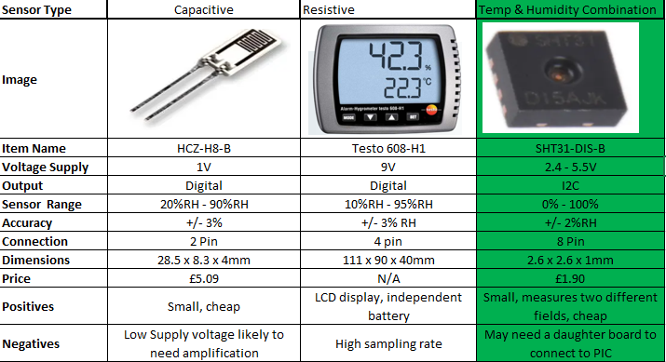

The above table shows three different types of humidity sensor, that could be used within this weather system. Again, the combination sensor was chosen. It was chosen for the same reasons as with temperature. Capacitive sensor was discounted, as its supply voltage was very low, and would need amplification to work within the system. Resistive had some positives, like independent battery source, but ultimately the dual sensing field was deemed to be more important.
In order to decide on a combination sensor, three were compared. This can be seen below.
The SHT31 DIS-B was chosen for use in this system, for the same reasons as in the temperature comparison.

Wind Speed
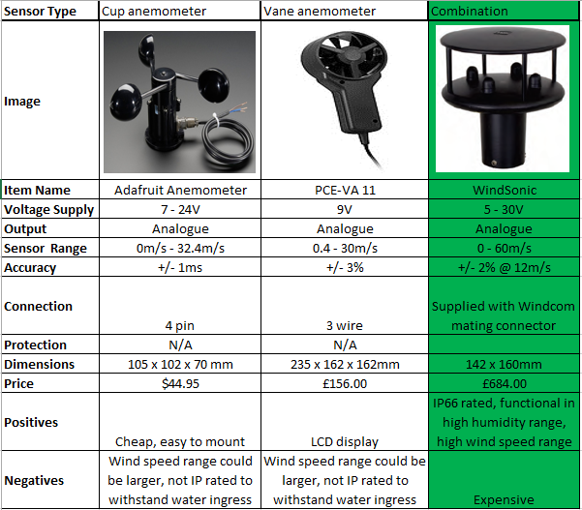
The above table shows the types of sensor that were considered for wind speed measurement. Again a combination sensor was chosen as the best option. This was because it could measure two fields at once, saving on circuitry, PCB space, and overall system space/weight. The cup anemometer and vane anemometer were discounted as they did not have as large a range of wind speed measurement. Also, many were not IP rated.

After choosing the combination sensor, an analysis of three combination sensors was made. This can be seen below.
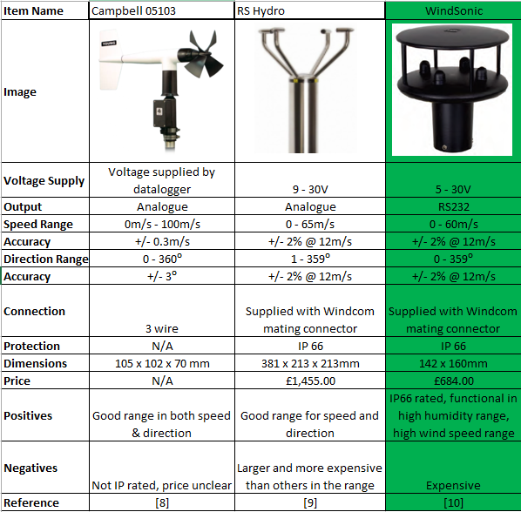
From the table, the Windsonic combination sensor has been chosen. It has been chosen for the following reasons.
- IP66 rated
- It is supplied with its own connector
- It has a wide range of wind measurement speeds
- Good level of accuracy
- Full range of wind direction measurement

Air Borne Particle Sensor
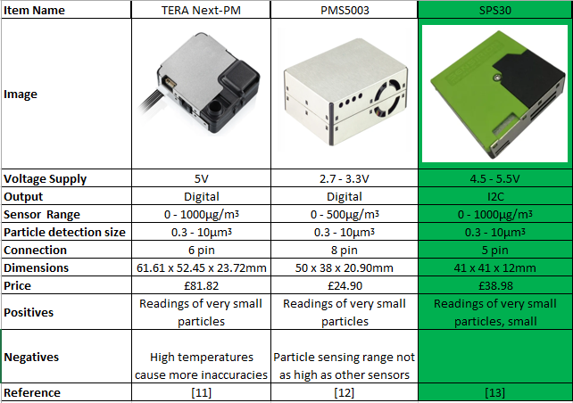
Three sensors were compared before selection for use within the weather system. They can be seen above. All sensors were similar in many areas, but one (the SPS30) excelled above the others. This is because of the following
- Uses I2C interface, so that it can be connected using software
- Wide sensing range
- Good level of particle size, detection
- Voltage range good for use with microcontroller

Sunlight Brightness Sensor
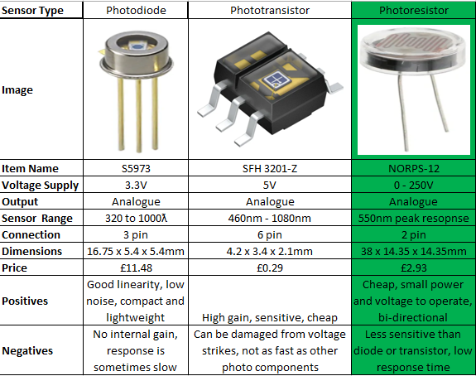
For sunlight brightness measurement, three types of sensor were compared. These can be seen above. A photo resistor, was chosen as the most suitable for use in this system. This is because it has a large voltage range, and peak voltage. These sensors are small, cheap, and bi-directional. The reason that photodiode and photo transistor, were discounted, is that the gain is small on them, and the photo transistor can be damaged by voltage spikes.
In order to select the best photo transistor, three were compared. This can be seen below.
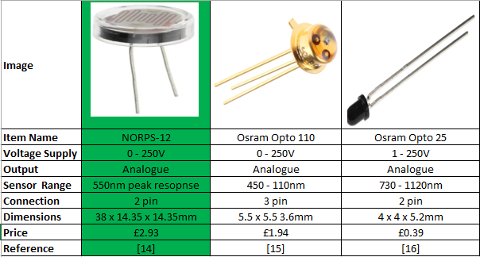
From these three, the NORPS-12 has been chosen for use. This is because of the following reasons
- Small, cheap, easy 2 pin connection
- Has a range from 0 – 550nm. The others do not start at 0nm

UV Sensor
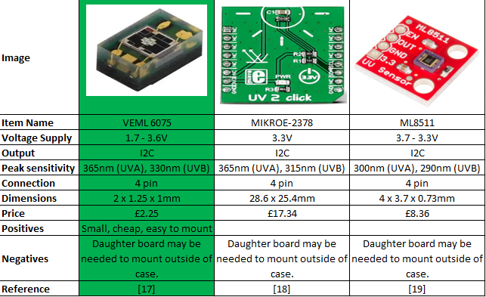
Three UV sensors were compared for use, they can be seen above. The VEML 6075 was chosen for the following reasons.

- Has the best spectral range of those compared
- Cheapest of those compared
- Small, easy to mount
- I2C allows for software connection between boards

VOC Sensor
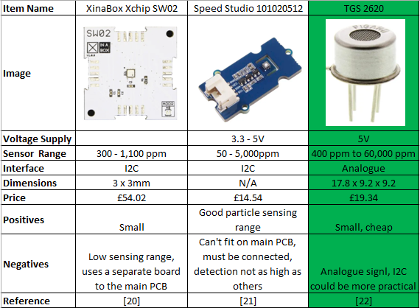
Above is a comparison of three VOC sensors, that could have been used for this system. The TGS-2620 was chosen for use, for the following reasons.
- Suitable voltage range for microcontroller
- Small and cheap
- Very high particle sensing range, more suited to different types of particle detection

GPS Sensor
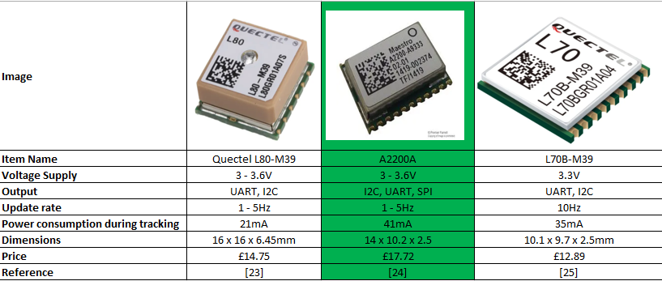
Above is a comparison of three GPS sensors. The AA2200A was chosen for the following reaons.
- Multiple interface choices
- Small, cheap
- I2C makes it easy to connect via software

Sensor Calculations and Timings

All sensor timings have been deduced from market research.

Temperature and Humidity
Temperature and humidity readings will be taken every 30 seconds, as they are both read on one sensor. This sensor will use 1 I2C output.

Wind Speed & Direction
Wind speed and direction will be read at a rate of one reading per 0.2s. This sensor uses one RS232 output.

Air Borne Particle
Air borne particle readings will be taken once every 30 seconds. The air borne particle sensor uses one I2C output.

Sunlight Brightness
Sunlight brightness readings will be taken once every seconds. The airborne particle sensor uses one analogue output.

UV Level
UV levels are read once every 5 seconds. UV sensor uses one I2C output.

GPS
GPS is read once, on first use of the system. Once the system starts, a GPS reading is taken, and this is the only reading needed for the duration of the 14 days.

VOC Level
VOC readings are read every 10 seconds. VOV sensor uses 1 analogue output.

Non-volatile memory
From the timings given above, it is possible to calculate readings per cycle (30s is cycle time as it is the longest reading). This gives the following.
Sensor | Rate of data transmission | Readings per 30s | Bytes
Temp & Humidity | 30s | 1 | 1
Wind speed & direction | 0.2s | 150 | 300
Air borne | 30s | 1 | 1
Sunlight brightness | 1s | 30 | 60
UV | 5s | 6 | 6
GPS | 1 reading only | 1 | 1
VOC | 10s | 3 | 3
 |  |  | 372
Analogue outputs for wind speed/direction, and sunlight brightness are multiplied by two, as the readings are used in a 10bit analogue to digital converter. As this calculation is for 30s timings, a calculation must be carried out for the 14 day cycle. Number of seconds in an hour = 60x60 = 3600s x 24 for seconds in a day = 86400 x 14 for seconds in 14 days = 1,209,600s/2 for 30s cycles = 604,800 x 372 bytes = 224,985,600 bytes. Non-volatile memory will need to be at least 225MB.

Microcontroller selection

In order to select the appropriate microcontroller, a spec list was created. This can be seen below.

Number of pins
3 digital inputs
2 analogue inputs
4 I2C
3 usb
3 SPI
1 start button
2 rs232 digital
1 digital ‘tell’ (shows that the microcontroller is currently on)
3 power
3 ground

16kb or above, memory
ADC input of 8 or above
Max ADC resolution of 10
1 UART (allows for connection to rs 232)

Total pins comes to 25, meaning a 28 pin chip was chosen as 25 is not possible. From the above parameters, PIC18F25K50 was chosen.
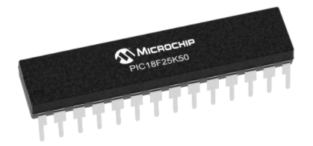

Casing
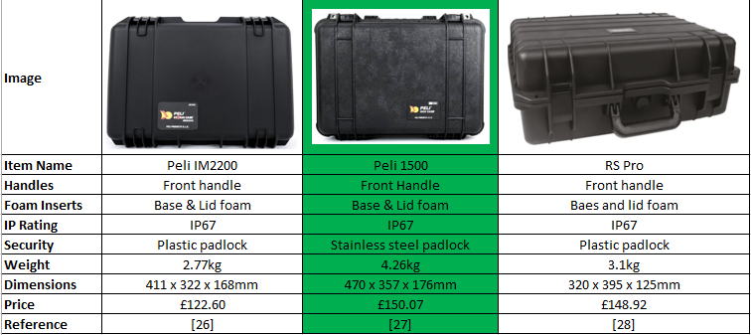
In order to carry all the components, a suitable carry case is needed. In order to better evaluate some products that are available, a comparison table has been created. This can be seen above. The Peli 1500 case has been chosen, as it is large enough to carry all, robust and durable, and has an IP67 protection rating in case the user gets caught in the elements. This case also has stainless steel padlock eyelets, where the others only have plastic. This case is the only one of the three, that has an eyelet seal, that allows for connectors to travel through to connect within.

Connectors
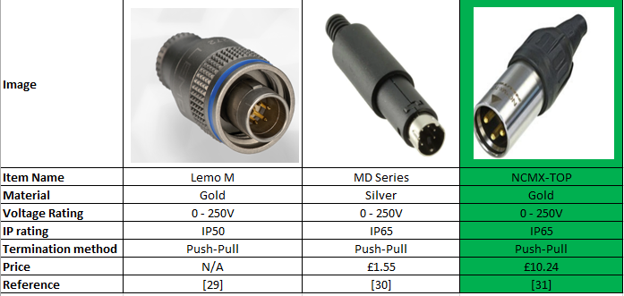
From the above connectors, the NCMX-Top was chosen.
This connector is
- IP65 rated for outdoor use
- Push-pull connection making it easy to connect
- Gold plated pins, to prevent corrosion

Battery
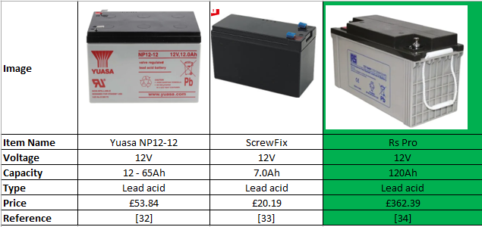
Three batteries have been compared, and the Rs PRO was chosen for use.
- 12V suitable for the designed system
- Long life, will support the full 14 day cycle

System layout & PCB design

Here is the system design from EasyPC and Proteus.

PIC, SD, USB, GPS, START/STOP
Here is the PIC layout of the designed system, with SD CARD, USB, GPS and start/stop connected.

Sunlight, Air borne
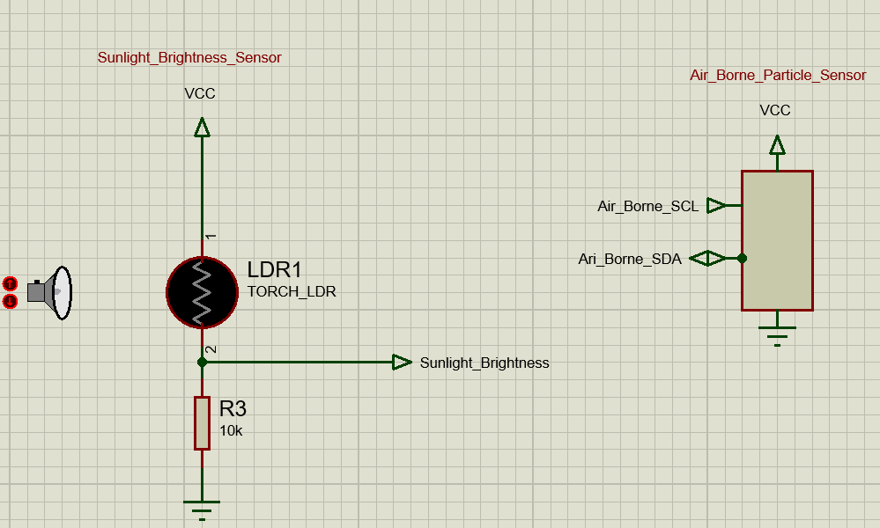
Here is the sunlight brightness, represented with LDR, and air borne particle sensor. The air borne sensor is using I2C to communicate with the PIC.

VOC
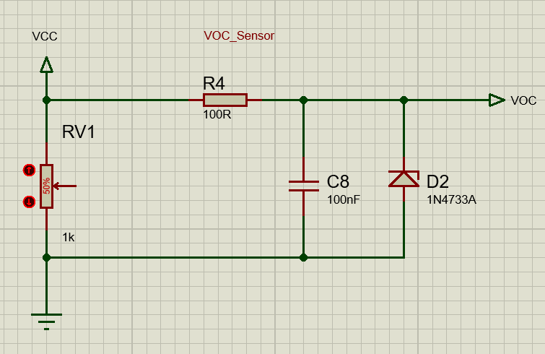
Here is the VOC sensor from Proteus. It has been represented using a potentiometer to simulate the analogue signal.

Temp&humidity, wind speed&direction, UV
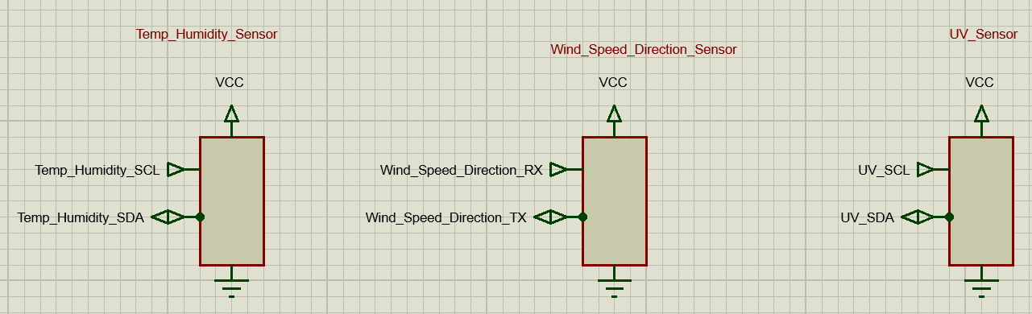
These are the schematics for the above mentioned sensors. All have been represented in the same manner as temp&humidity , and UV are I2C, and wind speed&direction is RS232.

Voltage Reg
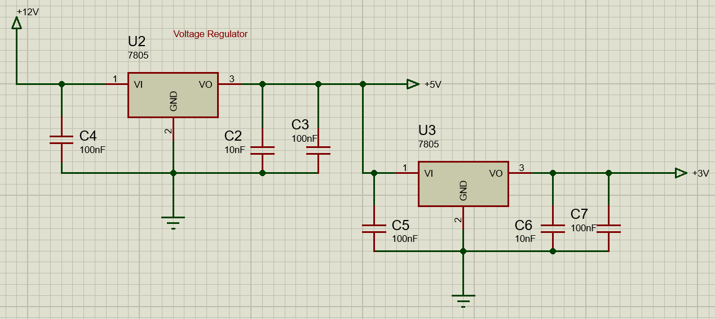
This is the voltage regulator of the circuit. It attenuates from 12V to 5V, and then again from 5V to 3v.

EasyPC
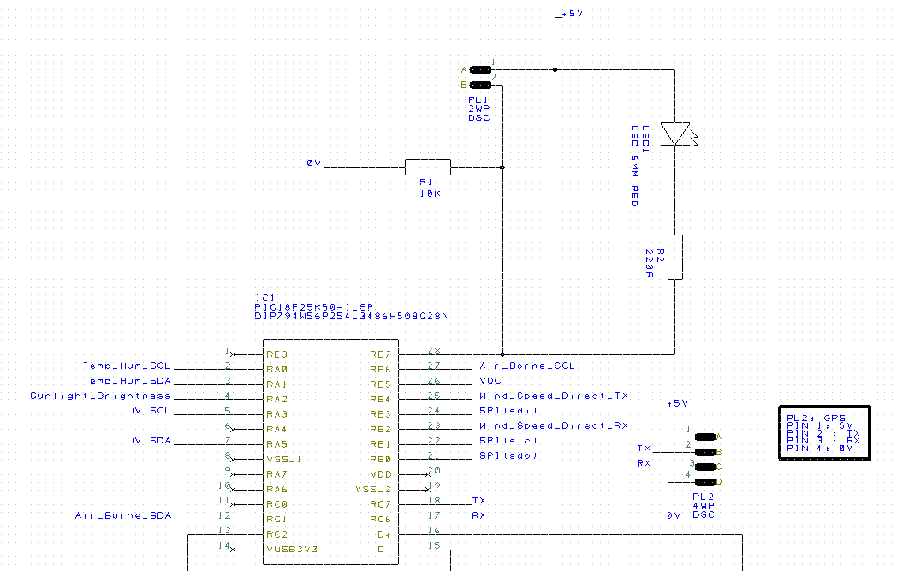

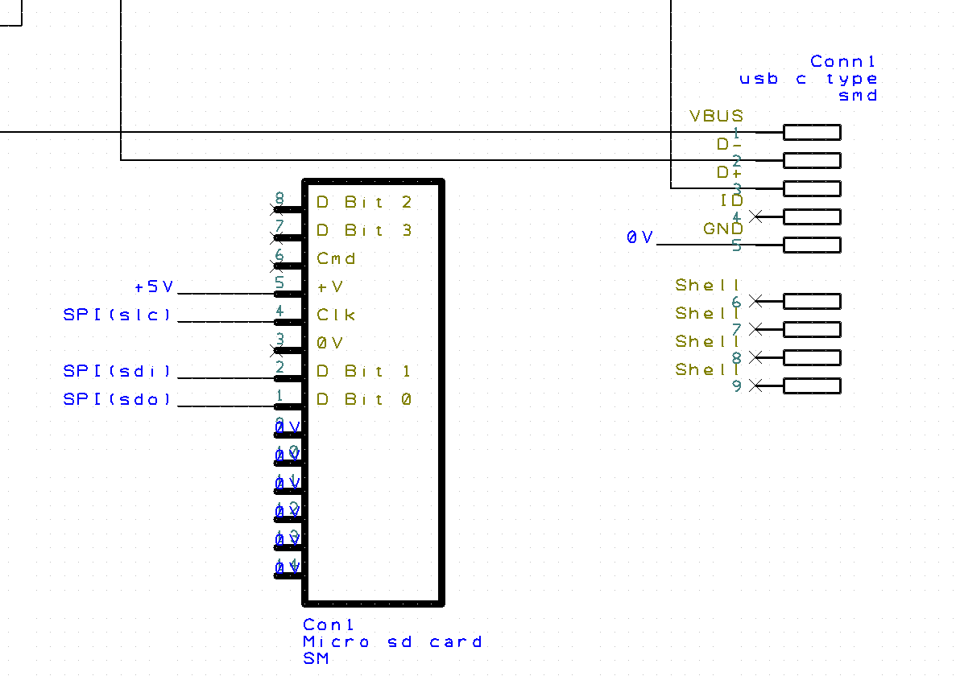
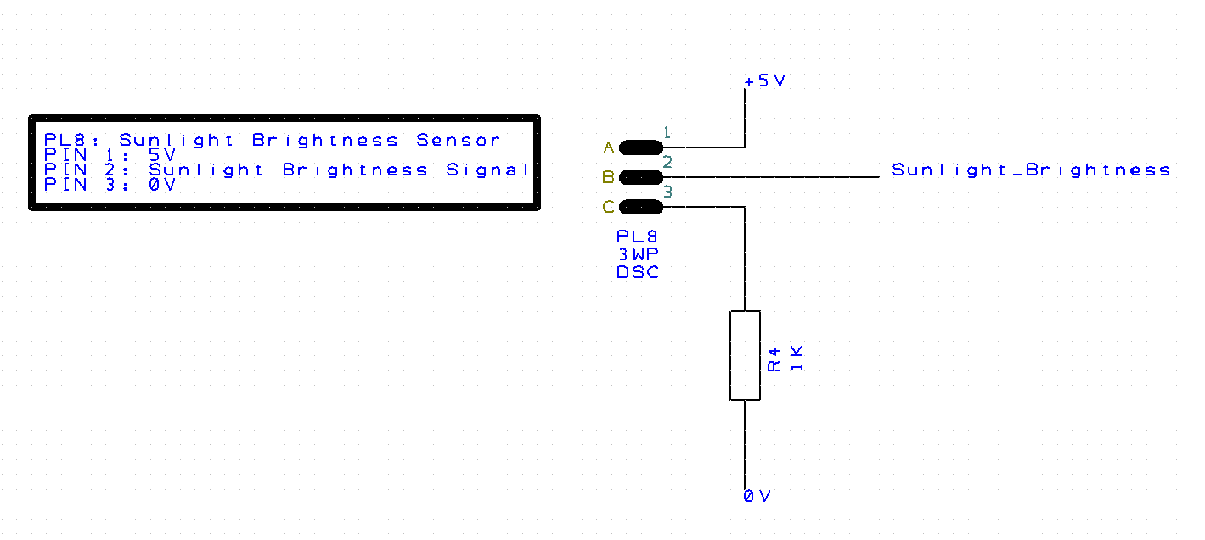
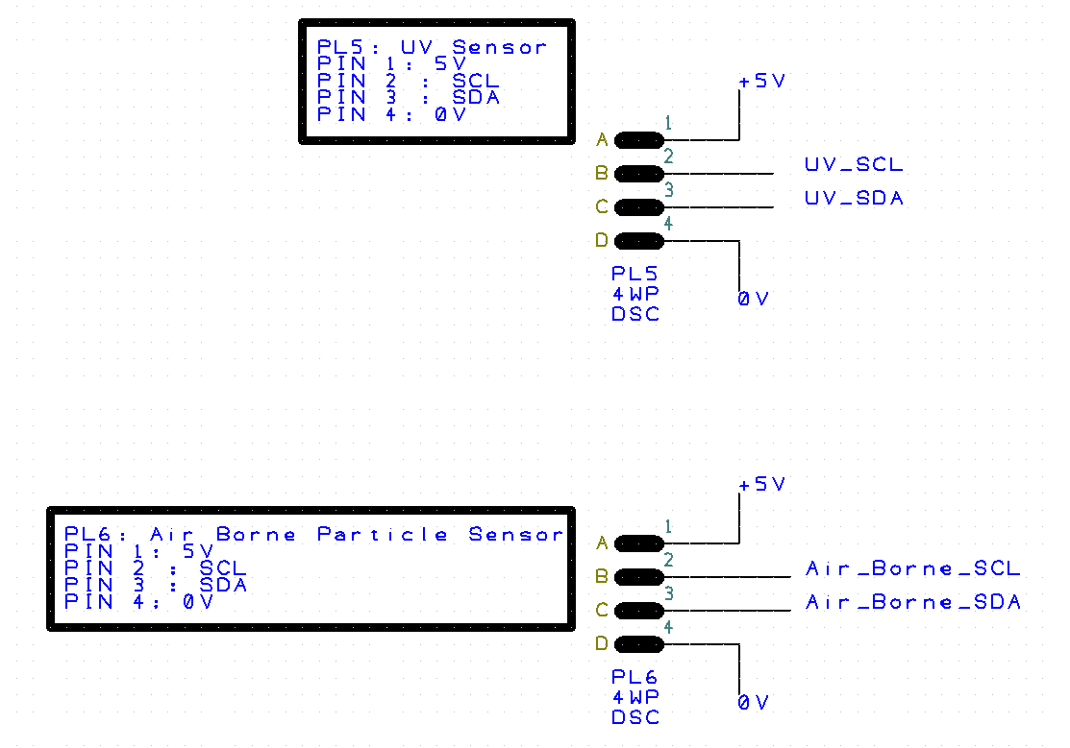
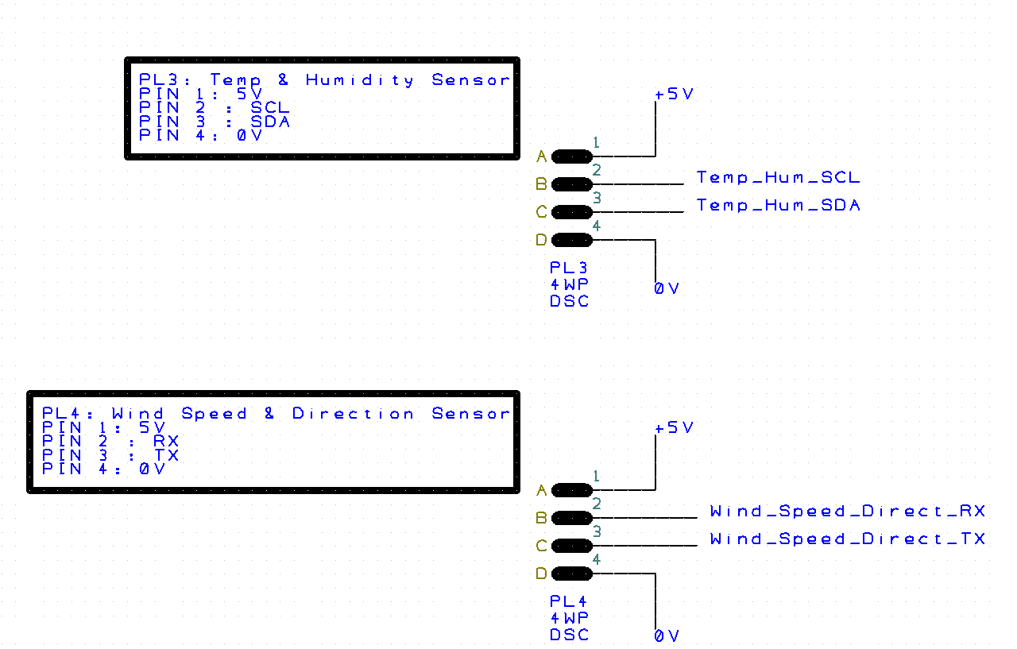
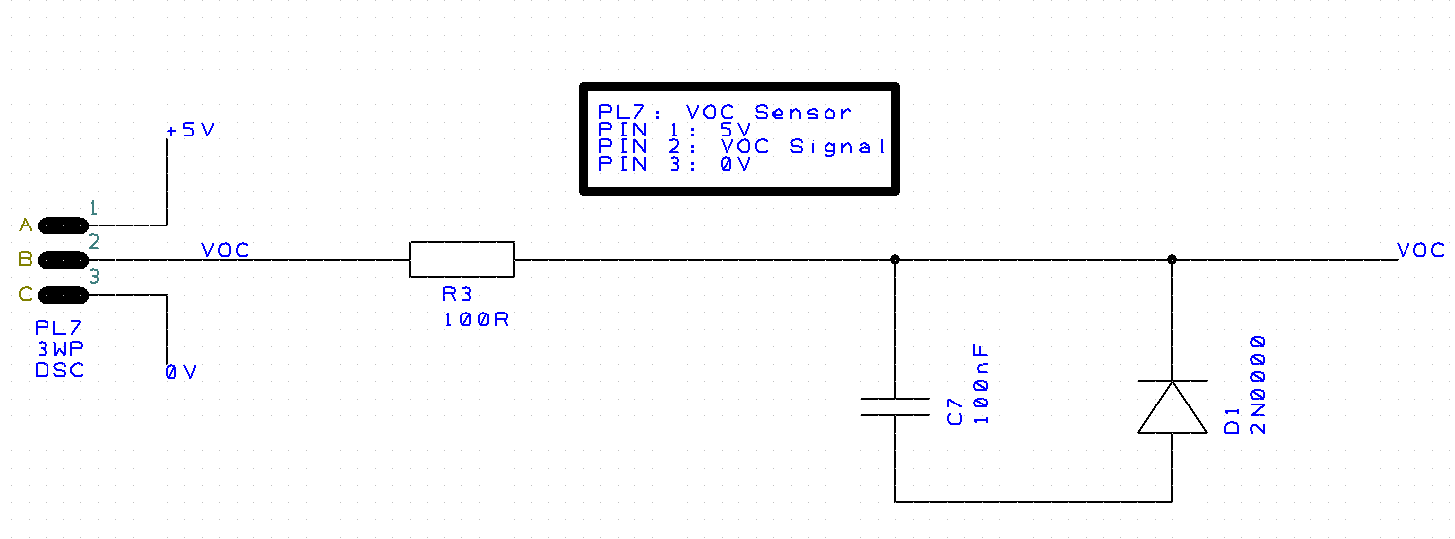
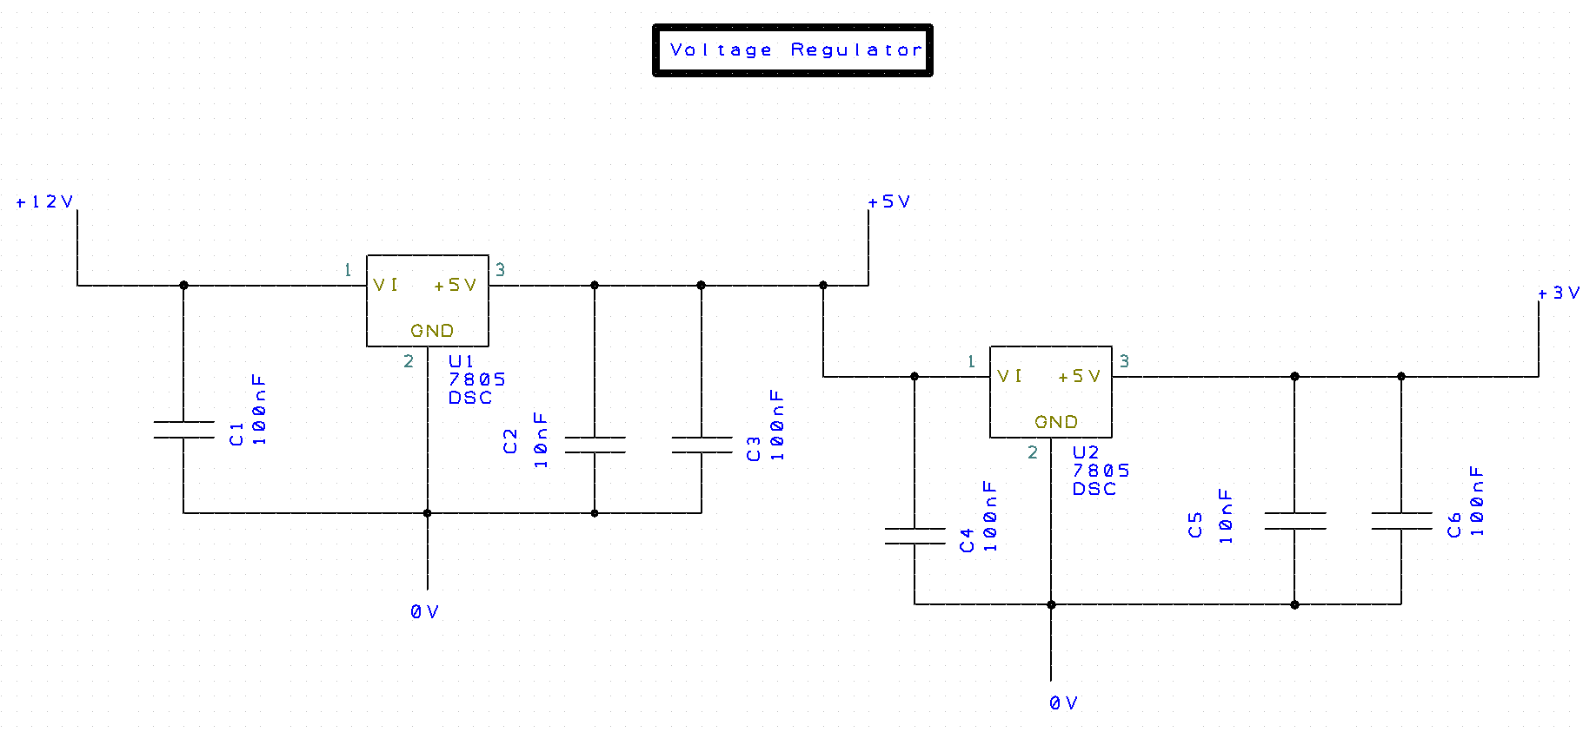
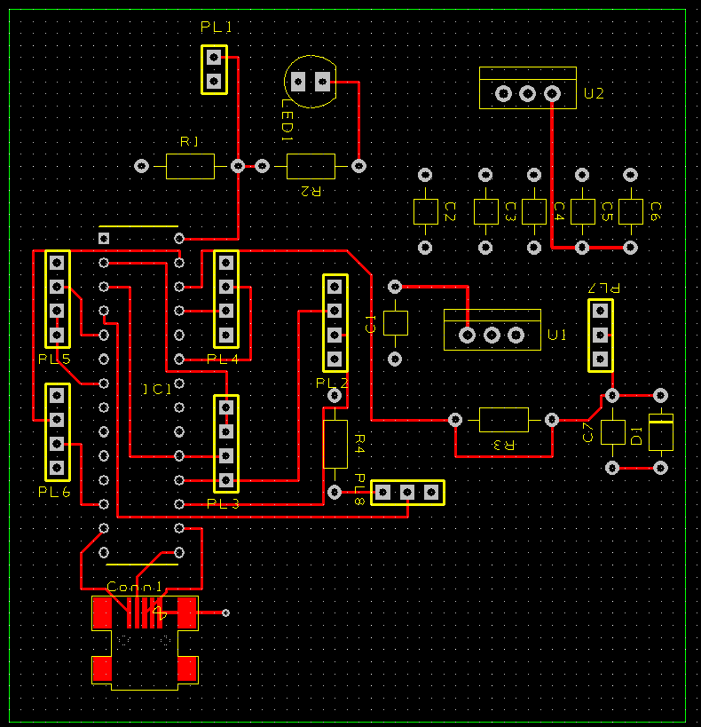
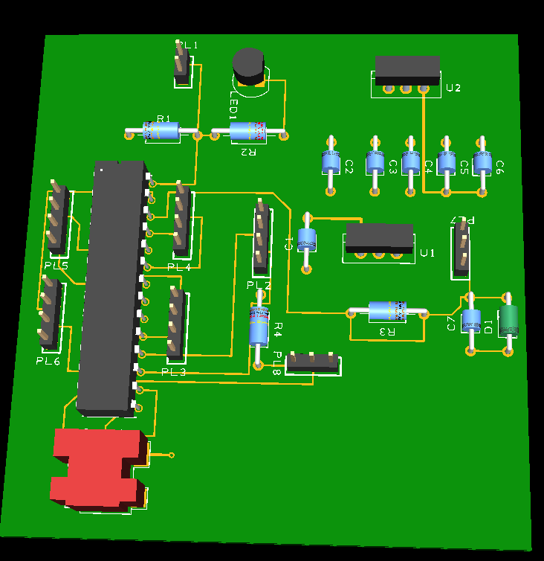

Costing
Below is a table of the component costs of this project.
Component | Price per unit | Number of units | Total cost
SHT31 DIS-B | £1.90 | 1 | £1.90
WindSonic | £684.00 | 1 | £684.00
SPS30 | £38.98 | 1 | £38.98
NORPS-12 | £2.93 | 1 | £2.93
VEML 6075 | £2.25 | 1 | £2.25
TGS-2620 | £19.34 | 1 | £19.34
A2200A | £17.72 | 1 | £17.72
PIC18F25K50 | £2.02 | 1 | £2.02
Peli 1500 | £150.07 | 1 | £150.07
NCMX-TOP | £10.24 | 7 | £71.68
Rs Pro battery | £362.39 | 1 | £362.39
PCB 4 Layer | £187.77 | 1 | £187.77
 |  |  | £1,541.05

PCB Quote
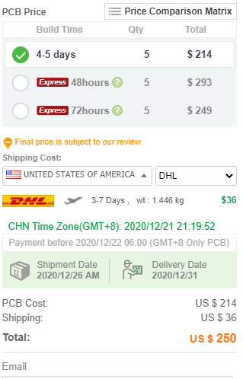

Improvements of Spec

Based on market research, there are some inclusions that could improve the spec of this assignment. They are as below.

LCD Display
Most products on the market, include some kind of digital display that shows real time data. This could be a useful addition to the spec.

Solar charger
Many products on the market, utilise a solar charger, that continues to top up the battery. This could reduce the need for such a large battery, saving on cost and weight. It would also be more efficient as the system is already sitting in sunlight for part of the day. One drawback is it will not charge if in an area that is persistently cloudy/dark.

Tripod
Some form of tripod, or mount would be useful for the next generation of design. As wind speed/direction would benefit from being at a higher position, and it would prevent the system from being too close to the ground in the event of heavy rain or snowfall.

References
[1] (OmniInstruments, 2020)
[2] (Omega, 2020)
[3] (Delta-t, 2020)
[4] (RsHydro, 2020)
[5] (Rs-online, 2020)
[6] (Rs-online, 2020)
[7] (Rs-online, 2020)
[8] (Campbell, 2020)
[9] (RsHydro, 2020)
[10] (Instruments, 2020)
[11] (Rs-online, 2020)
[12] (Pimoroni, 2020)
[13] (Rs-online, 2020)
[14] (Rs-online, 2020)
[15] (Rs-online, 2020)
[16] (Rs-online, 2020)
[17] (Farnell, 2020)
[18] (Rs-online, 2020)
[19] (Savy, 2020)
[20] (Rs-online, 2020)
[21] (Rs-online, 2020)
[22] (Rs-online, 2020)
[23] (Rs-online, 2020)
[24] (Farnell, 2020)
[25] (Rs-online, 2020)
[26] (Products, 2020)
[27] (Products, 2020)
[28] (Rs-online, 2020)
[29] (Lemo, 2020)
[30] (Devices, 2020)
[31] (Canford, 2020)
[32] (Rs-online, 2020)
[33] (Fix, 2020)
[34] (Rs-online, 2020)
[35]

