

An Investigation into Sea Depth Measurement
by
Andrew Prescott

Supervisor: Steve Mosey
Second Marker: Gareth Jones

Project submitted as part of the requirements for the award of BEng (Hons) Electronic and Electrical Engineering

April 2017

Declaration Form and Form of Consent
DECLARATION
I, ....................................................... declare that I am the sole author of this Project; that all references cited have been consulted; that I have conducted all work of which this is a record, and that the finished work lies within the prescribed word limits.

This work has not previously been accepted as part of any other degree submission.

Signed: .............................................

Date: ...............................................

FORM OF CONSENT

I ............................................…………………………………hereby consent that my Project, submitted in candidature for the B.Eng. Electronic and Electrical degree, if successful, may be made available for inter-library loan or photocopying (subject to the law of copyright), and that the title and abstract may be made available to outside organisations.

Signed: .............................................

Date: ...............................................

1. Abstract
Accurate sea depth measurement is key to exploration and navigation of the oceans, the aim for this project was to investigate the methods used to make sea depth measurements and compare their features; with the further aim being to develop a system capable of making depth measurements using one of the investigated methods. The methods investigated were satellite methods, echo sounders, restricted floating sensors and automated underwater vehicles; each of these methods had their own application, the satellite methods could cover a greater area in less time than other methods, but they were also less accurate, whereas restricted floating sensors may only cover a small area but are extremely accurate. It was decided that the echo sounding method was the most appropriate for further investigation and development due to the complexity to employ other methods. Echo sounders and the theory of longitudinal waves and their properties in different mediums was investigated, then using this information the development of an ultrasonic distance measurement device was undertaken. There were five prototypes developed, starting with a simple system working towards a more advanced system by the fifth prototype. The final prototype could make fluid level measurements in air using the surface of the liquid as the reflector in a container of a known depth; however, due to the budget and time constraints submerged depth measurements were unattainable by the final prototype due to the quality of the transducers used. It was found that there is a difference between waterproof transducers and transducers that were capable of functioning underwater. Much higher power transducers are needed to generate a large amplitude ultrasonic wave when submerged in water compared to the power required for air. It was also found even in air ultrasonic measurements are extremely susceptible to interference such as temperature changes and air flow etc.

Contents
Declaration Form and Form of Consent 1
1. Abstract 2
Table of Figures 6
Table of Tables 7
2. Introduction 8
2.1 Aim of Project 8
2.2 Objectives of Project 8
2.3 Project Report Layout 9
3. Initial Research 9
3.1 Echo Sounders 10
3.2 Autonomous/Remote Underwater Vehicles (AUV/RUV) 11
3.3 Satellite methods 12
3.4 Restricted Floating sensors 13
3.5 Conclusions from initial research 14
4. Echo Sounders Full investigation 14
4.1 Sound 15
4.2 Ultrasonic measurements and devices 19
4.3 Echo Sounder Evaluation 20
5. Research and Development Methods 21
5.1 Research Methods 21
5.1.1 Research Philosophy 21
5.1.2 Research Approach 22
5.1.3 Research strategies and Data Collection 22
5.2 Research Deliverables 24
5.2 Development Methods 24
5.2.1 Development Deliverables 25
6. Design and Prototype Development 25
6.1 Initial Prototype 26
6.1.1 Component Selection 26
6.1.2 Design 30
6.1.3 Testing 32
6.1.4 Evaluation 35
6.2 Second Prototype 35
6.2.1 Component Selection 36
6.2.2 Design 37
6.2.3 Testing 37
6.2.4 Evaluation 39
6.3 Third Prototype 39
6.3.1 Component Selection 39
6.3.2 Design 44
6.3.3 Testing 44
6.3.4 Evaluation 48
6.4 Fourth Prototype 49
6.4.1 Component Selection 49
6.4.2 Design 49
6.4.3 Testing 49
6.4.4 Evaluation 52
6.5 Transducer Investigation 52
6.6 Final Prototype 53
6.6.1 Component Selection 53
6.6.2 Design 53
6.6.3 Testing 55
6.6.4 Specifications 58
6.6.5 Evaluation 59
6.7 Development Summary 60
8. Project Evaluation 60
9. Conclusions and Recommendations 62
9.1 Summary 62
9.2 Conclusions 62
9.3 Areas for Further Research 63
10. Reflection 63
11. Bibliography 65
12. Index 74

Table of Figures
Figure 1 [3] Effects of pitch changes on echo sounder measurements. 10
Figure 2 [14] AUV operation and relation to mothership. 11
Figure 3 [26] Image of sea surface temperature produced from satellite data. 13
Figure 4 [29] Restricted floating sensor operation. 13
Figure 5 [31] Basic principle of echo sounder operation for distance measurement. 15
Figure 6 [32] Longitudinal wave. 15
Figure 7 [33] Reflection and absorption of a longitudinal wave at a change in medium. 17
Figure 8 [47] Transducer example 3D beam pattern. 18
Figure 9 [48]Garmin Striker 19
Figure 10 [49] Furuno DFF-3D 19
Figure 11 [50] Ultrasonic Water Depth Meter 20
Figure 12 [55] The spiral development cycle. 25
Figure 13 Initial prototype block diagram. 26
Figure 14 US-015 27
Figure 15 HC-SR04 28
Figure 16 LV-MacSonar-EZ3 28
Figure 17 Proteus initial circuit 30
Figure 18 First prototype circuit constructed. 32
Figure 19 Example test measurement. 33
Figure 20 Initial prototype accuracy test. 34
Figure 21 HC-SR04 with ZHIPU transducers. 37
Figure 22 Second prototype test. 38
Figure 23 Trigger pulse (Left) Echo pulse (Right). 38
Figure 24 DYP-ME007Y. 40
Figure 25 MB7052 XL and its different case variations. 41
Figure 26 Senix Toughsonic 3. 42
Figure 27 JSN-SR04T. 43
Figure 28 Third prototype constructed circuit. 44
Figure 29 Graph of measured distance to actual distance. 45
Figure 30 Graph of timer1 to Pulse width 45
Figure 31 JSN-SR04T-2.0 Board 46
Figure 32 Underwater distance test for third prototype. 47
Figure 33 Larger test container. 48
Figure 34 JSN-SR04T board. 50
Figure 35 Fourth prototype in air test. 50
Figure 36 Fourth prototype accuracy test. 51
Figure 37 Final prototype. 54
Figure 38 Final prototype schematic. 55
Figure 39 Water surface reflection tests. (HC-SR04 right, JSN-SR04T left) 56
Figure 40 Graph of accuracy with water reflection. 57
Figure 41 Normal output of system. 59

Table of Tables
Table 1US-015 Specifications. 27
Table 2 HC-SR04 Specifications 28
Table 3 LV-MacSonar-EZ3 specifications 28
Table 4 Microcontroller requirements 29
Table 5 PIC16F887 Specifications 30
Table 6 7805 Voltage regulator output test. 32
Table 7 Waterproof transducer comparison 36
Table 8 DYP-ME007Y Specifications. 40
Table 9 MB7052 XL Specifications. 41
Table 10 Senix Toughsonic 3 Specifications. 42
Table 11 JSN-SR04T Specifications. 43
Table 12 Current draw of final prototype components. 58
Table 13 Total final prototype cost. 58
Table 14 Final prototype specifications. 59

2. Introduction
Exploration has always been key to the advancement of society, the ocean covers around 71% of the Earth’s surface around 95% is unexplored by human, which is a huge amount [1]. The knowledge of the ocean is not only important for discovering new species and environmental monitoring, but also the navigation of most sea vessels recreational or commercial, submerged or surface. There are many variables that can be monitored to gain understanding of the oceans from temperature to current flow; this investigation focuses on depth measurement. Most of the data about the ocean comes from satellite measurements, this data is usually used for surveys and weather etc. as they cover a large area in short time periods however these methods can be inaccurate [2]. The method most commonly used for navigation and exploratory purposes is sonar which detects pulses of sound reflected from an object, to obtain a depth measurement this object would be the sea floor; these methods are more accurate than the satellite methods but cover a much smaller area [3]. Depth measurement has been chosen as the information can be used for several applications which are key to the functionality of marine exploration, the maritime industry and personal use.

2.1 Aim of Project
The aim of this project is to investigate sea depth measurement techniques and analyze the concepts and issues involved with these measurements then develop a system capable of making depth measurements to further explore the subject area.

2.2 Objectives of Project
The objectives of this project:
- Investigate several sea depth measurement techniques and evaluate each method based on its strengths, weaknesses, and applications.
- Gain a full understanding of one of these methods.
- Use the fully investigated method to develop a functioning depth measurement device.
- Perform tests and experiments on the developed device to obtain an understanding of the physical concepts and constraints of the investigated technology.
- Compare the information from the investigation to the information obtained from the developed system to evaluate the depth measurement method that was chosen.

2.3 Project Report Layout
Section 3 Initial research: This section is a literature review investigating several depth measurement methods including their strengths, weaknesses, and applications.
Section 4 Echo sounder full investigation: This section fully investigates echo sounder technology, and its applications. This is done through a review of longitudinal waves and their properties in different mediums, and by investigating products using this technology comparing their features and finding similarities between them.
Section 5 Research and development methods: This section covers the selection of the research and development methods used for the project. This section also justifies each selection detailing why it is the most appropriate for its application within the project.
Section 6 Design and prototype development: This covers the development process for the entire project and the creation of iteratively improved prototypes. This section also covers an investigation of the physical properties of piezoelectric transducers.
Section 8 Project evaluation: This compares the project outcomes to the aim and objectives set in sections 2.1 and 2.2 and the research done in sections 3 and 4. This section also summarizes the findings of this investigation, and any improvements to be made if the project was repeated.
Section 9 Conclusions and recommendations: This reviews the entire project and investigates the possibilities and areas for further work based on the findings from the project.
Section 10 Reflection: This section details how the project was conducted and how it could be done more effectively next time with the personal improvement and findings in areas such as project management etc. from completing this project.

3. Initial Research
To gain an understanding of the methods used to obtain depth measurements an investigation into each method and its features was undertaken, below in sections 3.1 to 3.4 are the evaluations for several different depth measurement techniques already in practice and the uses of the data they provide. After each method has been reviewed one will be selected to investigate fully.

3.1 Echo Sounders
This technology measures the depth of water by detecting an acoustic pulse, hence the name echo sounder. These devices have two forms passive and active sonar; passive sonar detects acoustic emissions from objects around it, whereas active sonar detects the reflection of an emitted sound wave from the device [3] active is the most commonly used for depth measurements as the sea floor emits no detectable sound apart from seismic events [4]. In the beginning of their development during the early 20th century most active sonar devices used a single transmitter (single beam) to obtain one measurement per pulse; the device could either be narrow or wide beam, narrow beams are more accurate however measure a small area whereas the wide beam is less accurate but able to map much greater areas with each pulse [3]. In 1964 one of the first techniques to create multi-beam sonars was developed at the Harris Anti-Submarine Warfare Division this used several narrow beam measurements to obtain accurate measurements over a large area, the US Navy used this technique to build multi-beam sonar devices to detect other vessels; after further development in 1977 similar multi-beam systems were equipped in oceanographic surveying vessels to map the sea floor [3] [5]. Errors in these measurements can come from many sources, for example the speed of the sound in the medium changes according to its temperature and density etc. affecting distance calculations [6]; if the system is mounted to a vessel the movement of the vessel and in turn the device, changes the emission and receive angles creating many issues this can be seen in figure 1 [3] . A problem with this technology is that it can only measure a relatively small area around the vessel e.g. the cone in figure 1.
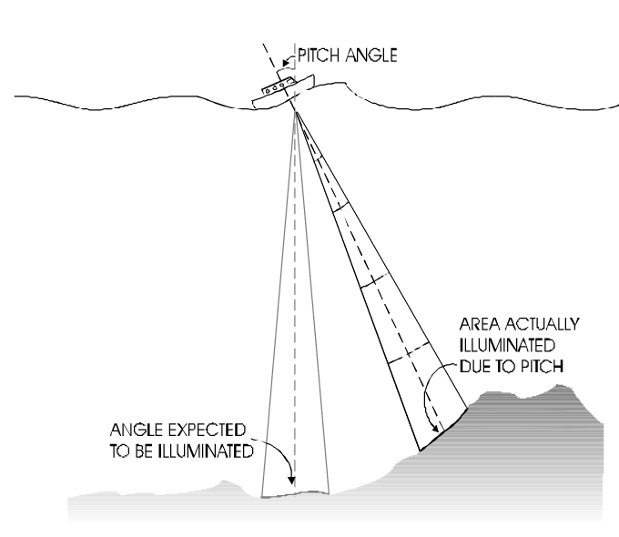
Figure 1 [3] Effects of pitch changes on echo sounder measurements.
Newer versions of multi-beam systems are still in use in many applications, with recent developments in this area of technology moving towards error removal and increase in data retrieval (e.g. water temperature and subsurface mapping [7]), this is done in multiple ways from developing more complex and advanced error removal algorithms to changing the layout of the beam array, there are countless reliable sources available each with a slightly different method to improve this technology and comparing these improvement methods [8] [9] [10] [11]. Many of these multi-beam echo sounder (MBES) devices are now being applied to underwater vehicles to improve their accuracy and decrease the amount of time to measure large areas [12], these are covered below in section 3.2.

3.2 Autonomous/Remote Underwater Vehicles (AUV/RUV)
These devices are small unmanned motorized submersible vessels that are dropped from a manned vessel; an AUV will follow a preprogramed path, whereas an RUV must be remotely controlled by an operator; RUVs are usually used for an inspection of a specific object and AUVs are used for surveying an area [13], this can be seen in figure 2 [14].
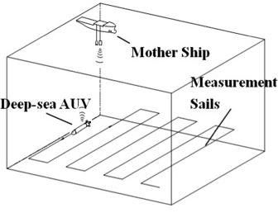
Figure 2 [14] AUV operation and relation to mothership.
These vehicles are a relatively new technology with basic prototypes being developed in the 1990’s they are used for many applications such as environmental monitoring [12]; they are equipped with a variety of sensors to monitor the aspects of the body of water they are submerged in, these sensors will include an MBES to detect objects around it including the sea floor [12] [15] [16].
As mentioned in section 3.1 these vessels increase accuracy and measurement area compared to surface vessel mounted MBES sensors; this is due to the AUV/RUV being much closer to the measurement target counteracting the source of errors mentioned in section 3.1 such as sound velocity variations. The increase in measurement area is because an AUV requires no human interaction whilst it is follows the programmed route and multiple vessels can be launched simultaneously [12]. There are a few disadvantages to this technology, one being that these devices have a maximum battery life meaning they can only operate for a certain period before they need to be recharged etc. the equivalent being refuelling the surface vessel however this is required much less often; another disadvantage is that to program a path for the AUV some prior knowledge of the area is needed, this could be acquired through the launching vessel or through an RUV [17] [18]. Current developments in this field are focused on improving the path planning and following of AUVs, there are many papers with different techniques, these techniques range from altering the construction of the AUV propellers to developing path tracking algorithms that can counteract drift due to current flow or other unexpected movements [19] [20] [21]; attempts to improve efficiency for longer active periods are also being tested [22]. There are many papers testing many different variations of similar methods however they are all focused of fixing the same issues mentioned above, the sources used are mostly reliable as they are published in respectable journals and have themselves referenced reliable sources, however one source may be biased as it is a brochure for a product which may be manipulated to sell devices.

3.3 Satellite methods
Satellites much like an MBES system use the transmission and receiving of ultrasonic waves, however satellite systems usually use infrared or microwave beams. These systems are capable of measuring several variables about the ocean, these variables include surface level, depth, temperature etc. [23] [2]. Due to the nature of how satellites operate an exceptionally large area is capable of being measured in a short amount of time compared to the other methods already discussed in 3.1 and 3.2. However, the large distances involved in these measurements makes them very susceptible to inaccuracies and errors, these can be introduced from many sources such as a change in air humidity or weather conditions [2] [24] [25]. Ocean satellite measurements are can be used to measure sea depth more so to monitor environmental changes such as sea level or temperature, these can also be used for meteorology to predict weather this can be seen in figure 3 [26].
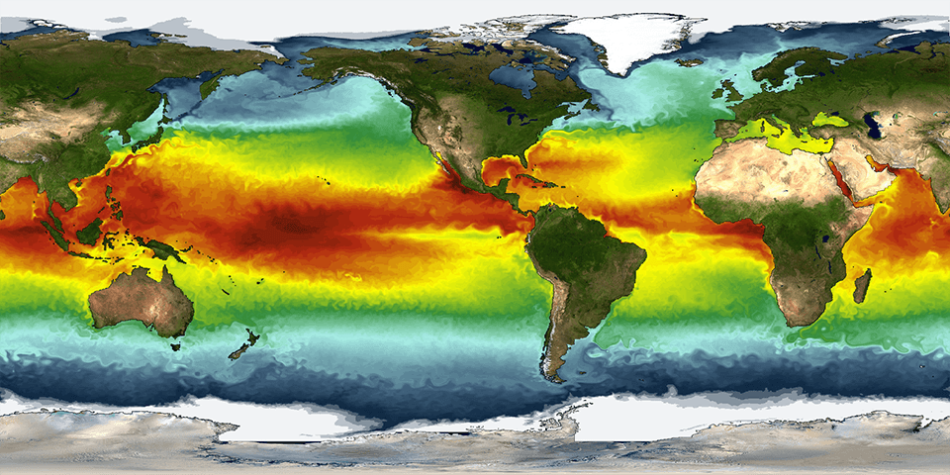
Figure 3 [26] Image of sea surface temperature produced from satellite data.
As climate change is such a prominent issue in the world, current work in this field much like the other methods discussed is error removal and improvement of accuracy, this is largely done through algorithm development [27] [28]. There sources used were from a variety of publications and each source contained matching information where applicable indicating reliability.

3.4 Restricted Floating sensors
This technology as the name suggests uses a floating object tethered to the sea floor, the depth is then calculated using the position of the sensor as shown in figure 4 [29].
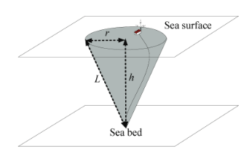
Figure 4 [29] Restricted floating sensor operation.
These sensors are far more accurate than any other method previously mentioned, this is because there is a direct contact, however to achieve this direct contact a lot of previous knowledge of the water being measured is needed, the body of water also cannot be too deep as there must be a connection to the surface from the sea floor. These sensors are often used in harbours as usually these are not too deep, previously explored, and an extremely high accuracy measurement is needed to ensure there is no damage or beaching of vessels [29]. To map the depth of the harbour a large number of these sensors are tethered in the area, these sensors then feed the data to a monitoring station wirelessly [30]. These sensors are a relatively new method of depth mapping, however there is not much in the way of current work, as there are not many areas to improve apart from ruggedness of the devices and network latency [29] [30]. The lack of work in this field may mean the sources are unreliable, however, as the sources are in reputable journals it can be assumed the data is reliable and factual.

3.5 Conclusions from initial research
All methods researched in the previous sections are valid approaches for sea depth measurement. To further increase the understanding of this area one method was chosen as the main focus to further investigate. The method chosen to focus was echo sounders, this is because of several reasons, firstly satellite methods are completely impossible with the budget and timeframe of the project, AUV/RUV methods use echo sounders to measure depth so this form of sensor would need to be developed anyway. As mentioned in section 3.4 there is little current work on restricted floating sensors, making research data difficult to find and therefore difficult to compare any experimental data to.

4. Echo Sounders Full investigation
As mentioned in section 3.1 for depth measurement active sonar is used, this section aims to investigate the exact function of these systems.
First the method in which these acoustics are used to measure distance should be fully investigated, the operation of an echo sounder is shown in figure 5 [31].
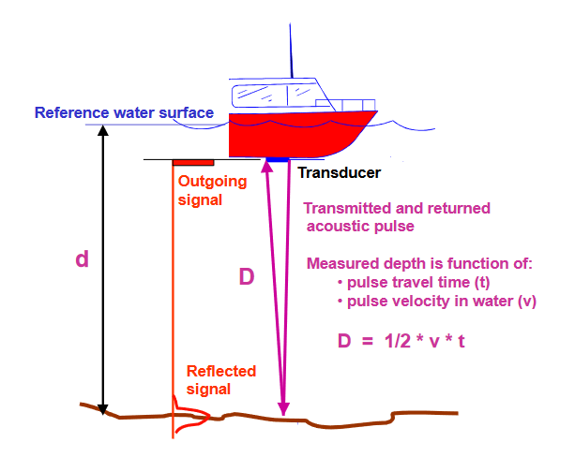
Figure 5 [31] Basic principle of echo sounder operation for distance measurement.
It is apparent from this image (figure 5) to calculate distance, a pulse of a known speed must be transmitted, reflected, and received. To understand how this acoustic pulse travels in water the physics of sound waves must also be investigated.

4.1 Sound
Sound waves are produced through vibration and are therefore longitudinal meaning they traverse through a medium by vibrating the particles within that medium, the extent to which these particles are vibrated is seen as the amplitude of the wave and the distance for one complete cycle of compression and rarefaction is the wavelength this can be seen in figure 6 [32].
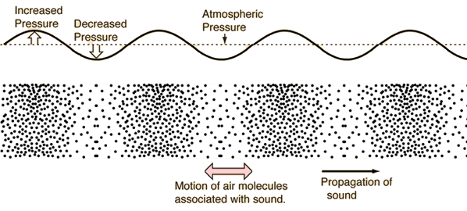
Figure 6 [32] Longitudinal wave.
The properties of the wave are defined by the equation $v=λf$ where $v$ is the velocity of the wave, $λ$ is the wavelength, and $f$ is the frequency of the wave [33].

Transmission
The medium through which the sound is travelling also effects the speed at which these vibrations travel this is down to the properties of the medium. In liquids $K_{T}$ this is the isothermal bulk modulus this defines the properties of the material, and ρ its density, this forms the equation: $v=\sqrt{\frac{K_{T} }{ρ}}$ [33]. The elastic properties of the medium vary with temperature and other variables, in turn changing the speed of sound in that medium. By these rules sound will travel faster in water than in air however liquids are more rigid than gasses therefore are more difficult to compress e.g. larger amplitude wave is required. The speeds of sound in different medium shave been tested and verified by other sources to be 340m/s in air and around 1400m/s in water dependent on temperature, salinity etc. using the equation$v=λf$an increase in speed indicates a change in wavelength [33] [34] [35] [36]. This is why an earlier paper focused on error correction of to speed variations in these measurements, these speed variations can be caused by density, temperature, and salinity changes (and many other things) in the water being measured [6]. When used for an electronic application the generation of this ultrasonic wave is done by a transducer, the most common form is a piezoelectric transducer, this crystal changes in size (very small amount) dependant on the voltage applied, this can be used to generate the ultrasonic frequencies required for these measurements [36] [37] [38].

Reflection
This method uses the reflection of an acoustic pulse to measure depth, this reflection occurs when there is a change in medium, in this case liquid to solid, when this happens some of the energy in the wave is passed into the new material and some of the energy in the wave is reflected back the relations to the velocities and the angles are shown in figure 7 (Snell’s Law) [33]. If the sound is close to parallel with the surface the wave does not pass to the next material. If the object that causes the reflection is moving this causes a shift in frequency this is known as the Doppler Effect [33].
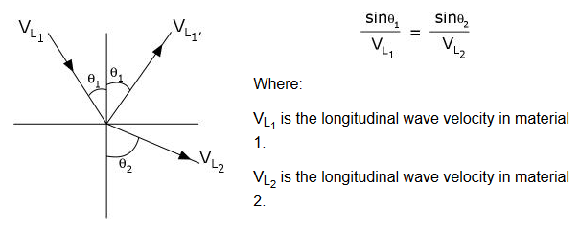
Figure 7 [33] Reflection and absorption of a longitudinal wave at a change in medium.

Detection
To receive the transmitted wave the received wave must be measurable, meaning it must have a large enough amplitude; to ensure that is the case the way sound propagates through a medium must also be understood. When sound travels over a distance its vibrations spread in area this causes a reduction in intensity, the larger the area the lower the intensity; there are also losses due to random vibrations in the particles of the medium this is called damping each medium will have its own acoustic impedance defined by its properties (water has a higher damping factor than air, waves may travel faster, however they are diminished faster); these factors do not manipulate wavelength, frequency, only amplitude and speed [33] [35] [39] [40]. The exact amount of attenuation is difficult to quantify however it is known waves of the same frequency with a higher starting amplitude will travel further in the same medium than those of lower starting amplitudes without completely diminishing. High frequency short wavelength sounds tend to be more directional, reducing the rate at which the intensity of the wave spreads therefore reducing the intensity losses, higher frequencies produce a more focused beam compared to lower frequencies the intensity of a wave at a given distance can be calculated using $I=\frac{P_{a}}{A_{r}}$ (I= intensity,$P_{a}$= acoustic power source, and $A_{r}$=area at a given distance) [41] [35]. The beam angle can be calculated using its wavelength and size of emitter in the equation,$δ =arcsin⁡(\frac{λ}{D})$ where $δ$ is the half beam divergence angle, $λ$ is the wavelength, and $D$ is the diameter of the emitter [35]. However the higher the frequency the greater the rate of absorption of the wave reducing its range; lower frequencies can travel much further than higher frequencies, this is why ultrasonic frequencies are used for distance measurement applications, as they provide a good balance between beam spread and low absorption losses [42] [43] [44] . Ultrasonic waves vary from 20kHz to 20MHz, however for distance measurements only around the 20-800kHz range is used, higher frequencies have a higher resolution however cannot propagate very far; these higher frequencies are used in medical ultrasound for example [45]. When applied in an electronic sense these reflected ultrasonic waves are also detected by transducers again usually piezoelectric, however for detection instead of applying a voltage to create a distortion of the crystal, the distortions of the crystal caused by incoming acoustic events are used to produce a voltage, as shown earlier in the section the time between transmission and receival can be used to calculate distance, using the frequency and amplitude of this wave can also enable other variables to be calculated such as if the object is moving or what the material is [33] [36] [37]. The ability to detect the transmitted wave which will become noisy (from many sources) whilst travelling in the medium, amongst other interference requires complex filtering and signal processing to detect specified frequencies etc. [36] [37] [46]. A transducer also has a beam pattern this is based on its beam divergence an example of a beam pattern is shown in figure 8.
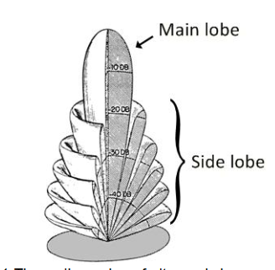
Figure 8 [47] Transducer example 3D beam pattern.

4.2 Ultrasonic measurements and devices
To further investigate how this technology functions how ultrasonic measurements are taken, devices available using this technology was investigated.

Garmin STRIKER [48]
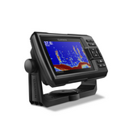
One of the most common applications for this technology is in fish finders. The Garmin striker is a single beam device which uses ultrasonic measurements to display the location of fish in a body of water and the depth if it is within range (700m freshwater, 335m saltwater). This device powers an interchangeable transducer of varying frequency with 500W_{RMS}, this device is compatible with a variety of frequencies and includes a feature called CHIRP, this technology functions as so:
Figure 9 [48]Garmin Striker
“Instead of sending just 1 single frequency, CHIRP sends a continuous sweep of frequencies, ranging from low to high, then interprets them individually upon their return. Since the frequencies provide a wider range of information, CHIRP sonar technology can create crisper fish arches with greater target separation.” [48]
This suggests this method has improved accuracy/clarity compared to single frequency measurements, although it is unknown whether this is applicable to depth measurements or just fish finding, no quantified accuracy to the device is listed, this may be due to the many variables in water affecting the speed as mentioned earlier and therefore measurements, changing the accuracy dependent on the medium.

Furuno DFF-3D [49]
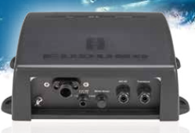
This is a multi-beam device that has an 1200m range from an 800W beam, the transducers are interchangeable and of varying frequencies, and the display comes separately. This device handles all the signal processing from the sensors and converts that data into a viewable form if a display is connected. If some form of motion sensor is connected alongside the ultrasonic sensor, the images can be stabilised to counteract the motions of the vessel it is mounted to. This device is intended for recreational and fishing vessels, it can be used for fish/structure finding or navigation. This device also includes a side scan sonar with a 300m range, this enables measurements to be taken from around the vessel rather than just below allowing for a full map of the environment around the boat to be plotted. Again there was no specification as to how accutrate this device is but this may be for the same reasons as the Garmin device.
Figure 10 [49] Furuno DFF-3D

Ultrasonic Water Depth Meter [50]
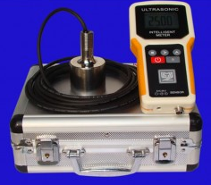
This device is used for much shorter much more accurate measurements, this uses a 200-2000kHz pulse to measure from 1-100m with a 1mm accuracy. This device has a simplistic output simply using an LCD to display one reading at a time. The power of the beam is not listed but the normal power consumption of this device is <0.5W indicating a much less powerfull beam hence the lower effective range of the device. This device can also take accurate measurements in flowing water of up to 5m/s. This device seems to be for more handheld measurements.
Figure 11 [50] Ultrasonic Water Depth Meter

4.3 Echo Sounder Evaluation
In these sections the application of this technology was investigated, a few things are apparent from these devices, their applications include: fish finding, depth measurements, environmental monitoring, and navigation etc. [48] [49] [50]. These devices also use high power beams for greater effective range (800W [49]), they also have complex signal conditioning to ensure the beam received is the beam that was transmitted from the device, and to recognise the beam has been reflected; if there are multiple beams this processing is more complex. From these measurements the data can be interpreted in different methods, these range from full 3D mapping to simple LCD displays. From the nature of sound there will be a reflection from any change in medium, this means if the sensor is in the air when trying to take these measurements a large portion of the energy will be reflected from the surface giving a false reading and possibly not allowing enough energy through for proper measurement [33], this means the sensor is often submerged in this application for full energy transfer from transducer to water. All these devices use the time of flight of an ultrasonic wave to calculate distance, this frequency of this ultrasonic wave will affect its travel distance and beam width, and its wavelength will affect the resolution of the measurement. Two of the devices could operate dependent on the attached sensor at frequencies in the ultrasonic range of around 60-800kHz, the Ultrasonic Water Depth Meter used 200-2000kHz, this used higher frequencies as the measurement was relatively short range however were much more accurate (1mm) [48] [49] [50].

5. Research and Development Methods
The main aim of the project is to investigate depth measurement methods, to ensure this aim was met and the project was carried out in a proper manner and the results and conclusions were the most valid and reliable the correct research and development methodologies needed to be chosen; there are several options for each research and development methods, all with different strengths and weaknesses; only some of these were appropriate for this project. The main contributing factor to the selection of these methods is whether the bulk of the data in the project is known to be true (quantitative) or believed to be true (qualitative); a large part of the research selection process also relies on ethics [51] however it is unclear how individuals other than the author (and the authorities of the project however they are not actively involved in the research process) will be involved as the research and development of this project is based on secondary research through conference proceedings and reliable journals etc. and through primary research through experimentation.

5.1 Research Methods
This section outlines the research methods (philosophy, approach, and strategies) selected to follow when conducting the research for this project.

5.1.1 Research Philosophy
Selecting the correct research philosophy is particularly important as this selection dictates the research information available for the project, if the information is unreliable the conclusions drawn from the research would also be unreliable. The research philosophy is selected based on the assumptions made when interpreting information, selecting the philosophy defines what assumptions are made [52]. In this case the project has large amounts of quantitative data due to the development of a device which will have test results etc. and the review of reliable sources findings on the subject, therefore positivism was chosen. This philosophy was chosen as it is highly structured, and focuses on quantitative data and measurements; however, this method also allows for qualitative evaluation of the quantitative information [52]. The disadvantage of this method is that the basis for all understanding in the project and its conclusions is from the quantitative data collected through either secondary or primary sources, if any of this data is incorrect or inaccurate the conclusions drawn would also be inaccurate devaluing the purpose of the project. To avoid this great effort was made to collect data from reliable and trusted sources.

5.1.2 Research Approach
The next stage in research methods is to select an approach, this is also an important decision as this choice dictates the importance of the hypothesis, or in this case the objectives set for the project. The most suited approach to this project and the selected philosophy is known as the deductive approach this focuses on quantitative data [52]. This approach is very objective, this suits the project very well as any information gained from primary or secondary tests should not be influenced or changed by personal opinion in any way [53]; doing this would obscure the result giving conclusions based on opinion rather than fact, which is not appropriate for this project as personal opinion does not change the depth of a body of water (whether the glass is half full or half empty the amount of water is the same). The only human input should be reasoned deductions from reliable and precise data, hence the name deductive approach. This approach was chosen as accuracy and reliability are especially important to this project, this approach will also help maintain progress on the project as much like the project it is very objective driven. The disadvantages with this method are similar to that of the chosen philosophy; as both the philosophy and approach are entirely fact based there is a chance errors could be introduced to the project through false information gained in the research process, this will change the development process and the conclusions drawn from the investigation. The method to counteract this is the same as for the philosophy, every effort was made to used accurate information from multiple reliable sources of the same or similar results.

5.1.3 Research strategies and Data Collection
There are many research strategies that have been formulated by many people throughout the years each with its own specialised application. Three strategies were chosen to apply to this project, there were: document review, laboratory/field experiments and case studies. In this section each of these strategies are explained and evaluated.

Document review
Part of this strategy was covered in part in sections 3 and 4 in the literature review, this is an extremely useful strategy for most projects as it gives an overview of the subject and validates a proposed hypothesis. This process can be repeated throughout the project at different levels of complexity; this helps gain further understanding of the subject area. This strategy can be difficult to implement if the research area is new and relatively unexplored, meaning there is a lack of reliable work in the field, this was not the case for most of the research done apart for the lack of resources on restricted floating sensors in section 3.4. Much like the philosophy and approach chosen there is always a risk false information could be introduced, however, the strategy itself not only reviews the information of the source but also its reliability and quality. In this case this strategy was extremely useful as there is a large amount of data from reputable sources available on this subject, this enabled a large amount of data to be extracted to guide the later stages of the project. This also enabled the validation of the set objectives and aims.

Experiments
This strategy is used to prove cause and effect between two variables through experimentation, this is usually done with an independent and dependent variable; the independent is changed, and the dependent is then monitored for response to help find a correlation between the two variables if there is any [53]. The experimental strategy in conjunction with document review, will guide the areas to perform experiments on and provide information to draw conclusions from said experiments. The main disadvantages to this strategy are that it is often time consuming to carry out the experiments, and if the experiments are done in the research segment of the project a lack of understanding of the subject area may lead to time being wasted on experiments that produce no valuable information; as the technologies researched are established with a lot of literature there is a low chance of this occurring. More time may be wasted if there was any lack of equipment. This strategy was done in parallel with the first stages of the development (explained later) to ensure the project was within the timeframe and the maximum amount of information could be obtained with the maximum amount of progress.

Case Studies
A case study is an in-depth investigation into a subject, area, or group [54]. The example of this is in section 4 where echo sounders were fully investigated after the initial overview in section 3. This strategy was chosen as it grants a higher level of understanding of the topic area and enables further progress towards the complete the goals of the project. The disadvantage of this strategy is like the others selected, false information introduced at this stage could affect the later stages, and the methods to prevent this are also the same. This method is also time consuming and should be planned for accordingly.

5.2 Research Deliverables
The deliverables from these chosen methods are the literature review in section 3, this gives an overview of the topic area and enables the concept of the project to be validated. The case study on echo sounders is the second deliverable from the research this gives an in-depth investigation to this method and provides guidance for the development section of the project. The experimental strategy was combined with the development process, this is explained in section 5.3.

5.2 Development Methods
One of the aims for this project was to produce an electronic device capable of measuring depth, therefore to ensure the development process was effective for the project a development method was chosen; this can be applied to any physical development or software development involved. Much like the research methods there are many factors which contribute to the selection of the development methodology. The development method provides a structure for the development section of the project and with the right selection aids the completion of objectives and the addition of features within the timeframe. As the development of this device is largely experimental as mentioned in section 5.1.3, part of the development process will be used to gather experimental data to improve the understanding of the physical concepts involved in this area; to increase the amount of experimental data and therefore information learnt from that data the spiral development was chosen. The spiral method is an iterative development method, this allows for multiple prototype devices to be created, with the next iteration’s improvements based on the results and improvement of understanding from the previous. This iterative method is also highly effective when the area of development is unknown to the developer as it allows the complexity of the device to increase at the same rate as the understanding of the topic area, leading to a more featured device. The spiral method has four main steps, the first step sets the objectives and constraints for that prototype iteration, the next step is to identify and resolve risks, the third step is to develop and test that iteration of prototype, the fourth and final step is to use the information from step three to plan the next prototype iteration [55]. This is also shown in figure 12 [55].
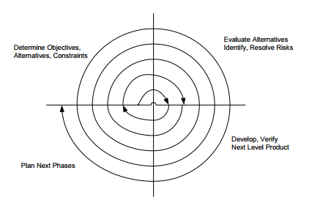
Figure 12 [55] The spiral development cycle.
The disadvantages of this method are that this method requires a lot of planning and that the process may go on indefinitely however this can be counteracted by allowing appropriate time and by stopping the process at an appropriate point for the time frame. The advantage to this method is that a plan can be made to develop the device without knowing how the device will work in the final stages [56].

5.2.1 Development Deliverables
The aim for the development section of the project is to develop an electronic depth measurement device, this will enhance the understanding of the topic area and demonstrate the applications of ultrasonic technologies. The number of features and level of functionality will be dependent on the number of times the spiral has been completed, there is no set required level for success.

6. Design and Prototype Development
To further investigate ultrasonic methods there was an attempt to develop a measurement device to obtain depth information. Using the spiral development method outlined in section 5.2, a series of prototypes were developed with developments on the next iteration based on the findings of the previous.

6.1 Initial Prototype
The first prototype needs to provide the information of the physical concepts and complications involved with ultrasonic measurements, to do this the aim was to develop a circuit that could obtain a relatively accurate measurement in the medium of air.
Aims of first prototype:
- Measure distance to the nearest centimetre.
- Measure distance using ultrasound.
- Measure distance in air.
- Display distance measurement.

6.1.1 Component Selection
To fulfil the aims of this prototype an ultrasonic sensor of some form needed to be selected, to take readings from the chosen sensor a microcontroller seemed the best choice (this will be specified when the specifications of the sensor etc. are known). To display the readings an LCD should suffice for this basic prototype. Other passive components will be decided based on the other selections. The basic block diagram for this system can be seen in figure 13.
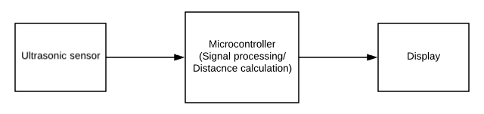
Figure 13 Initial prototype block diagram.

Ultrasonic sensor
Based on the aims for this prototype this component must be capable of measuring to the nearest centimetre in air, based on those specifications several devices were found. The devices researched were ultrasonic modules with the peripheral devices such as filters etc. as these parts of the system are complex and time consuming to design at this stage in the project.

US-015 [57]
This sensor consists of two transducers (transmit and receive), when the trigger pin is sent high a transmit pulse is sent, the echo pin is also sent high at this time, when the pulse is received the echo pin is sent low, the distance can be calculated using the width of the pulse from the echo pin. The circuit consists of a microcontroller to coordinate the pulses based on the input etc. the transmitter is powered by around 30V boosted from the 5V supply, and the receiver is fed through several filters back to the microcontroller. In table 1 are the basic specifications of this device and figure 14 is the device itself.
Power Supply | 5V DC
Static Current | 3mA
Distance Range | 2cm - 400cm
Resolution | 0.3cm
Measurement Angle | <=15 degrees
Frequency | 42kHz
Price | £5
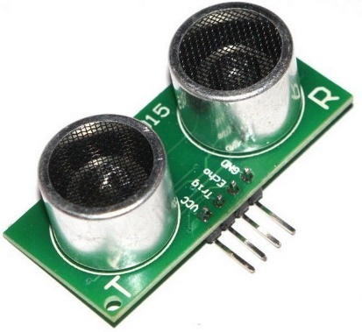
Table 1US-015 Specifications.
Figure 14 US-015

HC-SR04 [58]
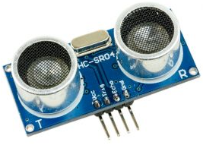
This sensor is much like the previous sensor in functionality and appearance, with the correct input a PWM signal proportional to the measured distance will be output. Below in table 2 the specifications for this device are shown and the device is shown in figure 15. This sensor and the US-015 share similar specifications apart from the operating frequencies and the price.
Figure 15 HC-SR04
Power Supply | 5V DC
Static Current | 20mA (Max)
Distance Range | 2cm - 400cm
Resolution | 0.3cm
Measurement Angle | <=15 degrees
Frequency | 40kHz
Price | £3
Table 2 HC-SR04 Specifications

LV-MaxSonar-EZ3 [59]
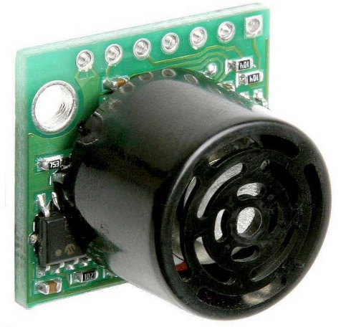
This device differs from the others as it has only one piezoelectric transducer this acts as the transmitter and the receiver, however the functionality is the same with the voltage boosted transmitter and filtered receiving path both fed to a microcontroller. This device can output a PWM signal like the others however it can also output an analogue voltage or a serial output. This sensor comes in several variations each with a different beam spread, this affects its effective measurement area, for this application the beam spread should be as narrow as possible for specific measurements. Below in table 3 and figure 16 are the specifications and an image of the device.
Figure 16 LV-MacSonar-EZ3
Power Supply | 2.5-5V DC
Static Current | 2mA
Distance Range | 38cm - 645cm
Resolution | 2.5cm
Measurement Angle | Model dependent
Frequency | 42kHz
Price | £24
Table 3 LV-MacSonar-EZ3 specifications

Final selection
All these devices have remarkably similar specifications, therefore as this is only and experimental prototype with basic aims for functionality the price was the deciding factor; for this reason, the HC-SR04 was selected as it was the cheapest sensor therefore it will have less impact on the project if the prototype is unsuccessful, and it has the features required for this prototype (<1cm accuracy).

Microcontroller
Now that the sensor is known the microcontroller can be specified. The requirements for the microcontroller are as follows in table 4.
- I/O pins
  - Ultrasonic sensor one input one output should be doubled twice to allow for more complex sensors later in development.
  - LCD used in parallel mode uses seven pins
  - Allowing up to five I/O pins for user control (switches etc.)
- Some form of timer module or CCP module is required to measure the width of the pulse output by the sensor.
- The clock speed requires at least two times the frequency of the sensor with a little extra to allow for calculations, however with most microcontrollers capable of values in the MHz range the minimum should be 2MHz.
- As the size of the code for the later prototypes is unknown the program and RAM values should be as large as possible whilst being cost effective.
I/O pins | Timer/CCP module | Clock Speed | Program memory | SRAM
20 | Compatible | >2MHz | Max possible (Min 8KB) | Max possible (Min 128B)
Table 4 Microcontroller requirements
Using the parametric search tool on the microchip website the best fit for this specification was found to be the PIC16F18877 as this matched the specification with excess allowing up to 32MHz clock speed and has 5 capture compare modules inbuilt, allowing for more complex prototype variations later in the development process. However, to prevent delays with delivery of this product the PIC16F887 was used as it met the specification adequately and was available with no delay, the specifications for this chip are listed in table 5.
I/O pins | Timer/CCP module | Clock Speed | Program memory | SRAM
35 | Two 8-bit counters and one 16-bit. | >=8MHz | 14KB | 368
Table 5 PIC16F887 Specifications

6.1.2 Design
Now the components had been selected the circuit could be designed. Firstly, the circuit was created in Proteus, this enabled for the circuit and any software required to be simulated accurately without any damage to physical components, which would need to be replaced which would be time consuming. The initial circuit created in Proteus is shown below in figure 17.
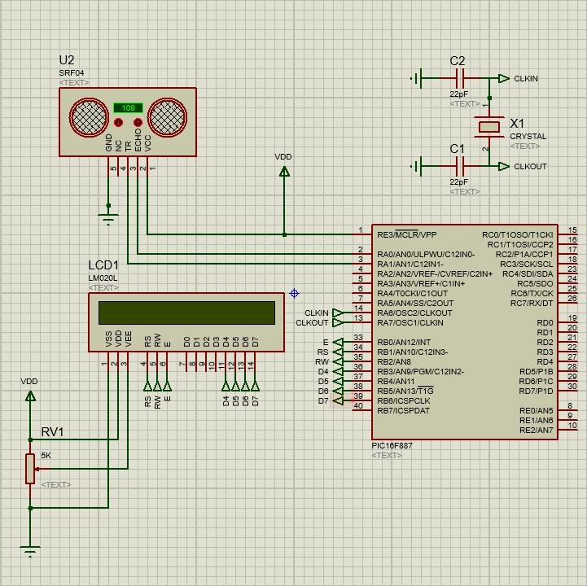
Figure 17 Proteus initial circuit
This circuit features the ultrasonic sensor (U2) microcontroller and LCD, the readings from the ultrasonic sensor are fed into the microcontroller which then outputs the readings on the LCD. The full code for this simulation can be found in the index (Entry 1), the basic principle of operation is as follows:
- A 10-microsecond pulse is sent from the microcontroller to the trigger pin of the sensor (TR), this causes the transmit transducer to send 8 pulses.
- After the 8 pulses are sent the echo pin (ECHO) outputs a logic high to the microcontroller.
- When the pulse is received by the receiving transducer the echo pin returns to logic zero.
- The width of the pulse is measured by the Timer1 module which is a 16-bit timer capable of measuring up to 65ms running from internal clock of 4MHz (8MHZ divided by 2).
- The distance is then calculated with a time of flight calculation using the pulse width and the speed of sound.
The calculations for the time of flight to distance calculations are below:
$$Distance=\frac{Speed × Time}{2}$$
$$speed=0.0343cm/μs and Timer1 increments every 1μs$$
The speed was calculated in cm/µs to give the distance per increment of timer1. To not use a small decimal number in this calculation the inverse was taken.
$$\frac{1}{0.0343}*2=constant$$
$$Distance=\frac{Timer1}{58.3}$$
After a small amount of testing within Proteus refining the calculation constant ($Distance=\left(\frac{Timer}{58.2}\right)+1$) the circuit was constructed. For the physical construction of this circuit a 7805-voltage regulator was put in place to ensure the voltage supply to the system did not exceed 5 volts. The constructed circuit is shown below in figure 18 this circuit is being supplied 7 volts through a bench power supply.
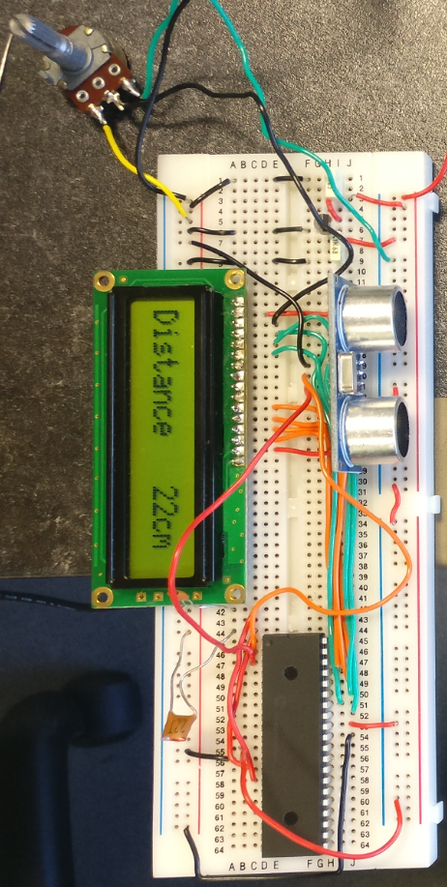
Figure 18 First prototype circuit constructed.

6.1.3 Testing
The circuit constructed in figure 18 was then tested to obtain the features of this device.

Voltage regulator
The voltage regulator was tested by measuring the output of the regulator for a given input this is shown below in table 6.
Supply Voltage (V) | Output Voltage (V)
6.5 | (Turn on) 4.98
7 | 5.02
8 | 5.01
9 | 5.00
10 | 5.03
11 | 5.03
Table 6 7805 Voltage regulator output test.
The voltage regulator coped adequately with the tested input voltages, the 6.5V test output slightly below however according to the data sheet the 7805 is rated from 7V-25V, as there was no heat sink applied to the regulator the test was concluded at 11V, this also confirms the system will be able to run on a 9V battery supply comfortably.

Device accuracy and function
This test was done to obtain the accuracy of the system. The method for this test was to place a flat object at a known distance away from the sensor, then compare the known distance with the measured distance displayed, moving the object gradually towards and gradually away were tested also but this had no effect on the results. This was repeated 10 times an example measurement from the test and the results for this test are graphed in figure 19 and 20.
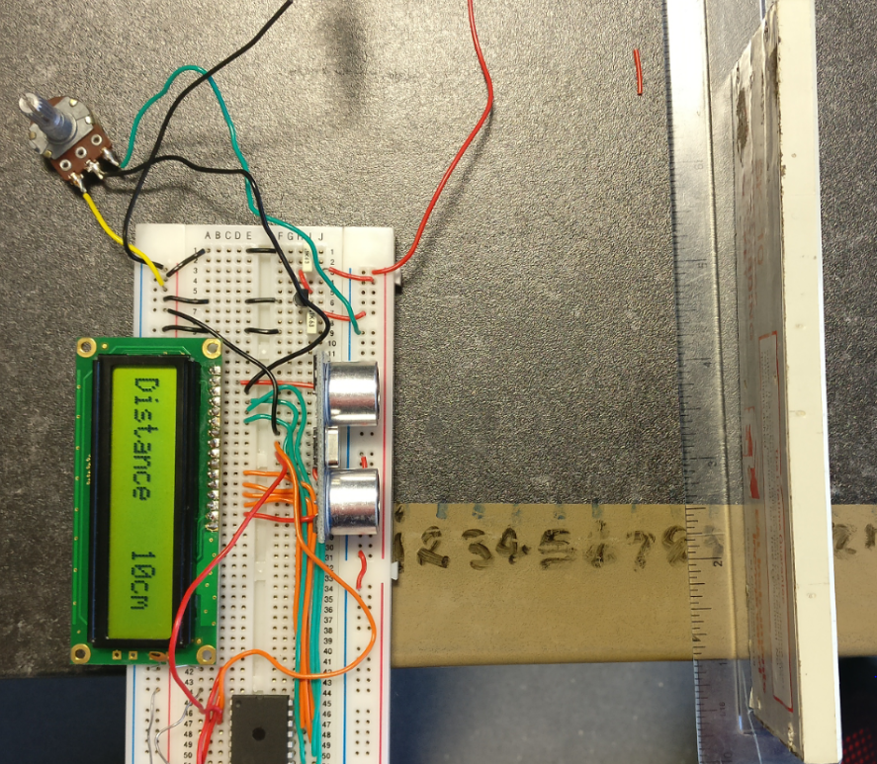
Figure 19 Example test measurement.

Figure 20 Initial prototype accuracy test.
It is apparent from these results that the system in its current state cannot measure below 4cm this is due to the minimum range of the sensor and the distance calculation, the system is also accurate mostly within 1cm above or more often below the actual measurement; however sometimes the system can be up to 2cm out like the 28cm measurement for example. If the blocking object was placed at an angle of more than around 20° there were major inaccuracies and inconsistencies in measurement. Inaccuracies in measurements when the object was parallel to the sensor could be caused by multiple factors such as:
- The markings of known distance, and the placement of the object on these markings in figure 19 could have been inaccurate, making the comparison of measured and known distances invalid.
- Blowing air across the measurement area did have a slight effect on the reading, it is possible airflow in the room may have disrupted some of the measurements, this could explain why the repeated measurements were different.
- Change in temperature has a known effect on the speed of sound changes in speed would cause a change in the time of flight and therefore the width of the pulse and in turn the measured distance.

6.1.4 Evaluation
The aims for this device were:
- Measure distance to the nearest centimetre.
- Measure distance using ultrasound.
- Measure distance in air.
- Display distance measurement.
Not all aims were met as the ability to measure distance to the nearest centimetre as in some cases the error in the measurement was greater than 1cm. This device did however show the complications involved with these measurements from speed of sound variations due to temperature and flow etc. to the positioning and quality of the reflective object.

6.2 Second Prototype
In theory the only changes this prototype would need to be capable of measuring underwater is a waterproof transducer and a change in the distance calculation to account for the increase in speed of sound.
The aims for this prototype:
- Obtain distance measurements in air.
- Obtain distance measurements in water.
- Keep functionalities from initial prototype.

6.2.1 Component Selection
The only thing that was required to change for this prototype is the transducers attached to the HC-SR04 board. These sensors will need to be fully waterproof and compatible with the board already in place. In table 7 is a comparison of different transducers found based on their key features required for this application.
Name | US125-25A [60] | SR015 [61] | ZHIPU reversing radar [62] | TD40200D [63]
Image | 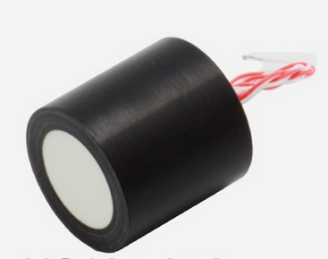 | 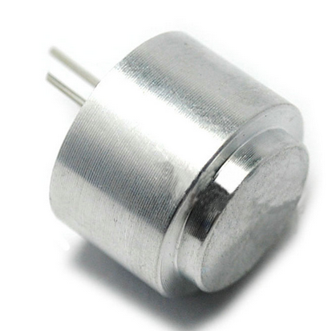 | 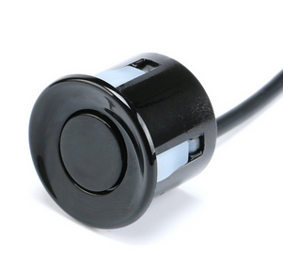 | 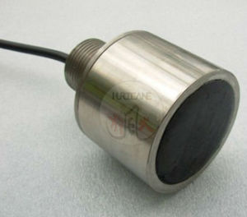
Operating frequency | 5KHz/125kHz | 40kHz | 40kHz | 40kHz
Voltage | 500Vp-p Max | 140Vp-p Max | 140Vp-p Max | 350Vp-p Max
Range | 0.2 - 4 meters | 0.3 – 3.5 meters | 0.2-4.5 meters | 0.5-150 meters
Waterproof | IP68 | Waterproof but unrated | Waterproof but unrated | IP65
Price | $30 | $26.99 | $4.32 | $89
Table 7 Waterproof transducer comparison
As the aim for this sensor was to be submerged in water to take measurements the SRO15 and the US125-25A seemed inappropriate as their connections are not waterproof, the ZHIPU and the TD40200 have enclosed electrical connections with a long cable that can connect to the system externally to the water. The ZHIPU was chosen as it had similar specifications to the TD40200D apart from a lower effective range, this factor was not important as this was only a proof of concept and the ZHIPU was much cheaper.

6.2.2 Design
The circuit for this prototype has the same circuit as the previous prototype however the transducers on the HC-SR04 was replaced with the ZHIPU transducers. The modified HC-SR04 board is shown in figure 21.
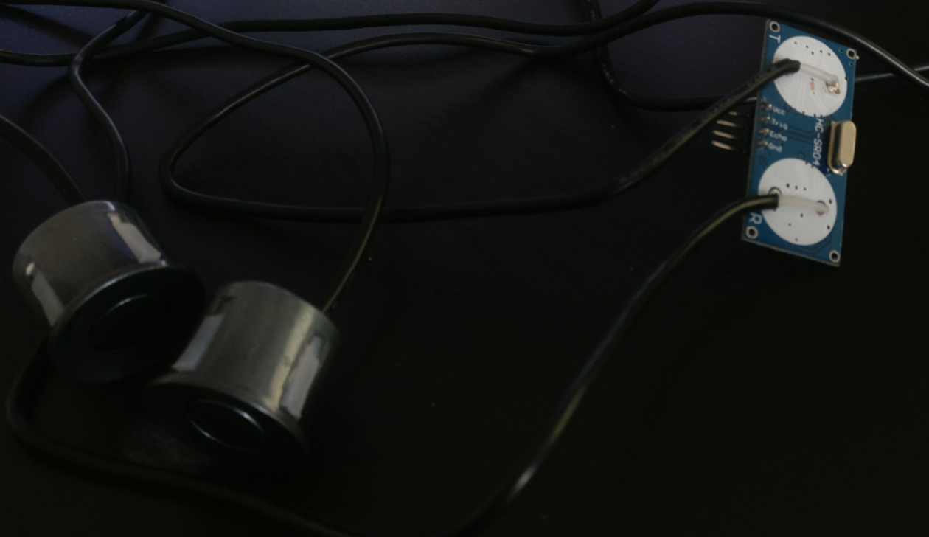
Figure 21 HC-SR04 with ZHIPU transducers.
The modified HC-SR04 was then placed back into the system with the same connections.

6.2.3 Testing
To ensure the system was functioning properly the system was tested using the same method as the accuracy test for the previous prototype. As the system did not function as intended a 16x2 LCD was added to display more information to monitor the measurement further this circuit test is shown in figure 22.
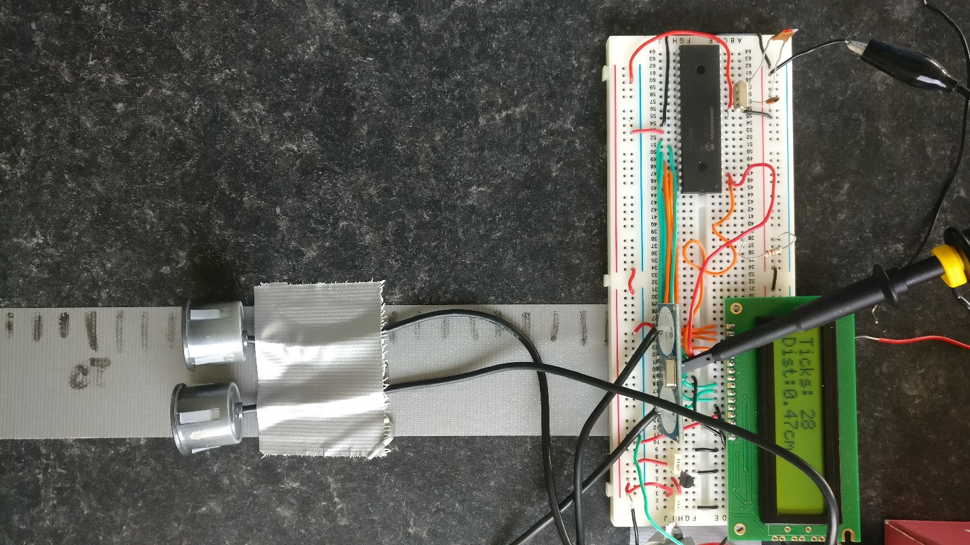
Figure 22 Second prototype test.
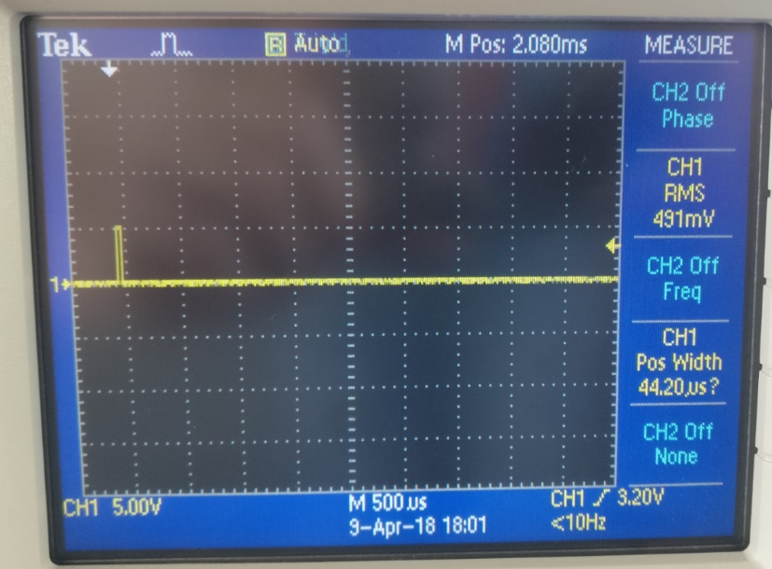
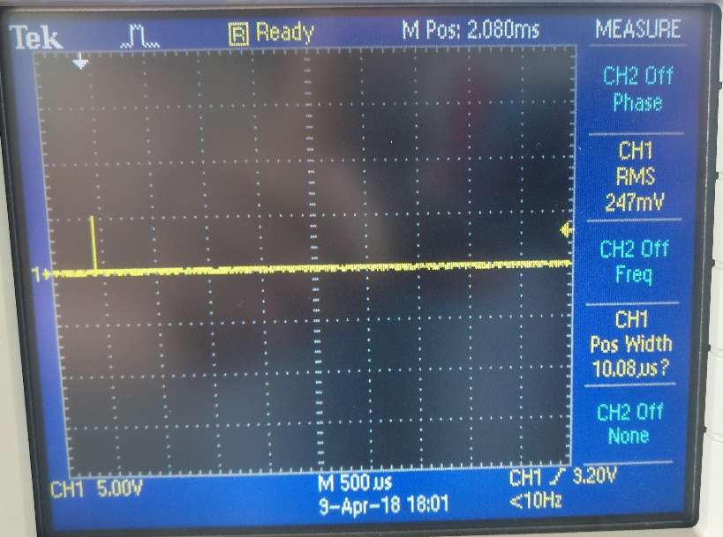
However, the output of the system no matter what distance or the material and surface texture of the reflective object the output was always the same, multiple orientations of the transducers were also tested. To ensure the system was triggering properly the trigger and echo pins were measured on the oscilloscope these outputs are shown in figure 23.

Figure 23 Trigger pulse (Left) Echo pulse (Right).
It can be seen from these readings that the trigger pulse (Left) is firing at the coded 10 microsecond pulse at 5 volts, and the echo pin (Right) has a noticeably short pulse. To ensure there was nothing wrong with the module the other sensors were soldered back onto the board, which functioned as per the last prototype. The waterproof transducers were reattached and retested which again failed to function. To test if the echo pin timings were different with these transducers, the timer1 module was set to run at 8MHz to achieve a higher resolution on the echo pin but lower overall range. This test achieved the same results with only one reading being output no matter the distance of the object.

6.2.4 Evaluation
This prototype was unsuccessful the HC-SR04 board with waterproof transducers was incapable of making distance measurements in air let alone water. As multiple other causes for the system not to function it could be assumed that these transducers were not functioning properly, this could be because they are faulty or incompatible with the HC-SR04 board; however, it is difficult to tell without time consuming tests the exact cause of this issue because of this a new sensing module should be used to prevent any further time to be wasted.

6.3 Third Prototype
It was made apparent from the previous prototype that the HC-SR04 board would not be appropriate for an underwater measurement with the changes made, therefore it was decided that a new ultrasonic module should be used in place of the HC-SR04. The aims for this prototype were the same as the previous:
- Obtain distance measurements in air.
- Obtain distance measurements in water.
- Keep functionalities from initial prototype.

6.3.1 Component Selection
As mentioned, due to the lack of functionality of the previous prototype a new ultrasonic module was needed once this had been selected it can be seen whether any other new components are needed. The ultrasonic sensor must be waterproof that is the only real requirement of this section of the circuit, the rest of the system can be modified if necessary to accommodate for any changes.

Ultrasonic sensor

DYP-ME007Y [64]
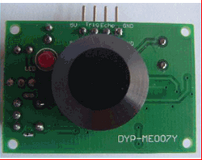
This sensor operates much like the HC-SR04 board this sensor uses the same trigger and echo pin configuration and measurement method however there is only one transducer which is fully waterproof used as the transmit and receive transducer. The specifications for this device are shown below in table 8 and the device is shown in figure 24.
Figure 24 DYP-ME007Y.

Power Supply | 5V DC
Static Current | 15mA
Distance Range | 30cm - 350cm
Resolution | 1cm
Measurement Angle | 30°
Frequency | 40kHz
Output | PWM
Waterproof | Transducer only
Price | £9
Table 8 DYP-ME007Y Specifications.

MB7052 XL [65]
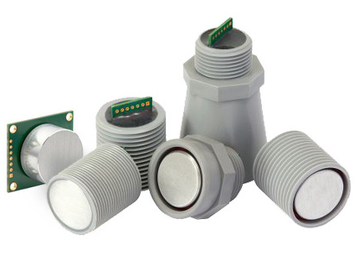
This sensor is a specific model in a range of ultrasonic transducers each with slightly different specifications (differing beam angle, range, resolution etc.). This model features firmware filtering that rejects reflections from smaller objects and only obtains the reading from the largest acoustic reflection. The specifications for this device are shown below in table 9 and the device is shown in figure 25.
Figure 25 MB7052 XL and its different case variations.
Power Supply | 3-5.5V DC
Static Current | 3.4mA
Distance Range | 20cm - 765cm
Resolution | 1cm
Measurement Angle | 4°
Frequency | 42kHz
Output | PWM, or analogue
Waterproof | Front side of module IP67
Price | £99
Table 9 MB7052 XL Specifications.

Senix Toughsonic 3 [66]
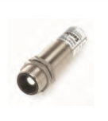
This sensor comes with its own computer software, the software has the ability to change timings and settings associated with the sensor, it can also monitor the sensors performance etc. This range of sensors also features multi-sensor synchronisation where up to 32 of these sensors can be used together taking readings in unison much like the MBES systems discussed in the research section. Below in table 10 and figure 26 are the specifications and the device itself.
Figure 26 Senix Toughsonic 3.
Power Supply | 10-30V DC
Static Current | 60mA
Distance Range | 4.5cm - 90cm
Resolution | 0.086mm
Measurement Angle | Not stated
Frequency | Not stated
Output | PWM, or analogue or RS232
Waterproof | IP68
Price | £429
Table 10 Senix Toughsonic 3 Specifications.

JSN-SR04T [67]
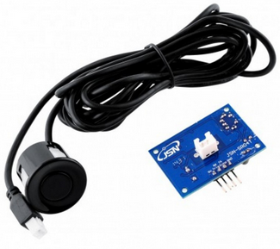
This module functions in the exact same way as the DYP-ME007, however the transducer can be attached to the device through a two-pin port allowing for the transducer (similar if not the same as the ZHIPU mentioned in section 6.2.1) to be placed externally to the device itself. The specifications are shown in table 11 and the device itself is shown in figure 27.
Figure 27 JSN-SR04T.
Power Supply | 5V DC
Static Current | 30mA
Distance Range | 20cm - 450cm
Resolution | 0.5cm
Measurement Angle | <50°
Frequency | 40kHz
Output | PWM
Waterproof | Not stated but transducer is waterproof
Price | £5
Table 11 JSN-SR04T Specifications.

Final Selection
The sensor chosen for this prototype was the JSN-SR04T, this was selected over the Senixc and MB7052XL due to the price, as although these sensors had good specifications these could not be justified for the upwards of £100 cost. The reason the JSN-SR04T was selected over DYP-ME007Y was due to the sensor connection to the board, on the DYP-ME007Y the sensor is directly attached to the circuit board meaning for a submersed measurement there is a high risk of the non-waterproof board coming into contact with the water, whereas the transducer on the JSN-SR04T is connected via a cable meaning space between the vulnerable components and the water can be made. Another reason for this selection is the dead zone or minimum measurement range, on the specification sheets this is defined for in air measurements, if the same time for a 20cm measurement in air was done in water this would be around 90cm (using 1498m/s for speed of sound in water and 340m/s for speed of sound in air). This means the JSN-SR04T would have the ability to measure objects closer than the DYP-ME007Y (30cm in air = 132cm approximately in water).

6.3.2 Design
As the JSN-SR04T board works on the same 10µs pulse trigger and outputs the same PWM signal as the HC-SR04 board therefore there were no changes made to the circuit from the second prototype, the 16x2 LCD was kept as it provided space for more information to be displayed for further analysis. The constructed circuit is shown below in figure 28.
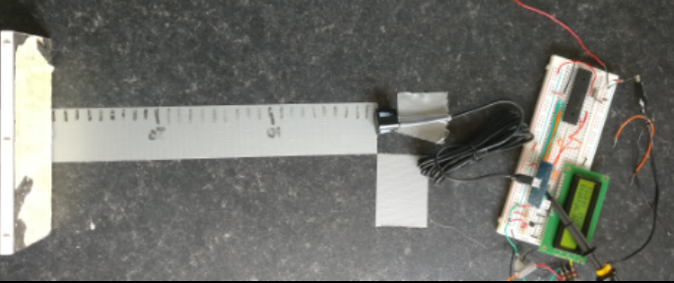
Figure 28 Third prototype constructed circuit.

6.3.3 Testing
The testing for this device was the same method as the initial prototype comparing a known distance to the distance measured by the device, ticks in Timer1 (LCD) and pulse width (Oscilloscope) were also monitored as this information can be used to finely adjust the calculations. The sensor was tested from 20-40cm at intervals of 1cm then from 40-80cm at 5cm intervals. A graph of the results from 20-40cm is shown below in figure 29 and the ticks in timer1 to pulse width is shown in figure 30 the testing method is shown in figure 28 also.
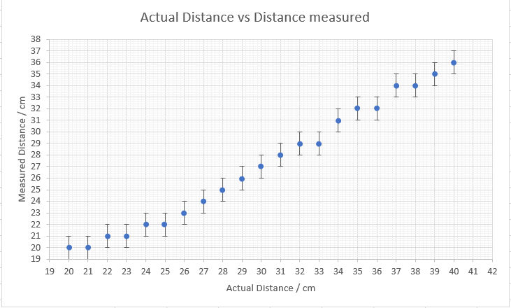
Figure 29 Graph of measured distance to actual distance.
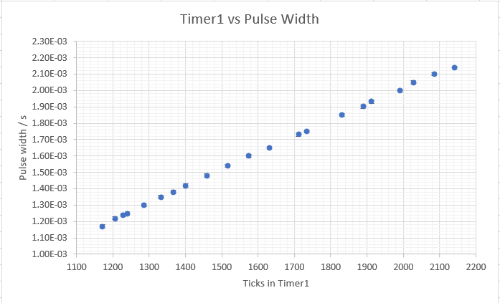
Figure 30 Graph of timer1 to Pulse width
The reason only the 20-40cm results were plotted is during the further measurements the maximum distance the system could measure was 46cm however if the sensor was suspended above the desk and not directly in contact as shown in figure 28 the system could measure to around 380cm with accuracy within 4-5cm this was possibly due to the beam pattern of the transducer (example in figure 8). The results for this were difficult to plot and specify as with the sensor suspended placing an object at a known distance became challenging due to it also being suspended. If the object was placed below the 20cm dead zone the board would output a 20cm pulse width.
When taking readings, the value in timer1 would vary by 12 or 11 ticks (error bars in figure 30 were from fluctuations in individual readings, although test was repeated 3 times.) and the pulse width would also vary accordingly, causing inconsistencies in distance measured (switching back and forth between two values). The readings would also occasionally drop to zero for a few readings (Not shown on graph) then stabilize to a normal expected reading; in an attempt to counteract this effect, the timing between readings was changed and tested at higher and lower values, however this did not fix the issue and the readings continued to drop to zero at random intervals. Although the board could make relatively accurate measurements if the calculation constant was adjusted as figure 30 is relatively linear, the readings continually fluctuated as the output of the board fluctuated when there was no movement of the reflective object.
On further inspection of the JSN-SR04T board the PCB had JSN-SR04T2.0 printed on the silk screen (figure 31).
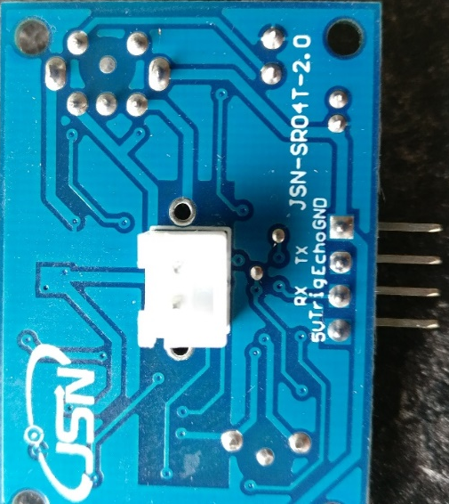
Figure 31 JSN-SR04T-2.0 Board
After looking online for this board there are multiple forum posts and YouTube videos suggesting this board is inconsistent and inaccurate [68] [69], many distributors do not specify which of the models is shipped, this board was advertised as JSN-SR04T however the 2.0 version was received.
Although the system was inaccurate as the pulse width from the board changed even though the distance to the object had not changed; the system could still be tested underwater for a proof of concept even if the readings were inaccurate. As mentioned previously the minimum distance this sensor is capable of measuring is just under 90cm, therefore a container longer than this length would be required to obtain a valid reading. For this reason, a 2-meter piece of guttering was used (tape was used to ensure a completely watertight seal) and the system was tested as shown below in figure 32.
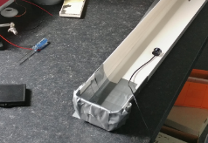
Figure 32 Underwater distance test for third prototype.
No changes were made to the code for this test as the only change that would be necessary would be to change the calculation constant to display distance, however as the Timer1 value was displayed and the board was inaccurate there was no need for this change. No results could be obtained from this test no matter the orientation of the sensor or distance the sensor was from the end of the guttering the JSN-SR04C-2.0 board output the same pulse width of 1.1ms giving the minimum reading of 20cm, this indicated the board was sending and receiving a pulse but also suggested the sensor was receiving an echo pulse sooner than the pulse width indicates (under the 20cm dead zone); this could have been caused by multiple factors, one being there is a difference between the theoretical new dead zone of the transducer in water and the actual dead zone in water causing the sensors new minimum detection range to be above the length of the container. Another possible reason for this reading being incorrect could have been caused by the transducer receiving an echo pulse that had been reflected from another part of the container (e.g. the wall or base) therefore receiving a time of flight measurement much lower than expected.
To test if this error in measurement was caused by reflections from the container a wider container with a greater amount/height of water (figure 33) was tested.
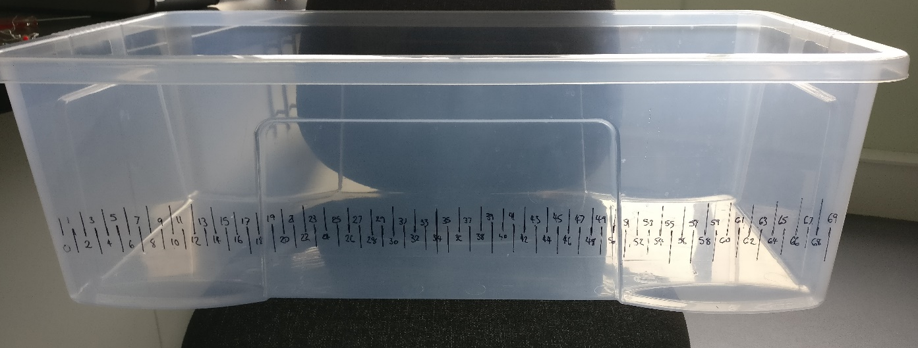
Figure 33 Larger test container.
This test yielded the same result as the previous test, the board output the default minimum reading. This could have been caused by this container only being 70cm in length 20cm below the minimum required; attempts were made to position the sensor diagonally downwards to obtain a greater length before reflection, but these were unsuccessful.
Removing the error checking loops in the code (Index entry 1, without echo pin checks) to attempt to remove any timing errors in the measurement of the pulse width (although these errors were not occurring in other measurements) had no effect on the measurements in water.
After testing the transducer in the water, it was tested again in the air with the same functionality as the first test, this indicated the transducers were fully waterproof as there were no negative effects on their functionality after being fully submerged in water.

6.3.4 Evaluation
This prototype had the ability to measure distance in air however with less accuracy than the first prototype created, this was possibly caused by having the 2.0 variant of the JSN-SR04T module, or perhaps using only one transducer to transmit and receive introduced inaccuracies. Attempts to measure in water were unsuccessful possibly because the transducer did not have to power create a pulse adequate for the medium, or the module was receiving the echo pulse too soon to be measured. This prototype was deemed unsuccessful as it was uncapable of making measurements when submerged in water.

6.4 Fourth Prototype
As the previous prototype was unsuccessful the aims for this prototype remained the same:
- Obtain distance measurements in air.
- Obtain distance measurements in water.
- Keep functionalities from initial prototype.
The main aim for this prototype was to obtain distance measurements in water, as the aim for the project as a whole is focused on obtaining measurements of water depth.

6.4.1 Component Selection
For this prototype the standard version of the JSN-SR04T module was ordered from a seller that guaranteed the standard version of this board, this module was used to try to determine the source of the errors with the previous prototypes, as improving the transducer would be incredibly costly.

6.4.2 Design
The design remained the same and the JSN-SR04T module was used in place of the JSN-SR04T-2.0 module.

6.4.3 Testing
This prototype was subjected to the same test as the other prototypes up to this stage, comparing a known distance to the measured distance of the device, this test was to determine if the standard variation of the board was more consistent with its measurements than the 2.0. The new ultrasonic sensing module can be seen in figure 34 and the experiment can be seen below in figure 35.
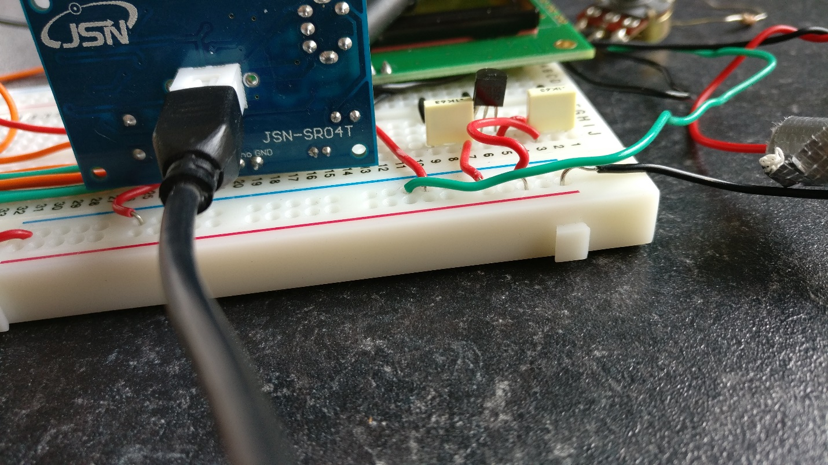
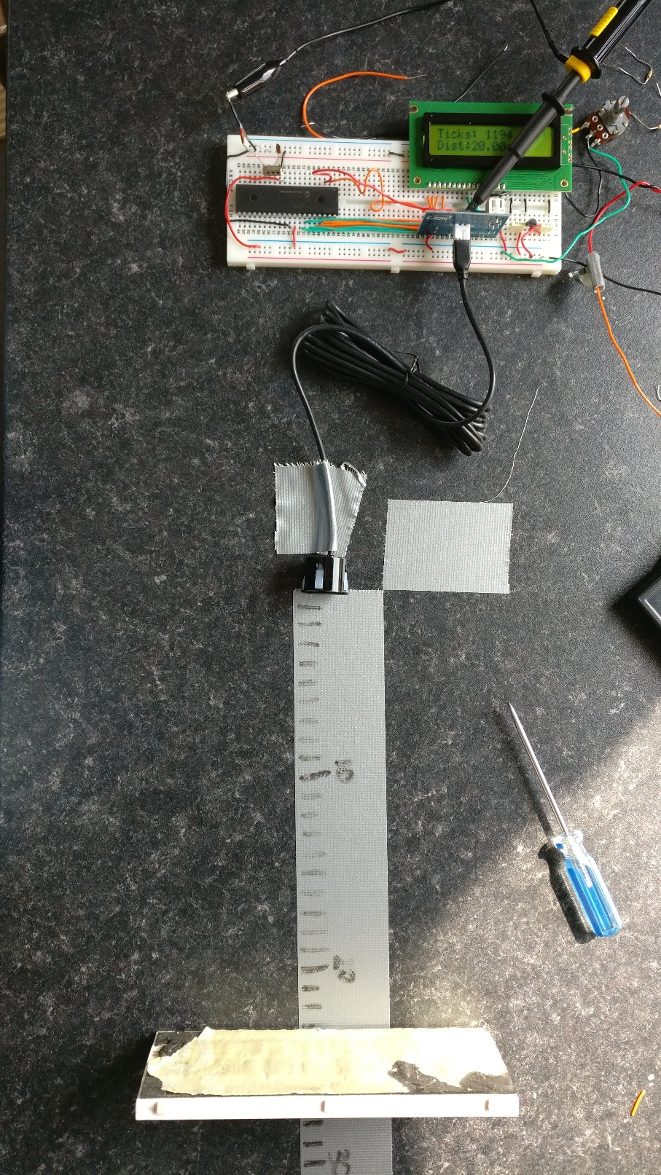
Figure 34 JSN-SR04T board.
Figure 35 Fourth prototype in air test.
These tests yeilded much more consistent results, once the object was placed the pusle width remained the same and therefore the timer1 values and the distance measured also remained the same. During these tests there were also no times where the reading form the board dropped to zero unexpectedly; these observations indicated that this board was more accurate and more stable than the 2.0 varient. Quantified results can be seen below in figure 36.
The tick values were averaged from three readings with only small variations most likely caused by the inconsistencies in the placement of the reflective object. As seen in the top right of figure 36 the gradient of this data series shows the dead zone of the sensor (20.273cm from measurements taken) and the distance calculation constant (53.895), this differs slightly from theoretical value calculated in section 6.1.2. this could be due to a change in temperature, humidity etc. compared to the first test, or more likely, this module has a slightly different pulse width to distance compared to the HC-SR04 module from the first prototype.
Figure 36 Fourth prototype accuracy test.
The next step was to test this transducer underwater, the same test containers were used, first the 2 meter length of guttering from figure 32 in section 6.3.3 then the larger container in figure 33 in section 6.3.3, these tests yielded the same results as the tests on the third prototype, this indicates there is a problem with the ultrasonic transducers transmission and receival rather than with issues with the sensing module, however there was an improvement in timing on the standard JSN-SR04T compared to the 2.0 board. The voltage powering the transducer is a 30V pulse boosted from the 5V supply, this gives a much lower power beam than the systems researched in section 4.2 this could be the reason for the inability to measure when submerged in the more rigid medium.

6.4.4 Evaluation
Although this sensor module was much more capable at making measurements in air than the 2.0 variant, it was clear at this point the selected transducers could not make measurements when submerged in water, however transducers rated to make measurements when submerged cost around £400 (Senix Toughsonic 3) this was not attainable with the budget for this project. For this reason, the possibility for the modification for an existing sensor was investigated this is below in section 6.5.

6.5 Transducer Investigation
As mentioned the transducers that accompany the JSN boards although waterproof cannot make measurements when submerged, a probable cause of the underperformance was that the output power of this module was very low compared to the commercial systems, and the maximum voltage for other more expensive sensors researched. There are a few factors which effect the performance of the transducer for this application. Firstly, the wavelength, from previous research in section 4 and the component selections throughout the development process, it was apparent that this was probably not the issue as multiple devices that could be used for this application use around 40kHz. The output power and force applied to the medium dictates how far the wave will propagate into the medium if at all, the pressure or amplitude of the wave produced by a given piezo electric transducer is based on the transducer displacement when a voltage is applied, where $ξ=d_{33}v$ where $ξ$ is the free displacement, $v$ is the applied voltage, and $d_{33}$ is the is the coupling coefficient in the thickness direction (tensor coefficient). The free displacement factor then has an impact on the amplitude of the wave created in the medium given by: $p=cρπfξ$ where $p$ is pressure, $c$ is the speed of sound, $ρ$ is the density of the medium, $f$ is the wave frequency, and $ξ$ is the transducer displacement [70] [71]. The force (amplitude) of the wave is given by $F=pA_{p}$ where $A_{p}$ is the area of the transducer. It can be seen with these equations the larger the voltage applied (to a limit) the greater the displacement of the transducer which in turn increases the amplitude of the wave produced. It can also be seen that the size/area of the transducer also influences its output power, this also changes beam divergence as seen in section 4.1.
Unfortunately, it was impossible to measure some of the variables in the above equations with the available equipment as $d_{33}$ is a vector (z axis) based measurement used to determine the tensor coefficient, e.g. how the material reacts to an applied voltage on a given axis (material dependent) [72]. On this basis the exact output wave amplitude from the transducers in the experiments could not be calculated although it is known that the output power is not enough in this case.
MaxBotix the producer of the MB7052 XL (figure 25) from section 6.3.1 explains although the warranty for this range of transducers does not cover submerged distance measurements, the transducer can make relatively short range submerged measurements (due to the frequency). These measurements can be made by adjusting the calculation for distance as the transducer is calibrated for in air measurements, and it is suggested to coat the outputs of the device with some form of waterproofing [73]. Although the MB7052 XL model only required a 3.3-5V power supply the output voltage on the transducer is not listed, however it assumed that this value is much greater, or that the reflection detection circuitry is more advanced on this model, compared to the JSN boards used in the third and fourth prototypes.

6.6 Final Prototype
At this late stage in the project the use of a more capable transducer such as the MB7052 XL was impossible to implement with its cost and the timeframe, so to obtain depth measurements a non-submerged level measurement was the aim for this prototype. The applications for this type of measurement could be tank or harbour level monitoring, any application where the bottom of the container is at a known distance from the transducer, therefore when filled with a liquid the depth/ height of the liquid can be found.
The aim for this prototype:
- Obtain accurate distance measurement in air with water as reflective surface.

6.6.1 Component Selection
There were no new components used for this prototype apart from the addition of a power indicating LED and that the system was operated from a 9V battery (Duracell plus power 550mAh) instead of a bench power supply, as the tests from prototype one indicated the system would function with a 9V supply (Table 6).

6.6.2 Design
As the outputs of the HC-SR04 board and the JSN-SR04T/2.0 boards all function on the same principle (10 microsecond trigger pulse and PWM output in proportion to distance), these chips can be interchangeable without modifying any circuitry. However, the distance calculation constants are different from chip to chip, this can be counteracted by having the pulse width (time of flight) output by the module displayed on the LCD (using a manipulation of timer1 code shown in index entry 2), then this value can be used to calculate distance using any calculation the user requires (regulating for temperature etc.). The system was placed into a plastic container for portability and the sensor input was attached in a way the sensor boards could be interchanged, the system is shown below in figure 37 and the circuit diagram for this system is shown in figure 38.
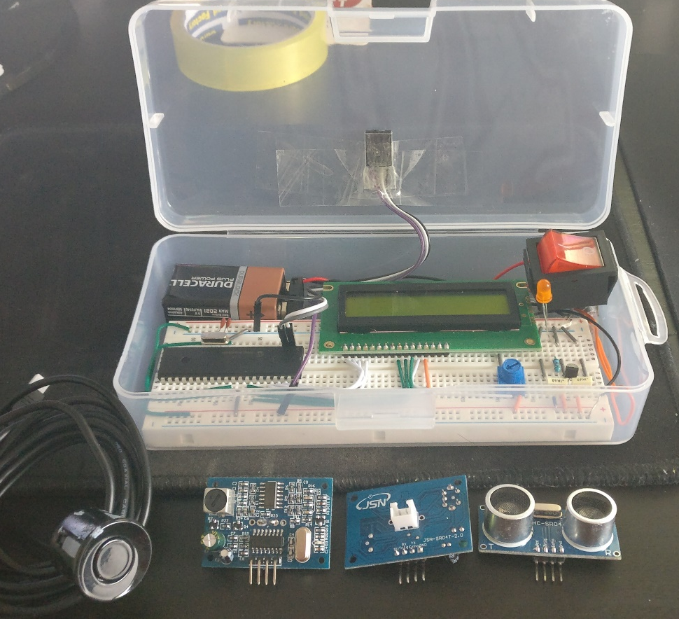
Figure 37 Final prototype.
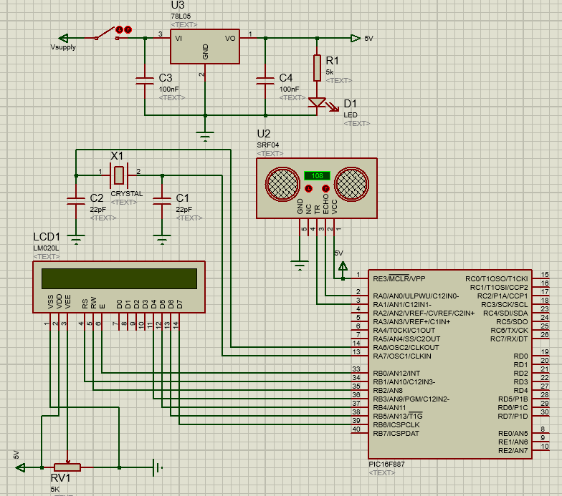
Figure 38 Final prototype schematic.

6.6.3 Testing
As both modules had been tested before in this circuit the only thing that had not been tested is the accuracy of the pulse width that is now measured and displayed on the device, and the quality of ultrasonic reflection from the surface of liquid.
The reflection of the ultrasonic beam from the surface of water was tested by placing a container of water under the transducer at varying distances, this test was completed with the HC-SR04 and JSN-SR04T. An example of this test can be seen in figure 39.
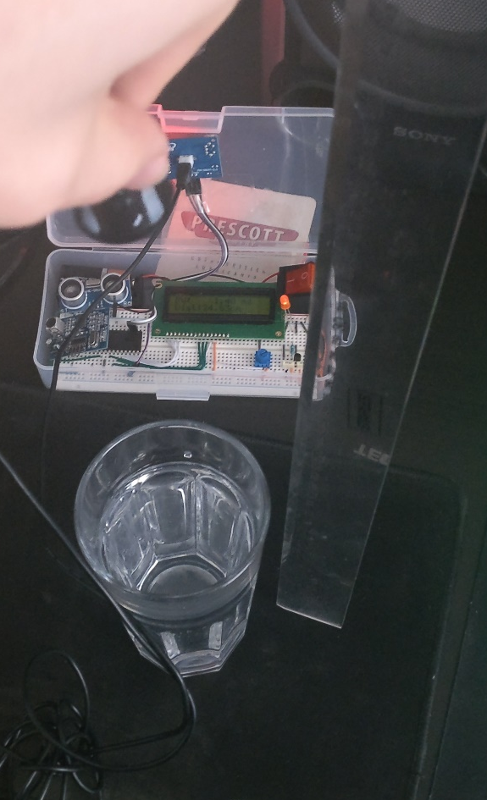
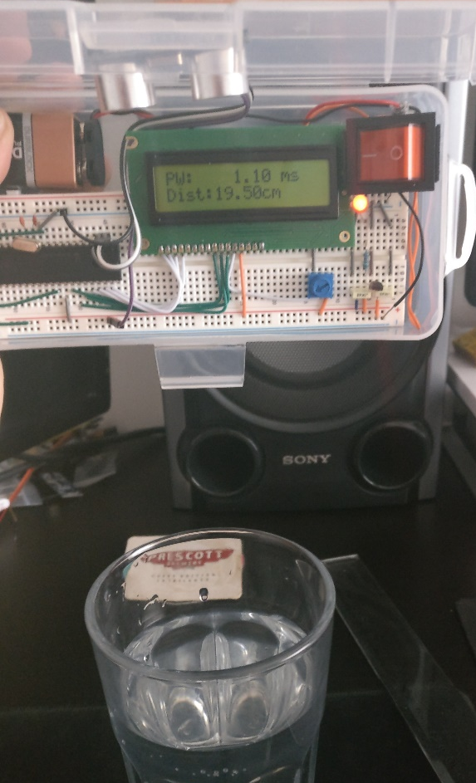
Figure 39 Water surface reflection tests. (HC-SR04 right, JSN-SR04T left)
From these tests the measured distance from the surface of the liquid was compared to the known distance, the HC-SR04 was tested from 10-20cm and the JSN-SR04T was tested from 20-30cm, this was due to the JSN transducer’s dead zone and that to test the HC-SR04 with the circuit layout required the board to be suspended above the container, making it difficult to measure accurately at greater distances. The test was repeated 5 times with each sensor the mean average results are plotted below in figure 40.
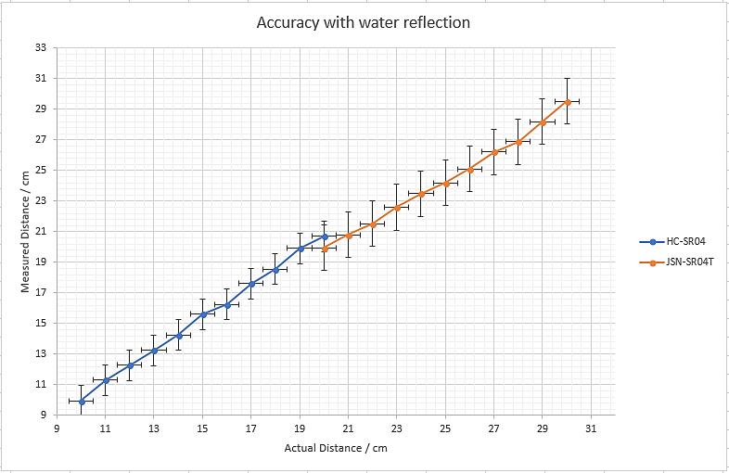
Figure 40 Graph of accuracy with water reflection.
These results show that both these ultrasonic sensors are capable of making a distance measurement using the surface of water as a reflector. The HC-SR04 board was able to be within 1.5cm with all measurements and the JSN was within 2cm; the inaccuracies of the JSN board are likely from the incorrect calculation constant as the microcontroller is calibrated for the HC-SR04 board. Inaccuracies are most likely also introduced for all measurements through the method of these tests, placing a ruler vertically adjacent to the container whilst suspending the transducer made measurements inconsistent and inaccurate (through movement of the ruler and transducer).
When measuring distances on a flat stable surface with the same testing methods as figures 28 and 35, each sensing board was tested every centimetre up to 80cm(HC-SR04) and 100cm(JSN-SR04T) and then every 10cm up to their maximum reading; this was repeated 3 times. the HC-SR04 could distance measurements with less than a centimetre error between 4-80cm and capable of making measurements up to 360cm with the least accurate reading being 3cm away from the actual distance this could have been due to the angle or placement of the reflective surface, the resolution of the system has increased from the initial prototype due to a change in the display of the float being changed to show two decimal places (%f changed to %.2f). The JSN-SR04T could measure within 2.5cm from 20-100cm and could measure up to 500cm with the least accurate reading being 4cm out.
To test the accuracy of the PWM measurement was then tested by comparing the oscilloscope reading of the pulse width to the measurement shown on the LCD adapted from the timer1 counter. The measured pulse width on the HC-SR04 between 5-80cm increased by increased on average across 3 repetitions by 57.22µs per cm (readings from oscilloscope, and device), however all PW measurements were below the oscilloscope value by 2-2.5µs, this is probably due to the structure of the code either at the start or end of the measurement possibly requiring a few clock cycles before the rising/falling edge is registered. Another cause for disparities could be that the oscilloscope reading was inaccurate however this was unlikely. Graphing these results revealed no clarity other than the information stated above. The outcome was similar for the readings from the JSN module however the average increase from the repeated tests in pulse width was 54.6µs per cm, again the readings displayed were 2-2.5µs lower than the oscilloscope reading.

6.6.4 Specifications
The current requirements of the components in final system are shown below in table 12.
Current
Device | LCD | Microcontroller | JSN | HC-SR04 | Other
Current | 5mA | 10mA | 30mA | 20mA | 10mA
Table 12 Current draw of final prototype components.
The costs of the system are shown below in table 13, some of these components were not paid for as they were part of the resources made available through the university stores these items were the passive components, LCD and microcontroller
Cost
Device | Supplier | Cost
Passive components | Various | £5
PIC16F887 | Microchip | £1.58
16x2 LCD | SparkFun | £10
HC-SR04 | Amazon | £6.95
JSN-SR04T | Amazon | £12.95
Battery | Duracell | £6
Table 13 Total final prototype cost.
The full system specifications are shown below in table 14.
Specifications
Supply voltage | Sensor board | Current consumption | PW accuracy | PW resolution | Range | Distance accuracy | Distance Resolution | Cost
7-11V | JSN-SR04T | 55mA | ±2.5µs | 2µs | 20-500cm | ±2.5cm 20-100cm ±4cm 100-500cm | 0.05cm | £35.53
7-11V | HC-SR04 | 45mA | ±2.5µs | 2µs | 4-360cm | ±1cm 4-80cm ±3cm 80-360cm | 0.05cm | £25.93
Table 14 Final prototype specifications.
The standard output of the system with no errors displays pulse width in milliseconds and distance in centimetres shown in figure 41.
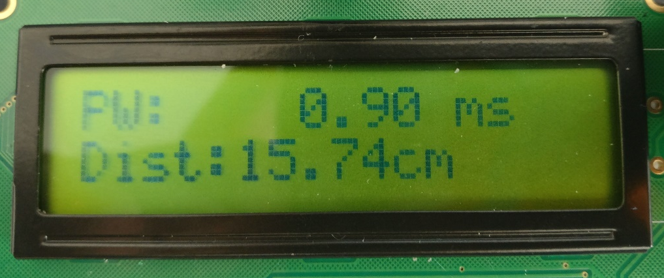
Figure 41 Normal output of system.
If the system displays out of range if there was no return pulse received and time out is displayed if the echo pin on the module is never sent high; no measurements are shown in either of these cases as there is no measurement made.

6.6.5 Evaluation
This prototype was very successful as it was capable of making ultrasonic distance measurements using water as a reflector with good accuracy, probably around 1cm (same as flat surface test) with the HC-SR04 as there were placement inaccuracies in the water reflective test.

6.7 Development Summary
The development outcome was mostly unsuccessful compared to the objectives of the project as none of the prototypes could obtain a depth measurement when submerged, however a lot of information about the physical properties of ultrasonic measurements and piezoelectric transducers was gained. There was a lack of progression in functioning prototypes due to budgetary and time constraints, as the transducers necessary for submerged measurements could not be obtained. However, a device that could obtain a fluid level measurement was created by the final prototype using either the HC-SR04 or the JSN-SR04T chip. With more time powering and receiver filtering circuitry could have been designed to obtain submerged measurements with the ZHIPU transducers.
The spiral philosophy worked well when applied to this project as it allowed for an understanding of the subject are to be gained and expanded upon gradually throughout the course of the project. This method was also extremely flexible as it provided time for the number of prototypes created and for the unexpected transducer investigation (section 6.5) initiated by lack of functional prototype progress.

8. Project Evaluation
The research sections of this project met the aim and objectives as multiple depth measurement methods were investigated and evaluated, the data gathered about these methods was mostly reliable as most of the sources were from reputable journals and any online sources were supported with information with reliable sources. The echo sounder investigation covered a lot about sound and its behaviours in different mediums, and current products and their features; however, the area of transducers was not fully covered which led to dysfunctional prototypes being created due to the use of the incorrect transducers for submerged measurements. This research then had to be done in the development section (section 6.5) which wasted further time and prevented a submerged depth measurement device from being created, however this may have been constrained through cost if there was time available for this addition.
It was found from the research that depth measurements can be obtained through satellite methods, restricted floating sensors, echo sounders from the surface, and echo sounders attached to AUVs. Satellite methods could cover large areas but being less accurate than other methods, restricted floating sensors were the most accurate out of the methods researched however this could only used in previously explored and relatively shallow areas. Echo sounders were a form of middle ground between satellite and floating sensors, this method can measure larger area less accurately than restricted floating sensors and a smaller are more accurately than satellite methods; it was also found the area of these measurements could be increased by adding multiple ultrasonic beams and increased in accuracy by mounting these sensors to AUVs therefore making measurements closer to the sea floor. The current work in these areas apart from the restricted floating sensors, was working on error removal algorithms and accuracy improvements.
The full investigation into echo sounding depth measurement methods revealed that depth was obtained with a time of flight calculation using the speed of sound and the time between sending and receiving the pulse, also that the speed of sound changes dependent on the medium (much faster in water compared to air). This section also covered the physical properties of longitudinal waves, where it was found higher frequencies had a higher measurement resolution and were more directional than lower frequencies however could not propagate very far into a medium, making them good for medical applications. Lower frequencies can propagate much further however had a lower measurement resolution making them useful for depth measurements if a high-power beam is used. The research of current devices also supported this as most of them used from 10kHz to 200kHz with high power beams. It was also discovered waves cannot propagate as far in water as in air but propagate much faster due to the density and elasticity of water in comparison to air.
The development was not successful in comparison to the aim and objectives. This section used the information from the literature reviews to construct a device capable of surface level measurements, submerged measurements were not possible as transducer theory was not conducted as part of the echo sounder investigation and had to be covered in the development section which prevented progress but revealed that the transducers in use although waterproof were not capable of making measurements when submerged as they could not deform the medium. Although unsuccessful the prototypes confirmed some of the research findings as the time of flight of the ultrasonic beam could be used to calculate the distance, and if the reflector was placed at a certain angle the beam could not be detected or gave an inaccurate due to the direction the wave was reflected. It was also confirmed that part of the wave is reflected from a change in medium as the beam could be detected using water and other objects as reflectors. Although the system in its current state could not measure submerged, in theory if an appropriate transducer with a PWM output was used only the calculation constant would need to be changed to account for the increased speed of sound.
If the project was repeated attempts to make the research more thorough to prevent what occurred during this project reoccurring and possibly leading to a more functional prototype earlier in the project and a more complete prototype by the end of the project. If repeated with a similar budget attempts to create powering and filtering circuitry to make the ZHIPU transducers capable of submerged measurements could have been made if more time was available. If repeated with a larger budget, transducers capable of submerged measurements could have been purchased.

9. Conclusions and Recommendations

9.1 Summary
This project investigated several depth measurement methods through literature review which created the starting point for a more detailed research of echo sounders and sound characteristics. The development section then used the research information to create a device which used ultrasonic methods to measure distance although submerged measurements could not be made.

9.2 Conclusions
There is a definite difference between waterproof transducers and transducers capable of making measurements when submerged, and a much larger amplitude wave is required for these measurements, this is the most likely explanation as to why these prototypes could not obtain submerged measurements although the exact reason these prototypes were unsuccessful is still unknown. The ability to detect the reflected pulse also requires filtering to ensure it is only the return pulse that is registered.
It was found that the HC-SR04 was more accurate than the JSN boards this could be because the HC-SR04 had separate transducers for sending and receiving removing the chance of noise/ringing on the received signal, whereas the JSN boards used the same transducer for sending and receiving the pulse.
The near field or dead zone of a transducer is increased in water due to the increase in speed of sound, which caused difficulty in testing.
The 40kHz chosen to use for these measurements was effective for the required range and resolution of these experiments. With a higher amplitude beam it is expected that this frequency would also be applicable to submerged measurements.
The timing of the flight of the wave is just as important as the selection of the transducer when attempting to make accurate distance measurements in any medium, as the JSN 2.0 was less accurate than the standard JSN board due to its surrounding circuitry; both factors must be considered when attempting to make accurate measurements.

9.3 Areas for Further Research
Multi beam sonar was investigated but not fully, the effects of combining multiple ultrasonic beams to create different wave patterns and changing the measurement area. The interaction of ultrasonic waves with each other could also be investigated. Although researched in theory, the effects of changing the frequency used for measurement was untested and is an area for further investigation.
A full investigation of transducers and their properties and the effects of each variable on the outcome of the distance measurement in different mediums. Although some research was done in this area much more could be done.
Creating bespoke circuitry to power the transmission and filter the receival of the ultrasonic beam would reveal further the requirements for depth measurements and maybe reveal areas for improvement within the field. Changing the timing method could also reveal areas for improvement.

10. Reflection
Throughout the course of this project there were many key points that improved understanding of personal and project management. The first being the selection of the depth measurement method to further develop from the initial literature review, this required a personal decision based on the information gained up to that point, based on the further progress of the project it was felt this was the right decision, and improved overall decision-making skills.
The research section of this project was very successful there were many reliable sources used to provide relevant information about the topic area and improved the ability to extract information from a source and determine the sources credibility.
One of the main reasons for the progression of this project was time management (project Gantt chart in index entry 3 and 4), ensuring that work was done when it was needed as there were no timetabled hours, and making choices if the actual course of the project varied from the initial plan. Moving to the next step at the right time and not dwelling on areas let led to little progress overall, this was the case from the fourth to final prototype when the transducer research was completed due to the lack of progress over the last few prototypes, this was done to decide the next step. The development process was relatively unsuccessful because of this lack of progress, this might have been different if it was decided or realised to research transducers fully before development or earlier in the development stages.
Before it was realised the cause of the issue was the transducers the testing of the prototypes to deduce the cause of errors in measurements etc. definitely improved over the course of development, leading to more decisive tests to eliminate variables to determine the cause of the problem.
Risk management was also involved, this included planning for delays in progress and unforeseen circumstances a risk matrix can be seen in entry 5 in the index. Reacting to these occurrences and adapting for these changes is a skill that was developed over the course of this project through various setbacks such as the corruption of experimental data that was on a USB drive, this test was repeated, and the results were rerecorded.
In summary the main things learnt from this experience were decision making and time management skills these were obtained by working independently to achieve the goal set of investigating depth measurement.

11. Bibliography

[1] | National Oceanic and Atmospheric Administration , “Oceans and coasts,” U.S. Department of Commerce, Unknown. [Online]. Available: http://www.noaa.gov/oceans-coasts. [Accessed 08 April 2017].
[2] | J. L. Garrison, J. K. Voo, S. H. Yueh, M. S. Grant, A. G. Fore and J. S. Haase, “Estimation of Sea Surface Roughness Effects in Microwave Radiometric Measurements of Salinity Using Reflected Global Navigation Satellite System Signals,” IEEE Geoscience and Remote Sensing Letters, vol. 8, no. 6, pp. 1170-1174, 2011.
[3] | L-3 Communications SeaBeam Instruments, “Multibeam Sonar Theory of Operation,” 2000. [Online]. Available: https://www3.mbari.org/data/mbsystem/sonarfunction/SeaBeamMultibeamTheoryOperation.pdf. [Accessed 28 09 2017].
[4] | National Ocean Service, “What is sonar?,” National Ocean Service, 23 January 2014. [Online]. Available: http://oceanservice.noaa.gov/facts/sonar.html. [Accessed 15 April 2017].
[5] | A. S. C. Wright, “Deep-towed Swath Bathymetry by an Interferometric Isophase Method,” in Exclusicve Economic Zone Symposium of Mapping and Research: Working Together in the Pacific EEZ, Portland, 1991.
[6] | D. Dinn, B. Loncarevic and G. Costello, “The effect of sound velocity errors on multi-beam sonar depth accuracy,” in OCEANS '95. MTS/IEEE. Challenges of Our Changing Global Environment. , San Diego, 1995.
[7] | K. Abukawa, A. Asada, M. Yamamuro, C. Xu, Z. Kikvidze and K. Sugimoto, “Survey of submerged aquatic vegetation with Multi-beam Echo Sounder in Towada Lake of Japan,” in Underwater Technology (UT), 2011 IEEE Symposium on and 2011 Workshop on Scientific Use of Submarine Cables and Related Technologies (SSC), Tokyo, 2011.
[8] | M. Snellen, K. Siemes and D. G. Simons, “A model-based method for reducing the sound speed induced errors in multi-beam echo-sounder bathymetric measurements,” in OCEANS 2009 - EUROPE, Bremen, 2009.
[9] | Y. Jiang, W. Xu, L. Chen and X. Pan, “Near-field beamforming for a Multi-Beam Echo Sounder: Approximation and error analysis,” in OCEANS 2010 IEEE, Sydney, 2010.
[10] | H. Li, D. Lu, X. Chen and L. Zhou, “Research and Implementation of Real-time Roll Compensation Technology for Multi-beam Bathymetric System,” in Second International Conference on Instrumentation & Measurement, Computer, Communication and Control, Harbin, 2012.
[11] | J. Yu, S. A. Henrys, C. Brown, I. Marsh and G. Duffy, “A combined boundary integral and Lambert's Law method for modelling multibeam backscatter data from the seafloor,” Continental Shelf Research, vol. 103, pp. 60-69, 2015.
[12] | D. R. Blidberg, “The Development of Autonomous Underwater Vehicles (AUV); A Brief Summary,” 2001.
[13] | National Oceanic and Atmospheric Administration, “What is the difference between an AUV and an ROV?,” National Ocean Service, 26 01 2018. [Online]. Available: https://oceanservice.noaa.gov/facts/auv-rov.html. [Accessed 29 01 2018].
[14] | Y. Wang, S. Shao, S. Wang, Z. Wu, H. Zhang and X. Hu, “Measurement error analysis of multibeam echosounder system mounted on the deep-sea autonomous underwater vehicle,” Ocean Engineering, vol. 91, pp. 111-121, 2014.
[15] | ECA Group, “A9-S / AUV / Autonomous Underwater Vehicle,” 2018. [Online]. Available: https://www.ecagroup.com/en/solutions/a9-s-auv-autonomous-underwater-vehicle. [Accessed 12 01 2018].
[16] | Y. Petillot, S. Reed and J. Bell, “Real time AUV pipeline detection and tracking using side scan sonar and multi-beam echo-sounder,” in OCEANS '02 MTS/IEEE, Biloxi, 2002.
[17] | X. Cao, H. Suna and G. E. Jan, “Multi-AUV cooperative target search and tracking in unknown underwater environment,” Ocean Engineering, vol. 150, pp. 1-11, 2018.
[18] | JoséMelo and A. Matos, “Survey on advances on terrain based navigation for autonomous underwater vehicles,” Ocean Engineering, vol. 139, pp. 250-264, 2017.
[19] | E. Barros and J.L.D.Dantas, “Effect of a propeller duct on AUV maneuverability,” Ocean Engineering, vol. 42, pp. 61-70, 2012.
[20] | R. Gore, K. K. Pattanaik and S. Bharti, “Dynamic path replanning algorithm for data gathering AUV,” in International Conference on Industrial and Information Systems, Roorkee, 2011.
[21] | F. C. Teixeira, J. Quintas and A. Pascoal, “AUV Terrain-Aided Doppler Navigation using Complementary Filtering,” IFAC Proceedings Volumes, vol. 45, no. 27, pp. 313-318, 2012.
[22] | J. Yan, X. Yang, X. Luo and C. Chen, “Energy-Efficient Data Collection Over AUV-Assisted Underwater Acoustic Sensor Network,” IEEE Systems Journal, vol. PP, no. 99, pp. 1-12, 2018.
[23] | L. W. O’Neill, D. B. Chelton and S. K. Esbensen, “High-Resolution Satellite Measurements of the Atmospheric Boundary Layer Response to SST Variations along the Agulhas Return Current,” Journal of Climate, vol. 18, pp. 2706-2723, 2005.
[24] | A. Chedin and N. Scott, “Sea surface temperature measurement from satellites: Validation and accuracy,” Advances in Space Research, vol. 2, no. 6, pp. 35-41, 1983.
[25] | G. Wick, J. J. Bates and D. J. Scott, “Satellite and skin-layer effects on the accuracy of sea surface temperature measurements from the GOES satellites,” Journal of Atmospheric and Oceanic Technology, vol. 19, no. 11, pp. 1834-1848, 2001.
[26] | National Ocean Service, “ GFDL Models,” National Ocean Service, 29 November 2016. [Online]. Available: https://www.gfdl.noaa.gov/model-development/. [Accessed 08 April 2017].
[27] | S. Castro, W. Emery and G. Wick, “Accuracy improvement in an infrared satellite skin sea surface temperature product,” in Geoscience and Remote Sensing Symposium, Seoul, 29-29 July 2005.
[28] | C. L. Gentemann, T. Meissner and F. J. Wentz, “Accuracy of Satellite Sea Surface Temperatures at 7 and 11 GHz,” IEEE Transactions on Geoscience and Remote Sensing, vol. 48, no. 3, pp. 1009-1018, 2010.
[29] | M. LI, Z. YANG and Y. LIU, “Sea Depth Measurement with Restricted Floating Sensors,” ACM Transactions on Embedded Computing Systems (TECS), vol. 13, no. 1, pp. 1-21, 2013.
[30] | H. Luo, K. Wu, Y.-J. Gong and L. M. Ni, “Localization for Drifting Restricted Floating Ocean Sensor Networks,” IEEE Transactions on Vehicular Technology , vol. 65, no. 12, pp. 9968 - 9981, 2016.
[31] | US Army Corps of Engineers, “Engineer Manuals Hydrographic Surveying,” 30 11 2013. [Online]. Available: http://www.publications.usace.army.mil/Portals/76/Publications/EngineerManuals/EM_1110-2-1003.pdf?ver=2014-01-06-155809-307. [Accessed 18 01 2018].
[32] | R. Nave, “Sound Waves in Air,” Hyper Physics, [Online]. Available: http://hyperphysics.phy-astr.gsu.edu/hbase/Sound/tralon.html. [Accessed 05 01 2018].
[33] | NDT Resource Center, “INTRODUCTION TO SOUND,” NDT Resource Center, 2002. [Online]. Available: https://www.nde-ed.org/EducationResources/HighSchool/Sound/introsound.htm. [Accessed 20 01 2018].
[34] | P. Vigoureux, “A Discussion on the 'Ear' Under Water,” Proceedings of the Royal Society of London. Series B, Biological Sciences, vol. 152, no. 946, pp. 49-51, 1960.
[35] | J. C. Drury, Ultrasonic Flaw Detection for Technicians 3rd Edition, Swansea: Silverwing Ltd., 2004.
[36] | J. Terzic, E. Terzic, R. Nagarajah and M. Alamgir, “Chapter 2 Ultrasonic Sensing Technology,” in Ultrasonic Fluid Quantity Measurement in Dynamic Vehicular Applications, Springer, 2013, pp. 11-34.
[37] | J. David and N. Cheeke, Fundamentals and Applications of Ultrasonic Waves, Boca Raton: CNC Press, 2002.
[38] | A. Simmons, “Ultrasound in Medical Diagnosis,” Medical Physics, [Online]. Available: http://www.genesis.net.au/~ajs/projects/medical_physics/ultrasound/. [Accessed 06 02 2018].
[39] | C. H. Colwell, “Introduction to Sound,” Physics LAB, 2018. [Online]. Available: http://dev.physicslab.org/document.aspx?doctype=3&filename=wavessound_introsound.xml. [Accessed 15 01 2018].
[40] | “Atmospheric Sound Propagation Considerations for the Birdstrike Project,” Montana State University, Montana, 2004.
[41] | L. Zhang and L. Zhao, “Research of ultrasonic distance measurement system based on DSP,” in International Conference on Computer Science and Service System, Nanjing, 2011.
[42] | R. A. Frosch, “Underwater Sound: Deep-Ocean Propagation,” Science, vol. 146, no. 3646, pp. 889-894, 1964.
[43] | C. Carlson, “Notes on Underwater Ranging,” Max Botix, 12 10 2015. [Online]. Available: https://www.maxbotix.com/Tutorials/underwater-ranging.htm. [Accessed 11 01 2018].
[44] | “Studies of Sound Transmission Fluctuations in Shallow Coastal Waters,” hilosophical Transactions of the Royal Society of London. Series A, Mathematical and Physical Sciences, vol. 265, no. 1169, pp. 567-606, 1969.
[45] | R. Nave, “Ultrasonic Sound,” Hyper Physics, [Online]. Available: http://hyperphysics.phy-astr.gsu.edu/hbase/Sound/usound.html. [Accessed 03 02 2018].
[46] | A. GODIN, THE CALIBRATION OF SHALLOW WATER MULTIBEAM ECHO-SOUNDING SYSTEMS, CANDA: DEPARTMENT OF GEODESY AND GEOMATICS ENGINEERING , 1998.
[47] | U. Meesangphrao, “Distributed underwater sonar,” 2008.
[48] | Garmin, “STRIKER™ 5dv,” Garmin, [Online]. Available: https://buy.garmin.com/en-GB/GB/p/576390#. [Accessed 05 02 2018].
[49] | Furuno, “Network Multi Beam Sonar DFF-3D,” Furuno, 2014. [Online]. Available: http://www.furuno.com/special/en/fishfinder/dff-3d/#Specifications. [Accessed 12 02 2018].
[50] | Ultrasonic-Flow, “Ultrasonic Water Depth Meter,” Ultrasonic-Flow, 2014. [Online]. Available: http://www.ultrasonic-flow.com/77-ultrasonic-depth-gauge.html. [Accessed 16 02 2018].
[51] | Skills You Need, “Research Methods,” Skills You Need, 2017. [Online]. Available: https://www.skillsyouneed.com/general/referencing.html. [Accessed 22 02 2018].
[52] | J. Dudovskiy, “Research Methods,” Research Methodology, 2016. [Online]. Available: http://research-methodology.net/research-methods/. [Accessed 04 29 2017].
[53] | V. Grover, “Research approach,” 02 Febuary 2015. [Online]. Available: https://www.slideshare.net/grovervijayk/research-approach. [Accessed 30 04 2017].
[54] | Z. Zainal, “Case study as a research method,” Universiti Teknologi Malaysia, Malaysia, 2007.
[55] | Department of health and human services USA, “SELECTING A DEVELOPMENT APPROACH,” Department of health and human services USA, 2008.
[56] | Tutorials Point, “SDLC - Spiral Model,” Tutorials Point, 2018. [Online]. Available: https://www.tutorialspoint.com/sdlc/sdlc_spiral_model.htm. [Accessed 25 02 2018].
[57] | “Ultrasonic Distance Sensor Module - US-015,” Fab.to.Lab, [Online]. Available: https://www.fabtolab.com/us-015-ultrasonic-distance-sensor. [Accessed 12 10 2017].
[58] | PiBorg, “Ultrasonic Distance Sensor (HC-SR04),” PiBorg, [Online]. Available: https://www.piborg.org/sensors-1136/hc-sr04. [Accessed 22 10 2017].
[59] | Pololu, “Maxbotix LV-MaxSonar-EZ3 Sonar Range Finder MB1030,” Pololu, [Online]. Available: https://www.pololu.com/product/793. [Accessed 11 11 2018].
[60] | AliExpress, “Ultrasonic level sensor US125-25A ( one ) Waterproof ultrasonic level sensor,” AliExpress, [Online]. Available: https://www.aliexpress.com/item/Ultrasonic-level-sensor-US125-25A-one-Waterproof-ultrasonic-level-sensor/32344023731.html?spm=2114.10010108.1000013.5.47aa4dc9J0GMwe&traffic_analysisId=recommend_2088_3_99734_iswistore&scm=1007.13339.99734.0&pvid=5d08dad1-6. [Accessed 13 01 2018].
[61] | AliExpress, “10pcs/lot Transceiver integrated 16mm 40KHz Ultrasonic Sensor waterproof type Ultrasonic module SR015,” AliExpress, [Online]. Available: https://www.aliexpress.com/item/10pcs-lot-Waterproof-Type-Ultrasonic-Sensor-Transceiver-Integrated-Diameter-16MM/1635113028.html?spm=2114.search0104.3.111.6b013319MYokuI&ws_ab_test=searchweb0_0,searchweb201602_4_10152_10151_10065_10344_10068_10130_10324_1. [Accessed 12 01 2018].
[62] | AliExpress, “Integration of the ultrasonic probe reversing radar | integrated ultrasonic distance sensor | Waterproof Ultrasonic sensor,” AliExpress, [Online]. Available: https://www.aliexpress.com/item/Integration-of-the-ultrasonic-probe-reversing-radar-integrated-ultrasonic-distance-sensor-Waterproof-Ultrasonic/32384495963.html?spm=2114.search0104.3.211.5d0252f7BAECol&ws_ab_test=searchweb0_0,searchweb201602_4_10152_10151. [Accessed 11 01 2018].
[63] | Alibaba, “waterproof ultrasonic transducer ultrasonic transducer 40khz/200Khz ultrasonic distance measurement,” Alibaba, [Online]. Available: https://astrohurricane.en.alibaba.com/product/60488883134-213150335/waterproof_ultrasonic_transducer_ultrasonic_transducer_40khz_200Khz_ultrasonic_distance_measurement.html. [Accessed 11 01 2018].
[64] | DatasheetCafe, “DYP-ME007Y Datasheet – DYP Ultrasonic Sensor,” DatasheetCafe, 18 01 2017. [Online]. Available: http://www.datasheetcafe.com/dyp-me007y-datasheet-dyp-ultrasonic-sensor/. [Accessed 8 02 2018].
[65] | MaxBotix, “MB7052 XL-MaxSonar-WRM1,” MaxBotix, [Online]. Available: https://www.maxbotix.com/Ultrasonic_Sensors/MB7052.htm. [Accessed 08 02 2018].
[66] | Omni Instruments, “Senix Toughsonic TSPC Ultrasonic Level Sensors,” Omni Instruments, 12 2015. [Online]. Available: http://www.omniinstruments.co.uk/level-distance-sensors/ultrasonic-level-distance-transmitter/senix-toughsonic-tspc-ultrasonic-level-sensors.html. [Accessed 11 02 2018].
[67] | Ebay, “JSN-SR04T Ultrasonic Module Distance Measuring Transducer Sensor Waterproof,” Ebay, [Online]. Available: https://www.ebay.com/itm/JSN-SR04T-Ultrasonic-Module-Distance-Measuring-Transducer-Sensor-Waterproof-/201322915390. [Accessed 15 02 2018].
[68] | S. Prakash, “Don't buy JSN-SR04T-2.0 ultrasonic distance sensor module,” YouTube, 02 09 2017. [Online]. Available: https://www.youtube.com/watch?v=N42Y-QOqwtA. [Accessed 25 02 2018].
[69] | “Hardware design for 3.3V ProMini and 5v sensor,” MySensors, 05 2017. [Online]. Available: https://forum.mysensors.org/topic/6761/hardware-design-for-3-3v-promini-and-5v-sensor. [Accessed 21 02 2018].
[70] | M. Martins, V. Correia, J. Cabral, S. Lanceros-Mendez and J. Rocha, “Optimization of piezoelectric ultrasound emitter transducers for underwater communications,” Sensors and Actuators A: Physical, vol. 184, pp. 141-148, 2012.
[71] | R. Rouffaud, F. Levassort and A. Hladky-Hennion, “Unified model for the electromechanical coupling factor of orthorhombic piezoelectric rectangular bar with arbitrary aspect ratio,” AIP Advances, vol. 7, no. 2, 2017.
[72] | R. Schiek and T. Pertsch, “Absolute measurement of the quadratic nonlinear susceptibility of lithium niobate in waveguides,” Optical Materials Express, vol. 2, no. 2, pp. 126-139, 2012.
[73] | C. Carlson, “Notes on Underwater Ranging,” MaxBotix, 10 12 2015. [Online]. Available: https://www.maxbotix.com/Tutorials/underwater-ranging.htm. [Accessed 16 03 2018].

12. Index
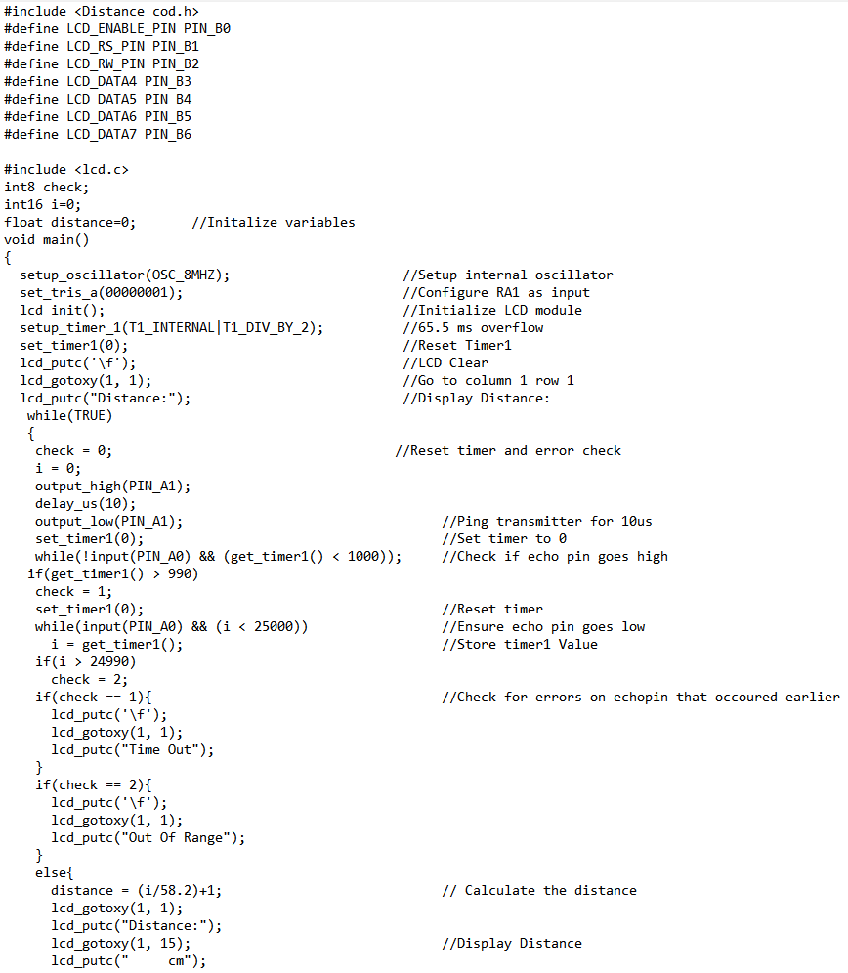
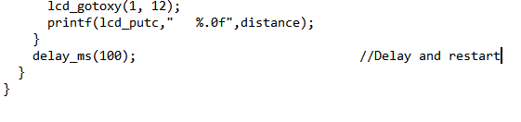
Entry 1Initial prototype code
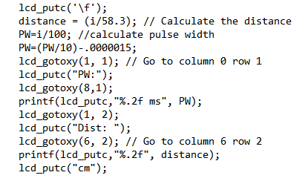
Entry 2 Final prototype code to display pulse width and distance.

Task Name | Duration | Start | Finish
Initial testing | 7 days | Mon 20-11-17 | Thu 14-12-17
Create test board | 1.75 days | Mon 20-11-17 | Thu 23-11-17
Test function of standard transducers in air | 1 day | Thu 23-11-17 | Mon 27-11-17
Swap and test transducers in air | 1.25 days | Wed 29-11-17 | Thu 30-11-17
Test new transducers in water | 2.25 days | Mon 04-12-17 | Mon 11-12-17
Evaluate test board | 1.5 days | Wed 13-12-17 | Thu 14-12-17
Christmas Break | 7 days | Sat 16-12-17 | Sun 07-01-18
Improvements | 7 days | Mon 08-01-18 | Wed 31-01-18
Research improvements | 2.25 days | Mon 08-01-18 | Thu 11-01-18
Implement improvements | 2.25 days | Thu 18-01-18 | Wed 24-01-18
Test improvements | 2.75 days | Wed 24-01-18 | Wed 31-01-18
Interim Viva | 4.75 days | Mon 15-01-18 | Fri 26-01-18
Interim Viva Prep | 2.25 days | Mon 15-01-18 | Thu 18-01-18
Present Viva | 2.25 days | Wed 24-01-18 | Fri 26-01-18
Viva complete | 0 days | Wed 24-01-18 | Wed 24-01-18
Gather results | 6.75 days | Wed 31-01-18 | Thu 22-02-18
Test system | 3.25 days | Wed 31-01-18 | Thu 08-02-18
Resolve errors within system | 4.5 days | Thu 08-02-18 | Thu 22-02-18
Create second prototype | 15 days | Mon 26-02-18 | Mon 23-04-18
Research improvements | 8 days | Thu 01-02-18 | Mon 05-03-18
Implement improvements | 2.75 days | Mon 05-03-18 | Mon 12-03-18
Test improvements | 11.5 days | Mon 12-03-18 | Mon 23-04-18
Resolve Project Prototypes | 2.25 days | Fri 23-03-18 | Wed 28-03-18
Report | 8.25 days | Sun 25-03-18 | Thu 26-04-18
Report Preparation | 8.75 days | Sun 25-03-18 | Wed 25-04-18
Final report hand in | 0 days | Thu 26-04-18 | Thu 26-04-18
Final Viva | 3.5 days | Mon 23-04-18 | Thu 03-05-18
Final Viva Preparation | 4 days | Mon 23-04-18 | Thu 03-05-18
Final Viva | 2.25 days | Tue 01-05-18 | Thu 03-05-18
Final Board | 2.25 days | Thu 26-04-18 | Fri 04-05-18
Poster Creation | 3.5 days | Thu 26-04-18 | Fri 04-05-18
Poster/Board submission | 0 days | Fri 04-05-18 | Fri 04-05-18
Entry 3 Gantt chart task list.

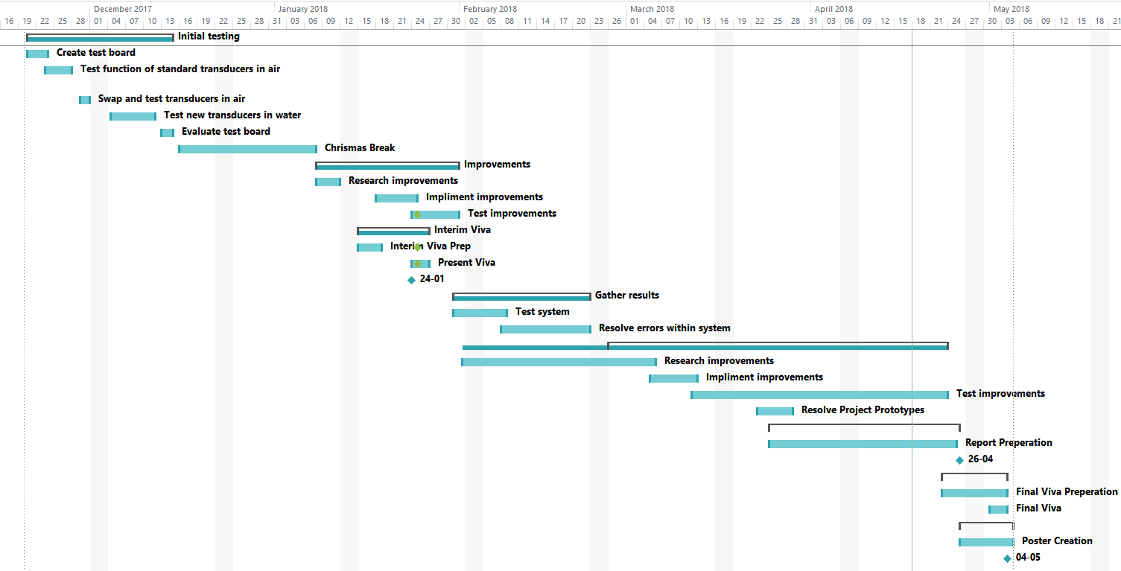
Entry 4 Gantt chart.

- Data loss – This can be from damage or loss of physical storage such as flash drives; data can also be lost through corruption. If any of these eventualities occur there would be loss of progress and therefore a delay in the development of the project. To prevent the loss of data multiple copies of all documents and files associated with the project will be saved in triplicate across different platforms (Flash drive, personal computer drive, and cloud-based storage).

- Illness – Becoming ill during the process of the project could cause a lack of attendance and therefore delay the work on the project. There is not much that can be done to prevent illness however it can be planned for with extra time being allocated to tasks or spare time being added within the plan.

- Room availability – If a room is not available for use during the allotted time then this will cause disruption to progress, this can be avoided through proper scheduling.

- Equipment availability – For project development multiple software packages and specific hardware are needed, if these are not available for any reason such as delayed delivery etc. then progress would be delayed. To avoid this delayed delivery should be planned for, however to a certain extent this cannot be totally counteracted in any way.
Significant
4  High  Impact | 1
 |  | 3
Moderate | 2
Low  Low | Moderate | Significant | High

Entry 5 Risk matrix.

