University of Wales Trinity Saint David
Wales Institute of Science and Art


Group A
Soapbox Rally
Integrating Project (ACHA4008)
Contents
1 Organisation of the team 1
1.1 Aims 1
1.2 Methods 1
2 Gantt chart 2
3 Research on relevant areas 3
4 Conclusion and reflections on continuing the project. 4
5 References 5

Organisation of the team
Dewi Miller 2112054- Group leader -Aims- Methods-
Kallum Mackay 2106948- Gantt Chart
Dillon Reed 2103933- Minutes
Elliot Horwood 2109597-

Aims
AIM 1: Create a soap box that provides full protection and adheres to the rules and regulations provided.
AIM 2: Create a successful soap box that utilities the weight and momentum provided at the start of the course.
AIM 3: Initialise a plan for each milestone you wish to take, throughout the project.

Methods
METHOD for AIM 1: We will adhere to the rules and utilize the roll cages into our design asked in the rulebook. The same will be applied to the brakes, we will adhere to the rules and utilize modern brakes for great performance.

METHOD for AIM 2: We will make a heavier cart than usual to utilize the weight, this will carry the soap box throughout the course and ensures a great speed throughout.

METHOD for AIM 3: We will create a Gantt chart that addresses each milestone and label dates with how long they take to complete.

Gantt chart

Research on relevant areas
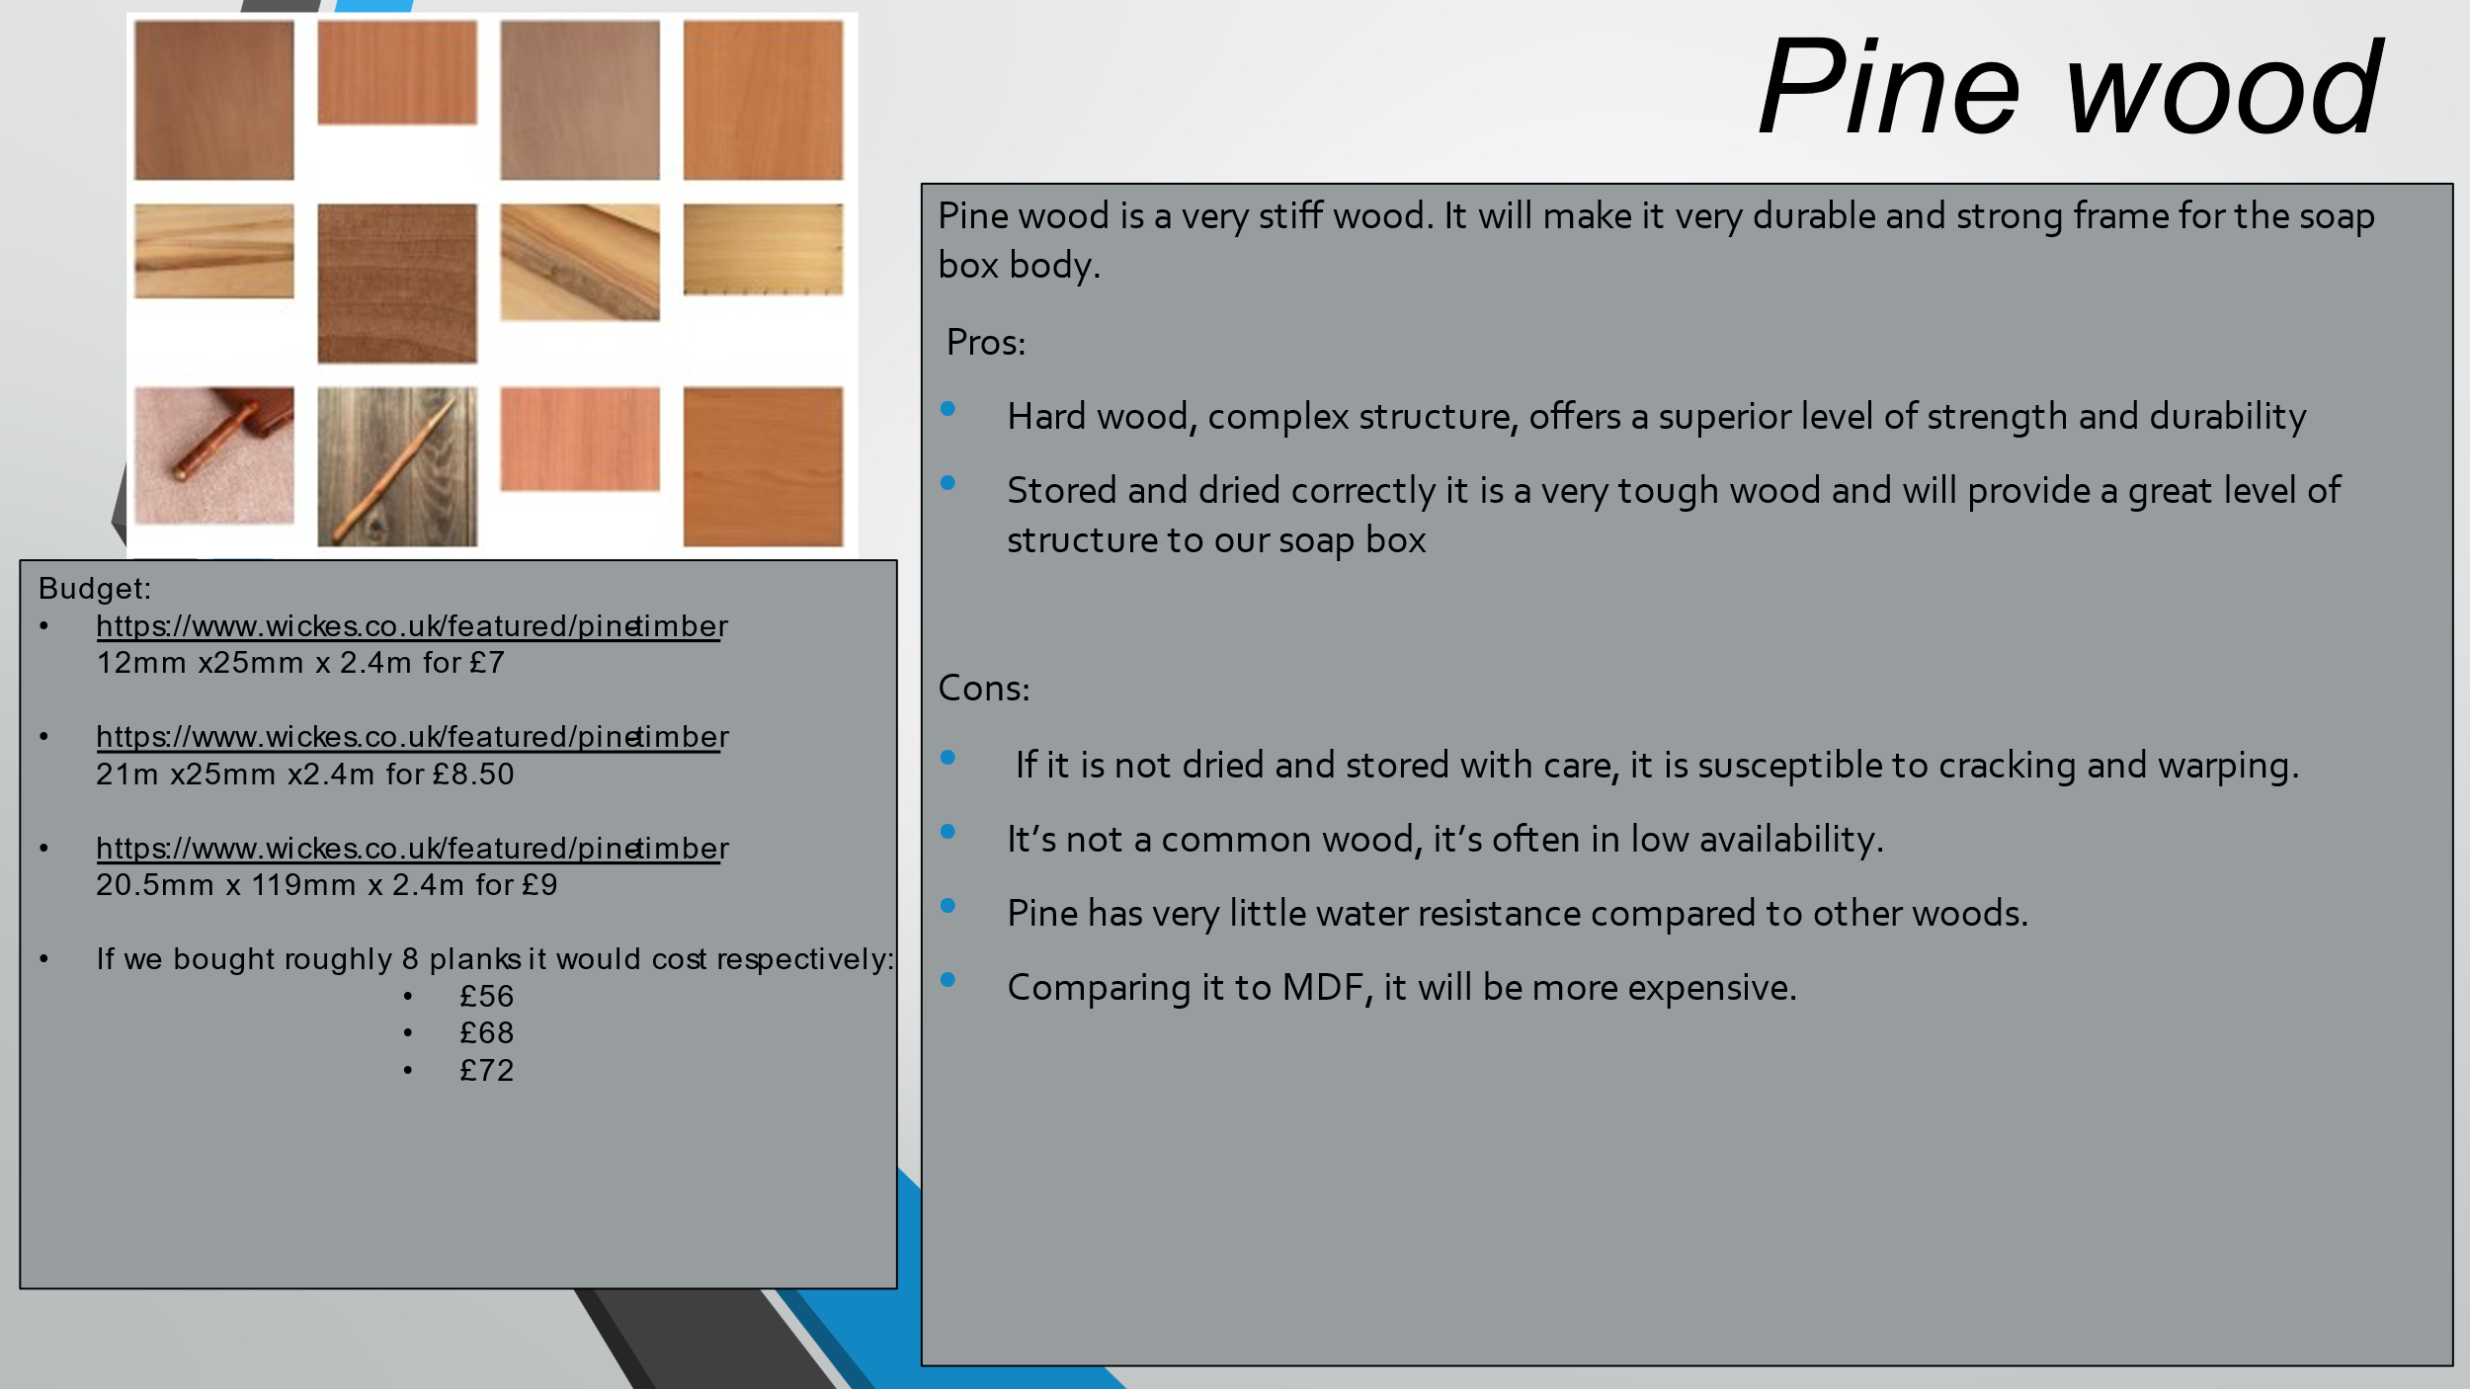
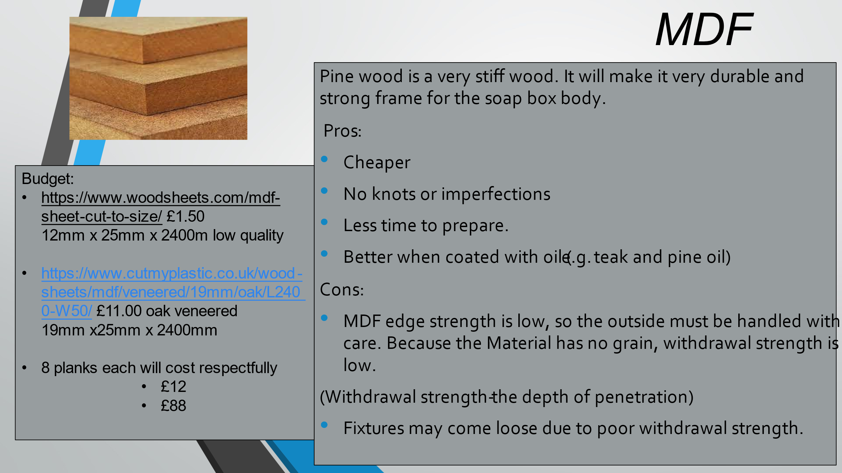

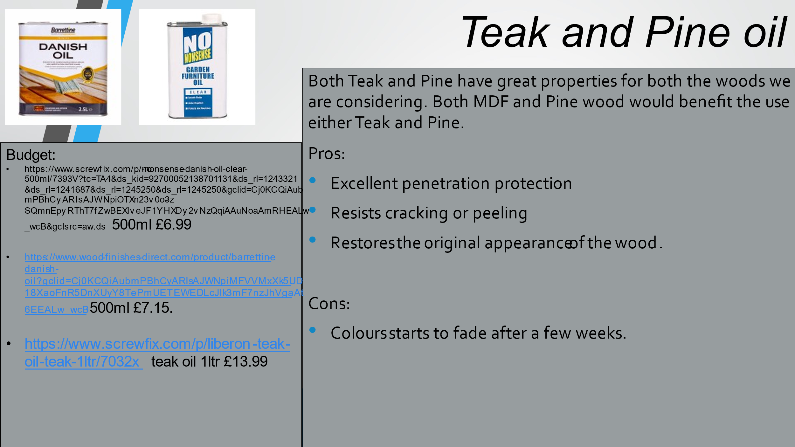
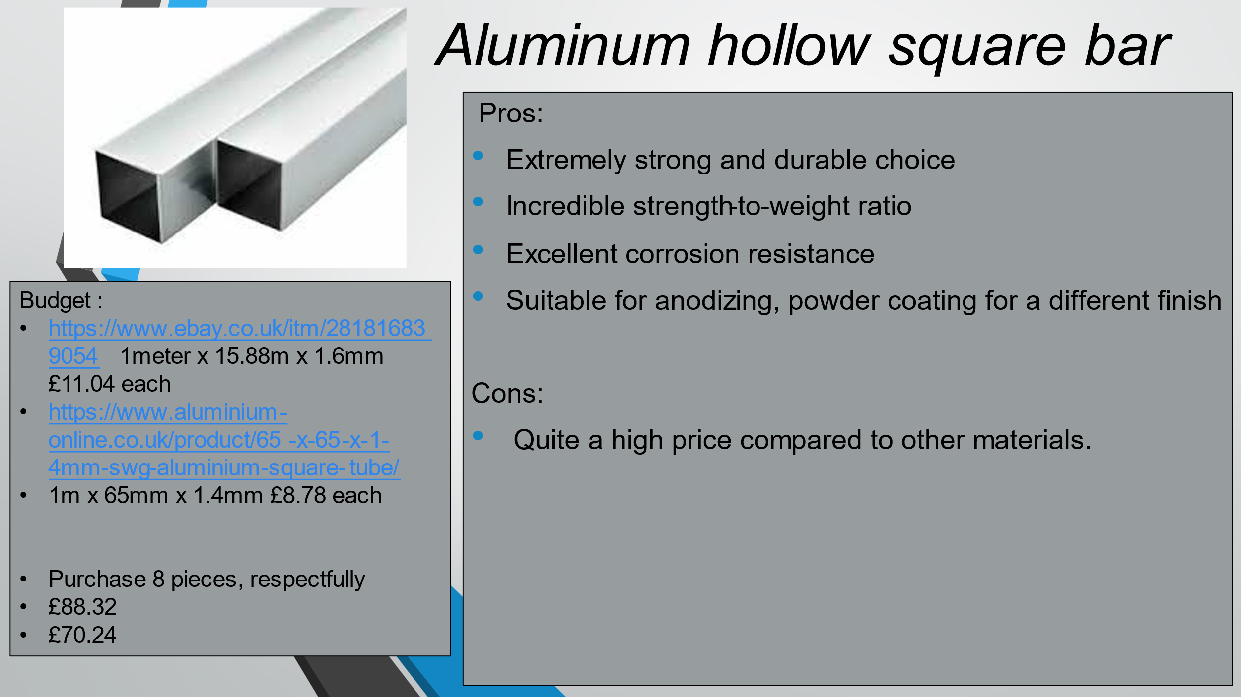

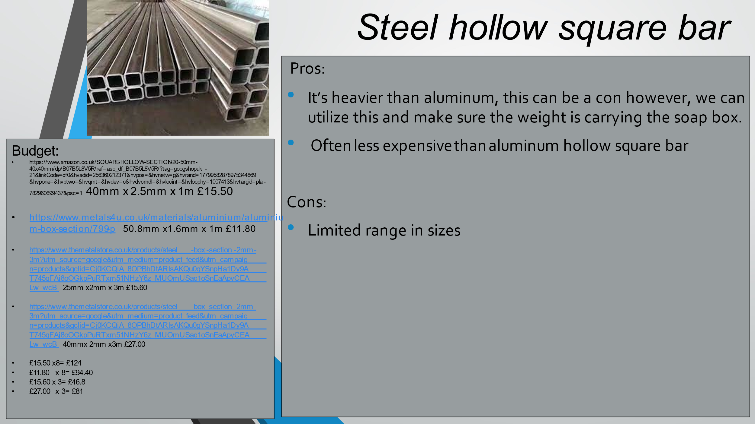
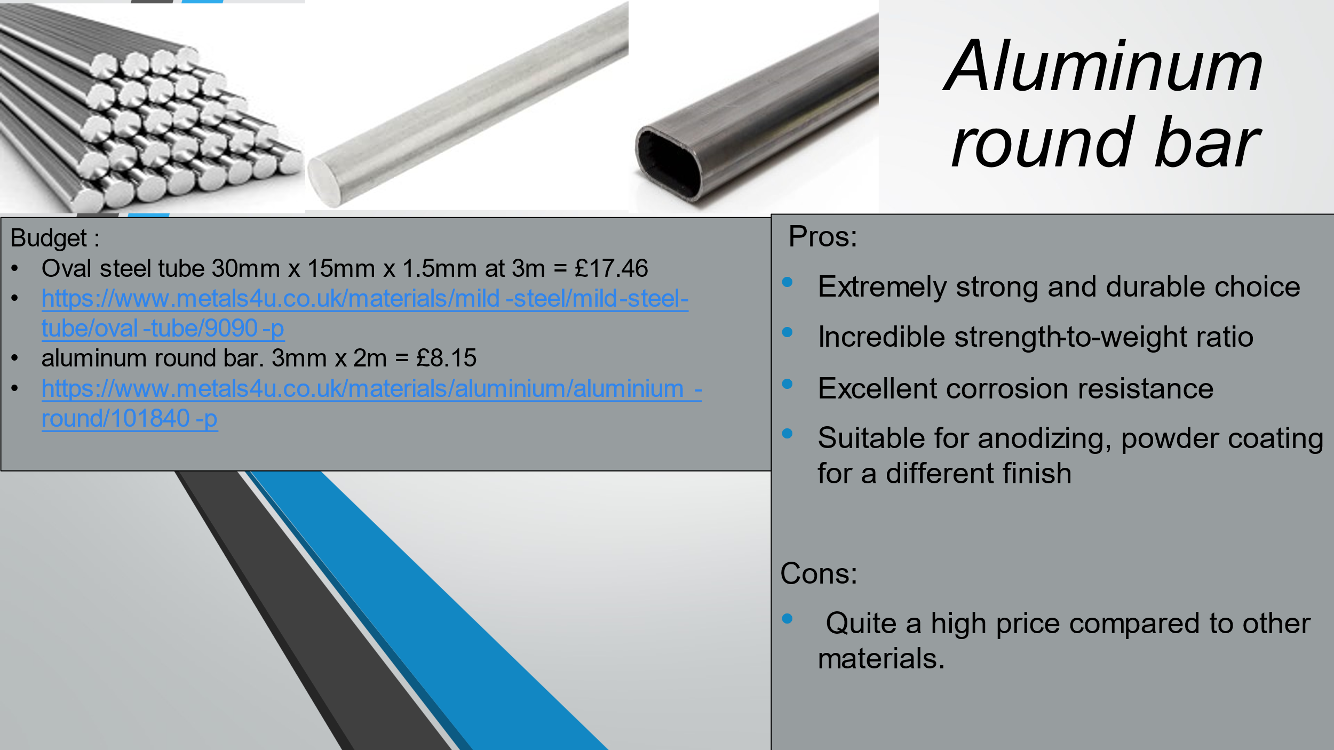
This will be used for our roll cages.
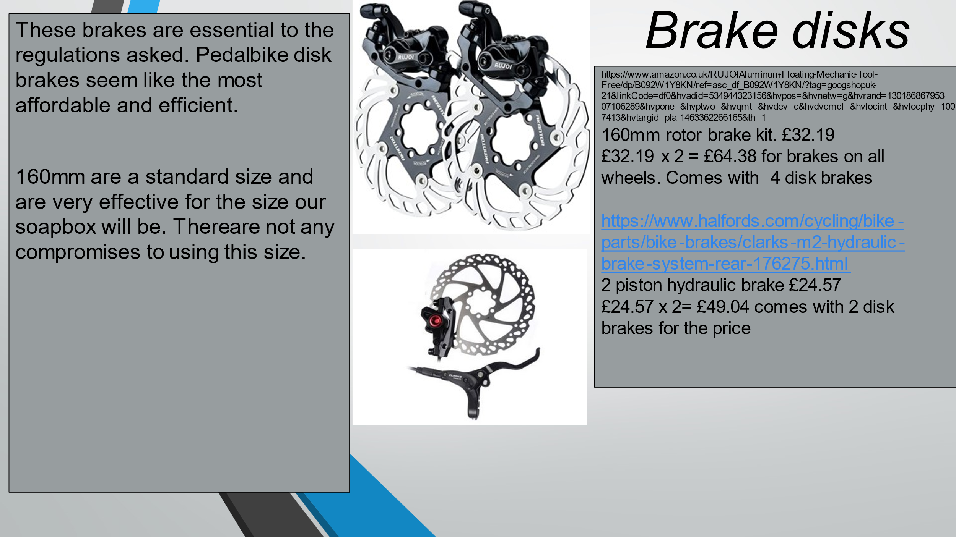
What to research next:
- In further research we shall look at steering columns
- sizes of steering wheel and handlebars. (Which will be more effective)
- we shall research into what size wheel we shall pick.
- We shall research into what thickness to choose

Purchasing steel hollow square bar for the frame and chases will be on the higher end of our budget. However, it is worth the extra cost for the rigidity and weight for the soapbox rally. Using MDF with teak oil for the chases and design.
Either aluminium round bar or the aluminium oval tube will be the best option for a roll cage. Aluminium oval tub will be the best
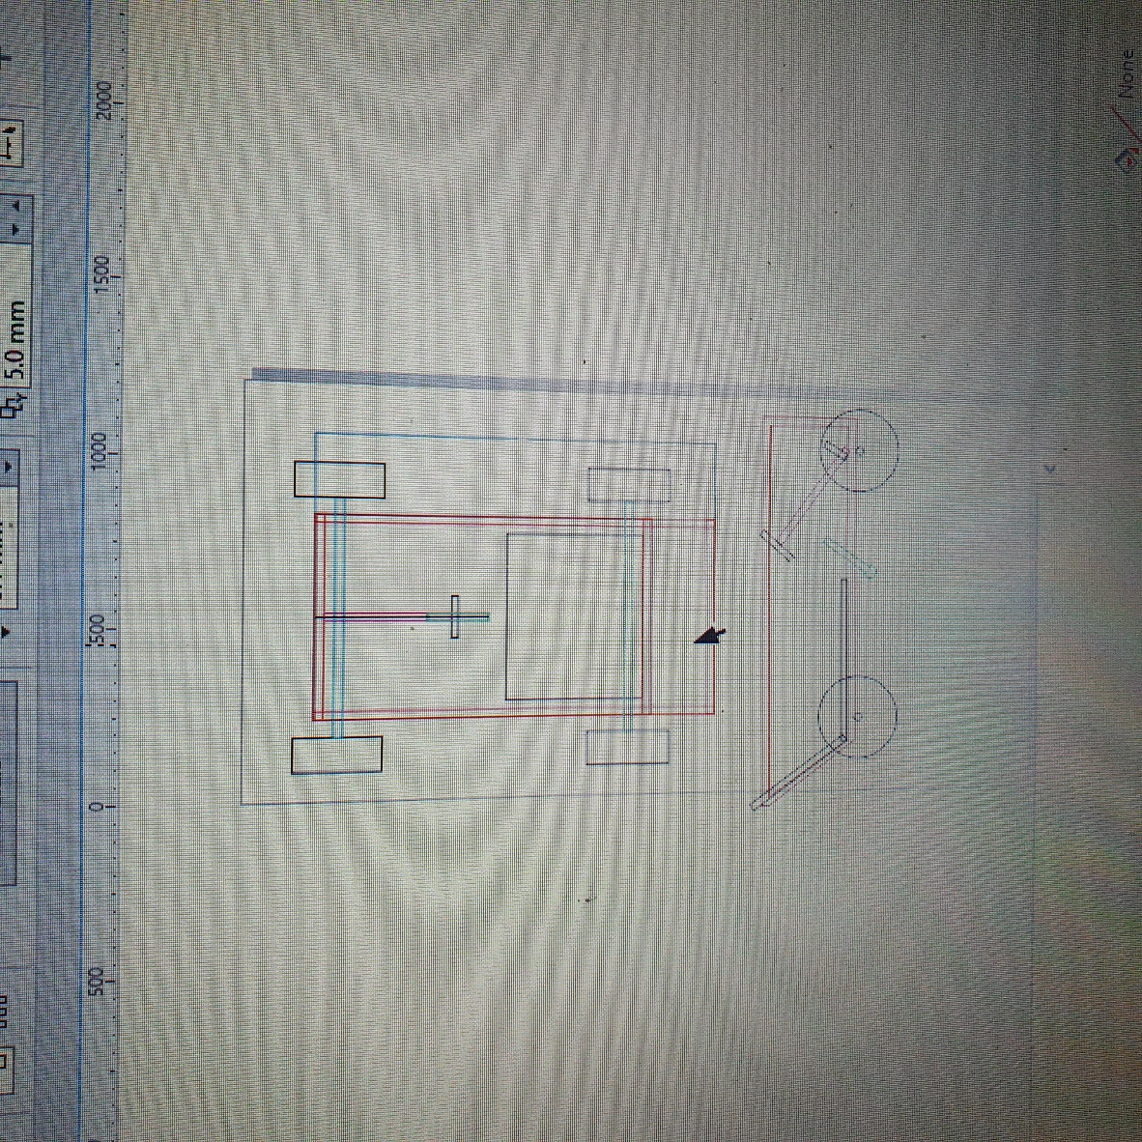
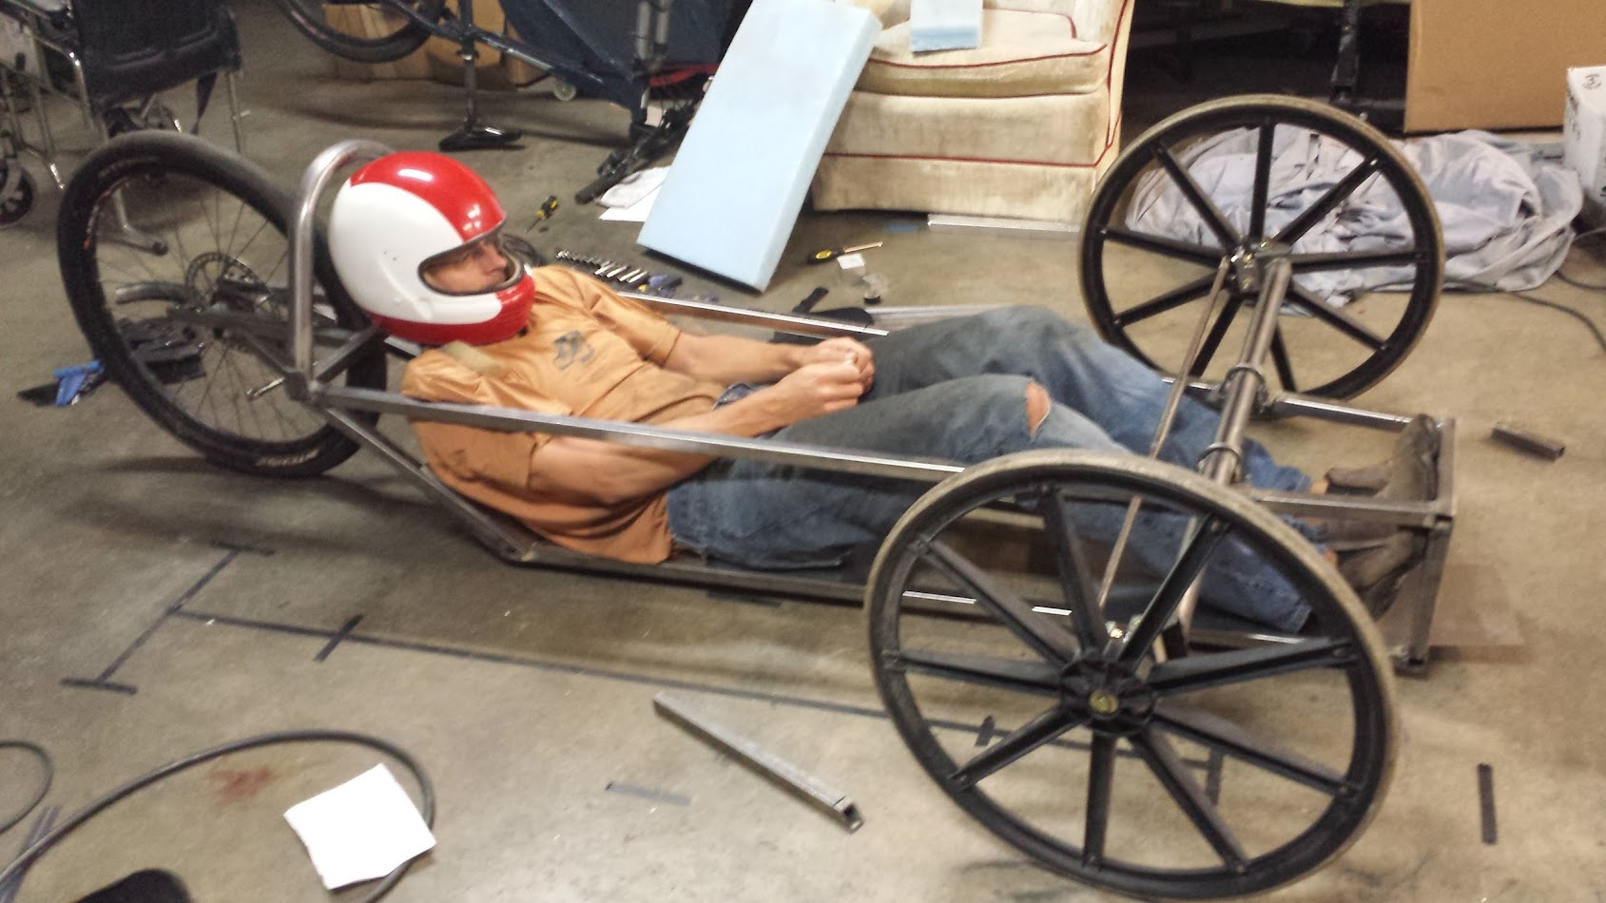
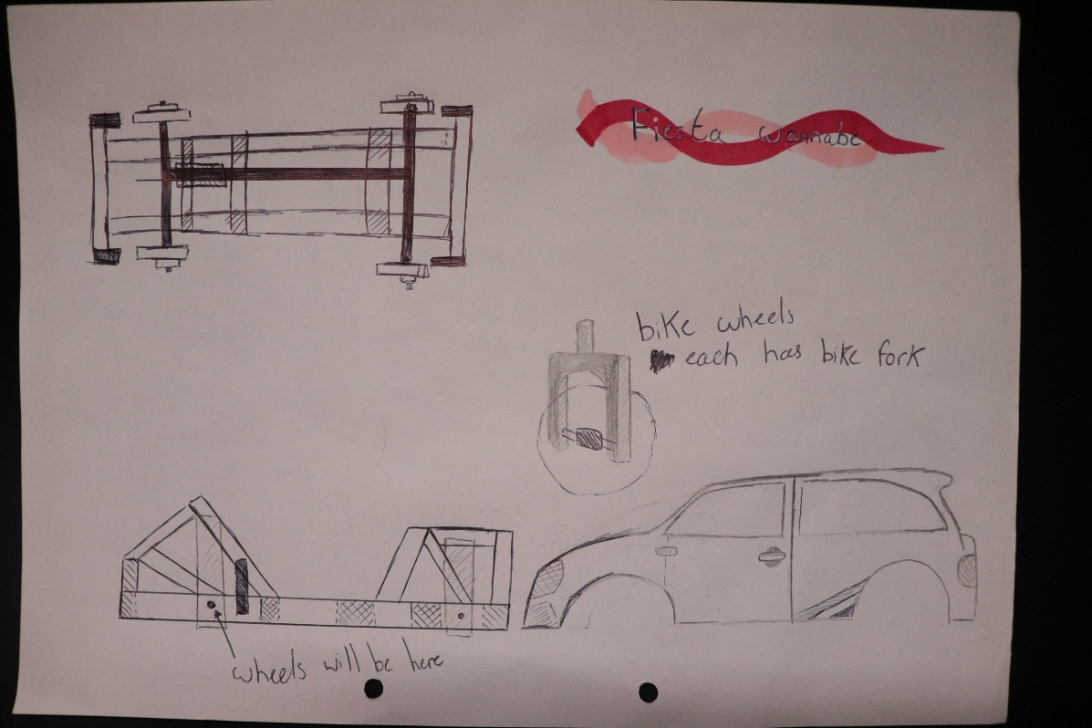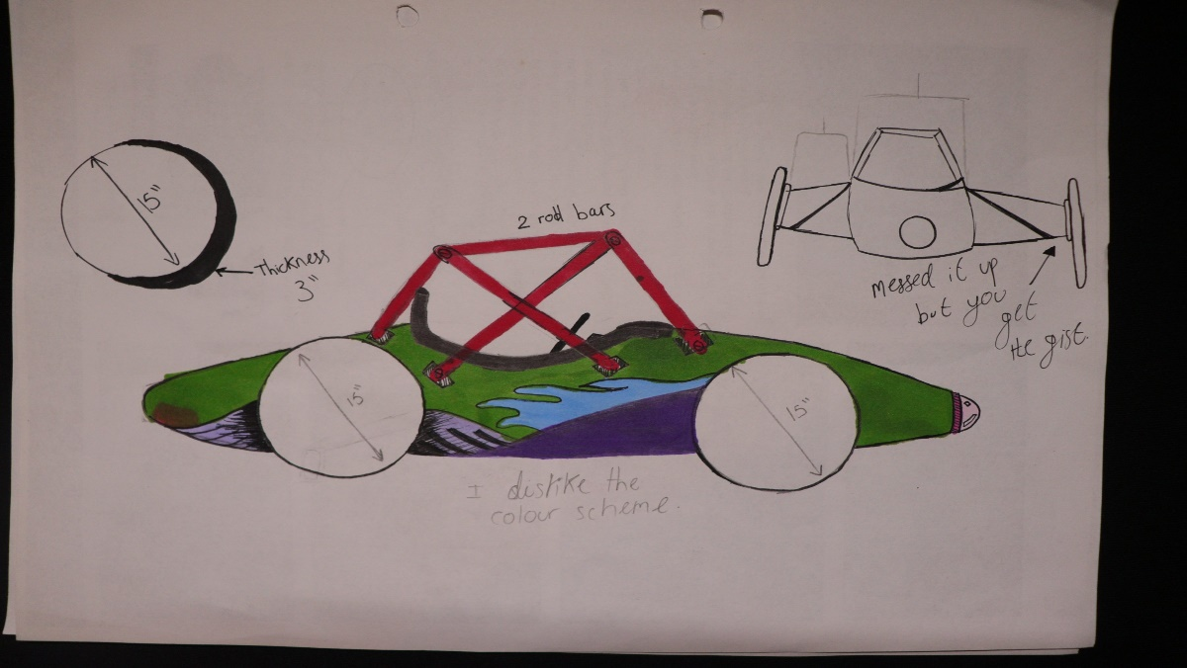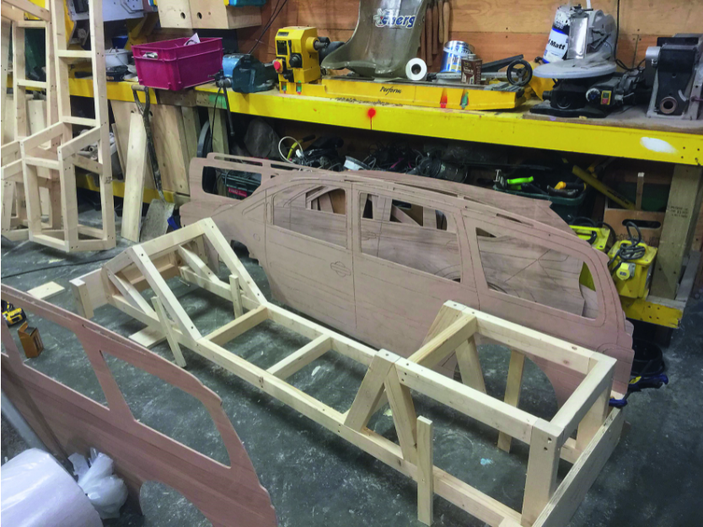
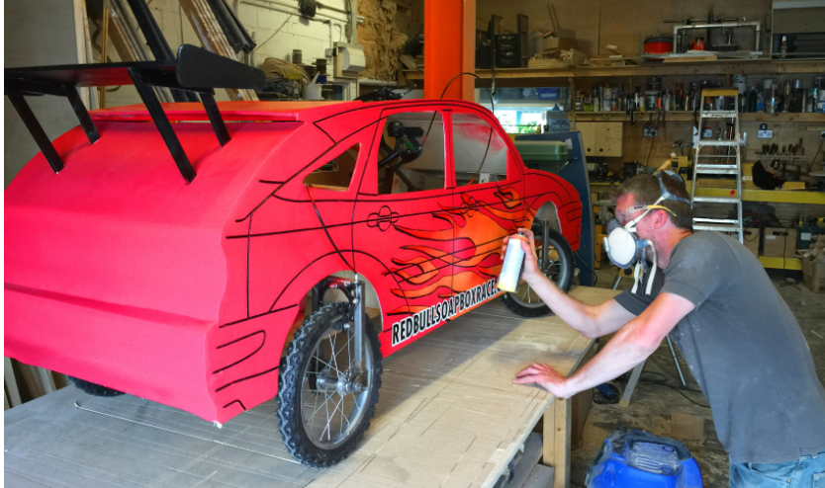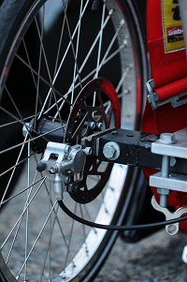

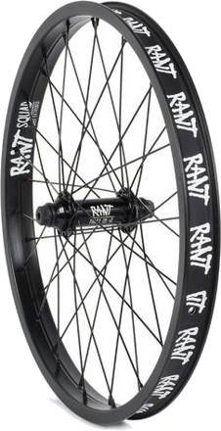
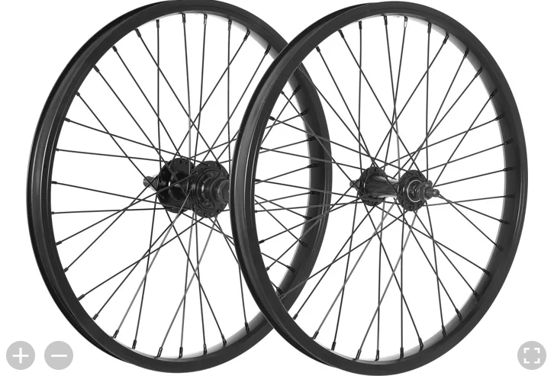
3
2
1
Tyres, wheel, and steering:
When researching for tyres and wheels, 20” BMX wheels were the most common and recommended. Because any larger and we would encounter it not being strong enough and will flex and buckle when cornering. A high pressure in our wheels will assist us in having a faster time on the course.
- £66.10 for two. £66.10x 2= £132.20 in total, unwise decision because of the material and the number of spokes, not enough. Structurally it will fail. Very quickly agreed not to move forward with this wheel.
- £69.95 x 4= £279.80. Structurally will be efficient however the price is high and will be the second option if the third option fails.
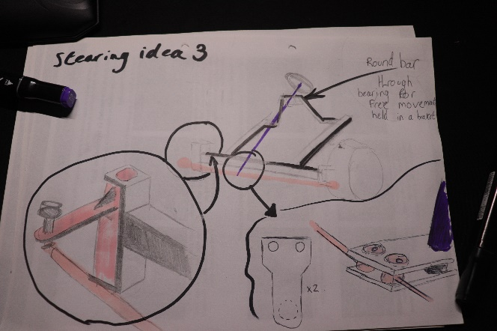
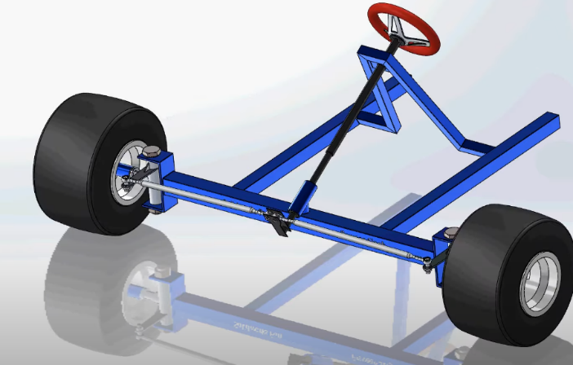
- £99.99x2= £199.98. This is great deal for two wheels in a set. Purchasing two of them is a better deal and structurally will give no compromises.
Steering column:
We began by thinking of using bike forks as our wheel holders. However, when design and assessing how the steering will come into play, we concluded that it would be especially difficult to control four bike forks.
When researching for alternative methods, we came across a video which assisted us in visualising the simplest form of steering, an adaptation we shall make is a stopper on the steering column, preventing oversteer.
(https://www.youtube.com/watch?v=u4h8nWkKU80&ab_channel=SolidworksFun) (Fun 20 in references)

Conclusion and reflections on continuing the project.

- A lot more research needs to be done, a lot more components need to factored in and priced. However, the total cost for all the current materials is: £397.78. This is due to change when we budget tyres, ball bearings, brake levers, cable ties, bucket seat, helmet, steering wheel, steering column itself and a lot more we haven’t even thought of.
- Our research has been very successful, we found a lot of useful material on the framework, steering mechanism, body work ideas, and what size wheels we have chosen.
- Reflecting on our efficiency throughout this project it could greatly improve. We were very late in starting the project, however we have made a great attempt in research and collecting our ideas together. to formulate a very pleasing start to the soapbox rally.
- Continuing from the project we must improve a great deal of our planning. Especially regarding what components, we need, ranging from the largest to smallest components.

References

(Carties, 2016)
(fun, 2020)
(aliexpress, 2020)
(Buffington, 2015)
(skatepro, 2019)
(reaction, 2019)
(Rujoi, 2021)
(Wilson, 2015)
(M2, 2021)
(4U, 2021)
(metal4u, 2021)
(store, 2020)
(TheMetalStore, 2022)
(TheMetalStore, themetalstore, 2022)
(themetalstore, 2021)
(online, 2022)
(Ebay, 2021)
(Liberon, 2020)
(Barrenttine, 2020)
(NOnosense, 2018)
(woodsheets, 2019)
(Wickes, 2021)
(Wickes, 2021)
(Wickes, 2021)

