Student name: | PETAR  ARTYUHOV | Student ID number: | 2123090
Programme: | BA (Hons) Business Management – Skills for the Workplace
Module: | Global Business Management
Module code: | LCBB4005_BIRM | Contribution to  Overall Module Assessment (%): | 50%
Module Coordinator: | Dr. Eric Osei | Internal Verifier: | Dr. Essa Bah
Assignment Title: | Individual project report | Word count (or equivalent): | 2500 + 10%

Table of Contents
1.0 Introduction
2.0 Overview of the Higher Education Sector.
3.0 Main Discussions
3.1PESTEL FRAMEWORK
3.2 Porter’s Five Forces
4.0 Conclusion
5.0 References

1.0 Introduction
The business environment of a firm depends on the current external and internal environmental factors. Every macro-environmental and micro-environmental element acquires equal contributions to the growth and sustainability of the company in the leading industry. With the aim of portraying the analysis of these factors, the PESTLE framework and Porter's Five Forces framework are rightly used with the assertion of valid information. This information is exclusively related to the UK higher education sector and the University of Wales Trinity Saint David (UWTSD). The chosen industry and the chosen firm are subject to be critically evaluated in the inception of theoretical information to assess the impact of those factors on the sustainability of the mentioned industry and the educational institution.

2.0 Overview of the Higher Education Sector
The higher education sector is one of the most critical sectors of the United Kingdom. As professionals are coming out after taking the degree from their higher education, Nowadays, the UK business impacts are more significant in the education sector. In order to adapt to the changes imposed by new technologies, the education sector has to involve sustainable management (Abad-Segura et al., 2022). Digital transformation directly represents the impact of business environmental factors in higher education. At the time of COVID-19, the sector was hit heavily and all the systems were changed from then. Right now, the changes are still in consideration as well. For example, online classes, lesser offline classes, digital study and so on. It was also found that the government also reduced the spending cost in this sector for various reasons (Clark, 2022). Current external and internal environmental factors are the main driver in the impact on the UK higher education sector. The higher education sector sets an example in the education sector of how education can be modernised by adopting different digital technologies and advanced systems. According to the report, it is also sound that big universities continuously implemented other technologies to mark themselves as pioneer of innovation. Apart from that, entering the new educational institutes in the UK education sector also changed the entire scenario of the education sector. Universities are now changing their teaching method and focusing more on innovation and technological parts simultaneously.

3.0 Main Discussions

3.1 PESTEL Framework
A PESTLE framework is helpful for the detailed analysis of the macro-environmental factors of a nation. With the consideration of this theoretical framework, every external environmental aspect, such as political, economic, social, technological, legal and environmental factors is depicted in the foundation of credible information. Statistical and evidence-based information is also depicted in line with the consideration of the UK higher education sector. In the same light, the implications of the factors reflected in the discussion are also portrayed considering the UWTSD. The external environment always impacts any organisation with its organisational functions as well as with its function at the same time. UWTSD is a well-known university. Opportunity and threats are the two aspects that can be fixed in any issue on the side of the organisation.
Political (T):
The United Kingdom is always known for its stable political condition worldwide. The education sector is a highly admirable sector in the world. Governments typically spend a lot of revenue to make it more advanced and innovative. Therefore, it helps the students to gather more knowledge and expertise for their future successful careers. However, after the hit of COVID-19, the GDP deliberately went down in the United Kingdom. After the pandemic, it was found that the government of the United Kingdom reduced the spending limit for the higher education sector all around. It significantly impacted the innovation and development of the industry. In addition to causing severe public health problems, the global pandemic also poses a serious economic, political, and social challenge (Williamson et al. 2020). A negative factor appears as the British government fails to invest appropriately in the UK education sector from 2021 to 2022 (Clark, 2022). However, there is no chance for any more improvement in this sector, which has also impacted the UWTSD. However, this counts as a threat to the brand.
Economic factor (O):
Growth in GDP per capita is a practical aspect of the UK economy (O'Neill, 2022). UK's economy is the sixth largest in the world by nominal GDP. The worldwide lockdowns of 2020 and 2021, however, burdened the Treasury heavily and ruined a number of companies in different sectors. Due to this, the UK economy gained £100 billion in 2020. The increased GDP can change the spending issue of the government as soon as possible. After the pandemic, the education sector is booming more than any other industry. Several newer organisations are also coming up with more unique and innovative ideas for advanced and intelligent learning. Universities in developing nations have implemented quality assurance to raise their operations' standards, following their equivalents' lead in affluent countries (Lim, 2018). Since the launch of COVID-19, the use of online technology has become commonplace; however, its use in UWTSD as a means of delivering discursive, problem-oriented statistics seminars is new (Davies, 2021). Quality assurance gives additional emphasis and purpose to the UWTSD system's work. It must be altered to fit the circumstances present in developing nations, though, by being straightforward in design, modest in aspirations, and practical in needs. There is a hope of opportunity for the university to improve its academic conditions. The future of the education sector of the United Kingdom is on the safer side. As the situation is now under control, everything is normalising like before. Therefore, there will also be more opportunities for the education sector. The initiative of UWTSD will also justify it as the students are more interested in online learning.
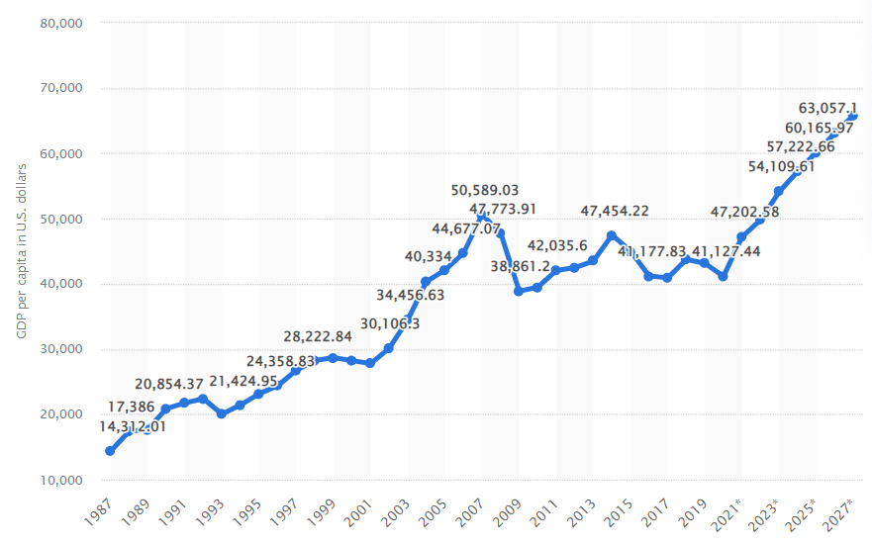. Gross domestic product (GDP) per capita in the United Kingdom in 2027(Source: O'Neill, 2022)
Social factor (T):
The COVID-19 epidemic is changing gradually and might aid higher education in broadening its horizons and entering the digital sphere (Fisk et al., 2020). Academic identity, which was once connected with academic independence, is now seen to be increasingly multiple individualities that sit at the intersection of a person's knowledge with their life path and the circumstances of higher education (Drennan et al. 2020). The people all kept themselves at their homes during the pandemic. However, the increasing demand from children made a move for brands and universities to place learning in online mode. Some findings examine the effects of Covid-19 on teacher educators' perceptions attached to the University of Wales Trinity Saint David (UWTSD) initial teacher education partnership (Barnes et al. 2021). UWTSD also took the initiative and implemented online education across the university operations. Online learning is widely accepted socially in the United Kingdom, which is why online learning platforms are still performing within the country and outside simultaneously. It was definitely a threat to the university, as it faced many obstacles socially.
Technological factor (O):
Technology is one of the most crucial and advanced sectors in the United Kingdom. The country is named one of the most technologically advanced countries in the whole world. Therefore, it is constructive for the education sector in the United Kingdom to adapt and implement different advanced technological tools to provide the best possible education to the students. Due to the convergence of new technologies, everyday Internet use (Palvia et al. 2018). The academic community, staff, and students of UWTSD are a close-knit group, and the university is renowned for its openness and friendliness (UWTSD, 2021). All kids have been placed in safe hands at UWTSD, which was voted first in the UK for the greatest COVID-19 safeguard. Technological advancements always create opportunities.
Legal factor (T):
At the beginning of the pandemic, the business environment was completely different from what it is now. Legally online learning was not at all acceptable. However, it is now widely available throughout the country. At that time, legal factors created an end number of issues for the education sector to operate smoothly. It is also found that due to the social distancing law by the government, many teenagers, as well as mid-aged students committed suicide as the depression level significantly increased in their minds (Yard et al. 2021). The pandemic made a curse on the students. It was a threat to the university at that time.
Environmental factor (T):
Environmentally, all the students at the time of the pandemic shut themselves in their homes. The business environment changed radically and all the systems were on an emergency basis. The environmental disruptions to student assistantships had the biggest effect on students’ confidence and preparedness throughout universities (Choi et al., 2020). The student of UWTSD also faced similar issues regarding the environmental factor at that time. Environmental factor was the most significant at that time in the education sector. However, with the willingness to learn and comprehend things, the education sector sustains itself and widely spreads its impact throughout the country and beyond. The environment did not allow the brand to be explored. Therefore, it is considered a threat to the university.

3.2 Porter’s Five Forces
Porter's Five Forces theoretical framework is rightly applied in the case of beholding the dynamics of the current market for the UK higher education sector. Detailed information about each of the market forces is portrayed in this section of the study to shed light on their propensity for the chosen sector. For the higher education sector, the COVID-19 pandemic's spread has become a critical challenge (Peimani and Kamalipour, 2021). In the same context, the implications of those forces on the business environment and operational service of the University of Wales Trinity Saint David (UWTSD) are also analysed with the inception of academic and non-academic data.
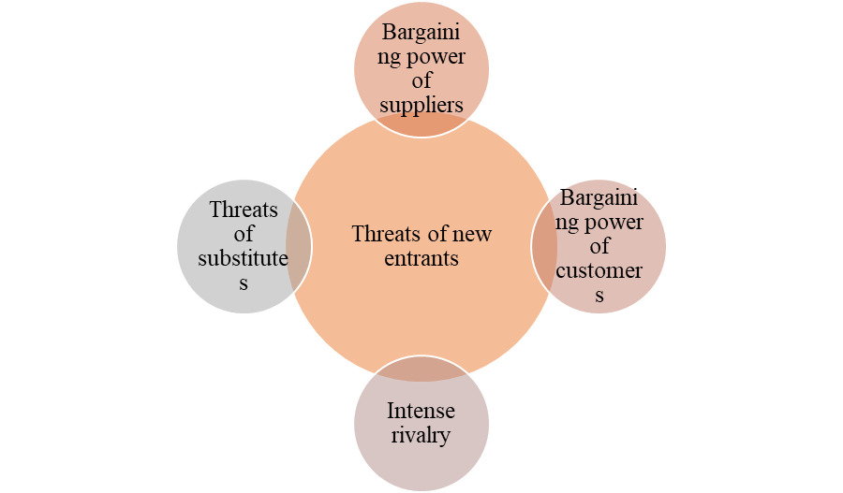. Porter’s Five Forces
As per the above diagram, it is transparent that each market force of this theoretical framework is highly significant enough to positively and negatively impact the University of Wales Trinity Saint David (UWTSD) business environment in the UK. COVID-19 approaches immediate remote teaching across the sector (Crick et al. 2020). With the affinity of portraying this analysis, a critical discussion of each of the mentioned market forces is depicted along with the higher education sector of the UK and the business environment of the UWTSD.
Bargaining power of suppliers (H):
At the time of the COVID-19 pandemic, every sector faced substantial business losses. It is applicable to the suppliers of the UWTSD as well. The book suppliers, libraries as well as technology suppliers, like the electric brands that provided the electronic devices for the university, pressured the university at that time and demanded better pay. However, this was a complete threat to the university at that time. In order to mitigate the issue aside from Orangebox production staff, UWTSD technicians provided technical support at that time (Whitehill et al. 2022). UWTSD completely shut off the supplier's help from the technological confrontation.
Bargaining power of customers (L):
At the time of the pandemic, due to the high demand and bargaining power of the students of UWTSD, the university started online education across all the courses for the students. Soon, the chosen educational case institution realised the importance of the virtual learning environment to lead in the education sector of the United Kingdom. It is also found that the bargaining power of UWTSD's students has increased due to embracing online learning methods. These methods cultivated creativity and action capabilities through constructive learning (Weicht and Jónsdóttir, 2021). UWTSD successfully found the case company achieved the future opportunity from this initiative and the positive implications.
Intense rivalry (H):
There were an endless number of excellent universities in the education sector of the United Kingdom. In that situation, the rivalry also increased to capture the online education market. Prominent universities like the University of London, Buckingham University and other respected universities also took the initiative in order to make their mark on social change. However, at the time, this idea was that modules within higher education could develop additional learning resources (Alharahsheh et al., 2022). The chosen university also took this initiative and made itself the pioneer in the sector. Thus, the intense rivalry threatens the survival and smooth workflow of the UK education centre.
Threats of substitutes (H):
Substitute universities were there to compete with UWTSD. However, this threat made the university stronger than before and gave it more power to compete in the competition. Distance learning programmes in the field of healthcare technology are offered by several educational institutions, associations, and other organisations (Clark, 2020). However, that was not enough for the other universities to beat UWTSD at that time and it started dealing with unbearable work pressure.
Threats of new entrants (H):
New online education institutes were one of the greatest threats that UWTSD encountered at that time. As a new organisation, they are possibly more technologically advanced than UWTSD. For that issue, columnists on higher education have discussed the university's future and its remodelled campus (Watermeyer et al. 2021). It was a threat to the UWTSD. This threat enabled the firm to receive poor managerial abilities in the competitive market.

4.0 Conclusion
Based on the above discussion, it is found that the different business environments have impacted the UWTSD throughout the COVID-19 phase and beyond that. Several positive as well as negative things were encountered. The university also competes per the standards with its rivals by implementing and adopting digital technologies into the system. The findings also summarise that certain environmental factors are the creators of positive as well as negative implications for the business sustainability of the chosen firm.

5.0 References
Abad-Segura, E., González-Zamar, M.D., Infante-Moro, J.C. and Ruipérez García, G., 2020. Sustainable management of digital transformation in higher education: Global research trends. Sustainability, 12(5), p.2107.
Alharahsheh, H.H., Munna, A.S., Hoffmann, S., Mazumdar, A. and Pius, A., 2022. Development of Learning Resources within Higher Education in Response to the Challenges of COVID-19. International Journal of Asian Education, 3(2), pp.148-153.
Barnes, J., Greenway, C. and Morgan, C., 2021. How has Covid-19 affected how teacher educators engage their students in learning?
Choi, B., Jegatheeswaran, L., Minocha, A., Alhilani, M., Nakhoul, M. and Mutengesa, E., 2020. The impact of the COVID-19 pandemic on final year medical students in the United Kingdom: a national survey. BMC medical education, 20(1), pp.1-11.
Clark, D., 2022. UK higher education spending 2022, Statista. Available at: https://www.statista.com/statistics/298902/higher-education-spending-uk/ (Accessed: October 22, 2022).
Clark, J.T., 2020. Distance education. In Clinical engineering handbook (pp. 410-415). Academic Press.
Crick, T., Knight, C., Watermeyer, R. and Goodall, J., 2020, September. The impact of COVID-19 and “Emergency Remote Teaching” on the UK computer science education community. In United Kingdom & Ireland Computing Education Research conference. (pp. 31-37).
Davies, C., 2021. Online seminars in statistics for doctoral students: A case study. Journal of University Teaching & Learning Practice, 18(2), p.06.
Drennan, J., Clarke, M., Hyde, A. and Politis, Y., 2020. Academic identity in higher education. In The international encyclopedia of higher education systems and institutions (pp. 35-40). Dordrecht: Springer Netherlands.
Fisk, M., Livingstone, A. and Pit, S.W., 2020. Telehealth in the context of COVID-19: changing perspectives in Australia, the United Kingdom, and the United States. Journal of medical Internet research, 22(6), p.e19264.
Lim, D., 2018. Quality assurance in higher education: A study of developing countries. Routledge.
O’Neill, A., 2022. United Kingdom - Gross domestic product (GDP) per capita 2027 | Statista. [online] Statista. Available at: <https://www.statista.com/statistics/263600/gross-domestic-product-gdp-per-capita-in-the-united-kingdom/#:~:text=In%202019%2C%20GDP%20per%20capita,in%20a%20world%20GDP%20ranking.&amp;text=GDP%20is%20a%20useful%20indicator,state%20of%20a%20nation&#39;s%20economy>[Accessed on 9 October 2022].
Palvia, S., Aeron, P., Gupta, P., Mahapatra, D., Parida, R., Rosner, R. and Sindhi, S., 2018. Online education: Worldwide status, challenges, trends, and implications. Journal of Global Information Technology Management, 21(4), pp.233-241.
Peimani, N. and Kamalipour, H., 2021. Online education and the COVID-19 outbreak: A case study of online teaching during lockdown. Education Sciences, 11(2), p.72.
UWTSD, 2021. Coronavirus | Information for Applicants [online] www.uwtsd.ac.uk Available at: <https://uwtsd.ac.uk/coronavirus/applicants/> [Accessed on 19 October, 2022]
Watermeyer, R., Crick, T., Knight, C. and Goodall, J., 2021. COVID-19 and digital disruption in UK universities: Afflictions and affordances of emergency online migration. Higher Education, 81(3), pp.623-641.
Weicht, R. and Jónsdóttir, S.R., 2021. Education for social change: The case of teacher education in wales. Sustainability, 13(15), p.8574.
Whitehill, S., Hayles, C.S., Jenkins, S. and Taylor, J., 2022. Engagement with Higher Education Surface Pattern Design Students as a Catalyst for Circular Economy Action. Sustainability, 14(3), p.1146.
Williamson, B., Eynon, R. and Potter, J., 2020. Pandemic politics, pedagogies and practices: digital technologies and distance education during the coronavirus emergency. Learning, Media and Technology, 45(2), pp.107-114.
Yard, E., Radhakrishnan, L., Ballesteros, M.F., Sheppard, M., Gates, A., Stein, Z., Hartnett, K., Kite-Powell, A., Rodgers, L., Adjemian, J. and Ehlman, D.C., 2021. Emergency department visits for suspected suicide attempts among persons aged 12–25 years before and during the COVID-19 pandemic—United States, January 2019–May 2021. Morbidity and Mortality Weekly Report, 70(24), p.888.

