Student Learning Log

BMIH6004 Managing Hotel Administration

Student Name: Alina Maria Butarita

Student ID:2207461

Module Leader: Lisa Bassler

I confirm that I have not used any AI tools in the research and creation of this assignment. I confirm that I have not presented any AI generated materials as my own work. I confirm I have copies of my drafts, notes, and other resources I used, which I may be asked to provide in evidence

Table of Contents
Introduction 3
Section 1: Reflection on Experience and Personal Development 3
Section 2: Critical Analysis of Work-Based Skills and Technical Knowledge 5
Section 3: Reflection on Organisational Issues 6
Conclusion and Action Plan 6
References 7

Introduction

The present study is a reflective learning log with an in-depth analysis of the professional experience during my placement at Hilton Garden Inn, Doncaster Racecourse. Hilton Garden Inn was founded in 2018 and is well-known for its modern facilities and significant hotel location (Hilton, 2025). The hotel is minutes from Lakeside Village Shopping, Yorkshire's Wildlife Park, and many other tourist attractions. This reflection concentrates on the administrative role within the Human Resource Management department. Using Kolb's experiential learning cycle, this study critically reflects on experience gained, personal development, work-based skills, and the challenges in the workplace. The key objectives of this reflective learning log are:
To gain a deeper understanding of the administrative operations within the hospitality industry.
To identify key challenges faced by the organisation and explore possible solutions.

Section 1: Reflection on Experience and Personal Development

The service or hospitality industry is among the key income generators worldwide and thus requires proper management and operating efficiency (Bamford, D., Forrester, and Reid, 2023). In this scenario, I shadowed a senior HR professional at Hilton Garden Inn, Doncaster Racecourse, which is located at Leger Way, Doncaster DN2 6BB, United Kingdom (Hilton, 2025). In this posting, I came across many aspects of what HRM encompasses, such as recruitment, the management of salary payrolls, and employee engagement activities and training programs. Additionally, the knowledge acquired was advantageous in the roles of actual HR, allowing their workforce to stay motivated yet active. Using Kolb's Learning Cycle, an attempt has been made to critically reflect on what I have been learning.
The stages of Kolb’s Learning Cycle include concrete experience, reflective observation, abstract conceptualisation, and active experimentation (Wijnen-Meijer et al. 2022).
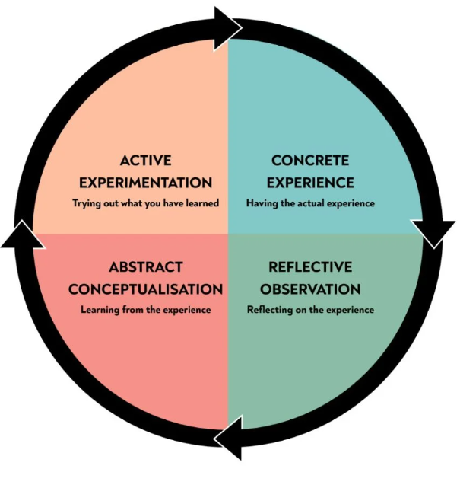
Figure 1: Kolb’s Learning Cycle
(Source: Wijnen-Meijer et al. 2022)
Concrete Experience
In the overall HR operations, I could assist and observe different administrative activities during my placement in the hotel. These included supporting recruitment, maintaining the records of the employees, and helping them out with training sessions. I also experienced problems in retaining employees and motivating staff. I worked under a senior HR professional who taught me how HR policies and strategies are deployed to maintain workforce effectiveness.
Reflective Observation
Reflecting on my experience, I realised that HR management is crucial in the hospitality sector as it directly influences service quality through employee satisfaction. A significant observation I made was the complexity of addressing employee concerns within the framework of organisational objectives. This revealed that employee engagement levels are high and necessitate constant communication, adequate training, and structured conflict resolution. Another important observation regarding technology in HR processes was the automated payroll system and the employee management software; such programmes significantly simplify administrative tasks (ASET, 2017).
Abstract Conceptualisation
From this experience, I conceptualised the importance of strategic HR planning in ensuring employee satisfaction and business efficiency. Employee training and engagement strategies have significantly reduced my turnover rates. In addition, I learned that a positive work environment through recognition programs and opportunities for career advancement contributes to employees' high morale and productivity. The experience also reinforced the significance of compliance with labour laws and ethical considerations in HRM (Bardi, 2010).
Active Experimentation
Following what I have learned, I will prepare an action plan to develop myself professionally. Thus, I will add more knowledge on HR software and analytics to benefit HR operations. In the future, I can increase my interpersonal skills to address employee issues efficiently while contributing to an effective workplace culture. Thus, through these above strategies, I will efficiently manage tasks related to human resources in upcoming roles.

Section 2: Critical Analysis of Work-Based Skills and Technical Knowledge

HRM emphasises work-based skills, primarily within the hospitality sector, for fostering proper employee relationships and effective business management (Casado, 2012). While at Hilton Garden Inn, Doncaster Racecourse, I identified the crucial skills that could enhance HR activities. Communication is vital, as clear dialogue enables conflicting parties to discuss issues and maintain open communication regarding various HR matters. Task management and organisation are equally significant, as they involve juggling multiple responsibilities simultaneously, and HR management software enhances the efficiency of maintaining employee records, attendance logs, and payroll processing (Hagg, 2013). Problem-solving is critical in addressing employee grievances and workplace conflicts through objective analysis to identify justifiable solutions that align with organisational policies. Furthermore, technological skills are paramount, as digital tools in HR, such as payroll systems and employee engagement software, improve operational effectiveness (QAA, 2018). I gained hands-on experience with HR software, which enhanced my technical knowledge and problem-solving abilities, reinforcing my belief in the significant role of technology in modern HRM. This skill set allows for a structured and effective HR environment, positively impacting employees and contributing to organisational success in hospitality operations (Fallon and Rutherford, 2010).

Section 3: Reflection on Organisational Issues

One of the major challenges that I faced at Hilton Garden Inn, Doncaster Racecourse, was employee retention. The hospitality industry has a high turnover rate, and one of my placement experiences confirmed this. Various reasons were involved: job dissatisfaction, a lack of career progression, and a lack of motivation (Johnston, Clark, and Shulver, 2012).
To overcome this challenge, full-fledged employee engagement strategies will greatly improve retention levels. If there are structured training programs, career development opportunities, and performance-based incentives, employees will be motivated and satisfied on the job (Rughubalan, 2009). In addition, flexible work arrangements and employee appreciation awards can bring about a positive workplace atmosphere.
The other challenge I identified was the resistance to technological advancement in HR operations. Technology simplifies administrative processes, but some employees hesitated to adopt digital HR systems (Tewan, 2009). Proper training and showing the benefits of technology can overcome this resistance and improve overall efficiency in HR management.

Conclusion and Action Plan

In conclusion, the analysis of the reflective discussion revealed that my placement at Hilton Garden Inn, Doncaster Racecourse, has allowed me to gain practical exposure to functions about HRM, allowing me to develop essential skills in an industry. This experience has emphasised that effective management of HR operations requires organisation, effective communication, and problem-solving. To improve my skills, I should focus on improvement in HR software and leadership strength, attending some conflict resolution seminars, and bringing structured time management techniques into use. The placement has helped mold my career, giving me appropriate competencies to perform well within the hospitality sector.

References

ASET (2017) Good Practice Guide for Work-based and Placement Learning in Higher Education. Sheffield: ASET.
Bamford, D., Forrester, P. and Reid, Kolb’s Learning Cycle stages include concrete experience, reflective observation, abstract conceptualisation, and active experimentation (Wijnen-Meijer et al., M. (2012) Housekeeping Management. London: Wiley.
Fallon, M. and Rutherford, D. (2010) Hotel Management and Operations. London: Wiley.
Hagg, E. (2013) Internship Guide: Work Placements Step by Step. 5th Ed. The Hague: Eleven International Publishing.
Hilton (2025) Hilton Garden Inn Doncaster Racecourse. Available at: https://www.hilton.com/en/hotels/dsadrgi-hilton-garden-inn-doncaster-racecourse/ (Accessed: 20 February 2025).
Jasper, M. (2013) Beginning Reflective Practice. Andover: Cengage Learning.Johnston, R., Clark, G. and Shulver, M. (2012) Service Operations Management: Improving Service Delivery. 5th Ed. London: Pearson.
QAA (2018) UK Quality Code, Advice and Guidance: Work-based Learning. London: QAA.
Lockwood, N. R. (2007). Leveraging Employee Engagement for Competitive Advantage: HR’s Strategic Role. SHRM Research Quarterly, 1, pp. 1-12.
Van Oest, A., Vold, T., Haave, H., Wahl, C., & Ranglund, O. (2023). Voice Behavior in Creative Teams: A Case Study of Music Production. European Conference on Innovation and Entrepreneurship, (), 486-492, R29.
Tewan, J. (2009) Hotel Front Office: Operations and Management. Oxford: Higher Education Press.
Wijnen-Meijer, M., Brandhuber, T., Schneider, A. and Berberat, P.O., 2022. Implementing Kolb s experiential learning cycle by linking real experience, case-based discussion and simulation. Journal of medical education and curricular development, 9, p.23.
Wiley, J. W. (2010). The Importance of Employee Engagement. Global Business and Organisational Excellence, 29(4), pp. 11-18.
Wood, R.C. (2013) Key Concepts in Hospitality Management. London: SAGE Publications Ltd.

