Data handling and business intelligence
LCBB5000
Assessment 2

Table of Contents
Task 1 3
Task 2 9
References 16

Task 1
1.1 Evaluation of Microsoft Excel
Excel is a versatile tool for performing a variety of data-processing-related activities. Duplicate detection and deletion, data filtering, and mistake fixing are only a few examples of what has to be done. By applying filters to Excel, such as date, value, or language, users may isolate relevant data for further examination. The user is free to make use of these filters. Excel is a great application for simple data processing and analysis, but according to study from 2020 by Hussain and Abbas, it may not be the best option when dealing with more intricate tasks. The data are prepared for analysis by organising, cleaning, and converting them during the pre-processing phase. This is done before any analysis is performed. The data will be useless until issue is resolved. Searching for and removing duplicates, filtering data, and fixing mistakes are just a few of the many actions and capabilities offered by Excel. Data may be organised, standardised, and filtered to exclude details that are irrelevant to the current task using Excel's in-built functions and formulas. There are other comparable formulas and functions available under the Data menu (Mehta and Singh, 2020). However, Excel may not be the ideal option for more complex data processing tasks. Analysing data is looking for regularities and trends that may be used to draw conclusions. Excel users may do statistical analyses like regression, hypothesis testing, and correlation using the software's in-built features. The data analysis activities users are tasked with completing may, however, need the use of more advanced statistical techniques or computer languages. Data analysis, as defined by Roque and Reis (2019), is the examination of data with the goal of identifying hidden patterns, correlations, and insights. Excel's statistical capabilities can conduct hypothesis tests and correlation analyses, and the program's pivot tables may make analysing massive datasets a breeze. Excel-based spreadsheets may benefit from using pivot tables in specific situations. Excel's flexibility means that it may be used to create everything from the simplest to the most complex models for economic research and forecasting. Excel's statistical functions allow for analyses including regression, hypothesis testing, and correlation (Manupati & Anisetti, 2020). Excel's pivot tables facilitate the summarization and evaluation of massive data sets. One of Excel's statistical features is a regression analysis tool. Users of Excel have access to these options and capabilities. Excel may be a useful tool for building financial models and forecasting models, even when they are quite complex. In order to complete the increasingly difficult data analysis tasks one have been assigned, one may need to switch to a new statistical method or computer language. Data visualisation is the process of displaying information clearly via the use of visual aids like charts and graphs. Charts in Excel may be customised to the specific demands of the user via a wide variety of formatting options, labelling systems, and colour schemes. The user may also modify the labels of the charts. Sparklines visually display data trends, and conditional formatting allows users to apply alternative styles to cells depending on user-defined criteria. Excel supports both of these strategies. Excel may be used to create a wide variety of charts, including bar charts, line charts, and pie charts (Kumar & Saini, 2020). Excel's built-in charting and visualisation capabilities are fine for creating simple charts and visuals, but for more complicated data visualisation projects, one may want to look into more powerful data visualisation platforms like Tableau or Power BI. Data visualisation is the process of making data more easily understood via the use of visuals. Customers may make their charts seem exactly as they want them to by selecting from a broad number of formats, labelling options, and colour schemes in Excel. Data patterns may be visualised using Sparklines and adjusted using tools called Conditional Formatting by the year 2020, according to research by Koo and Kim. One may find both of these types of calculators in Microsoft Excel. Bar charts, line charts, and pie charts are just few of the many types of charts that may be made with Excel. On the other hand, more complex data visualisation jobs may call for enterprise-level software.

1.2 Exercise of if function
Below is an example of an if statement that can be used in Excel, as well as the formula that can be used to determine whether the value in cell I2 is more than 10. Therefore, the algorithm will respond with "Lead time is more than 10 days" in this situation. If the condition is not met, the algorithm will assert that the "Lead time is less than 10 days" if the value of I2 is less than 10. This proves that the formula is doing a condition test (I2 > 10) and giving a true or false result. Excel users' deductive and reasoning skills will be put to the test in light of the supplied conditions.
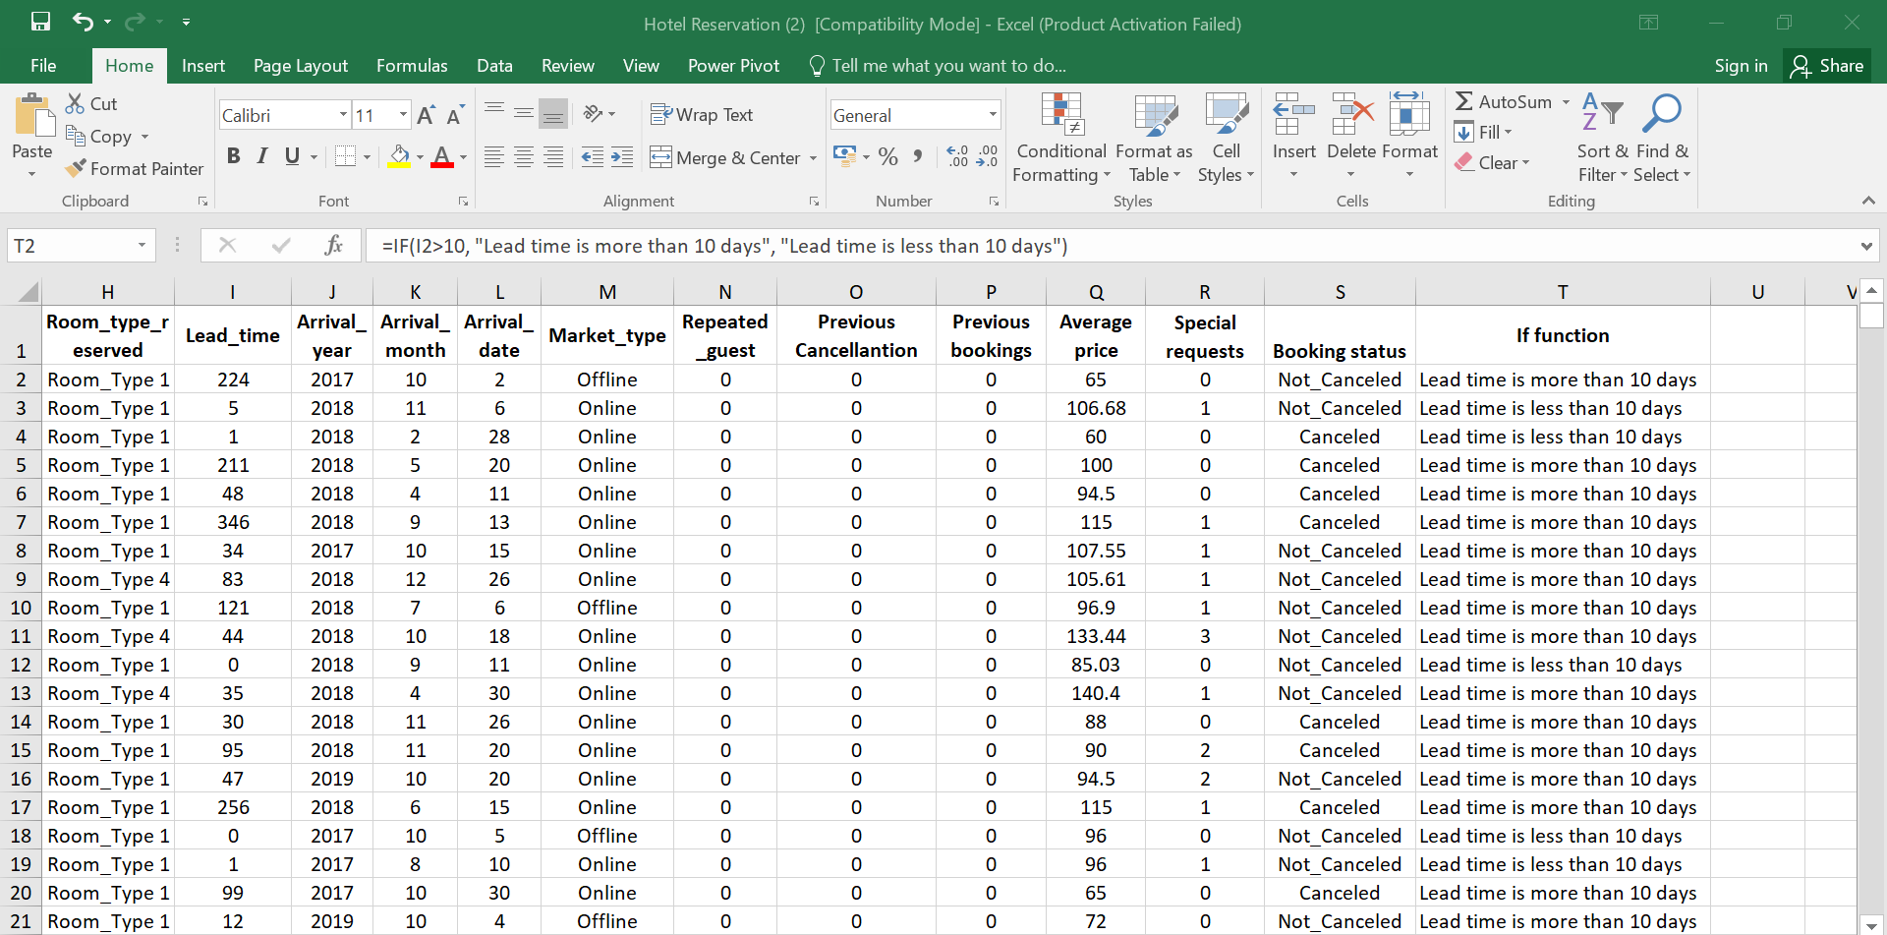
1.3 Exercise of Pivot table and charts
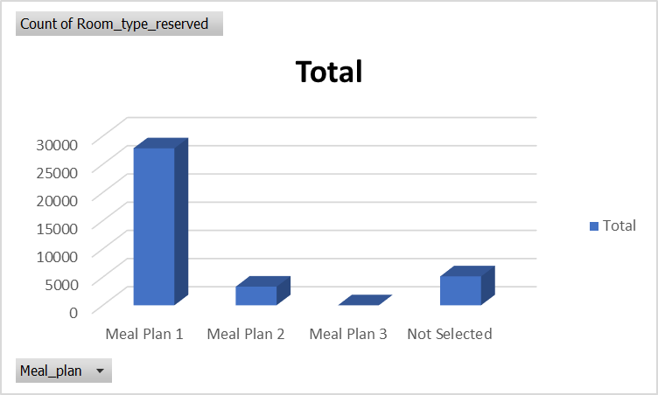
Graph: Meal plan vs hotel reservations
It has been calculated that out of a total of 36,275 nights spent at the hotel, "Meal Plan 1" has been chosen by 27,835 guests. This indicates that having access to Meal Plan 1 may be expected the vast majority of the time. With just 5% of guests selecting Meal Plan 3, it is safe to assume that it is either not a popular option or isn't provided very frequently. Vegetarian food is the third option for dinner. In all, 5,130 of the overnight guests chose without purchasing any kind of meal plan. It is likely that guests don't want to spend the money on a hotel meal plan since they intend to cook for themselves during their stay. The hotel personnel would be better equipped to cater to guests' demands and highlight popular meal deals with this data at their disposal. If guests are particularly interested in Meal Plan 1, the hotel may decide to put more resources on advertising and refining that option. If a significant number of guests decline the hotel's meal package, the business may promote local restaurants or introduce à la carte options to appeal to them.
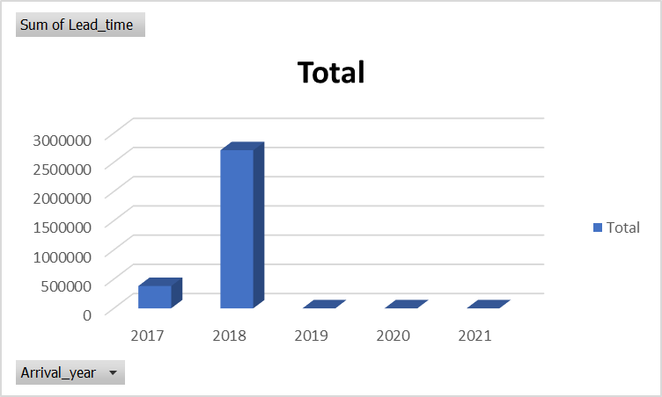
Graph: Arrival year vs lead time
Hotel rooms were booked an incredible 2,707,627 days in advance in 2018, as a record number of individuals travelled that year. In 2018, the hotel saw a dramatic surge in demand for its services, as shown by the fact that a significant portion of its guests booked their stays months in advance. The huge amount of confirmed bookings is evidence of this. In 2019, one had a total lead time of 631 days; by 2020, one expect that figure to have dropped to 319 days. It is possible that economic downturns or global catastrophes (like the COVID-19 epidemic) discouraged travel during those years, which might explain why the hotel witnessed a decline in advance bookings. Political turmoil in the area is another likely cause. It is also likely that the hotel was closed for renovations during that time period. Looking at the data more closely, one see that the total number of lead days varies significantly from one year to the next, with the lowest number of lead days occurring in 2021 (176 days) and the most occurring in 2018 (365 days). Keeping track of lead time information over time is crucial since it may provide valuable insights into hotel operations and inform future planning and decision making.
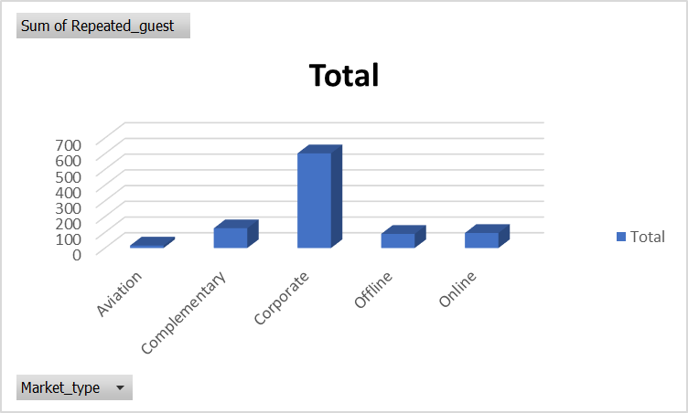
Graph: Market type vs repeated guest
602 consumers have made purchases from the company's corporate market in the past, according to the available data. A high percentage of the hotel's guests are probably there on business-related visits, therefore this might be a sign of the hotel's good standing with local businesses. During its time serving the aviation industry, just 16 original clients came back to do business with the firm again. This data might be interpreted to mean that either the aviation sector isn't interested or that there won't be many repeat guests staying at the hotel. These two meanings are not mutually exclusive. This may also imply that attracting new customers is challenging for businesses in this sector. The high rate of customer retention in the Complementary market segment (126 total) is a strong indicator of contentment. This might be because the hotel provides complimentary stays to visitors in exchange for great reviews, media coverage, or other incentives. Return visitors are most common in the business sector, followed by the educational sector, and finally the transportation sector. However, the aviation industry has much higher numbers compared to the other two industries. A hotel's success in attracting and retaining guests may depend in large part on the flexibility of its personnel to meet the needs of a wide range of guests.

Task 2
2.1 Gender

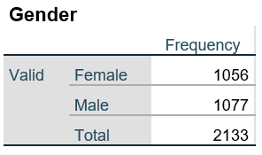
According to the data presented, there is a wide range of gender representation within the student body. There were a total of 2133 people present, 1056 of which were female and 1077 of which were male. The ratio of male to female students seems to be fairly near to equal at this institution. The administration may utilise the information about the visitors' gender to make the campus seem more inclusive and to tailor their advertising and services to the right demographics.
2.2 Lunch
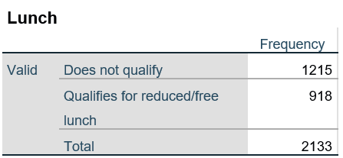
It is shown what percentage of students are male and what percentage are female at a certain institution. There were a total of 1056 women and 1077 men among the 2133 pupils. These numbers might be used to get some understanding of the sex dynamics within the student body. The gender ratio of a school's student body may provide light on the kinds of discrimination and challenges faced by different student groups. It is possible that schools might benefit from gender-specific programmes or curriculum in order to tackle issues like sexism and achievement gaps. To better accommodate students whose perspectives and experiences are different, schools may benefit from considering the gender dynamics of student groups.

2.3 Mean and median
The value of 1066.5 is close to both the mean (1215) and the median (918) of the submitted data, as determined by the provided computations. This supports the idea that the average of these two values is similar to their median value. One may use the numbers 1215 and 918 from these data as illustrations of the idea of central tendency. Larger samples are more vulnerable to having outliers skew the mean and median. Analysing data requires not just measures of central tendency, such as the mean and median, but also measures of variability and dispersion, such as the range and the standard deviation. The mean and the median, which are both computed differently, are useful indicators of central tendency. The significance of any number, however, will change depending on the circumstances.
2.4 Pretest and Posttest
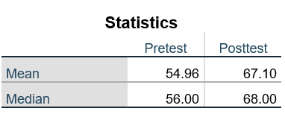
The average score increased up from 54.96 to 67.10 since this question showed up on both the practise test and the real examination. The median score, which had been 68 before and after the change, remained at that number after it was adopted. The average is found by adding up all of the potential points and then dividing by the final tally. Numbers at either end of the spectrum (extremes) are ideal examples of outliers that may distort statistical analysis. It is plausible that a few of extreme cases may account for a sizable dispersion around the mean. The posttest scores are much better than the prior pretest scores. The median, on the other hand, represents the midpoint of a data set. It may be easier to grasp the present state of affairs if the numbers are sorted from least to greatest. It is helpful for assessing data with a wide range of values since it emphasises the middle ground rather than the extremes. The middle numbers in the two collections of test results don't appear to be too far off. The great majority of posttest outcomes agreed with pretest results, despite a large discrepancy between the median and the mean. Even if the outcomes were different when comparing the mean to the median, this remained the case. No matter what number was used to get the group average, this held true.
2.5 Cluster

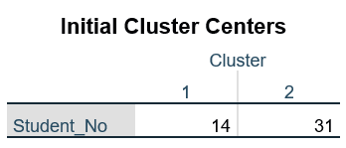

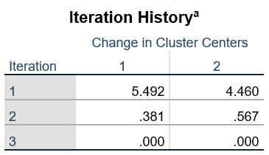

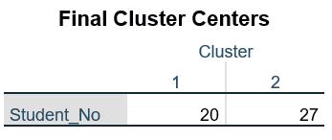

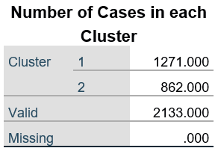
Cluster analysis, which classifies objects or observations into groups based on shared features, was used to examine the given data. Focus is on student 14 (identified by ID number 14) in the first set, and on student 31 (identified by ID number 31) in the second. Student No. 20 was chosen to represent Cluster 1, while Student No. 27 represented Cluster 2. The final cluster centres being so close together is indicative of high levels of agreement between the two sets of pupils on the assessed criteria. Cluster 1 has 1271 pupils, or a large majority, whereas cluster 2 contains 862 students, or a small fraction of the total. Insufficient information on the characteristics used to create the clusters prevents any firm conclusions from being drawn from the data. It is important to thoroughly assess cluster analysis results and, if feasible, corroborate them using other statistical methods. Cluster analysis is only one tool among several that may be used for exploratory data analysis.

2.6 Data mining and text mining methods
Sentiment analysis: Text data analysis using this method may be used to learn about the opinions and perspectives stated in places like social media posts, survey findings, and product reviews. Sentiment analysis has many practical uses in the business world, including PR, customer service, and even market research (Mehta and Singh, 2020). Monitoring and analysing customer comments and interactions online gives businesses a higher opportunity of acquiring insight into consumer issue areas and the best ways to handle them.
Decision making trees: It is possible to include user-defined criteria into a decision-making model using this approach. In this manner. Decision trees have several uses in the corporate sector, including but not limited to customer segmentation, risk assessment, and marketing campaign optimisation. The bank could use a decision tree to weigh factors including the applicant's salary, credit history, and other credentials (Manupati & Anisetti, 2020). The bank may additionally consider any relevant factors that aren't explicitly mentioned here.
Cluster mining: Cluster analysis is a technique used by businesses to classify clients into subsets defined by characteristics like their demographics, location, and purchasing habits. This strategy is often known as segmentation in the commercial sector. This method is used to categorise data in line with characteristics held in common by several entities. The corporate sector finds several uses for cluster analysis, including fraud and anomaly detection, consumer segmentation, and pattern identification.
Mining with association: One of the purposes of the associative mining strategy, a method for searching through data sets, is to mine for undiscovered correlations and patterns (Kumar & Saini, 2020). The commercial applications of mining for association rules include the analysis of consumer behaviour, the creation of product recommendations, and the verification of online shopping carts. To learn which products are often purchased together, one strategy is to mine for association rules.
Neural networks: This method recreates the complicated input-output connection dynamics via the use of node-based hierarchical networks. Neural networks are now being used for a variety of purposes in the business sector, including fraud detection, risk analysis, and demand forecasting. In retail, neural networks may be effective when used in conjunction with other variables such as weather, marketing efforts, and economic indicators to foresee potential sales trends. This is particularly the case when the networks are used in conjunction with other elements.
2.7 Advantages and Disadvantages of Using SPSS and Excel
Although Excel and SPSS are two of the most popular options, there are many additional tools available. Since each has benefits and drawbacks, choose between them will depend on the specifics of the job at hand.
Excel | SPSS
Excel should work well with even quite huge data sets. | The thoughtful organisational design of SPSS facilitates the processing of massive datasets.
While the built-in statistical tools of Excel are sufficient for many projects, more in-depth studies may need additional plug-ins. The built-in statistical capabilities of Excel may be useful in a wide variety of everyday contexts. | SPSS is a statistical package that allows for in-depth data analysis. This suggests that it might be a fruitful area of study for scholars in many fields. Cluster analysis is a technique used by businesses to classify clients into groups defined by their demographics, location, and past purchases. This strategy is often referred to as segmentation in the corporate sector. Fraud and anomaly detection, customer segmentation, and pattern identification are just some of the business uses for cluster analysis. Associative mining is a technique used to filter through data sets in search of previously unseen associations and patterns (Kumar & Saini, 2020).
The pre-installed charts and graphs in Excel may need an update, but the application makes it simple to construct the own. | Standard SPSS outputs include histograms and box plots, however they may not be enough for more involved research projects.
The sleek layout and adaptable ribbon menus in Excel only serve to further streamline the program's already intuitive interface. | Data analysis and other tasks are simplified by SPSS's intuitive interface and well-structured menus.
Excel is widely available at little cost, either preloaded on most new computers or available as a stand-alone download (Manupati & Anisetti, 2020). | The SPSS statistics software has a steep licencing charge.
Due to Excel's collaboration features, many people may work concurrently on the same file. | If everyone working on a group project required their own copy of SPSS and the data files associated with it, the project would never get off the ground.

References
Saputra, B. T., and Djunaidy, A. (2020). Big data analytics for business intelligence in decision making: A systematic review. In 2020 International Conference on Information Management and Technology (ICIMTech) (pp. 74-79). IEEE.
Roque, L., and Reis, M. J. (2019). A methodology to improve decision-making using business intelligence and big data analytics. Procedia Computer Science, 164, 447-454.
Özkan, İ., and Dursun, M. (2021). Business Intelligence and Big Data: An Analysis on Best Practices. In Business Analytics and Cyber Security Management in Organizations (pp. 185-196). IGI Global.
Mehta, N., and Singh, M. P. (2020). Big data handling techniques and tools for business intelligence: a review. Journal of Ambient Intelligence and Humanized Computing, 11(10), 3955-3971.
Manupati, V. K., and Anisetti, M. (2020). An efficient technique for handling big data in business intelligence using cloud computing. Future Generation Computer Systems, 105, 264-273.
Liu, Y., Chen, Y., and Liu, H. (2019). Big data-driven business intelligence. In Proceedings of the 2019 IEEE 43rd Annual Computer Software and Applications Conference (pp. 605-606). IEEE.
Kumar, S., and Saini, M. (2020). A review of big data analytics and business intelligence. Journal of Big Data, 7(1), 1-18.
Koo, H., and Kim, H. (2020). A literature review of big data and business intelligence for improving organizational performance. Sustainability, 12(7), 2762.
Hussain, T., and Abbas, A. (2020). Big data and business intelligence: A review of literature. Journal of Advances in Mathematics and Computer Science, 35(5), 31-39.
Do, T. T., and Nguyen, H. P. (2019). Big data analytics and business intelligence: A survey of the literature. International Journal of Data Mining and Knowledge Management Process (IJDKP), 9(5), 1-22.

