Speaker notes:

Student ID: Negrut alina 2412462

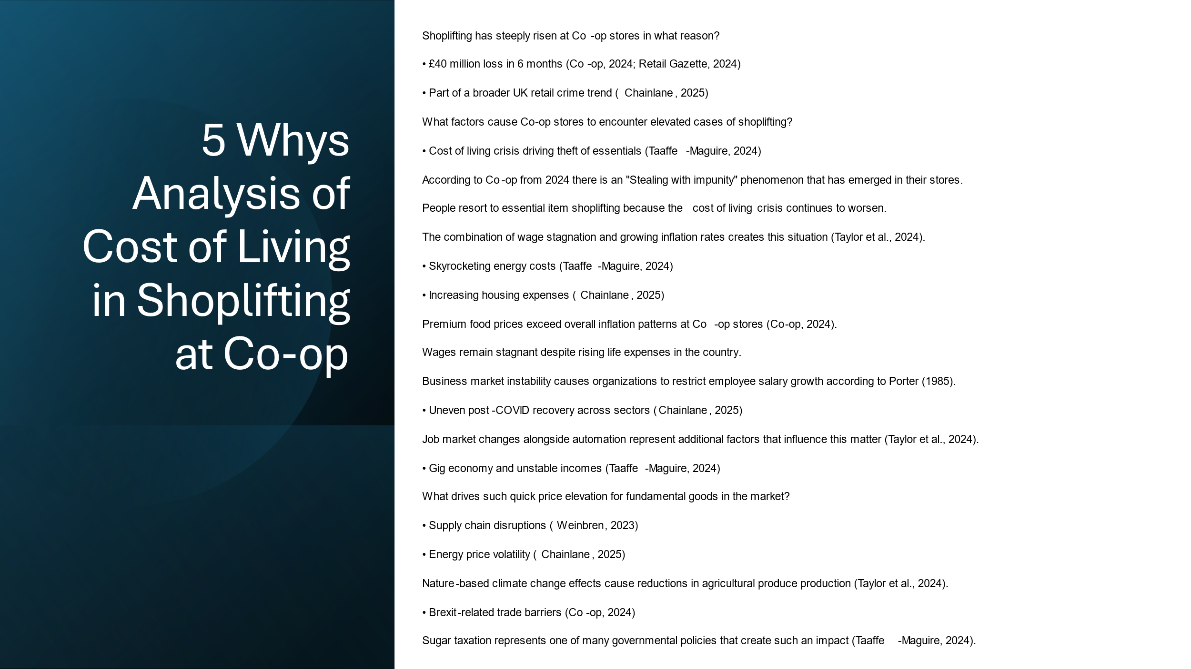

What factors are responsible for the rising number of shoplifters at Co-op distribution facilities?
Shoplifting incidents at Co-op retail stores have soared to levels that have resulted in approximately £40 million worth of losses during the recent six-month period according to Co-op (2024).
The Co-op stores experience increased cases of shoplifting by customers.
Many people who struggle with financial difficulties now engage in theft because of the long-lasting cost of living situation. The current cost of living crisis drives individuals to shoplift essential items at Co-op because the grocery chain faces these sophisticated theft attempts (Taaffe-Maguire, 2024).
What factors from the cost of living crisis drive people to take essential items from stores by shoplifting?
Several factors contribute:
Wage stagnation has separated from inflation growth so that real buying capacity remains constant (Taylor et al., 2024).
Rising energy prices have eaten into the funds available for purchasing food along with necessary household items (Taaffe-Maguire, 2024).
People face mounting financial strain since their housing expenditures including home rents and mortgage payments have escalated substantially (Chainlane, 2025).
Why are wages not keeping up with the cost of living increases?
The fear of uncertain economic times caused numerous companies to restrict pay raises in order to protect their profitability levels (Porter 1985).
The economic environment from COVID-19 still affects industries unevenly during recovery phases (Chainlane, 2025).
The introduction of automation and changes in the labor market caused wages to remain stagnant in particular business sectors (Taylor et al., 2024).
Businesses that operate in the gig economy as well as the growing adoption of part-time work positions create income instability for several workers (Taaffe-Maguire 2024).
Why are prices rising so rapidly, particularly for essential items?

Global disruptions in supply chains which began during the pandemic have increased business costs for retailers because of geopolitical tensions (Weinbren, 2023).
Soaring energy costs arise from market instability combined with the shift toward renewable energy technologies which raises production expenses as well as shipment expenses (Chainlane, 2025).
Climate change together with unexpected weather patterns have decreased agricultural harvests which resulted in elevated food-market prices (Taylor et al., 2024).

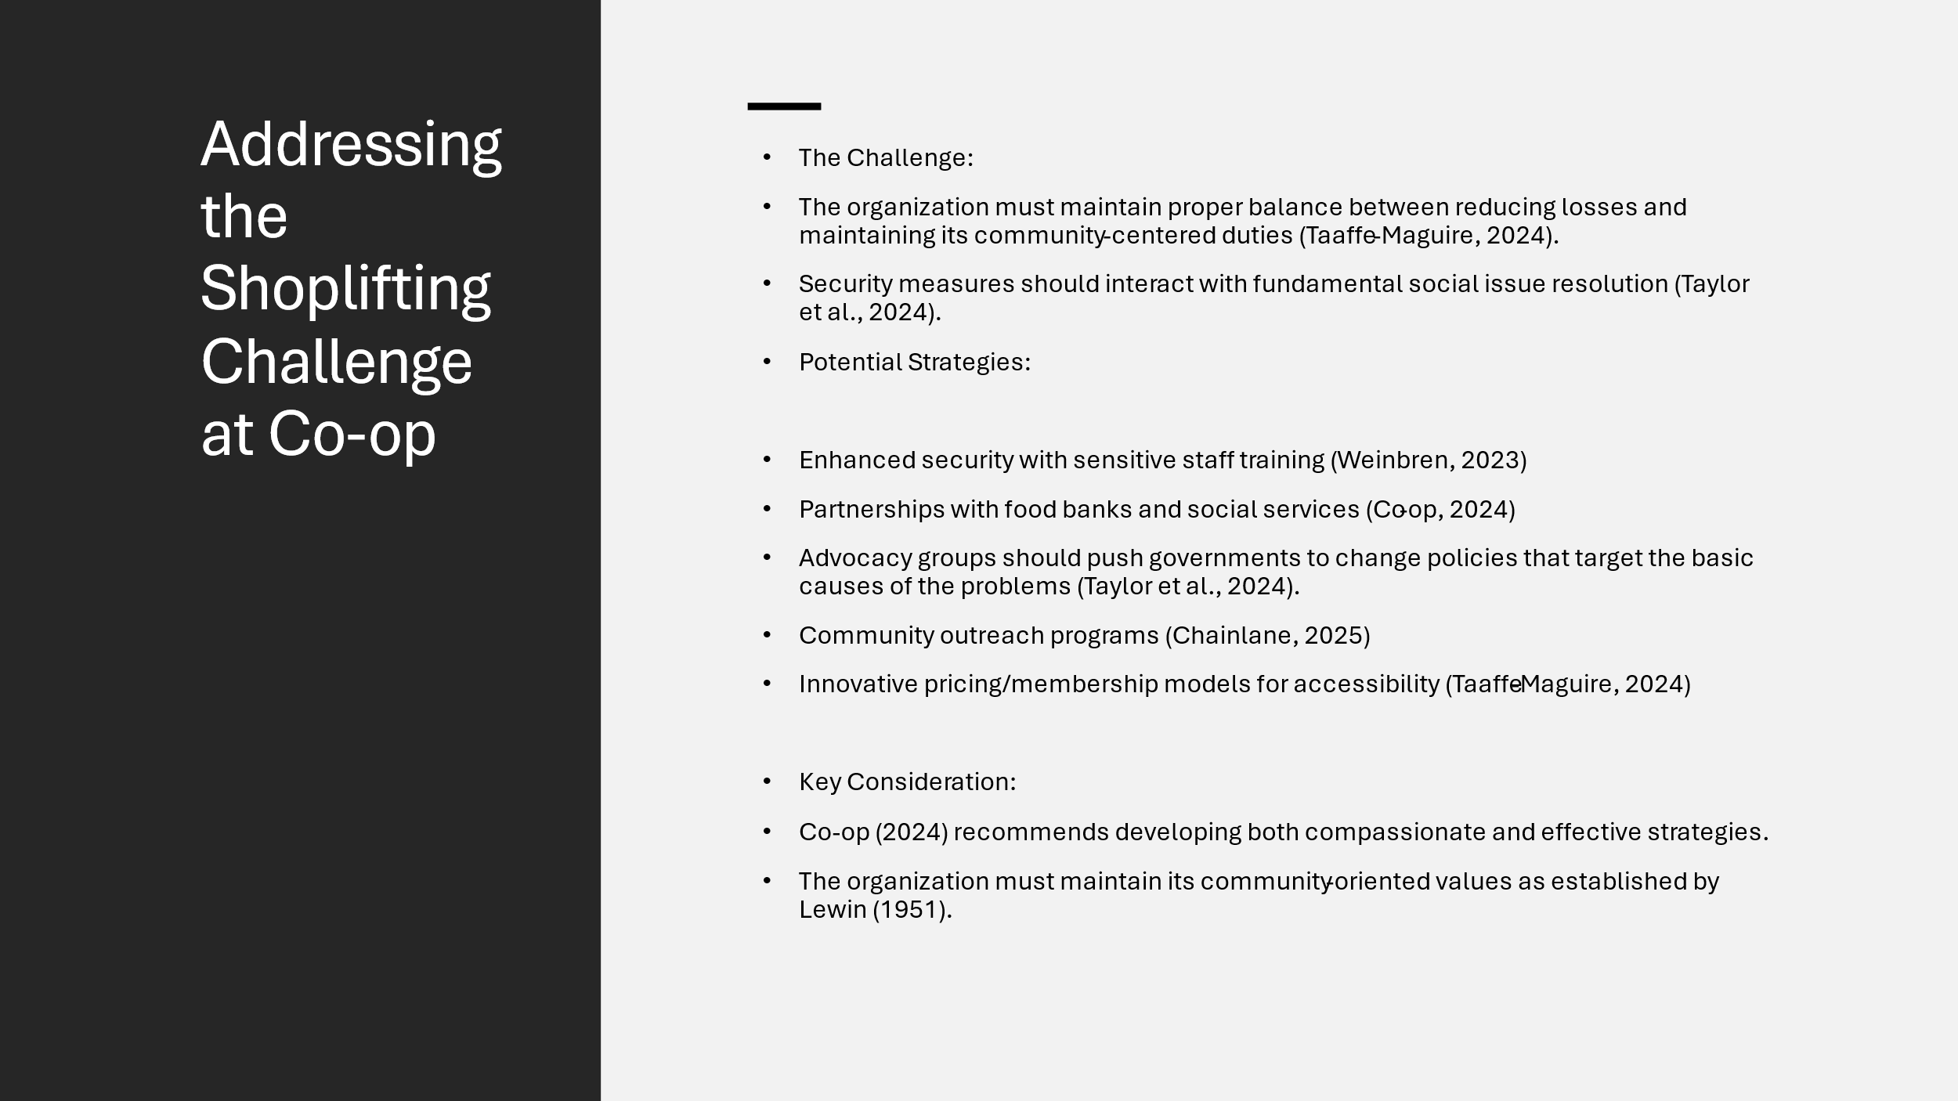

The Challenge:
Co-op encounters multiple challenges when it comes to handling the recent shoplifting increase.

Potential Strategies:

The combination of upgraded security with training for store staff according to Weinbren (2023) keeps theft at bay and enables proficient incident management by personnel.
According to Co-op (2024) the company intends to build alliances for joint assistance between local food banks and social services.
According to Taylor et al. 2024 the solution requires policy modifications to eliminate the base causes of the cost of living crisis.
The authors from Chainlane (2025) advocate for developing community outreach programs. Through these initiatives the organization gains better understand of local economic challenges to create responses which strengthen its community relationships.
According to Taaffe-Maguire (2024) Co-op should investigate new pricing approaches as well as membership plans.

Key Consideration:
The development of strategies should focus on both meaningful theft reduction and preventing compassionate treatment of people whose financial difficulties force them to shoplift according to Co-op (2024). The approach matches Lewin's (1951) field theory of behavioral outcomes that result from environmental and individual factors.

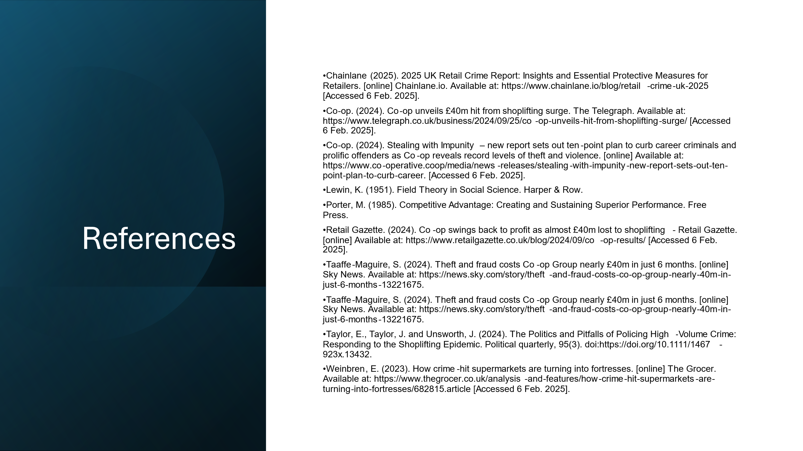

Chainlane (2025). 2025 UK Retail Crime Report: Insights and Essential Protective Measures for Retailers. [online] Chainlane.io. Available at: https://www.chainlane.io/blog/retail-crime-uk-2025 [Accessed 6 Feb. 2025].
Co-op. (2024). Co-op unveils £40m hit from shoplifting surge. The Telegraph. Available at: https://www.telegraph.co.uk/business/2024/09/25/co-op-unveils-hit-from-shoplifting-surge/ [Accessed 6 Feb. 2025].
Co-op. (2024). Stealing with Impunity – new report sets out ten-point plan to curb career criminals and prolific offenders as Co-op reveals record levels of theft and violence. [online] Available at: https://www.co-operative.coop/media/news-releases/stealing-with-impunity-new-report-sets-out-ten-point-plan-to-curb-career. [Accessed 6 Feb. 2025].
Lewin, K. (1951). Field Theory in Social Science. Harper & Row.
Porter, M. (1985). Competitive Advantage: Creating and Sustaining Superior Performance. Free Press.
Retail Gazette. (2024). Co-op swings back to profit as almost £40m lost to shoplifting - Retail Gazette. [online] Available at: https://www.retailgazette.co.uk/blog/2024/09/co-op-results/ [Accessed 6 Feb. 2025].
Taaffe-Maguire, S. (2024). Theft and fraud costs Co-op Group nearly £40m in just 6 months. [online] Sky News. Available at: https://news.sky.com/story/theft-and-fraud-costs-co-op-group-nearly-40m-in-just-6-months-13221675.
Taaffe-Maguire, S. (2024). Theft and fraud costs Co-op Group nearly £40m in just 6 months. [online] Sky News. Available at: https://news.sky.com/story/theft-and-fraud-costs-co-op-group-nearly-40m-in-just-6-months-13221675.
Taylor, E., Taylor, J. and Unsworth, J. (2024). The Politics and Pitfalls of Policing High‐Volume Crime: Responding to the Shoplifting Epidemic. Political quarterly, 95(3). doi:https://doi.org/10.1111/1467-923x.13432.
Weinbren, E. (2023). How crime-hit supermarkets are turning into fortresses. [online] The Grocer. Available at: https://www.thegrocer.co.uk/analysis-and-features/how-crime-hit-supermarkets-are-turning-into-fortresses/682815.article [Accessed 6 Feb. 2025].

