Shakeel hussain 2127229 lecterer ashiat

Assignment Title: Major Health Issue (Depression)

Submitted by:

Student ID:

Module Title: Introduction to Public Health

Module Code:

Submitted to:
Introduction:
Disease is a malfunction in a person's body. In general, illness is defined as any bodily function that differs from normal. Infectious diseases, deficient diseases, hereditary diseases (covering both genetic disorders and non-genetic hereditary diseases), and physiological diseases are the four primary categories of disease. Diabetes is a chronic condition brought on by either insufficient insulin production by the pancreas or inefficient insulin utilisation by the body. Diabetes mellitus represents a set of autoimmune, metabolic and genetic disorders that share one major characteristic hyperglycaemia.( Egan, A.M. and Dinneen, S.F., 2019.)A hormone called insulin controls blood sugar levels. Uncontrolled diabetes frequently causes hyperglycemia, also known as high blood glucose or raised blood sugar, which over time can seriously harm many different bodily systems, including the neurons and blood vessels. Blood sugar levels can occasionally rise above average but not to the point where diabetes is diagnosed. Because tension and mental stress can raise blood sugar levels, this condition may be referred to as pre-diabetes. When the number keeps rising, it is considered to be diabetes, which needs to be identified right once because untreated diabetes will only become worse over time. Diabetes, however, prevents the body from converting glucose into energy. This is a result of either insufficient insulin production or improperly functioning insulin that is produced. Although it can be controlled, there is currently no known cure for diabetes. Only by maintaining a healthy lifestyle, which includes eating well, exercising, and maintaining a healthy body weight, can the condition be managed.
The assignment will be determined by some rigorous standards, including the main risk factors for diabetes, the different forms of diabetes, how to test it, and diabetes prevention.

Main Body:
8.5% of persons who were 18 years of age and older had diabetes in 2014. A total of 1.5 million deaths were directly related to diabetes in 2019, and 48% of these deaths occurred in those under the age of 70. Diabetes contributed to an additional 460 000 renal disease deaths, and high blood glucose is responsible for 20% of cardiovascular fatalities. Globally, the death rate from diabetes grew by 3% between 2000 and 2019, reaching 13% in low- and middle-income nations. An estimated 2 million people died in 2019 from diabetes-related renal damage.

Types of Diabetes: Different types of diabetes has different causes, symptoms, risk factors. Those are discussing in below:

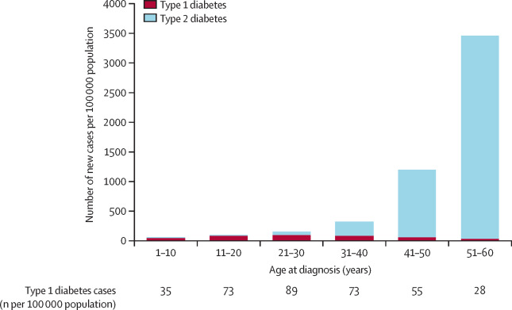

- Type-2 Diabetes: Type 2 diabetes develops when the body's insulin is ineffective. 90% of persons in the UK have Type-2 diabetes, which makes up more than 95% of all cases of diabetes. Unconsciously, the condition develops inside the body over years of excess body weight and inactivity until symptoms manifest. Although experts claim that youngsters are now also affected by these bacteria, this disease is primarily noticed in adults.
Symptoms:
Despite the fact that Type-2 diabetes develops slowly and cannot be detected fast, some symptoms may be noticed without explanation.
urinating more frequently than normal, especially at night.
- experience fatigue more often.
- vision problems.
- Weight loss
- Cuts and injuries take longer to heal.
- constant thirst
- itching in the vagina or penis, etc.

Risk Factors:
- In the UK, people with Type-2 diabetes are at danger for over 40 years of age, whereas Asians and Africans are at risk for over 25 years.
- For people who are obese or overweight.
- If the waistline is very big.
- This case involves genetics. There is a possibility that the subsequent generation will be genetically impacted if a family member already has this illness.
- High blood pressure and diabetes can interact readily if a person has a history of poor health, such as heart disease.

- Type-1 Diabetes:
In the UK, 8% of the population suffers with Type-1 diabetes, an extremely serious and chronic illness. Type-1 diabetes, sometimes referred to as insulin-dependent, juvenile, or childhood onset diabetes, is characterised by a complete lack of insulin in the body and a patient's ongoing reliance on insulin injections. Type 1 diabetes affected 9 million people in 2017, the majority of whom reside in high-income nations. Its aetiology and methods of prevention are unknown. Polyuria (excessive excretion of urine), thirst (polydipsia), excessive hunger, weight loss, visual abnormalities, and exhaustion are some of the symptoms. These signs could appear out of nowhere.

Symptoms:
The symptoms of Type-1 diabetes are-
- When the body attempts to eliminate glucose through the kidneys, the kidneys are badly impacted.
- continuous hunger
- excessive urge to pee.
- thirst that is excessive.
- An unexpected weariness may be noticed because the sickness tends to progress quickly—possibly within a week.
- losing vision
- continual decrease of weight.

Risk Factors:
- The body of a child can readily contract this type of diabetes.
- Being obese.
- Mental trauma and stress.
- Other heart conditions linked to elevated blood sugar levels.
- Anxiousness.

- Gestational diabetes: Gestational diabetes is a short-term sugar high condition as women only face this disease while pregnant. It is a risky phase for pregnancy as the baby grows excessively in the womb, the delivery of baby becomes more complex. It’s better to consult a doctor in this kind of situation.
- Impaired fasting glucose and impaired glucose tolerance: Between normalcy and diabetes, there are two intermediary conditions impaired glucose tolerance (IGT) and impaired fasting glycaemia (IFG). Although it is not a given, people with IGT or IFG are at a significant risk of developing type 2 diabetes.

Impact of Diabetes:
Diabetes can disrupt a person's ability to live a normal life in a number of ways.
Here are some effects of diabetes:
  - Diabetes can harm the nerves, eyes, kidneys, blood vessels, heart, and other organs.
  - The risk of heart attacks and strokes is two- to three-fold higher in adults with diabetes.
  - Neuropathy (nerve damage) in the feet, when combined with decreased blood flow, raises the risk of foot ulcers, infections, and ultimately the requirement for limb amputation.
  - Long-term cumulative damage to the retina's tiny blood vessels results in diabetic retinopathy, a significant cause of blindness. Diabetes causes about 1 million people to become legally blind.
  - Poor outcomes for a number of viral illnesses, including COVID-19, are more frequent in diabetics.

How to measure Diabetes:
In the UK, the NHS has set up General Practitioner(GP) offices where a diabetic patient can speak with a doctor and set up a regular checkup schedule. A doctor will consider recommendations like what diabetes is, what high blood sugar implies for health, and whether patient need to take medication. They will also consider food habit, exercise routine, and lifestyle choices, such as alcohol and smoking. When the results of the blood and urine tests for sugar levels are available, usually after one or two days, the doctor will explain what to do next. A1C testing determines the average blood sugar level during the previous two to three months. An A1C of 5.7% or less is considered normal, 5.7% to 6.4% indicates pre-diabetes, and 6.5% or over implies diabetes.
Recently, a self-testing device for determining blood sugar level was also discovered, and it is relatively affordable. Even so, the doctor may advise to check with them the first time because occasionally a urine sample might provide the right answer and the body's blood sugar level at the moment.
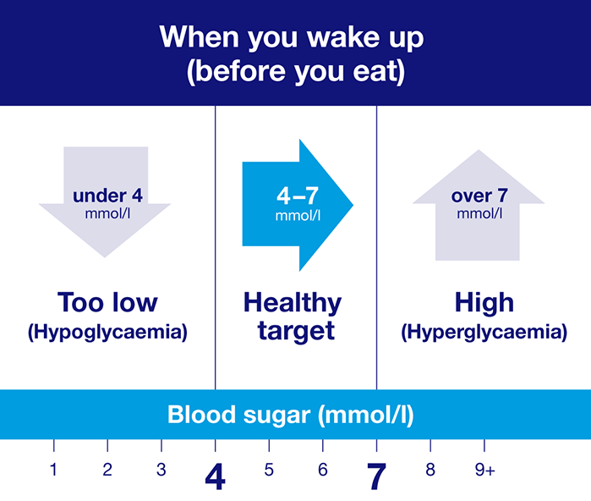
Low blood sugar can occur occasionally as well. That condition is known as hypo, which also needs to be addressed since, if it worsens, a person may have severe hypo, which is hazardous. The signs may include impaired vision, increased perspiration, nausea, dizziness, tingling in the lips, headache, inability to concentrate, etc.
So, if a person notices an abnormal change in their body, they should see a doctor for additional examination.

When to test blood sugar:
If a patient has type 1 diabetes, their doctor might advise 4–10 times a day of blood sugar testing. Patient may require testing

- Lunches and snacks before
- Exercise before and after
- prior to going to bed
- In the evening (sometimes)
- More frequently if a person is ill
- More frequently if they take a new medicine or alter their usual routine

Depending on the kind and dosage of insulin being used, a health care professional may ask to check the blood sugar level numerous times during the day if a person with Type-2 diabetes takes insulin twice daily. It is necessary to check yourself before and after meals if you take more than one dose of insulin each day to detect fluctuations. Once the level is understood, the patient no longer has to check on a frequent basis since a balanced diet, regular exercise, and lifestyle will be sufficient to control the condition.

Prevention of Diabetes:
Diabetes still has no known treatment, as was previously indicated, although it may be managed by taking certain measurements.
  - Medicinal knowledge: The patient must be informed of the appropriate medications for their particular kind of diabetes. The most popular treatment for type 2 diabetes is metformin. However, in most cases, doctors advise pregnant women to increase their physical activity and eat a balanced diet rather than taking any medications. For some patients, insulin is another drug, although it's always best to speak with a doctor before taking any medication.
  - Know the kind: Testing is crucial before beginning any medication. Knowing the kind, the doctor can then recommend.
  - Food and keeping active: A good diet and regular exercise are essential for controlling blood sugar, which can also help you lose weight and feel better overall. A person with Type-2 diabetes is able to eat anything as long as they restrict a few items:
*consume a variety of foods, such as fruit, vegetables, and certain starchy foods like pasta;
* limit the intake of sugar, fat, and salt;
*eat breakfast, lunch, and supper every single day; do not skip meals.
In order to balance things out, patients can also alter their eating habits a little bit each week. A diabetic patient should strive for 2.5 hours of daily physical activity to manage their condition. Exercise options include brisk walking, stair climbing, more demanding housekeeping, and gardening.
  - Getting routine check-ups: Diabetic patients are required to get a check-up or a HbA1C test every three months from a doctor or hospital. Additionally, it's important to get your kidneys, blood pressure, blood sugar, blood pressure, and feet tested once a year because diabetes might have an effect on those bodily components. Regular examinations are essential to avoid
    - heart disease and stroke
    - loss of pain and emotion (nerve damage)
    - issues with the feet, such as sores and infections
    - blindness and a loss of eyesight
    - renal issues after loss and miscarriage
    - sexual issues, such as difficulty obtaining or maintaining an erection.

Conclusion:
The healthcare system for all diseases has improved in the UK since the founding of the NHS in 1948 thanks to the existence of local support groups for patients across the whole nation. 120 diabetes research initiatives around the UK are discovering breakthroughs thanks to local organisations, funders, and supportive members. 66 million pounds have been spent in these projects. There are also various online forums where 23,268 more people share their knowledge and experiences together with 1,117,010+ entries. The NHS has a help truck available to give assistance in an emergency.
A simple 4T technique, which stands for T=Toilet, T=Thirsty, T=Tired, and T=Thinner, was also provided on the NHS website to help people understand the symptoms of diabetes. The doctor also offers some recommendations for keeping the illness under control. 2018 recommendations stress a flexible, customised approach to managing diabetes and losing weight and highlight the newly available data supporting Type 2 diabetes remission.(Dyson, P.A., Twenefour, D., Breen, C., Duncan, A., Elvin, E., Goff, L., Hill, A., Kalsi, P., Marsland, N., McArdle, P. and Mellor, D., 2018). The recommendations are also available on the UK nutrition website.
Additionally, they advise calling a doctor's office to schedule an appointment if any diabetic symptoms are present because each person's illness and treatment plan may differ. In order to control the disease in the future, individuals must be aware of these factors.

References

- Egan, A.M. and Dinneen, S.F., 2019. What is diabetes?. Medicine, 47(1), pp.1-4.
- https://www.who.int/news-room/fact-sheets/detail/diabetes [Accessed on 19 Nov,2022]
- Diabetes mellitus, fasting blood glucose concentration, and risk of vascular disease: a collaborative meta-analysis of 102 prospective studies. Emerging Risk Factors Collaboration. Sarwar N, Gao P, Seshasai SR, Gobin R, Kaptoge S, Di Angelantonio et al. Lancet. 2010; 26;375.
- Causes of blindness and vision impairment in 2020 and trends over 30 years, and prevalence of avoidable blindness in relation to VISION 2020: the Right to Sight: an analysis for the Global Burden of Disease Study GBD 2019 Blindness and Vision Impairment Collaborators* on behalf of the Vision Loss Expert Group of the Global Burden of Disease Study† Lancet Global Health 2021;9:e141-e160.
- 2014 USRDS annual data report: Epidemiology of kidney disease in the United States, United States Renal Data System. National Institutes of Health, National Institute of Diabetes and Digestive and Kidney Diseases, Bethesda, MD, 2014:188–210.
- https://www.nhs.uk/conditions/type-2-diabetes/getting-diagnosed/ [Accessed on 19 Nov,2022]
- Dyson, P.A., Twenefour, D., Breen, C., Duncan, A., Elvin, E., Goff, L., Hill, A., Kalsi, P., Marsland, N., McArdle, P. and Mellor, D., 2018. Diabetes UK evidence‐based nutrition guidelines for the prevention and management of diabetes. Diabetic medicine, 35(5), pp.541-547.
- https://www.diabetes.org.uk/diabetes-the-basics/types-of-diabetes/type-1/symptoms [Accessed on 19 Nov,2022]

