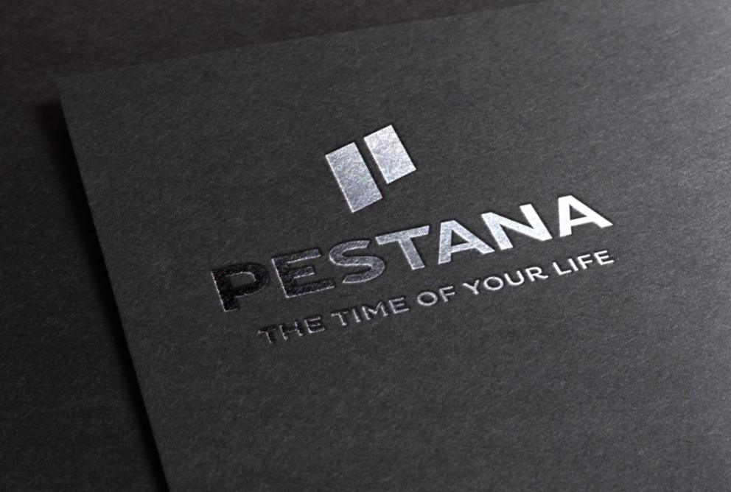
HOTEL PESTANA ORGANISATINAL STRUCTURE
Organisational Audit
BMIH5004
Module tutor: Robyn Griffiths Student n.: Natalia Sanches (2013495@student.uwtsd.ac.uk) | 7/6/22 | Management and Organisational Behaviour

Executive Summary
There are many challenges to be faced by entrepreneurs in hospitality, nowadays the hotel industry lives in intense expansion due to the growth of the tourism sector among other factors, the need for innovation is a constant, being a very competitive market, having to face challenges such as impetuous competition, incitement to business structuring due to external or global factors such as pandemics, wars even simple changes in customer behaviours. The information is coming to people each time faster due to the dynamic of products and services. To keep up with this speed hotel groups and administrators are required to update themselves day after day, planning and setting the objectives of their organizations.1
The objective of this Report consists of an audit that provides a whole diverse and updated set of information to enable an analysis of the organizational reality of the Pestana group, and the structure presented obeying a framework of the management of organizations in a globalizing perspective, which requires to relate situations to concepts taught, to make known a Portuguese hotel group in rapid growth nationally and internationally.

Executive Summary 1
Introduction 2
Organisational Structure, Culture e Goals 4
Structure Organisational 4
Culture and Goals 4
Vision and Mission 5
Recent Change Initiatives 6
Strategic Direction 7
Business Performance 7
Sustainability policies 7
Competitive Advantages 8
Conclusion 8

Introduction
The Pestana Hotel Group (HPG) is the greatest multinational group of Portuguese origin in the tourism sector and leisure corporation, founded in 1965, opening its first hotel in 1972 the current Pestana Carlton Madeira, includes 63 companies in 16 countries, each one is sponsored by an appropriate sub-holding organisation:
Grupo Pestana S.G.P.S, S.A Portugal (Hospitality, Vacation Club, Resicende, Golf, Entertainment, and Brewery)
Djebel S.A., Brasil South America (Hospitality)
ESGAP S.A., (Group’s shared services companies)
Hotels do Atlantico, S.A., Europe, and North America, (Hospitality)
Pestana Inversiones, Lda., South American Spanish-speaking countries, (Hospitality)
Salvintur S.A., Africa (Hospitality, Real Estate, Residence, and Entertainment)
Pestana International Holdings S.A. Portugal is the last one holding company the share capital is 100% owned by Mr. Dionisio Pestana, president, and son of the Group’s founder. Quadro 4
With its chain of more than 100 hotels divided between 4 hotel brands (Pestana Hotels & Resorts, Pestana Collection Hotels) on three different continents, Europe, South America (Argentina and Brazil), Africa (Cape Verde, Mozambique, São Tome, and Principe, South Africa) and more recently North America (New York). 2 The group manages "Pestana Pousadas de Portugal" since 2003, 34 historic buildings belonging to the Portuguese state 3, marking the beginning of the entry into Europe the HPG opens its first property in London the Pestana Chelsea Bridge Hotel & Spa in 2011, followed by many others international investments announced by the group are expected to be opened. 6
In 2016 the group joined up with Cristiano Ronaldo to open a hotel chain with the player's brand, Pestana CR7 Lifestyle Hotels being the first hotel opened in Madeira Island (Funchal), above the CR7 museum later that same year inaugurated another Pestana CR7 in Lisbon, at this time with two more hotels one in Marrakech, the 4th and most recent in 2020 in New York centered Time Square 4, it owns the Portuguese airline EuroAtlantic Airways, has a stake in the national airline of São Tome and Príncipe "STP Airways". The Pestana group owns timesharing properties, six golf courses, three tourist real estate developments, a game concession for casinos (Casino Madeira and Casino S.Tome e Principe) a travel agency, and three tour operators.5 Unlike other hotel groups that only manage Brands and management contracts, Pestana Hotel Group owns its hotels and investments, valued at 1.1 billion euros. Falta ref.

Organisational Structure, Culture e Goals

Structure Organisational
The organizational structure of the Pestana group is formed by the administrative council with the maximum responsibility for the activity of the companies it integrates, composed of 14 executive directors with capability over the several existing companies in the distinct geographical areas where is the group present, Photo 5 being a holding company that who owns the majority of the shares of other companies holding control of its management and internal policies of the group, coordinated at a central level, on the other hand with a good Chain of command with business autonomy and specific knowledge of each hotel unit on the market, are reinforced within the business areas ensuring that all tasks and positions have a person responsible for the performance, eliminating the need for an employee to report to several bosses. Thanks to well-settled structures, clearly defined areas of ability, and collective values joining efficient collaboration the group offers a stable foundation to further consolidate the market position of each of the organisations leading the group to success.16 foto6

Culture and Goals
With the abrupt disruption due to the covid 19 that the hospitality department suffered in 2019 created an opportunity for the sector to adapt to the new requirements of globalisation, with a long way to go to achieve pre-pandemic recovery levels, now in 2022 it is closer to normal and the hospitality sector will not return to the strict constraints of the past. 8 foto3
The Pestana Group came from successive years of growth due to the growing tourist demand, but also its strategy of diversification of sustained growth with a high commitment between the excellent quality of service and focus on results through strict cost control, took advantage of these times to reorganize, diversify, modernize, reduce its level of indebtedness preparing for the future. With its units closed resorted to the measure to support the maintenance of employment (Lay-off simplified) support there resume progressive initiative of the aid of the government Portuguese, another of the measures to support liquidity with the legal application of moratoriums on the repayment of capital in bank loans through prior agreement with these entities. It has reinvested its profits by adopting innovation and cutting-edge technology in its processes, developing new business models, training its professionals based on the best practices in the sector, complementing with the hiring of qualified professionals who have incorporated “know-how” and experience even obtained in other economic sectors. 15
Nowadays the perception about organizational cultures, with the economic recovery and the growth of business stability, owners and administrators had a greater need to create an internal culture to achieve a concept that is pleasant for all, in the hospitality sector is extreme importance the well-being of the employee because reflected in work and interactions with colleagues and guests, increasing the prosperity of the corporation. As employees are the soul of most hotel businesses, their happiness almost always results directly in the satisfaction of guests.10 To implement a successful organizational culture first is necessary to create a brand vision, identifying what differentiates it from other markets, such as customer service, economic accommodations, event organizations or local tours, and others, and in all cases and possible the company can combine its vision with an organizational culture that happy employees welcome creating positive and relaxed environments.7

Vision and Mission
The slogan of Pestana Group is “The world would be a better place if everyone had the opportunity to have the time of their lives”.9 In a globalized and competitive context, HPG Group creates proposals of differentiated values betting on the quality of excellence of its products and services to the customer and human capital, identifying people's skills and developing them to maximize results and individual and organizational well-being, some of the benefits created for employees is to offer discount cards, access to health insurance and psychological support, access to the Pestana Academy which programs for development and progression of careers, mobility & internal opportunities inside the group internationally, Hybrid Model of Work, community support and volunteering, organized by the Planet Guest program.11
espaco
Being the mission the window that will present the global positioning of a company showing its values as codes of conduct are the fundamental principles of how it wants to be recognized by its customers, employees, and partners following its journey 12. The mission of the HPG Group is to create memorable experiences for its visitors by offering them distinctive and creative products, superior services, sustainable profitability, and the right social attitude with a motivated, skilled, and dedicated team.
Pestana Group has already worked actively and consequently achieving its objectives in the area of sustainability since 2009, creating its own program the "Planet Guest" 13 based on sustainability principles on the economic, social, and environmental pillars showing transversality of the group's social responsibility under the motto "We are only guests of the Planet", which resulted from an analysis of management and performance approaches in the areas involved carried out by an internal team of different departments and a benchmarking analysis carried out to the main international hotel groups.14

Recent Change Initiatives
One of the group's recent initiatives was to foster the concept of efficiency in the city hotels, with the concept of "We want you to feel at home", the company has digitally transformed itself with Microsoft technology, using three pillars for its growth, efficiency, online business improvements and creating unique experiences for its customers.22 Having an internal data-sharing service with improvements, all the companies in the group without geographical exceptions, can have general information in real-time, being able to react instantly to any eventuality, allow to be managing more efficiently, providing excellent services.19
Another of Pestana Group's initiatives in Portugal is the form of thanks to the health professionals who fought against the Covid-19 pandemic, creating a 50% discount offer on stays with breakfast included in their hotel units.23

Strategic Direction
Pestana Group's as development strategies are the continued expansion of units preferably in large European and North American cities, with investments controlled based on the ability to generate cash flow, reflections of recent years with the emergence of the country and recently the war in Ukraine. Invest in innovation by implementing new technologies adapting to new markets or even exploring different business models, investing in human capital from creating jobs through more investment in internal training to partnerships with hotel schools, and attributing excellent services to all units of the group.18

Business Performance
Pestana Group has shown sustained sales growth in recent years, which is reflected in considerably profitable of 13.2%, and in 2018 its income of €364.9 MM (+6.7%), excluding the development of opening of new units in Europe and the USA, annual growth was about 16% thanks to the extraordinary growth of its real estate business.17Foto 3

Sustainability policies
Nowadays sustainable development in companies and extremely important and is no longer just an environmental and social obligation, contemplating a series of large-scale actions in strategic decision-making. 20
Being created in 2009 by the pestana group, the sustainability initiative "Planet Guest" with its slogan "We are just guests of the planet", combines all initiatives that help the sustainability of PHG, transmitting the position of the group and their employees with regard to the sustainability of the planet in which one lives. With the Pestana group's focus, the extreme concern towards future generations aims to create long-term value for the organisation, developing its activity with apprising for the environment, acquiring "Green Key" accreditation in all hotels, including local communities, staff, clients, and other pertinent stakeholders in the execution of its activities.21
In addition to the environmental focus, embracing the social pillar, creating initiative as the creation of a campaign "Thank you for helping", which consists of each amount given by the guests at check-out, the hotel chain doubles the same amount for the projects to be developed in each location, where the hotel unit is inserted, working to defend the rights of people living in precarious situations, education and culturally against social inclusion, and many others.24
In this context, the group's sustainability concept is a key component of the loyalty of guests and employees through a policy of quality of services, valorisation of the size of its market and its impact on the communities where they are included, through a corporate social responsibility policy, developing the quality of life with an impact on productivity, through a policy of safety and hygiene at work, and reducing the impact of products and the group's activity on the environment through environmental policies

Competitive Advantages
Pestana Hotel Group is globally recognised by the hotel corporation and its partners including institutions such as World Travel Awards, Travelife, Green Key, and others, being distinguished with the quality seal of international consortia.25

Conclusion
The results found in the question of the study proposal provided answers identifying the particularities related to the cultural and structural aspects of the Pestana Group, indicating the existence or not of congruence of this in relation to the expectations of the management of this organization, thus fulfilling the objective to which it was proposed. This study makes a critical analysis of the structural and cultural components of the group, going in addition to the description of the practices and challenges of its management. In this sense, it reflects an advance in thinking about the management of this institution from practices of its own reality demonstrating that traditional organizational theories are not the most indicated for the analysis of this corporation.
It is essential to consider the national/international reality, and also original characteristics inherent to the social character of the Pestana Group, for the configuration of a model of own management that responds to the expectations of the organization, both technically with an example of the type of public to be reached, development of projects and necessary personnel, as well as flexibility, valorisation of cultural aspects, communication, participation, and integration.
The Pestana group a company with well-rooted foundations with a portfolio of generations in which all the £ has to be respected, created an asset-based model that limits the pace of rampant growth protecting itself from exposing to a high risk of demand compared to other models, obtaining better results and flexibility in cases of fragility shudder. Being a company that in previous years the crises that have been experienced in recent years, obtained profitability allowed the group to generate enough cash flow for reinvestments or even to significantly reduce its misfortunes, in some cases as examples in South America and Africa eliminated completely, all debt settlement plans were oriented with the management capacity of each unit.
The group's guiding principles and commitments are reflected in its policies and show how it approaches sustainability by generating long-term benefits for the business by conducting its operations in a way that respects the environment, local communities, culture, workers, and clients.
The total rationality in the investments made and the day-to-day management of the business, based on the lessons accumulated over four decades, give Pestana Hotel Group an unparalleled competitive advantage in its future sustainability index.

References

